Patterns of Distribution and Migration of Elements in Precipitation in the Cities of the Zeravshan Valley
Madaminkhoja Khoshimkhodzhaev, Khadicha Khuramova^{a)},
Sharifjon Rakhmanov, Shukhrat Mamadaliev
Namangan State Technical University, Namangan, Uzbekistan

^{a)}Corresponding author: xuramovaxadicha3@gmail.com
Abstract. This work is devoted to the study of the patterns of spatio-temporal distribution of the concentration of toxic and other elements in atmospheric precipitation of some cities of the Zeravshan Valley. The formation of the microelement composition of atmospheric precipitation in these cities has been practically not studied. The Zeravshan Valley, where the cities of Samarkand, Navoi and Bukhara are located, is oriented from southeast to northwest. Intense precipitation within the study area is observed on the cold front, especially when cold air masses from northern latitudes invade the rear of the cyclone. During the research, the concentrations of Na, Th, Sc and rare earth elements (REE) in the atmospheric precipitation of the cities under study are approximately the same and possibly have a similar genesis. A relatively increased content of Zn, Co, and Sb is observed in atmospheric precipitation collected at post No. 3 in Samarkand. It is concluded that is apparently due to emissions from adjacent industrial enterprises.
Keywords: aerosol, snow cover, indicator, precipitation, rainwater, man-made sources.
INTRODUCTION
An indirect characteristic of the physicochemical nature and possible sources of atmospheric aerosols is the chemical composition of precipitation and cloud water. By washing out various impurities from the atmosphere, precipitation helps to cleanse the atmosphere, and their chemical composition is thus an integral characteristic of the pollution of a certain layer of the atmosphere through which they pass. Consequently, samples of rainwater and snow cover can be used as an indicator of not only atmospheric air pollution, but also subsequent water and soil pollution [1].
The Zeravshan Valley, where the cities of Samarkand, Navoi and Bukhara are located, is oriented from southeast to northwest. 140-150 km west of Samarkand it expands greatly and in this area is directly adjacent to the vast desert expanses of Kyzylkum. The Zeravshan Valley, located in subtropical latitudes, is characterized by low dissipative capacity, that is, increased pollution potential (PPA), high natural dust content and high intensity of solar radiation, which promotes photochemical reactions in the atmosphere. Weak winds and calms, temperature inversions and air stagnation occur much more often. Over the Zeravshan Valley, the wind regime develops under the influence of synoptic processes characteristic of plains and foothills. In addition, the wind regime is influenced by local terrain features. The territory of the Zeravshan Valley is characterized by low rainfall. Its southwestern part (Bukhara region) is especially dry. Here, annual precipitation amounts do not exceed 114-133 mm on average over a long-term period. The central part (Samarkand region) has slightly better atmospheric humidity. The amount of precipitation there increases to 200-300 mm on average per year [2, 3].
This region is characterized by the presence of extensive biogeochemical areas of polymetallic deposits, chemical, engineering and intensive agriculture, as well as the maintenance of a large fleet of vehicles, which should be reflected in the state of environmental objects - the atmosphere, soil and water.

METHODS
According to long-term data, intense precipitation within the study area is observed on the cold front, especially when cold air masses from northern latitudes invade the rear of the cyclone. In the cities of Samarkand and Navoi, snow precipitation was collected, and in Bukhara, rainfall was collected. Rainfall was collected using a precipitation gauge at stationary posts of Uzhydromet. Snow samples were taken using a polyethylene spatula on the surface layer of the snow cover. From the selected sample, average samples were prepared, which were packed in plastic bags, labeled and delivered to the laboratory. Then the samples were sequentially filtered through a membrane filter with pore sizes of ~0.45 and ~0.23 μm, and the liquid phase was immediately acidified to pH=2 with distilled HNO3. The liquid phase of atmospheric precipitation with a volume of 250-300 ml was evaporated in porcelain cups in a sand bath under a drying lamp at 90-95°C to a volume of 3-4 ml. Then the concentrate was quantitatively transferred into a polyethylene “boat” and evaporated to a dry residue. To carry out instrumental neutron activation analysis, samples of the liquid and insoluble phases were packaged separately in plastic bags and aluminum foil. Then 90-100 samples were simultaneously placed in an aluminum irradiation case in the reactor channel along with the corresponding standards [4, 5].
RESULTS AND DISCUSSION
Data on the average content of macrocomponents in precipitation of the studied cities are given in Table 1. In terms of the content of macrocomponents, the city of Navoi stands out, where the content of calcium and bicarbonates is increased. The results of studying the spatial distribution of the content of elements in atmospheric precipitation in the cities of Samarkand, Navoi, Bukhara and Kattakurgan are presented in Table 2, 3 and 4.
TABLE 1. Content of macrocomponents in precipitation
Macro components | Samarkand city | Navoi city
Sulfates, mg/l | 12,7 | 14,5
Nitrates, mg/l | 0,46 | 0,54
Ammonium ions, mg/l | 1,04 | 0,58
Chlorides, mg/l | 2,2 | 2,2
Hydrocarbonates, mg//l | 18,2 | 43,9
Potassium, mg/l | 0,5 | 0,5
Calcium, mg/l | 6,9 | 14,9
Magnesium, mg/l | 7,0 | 7,0
Hardness, mg.eq./l | 0,93 | 1,33
pH | 6,2 | 7,0
TABLE 2. Phase distribution of average concentrations of elements in precipitation in Samarkand, µg/l
Element | Samarkand, post №1 |  |  | Samarkand, post №3 |  |  | Samarkand, post №4
Element | Suspended phase, µm |  | Dissolved phase | Suspended phase, µm |  | Dissolved phase | Suspended phase, µm |  | Dissolved phase
Element | ≥0,45 | ≥0,23 | Dissolved phase | ≥0,45 | ≥0,23 | Dissolved phase | ≥0,45 | ≥0,23 | Dissolved phase
Na | 22 | 0,3 | 290 | 28 | 0,39 | 480 | 23 | 0,3 | 510
Sc | 0,75 | 0,01 | 0,005 | 0,1 | 0,01 | 0,02 | 0,08 | 0,006 | 0,007
Cr | 3,4 | ≤0,04 | 0,46 | 1,8 | ≤0,04 | 1,7 | 0,72 | ≤0,04 | 0,4
Fe | 760 | 8,3 | 29 | 150 | 14 | 42 | 90 | 5,4 | 15
Co | 0,16 | ≤0,01 | 0,2 | 0,05 | 0,02 | 0,17 | 0,05 | ≤0,01 | 0,27
Zn | 49 | 16 | 27 | 19 | 14 | 54 | 8,7 | 6,7 | 27
As | 0,67 | 0,02 | 0,23 | 0,1 | ≤0,01 | 0,66 | 0,13 | 0,03 | 0,47
Se | 0,23 | ≤0,01 | 0,08 | 0,19 | 0,03 | 0,3 | 0,17 | 0,04 | 0,09
Mo | 5,2 | ≤0,1 | 2,6 | 0,6 | ≤0,1 | 10 | 0,7 | 0,23 | 2,4
Cd | ≤0,05 | ≤0,05 | 0,87 | ≤0,05 | ≤0,05 | 2 | ≤0,05 | 0,09 | 1,1
Sb | 0,69 | 0,02 | 0,27 | 0,23 | 0,06 | 0,7 | 0,07 | 0,01 | 0,16
La | 0,85 | 0,05 | 0,06 | 0,33 | 0,06 | 0,16 | 0,27 | 0,03 | 0,07
Sm | 0,48 | ≤0,001 | 0,035 | 0,06 | ≤0,001 | 0,05 | 0,04 | ≤0,001 | 0,02
Eu | 0,07 | 0,005 | 0,01 | 0,01 | 0,002 | 0,008 | 0,01 | 0,004 | 0,01
Au | 0,008 | 0,009 | 0,001 | 0,005 | 0,002 | 0,001 | 0,003 | 0,009 | 0,006
Hg | 0,35 | 0,04 | 0,57 | 0,51 | 0,23 | 0,92 | 0,98 | ≤0,01 | 0,38
Th | 0,23 | 0,003 | 0,01 | 0,07 | 0,01 | 0,014 | 0,05 | 0,006 | 0,01
U | 0,11 | 0,02 | 0,24 | 0,02 | 0,014 | 0,14 | 0,03 | 0,011 | 0,09

The spatial distribution of concentrations of elements and their phase distribution in the studied samples of atmospheric precipitation varies over a wide range. In particular, the concentrations of Na, Th, Sc and rare earth elements (REE) in the atmospheric precipitation of the cities under study are approximately the same and possibly have a similar genesis. A relatively increased content of Zn, Co, and Sb is observed in atmospheric precipitation collected at post No. 3 in Samarkand. This is apparently due to emissions from adjacent industrial enterprises.
TABLE 3. Phase distribution of average concentrations of elements in precipitation in Samarkand and Kattakurgan, µg/l
Element | Samarkand, Central State Museum |  |  | Samarkand, Airport |  |  | Kattakurgan
Element | Suspended phase, µm |  | Dissolved phase | Suspended phase, µm |  | Dissolved phase | Suspended phase, µm |  | Dissolved phase
Element | ≥0,45 | ≥0,23 | Dissolved phase | ≥0,45 | ≥0,23 | Dissolved phase | ≥0,45 | ≥0,23 | Dissolved phase
Na | 11 | 0,17 | 340 | 15 | 0,3 | 1000 | 65 | 5,8 | 770
Sc | 0,04 | 0,006 | 0,006 | 0,14 | 0,09 | 0,01 | 0,15 | 0,06 | 0,01
Cr | 0,34 | ≤0,04 | 0,47 | 1,2 | ≤0,04 | 0,45 | 1,2 | 0,15 | 0,4
Fe | 39 | 2,9 | 27 | 430 | 15 | 22 | 160 | 56 | 22
Co | 0,02 | ≤0,01 | 0,16 | 0,09 | 0,08 | 0,18 | 0,18 | 0,05 | 0,19
Zn | 4,4 | 7,8 | 25 | 38 | 14 | 50 | 29 | 62 | 48
As | 0,21 | ≤0,01 | 0,22 | 0,61 | 0,14 | 0,25 | 0,13 | 0,17 | 0,2
Se | 0,09 | ≤0,01 | 0,08 | 0,12 | ≤0,01 | 0,09 | 0,06 | 0,2 | 0,35
Mo | 0,68 | ≤0,1 | 2,5 | 2,9 | ≤0,1 | 5 | 2,2 | ≤0,1 | 3,2
Cd | ≤0,05 | ≤0,05 | 1,7 | ≤0,05 | ≤0,05 | 2,1 | 0,3 | ≤0,05 | 2,6
Sb | 0,03 | 0,02 | 0,1 | 0,44 | 0,02 | 0,47 | 0,11 | 0,09 | 0,32
La | 0,12 | 0,02 | 0,04 | 0,83 | 0,05 | 0,3 | 0,57 | 0,19 | 0,29
Sm | 0,03 | ≤0,001 | 0,02 | 0,21 | 0,01 | 0,05 | 0,12 | 0,003 | 0,07
Eu | 0,09 | 0,002 | 0,007 | 0,04 | 0,01 | 0,014 | 0,016 | 0,01 | 0,015
Au | 0,004 | 0,003 | 0,001 | 0,008 | 0,006 | 0,001 | 0,009 | 0,012 | 0,001
Hg | 0,47 | 0,05 | 0,19 | 0,38 | ≤0,01 | 1,3 | 0,85 | 0,5 | 0,72
Th | 0,03 | 0,003 | 0,007 | 0,19 | 0,02 | 0,007 | 0,11 | 0,04 | 0,006
U | 0,01 | 0,01 | 0,09 | 0,14 | 0,04 | 0,14 | 0,03 | ≤0,01 | 0,2

In atmospheric precipitation samples taken in the area of the airport (Samarkand), a relatively high mercury content was noted. In atmospheric precipitation collected in the city of Navoi (near the cement plant), the concentrations of chromium, cadmium and arsenic were increased. Concentrations of most elements in sediment samples collected in Bukhara, Kattakurgan are relatively low compared to samples taken in the cities Navoi and Samarkand.
TABLE 4. Phase distribution of average concentrations of elements in precipitation in Navoi, µg/l
Element | Navoi, post №1 |  |  | Navoi, post №3 |  |  | Navoi, hospital town
Element | Suspended phase, µm |  | Dissolved phase | Suspended phase, µm |  | Dissolved phase | Suspended phase, µm |  | Dissolved phase
Element | ≥0,45 | ≥0,23 | Dissolved phase | ≥0,45 | ≥0,23 | Dissolved phase | ≥0,45 | ≥0,23 | Dissolved phase
Na | 10 | 0,2 | 590 | 16 | 0,3 | 280 | 100 | 0,4 | 890
Sc | 0,07 | 0,006 | 0,006 | 0,11 | 0,013 | 0,005 | 0,45 | 0,008 | 0,007
Cr | 0,7 | ≤0,04 | 4,1 | 1,3 | ≤0,04 | 2,2 | 3,8 | ≤0,04 | 0,78
Fe | 75 | 4,5 | 35 | 119 | 12 | 27 | 442 | 7,9 | 19
Co | 0,05 | 0,04 | 0,12 | 0,07 | 0,01 | 0,12 | 0,19 | 0,09 | 0,15
Zn | 8,6 | 10 | 37 | 27 | 5,8 | 20 | 39 | 7,9 | 14,5
As | 0,05 | ≤0,01 | 1 | 0,06 | 0,05 | 0,21 | 0,26 | 0,04 | 0,3
Se | 0,23 | 0,05 | 0,13 | 0,17 | ≤0,01 | 0,08 | 0,3 | ≤0,01 | 0,12
Mo | 0,62 | 0,8 | 1,9 | 0,69 | 1,6 | 1,7 | 2,2 | ≤0,1 | 7,5
Cd | ≤0,05 | ≤0,05 | 2 | ≤0,05 | ≤0,05 | 1,3 | ≤0,05 | ≤0,05 | 2,9
Sb | 0,05 | 0,02 | 0,21 | 0,06 | 0,03 | 0,09 | 0,16 | 0,016 | 0,36
La | 0,19 | 0,02 | 0,17 | 0,33 | 0,05 | 0,08 | 1,2 | 0,02 | 0,08
Sm | 0,03 | ≤0,001 | 0,08 | 0,04 | 0,003 | 0,025 | 0,22 | ≤0,001 | 0,06
Eu | 0,005 | 0,003 | 0,01 | 0,015 | 0,003 | 0,004 | 0,03 | 0,002 | 0,01
Au | 0,004 | 0,001 | 0,008 | 0,005 | 0,001 | 0,001 | 0,01 | 0,001 | 0,002
Hg | 0,12 | ≤0,01 | 0,71 | 0,4 | ≤0,01 | 0,62 | 0,4 | ≤0,01 | 0,39
Th | 0,03 | 0,005 | 0,008 | 0,06 | 0,007 | 0,009 | 0,23 | 0,006 | 0,007
U | ≤0,01 | ≤0,01 | 0,52 | 0,05 | 0,04 | 0,58 | 0,08 | ≤0,01 | 0,8
The chemical composition of atmospheric precipitation is formed mainly by aerosols of various origins, and at each observation point, the change in average concentrations of elements is apparently determined mainly by the local influence of natural and anthropogenic factors [6].
Differences in the chemical composition of atmospheric precipitation in the studied cities are a consequence of the presence in the studied cities of industrial enterprises that differ in the nature of the raw materials processed and the details of technological processes.
The results on the relative content of elements in the dissolved state of atmospheric precipitation are shown in Fig. 1.

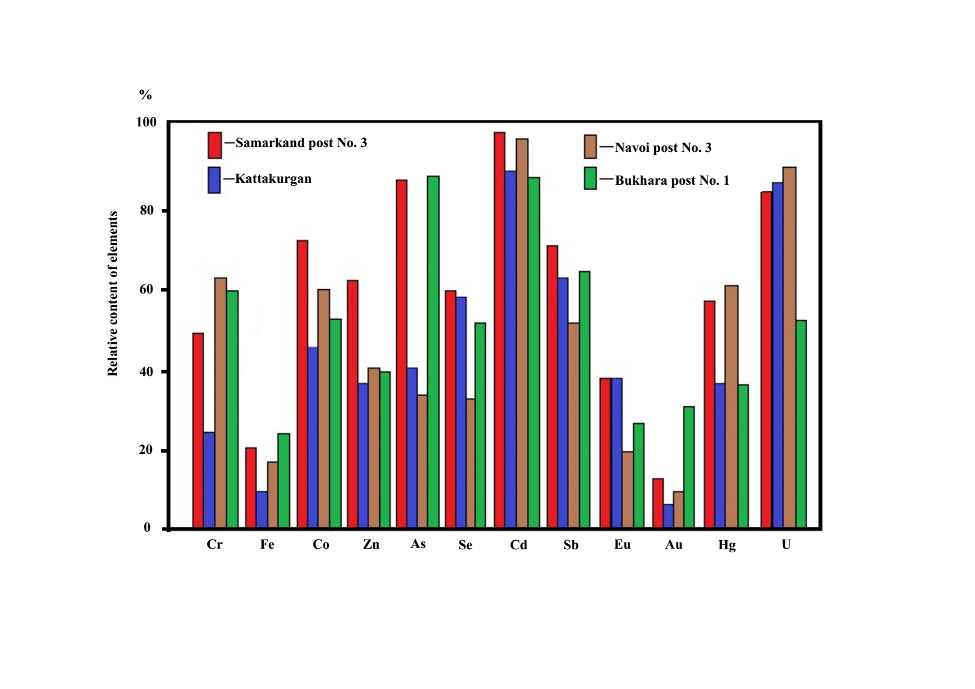
FIGURE 1. Relative content of elements in dissolved state in precipitation of cities of the Zeravshan Valley

In the studied atmospheric precipitation, Cd, U, Sb, Se, As, Co, Cr are found in predominant quantities in dissolved form, which determines their high mobility in the “precipitation-soil-natural water” system. Moreover, in the phase distribution of element concentrations in urban atmospheric precipitation samples, some differences can be traced, associated, as already noted, with the composition of the atmosphere and the underlying surface. In particular, in sediment samples taken in the city of Kattakurgan, the undissolved phase of Cr, Fe, Co, As, Au and Hg predominates, which is apparently due to the contribution of natural atmospheric aerosols, since there are practically no large industrial plants in this city sources of emissions of heavy metals and their compounds. The predominant proportion (>50%) of Fe, Au, Zn and Eu in sediments is in undissolved form.
Tables 5-6 show the data of correlation analysis between pairs of elements in the suspended and dissolved phases of atmospheric precipitation. Due to the limited scope of work, only some tables of pairwise correlation coefficients between element concentrations are given below. These tables differ somewhat from the commonly used standard triangular matrices. Here the elements are divided into two (equal in this case) groups, and the correlation coefficients of the elements are also presented in two submatrices. In the first submatrix, above its diagonal, the correlation coefficients between the elements of the first group are given, and below - between the elements of the second group. And the correlation coefficients between elements of different groups are given in the second submatrix. In the tables, significant (at the α=0.05 level [7]) correlation coefficients (r>0.63) are underlined.

TABLE 5. Coefficients of pairwise correlations between elements in the suspended phase of snow waters in Samarkand
 |  | Zn | As | Mo | U | Sb | La | Sm | Element
 |  | 0,91 | 0,84 | 0,99 | 0,87 | 0,96 | 0,91 | 0,74 | Fe
Sc | 0,77 |  | 0,88 | 0,86 | 0,83 | 0,95 | 0,85 | 0,76 | Zn
Сr | 0,70 | 0,90 |  | 0,84 | 0,91 | 0,84 | 0,86 | 0,75 | As
Au | 0,81 | 0,79 | 0,58 |  | 0,86 | 0,93 | 0,89 | 0,72 | Mo
Se | 0,22 | 0,45 | 0,69 | 0,22 |  | 0,83 | 0,92 | 0,54 | U
Hg | -0,48 | -0,42 | -0,22 | -0,27 | 0,47 |  | -0,39 | 0,81 | Sb
Cd | 0,03 | 0,25 | 0,13 | 0,51 | 0,50 | 0,55 |  | 0,73 | La
Eu | 0,02 | 0,19 | 0,06 | -0,08 | -0,28 | -0,33 | -0,30
Element | Co | Sc | Cr | Au | Se | Hg | Cd

Element | Cr | Sc | Co | Au | Eu | Se | Hg | Cd
Sm | 0,88 | 0,96 | 0,86 | 0,76 | 0,29 | 0,40 | -0,46 | 0,14
Sb | 0,79 | 0,68 | 0,74 | 0,37 | 0,32 | 0,50 | -0,28 | -0,13
Zn | 0,75 | 0,61 | 0,73 | 0,39 | 0,33 | 0,49 | -0,11 | -0,08
La | 0,60 | 0,56 | 0,81 | 0,41 | -0,31 | 0,31 | -0,37 | -0,16
Fe | 0,66 | 0,58 | 0,62 | 0,28 | 0,42 | 0,47 | -0,19 | -0,08
As | 0,52 | 0,56 | 0,79 | 0,51 | 0,49 | 0,12 | -0,32 | -0,10
Mo | 0,59 | 0,55 | 0,58 | 0,27 | 0,49 | 0,40 | -0,21 | -0,06
U | 0,35 | 0,31 | 0,66 | 0,26 | 0,35 | 0,14 | -0,23 | -0,21

Such a representation, in addition to its compactness, will be more informative if the elements are divided into groups according to a certain criterion, for example, according to the degree of their connection with each other. This feature is used in the tables below. Namely, the first group included the elements most closely related (together) to each other, and the second group included the rest. However, within both the first and second groups, the elements are ordered according to the degree of connection of the element with the elements of this group (in the first submatrix) or with the elements of another group (in the second submatrix). For example, in the first submatrix of Table 3, the element Zn belongs to the first group and has the greatest connection with the elements of this group, and the element Sm, also belonging to this group, has the least connection. The relative arrangement of these elements in the second submatrix indicates that Sm, compared to Zn, has closer correlations with elements of the second group.
Note that as measures of the connection of an element with elements of a given or another group, the average values of the sums of the absolute values of the coefficients of pairwise correlations of an element with elements of a given and another group, respectively, were used. The division of elements into groups and their ordering was carried out using a program developed by us for this purpose in the Fortran-IV language.
As can be seen, there are significant differences between the values of the correlation coefficients of elements in the suspended and dissolved phases of precipitation in the studied cities. In the suspended phase of atmospheric precipitation, Fe, Sb, La, Sm, U, Mo, Sc, Cr and Co have close correlations, i.e. elements, apparently, of natural (soil) origin. For Hg, Se and Cd, which probably have both natural and technogenic origin, the number of correlations with other elements is small. It is difficult to explain the lack of correlation between Eu in atmospheric precipitation of Samarkand and other elements of natural origin.
Compared to the suspended phase in the dissolved phase of urban atmospheric precipitation, the number of correlations decreases significantly (see Table 6), which is apparently associated with the dissolution of sorbed submicron aerosols containing elements. In particular, in the liquid phase of atmospheric precipitation in the cities studied, Cd, Au, Se, Zn and U are characterized by the absence of significant correlations with other elements. This indicates, in our opinion, different sources of these elements entering the city atmosphere [7-9].

TABLE 6. Pair correlation coefficients between elements in the dissolved phase of snow waters in Samarkand
 |  | Mo | Zn | Sm | Hg | La | Sb | Se | Element
 |  | 0,89 | 0,84 | 0,60 | 0,63 | 0,48 | 0,57 | 0,77 | Se
Au | 0,76 |  | 0,68 | 0,77 | 0,48 | 0,44 | 0,81 | 0,57 | Mo
Fe | 0,77 | 0,42 |  | 0,68 | 0,87 | 0,70 | 0,31 | 0,46 | Zn
U | 0,22 | 0,42 | 0,36 |  | 0,75 | 0,72 | 0,77 | 0,18 | Sm
Eu | -0,40 | -0,26 | -0,18 | 0,58 |  | 0,84 | 0,36 | 0,32 | Hg
Cd | 0,29 | 0,29 | 0,45 | 0,74 | 0,45 |  | 0,43 | 0,07 | La
Co | -0,50 | -0,50 | -0,37 | 0,42 | 0,67 | 0,22 |  | 0,38 | Sb
As | 0,79 | 0,41 | 0,50 | 0,19 | -0,28 | 0,27 | -0,03
Element | Cr | Au | Fe | U | Eu | Cd | Co

Element | Fe | As | Cr | Co | Eu | Cd | U | Au
Se | 0,78 | 0,86 | 0,96 | -0,40 | -0,40 | 0,29 | 0,13 | 0,58
Sb | 0,52 | 0,39 | 0,23 | 0,31 | 0,49 | 0,65 | 0,38 | -0,20
Sc | 0,52 | 0,67 | 0,61 | -0,35 | -0,30 | 0,19 | -0,27 | 0,05
Zn | 0,20 | 0,27 | 0,34 | -0,54 | -0,30 | -0,11 | -0,59 | -0,08
Mo | 0,54 | 0,51 | 0,36 | -0,04 | -0,03 | 0,31 | -0,14 | -0,26
Sm | 0,31 | 0,03 | 0,03 | -0,04 | 0,36 | 0,22 | -0,13 | -0,38
Hg | 0,12 | 0,11 | 0,26 | -0,40 | 0,08 | 0,02 | -0,30 | 0,04
La | -0,01 | -0,09 | 0,01 | -0,23 | 0,28 | 0,34 | -0,17 | -0,08

According to work [4], most of these elements are emitted into the city atmosphere from high-temperature technogenic sources in the form of submicron particles or a vapor-gas phase and, probably, dissolving in atmospheric precipitation, pass into the dissolved phase. For them, the composition of urban precipitation is likely dominated by the contribution of technogenic sources. This is especially typical for atmospheric precipitation sampled in the cities. Samarkand and Navoi, the most polluted by various industrial emissions.
Thus, the results of correlation analysis between pairs of elements show that the main factor in the formation of the elemental composition of atmospheric precipitation in cities is atmospheric aerosols of natural and technogenic origin. It was found that in cities with powerful industrial production, correlations between pairs of elements are significantly disrupted compared to cities with less industrial potential.
In order to identify the genesis of elements, the values of enrichment coefficients ($K_{o}$) were calculated in two fractions of the insoluble (suspended) phase of atmospheric precipitation using the following formula:
$K_{o}$= $\frac{C_{i}/C_{n}}{P_{i}/P_{n.p}}$ (1)
where, $C_{n}$ – concentration of a reference element (one of the most characteristic soil elements) in the suspended phase of sediments;
$P_{n.p}$ – clarke content of a reference element in the lithosphere.
The values of $K_{o}$ elements, normalized by Sc, are given in Table 7.
The obtained $K_{o}$values can be divided into two groups. The undissolved phase of atmospheric precipitation is enriched in relation to the earth's crust due to natural and anthropogenic processes from several units to hundreds of units. For a large group of elements, such as Th, Cr, Fe, Co and rare earth elements, the $K_{o}$values in most cases do not exceed 10.
Apparently, for these elements in the composition of the suspended phase of atmospheric precipitation in the studied cities, the contribution of natural aerosols predominates. High values of $K_{o}$ suspended phase of atmospheric precipitation are typical for: Mo, U, Cd, Au, As, Se, Hg, Zn and Sb. Moreover, the small fraction of the suspended phase of sediments (≥ 0.23 and ≤ 0.45 μm) is universally enriched compared to the large fraction (≥ 0.45 μm). Apparently, in the fine fraction of the suspended phase of precipitation, the contribution of technogenic aerosols containing heavy metals and their compounds mainly predominates.

TABLE 7. Undissolved phase enrichment factors atmospheric precipitation
Element | Samarkand post №2 |  | Navoi post №2 |  | Bukhara post №1
Element | Suspended phase, µm |  | Suspended phase, µm |  | Suspended phase, µm
Element | ≥ 0,45 | ≥ 0,23 | ≥ 0,45 | ≥ 0,23 | ≥ 0,45 | ≥ 0,23
Cr | 0,75 | 2,6 | 0,76 | 7,2 | 0,8 | 1,5
Fe | 0,25 | 0,22 | 0,4 | 0,3 | 0,4 | 0,4
Co | 0,2 | 0,25 | 0,26 | 0,7 | 0,15 | 0,14
Zn | 4 | 20 | 7,3 | 52 | 17 | 80
As | 5 | 4 | 4,4 | 35 | 2 | 2,5
Se | 210 | 140 | 40 | 400 | 120 | 1300
Mo | 100 | 8 | 50 | 180 | 50 | 2,2
Cd | 12 | 110 | 2,1 | 810 | 130 | 65
Sb | 30 | 30 | 8 | 50 | 5,2 | 32
La | 1,3 | 1,5 | 1,1 | 1,4 | 0,8 | 1,1
Sm | 0,9 | 0,5 | 0,7 | 0,6 | 0,4 | 0,5
Eu | 1,18 | 3,8 | 0,89 | 3,1 | 0,85 | 1,9
Au | 18 | 33 | 44 | 230 | 17 | 190
Hg | 66 | 180 | 3,4 | 500 | 9 | 100
Th | 0,3 | 1,47 | 4,3 | 0,46 | 0,39 | 0,57
U | 1,1 | 4,3 | 1,2 | 65 | 3 | 11

There is some difference in the values of $K_{o}$ precipitation in individual cities. In particular, the atmosphere of Navoi is enriched in Mo, U, Au and Hg compared to the atmosphere of other cities, which is a specific feature of the city’s industrial technology. According to work [4], elements with high $K_{o}$ values in the atmospheric air of cities migrate as part of submicron particles or in the vapor-gas phase.
The further behavior, distribution and accumulation of elements in the ecosystem largely depends on their forms of occurrence in precipitation. We have made an attempt to characterize the behavior and forms of migration of elements in precipitation using a set of previously developed techniques [4, 5].
Data on the forms of occurrence of elements in the most characteristic points of the cities under study are shown in Fig. 2. As a percentage of the gross content of elements in precipitation, as one would expect, anionic forms for Mo, U, As, and Hg dominate in atmospheric precipitation in cities.
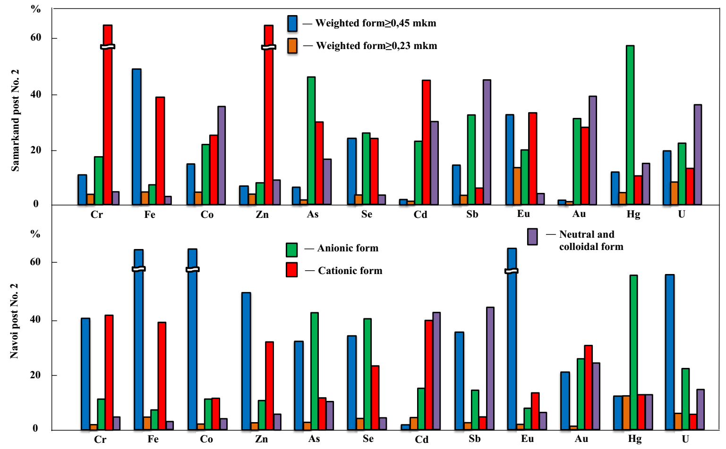
FIGURE 2. Forms of occurrence of elements in the snow waters of the cities of the Zeravshan Valley

Apparently, possible anionic forms of their migration in precipitation are: ${MoO}_{4}^{2-}$, ${UO_{2}(CO}_{3})_{3}^{4-}$, ${HAsO_{4}^{2-}, H}_{2}$As$O_{4}^{-}$, Hg$X_{4}^{2-}$ (X = ${Cl}^{-}$, ${Br}^{-}, I^{-}$). Cd, Na, La, Zn, Fe and REE migrate in atmospheric precipitation, mainly in cationic form. For Fe and REE, these are cationic hydroxo complexes of the Me(OH$)_{n}^{+}$. A certain proportion of Au, Se, Cr, Co and Sb is found in both anionic and cationic forms. Possible anionic forms for Au - (AuC$l_{4}^{-}$), Se-(Se$O_{4}^{2-}$), Cr - (Cr$O_{4}^{2-}$, CrO${H)}_{2}^{+}$).
It was difficult to explain the presence of a certain proportion (10-20%) of cationic forms of Au, Sb and Co in the studied atmospheric precipitation. Apparently, this phenomenon can be explained by the physical sorption of positively charged colloidal particles of these elements on the surface of the cation-exchange membrane. Antimony is characterized by migration in the form – Sb(OH$)_{6 }^{-}$.
СONCLUSION
Using the proposed complex of radio-analytical methods, some patterns of spatial distribution of the content of elements in atmospheric precipitation of the cities of the Zeravshan Valley were studied and assessed.
It has been established that Fe, Sc, Eu migrate in the atmospheric precipitation of cities in suspended form, and Cd, U, Sb, Se, As, Co and Cr migrate in dissolved form. It has been established that in atmospheric precipitation of cities, Fe, Sc, and Eu migrate in suspended form, while Cd, U, Sb, Se, As, Co, and Cr migrate in dissolved form. The forms of migration of elements in urban precipitation have been established. The predominant amount of Mo, U, As and Hg migrate in anionic form. The cationic form of migration is characteristic of Cd, Na, La, Fe, Zn and rare earth elements.
It has been established that in cities with powerful industrial production, correlations between pairs of elements are significantly disrupted compared to cities with less industrial potential. Contaminated precipitation containing heavy metals and their compounds is one of the sources of environmental pollution.
Matrix tables reflecting the results of correlation analysis between pairs of elements are proposed, which, in addition to their compactness, are more informative if the elements are divided into groups according to a certain criterion, for example, according to the degree of their connection with each other.
REFERENCES
- Tolkacheva, G. A., Smirnova, T. Yu., & Kovalevskaya, Yu. I. (2004). Atmospheric precipitation (dry, wet) as an indicator for assessing climate‑chemical interactions. In Proceedings of the International Conference on Measurements, Modeling and Information Systems for Environmental Studies: ENVIROMIS – 2004 (pp. 234–245). Tomsk.
- Aizenshtat, B. A. (1983). Climate of Samarkand. Leningrad: Gidrometeoizdat.
- Smirnova, E. N., & Babushkin, O. L. (2009). Climatic description of Navoi and Bukhara viloyats. Tashkent: NIGMI.
- Kulmatov, R. A., Abdullaev, B., & Kist, A. A. (1983). Contents and forms of presence of heavy metals in atmospheric air and precipitation. Geochemistry, (10), 1447–1452.
- Kist, A. A., Zhuk, L. I., Kulmatov, R. A., et al. (1986). Experience in using nuclear physical methods in monitoring the natural environment. In Proceedings of the III International Symposium: Comprehensive global monitoring of the state of the biosphere (Vol. I, pp. 164–178). Leningrad: Gidrometeoizdat.
- Brimblecombe, P. (1988). Composition and chemistry of the atmosphere. Moscow: Mir.
- Muller, P., Neumann, P., & Storm, R. (1982). Tables on mathematical statistics. Moscow: Finance and Statistics.
- Martin, D. B., & Hartman, W. A. (1987). Chemical contaminants monitoring: Correlations between selected trace elements and organic matter and texture in sediments of Northern Prairie Wetlands. Journal of the Association of Official Analytical Chemists, 70(5), 916–919.
- Khuramova, K. M., Isakhanov, K., Muradov, R., & Raximov, F. (2025). Changes in energy consumption during extraction of cotton pieces in an improved regenerator. AIP Conference Proceedings, 3304, 030030. https://doi.org/10.1063/5.0269104

