Identification of Maghemite-Core Particles as a Primary Vector for Gold Loss in Refractory Calcine
Kuvondik Sanakulov, Hayrullo Hamidov, Omon Fuzaylov^{a)}, Jakhongir Narzullaev, Shakhlo Sattarova
Navoi State University of Mining and Technologies, Navoi, Uzbekistan

^{a)}Corresponding author: omonfuzaylov@gmail.com
Abstract. Roasting of refractory gold ores is a common pretreatment method. However, it is usually followed by incomplete gold extraction during subsequent cyanidation. The current investigation concerned the mineralogical causes of gold losses during cyanidation tails (calcine) of a roasted gold-concentrate. A multifaceted method comprising X-ray Diffraction (XRD) with Rietveld refinement, Scanning Electron Microscope (SEM-EDS) with EDS-signal mapping, magnetic fractionation, and notably Fourier Transform Infrared (FTIR) Spectroscopy was adopted. XRD composition of the total calcine confirmed coexistence of hematite (3.4%) and maghemite (1.0%). But gold losses occurred mainly due to isolation of a magnetic fraction among the total calcine tails. This fraction represented only 5% of the total material and included 11g Au/t; it represented 25% of total gold losses. It contained a remarkably high amount of gold. This sample presented a paradox to analytical methods: it represented mainly hematite to surface-near XRD. But to total-investigative non-surface-sensitive method like FTIR Spectroscopy performed on individual particles of iron oxide.
Keywords: gold, maghemite, calcine, refractory gold ore, gold loss, cyanidation, magnetic separation, XRD, rietveld analysis, SEM-EDS, FTIR spectroscopy.
INTRODUCTION
Gold is also contained in refractory gold ores, which can be considered as the complex sulfide ore with fine dissemination of gold in pyrite and arsenopyrite being widely disseminated at submicron scale. This material responds poorly to direct cyanidation, and requires a pre-treatment stage in order to destroy sulfide confinement. The most comminution method used for gold ores involves the application of a cyanide leach after some sort of pretreatment (e.g. oxidative roasting), which is designed to convert iron sulfide that hosts the gold into a porous hematite and thus free up the encapsulated gold [1].
However, in practice industrial the recoveries of gold from the calcines were found to be non complete (less than 85 %), meaning there is some quantity of "locked" gold [2]. One such longstanding theory is the production of secondary iron oxide phases during roasting. In particular, the generation of maghemite is a major problem. Compared to hematite, maghemite oxide is also characterized by a compact and non-porous crystal lattice in the spinel structure [3]. During the solid-state sulfide-to-oxide conversion, gold particles may be re-trapped with such a non-porous maghemite matrix and thus emerge as "re-locked" content of gold which is now not approachable by CN [4].
As we will show, this conjecture is analytically hard to establish. Maghemite is metastable and transitions to the more stable hematite, the two phases can then occur within complex intergrowths.
Moreover, a "core-shell" model is sometimes suggested, the core being maghemite and the shell resulting from surface oxidation to characterized by hematite[5]. Such a structure would lead to misleadingly low standard surface analysis, such as XRD, readings that favored the non-fairforming hematite shell at the expense of the maghemite core. This ambiguity in interpretation has resulted in a lack of quantitative understanding of the “maghemite problem.”
A detailed study of one refractory ore calcine is reported here. In order to identify the gold loss phases and determine their associated gold losses, this research will integrate mineralogical, chemical and physical separation methodologies. The proof of existence and structural role of such maghemite to lock metallic gold can conclusively be established for the first time based on targeted sample preparation in combination with Fourier Transformation Infra-Red (FTIR) Spectroscopy as the ultimate technique to overcome previous methodological restrictions [6].
METHODS
The sample examined was a calcine roast sample collected from the sorption tails of a cyanidation circuit, which is the last residue stream after roasting and leaching.
X-ray Diffraction (XRD) patterns were used to identify the mineralogy of the bulk powder sample. A semi-quantitative analysis of the mineral weight percentages was carried out via Rietveld refinement.
SEM (EDS) was conducted to determine the morphology, microtexture and element analysis of the sample. Fe maps were also retrieved at multiple magnifications to map the elemental associations and distributions. This was crucial to identify the principal oxide phases and follow the distribution of the elements of interest, such as sulfur, arsenic, and iron [7].
To verify the suspected gold-locking phase, part of the calcine tail was submitted to magnetic separation using a Sta-fe high field permanent magnet. The mass percentage of the recovered magnetic fraction was measured, and this sample was used for gold analysis and processed to perform XRD and FTIR mineralogical analysis studies.
FTIR spectroscopy was chosen as the primary investigative technique to chemically characterize iron oxide phases in the bulk, supplementing XRD which is surface sensitive. Spectra were recorded in reflectance mode using a Nicolet Continuum FTIR microscope
Preliminary examination of the bulk powder was not productive. The 100-micron path size was much bigger than the individual mineral grain sizes, creating parasitic spectra that were contaminated with data from radiating minerals in the surrounding area. To circumvent this and specifically analyze single mineral grains, a unique sample preparation procedure was developed.
A sample of about 100 mg was put in 40 ml of de-ionized water and sonicated in an ultrasonic bath for 20 minutes. The goal of this process was to break up the particles and wash away very small and light mineral phases (the colloidal fraction), which were then thrown away. After being cleaned, the heavier mineral sediment was dried and put on a silver mirror for analysis. This "ultrasonic cleaning" was an important step because it made it possible to get clean, identifiable spectra from the iron oxide particles that were the target. We also did more tests on the magnetic fraction, which was made in the same way.
RESULTS AND DISCUSSION
The Rietveld analysis of the bulk calcine (Table 1) showed that it was mostly made up of quartz (36.4%), muscovite/illite (31.0%), and albite (13.6%). The analysis critically identified two distinct iron oxide phases: Haematite (3.4%) and Maghemite (1.0%). This first XRD result showed that maghemite was present, but it didn't say anything about its structure, shape, or how it was related to gold. Fig. 1. Shows the calcine's powder diffraction pattern.
Further details of the calcine were given by the SEM-EDS results. The top surface of the material is completely oxidized. Elemental mapping (Fig. 2) indicated iron to be present with oxygen, and sulfur with calcium. This is consistent with CaSO₄. This confirmed the effectiveness of sulfur removal in the roast process.
The co-occurrence of hematite and maghemite, which is highly magnetic, gave rise to the proposal of the gold-locking phase with a magnetic component. A test of magnetic separation on the sorption tails followed. This marked the first important discovery. This resulted in the isolation of the magnetic materials comprising 5% of the total weight of the tailings.
Gold assay of this small but strongly magnetic fraction showed it to have 11 g/t Au. A quick mass balance calculation showed that this 5% material is contributing 25% of the total gold going to the tails. This finding proved to be extremely important as it established a direct relationship between gold losses and the particular magnetic fraction.

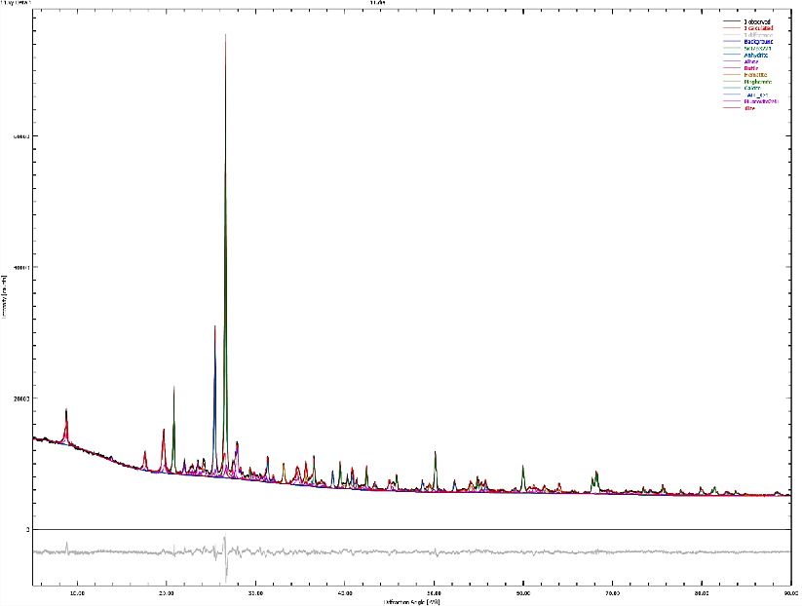
FIGURE 1. The calcine's powder diffraction pattern

TABLE 1. Semi-quantitative mineral composition of calcine roast material determined by Rietveld method
Mineral | Content, %
Quartz | 36.4
Muscovite/Illite | 31.0
Albite | 13.6
CaSO₄ | 11.6
Hematite | 3.4
Maghemite | 1.0
TiO₂ | 1.3
Calcite | 1.0
Talc | 0.7

Now that the gold-bearing magnetic fraction had been isolated, a crucial analytical paradox had arisen. When this magnetic fraction had been analyzed with XRD, it had been found to be "mostly hematite". This presented a contradiction. Hematite is anti-ferromagnetic (i.e., not strongly magnetic) and should not have been recovered by a permanent magnet, while the strongly magnetic maghemite, which must be present, was not reported as the main phase.
This paradox is explained by the differing penetration depths of the analytical methods. XRD is a surface-sensitive technique, typically analyzing only the top few microns of a particle. The solution required a method capable of analyzing the bulk of the particle.
This is where the FTIR analysis, using the ultrasonically cleaned samples, became the decisive analytical tool. Spectra were collected from both the cleaned bulk sample and the isolated magnetic fraction. The resulting spectra (Fig. 3) clearly showed the formation of maghemite minerals. The spectra also contained a characteristic peak at 455 cm-1, which is indicative of hematite.
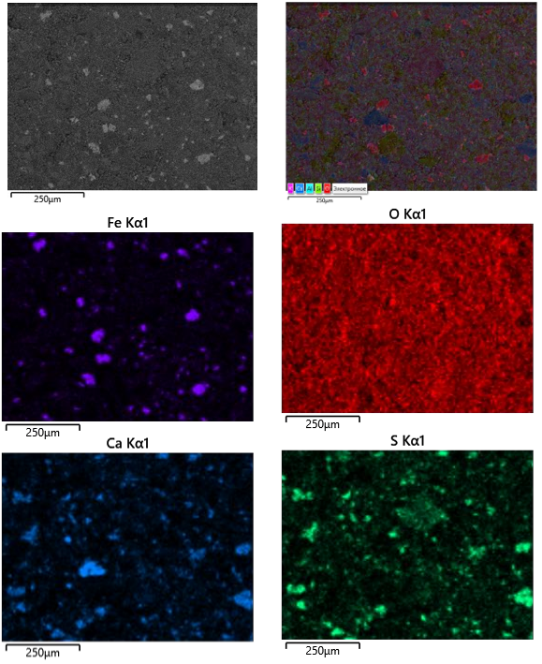
FIGURE 2. Elemental mapping of the calcine

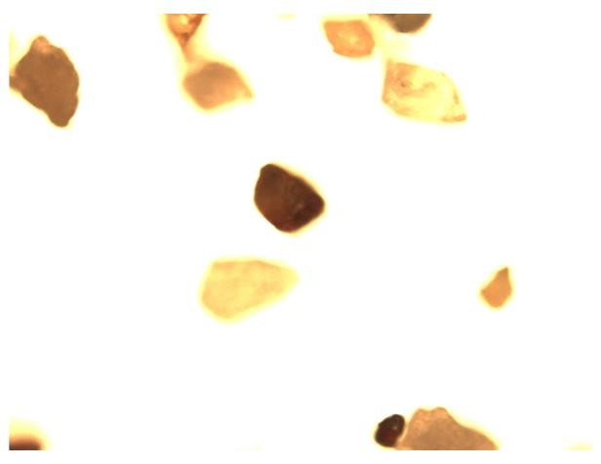 | 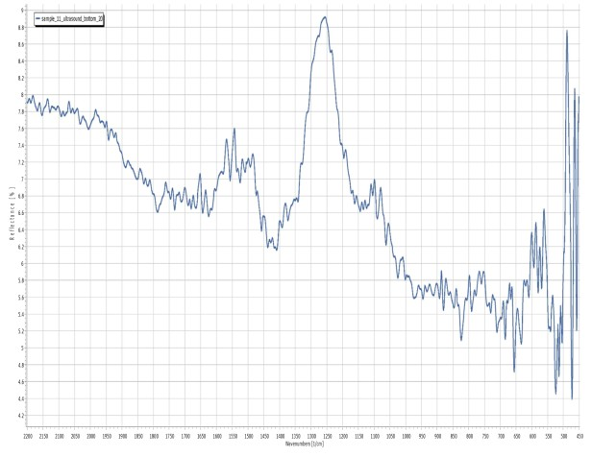
FIGURE 3. FTIR spectrum of selected particles in the calcine

The combination of these data points provides a clear solution: the magnetic particles are composite grains. The FTIR, which can analyze the entire depth of the particle, confirms the presence of bulk maghemite (the source of the magnetism). The XRD only sees the outer surface, which has converted to hematite. The particle is therefore a maghemite core (magnetic, gold-bearing) hidden inside a hematite shell (non-magnetic, misleading).
Based on this evidence, a complete model for the gold loss can be constructed. During the initial roasting of the pyrite/arsenopyrite, gold is liberated but becomes encapsulated within a newly formed, dense, non-porous maghemite phase. As roasting proceeds, or perhaps during cooling, the outer surface of this maghemite oxidizes further, converting to the more stable, porous hematite.
This creates a “Trojan horse” particle. The cyanide solution perceives a porous hematite particle, but gold
is tightly locked away in the non-porous maghemite core. This is why 25% of gold is still not leached and goes to the magnetic fraction.
CONCLUSION
It successfully identified and quantified a primary mechanism of gold loss in a refractory gold ore calcine. This resolves a paradoxical analytical problem associated with the gold refining process.
The initial bulk XRD patterns have confirmed the co-existence of hematite (3.4%) and maghemite
A gold-bearing magnetic fraction (11 g/t Au) was obtained from the tails, confirming that 25% of gold losses are related to a magnetic component, although the latter is only 5% of the tailing material.
A critical analytical paradox was discovered: XRD identified this magnetic fraction as "mostly hematite".
The paradox was solved using FTIR spectroscopy on samples prepared by ultrasonic cleaning. FTIR, a bulk-analysis technique, confirmed the presence of maghemite cores.
The gold-locking mechanism is definitively identified as composite, core-shell particles. A non-porous maghemite core, which encapsulates gold from the original sulfide, is concealed by an outer hematite shell.
The results demonstrate that incomplete conversion of maghemite to hematite during roasting is a critical, and now quantified, cause of poor leaching performance. This study also establishes that a combination of magnetic separation and FTIR spectroscopy is essential for correctly identifying this locking mechanism, as surface-sensitive methods like XRD alone are misleading.
REFERENCES
- Thomas, K. G., & Cole, A. P. (2005). Roasting developments – especially oxygenated roasting. In M. D. Adams (Ed.), Advances in Gold Ore Processing (Vol. 15, pp. 403-423). Elsevier.
- Lyu, H., Chen, J., Li, H., Liu, G., & Yang, K. (2017). Improvement of Gold Leaching from a Refractory Gold Concentrate Calcine by Separate Pretreatment of Coarse and Fine Size Fractions. Minerals, 7(5), 80.
- Cornell, R. M., & Schwertmann, U. (2003). The Iron Oxides: Structure, Properties, Reactions, Occurrences and Uses. Wiley-VCH, Weinheim.
- Paktunc, D. (2008). Distribution of gold in pyrite and in products of its transformation resulting from roasting of refractory gold ore. Canadian Metallurgical Quarterly, 47(3), 255-266.
- Goodall, W. R., & Scales, P. J. (2007). An overview of the advantages and disadvantages of the determination of gold mineralogy by automated mineralogy. Minerals Engineering, 20(5), 506-517.
- Pirnazarov, F., Umirov, F., & Kurbonov, M. (2025). Production of magnesium chlorides by conversion method by thermal treatment of local saponite mineral. E3S Web of Conferences, 627, 03004. https://doi.org/10.1051/e3sconf/202562703004
- Aripov, A. R., Vokhidov, B. R., Asrorov, A. A., Sayfullaev, F. I., & Kurbonov, M. N. (2024). Application of sand mold casting modelling for casting pump volute. Journal of Physics Conference Series, 2697(1), 012037. https://doi.org/10.1088/1742-6596/2697/1/012037

