Impact of Active Aluminum Oxide Grade as a Catalyst on α-Methylbenzyl Alcohol Dehydration
Tulkinbek Sitmuratov^{a)}, Dinara Buranova, Elyor Atashev
Urgench State University named after Abu Rayhan Biruni, Urgench, Uzbekistan

^{a)}Corresponding author: tulkinbek@urdu.uz
Abstract. The aim of the study is to evaluate the effect of catalysts—different grades of active aluminum oxide—on the conversion of α-methylbenzyl alcohol and the selectivity of styrene formation as the target product. A fraction of methylphenylcarbinol with a main substance content of more than 80 % by mass was used as the raw material for the study. The α-methylbenzyl alcohol fraction was provided by PJSC "Nizhnekamskneftekhim" plant. The process of dehydrating the α-methylbenzyl alcohol fraction in the presence of heterogeneous catalysts θ-Al₂O₃, δ-Al₂O₃, and γ-Al₂O₃ was studied in the vapor phase. A quantitative and qualitative analysis of the reaction products was carried out using gas chromatography-mass spectrometry. The process conditions (catalyst type, time, temperature, and the amount of water added for steam dilution) were determined in terms of their effect on the selectivity of styrene formation and α-methylbenzyl alcohol conversion. It was shown that the γ-Al₂O₃ catalyst exhibited the highest activity, ensuring the maximum styrene content in the reaction products and the lowest amount of acetophenone in the "catalyzate" at a temperature of 290 °C for 60 minutes with a mass ratio of α-methylbenzyl alcohol:H₂O = 1:1.
Keywords: styrene, α-methylbenzyl alcohol, dehydration, heterogeneous catalyst, aluminum oxide.
INTRODUCTION
Styrene is one of the high-tonnage products of industrial petrochemical synthesis. It is used in the production of polystyrene and plastics based on it, butadiene-styrene rubbers, latexes, as well as in the manufacturing of paints, varnishes, and unsaturated polyester resins [1, 2, 3]. In industry, it is obtained by various methods, including ethylbenzene dehydrogenation, oxidative dehydrogenation, and the cumene process. These processes are primarily carried out using superheated steam on oxide catalysts containing promoting additives [4]. Each method has its technological features and is selected based on economic feasibility and raw material availability [5, 6, 7].
In the Russian Federation, styrene production has been established using an alternative industrial method based on the use of α-methylbenzyl alcohol as the starting material. Styrene is obtained by the dehydration of aromatic alcohol. The chemical aspects of this process have been thoroughly studied. Both protic and aprotic acids, as well as metal oxide-based catalysts, are used as catalysts. In industrial production, activated gamma-alumina (γ-Al₂O₃) is used as the catalyst [8, 9, 10]. The dehydration process of α-methylbenzyl alcohol is carried out in a two-stage adiabatic reactor with intermediate heating of the contact gas, while catalyst regeneration is performed using a steam-air mixture [11, 12, 13]. In this process, the dehydration of α-methylbenzyl alcohol can proceed through several pathways (see Fig. 1).
The vapor-phase dehydration of α-methylbenzyl alcohol to styrene in the presence of γ-Al₂O₃ (Figure 1, Reaction 1) is accompanied by the parallel formation of 1,1'-diphenyldiethyl ether (Figure 1, Reaction 2). 1,1'-diphenyldiethyl ether (DPhDE) then converts into styrene (Figure 1, Reaction 4). As a result of the dehydrogenation reactions of α-methylbenzyl alcohol and the decomposition of 1,1'-diphenyldiethyl ether, acetophenone and ethylbenzene are formed (Figure 1, Reactions 3 and 6). Additionally, benzaldehyde (Figure 1, Reaction 7), benzoic acid, and α-methylstyrene (Figure 1, Reaction 8) are observed in this process. The conversion of α-methylbenzyl alcohol is approximately 90 %, while the selectivity for the target product reaches 97 %.
At low temperatures, styrene is primarily formed through 1,1'-diphenyldiethyl ether. As the temperature increases, styrene is obtained directly from α-methylbenzyl alcohol, bypassing Stages (2) and (4). This is due to the lower activation energies of E₁ = 5.8 kJ/mol and E₄ = 20.9 kJ/mol, compared to E₂ = 79.5 kJ/mol [14].

FIGURE 1. Reaction scheme for the dehydration of α-methylbenzyl alcohol to Styrene

In this process, the obtained products ("catalyzate") resulting from the dehydration of α-methylbenzyl alcohol are separated by rectification. However, the high temperature leads to the tendency of styrene to polymerize, which in turn complicates its separation under normal conditions. Therefore, the separation of the "catalyzate", containing styrene, is carried out under deep vacuum with the addition of polymerization inhibitors [15, 16].
At PJSC Nizhnekamskneftekhim, the catalyst used for the dehydration of α-methylbenzyl alcohol to styrene is an active form of aluminum oxide – γ-Al₂O₃ [2].
The aim of this study is to evaluate the influence of different grades of active aluminum oxide catalysts on the conversion of α-methylbenzyl alcohol and the selectivity for the target product – styrene.
EXPERIMENTAL METHODS
Feedstock: The α-methylbenzyl alcohol fraction obtained from PJSC "Nizhnekamskneftekhim" was used as the feedstock for dehydration studies. The component composition of the fraction is presented in Table 1 [17, 18].

TABLE 1. Composition of the Initial MPC Fraction, wt.% [13, 14]
Component name | Content, wt.%
Low-boiling components | 0.03
Ethylbenzene | 0.46
Styrene | 0.13
Acetophenone | 15.09
α-methylbenzyl alcohol | 81.74
1,1'-diphenyldiethyl ether | 2.55

In the technology of PJSC Nizhnekamskneftekhim, the α-methylbenzyl alcohol fraction of the above composition is used as a raw material for the styrene production by catalytic dehydration in the presence of steam on a fixed-bed catalyst – γ-aluminum oxide – within a temperature range of 290-320°C in a two-stage adiabatic reactor.
Catalysts: Three grades of active aluminum oxide were used as catalysts: δ-Al₂O₃, θ-Al₂O₃, and γ-Al₂O₃, with specific surface areas of: δ-Al₂O₃ ~ 400 m²/g; θ-Al₂O₃ ~ 110 m²/g; γ-Al₂O₃ ~ 180 m²/g/.
Laboratory setup: The study was conducted on an experimental setup consisting of a reactor, evaporator, condenser-cooler, separator, water phase distillate receiver, hydrocarbon phase distillate receiver, α-methylbenzyl alcohol feed tank, water feed tank, and a pump for supplying water to generate steam for steam dilution. Additionally, the setup included a pump for α-methylbenzyl alcohol supply, KSP-4 potentiometer, laboratory transformers, and a thermocouple (see Fig. 2).
Comparative experiments on the vapor-phase dehydration of α-methylbenzyl alcohol on a heterogeneous catalyst were carried out using the setup shown in Figure 2.
The reactor and evaporator of the setup are made of quartz glass, with heat supplied by electric heaters, which are powered through transformers. Temperature regulation in the reactor and evaporator is carried out using a potentiometer. The reactor is loaded with a catalyst, completely filling the heated jacketed volume of the reactor (Reactor 1 in Fig. 1), while the evaporator is filled with crushed quartz glass. The dosing of α-methylbenzyl alcohol is performed using a plunger pump at a volumetric rate of 0.6 h⁻¹. The flow rates of α-methylbenzyl alcohol and water are monitored using graduated burettes. After exiting the reactor, the product vapors are condensed in a cooler and directed to a separator, where they are separated into aqueous and hydrocarbon phases.

FIGURE 2. Laboratory Setup for Continuous Vapor-Phase Dehydration of α-methylbenzyl Alcohol: 1 – reactor, 2 – evaporator, 3 - condenser-cooler, 4 – separator, 5 - receiver for the distillate aqueous fraction, 6 - receiver for the distillate hydrocarbon fraction, 7 - feed tank for α-methylbenzyl alcohol fraction, 8 - water feed tank, 9 - pump for α-methylbenzyl alcohol supply, 10 - pump for water supply, 11 - ksp-4 potentiometers, 12 - laboratory transformers, 13 – thermocouples

Analytical Methods: Quantitative and qualitative analysis of the reaction products was carried out using a gas chromatograph with a mass-selective detector, Agilent 5975, and Agilent GC/MSD ChemStation software.

Data Processing: The selectivity of styrene formation based on decomposed α-methylbenzyl alcohol and the conversion of α-methylbenzyl alcohol were determined from their content in the composition of the "catalyzate" based on chromatographic analysis results.
The main technological parameters of the process were calculated as follows.

Conversion (αA) – Conversion is the fraction of the reacted initial reagent relative to its initial amount:

(1)
where:
αA – conversion of the main reagent A;
m – mass of the substance, g;
n – amount of substance, mol.

Selectivity (SiA) – Selectivity represents the fraction of the converted initial reagent that is used for the formation of the target product:

(2)
where:
SiA – selectivity for product i based on the main reagent A;
Ν – stoichiometric coefficients of the reaction equation.
Obviously, for key substances:
∑SiA=1

RESULTS AND DISCUSSION
Influence of Catalyst Grade: The influence of different grades of Al₂O₃ on the selectivity of styrene formation during the decomposition of α-methylbenzyl alcohol, as well as the effect of temperature on α-methylbenzyl alcohol conversion, was studied. The component composition of the "catalysate" from α-methylbenzyl alcohol dehydration over time is presented in Table 2. It follows that the highest amount of styrene is observed 60 minutes after the start of the reaction in the presence of θ-Al₂O₃ and γ-Al₂O₃ catalysts, while for the process with δ-Al₂O₃ catalyst, the maximum is reached after 240 minutes.
Among the tested catalysts, γ-Al₂O₃ exhibited the highest activity, yielding the highest styrene content in the "catalysate." During experiments lasting 300 minutes, a slight decrease in the activity of γ-Al₂O₃ was observed. However, this catalyst still maintained the highest styrene concentration and the lowest concentration of acetophenone (ACP) compared to the other catalysts (θ-Al₂O₃ and δ-Al₂O₃).

TABLE 2. Influence of Al₂O₃ catalyst grade on the composition of the "catalysate" from α-methylbenzyl alcohol (MBA) dehydration over time (τ). Temperature – 290°C. Mass ratio MBA:H₂O = 1:1
Catalyst grade | τ,min | Components, wt.%
Catalyst grade | τ,min | Low-boiling | Ethylbenzene | Styrene | ACP | MBA | DPhDE
δ-Al₂O₃ | Initial | 0,03 | 0,46 | 0,13 | 15,09 | 81,74 | 2,55
δ-Al₂O₃ | 60 | 0,73 | 0,39 | 82,29 | 16,15 | 0,08 | 0,36
δ-Al₂O₃ | 120 | 0,79 | 0,35 | 80,71 | 17,81 | 0,08 | 0,26
δ-Al₂O₃ | 180 | 0,68 | 0,49 | 80,75 | 17,45 | 0,15 | 0,48
δ-Al₂O₃ | 240 | 0,66 | 0,43 | 84,78 | 13,79 | 0,00 | 0,34
δ-Al₂O₃ | 300 | 0,61 | 0,61 | 81,21 | 16,69 | 0,19 | 0,69
θ-Al₂O₃ | Initial | 0,03 | 0,46 | 0,13 | 15,09 | 81,74 | 2,55
θ-Al₂O₃ | 60 | 0,62 | 0,22 | 83,36 | 15,08 | 0,51 | 0,21
θ-Al₂O₃ | 120 | 0,28 | 0,28 | 82,08 | 16,81 | 0,13 | 0,42
θ-Al₂O₃ | 180 | 0,29 | 0,04 | 81,93 | 17,23 | 0,20 | 0,31
θ-Al₂O₃ | 240 | 0,47 | 0,38 | 81,32 | 16,98 | 0,29 | 0,56
θ-Al₂O₃ | 300 | 0,72 | 0,36 | 79,58 | 18,52 | 0,30 | 0,52
γ-Al₂O₃ | Initial | 0,03 | 0,46 | 0,13 | 15,09 | 81,74 | 2,55
γ-Al₂O₃ | 60 | 0,54 | 0,44 | 86,98 | 11,27 | 0,48 | 0,29
γ-Al₂O₃ | 120 | 0,45 | 0,34 | 85,05 | 13,25 | 0,28 | 0,63
γ-Al₂O₃ | 180 | 0,64 | 0,25 | 83,76 | 13,87 | 0,64 | 0,84
γ-Al₂O₃ | 240 | 0,63 | 0,44 | 81,67 | 15,82 | 0,16 | 1,28
γ-Al₂O₃ | 300 | 0,67 | 0,42 | 81,87 | 15,59 | 0,21 | 1,24

To study the effect of the Al₂O₃ catalyst grade on α-methylbenzyl alcohol conversion and styrene selectivity per decomposed α-methylbenzyl alcohol, experiments were conducted with sampling every 60 minutes.
The analysis results showed a 100% conversion of α-methylbenzyl alcohol when using δ-Al₂O₃ and θ-Al₂O₃ catalysts (Table 3). However, the selectivity of styrene formation per decomposed α-methylbenzyl alcohol was higher when using γ-Al₂O₃ (see Table 4).

TABLE 3. Effect of Al₂O₃ catalyst grade on α-methylbenzyl alcohol conversion depending on process duration (τ). Temperature – 290°C. Mass ratio MBA:H₂O = 1:1
Catalyst grade | MBA conversion, % мас.
Catalyst grade | τ, min.
Catalyst grade | 60 | 120 | 180 | 240 | 300
δ-Al₂O₃ | 99,89 | 99,91 | 100,00 | 99,89 | 100,00
θ-Al₂O₃ | 99,44 | 100,00 | 100,00 | 99,68 | 100,00
γ-Al₂O₃ | 99,64 | 99,68 | 99,92 | 99,98 | 99,78

The test results presented in Tables 2–4 allow us to conclude that the styrene content in the "catalysate" is practically identical when using δ-Al₂O₃ and θ-Al₂O₃. However, since the γ-Al₂O₃ catalyst provided the best technological performance, further studies were conducted using this catalyst at different temperatures: 150 °C, 250 °C, and 290 °C.

TABLE 4. Effect of catalyst grade on styrene selectivity per decomposed α-methylbenzyl alcohol depending on process duration (τ). Temperature – 290°C. Mass ratio MBA:H₂O = 1:1
Catalyst grade | Selectivity, mol. %
Catalyst grade | τ, min.
Catalyst grade | 60 | 120 | 180 | 240 | 300
δ-Al₂O₃ | 119,48 | 117,07 | 117,27 | 122,98 | 117,78
θ-Al₂O₃ | 120,19 | 117,60 | 117,43 | 116,78 | 114,16
γ-Al₂O₃ | 127,55 | 124,08 | 121,71 | 118,44 | 119,31

As expected, increasing the dehydration temperature under otherwise identical conditions led to higher conversion (see Fig. 3) and selectivity (Fig. 4). The highest values for these parameters were reached at 290 °C, regardless of reaction time. However, despite the lower α-methylbenzyl alcohol conversion at 250 °C (Fig. 3), the selectivity at this temperature remained high, comparable to that at 290 °C (see Fig. 4).

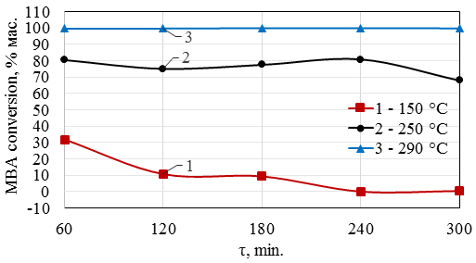
FIGURE 3. Effect of Temperature on α-methylbenzyl alcohol conversion using γ-Al₂O₃ Catalyst Depending on Process Duration (τ). Mass ratio MBA:H₂O = 1:1.

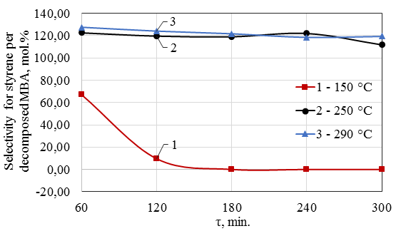
FIGURE 4. Effect of Temperature on styrene selectivity per decomposed α-mthylbenzyl alcohol using γ-Al₂O₃ catalyst depending on process duration (τ). Mass ratio MBA:H₂O = 1:1.

The data presented in Fig. 4 show that the best α-methylbenzyl alcohol conversion is achieved at 290 °C, with a mass ratio of MBA:H₂O = 1:1. However, since the decomposition of α-methylbenzyl alcohol produces water, it was of interest to reduce the amount of supplied steam. Therefore, further studies were conducted at MBA:H₂O = 1:0.5.
Experimental data (see Fig. 5 and 6) indicate that at 290 °C, maximum α-methylbenzyl alcohol conversion is achieved and remains stable from the beginning to the end of the process.

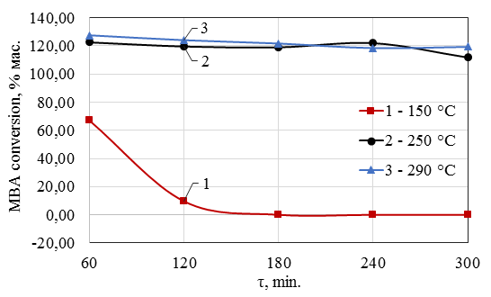
FIGURE 5. Effect of temperature on α-methylbenzyl alcohol conversion using γ- Al₂O₃ catalyst depending on process duration (τ). Mass ratio MBA:H₂O = 1:0,5.

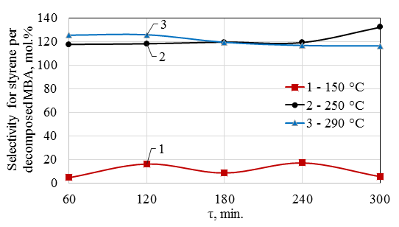
FIGURE 6. Effect of temperature on styrene selectivity per decomposed α-methylbenzyl alcohol using γ-Al₂O₃ catalyst depending on process duration (τ). Mass ratio MBA:H₂O = 1:0,5

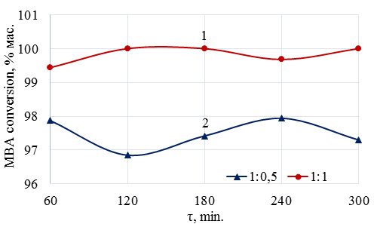
FIGURE 7. Effect of MBA:H₂O mass ratio on α-methylbenzyl alcohol conversion using γ-Al₂O₃ catalyst depending on process duration (τ). Temperature – 290°C.
A comparison of the results regarding the influence of the MBA:H₂O mass ratio on the technological parameters of α-methylbenzyl alcohol dehydration shows that reducing the amount of supplied water has little effect on both α-methylbenzyl alcohol conversion and styrene selectivity per decomposed α-methylbenzyl alcohol (see Figs. 7–8).

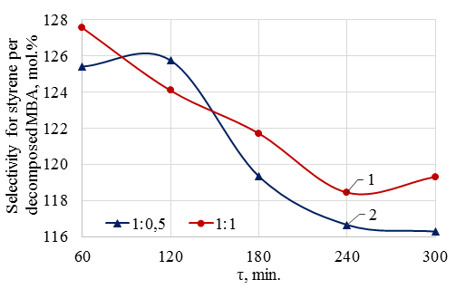
FIGURE 8. Effect of mba:h₂o mass ratio on styrene selectivity per decomposed α-methylbenzyl alcohol using γ- Al₂O₃ catalyst depending on process duration (τ). Temperature – 290°C.
CONCLUSION
A comparative laboratory study was conducted to examine the catalytic properties of zeolite-containing catalysts: δ-Al₂O₃, θ-Al₂O₃, and γ-Al₂O₃ in the dehydration reaction of α-methylbenzyl alcohol to styrene. It was established that γ-Al₂O₃ exhibits the highest selectivity for the decomposition of α-methylbenzyl alcohol into styrene.
The technology for producing styrene by dehydrating α-methylbenzyl alcohol allows the use of the γ-Al₂O₃ catalyst at 250 °C and at a lower MBA:H₂O mass ratio (1:0,5). However, at this ratio, an inverse relationship between styrene selectivity and α-methylbenzyl alcohol conversion is observed.
It was determined that at MBA:H₂O = 1:1 and a reaction temperature of 290 °C, in the presence of γ-Al₂O₃, almost complete conversion of α-methylbenzyl alcohol can be achieved. At the same time, a high selectivity for the conversion of α-methylbenzyl alcohol into styrene (120–129 mol.%) is observed. This selectivity is explained by the fact that at this temperature, acetophenone hydrogenation and the decomposition of heavy products occur, leading to the formation of additional styrene.
REFERENCES
- Lebedev, N.N. (1981). Chemistry and technology of basic organic and petrochemical synthesis. 3rd ed. Moscow: Khimiya. (in rus).
- Styrene production in Russia. (2025, March 5). Chemical Industry. Retrieved from https://himonline.ru/news/?n=401699 (accessed 03.09.2025).
- Logunova, T.V. & Sosnovskaya, L.B. (2023). Preparation of styrene by dehydration of methylphenylcarbinol. In: Science. Innovations. Future – 2023. Petrozavodsk: ICSP “New Science”, pp. 318–325.
- Semenov, P.V. (2016). Production of styrene via catalytic routes. Young Scientist, 109(5), 168–172. https://moluch.ru/archive/109/26277/ (in rus).
- Seymour, R. B., Mark, H. F., Pauling, L., Fisher, C. H., Stahl, G. A., Sperling, L. H., Marvel, C. S., & Carraher, C. E. (1989). Pioneers in polymer science. https://doi.org/10.1007/978-94-009-2407-9
- Kenzhin, R. M., Vedyagin, A. A., Volodin, A. M., Mishakov, I. V., & Chumachenko, V. A. (2017). Catalyst development for styrene technology. Chemistry for Sustainable Development, 1, 25–33. https://doi.org/10.15372/KhUR20170104
- Chukin, G. D. (2010). Structure of alumina and hydrodesulfurization catalysts. Paladin / Printa.
- Yurov, V. M., Goncharenko, V. I., Oleshko, V. S., & Guchenko, S. A. (2021). Thickness of surface alumina layers. Symbol of Science, 8, 6–10. https://os-russia.com/tolshchina-poverkhnostnogo-sloya-oksida-alyuminiya
- Vansheidt, A. A., & Zeltser, V. M. (1948). Styrene production by vapor-phase dehydration of methylphenylcarbinol. Zhurnal Prikladnoi Khimii, 21, 512.
- Kirpichnikov, P. A., Beresnev, V. V., & Popova, L. M. (1986). Process flow diagrams of synthetic rubber industry (2nd ed.). Khimiya.
- Serebryakov, B. R., Masagutov, R. M., Pravdin, V. G., & Smirnov, V. V. (1989). New processes in organic synthesis. Khimiya.
- Stiller, V. (2000). Arrhenius equation and nonequilibrium kinetics. Mir.
- Galimova, A. T., & Sagdeev, A. A. (2015). Regeneration of catalyst for methylphenylcarbinol dehydration. Bulletin of the Technological University, 18, 24–26. https://elibrary.ru/download/elibrary_25106031_58567483.pdf
- Sitmuratov, T. S., Petukhova, L. A., Bakhtinova, I. I., & Petukhov, A. A. (2018). Catalytic decomposition of high-boiling residue fractions formed during styrene and propylene oxide production. Butlerov Communications, 56, Issue 10, p. 118. https://butlerov.com/files/reports/2018/vol56/10/118/18-56-10-118-.pdf
- Stytsenko, V. D., & Melnikov, D. P. (2016). Selective hydrogenation of diene and acetylene compounds on metal-containing catalysts. Journal of Physical Chemistry, 90, 691–702. https://doi.org/10.7868/S0044453716040300
- Ngo, K. K., Sitmuratov, T. S., Taymasov, I. R., Petukhov, A. A., & Grigoryev, E. I. (2015). Techno-economic evaluation of wastewater treatment methods in joint production of styrene and propylene oxide. Bulletin of the Technological University, 18, 63–65. https://elibrary.ru/item.asp?id=24213399
- Sitmuratov, T. S., Chugunov, Yu. V., & Petukhov, A. A. (2021). Component composition of high-boiling products in styrene production. Butlerov Communications, 65, 130–136. https://doi.org/10.37952/ROI-jbc-01/21-65-2-130
- Deryugina, O. P. (2016). Theory of chemical processes of organic and petrochemical synthesis. Tyumen Industrial University. https://e.lanbook.com/book/94956

