Investigation of Gold Nanoparticles in the processing of Refractory Gold-Bearing Ore
Hayrullo Hamidov^{a)}, Omon Fuzaylov, Jakhongir Narzullaev, Aziza Azimova, Surayyo Jabborova
Navoi state university of mining and technologies, Navoi, Uzbekistan

^{a)}Corresponding author: hayrullo.hamidov@gmail.com
Abstract. Latest analytical studies reveal that in most deposits with refractory gold-bearing raw materials involved in processing, gold is found not only in its usual form, but also in nano-sized particles. At the same time, existing technologies for processing refractory ores are ineffective for extracting gold of such fine dispersion. Research into gold nanoparticles in raw ore and industrial environments is in its infancy, but modern analytical methods, widespread access to gold-bearing samples, and growing scientific interest in nano-gold in manufacturing are opening up new avenues for in-depth assessment of their value and significance. Modern techniques of detection using electron microscopy and chemical-physical analysis allow this question to be resolved and confirm the growing interest in the fact that gold nanoparticles play an important role in the formation of gold-bearing ore deposits.
Keywords: leaching, refractory gold ore, nanoparticles, pyrit, SEM, XRD, flotation, roasting, calcine, biooxidation.
INTRODUCTION
The attention of researchers to the study of nanoparticles of gold has increased significantly. R.M. Hough, Ciobanu, Deditius and others in their works unanimously agree that natural minerals contain a significant amount of ‘invisible’ gold, i.e. gold particles of nanoscale size [1, 2, 3]. According to scientists, it is precisely through greater involvement in the processing of ultra-fine gold-bearing ores of refractory composition that the main growth in metal production worldwide can be ensured in the current decade. It is necessary to reorient the development of improved technologies for the extraction of ultrafine gold from nanogeochemistry and nanomineralogy to nanometallurgy of gold [4]. In this regard, according to experts, the following tasks need to be addressed:determining the proportion of nanoscale gold in the total volume of natural resources and available reserves of gold-bearing ore deposits; studying the patterns of behaviour of natural nanogold in metallurgical processing during the processing of refractory ores; consideration of new possibilities for the formation of nanoscale gold and its physicochemical properties like melting point, boiling point, chemical reactivity and, stability, etc.) in the development of technological processes for processing complex gold-bearing ores.
Research into the properties of nanogold has shown that it has its own specific characteristics [5, 6, 7]. Under standard conditions, the properties of ultramicroscopic gold particles often bear no similarity to those of macrogold. Nano-sized gold particles are characterised by colloidality, clustering, agglomeration, buoyancy, lower melting point, magnetisability, volatility, etc.
When classifying ores with dispersed gold into a separate category, it should be noted that the technological stubbornness of raw materials with ultradispersed gold is determined by two main factors: nanogold under physical depression and chemically bound nanogold under physical depression.
The reasons for the ‘physical depression’ of ores are as follows: the surface of gold is covered with a shell of minerals that blocks access to it by cyanides; the ores contain substances that have a higher sorption activity towards gold than the technological sorbent [5].
The group of ‘chemically bound nano particles of gold under physical depression’ includes the following factors: the ore contains tellurides that do not dissolve in cyanide solutions; the presence of minerals and organic substances in the ore, which, when interacting with technological solutions and gold-cyanide complexes, lead to the formation of rhodanides and absorb dissolved oxygen [5].
Thus, the study of ultra-disperse gold and the possibility of its extraction from technologically refractory raw materials is one of the most important tasks facing modern science, the solution of which requires consideration of the inextricable link between geochemistry, geology and metallurgy.
METHODS
Modern approaches to the study of gold nanoparticles (NPs). A number of experimental methods are used to study the behaviour of gold nanoparticles of the gold metallurgy process:
1. Scanning electron microscopy (SEM) [8] and transmission electron microscopy (TEM): SEM and TEM provide high-resolution images of gold nanoparticles in various metallurgical samples, allowing their size, shape, distribution, and interaction with other components to be visualised [9].
2. X-ray diffraction (XRD): X-ray diffraction is used to analyse the crystal structure of gold nanoparticles and identify any phase changes or alloy formation during metallurgical processes [10].
3. Inductively coupled plasma mass spectrometry (ICP-MS): ICP-MS determines the concentration of low-purity gold and other types of gold in metallurgical samples, providing insight into their distribution and separation during processing [11].
4. Surface analysis methods: Surface analysis methods such as X-ray photoelectron spectroscopy (XPS) and atomic force microscopy (AFM) can be used to determine the chemical composition, surface charge and topography of low-purity gold, which influence its behaviour in metallurgical processes.
The objects of study were selected as flotation products from the Kokpatas ore deposits and foam from bio-oxidation bioreactors at hydrometallurgical plant No. 3 of Navoi Mining and Metallurgical Combine JSC.
RESULTS AND DISCUSSION
Gold nanoparticles in flotation concentrate samples from the Kokpatas deposit at various temperatures.
Since the concentration of gold in concentrates is higher than in initial ore, gold nanoparticles are formed during the roasting of samples, which can be observed using a JEOL IT200 scanning electron microscope. It should be noted that nanogold particles were not observed in sulphide concentrates using the same equipment, which may indicate the formation of gold nanoparticles from even smaller gold nanoparticles embedded in sulphide minerals. The oxidation of sulphide minerals into porous hematite may play a major role in the formation of these gold nanoparticles. The observed sizes of gold nanoparticles range from approximately 70 nm (there may be smaller gold nanoparticles in the sample, but the equipment does not have the desired resolution to observe smaller particles).
In the sample of flotoconcentrate from the Kokpatas deposit, roasted at 750°C, gold particles of nanometre and micrometre size were observed.
Fig. 1 shows some nanometre and micrometre gold particles.
Gold nanoparticles in samples of foam from BIOX reactors when roasted at different temperatures.
Elemental analysis of the sample surfaces at 40x magnification to obtain the average number of elements is shown in Table 1.
The amount of carbonaceous material is high in the sample of foam from BIOX reactors roasted at 300°C, then its amount decreases in samples roasted at 490°C and 625°C. For unknown reasons, which we were unable to establish, the amount of carbonaceous material increases again in the sample roasted at 800°C.

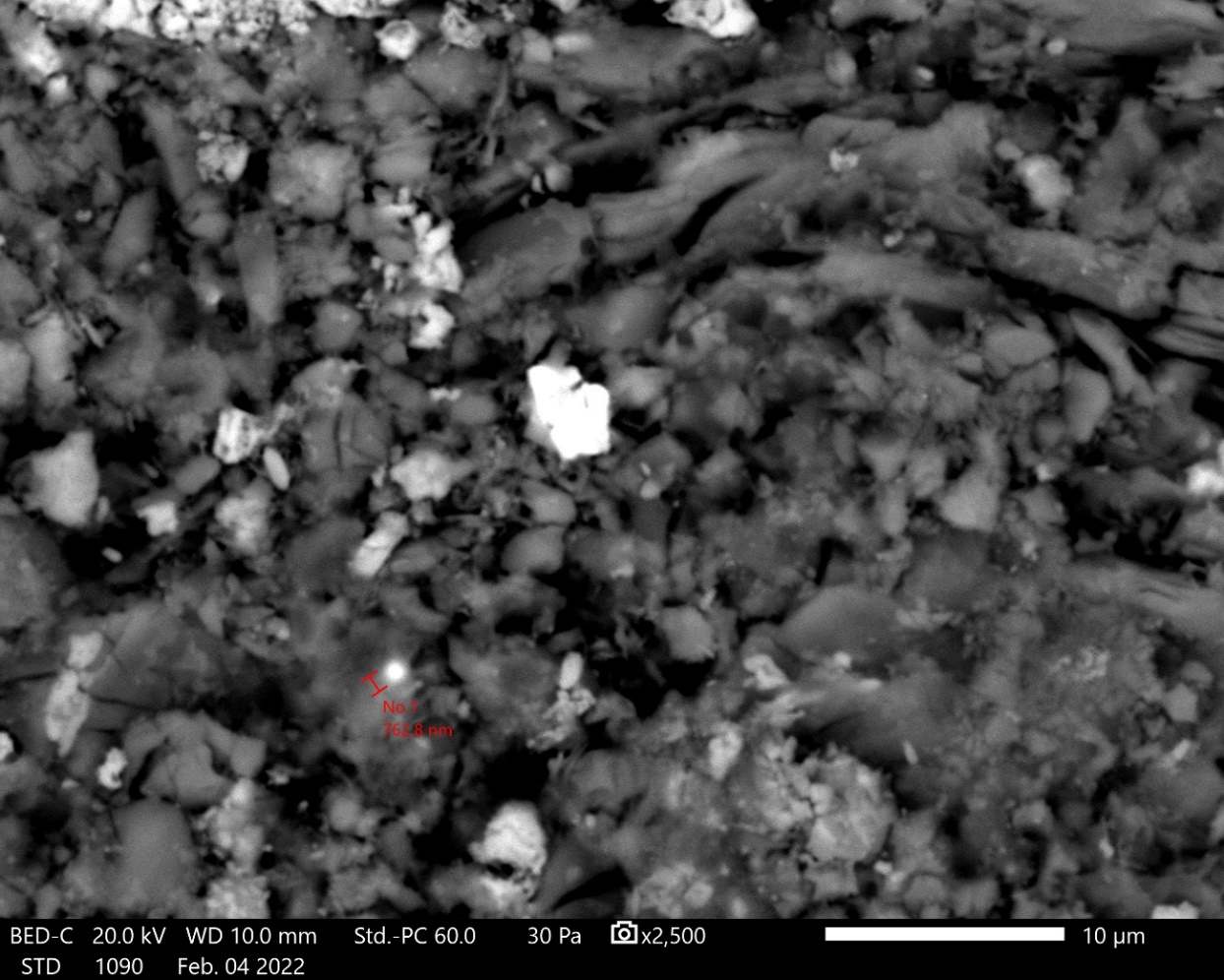 | 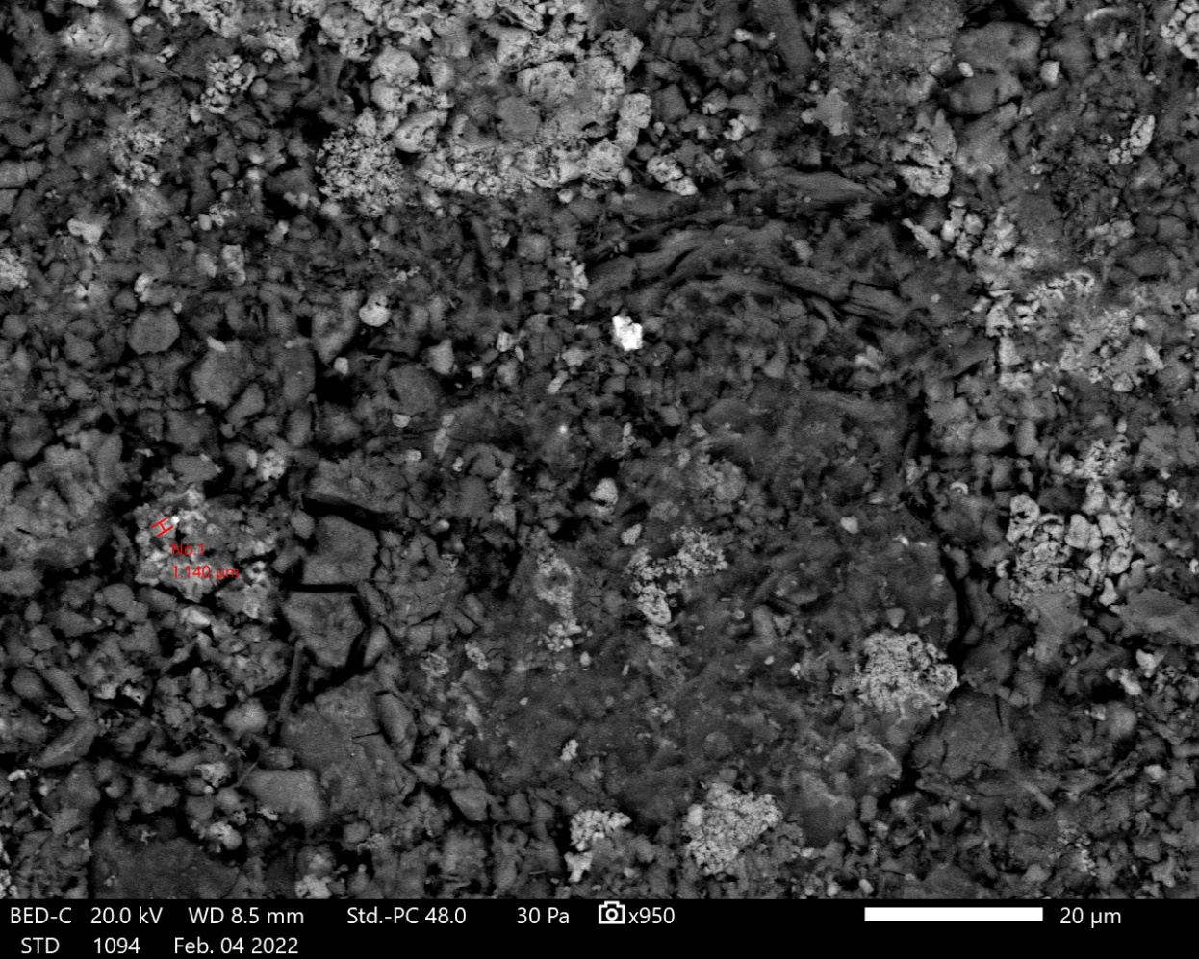
a) | b)
FIGURE 1. Nanometre (760 nm) upper and micrometre (1.2 micron) lower gold particles in the sample ‘Float concentrate from the Kokpatas deposit’, calcined at 750°C: a) 10 mkm, b) 20 mkm.

TABLE 1. Elemental analysis from the surface of samples of Foam from BIOX reactors fired at different temperatures
Elements from SEM | Roasting temperature of the sample foam with BIOX reactors
Elements from SEM | 300°С | 490°С | 625°С | 800°С
Elements from SEM | Contents, % | Contents, % | Contents, % | Contents, %
C | 12.29 | 3.81 | 3.75 | 12.78
O | 42.06 | 45.72 | 45.8 | 41.78
Na | 0.38 | 0.4 | 0.39 | 0.48
Mg | 1.64 | 1.61 | 1.82 | 1.56
Al | 7.87 | 9.26 | 9.54 | 7.9
Si | 16.49 | 19.67 | 19.73 | 17.4
P | 0.15 | 0.18 | 0.08 | 0.15
S | 0.63 | 0.67 | 0.5 | 0.78
K | 3.23 | 4.26 | 3.98 | 3.44
Ca | 0.24 | 0.26 | 0.26 | 0.24
Ti | 1.29 | 1.46 | 1.42 | 1.4
Fe | 10.07 | 10.98 | 11.18 | 10.67
As | 3.67 | 1.73 | 1.56 | 1.42

The sample foam from BIOX reactors has a high concentration of gold, so roasting the sample at specified temperatures led to the formation of gold nanoparticles, which could be observed using SEM. In the previous SEM analysis of the sample foam from BIOX reactors, gold nanoparticles were not detected. The observed sizes of gold nanoparticles range from approximately 80 nm (there may be smaller gold nanoparticles in the sample, but the equipment does not have the desired resolution to observe smaller particles), and as the roasting temperature increases, a greater number of larger microns are observed. The size of the gold particles increases.
Fig. 2 shows examples of the gold nanoparticles and micron-sized particles observed, with the roasting temperature and particle sizes given below each image.
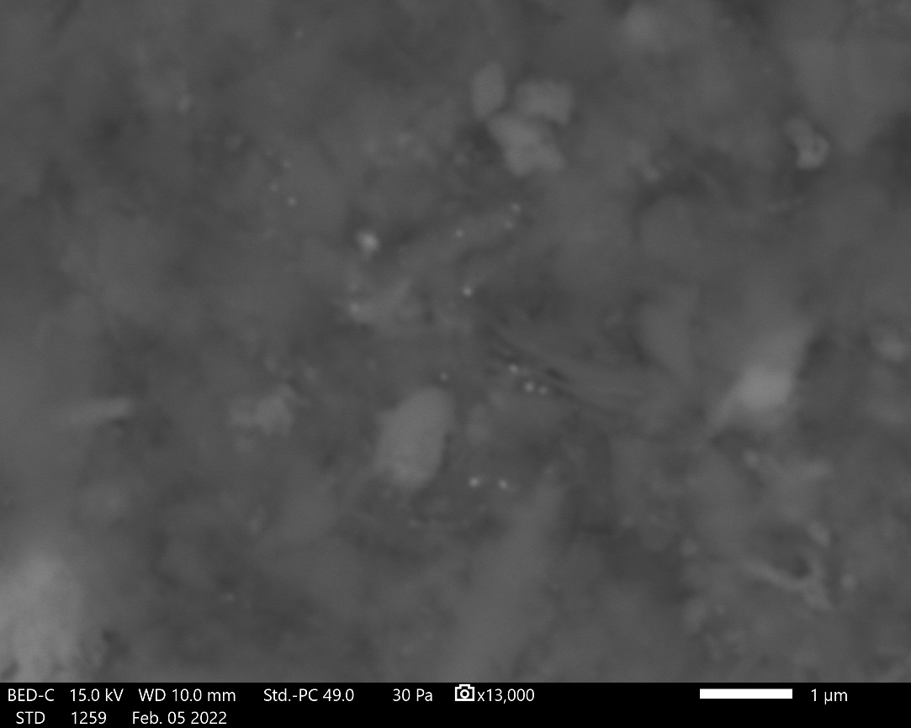 | 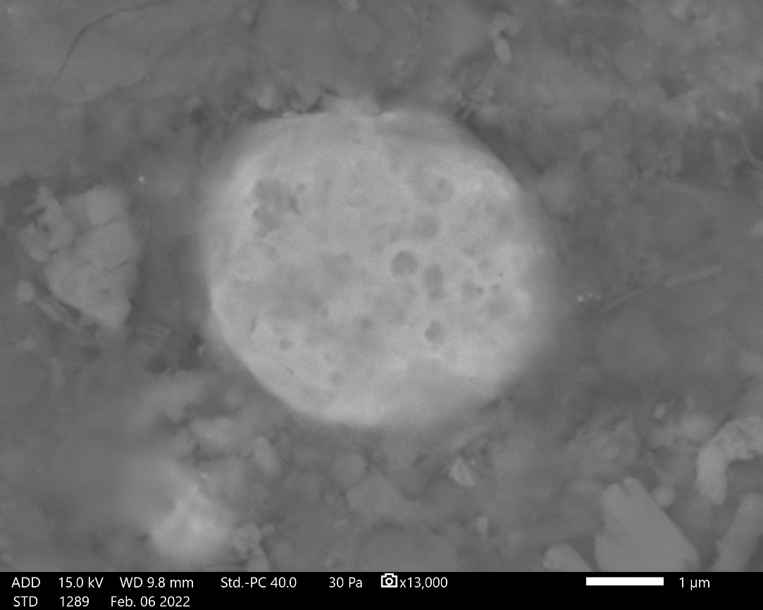
a) | b)
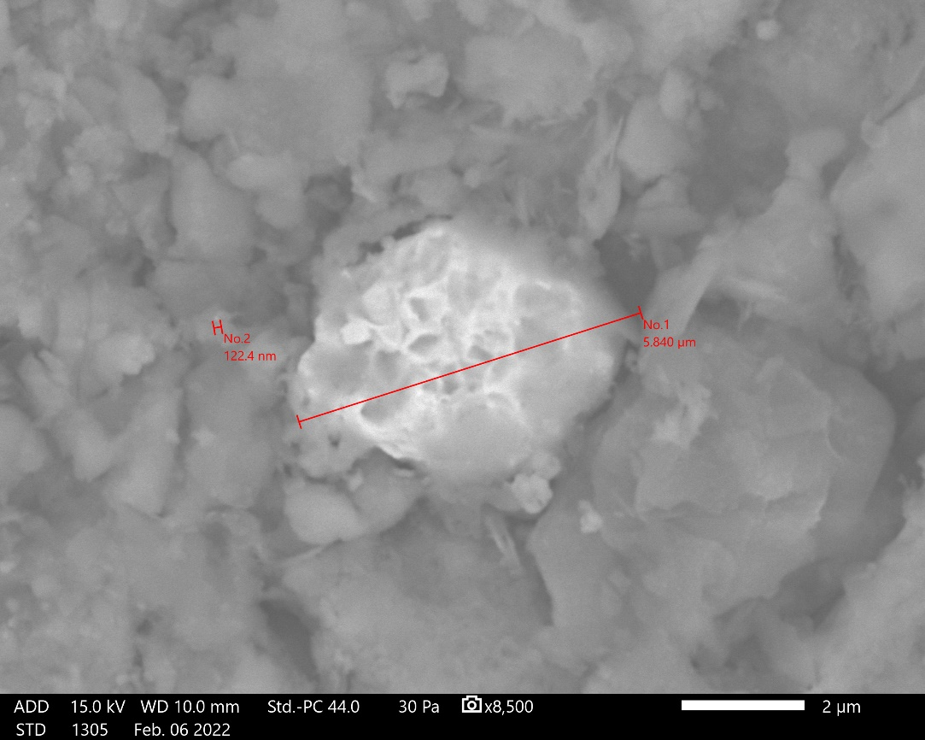 | 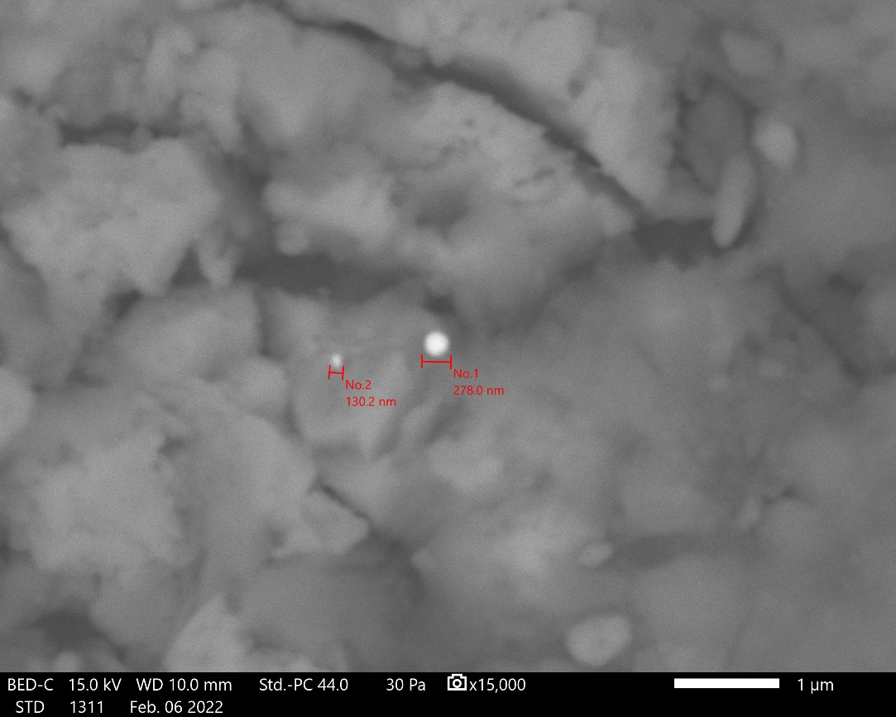
c) | d)
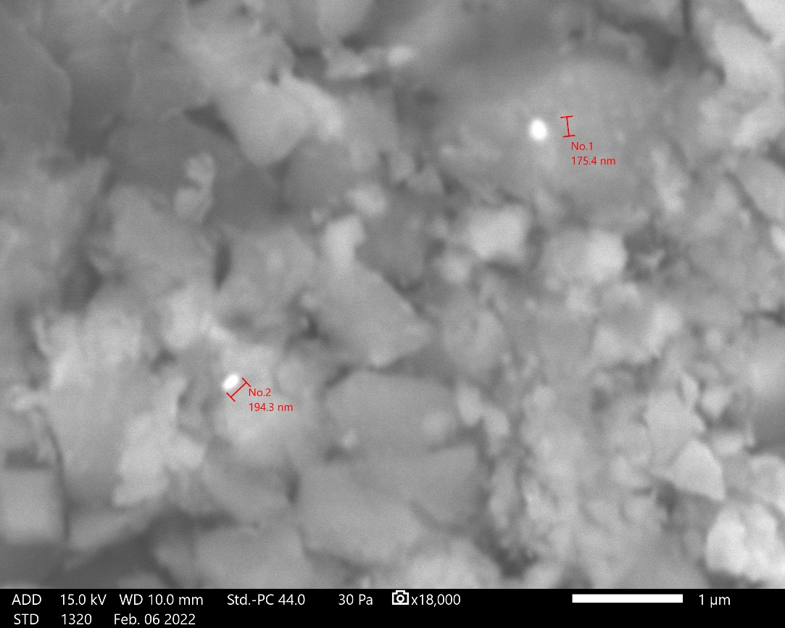 | 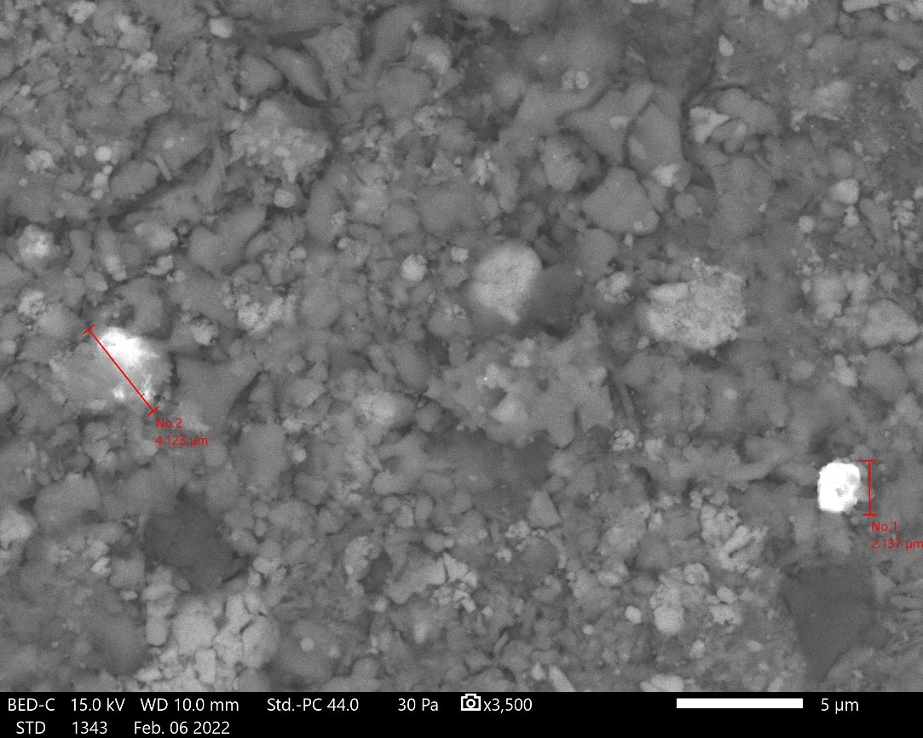
e) | f)
FIGURE 2. Nanometre- and micrometre-sized gold particles observed in the ‘Foam from BIOX reactors’ sample at different firing temperatures: a) Temperature – 300°C, particle size less than 100 nm to 250 nm; b) Temperature – 490°C, large gold particles measuring approximately 5 microns and smaller nanoparticles measuring between 50 and 100 nm; c) Temperature – 625°C, large gold particles measuring approximately 6 microns and smaller nanoparticles measuring 120 nm; d) Temperature – 800°C, gold nanoparticle size 130 nm and 280 nm; e) Temperature – 800°C, gold nanoparticle size 175 nm and 195 nm; f) Temperature – 800°C, large gold particles measuring approximately 4 and 2 microns and smaller nanoparticles indicated by red arrows (bright particles).

In samples of ‘BIOX reactor foam’ roasted at different temperatures, a large number of gold particles of both nanometre and micrometre size were observed. The number of larger gold particles increases in samples roasted at higher temperatures, but we can still observe many smaller gold particles measuring about 100 nm in the samples. The increase could be due to the agglomeration of smaller gold particles in the sample, or it could simply be a result of chance, as we roasted the sample from the part of the sample where there were many gold particles.
CONCLUSION
The amount of carbonaceous material decreases at higher temperatures, and typically very little carbonaceous material is observed in samples roasted at temperatures above 600°C, with the exception of the foam sample from the BIOX reactors, where the amount of carbonaceous material increased in the sample calcined at 800°C.
Gold nanoparticles of various sizes, ranging from approximately 70 nm to 800 nm, were observed in samples of roasted flotation concentrates from the Kokpatas deposit, and in foam from BIOX reactors, where the gold concentration is higher than in other samples.
Larger micrometre-sized gold particles were observed in the BIOX reactor foam sample at higher firing temperatures, although this may indicate that gold particle sizes increase at higher temperatures, the observation of smaller nanoparticles together with micrometre-sized gold particles suggests that there may not be a direct correlation between higher temperatures and gold particle sizes.
REFERENCES
- Hough, R., Noble, R., & Reich, M. (2011). Natural gold nanoparticles. Ore Geology Reviews, 42(1), 55–61. https://doi.org/10.1016/j.oregeorev.2011.07.003
- Ciobanu, C., Cook, N., Utsunomiya, S., Pring, A., & Green, L. (2011). Focussed ion beam–transmission electron microscopy applications in ore mineralogy: Bridging micro- and nanoscale observations. Ore Geology Reviews, 42(1), 6–31. https://doi.org/10.1016/j.oregeorev.2011.06.012
- Deditius, A. P., Utsunomiya, S., Reich, M., Kesler, S. E., Ewing, R. C., Hough, R., & Walshe, J. (2011). Trace metal nanoparticles in pyrite. Ore Geology Reviews, 42(1), 32–46. https://doi.org/10.1016/j.oregeorev.2011.03.003
- Nurmurodov, T., Saidova, N., Ashurov, O., Rakhimova, G., Fuzaylov, O., & Narzullaev, J. (2023b). Investigation of gold content in the bio-oxidation process. E3S Web of Conferences, 417, 02011. https://doi.org/10.1051/e3sconf/202341702011
- Khamidov, R., Narzullayev, J., & Kuznetsov, E. (2021). Research of the application of roasting in the processing of the foamy product of the process of bacterial oxidation of flotation concentrate in a separate cycle. E3S Web of Conferences, 278, 01018. https://doi.org/10.1051/e3sconf/202127801018
- Gimeno, M., & Laguna, A. (2003). Silver and gold. In Elsevier eBooks (pp. 911–1145). https://doi.org/10.1016/b0-08-043748-6/05122-7
- Reich, M., Utsunomiya, S., Kesler, S. E., Wang, L., Ewing, R. C., & Becker, U. (2006). Thermal behavior of metal nanoparticles in geologic materials. Geology, 34(12), 1033–1036. https://doi.org/10.1130/G22829A.1
- Barnard, A. S., & Guo, H. (Eds.). (2012). Nature’s nanostructures. Pan Stanford Publishing.
- Ogundare, O. D., Akinribide, O. J., Adetunji, A. R., Adeoye, M. O., & Olubambi, P. A. (2019). Crystallite size determination of thermally deposited Gold Nanoparticles. Procedia Manufacturing, 30, 173–179. https://doi.org/10.1016/j.promfg.2019.02.025
- Reich, M., Chryssoulis, S. L., Deditius, A., Palacios, C., Zúñiga, A., Weldt, M., & Alvear, M. (2010). “Invisible” silver and gold in supergene digenite (Cu1.8S). Geochimica Et Cosmochimica Acta, 74(21), 6157–6173. https://doi.org/10.1016/j.gca.2010.07.026
- Seitz, O., Chehimi, M. M., Cabet-Deliry, E., Truong, S., Felidj, N., Perruchot, C., Greaves, S. J., & Watts, J. F. (2003). Preparation and characterisation of gold nanoparticle assemblies on silanised glass plates. Colloids and Surfaces a Physicochemical and Engineering Aspects, 218(1–3), 225–239. https://doi.org/10.1016/s0927-7757(02)00594-0

