Application of Polyaldehyde Inuline for Modification of Low Molecular Drugs
Gappar Rakhmonberdiev¹, Arslonnazar Khusenov^{1, a)}, Sitora Umarova¹, Nigina Muinova¹, Otabek Abdullayev², Sardor Khudoyorov³
¹Tashkent Institute of Chemical Technology, Tashkent, Uzbekistan

² Karshi State Technical Universitety, Karshi, Uzbekistan

³Tashkent State Technical Universitety, Tashkent, Uzbekistan

^{a)}Corresponding author: sytk@tkti.uz
Abstract. In polymer chemistry, the development of new synthetic routes for biologically active high-molecular compounds consisting of polysaccharides and low-molecular-weight active ingredients is considered an interesting area. In this area of scientific and practical research, significant advances have been made in the synthesis of antitumor polymer conjugates. Therefore, we developed a new approach to chemically modifying adriamycin with inulin macromolecules functionalized by periodate oxidation. We identified the conditions for chemical synthesis and demonstrated the physicochemical properties of the synthesized compounds. The molecular weight of the obtained conjugates was 4200-5160 Da. All synthesized compounds had high solubility in water. Adriamycin molecules bound to inulin were shown to have a prolonged release under physiological conditions. This phenomenon is undoubtedly explained by the polymeric nature of the developed polymeric form of the drug.
INTRODUCTION
Natural polymers are unique raw materials for the chemical modification of biologically active substances containing functional groups in their structure. Among natural polymers, polysaccharides isolated from plants are the most widely used. The structural and molecular weight properties of isolated polysaccharides enable the development of physiologically active polymer systems, where the active ingredient is a chemically immobilized drug [1-3]. The most important physicochemical properties of the developed biologically active polymers include the type of chemical bond between the drug and the polymer molecule, molecular weight, composition, and stability under physiological conditions. Before chemically immobilizing drugs into monomeric units of polysaccharides, they must first be functionalized. A striking example of such functionalization methods is the oxidation of polysaccharides in the presence of periodates. During periodate oxidation of polysaccharides, aldehydes are formed in the macromolecular chain, which readily react with primary amines. Polymeric drugs obtained using this principle are capable of exhibiting unique biomedical properties [5-7].
One of the pressing problems of modern biomedical chemistry is the creation of environmentally friendly methods for modifying drugs. To solve these problems, the immobilization of low molecular weight biologically active substances into the structure of polyaldehyde polysaccharides through easily hydrolyzed covalent azomethine bonds is the most suitable method. This chemical modification approach is safe in that the reaction takes place at low temperature and in an aqueous environment without the participation of hazardous solvents [8]. In addition, some studies have proven that by changing the quantitative content of aldehyde groups in the polymer chain of oxidized polysaccharides, reaction products with different physicochemical characteristics can be obtained.
Considering the above, the purpose of this work is to obtain polyaldehydeinulin and use it for the chemical modification of the anticancer [antitumor] drug Adriamycin.

METHODS
Study of polyaldehydinulin with varying degrees of oxidation. A sample of inulin (500 mg, molecular weight 5600 Da), extracted from the Jerusalem artichoke variety Muzhiz, was dissolved in 100 mL of acetate buffer at pH 4.5. After the polymer had completely dissolved, 200 mg of sodium periodate (NaIO₄) was introduced into the solution. The oxidation process was carried out for 1–5 hours at 25 °C. To terminate the reaction, 15 mL of ethylene glycol was added, and the mixture was stirred for an additional 10 minutes. Subsequently, the reaction solution was dialyzed against distilled water for 48 hours using dialysis tubing with a molecular weight cutoff of 2000 Da. The oxidized product was obtained by lyophilization (freeze-drying) of the aqueous solution. The oxidation degree of the resulting samples was determined by iodometric titration.
Chemical modification of adriamycin with polyaldehydinulin. A sample of polyaldehyde inulin (250 mg) was dissolved in 50 mL of distilled water. After complete dissolution, 100 mL of phosphate buffer (pH 8.0-8.2) was added, followed by the gradual addition of 160 mg of adriamycin. The mixture was stirred at room temperature for 5 hours to allow covalent bond formation between the polymeric carrier and the drug. The resulting reaction solution was then dialyzed against distilled water for 24 hours to remove unbound molecules and low-molecular-weight impurities. The purified conjugate was obtained by freeze-drying the dialyzed solution.
Study of the structure of inulin-adriamycin. FTIR-spectra of all obtained compounds were recorded on a Vector-22 FTIR-spectrometer in the wavelength range 400-4000 cm⁻¹ in KBr tablets (3 mg sample/300 mg KBr). Spectrophotometric studies of the samples were carried out using a UV 1280 spectrophotometer (Shimadzu, Japan), in the wavelength range 200-800 nm. The amount of nitrogen in the samples was determined on an elemental analyzer brand Eura EA (Italy).
The release profile of adriamycin was investigated using a dialyzer with a membrane cutoff of 2000 Da, allowing separation between the donor and receiver compartments. First, a calibration curve was constructed by measuring the absorbance of adriamycin solutions at λ_{max}=490 nm as a function of concentration. Then, 100 mg of the polymer-drug conjugate was dissolved in 50 mL of buffer solution and introduced into one compartment of the dialyzer, while the corresponding buffer (pH 2.0 or 7.4) was added to the opposite compartment. The release rate of adriamycin was simulated at physiological temperature (37°C). At predetermined time intervals, aliquots were collected from the buffer compartment, and the concentration of free adriamycin was quantified by measuring the UV absorbance at λ_{max}=490 nm. The resulting data were used to construct release profiles and evaluate the sustained-release behavior of the conjugate.
RESULTS AND DISCUSSION
When chemically modifying low-molecular-weight biologically active substances with polymer systems, the key factors are the conditions of the chemical modification, composition, and molecular weight properties of the final products. These characteristics of the synthesized polymer systems determine their biomedical properties. For these reasons, we investigated the key physicochemical properties of the resulting polymer conjugates. It should be particularly noted that in the present study, chemical immobilization of a low molecular weight antitumor agent into monomeric units of functionalized inulin was carried out for the first time.
To obtain the polymeric form of adriamycin, we have first obtained samples of polyaldehydinulin with different degrees of oxidation. The choice of polyaldehydinulin as a matrix for Adriamycin can be justified by the following reasons: firstly, the content of aldehyde groups in oxidized inulin will allow the modification of Adriamycin under mild synthesis conditions; secondly, by varying the degree of oxidation of polyaldehydinulin, it is possible to obtain reaction products with different contents of low molecular weight active substance; thirdly, the chemical addition of adriamycin to polyaldehydinulin macromolecules will give it a prolonged release under physiological conditions. One of the most optimal chemical bonds between biologically active substances and oxidized polysaccharides is considered to be covalent azomethine bonds, which undergo hydrolysis under physiological conditions.
Since the adriamycin molecule contains in its structure a primary -NH₂ group capable of reacting with the aldehyde groups of oxidized inulin, the reaction should occur as follows:
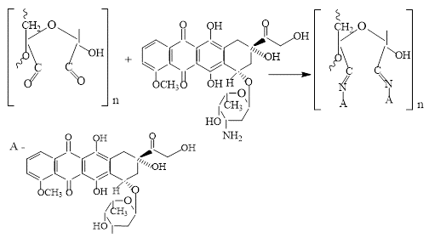
FIGURE 1. Primary -NH₂ group capable of reacting with the aldehyde groups of oxidized inulin

The table 1 presents data indicating the influence of the oxidation state of polyaldehyde inulin on some characteristics of the reaction products.
TABLE 1. Influence of the degree of oxidation of inulin on the characteristics of reaction products

Oxidation level of inulin | Nitrogen content, % | Adriamycin content,% | Molecular weight, Da
16.5 | 1.6 | 5.8 | 4200
25.4 | 2.0 | 7.0 | 4270
31.5 | 2.5 | 9.2 | 4500
39.0 | 3.2 | 11.5 | 5160

The relationship between the oxidation degree of polyaldehyde inulin and its ability to bind adriamycin was investigated. Based on the data obtained, it can be clearly noted that the weight content of chemically bound adriamycin in the final products directly correlates with the quantitative content of electrophilic aldehydes (the oxidation degree of inulin). This indicates that the introduction of additional aldehyde groups enhances the reactivity of the polymer matrix toward the amino groups of the drug. As the number of aldehyde groups in the oxidized inulin structure increases, the adriamycin content rises from 5.8% to 11.5%. However, the overall yield of the reaction products decreases, which can be attributed to the partial degradation of polyaldehyde inulin under the alkaline conditions (pH 8.0–8.2) employed during synthesis.

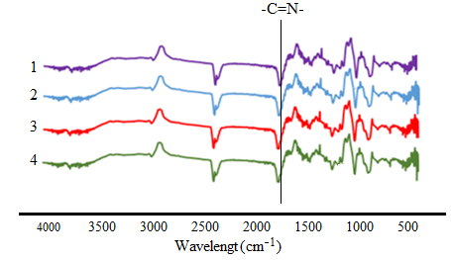
FIGURE 2. FTIR spectrum of inulin-adriamycin with a quantitative content of the drug of 5.8% (1), 7.0% (2), 9.2% (3) and 11.5 % (4)

When studying the synthesized samples using FTIR-spectroscopy, an absorption band was discovered in the region 1645-1658 cm⁻¹. These data prove that the chemical addition of adriamycin to polyaldehydinulin macromolecules occurs through covalent -C=N- bonds. Since azomethine bonds can undergo hydrolysis in an acidic or alkaline environment, we studied the release rate of adriamycin.

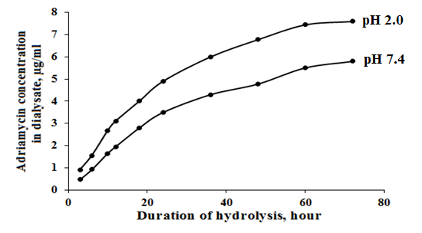
FIGURE 3. Adriamycin release (sample (4) with a quantitative drug content of 11.5%)

The results of the study showed that the azomethine bond formed between adriamycin and polyadehydinulin in the polymer conjugate exhibits varying stability in the model environment of gastric juice (pH 2.0) and bloodstream (pH 7.4). At the same time, the increase in the concentration of adriamycin in the buffer solution occurs gradually, which proves the presence of a prolonged effect and controlled release of the cytotoxic agent.

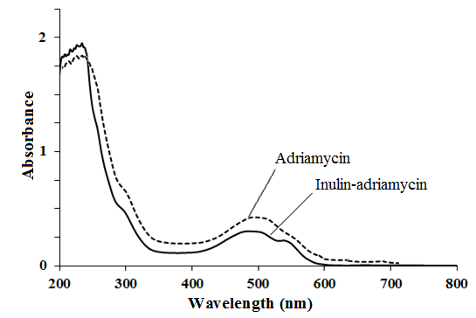
FIGURE 4. UV spectrum of adriamycin c=1.5 mg/ml and inulin- adriamycin (sample (4) c=5 mg/ml

To substantiate the composition of the reaction products, the method of UV spectroscopy was used. It was found that the original adriamycin has intense absorption in the region of λ_{max}=490 nm at a concentration of 1.5 mg/ml. The synthesized inulin-adriamycin also exhibited absorption in the region of λ_{max}=490 nm at a concentration of c=5 mg/ml. The intense absorption band proves the presence of immobilized adriamycin molecules in the modified inulin.
CONCLUSION
The conducted studies demonstrated optimal conditions for chemical immobilization of an antitumor agent to inulin functionalized by periodate oxidation. Physico-chemical analysis methods were used to substantiate the composition and structure of the resulting polymer conjugates based on inulin and adriamycin. The kinetics of cleavage of the immobilized biologically active agent from the polymer molecules of modified inulin was studied under physiological conditions. Chemical binding of adriamycin to inulin was shown to result in prolonged release. The developed method of chemical modification of adriamycin with inulin can find wide application in the creation of a new generation of biologically active polymers.
REFERENCES
- Rakhmonberdiev, G., Ibragimova, K., Tilakov, J., & Khusenov, A. (2023). Isolation and comparative study of various polymorphic forms of inulin. E3S Web of Conferences, 434, 02025. https://doi.org/10.1051/e3sconf/202343402025
- Asere, T. G., Mincke, S., & Folens, K. (2019). Dialdehyde carboxymethyl cellulose cross-linked chitosan for the recovery of palladium and platinum from aqueous solution. Reactive and Functional Polymers, 141, 145–154. https://doi.org/10.1016/j.reactfunctpolym.2019.04.020
- Akhmedov, O. R., Shomurotov, S. A., Turaev, A. S., & Sidarenka, A. V. (2022). Dependence of Antimicrobial Effects of Guanidine-containing Pectin Derivatives from Some Structural Characteristics. Drug Development & Registration, 11(2), 38–45. https://doi.org/10.33380/2305-2066-2022-11-2-38-45
- Dussan, K., Girisuta, B., Haverty, D., Leahy, J. J., & Hayes, M. H. B. (2014). The effect of hydrogen peroxide concentration and solid loading on the fractionation of biomass in formic acid. Carbohydrate Polymers, 111, 374–384. https://doi.org/10.1016/j.carbpol.2014.04.039
- Muchova, M., Munster, L., Capakova, Z., Mikulcova, V., Kuritka, I., & Vicha, J. (2020). Design of dialdehyde cellulose crosslinked poly (vinyl alcohol) hydrogels for transdermal drug delivery and wound dressings. Materials Science and Engineering: C, 116, 111242. https://doi.org/10.1016/j.msec.2020.111242
- Akhmedov, O. R., Shomurotov, S. A., Rakhmanova, G. G., & Turaev, A. S. (2017). Synthesis and study of biological activity of sulfamic polysaccharide derivatives. Russian Journal of Bioorganic Chemistry, 43(7), 716–721. https://doi.org/10.1134/s1068162017070020
- Bolotova, M. V., Danilov, E. A., Gavrilov, Y. V., & Bukharkina, T. V. (2018). Physical and chemical characteristics of PAN/CNT composite powders and their solutions. Fibre Chemistry, 49(6), 360–364. https://doi.org/10.1007/s10692-018-9901-7
- Yang, L., Yuan, J., Zhang, P., Wei, T., Chen, J., Lou, J., Huang, R., & Deng, J. (2022). An interpenetrating-network-like structure in cellulose nanocrystal/polyurethane composites and the relative strengthening mechanism. Cellulose, 29(9), 5007–5019. https://doi.org/10.1007/s10570-022-04612-8

