Methods of Beneficiation, Bleaching, and Determination of Whiteness Index of Khojakul Kaolin Deposit
Aida Ruzmetova ^{a)}, Sherzod Matchanov, Yusufboy Yakubov
Urgench State University named after Abu Rayhan Biruni, Urgench, Uzbekistan

^{a)}Corresponding author: aida0330@list.ru
Abstract. This work considers the characteristics of the kaolins from the Khojakol mine, located in the territory of Karakalpakstan. Methods of chemical, thermal, and biological bleaching of kaolins were considered, and their effectiveness was analysed depending on the composition of the initial raw materials. In addition, methods for determining the whiteness index, which controls the quality of the finished product, are considered. The obtained results can be useful in increasing the efficiency of kaolin processing and expanding its industrial application.
INTRODUCTION
Kaolin is an important raw material for ceramics, paper, paint, rubber, and other industries due to its chemical purity, whiteness, and plasticity. At the same time, enrichment and bleaching methods aimed at improving the physicochemical characteristics of kaolins and increasing their quality are of particular importance, primarily the whiteness index.
The Khojakul deposit is located in the southwestern part of Uzbekistan and is famous for its large-scale kaolin reserves, but the effectiveness of their use in industry often depends on the level of primary processing. Modern approaches to the enrichment of various ores include physical (hydrocyclone, magnetic separation, flotation) and chemical (acid alkalisation, thermal processing) methods aimed at removing unwanted impurities [1-8].
The quality of kaolin depends on its kaolinite content, the size of its particles, and the presence of impurities such as iron, titanium, or quartz. Therefore, the beneficiation process of kaolin is of great importance for its preparation in accordance with industrial requirements. Over the past five years, physical, chemical, biological, and innovative approaches have been used for kaolin beneficiation, applied both jointly and separately, and research continues to improve their efficiency [9].
Dry beneficiation works best in areas with little water. It separates kaolinite from quartz using grinding and air. This method can give up to 91% pure kaolinite. It also saves energy and is good for the environment [10].
Wet beneficiation has a few ways. One way is flotation. Another way is sedimentation. Flocculation is also used. Magnetic separation can be used too.
During flotation, effective separation of kaolin is achieved in an acidic medium, while in the flocculation process, impurities are efficiently removed using special reagents [11].
Chemical beneficiation methods, such as acid treatment and bleaching, are the most common and allow for increasing the technological value of the product by separating Al₂O₃, SiO₂, and TiO₂ from kaolin. Heating, acid treatment, and using hydroxide solutions can increase artificial rutile (TiO₂) up to 91%. This also allows making valuable products like sodium silicate.
In order to reduce the amount of iron compounds, the use of thiourea dioxide, an environmentally friendly bleaching agent, has been observed to significantly increase the whiteness of kaolin [14].
Biological methods of enrichment are particularly environmentally friendly; for example, when bioleaching was carried out using the fungus “Aspergillus niger”, the amount of Fe₂O₃ decreased from 1.723% to 0.394% in 21 days. These biotechnological processes are carried out at low temperatures and do not harm the environment.
Another new direction for increasing the efficiency of enrichment is the combination of physical and chemical methods. For example, it has been proven that it is possible to effectively extract useful components from kaolin to the maximum extent possible using thermal activation, acidification, and the complex use of hydroxide solutions.
In addition, the high speed and efficiency of acidification using ultrasonic cavitation were observed, resulting in the formation of 90% Al(OH)₃. At the same time, it was shown that it is possible to separate kaolin from coal waste by flotation, using innovative reagents and optimising technological parameters, thereby improving the quality of the product.
Methods for bleaching kaolin are constantly being improved. The primary purpose of bleaching kaolin is to remove iron oxides, organic substances, and other impurities that impart colour. Each method has its own characteristics, advantages, and disadvantages.
Among chemical methods, the processing of kaolin with acids is widely used. Iron oxides dissolve with the aid of sulphuric and oxalic acids, making kaolin whiter. For example, treatment with a 2 mol/L H₂SO₄ solution at 100°C for 2.5 hours increases the whiteness level by 94.5% [19]. Another chemical method uses sodium dithionite or sodium borohydride to reduce the amount of iron oxides in kaolin and lighten its colour [20].
Biotechnological approaches also provide effective results. For example, certain bacteria, such as Thiobacillus ferrooxidans, naturally oxidise and dissolve iron oxides. This method is considered environmentally friendly and energy-efficient [21].
Physical methods, such as thermal processing, change the crystal structure of kaolin, which increases its bleaching efficiency. Calcination at temperatures of 500-800°C also increases the whiteness level of kaolin, but this method requires high energy consumption. When using the microwave irradiation method, the surface of kaolin is exposed to chemical reagents more quickly, and the bleaching process is accelerated. This method is more effective when carried out in combination with sodium dithionite or oxidants.
New nanotechnologies can be used to bleach kaolin more effectively. For example, by attaching zinc oxide (ZnO) nanoparticles to the surface of kaolin, its adsorption properties are increased, which significantly affects the degree of whiteness. The use of nanotechnologies requires new scientific approaches, the effectiveness of which has been reflected in many scientific works.
Washing kaolin with surfactants is also an effective method of bleaching. The experiments are aimed at studying the complex characteristics of unbeneficiated kaolin from the Khojakul deposit, its beneficiation and bleaching, along with the determination of its whiteness index.
METHODS
The chemical and granulometric compositions of the raw material were studied in accordance with the current standards GOST 19286-77 “Beneficiated Kaolin. Methods for Determining Granulometric Composition” and GOST 19607-74 “Beneficiated Kaolin for the Chemical Industry. Technical Specifications.”
To determine kaolin whiteness, standard methods according to GOST 16680-79 “Beneficiated Kaolin. Method for Determining Whiteness” were used. The method is based on measuring the surface reflectance coefficient of the tested sample.
IR spectroscopic analysis was carried out using a Fourier IR spectrophotometer. The samples were pressed into KBr pellets. Spectra were studied in the range of 500–3600 cm⁻¹. The crystalline phases in the kaolin composition were determined by X-ray phase analysis using a Shimadzu XRD diffractometer at 40 kV and 30 mA. Identification of minerals corresponding to the diffraction maxima of the X-ray patterns was performed using reference tables by L.Ya. Giller, V.N. Mikheev, and ASTM reference data.
Differential thermal analysis of the raw material was carried out to determine its physicochemical changes and mass loss upon heating. The studies were performed using a derivatograph by I. Paulik, L. Erdey, and F. Paulik operating under the systematic scheme R-1500D. In this method, four curves of the analyzed sample were recorded: T (simple heating curve), DTA (differential thermal curve showing heat flow changes), DTG (differential curve showing mass loss rate changes), and TG (thermogravimetric mass change curve).
Kaolin samples were collected following standard rules. Each sample was about 50 grams. The samples were dried at around 105°C.
Wet-beneficiated kaolin was pre-dried first. Any lumps were crushed in a porcelain mortar and passed through a sieve. Then it was spread in a thin layer and dried until it reached a constant weight.
The whiteness of kaolin was determined using an SBDY-1P whiteness meter based on the photoelectric effect and light source D65 (R457) for measuring the whiteness of kaolin powder. For this purpose, the required amount of kaolin was poured onto a sheet of paper and lightly compacted by folding the sheet and pressing with the palm. The sample was then mixed with a small spoon, poured into the cuvette of the photometer, and lightly tapped to eliminate voids, leaving a cone 4–6 mm high. The kaolin was pressed with a clean glass plate. Extra kaolin at the edges was removed. A second press made the surface even with the cuvette edges. The glass plate was not moved to avoid a shine that could change the results.
The microstructure of kaolin was examined using a SALD-7500nano electron microscope with a 405 nm UV semiconductor laser and 40 W output, and a Tescan Vega 3 Sbh scanning electron microscope equipped with an Azteclive Lite Xplore 30 energy-dispersive system and a tungsten cathode. For electron microscopy, the samples were prepared using a simple platinum–carbon method.
RESULTS AND DISCUSSION
Analytical studies showed that the kaolin content in the rock stays mostly the same. The deposit gives about 32–39% kaolin. The main parts are silica (55.06%) and alumina (35.91%). Impurities from alkali metal oxides are less than 4–5%.
The kaolin mass is white with a grayish tint, the gray color being caused by quartz and feldspar components. As is known, raw kaolin in its natural state usually does not meet the requirements for industrial raw materials. Kaolin requires preliminary processing at a beneficiation plant. The purpose of kaolin beneficiation is to obtain a concentrate consisting of clay material that is as close as possible in theoretical chemical composition and physical properties to the kaolinite mineral, through the maximum removal of impurities from the kaolinite rock.
The results of chemical analysis of average raw kaolin samples from the Khojakul deposit before beneficiation are as follows: SiO₂ — 55.06%, Al₂O₃ — 35.91%, Fe₂O₃ — 0.48%, CaO — 1.68%, MgO — 0.53%, K₂O — 1.27%, Na₂O — 0.70%, TiO₂ — 0.24%, SO₂ — 0.40%, and LOI — 3.76%. It is evident that the raw kaolin differs in its chemical composition by having a higher content of silica and alkali oxides. The alumina content (before beneficiation) in the studied kaolin is almost twice lower than that of foreign kaolins.
The granulometric composition of the kaolins showed that they belong to the highly dispersed group, with a fraction of less than 0.001 mm making up 70.0–85%. The granulometric composition of the kaolins is presented in Figure 1.

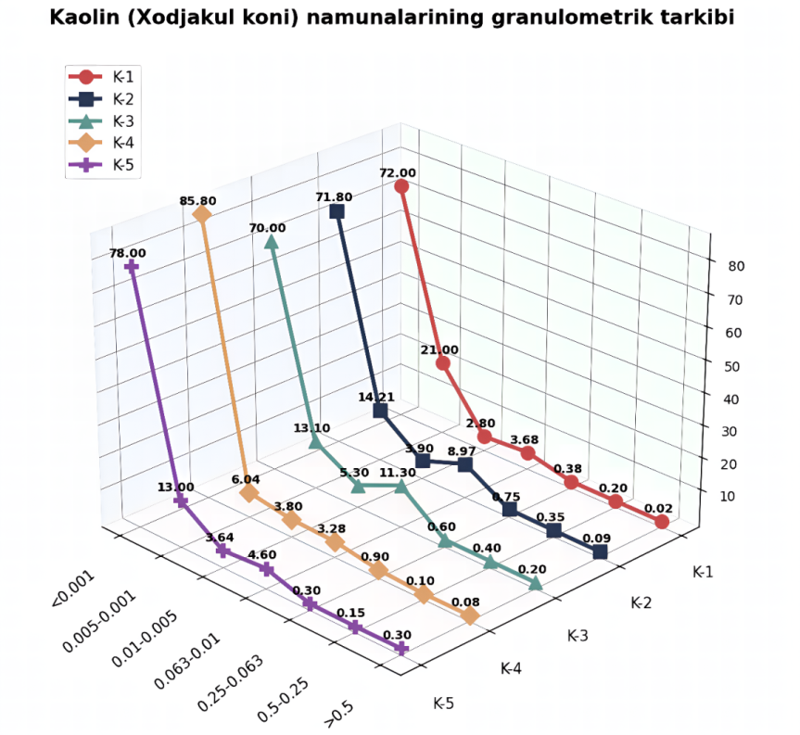
FIGURE 1. Granulometric composition of kaolin from the Khojakul deposit.

All samples have the same minerals, but the amounts are different. The main ones are kaolinite and quartz.
The limiting impurities that reduce the quality of kaolins are iron and titanium compounds. For this kaolin sample, the average contents of total Fe₂O₃ and TiO₂ are 1.21% and 0.71%, respectively. It should be noted that part of the titanium and iron is isomorphically incorporated into the kaolinite structure.
The experiment began with the study of the elemental composition of the raw kaolin obtained using a scanning electron microscope (see Fig. 2).
The analysis results show that the sample composition mainly consists of Si — 64.90% and Al — 31.14%, with small amounts of Fe — 1.21% and Ti — 0.71%, and, as seen in the figure, the content of other elements is insignificant.
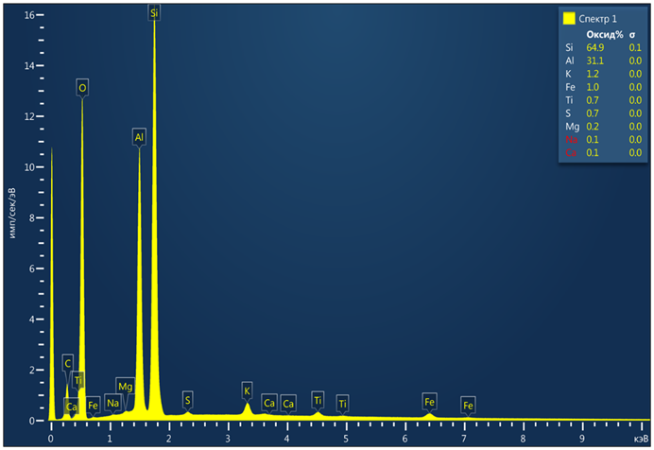 | 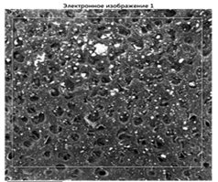
 | 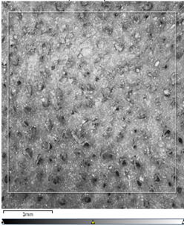
FIGURE 2. SEM image of the raw kaolin from the Khojakul deposit.

The raw kaolin from the Khojakul deposit is made up of small clay flakes and some quartz particles. The clay flakes, which are the main part, range in color from nearly colorless to light brown and have a scaly, slightly rough texture. The flakes are a bit long and uneven in shape because they grow very close to each other and interlock in different ways. Some flakes are more elongated, while others are almost square-like. This close intergrowth gives the clay a heterogeneous look. Figure 3 shows a photo of this kaolin taken under an electron microscope, showing the detailed structure of the flakes.

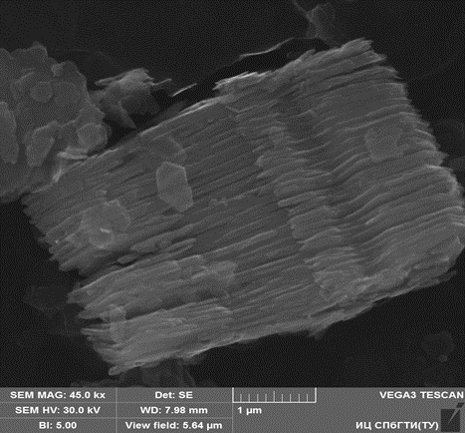
FIGURE 3. Electron microscopic image of the raw kaolin from the Khojakul deposit.

The next stage of the experiment was aimed at kaolin beneficiation. A wet beneficiation method was chosen based on the technological scheme studied from source, since the use of the dry method—which includes the main operations of crushing, drying, grinding, dry separation, and sedimentation—was found to be ineffective according to the literature. The proposed technological scheme of wet beneficiation is shown in Fig. 7. The results of determining the elemental composition after wet beneficiation of the kaolin sample from the Khojakul deposit, obtained using a scanning electron microscope, are presented in Fig. 4.

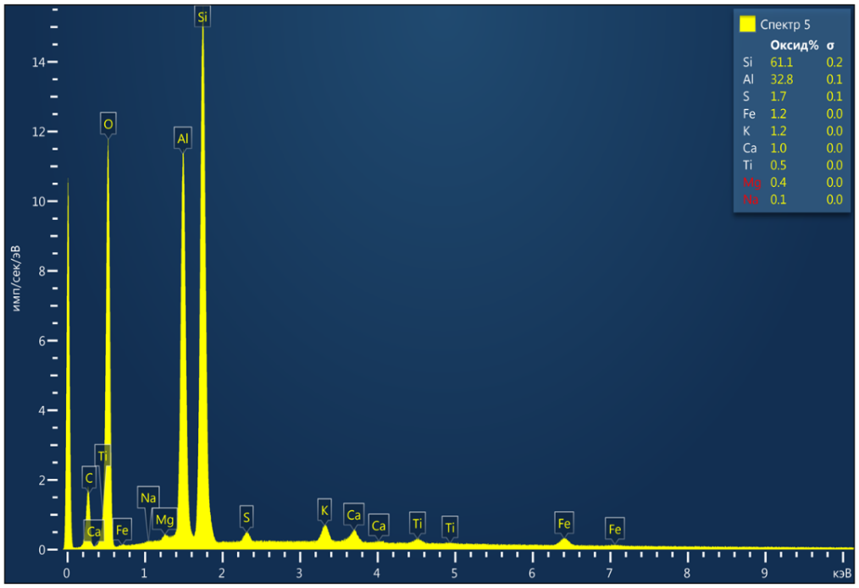 | 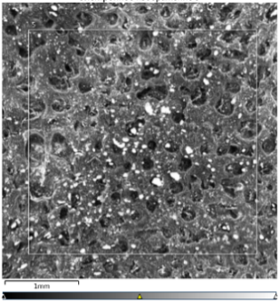
 | 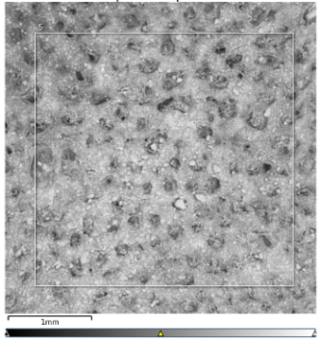
FIGURE 4. SEM image of the beneficiated kaolin from the Khojakul deposit.

According to the analysis results, the Al content increased from 31.14 to 32.80; the Si content decreased from 64.90 to 61.10; and the Fe and Ti contents remained practically unchanged.
For this kaolin sample, the acid treatment method was selected. In the lab, kaolin was bleached using acids. The acids included sulfuric acid (H₂SO₄), hydrochloric acid (HCl), nitric acid (HNO₃), and oxalic acid (C₂H₂O₄). Both the raw and wet-beneficiated kaolin samples were subjected to bleaching. The experiments were carried out using acid solutions of concentrations ranging from 5 to 20% at a temperature of 100 °C for 2 hours with a liquid-to-solid ratio of 5:1, followed by repeated washing and filtration. To evaluate the kaolin whiteness level, a blue light filter with a working wavelength of 457 nm was used. The instruments were calibrated and measurements were done following the operating manual, and the results were rounded to 0.1%. Upon completion of each measurement cycle, which included 16–20 readings, the photometer was calibrated using a reference plate whose whiteness closely matched that of the analyzed sample.
When using H₂SO₄, HCl, and HNO₃ at the specified concentrations, the kaolin whiteness did not meet the requirements of GOST 16680-79 “Beneficiated Kaolin. Method for Determining Whiteness.” The best bleaching result was achieved with a 20% oxalic acid (C₂H₂O₄) solution. The obtained results using different acids are presented in Table 1.
Experimental results show that chemical bleaching helped remove unwanted impurities, like iron oxide (Fe₂O₃) and titanium oxide (TiO₂), which directly affect the whiteness of kaolin. The laboratory studies also showed that using a 20% oxalic acid solution provided an impurity removal efficiency of 13.20%, confirming that this approach can improve the quality of kaolin.
This conclusion is fully confirmed by the obtained numerical values of the kaolin sample whiteness index, determined using a high-precision instrument — the SBDY-1P whiteness meter (see Table 2).
To clearly show how kaolin whiteness changes during processing, certain experimental measurements need to be taken. At the beginning, the unprocessed kaolin had a whiteness index of 68.80%, which reflects the impurities that reduce its optical quality. After the wet beneficiation stage, the whiteness increased to 75.30%, indicating that some of the contaminating substances had been removed.

TABLE 1. Comparative results of kaolin after acid treatment

Kaolin samples |  | Original sample (reference)
Beneficiated kaolin | 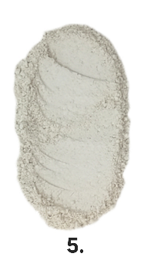 | 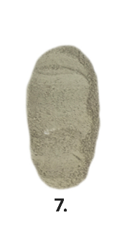
Beneficiated kaolin with H₂SO₄ | 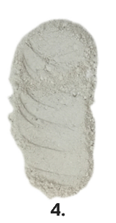 | 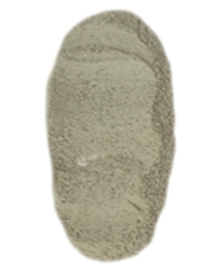
Beneficiated kaolin with HCl | 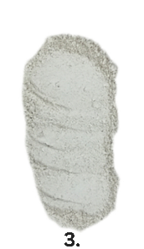
Beneficiated kaolin with HNO₃ | 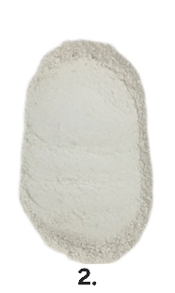
Beneficiated kaolin with C₂H₂O₄ | 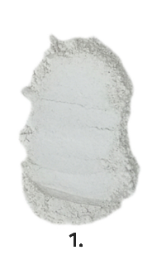

TABLE 2. Results of chemical bleaching

Raw material | Leaching conditions, concentration, % |  | Content, % |  |  |  | Whiteness index,  R (457)
Raw material |  |  | Fe₂O₃ | TiO₂ | Аl₂O₃ | SiO₂ | Whiteness index,  R (457)
Unbeneficiated kaolin | - |  | 1,21 | 0,71 | 31,14 | 64,90 | 68,80
Beneficiated kaolin | - |  | 0,99 | 0,55 | 32,81 | 61,10 | 75,30
Beneficiated kaolin with C₂H₂O₄ | C₂H₂O₄ | 5 | 0,97 | 0,50 | 32,93 | 60,99 | 76,66
Beneficiated kaolin with C₂H₂O₄ | C₂H₂O₄ | 10 | 0,95 | 0,47 | 33,80 | 60,66 | 78,43
Beneficiated kaolin with C₂H₂O₄ | C₂H₂O₄ | 15 | 0,93 | 0,44 | 35,92 | 60,21 | 80,15
Beneficiated kaolin with C₂H₂O₄ | C₂H₂O₄ | 20 | 0,92 | 0,42 | 37,61 | 59,10 | 82,40

The highest whiteness value was recorded after chemical treatment of the kaolin: as a result of the action of active reagents, particularly oxalic acid, a whiteness index of 82.40% was achieved, confirming the effectiveness of this purification method. Figure 4 presents the diagram of the chemical bleaching results. Figure 5 shows the results of the elemental composition analysis of the beneficiated kaolin sample from the Khojakul deposit after acid treatment, obtained using a scanning electron microscope.
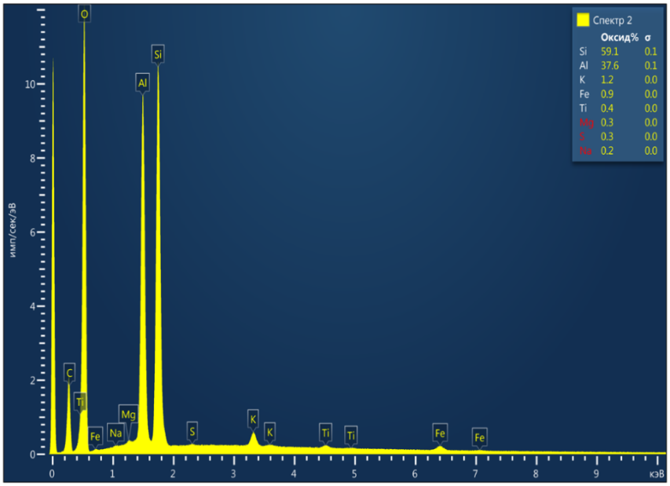 | 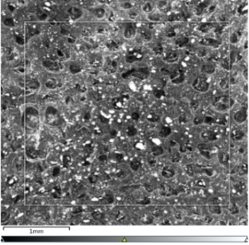
 | 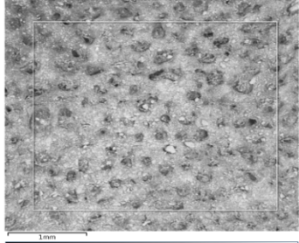
FIGURE 5. Scanning electron microscope (SEM) image of the beneficiated kaolin treated with acid from the Khojakul deposit.

According to the analysis results, the Al content increased from 31.14 to 37.60; the Si content decreased from 64.90 to 59.10; the Fe content decreased from 1.21 to 0.92; and Ti from 0.71 to 0.42.
In the electron microscopic images of the beneficiated kaolin (see Fig. 6), well-formed and slightly indistinct hexagonal plate-like structures characteristic of kaolinite are observed. In some cases, the hexagonal outlines of the plates are only schematically expressed, which may be associated with the predominance of smaller particles. The structure is fine-scaly, with plate sizes mainly less than 0.01 mm; however, most of them are larger than 0.001 mm. The shape of the plates is represented by rarely occurring hexagonal sections.

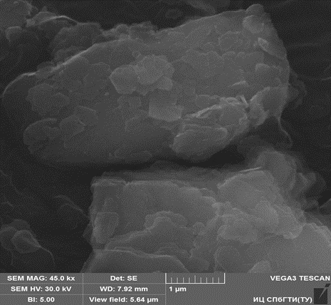
FIGURE 6. Electron microscopic image of the acid-treated beneficiated kaolin from the Khojakul deposit

At the initial stage of wet beneficiation of the raw kaolin, disintegration was used, followed by screening and classification operations on vibrating screens and a hydrocyclone (see Fig. 7).
The kaolin obtained through the above sequence of operations was dewatered in chamber filter presses at a pressure of 1 MPa and a filtration time of 50 minutes. The resulting cakes were then crushed and fed into an acid treatment unit, where a 20% oxalic acid solution was introduced. The process duration was at least 2 hours at a temperature of 90–100 °C. The resulting mass was then sent to a rotary dryer. The temperature of the heat carrier at the dryer inlet was 800–900 °C, and at the outlet 100–120 °C. The residual moisture content of the kaolin was 8–10%. After the kaolin was dried, we put it into bags. Then the bags were moved to the warehouse. This kaolin is now ready as the final product.
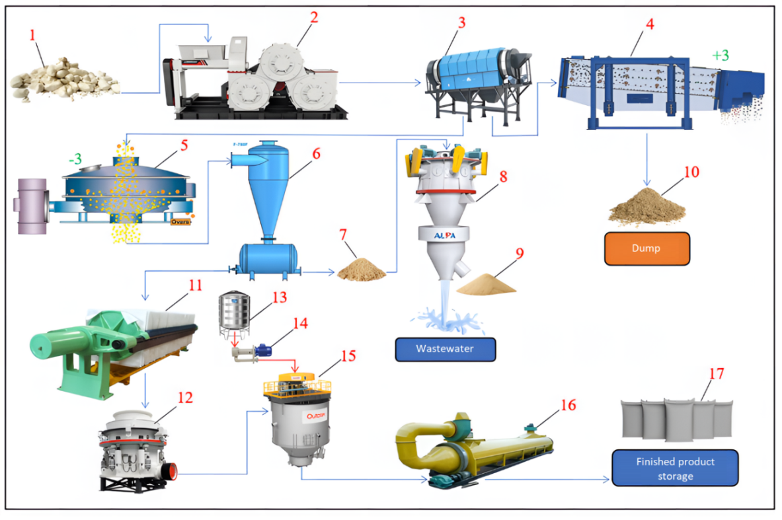
FIGURE 7. Technological flow diagram of wet beneficiation of the Khojakul kaolin deposit with acid treatment: 1 – Kaolin storage; 2 – Disintegration; 3–4–5 – Screens; 6 – Hydrocyclone; 7–9–10 – Sands; 8 – Recleaning classification; 11 – Filter press; 12 – Cone crusher; 13 – Oxalic acid (C₂H₂O₄) tank; 14 – Pump; 15 – Chemical treatment unit; 16 – Drying drum; 17 – Finished product storage..
CONCLUSION
The conducted studies showed that the kaolin of the Khojakul deposit is a raw material with significant industrial potential, but it requires deep processing for its use in high-quality areas. The wet method of enrichment significantly reduced the amount of undesirable mineral additives, particularly iron-containing compounds, that affect the colour of kaolin. The study showed that the most effective method was the method of alkalisation with 20% concentrated oxalic acid. This result was obtained using the SBDY-1P whiteness level measuring device and confirmed the effectiveness of the selected technology.
The results obtained allow the use of developed methods for industrial processing of kaolin from the Khojakul deposit, which will increase its competitiveness and reduce the need for imported analogues.
Thus, a complex technology that includes operations such as enrichment, bleaching, and quantitative assessment of the degree of whiteness can be recommended for industrial processing of kaolin from the Khojakul deposit to obtain high-quality raw materials. Further research will be aimed at improving the technological parameters of the bleaching process, as well as studying the environmental aspects of the use of chemical reagents.
REFERENCES
- Jumanyazov M.J., Atashev E.A., Aitova Sh.K., Pirnapasova H.A. Research results on flotation of talc-magnesite raw materials from the Zinelbulak mine // Research and education ISSN: 2181-3191 volume 3. issue 8. 2024. Pp 66-72. DOI: https://doi.org/10.5281/zenodo.13898527
- Buranova D, Matchanov Sh, Atashev E. Physicochemical and mineralogical characterization of Sultan Uwais feldspar for sustainable glass manufacturing in earth and environmental sciences. E3S Web of Conferences 633, 06001 (2025) https://doi.org/10.1051/e3sconf/202563306001
- Jumaniyazov, M., Kurambayev, S., Atashev, E., Jumaniyozov, A., & Buranova, M. (2025). Determination of the composition of the Zinelbulak talc-magnesite deposit rock using modern physicochemical methods. E3S Web of Conferences, 633, 06002. https://doi.org/10.1051/e3sconf/202563306002
- Khadzhiev A, Atabaev F. Influence of silica-containing additives on physical and mechanical properties of Portland Cement Co. Ltd “Karakalpaksement”. *E3S Web of Conferences* 2023;401:05051. https://doi.org/10.1051/e3sconf/202340105051
- Sánchez-Palencia, Y., Bolonio, D., Ortega, M. F., García-Martínez, M., Ortiz, J. E., Rayo, F., Arregui, L., Serrano, S., Llamas, J. F., & Canoira, L. (2022). Iron Removal from Kaolin Waste Dumps by Chemical (Oxalic and Citric Acids) and Biological (Bacillus Strain) Leaching. Clays and Clay Minerals, 70(3), 386–404. https://doi.org/10.1007/s42860-022-00192-7
- Ibrahim, A. S., & Baba, A. A. (2023). Dissolution kinetics studies of kaolin ore as raw material for mesoporous silica by acid leaching. Canadian Metallurgical Quarterly, 63(1), 203–212. https://doi.org/10.1080/00084433.2023.2183649
- Padilla, J., Guzman, A., Molina, D., & Poveda-Jaramillo, J. C. (2020). Structural transformation of kaolin as an active matrix for the in situ synthesis of zeolite Y. Clay Minerals, 55(4), 293–302. https://doi.org/10.1180/clm.2020.40
- Berroug, F., Bellaziz, Y., Ouazzani, N., Nouh, F. A., Hejjaj, A., Boukhattem, L., Idlimam, A., Mahmoudi, H. E., & Mandi, L. (2021). Experimental and numerical investigations on conductive drying of phosphate washing waste clay. Minerals, 11(5), 482. https://doi.org/10.3390/min11050482
- Moreira, I. S., Amorim, C. L., Ribeiro, A. R., Mesquita, R. B., Rangel, A. O., Van Loosdrecht, M. C., Tiritan, M. E., & Castro, P. M. (2015). Removal of fluoxetine and its effects in the performance of an aerobic granular sludge sequential batch reactor. Journal of Hazardous Materials, 287, 93–101. https://doi.org/10.1016/j.jhazmat.2015.01.020
- Liu, R., Liu, F., Hu, C., He, Z., Liu, H., & Qu, J. (2015). Simultaneous removal of Cd(II) and Sb(V) by Fe–Mn binary oxide: Positive effects of Cd(II) on Sb(V) adsorption. Journal of Hazardous Materials, 300, 847–854. https://doi.org/10.1016/j.jhazmat.2015.08.020
- A Simon, M., & Joshi, H. (2021). A review on green technologies for the rejuvenation of polluted surface water bodies: Field-scale feasibility, challenges, and future perspectives. Journal of Environmental Chemical Engineering, 9(4), 105763. https://doi.org/10.1016/j.jece.2021.105763

