The Importance of Bentonite Coating in Reducing the Filtration Process
Toxirjon Kasimov, Sherali Jurayev^{a)}, Davron Axatov, Nizomiddin Xudayberdiyev, Sodiqjon Khakimov
Namangan State Technical University, Namangan, Uzbekistan

^{a)}Corresponding author: jorayev1981@gmail.com
Abstract. In the Republic of Uzbekistan, the majority of irrigation canals are unlined. This, in turn, leads to water losses during distribution. In canals constructed from local soil, a filtration process occurs, depending on the soil type. Currently, with special attention being paid to water conservation, there is a need to use economically viable linings in canals. The local raw material - bentonite clay - is chemically rich with a diverse composition and has a filtration coefficient of 10⁻⁸ m/day. Using this clay as a waterproof lining based on special methods results in cost-effective efficiency.
Keywords: canal, water, coating, filtration, bentonite, montmorillonite, clay.
INTRODUCTION
In the implementation of economic reforms in our republic, increasing the efficiency of irrigation networks in water management and reducing operating costs are considered urgent issues [1-4].
According to statistical data, currently in our Republic, 40% of water taken from rivers, canals, and reservoirs for irrigation purposes is lost in the process of delivering it to each irrigated area. This means that throughout the year, we are losing water equivalent to the volume of almost 10 Charvak reservoirs while delivering water through irrigation networks. These losses are distributed across irrigation networks as follows [5, 9].
Main canals account for 10% (1.66 billion m3), inter-farm canals 25% (4.14 billion m³) and intra-farm canals 65% (10.76 billion m³). Naturally, these losses are primarily due to filtration and evaporation.
In earthen canals, 90% of the lost water is attributed to filtration, while only 10% is lost to evaporation. Consequently, the water loss due to filtration is indeed significant. The intensification of this process leads to the deterioration of the land's reclamation status. As a result, soil salinization occurs and ultimately leads to decreased yields on irrigated lands at a time when the current global food crisis is emerging. The current relevance of this process lies in the fact that even with a certain loss of available water resources, both the efficiency of irrigation networks and the land use coefficient are declining [6-10].
In our republic, numerous studies have been conducted to investigate and reduce filtration processes in earthen canals. For instance, in the Mirzachul and Karshi deserts, which are among the last major developed territories of our Republic, over 90% of all irrigation systems have been covered with various coatings, resulting in a notable reduction of filtration losses.
METHODS
In the practical use of irrigation canals, clay structures (screens and other coatings) are widely employed to counteract filtration processes in existing canals. When designing these structures, it is crucial to accurately assess the water permeability of the clay. Overestimating the effectiveness of this property leads to wastage of material resources, increased inefficient expenses, and high filtration losses. The storage of these clays, the environmental impact of various harmful chemical compounds they contain, their economically inefficient use, and long-term utilization contribute to environmental pollution [11].
The water permeability of clays is evaluated based on the value of the filtration coefficient.
Determining the filtration coefficient of bentonite clay cannot be accomplished in a short time. To assess water permeability, research must be conducted for no less than 30 days. Data obtained in a short period may contain numerous errors. During this time, attempts to accurately predict the filtration coefficient also do not yield positive results [12].
The objectives of this study are as follows:
1. To establish the possibility of determining the exact value of the filtration coefficient for bentonite samples with low water permeability and disturbed structure using filtration coefficient measurement devices.
2. To determine the minimum time required for each experiment, allowing for the measurement of the filtration coefficient with sufficient accuracy to achieve the practical goal of the study.
3. To identify methods for determining the filtration coefficient value based on water permeability, taking into account the amount of water present in the bentonite.
It is essential to conduct these studies using precise methods, as there is insufficient data in the literature regarding the determination of water permeability and filtration coefficient of bentonite. Furthermore, some authors doubt the possibility of direct determination through simple methods, thus recommending indirect calculation of bentonite clay properties using other significant methods.
Fractional analyses of Logon bentonite from the Kuvasay district of Fergana region are presented in Table 1. Laboratory studies of bentonite permeability were conducted according to GOST 25584-2016 "Methods for Determining the Filtration Coefficient of Soils" [13].

TABLE 1. Fractional analysis of bentonite

Sample Code | Fractional weight (mm), %
Sample Code | >0.25 | 0.25-0.10 | 0.10-0.05 |  | 0.05-0.01 |  | 0.01-0.005 | 0.005-0.001 | <0.001 | Physical soil
Light | 0.8 | 0.6 | 26.2 |  | 9.1 |  | 24.5 | 2.3 | 36.5 | 65.5
Assessment by Kachinsky method |  | Fractional composition (mm)  USDA Soil Texture Triangle, % |  |  |  |  |  | FAO Classification
 |  | sand  0.05-2.0 |  | silt 0.002-0.05 |  | clay <0.002
Light soil |  | - |  | 28 |  | - |  | CL - Clay Loam |  |  | Clay Loam

Fractional analyses of bentonite were carried out to provide a complete description of its structural properties. The results are presented in Table 1.
According to V.V. Okhotin's classification, bentonite belongs to the category of clay-like clay rocks. It can be included in this category because particles with a size of d<0.005 mm constitute more than 30% of its composition.

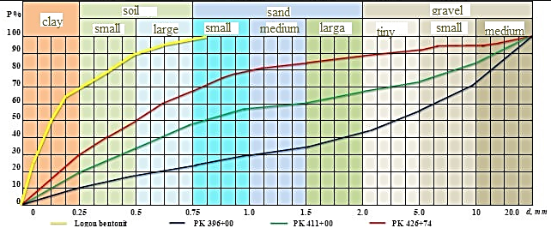
FIGURE 1. Fractional composition of Logon bentonite clay and canal bed soil.

To achieve the intended goals, considering the existing hydraulic devices, an experimental apparatus was constructed based on the design of N.V. Kolomensky's device. This apparatus determines the filtration coefficient of bentonite and canal soil mixtures for both ordered and disordered structures (see Fig. 2). Devices of this type are also recommended by GOST standards. The experimental setup is located in the laboratory of the Hydraulics Department at Namangan State Technical University for conducting scientific research.
The device consists of a rectangular hollow polyethylene pipe with dimensions of 50 cm in width, 40 cm in length, and 60 cm in height, with an internal diameter of 20 mm, as well as a glass container for collecting the filtered water. The glass container is divided into 3 equal parts by glass sheets. At the bottom of the container, a metal sheet ring with uniformly spaced circular holes is installed. To prevent the mixture from clogging the holes, we place a mesh filter paper.

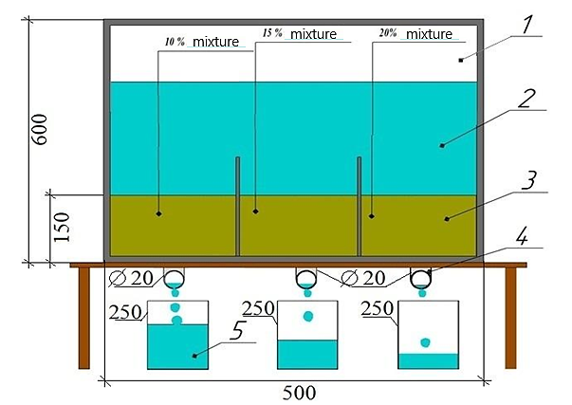
FIGURE 2. Schematic diagram of the experimental device for determining filtration flow rate: 1 - transparent container; 2 - water layer; 3 - bentonite soil layer; 4 - water outlet pipe; 5 - water container.

Then we mix bentonite with the soil sample in proportions of 10%, 15%, and 20% and place it inside the device. We pour water from the top until the soil is moistened. We compact the moistened soil mixture. We fill the container with water until a constant level is achieved above the soil mixed with bentonite clay. The upper part of the device is open, exposed to atmospheric pressure. The water level inside the container is periodically monitored, and if a change in the water level is observed, additional water is added to the container.
The filtration coefficient is calculated using the following formula (cm/s):
$k=\frac{Wl}{hFT}$ (1)
Where W is the water volume, cm3; L is the filtration path length equal to the height of the soil layer, cm; h is the head, cm; F is the area of the sample section, cm²; The duration of filtration T can be calculated using the following formula:
$k_{f}^{10}=\frac{h}{t}ϕ\left(\frac{S}{H_{0}}\right)\frac{864}{T}$. (2)
Where S is the change in the controlled water level in the piezometer from its initial state to its final state, cm; H0 is the initial head, cm; φ (S/H0) is a dimensionless coefficient; t is the time of water level drop, s; h is the soil height in the sample, cm; T0 = (0.7+0.03Tf) is the temperature formula for adjusting the filtration coefficient during the water filtration process at 10°C; where Tf is the actual water temperature during the experiment, °C; 864 is the conversion factor (for converting from cm/s to m/day).
Transparent glass container filled with bentonite soil (see Fig. 3). Inside the glass apparatus, 5% bentonite clay was mixed with soil layered 15 cm thick. The prepared mixture was compacted using special equipment. Then the container was filled with water, which moved from top to bottom. A measuring tank was placed to collect and measure the water that filtered through the bentonite soil over time.
The research results showed that the water passing through the bentonite layer is very clear, demonstrating bentonite's filtering ability.

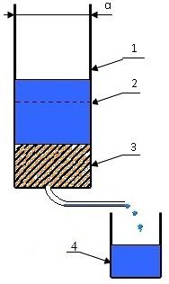
FIGURE 3. Diagram of the apparatus with a bentonite clay mixture ranging from 5 to 50 percent of the natural soil sample: 1 - glass container; 2 - water layer; 3 - soil mixed with bentonite clay; 4 - container for measuring water.

This property explains why bentonite can be used as a filter in various industries. Based on the experimental data, preliminary results on the water permeability of bentonite were obtained.
RESULTS AND DISCUSSION
In the conducted laboratory studies, 18 kg of the canal bed soil sample was mixed with a 5% bentonite clay sample and placed in the device. As a result, it was determined that the average value of the filtration coefficient per unit of time is kf = 0.082 m/day.
As mentioned above, a 10 cm layer of soil was placed inside the glass structure. A layer of bentonite soil with concentrations of 5, 10, 15, 20, 30, 40, and 50% was placed on the top layer with a thickness of 15 cm, and water was supplied from the top layer to the bottom. In the conducted experiments, the amount of water flowing through the layer per unit of time was determined. The obtained results showed that the pressurized movement of water occurs through layers of soil mixed with bentonite clay inside a transparent glass device. In our opinion, these conditions indicate the occurrence of mechanical decomposition (suffusion).

TABLE 2. Table of average filtration coefficients (as percentages) for mixtures of riverbed soil and bentonite clay

Soil | P % | kf, cm/day | kf, m/day
Canal soil |  | 29.80 | 0.30
Bentonite and canal soil mixture | 5 | 8.41841 | 0.082
Bentonite and canal soil mixture | 10 | 6.35049 | 0.062
Bentonite and canal soil mixture | 15 | 4.23366 | 0.041
Bentonite and canal soil mixture | 20 | 2.82244 | 0.027
Bentonite and canal soil mixture | 30 | 2.56586 | 0.025
Bentonite and canal soil mixture | 40 | 2.3326 | 0.022
Bentonite and canal soil mixture | 50 | 2.2320 | 0.021
Average value |  | 4.45391 | 0.040

Water in soil layers moves at different speeds depending on specific conditions and reaches "critical" velocities. As the velocity increases, mechanical disintegration (suffusion) occurs. Water first moves through small soil masses, then increasing porosity leads to separation of connections between larger and other particles. As a result, a sharp change occurs in the main volume of the soil, and we can observe filtration processes similar to those in channels. The identified results were summarized in the following table and statistical analysis was carried out.
The data obtained in laboratory studies were analyzed using methods of mathematical statistics (see Fig. 4). Based on the analysis, the following relationship was derived to determine the relative filtration coefficient of the coating (screen):
(4)
$n_{0}=\frac{k_{e}}{k_{g}}$- relative filtration coefficient of the screen; P_{g} - amount of canal soil [%], P_{b} - amount of bentonite clay [%].
The obtained relationship is recommended for determining the relative filtration coefficient of the anti-filtration screen created in the channel bed.
According to the results of the conducted research, it was determined that the optimal amount of bentonite clay mixture in the soil sample is 30-35%.

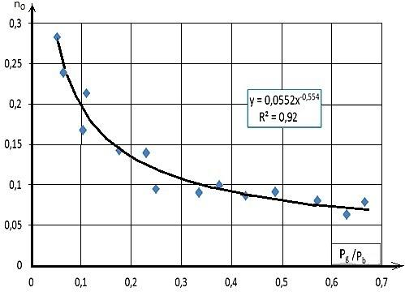
FIGURE 4. Graph showing the dependence of the relative filtration coefficient of the lining on the mixture of riverbed soil and bentonite

The obtained relationship is recommended for determining the relative filtration coefficient of the anti-filtration screen created in the channel bed.
As a result of covering the canal bed with a bentonite clay mixture, a significant decrease in the filtration coefficient is achieved. In this case, bentonite clay forms a waterproof screen with the bottom soil. We will calculate the water loss due to filtration from the bottom of the channel for a length of 4173 m from PK 396+00 to PK 437+01. Calculations will be carried out for both the initial channel soil and the bentonite mixture. As a result of screen formation, we approach the calculation of filtration flow from the bottom and side walls of the channel as follows.
The amount of filtration from the bottom of the channel was determined by the following expression:
(5)
Where Q_{f} is the water discharge lost due to filtration [m³/s], - canal bottom width [m²], - flow depth [m], - lining thickness [m], k_{e} - screen filtration coefficient [m/day].
The amount of filtration from the channel slope was determined by the following expression:
(6)
Where m is the canal slope [m].
To determine the filtration flow rate from a screen formed from a mixture of bentonite clay and canal bed soil, calculations were carried out using the following expression:
. (7)
$ke$where Qf is the water loss due to filtration in the lined channel, [m3/s], is the filtration coefficient of the lining (screen), [m/day], δ is the lining thickness, [m]. B is the width of the canal at the water surface [m], X is the wetted perimeter [m].

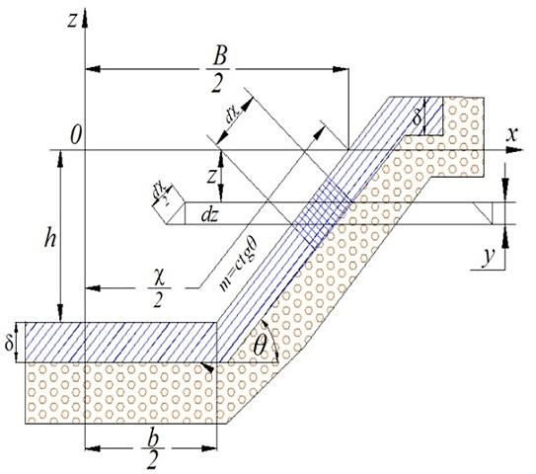
FIGURE 5. Calculation scheme

Based on the calculations using the developed formula, the thickness of the screen formed from bentonite clay was determined to reduce filtration losses from the North Fergana Main Canal by 80%. It was found that the thickness of the screen formed from bentonite clay for the canal bed should be 0.25 meters.

TABLE 3. Calculation of filtration rates when creating a screen

δ (m) | ke (m/day) | b (m) | h (m) | Qf (m/s)
0.12 | 0.031 | 30 | 2.4 | 16.022
0.13 | 0.029 | 30 | 2.4 | 13.727
0.15 | 0.025 | 30 | 2.4 | 10.837
0.2 | 0.019 | 30 | 2.4 | 6.216
0.25 | 0.015 | 30 | 2.4 | 4.77
0.3 | 0.013 | 30 | 2.4 | 2.868
0.4 | 0.009 | 30 | 2.4 | 1.673
0.5 | 0.008 | 30 | 2.4 | 1.109

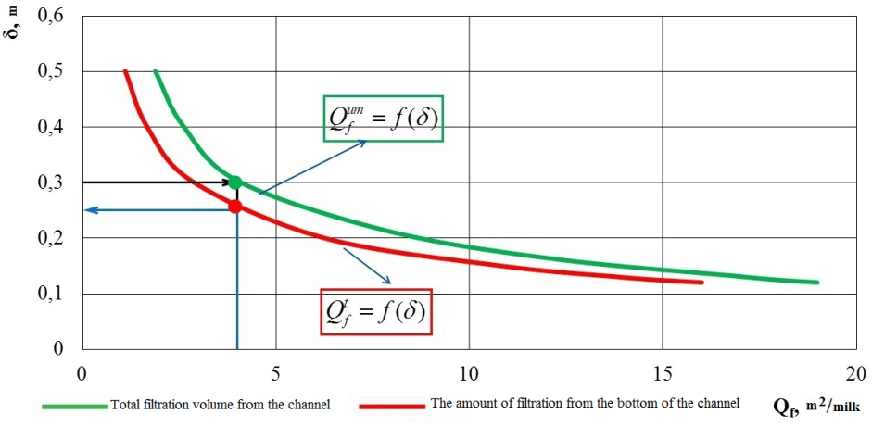
FIGURE 6. Graph for calculating screen thickness to reduce filtration in the canal

Efficiency assessment and comparative calculation. The hydraulic efficiency of the developed recommendations was assessed based on the research results. According to the results of field studies and calculations, the average filtration flow rate from the unlined section of the North Fergana Main Canal was found to be 19-20 m²/day.

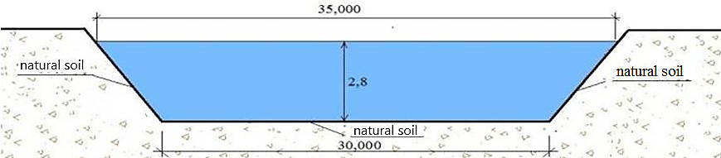
FIGURE 7. Cross-section of a canal without natural soil lining

It is known that currently, both sides of the main canals are being concreted, while the bottom is left in its natural state. There are several reasons for this, such as prolonged cessation of flow in main canals leading to water shortages, high volume of concrete work due to the large width of the bottom, high cost, and so on.
If both sides of the canal are concreted and the bottom is natural soil, we calculate the amount of filtration from the canal bottom as follows. According to the calculation results, it was found that the filtration flow rate decreases by 20-25%.
$$Q_{f}=Ak_{f}(b+3,2h)=1,12⋅0,3(30+3,2⋅2,4)=14,5m^{2}/milk$$
As can be seen from the above results, 75-80% of filtration flow occurs at the bottom of the canal. In such cases, one of the most effective methods against filtration is the recommended method of creating a screen from bentonite clay. We determine the amount of filtration from the bottom of the canal as follows when both sides are concreted and a screen is formed at the bottom using bentonite clay.
$$Q_{f}=\frac{k_{e}b}{δ}(h+δ)=\frac{0,015⋅30}{0,25}(2,4+0,25)=4,77m^{2}/milk$$
As a result of implementing the provided recommendations, namely concreting both sides of the canal and creating a screen on the bottom using bentonite clay, the hydraulic efficiency of the canal has increased. Based on the comparison of the above data, it was possible to reduce the amount of water lost to filtration by an average of 80%.

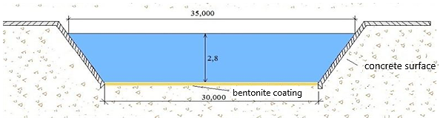
FIGURE 8. Cross-section of a canal with concrete-lined sides and a screen made of bentonite clay at the bottom

If we compare the hydraulic efficiency of the implementation, it is possible to save an average of 15 m3 of water per day.

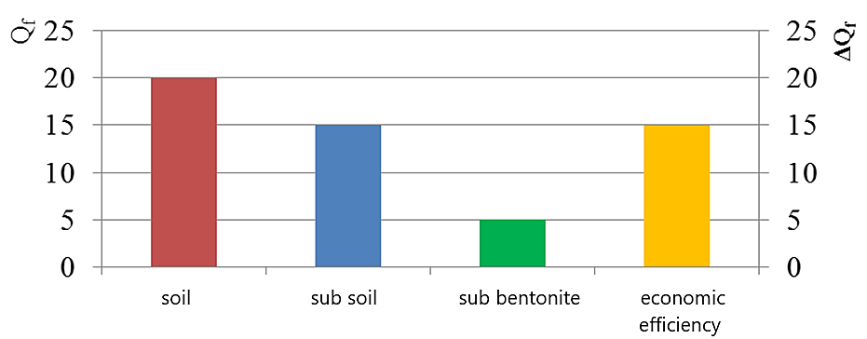
FIGURE 9. Graph of hydraulic efficiency of the implementation

TABLE 4. Calculation of water loss due to filtration from the bottom of the canal bed

Picket | L | Qf.ground | kf.screen | Qf.screen | ΔQf | ΔQf %
PK 396+00
 | 1,500 | 25,344 | 0.03 | 4,262 | 21,082 | 83.184
PK 411+00
 | 1,500 | 19,872 | 0.03 | 4,262 | 15,610 | 78.553
PK 426+74
 | 1,173 | 11,232 | 0.03 | 3,332.9 | 7,899.14 | 70.327
PK 437+01
Total | 4,173 | 56,448 |  | 11,857 | 44,591.2

According to the calculation results, as a result of creating a screen using bentonite clay on a 4,173 m section of the canal, 11,857 m3/day of water is lost to filtration. 44,591 m3/day of water is saved compared to an earthen channel. The amount of water saved using bentonite clay is 70-80% compared to the earthen channel.

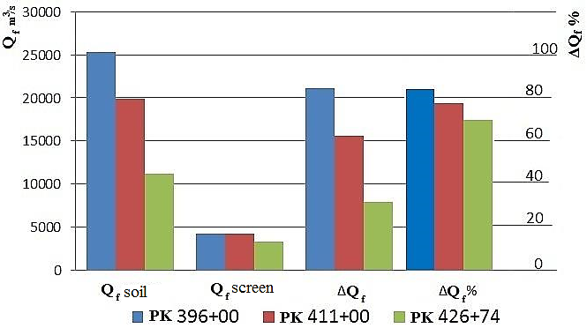
FIGURE 10. Economic efficiency resulting from covering the canal bottom with bentonite clay

A significant reduction in filtration from channels is achieved by creating a screen at the bottom of double-sided concrete-lined channels using bentonite clay. When organizing construction work, considerable savings in financial resources for construction materials are achieved compared to concrete lining.
As we know, the processes of reconstruction and concrete lining of main canals are time-consuming and require stopping the water flow in the canal for extended periods. This situation leads to objections from the owners of irrigated lands.
By using the proposed method of creating a screen from local raw material bentonite clay as a resource-saving anti-filtration coating in unlined channels, the time required for reconstruction processes is reduced to some extent, and water losses from main canals are decreased by 70-80%.
CONCLUSION
Time plays a crucial role in determining the filtration coefficient of the bentonite clay mixture, with longer experiment durations leading to more accurate results. Research findings indicate that the optimal amount of bentonite clay mixture in the soil sample is 30-35%. Laboratory analyses were conducted without considering chemical processes, as the properties of bentonite have not yet been fully studied. In the experiments, sufficient soil compaction was determined at densities of 1600-1800 kg/m3 over various time periods. It was established that the average filtration coefficient based on a mixture of riverbed soil and bentonite clay additives is equal to kf=0.04 m/day. To prevent bentonite clay from being washed away by water flow in uncovered canals, it is advisable to mix and compact bentonite clay into the canal soil using cultivators. According to the results of studying the water permeability of bentonite clay mixtures in powder form, it is possible to create a state of mechanical decomposition (suffusion) around bentonite and soil without forming a crust, which may lead to an increase in the filtration process.
REFERENCES
- Akramov, A., Juraev, S., Xoshimov, S., Axatov, D., & Pathidinova, U. (2022b). Optimum placement of thin-layer elements in a horizontal sedimentation tank purification of drinking water. IOP Conference Series Earth and Environmental Science, 1112(1), 012139. https://doi.org/10.1088/1755-1315/1112/1/012139
- Mukhammediev, M. G., & Makhkamov, M. A. (2016). Composite gels of polyacrylic acid with bentonite clay and their properties. Universum: Chemistry and Biology, (11), 34–41.
- Maksimova, V. V., Arzanova, I. A., Sultanova, E. M., Veshukurova, O. N., Salikhova, S. I., Rakhmatkariev, G. U., Fleming, P., & Larid, D. A. (2012). Physicochemical and adsorption properties of bentonites in the Uzbekistan region. Uzbek Chemical Journal, (2), 3–7.
- Juraev, S., Akramov, A., Abdurazzokov, A., & Pathidinova, U. (2022). Increasing the efficiency of sedimentation tanks for drinking water treatment. IOP Conference Series Earth and Environmental Science, 1076(1), 012049. https://doi.org/10.1088/1755-1315/1076/1/012049
- Federal Agency on Technical Regulating and Metrology (Rosstandart). (2016). Methods for laboratory determination of the filtration coefficient (Interstate Standard GOST 25584-2016). Standartinform.
- Razzaqov, S. J., Jurayev, S. S., Xakimov, S. A., Qayumov, D. A., & Yuldashev, J. G. (2023d). The importance of soil and water for increasing the strength of ceramic products. IOP Conference Series Earth and Environmental Science, 1231(1), 012080. https://doi.org/10.1088/1755-1315/1231/1/012080
- Xoshimov, S., Atakulov, D., Yalgashev, O., Komilov, S., & Boykulov, J. (2023). Evaluation of sedimentation of water reservoirs with modern technologies. E3S Web of Conferences, 365, 03033. https://doi.org/10.1051/e3sconf/202336503033
- Joraev, S., Yuldashev, M., & Qosimov, T. (2019, November 7–9). Study of the filtration flow rate of local soil in the Fergana region [Conference presentation]. International Scientific and Technical Conference "Innovations in Construction, Energy-Saving Technologies, Structural and Seismic Safety of Buildings and Structures", Namangan, Uzbekistan.
- Federal Agency on Technical Regulating and Metrology (Rosstandart). (2010). Soils. Methods of laboratory determination of strength and deformability characteristics (Interstate Standard GOST 12248-2010). Standartgiz.
- Zhilenkov, V. N. (2011). On water permeability and criteria of suffusion stability of clay soils and materials. Proceedings of the B.E. Vedeneev All-Russian Research Institute of Hydraulic Engineering, *263*, 18–37.
- Kostyakov, A. N. (1960). Fundamentals of land reclamation (6th ed.). Selkhozgiz.
- Ministry of Regional Development of the Russian Federation. (2011). Foundations of hydraulic structures (Code of Rules SP 23.13330.2012).
- Federal Agency on Technical Regulating and Metrology (Rosstandart). (2015). Laboratory methods for determining granulometric and microaggregate composition (Interstate Standard GOST 12536-2014). Standartinform.

