Production of Cast Blanks of High-Purity Magnesium Alloys Mg-Zn-Ca-Mn for Bioimplants: the Effect of Melting Conditions and Refining Technology
Avaz Aripov, Mekhrob Kurbonov^{a)}, Farrukh Sayfullayev, Feruz Pirnazarov
Navoi State University of Mining and Technologies, Navoi, Uzbekistan
^{a)}Corresponding author: mehrob.qurbonov99@gmail.com
Abstract. This work develops a melting technology for the Mg-Zn-Ca-Mn alloy system to produce high-purity cast blanks with the necessary mechanical and corrosion properties intended for the production of bioimplants. A comparison of the quality of cast blanks obtained using different crucible materials, melting media, and refining methods is conducted. The main tasks of the study included: developing a technology for alloy preparation for melting; studying the composition, structure, phase composition, and properties of Mg-Zn-Ca-Mn alloys produced by various methods; and comparing the quality of blanks depending on the materials and technologies used. Based on the obtained data, recommendations are provided for selecting the optimal melting method for high-purity magnesium alloys, ensuring the required level of performance characteristics.

Introduction
Over recent years there has been great success in the use of magnesium, and other magnesium alloys, in medicine. The applications of these materials are being explored very quickly, primarily due to the numerous benefits of using these materials. Magnesium and its alloys exhibit excellent biocompatibility and a very unique degradative capability to release nontoxic corrosion byproducts during degradation. The Mg-Zn-Ca-Mn alloy system, in particular, exhibits excellent strength, low density and excellent biocompatibility; therefore, it represents an ideal candidate for use in medical implants.
Although magnesium and its alloys present many benefits, they do present some challenges. One of the primary challenges facing magnesium and its alloys is improving their chemical purity and corrosion resistance, while maintaining their desirable mechanical properties. Magnesium's susceptibility to oxidation and ignition, as well as the formation of nonmetallic inclusions is primarily due to inadequate protection of the oxide film that forms on the surface of the material. This creates significant operational problems for bioimplants, significantly reducing both the mechanical and corrosion characteristics of the implant.
It is typically not sufficient to apply heat treatments to the steel substrate before brazing, since the previous mechanical properties of the material are lost when the substrate is heated to high brazing temperatures. Therefore, it is critical to coordinate the heat treatments applied to the substrate and the braze mode used. Hardening of the steel following brazing can be beneficial in enhancing the mechanical properties of the steel, however, this process can result in detrimental effects to the properties of the carbide insert, resulting in the fracture or loss of strength of the carbide insert. Therefore, identifying the best possible solution to enhance the mechanical properties of the steel and carbide insert, while minimizing the deterioration of the properties of the solder joint between the two components is a major challenge.
Magnesium and its alloys have become a major focus area in the area of medicine, specifically for orthopedic implants and cardiovascular devices, replacing traditional materials like steel and titanium. Although magnesium and its alloys have shown promise as alternatives to traditional materials, the need for additional surgical procedures to remove the implant is still required because magnesium and its alloys do not degrade within the body, and may create complications related to the remodeling of the bone tissue. In contrast, magnesium alloys have demonstrated bioreabsorbable capabilities and mechanical properties that are similar to those of bone, thus providing a promising alternative for the development of medical implants [1-8].
A major drawback of magnesium is that in its pure state, it degrades so rapidly that the structural integrity of the implants is lost prior to the regeneration of bone tissue. Moreover, magnesium corrodes in association with the emission of hydrogen, which has adverse effects upon adjacent tissues and hampers the healing processes [9] . At the start of the twentieth century, researchers experimented with magnesium-based implants, e.g., in 1906, but reported rapid degradation due to corrosion [10]. Later research, conducted in the 1930s on pure magnesium, indicated less problematic results [10].
Magnesium is also susceptible to localized corrosion, leading to the creation of defects in the mechanical properties and function of implants. Therefore, methods to regulate and distribute the corrosion uniformly throughout the lifetime of the material will be necessary to provide consistent stability and reliability to the implants.
Alloying magnesium with other metals, i.e., zinc, calcium, manganese etc., increases the corrosion resistance of magnesium alloys; however, alloying does not always resolve the issue of localized corrosion. Researchers are investigating methods to control the corrosion behavior of magnesium alloys through the utilization of different melting mediums, refining methods, and crucible materials [11].
When magnesium alloys melt, they react extremely readily with oxygen to produce fire when exposed to air in the molten state. As a result, researchers have developed methods to prevent fires and oxidation, e.g., melting magnesium alloys under fluxes or in a protective gas medium, typically an inert gas such as argon to minimize the likelihood of fires and oxidation.
Fluxes create a protective film on the molten metal surface, separating the molten metal from the ambient air and removing oxide and nitride layers that develop during the melting process. Fluxes must possess certain characteristics to effectively protect the metal and not react with alloying elements, i.e., low melting temperature, high density, appropriate viscosity and surface tension. Additionally, fluxes assist in the removal of unwanted impurities present during the melting process to ensure that high-quality alloys are produced.
Although the flux melting process provides several beneficial aspects, there are disadvantages, i.e., worker exposure to hazardous fumes, loss of metal to slag, corrosion of equipment, and possible contamination of castings, which necessitate an evaluation of risks and exploration of alternative methods to enhance the safety and efficiency of melting magnesium alloys.
Fluxless melting utilizes magnesium-reactive gases, e.g., sulfur hexafluoride (SF6), to enhance the protective film-forming capabilities on the molten metal surface. The SF6 produces a protective film on the molten metal surface that precludes ignition and minimizes the necessity to utilize traditional fluxes. Furthermore, this technique aids in solving issues related to flux utilization, e.g., corrosion of equipment and castings, loss of metal to slag, and environmental hazards associated with fluxes.
Benefits of fluxless melting include shortening of melting times, reduction of metal loss, improved quality of castings, reduced corrosion of equipment and improved working conditions for employees. Additionally, the employment of SF6 contributes to providing a safe and environmentally acceptable work environment by eliminating the negative impacts of fluxes on employee health.
Several beneficial attributes of magnesium and magnesium alloys make them popular alternatives to other implant materials. A primary attribute is the relatively low density of magnesium (approximately 1.75–2.1 g/cm3), similar to the density of cortical bone tissue, which allows magnesium to be a light-weight material [13]. Additionally, magnesium exhibits high damping properties, which are advantageous for implants that must dissipate energy and cushion loads, thus reducing vibration [14].
Magnesium is among the most ductile of all metals, which makes it easy to shape into complex forms for medical applications [15, 16] . The ductility of magnesium reduces the risk of stress shielding, which occurs in implants (e.g., titanium or stainless steel) having high densities and stiffnesses, resulting in bone deformations around the implants [17, 18]. Magnesium exhibits an elastic modulus of approximately 45 GPa, which is closer to the elastic modulus of bone tissue (approximately 20 GPa), thereby minimizing stress shielding [19].
Furthermore, magnesium is highly biocompatible and stimulates the growth of bone tissue, which enhances the ability of magnesium to restore bone health. In contrast to titanium and steel, magnesium implants may dissolve in the body without requiring removal [20].
Corrosion of magnesium alloys results in the gradual dissolution of the implants in the body, which eliminates the possibility of accumulating foreign bodies in the body and reduces the risk of harm to patients [21].
Magnesium alloys are rapidly degrading and releasing dangerous amounts of toxic magnesium and other elements when they degrade. To prevent toxicity, the magnesium ion release from the implant must be controlled. Magnesium is removed from the body via urine; hydrogen gas is eliminated through muscle tissues.
In the case of hydrogen gas released from the implant after it has been placed in the body, the resulting bubble formation can result in dissection of tissue, necrosis of tissue and poor blood circulation to the area [23, 24]. Although the hydrogen release rates of many of the magnesium alloys tested are within safe limits, the hydrogen release rates can increase in areas of the body that have good blood flow, thus increasing the potential risks [25].
Alloying elements are added to magnesium to improve mechanical properties, corrosion resistance, and biological compatibility. When the right combination of alloying elements is selected to provide the best characteristics of the alloy, they make suitable candidates for biodegradable medical applications.
Calcium is one of the most abundant minerals in the human body and 99% of calcium is found in bone and tooth structure; it serves a number of important functions in the human body [26]. As such, calcium is often added to magnesium alloys in limited quantities to modify the metallurgical characteristics of the alloy to produce smaller grains. Additionally, the presence of calcium can improve both mechanical strength and creep resistance. For example, the addition of less than 0.38% calcium to the Mg–2% Zn–0.2% Mn alloy, can decrease the degradation rate of the alloy by producing a thick passivation layer. However, if greater than 0.5% calcium is added to the Mg–2% Zn–0.2% Mn alloy, then the weldability of the alloy can be reduced and the alloy can become brittle; therefore, this can be an issue for casting and deformation of the alloy. Furthermore, in aluminum-containing alloys, calcium can disrupt the heat treatment of aluminum by preventing the solutioning of aluminum in magnesium.
Manganese can enhance the corrosion properties of magnesium and improve its ability to withstand high hydrogen pressures. During melting, the addition of manganese can promote the formation of a protective hydrated oxide layer on the surface of the melt to improve its ability to resist harsh environments. Also, manganese can reduce the solubility of iron in magnesium to eliminate iron contamination of the melt, which is important for the purification of metals. Although manganese does not provide any substantial improvement in the tensile strength of magnesium, it slightly improves its yield strength. In magnesium alloys containing manganese, the solubility of manganese in magnesium undergoes significant changes during cooling, and as a result, it can form several different phases based on temperature.
Zinc can improve the mechanical properties and corrosion resistance of magnesium when it is added in low amounts (9% zinc can increase the corrosion rate and limit its use in specific applications [27, 28]. Zinc can improve the castability of magnesium and contribute to increased elongation in magnesium alloys that contain aluminum. However, high levels of zinc can negatively affect pressure processing and increase the porosity of magnesium alloys. Zinc is an essential trace element for humans, and is needed for the synthesis of DNA and proteins, wound healing, and as a co-factor in enzyme catalysis [29].
With knowledge of the properties of magnesium alloys [30-33] and the alloying of magnesium, we can now proceed to discuss the research methods that will be used to evaluate the biocompatibility, corrosion resistance, and mechanical properties of magnesium alloys. The next section will describe in detail the experimental methods, testing conditions, and statistical analysis methods that will be used to assess the performance of magnesium implants.

methods
The object of the study is a biodegradable magnesium alloy in the Mg-Zn-Ca-Mn system. The alloy was produced using charge materials, including high-purity magnesium (Mg95), extra-pure zinc (CZ00), and in-house produced alloys Mg-17%Ca and Mg-3%Mn. The chemical composition of the Mg-Zn-Ca-Mn alloy is presented in Table 1.
TABLE 1. Chemical composition of Mg-Zn-Ca-Mn alloy.

Component | Mg | Zn | Ca | Mn
Content, mass % | 95.5 – 96.9 | 2.0 – 2.5 | 0.3 – 0.8 | 0.8 – 1.2
The high purity magnesium (Mg95%) and manganese (in flake) were utilized for the preparation of Mg-Mn alloys. An induction furnace utilizing a steel crucible was used to melt the Mg-Mn alloy. Prior to melting all of the raw materials were cleansed of impurities. Manganese was added in batches during the melting process to minimize the loss of manganese during the melting process. The Mg-Mn melt was stirred regularly during the melting process and slag was removed on a regular basis. The resulting Mg-Mn alloy was poured into a graphite mold. The microstructure of the Mg-3%Mn alloy as shown in figure 1 consisted of two discrete phases; one consisting of a lighter manganese phase, and another consisting of a darker magnesium phase.

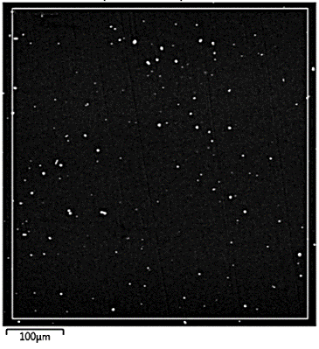
Figure 1. Microstructure of the Mg-3%Mn alloy.

For the preparation of the Mg-Ca alloy, high-purity magnesium (Mg95) and metallic calcium in kerosene were used. The melting was carried out in an induction furnace using a steel crucible. The materials were cleaned to remove contaminants, and the charge was loaded into the crucible at a temperature of 150 ºC. After melting the magnesium at 720–730 ºC, calcium was added in two stages, with the temperature decreasing to 705–715 ºC. The melt was stirred with a graphite stirrer every 10 minutes, and slag was removed before pouring. The pouring was done at a temperature of 700–710 ºC into a graphite mold. Figure 2 shows the microstructure of the obtained Mg-17%Ca alloy. The microstructure of the Mg-17%Ca alloy showed a magnesium matrix with magnesium-calcium compounds (Mg₂Ca).

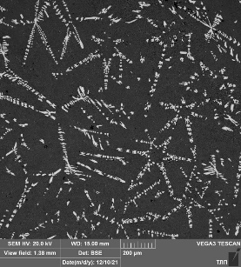
Figure 2. Microstructure of the Mg-17%Ca alloy.

The melting under fluxes was carried out in a high-frequency induction furnace using a 2 kg capacity steel crucible. The flux used was carnallite (KCl∙MgCl₂). When the furnace was heated to 150 ºC, the charging materials were placed on the side to prevent rapid heating. Primary magnesium and Mg-3%Mn alloy were loaded into the crucible. The amount of flux used was 0.5–1.0% of the charge weight. At a temperature of 720 ºC, Mg-17%Ca alloy was added, followed by pure zinc at the same temperature. After adding zinc, the melt was held for 5–10 minutes. Before pouring, the slag was removed from the surface of the melt using a steel stirrer, and the melt itself was stirred gently. Pouring was done without holding time into a pre-cleaned graphite mold at a melt temperature of 710–720 ºC.
All flux-free melting experiments were carried out in a resistance furnace. Various melting crucibles were used: steel (without coating and with boron nitride), graphite (without coating and with boron nitride), and magnesite crucibles. All charge materials were carefully cleaned with a metal brush before melting to remove oxide films, coolant residues, and other contaminants.
In an inert atmosphere formed from a mix of argon and 0.5% SF6, the melts were processed. The argon-SF6 mix was made by manual preparation and used as the flowing gas medium for rotameter flow rate control with a gas flow rate of 5 liters per hour. In order to remove nonmetallic inclusions the argon flow was increased to 10 liters per hour and the melt was blown for two minutes at a temperature between 710 – 730°C with a chromel-alumel thermocouple being utilized to monitor the temperature of the melt.
After cleaning, the crucible was charged with a magnesium mixture. The protective environment was provided via a copper tube that had been bent into a curve. A lid closed the furnace, and when the magnesium (which melts at approximately 710-730°C) began to melt, the two alloys Mg–3%Mn and Mg–17%Ca were poured in one after the other, followed by the addition of zinc. Once this melt had solidified sufficiently to be mixed without melting, it was then agitated (stirred) by inserting a graphite rod into the melt and moving it in circles. Argon was bubbled into the melt from an insertable steel tube that was moved in circles through the melt while it was being agitated.
The melting process was carried out under different conditions to determine the influence of technological parameters on the corrosion resistance and mechanical properties of the samples:
1. Melting in a steel crucible with a covering-refining flux.
2. Melting in a steel crucible under gas with argon purging.
3. Melting in a steel crucible coated with boron nitride under gas with argon purging.
4. Melting in a graphite crucible under gas with argon purging.
5. Melting in a graphite crucible coated with boron nitride under gas with argon purging.
6. Melting in a magnesite (periclase) crucible under gas with argon purging.
Before pouring, the slag formed on the surface of the melt was removed using a steel skimmer, and the melt was mixed with smooth movements of a stirrer. The pouring was done into a pre-cleaned graphite mold at a melt temperature of 710–730 °C.
The chemical composition of the alloys was determined using EDS (Energy Dispersive X-ray Spectroscopy, Oxford) analysis on the prepared surface of the specimen with an area of 1 mm². The specimens were initially polished with sandpaper of various grits, followed by final polishing with diamond paste. For each sample, analysis was performed in three zones, and the average chemical composition was calculated.
Tensile tests were conducted on a universal testing machine INSTRON 5569 at a deformation rate of 1 mm/min at room temperature. The alloy Mg – 2 % Zn – 0.5 % Ca – 1 % Mn was tested in both the initial and deformed states using cylindrical specimens with a working diameter of 5 mm and a working length of 30 mm (type IV) in accordance with GOST 1497-84. The drawing of the specimen for the mechanical test is shown in Figure 3.

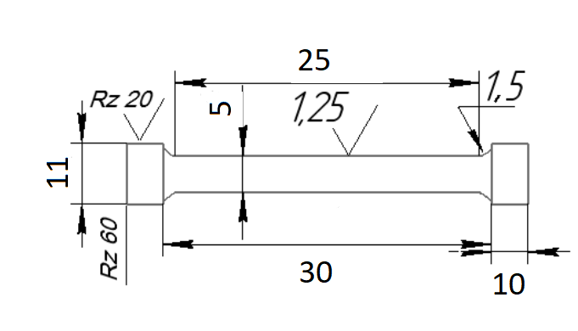
Figure 3. Cylindrical specimen used for tensile testing.

Results and discussion
The study aimed to develop an optimal melting process for a magnesium alloy in the Mg-Zn-Ca-Mn system to obtain a material with high corrosion and mechanical properties. For this purpose, the following melting methods were considered:
1. Melting in a steel crucible with the use of covering-refining flux. The use of carnallite flux (KCl∙MgCl₂) helps to isolate the melt from contact with air and facilitates the removal of oxides and nitrides from the alloy. However, for biodegradable magnesium alloys, the use of fluxes can lead to uncontrolled flux corrosion, which reduces the quality of the final material.
2. Melting in a steel crucible that has been purged with an argon-protective atmosphere (the mixture of 0.5% SF6 and 99.5% Ar). In this method, a protective atmosphere is created. The protective atmosphere created by the argon creates a barrier to prevent the melt from oxidizing. Purging the melt with argon will remove non-metallic inclusions (dissolved gases) that were present in the metal prior to being melted. SF6 provides additional protection by virtue of its chemical inertness, thereby providing a higher degree of purity and homogeneity to the alloy.
3. Melting in a boron nitride (BN)-coated steel crucible under the influence of an inert gas. A BN-coated steel crucible will reduce the degree of adhesion between the melt and the crucible and the degree of chemical reaction between them. BN is very thermally stable and chemically inert; therefore, the chemical composition of the alloy will be maintained.
4. Melting in a graphite crucible under the influence of an inert gas with argon purging. Graphite crucibles have good thermal stability and are generally considered to be reactive; however, when graphite comes into contact with the melt, the chemical composition of the alloy may be altered. Therefore, analysis of the melt should be done as soon as possible after solidification to determine if any changes have occurred. The presence of the protective atmosphere will prevent the melt from oxidizing and favor the elimination of non-metallic inclusions.
5. Melting in a boron nitride (BN)-coated graphite crucible under the influence of an inert gas. The BN-coating on the graphite crucible will minimize contact between the melt and the crucible material, thereby minimizing contamination of the melt and maintaining the purity of the alloy.
6. Melting in a magnesium oxide (magnesite or periclase) crucible under the influence of an inert gas. Magnesium oxide crucibles create an environment that is chemically inert to the melt. This method provides the best means of protecting the melt from foreign elements and maintains the highest level of purity and homogeneity of the alloy.
This study was conducted to find the most suitable melting process for the Mg-Zn-Ca-Mn alloy to produce the desired corrosion and mechanical properties. Factors such as alloy purity, adhesion to the crucible, temperature stability, and atmosphere were considered. Table 2 shows that the melting conditions do not affect the chemical composition of the alloy. Figure 4 presents the microstructure of the alloys after flux and flux-free melting, which shows no significant difference. Figure 5 demonstrates the presence of a magnesium solid solution, an eutectic phase rich in magnesium, calcium, and zinc, as well as compact inclusions of a high-manganese phase. Thus, the composition, structure, and phase composition of the Mg-2% Zn-0.5% Ca-1% Mn alloy remain unchanged under different melting methods.
TABLE 2. Content of elements in the prepared alloys.

Modes | Content, mass %
Modes | Mg | Zn | Ca | Mn
1 | 96.45 | 2.24 | 0.32 | 0.99
2 | 96.08 | 2.37 | 0.67 | 0.88
3 | 96.07 | 2.27 | 0.66 | 1.00
4 | 96.14 | 2.34 | 0.68 | 0.84
5 | 95.88 | 2.32 | 0.64 | 1.16
6 | 96.06 | 2.25 | 0.73 | 0.86
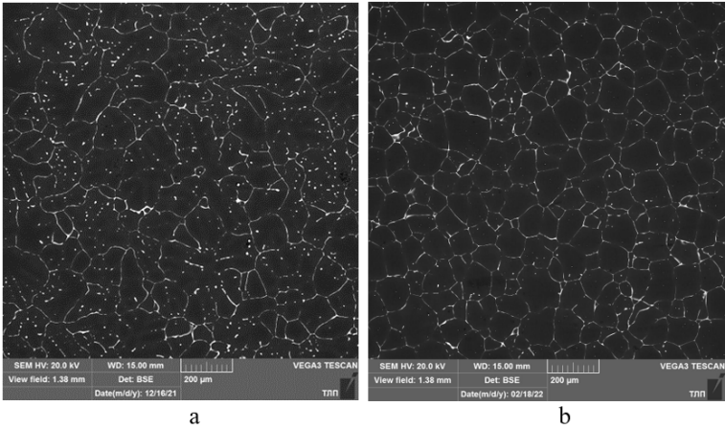
Figure 4. Microstructure of the alloy Mg – 2% Zn – 0.5% Ca – 1% Mn in flux (a) and flux-free (b) melting.

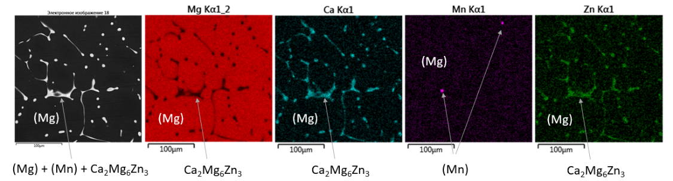
Figure 5. Microstructure of the head part of the pick RSH 35-95L95/22BM after quenching in different media.

The results of mechanical tests and the influence of melting conditions on the properties of the alloy Mg-2% Zn-0.5% Ca-1% Mn are presented in Table 3. The tensile strength and elongation at fracture are lower for fluxless melting compared to flux-assisted melting due to the less effective removal of non-metallic inclusions from the melt. Analysis showed that the content of non-metallic inclusions in the samples exceeded the permissible level (0.005%), which reduced the alloy's plasticity. It was also found that large MgO inclusions were present in the Mg-3% Mn alloy used during air melting, with a volume fraction of about 10%.
TABLE 3. Content of elements in the prepared alloys.

Melting conditions | Yield strength σ₀₂, MPa | Tensile strength σ_{v}, MPa | Elongation δ, % | Volumetric fraction of oxide films, %
Mg-3Mn аlloy | – | – | – | 10.00
1 | 88.81 | 164.96 | 4.78 | –
2 | 87.31 | 139.60 | 1.07 | 1,50
3 | 98.38 | 120.86 | 1.22 | 1,50
4 | 88.96 | 118.21 | 1.13 | 4,07
5 | 97.09 | 141.13 | 2.55 | 3,70
6 | 90.57 | 128.92 | 1.75 | 5,00
In Figure 6, the fracture surface structure of the sample obtained by flux-free melting is shown. The fracture surface clearly reveals oxide films (MgO), which negatively impact the mechanical properties of the alloy. An analysis of the composition of non-metallic inclusions found on the fracture surface has been conducted.

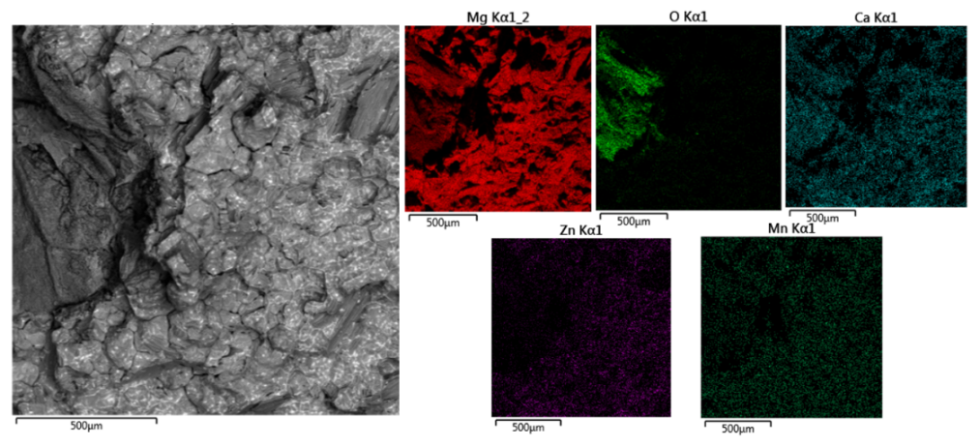
Figure 6. Fracture surface structure of the Mg – 2 % Zn – 0.5 % Ca – 1 % Mn alloy obtained by flux-free melting.

On the fracture surfaces of the flux-free melting samples, shown in Figure 7, oxide films (MgO) are visible, negatively affecting the mechanical properties. The first images show fractures without any films, while subsequent images show their presence. The fracture remains ductile, excluding brittle failure, but the oxide films significantly reduce the mechanical performance.

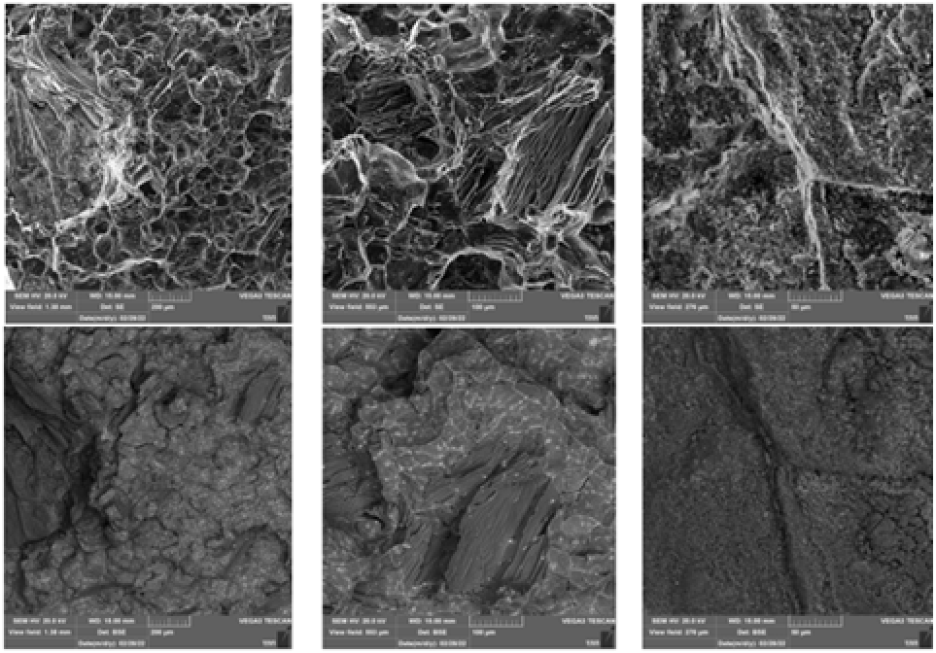
Figure 7. Fractographs of fractures after mechanical testing.

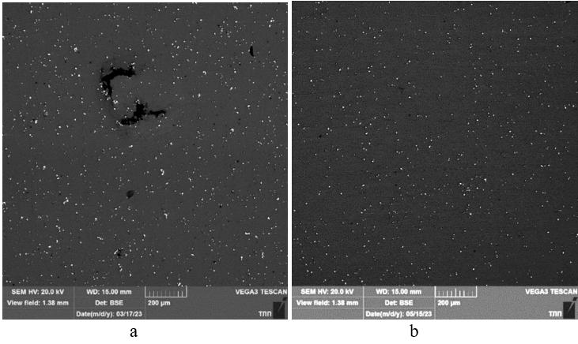
Figure 8. Microstructure of the Mg-Mn alloy: a - when melted in air, b - when melted under argon with purging.

During flux-free melting of the alloy under a protective gas, oxide films do not form, but instead, they enter the melt from the raw materials, which contain non-metallic inclusions. It was established that when melting the Mg-Mn alloy without protective gas, the number of oxide films increases. To obtain a pure alloy of Mg – 2 % Zn – 0,5 % Ca – 1 % Mn, it is necessary to develop a technology for producing the Mg-Mn alloy without non-metallic inclusions.
The Mg-Mn alloy was melted using a new technology in an induction crucible furnace under a protective argon atmosphere with purging. The melting was carried out in a steel crucible (1 kg) with an argon flow rate of 5 L/h, with additional purging before casting (10 L/h, 2 minutes, 790–810 ºC). Figure 8 shows that the alloy produced under the protective gas does not contain large oxide inclusions, which were present in the samples melted in air.

Conclusion
Based on the results of the experiments on the melting of the Mg-Zn-Ca-Mn alloy using various crucibles and protective measures, it was found that the most suitable methods for obtaining high-purity alloy are melting in a graphite or BN-coated steel crucible with the use of a protective atmosphere (Ar+SF₆).
It was found that the main cause of alloy contamination with oxide inclusions is their introduction into the melt from the Mg-Mn alloy.
To obtain an Mg-Mn alloy free from oxide films during its production, the melting process must be carried out as quickly as possible with the mandatory use of a protective atmosphere and refining by argon purging.
The use of the Mg-Mn alloy, obtained by melting in a protective atmosphere and containing a minimal amount of non-metallic inclusions, for the preparation of the Mg-Zn-Ca-Mn alloy, allowed for a twofold increase in the elongation of the alloy compared to the alloy produced using the air-melted Mg-Mn alloy.

References
- Sanchez, A. H. M., Luthringer, B. J., Feyerabend, F., & Willumeit, R. (2014). Mg and Mg alloys: How comparable are in vitro and in vivo corrosion rates? A review. Acta Biomaterialia, 13, 16–31. https://doi.org/10.1016/j.actbio.2014.11.048
- Virtanen, S. (2011). Biodegradable Mg and Mg alloys: Corrosion and biocompatibility. Materials Science and Engineering B, 176(20), 1600–1608. https://doi.org/10.1016/j.mseb.2011.05.028
- Niinomi, M., Nakai, M., & Hieda, J. (2012). Development of new metallic alloys for biomedical applications. Acta Biomaterialia, 8(11), 3888–3903. https://doi.org/10.1016/j.actbio.2012.06.037
- Kannan, M. B., Yamamoto, A., & Khakbaz, H. (2015). Influence of living cells (L929) on the biodegradation of magnesium–calcium alloy. Colloids and Surfaces B: Biointerfaces, 126, 603–606. https://doi.org/10.1016/j.colsurfb.2014.11.028
- Zheng, Y. F., Gu, X. N., & Witte, F. (2014). Biodegradable metals. Materials Science and Engineering: R: Reports, 77, 1–34. https://doi.org/10.1016/j.mser.2014.01.001
- Li, X., Liu, X., & Wu, S. (2016). Design of magnesium alloys with controllable degradation for biomedical implants: From bulk to surface. Acta Biomaterialia, 45, 2–30. https://doi.org/10.1016/j.actbio.2016.09.003
- Atrens, A., Liu, M., & Abidin, N. I. Z. (2011). Corrosion mechanism applicable to biodegradable magnesium implants. Materials Science and Engineering: B, 176(20), 1609–1636. https://doi.org/10.1016/j.mseb.2011.05.053
- Chen, Y., Xu, Z., & Smith, C. (2014). Recent advances on the development of magnesium alloys for biodegradable implants. Acta Biomaterialia, 10(11), 4561–4573. https://doi.org/10.1016/j.actbio.2014.07.005
- Uddin, M. S., Hall, C., & Murphy, P. (2015). Surface treatments for controlling corrosion rate of biodegradable Mg and Mg-based alloy implants. Science and Technology of Advanced Materials, 16(5), 053501. https://doi.org/10.1088/1468-6996/16/5/053501
- Lambotte, A. (1932). L’utilisation du magnesium comme materiel perdu dans l’osteosynthese [The use of magnesium as material for osteosynthesis]. Bulletin Et Memoires De La Societe Des Chirurgiens De Paris, 28, 1325–1334.
- Verbrugge, J. (1934). Le materiel métallique résorbable en chirurgie osseuse [Resorbable metallic material in bone surgery]. La Presse Médicale, 23, 460–465.
- Walker, J., Shadanbaz, S., & Woodfield, T. B. F. (2014). Magnesium biomaterials for orthopedic application: A review from a biological perspective. Journal of Biomedical Materials Research Part B: Applied Biomaterials, 102(6), 1316–1331. https://doi.org/10.1002/jbm.b.33113
- Richards, A. M. (2010). Bone density and cortical thickness in normal, osteopenic, and osteoporotic sacra. Journal of Osteoporosis, 2010, Article 504078. https://doi.org/10.4061/2010/504078
- Avedesian, M. M., & Baker, H. (Eds.). (1999). ASM specialty handbook: Magnesium and magnesium alloys. ASM International.
- Emley, E. F. (1966). Principles of magnesium technology. Pergamon Press.
- Kirkland, N. T. (2011). Synthesis and properties of topologically ordered porous magnesium. Materials Science and Engineering: B, 176(20), 1666–1672. https://doi.org/10.1016/j.mseb.2011.09.018
- Tsantrizos, A. (2000). Segmental stability and compressive strength of posterior lumbar interbody fusion implants. Spine, 25(15), 1899–1907. https://doi.org/10.1097/00007632-200008010-00007
- Rashmir-Raven, A. M. (1995). The response of cancellous and cortical canine bone to hydroxylapatite‐coated and uncoated titanium rods. Journal of Applied Biomaterials, 6(4), 237–242. https://doi.org/10.1002/jab.770060403
- Staiger, M. P. (2006). Magnesium and its alloys as orthopedic biomaterials: A review. Biomaterials, 27(9), 1728–1734. https://doi.org/10.1016/j.biomaterials.2005.10.003
- Kamachi Mudali, U., Sridhar, T. M., & Raj, B. (2003). Corrosion of bio implants. Sadhana, 28(3–4), 601–637. https://doi.org/10.1007/BF02706445
- Puleo, D. A., & Huh, W. W. (1995). Acute toxicity of metal ions in cultures of osteogenic cells derived from bone marrow stromal cells. Journal of Applied Biomaterials, 6(2), 109–116. https://doi.org/10.1002/jab.770060206
- Davis, K. G., Marras, W. S., & Waters, T. R. (1998). Evaluation of spinal loading during lowering and lifting. Clinical Biomechanics, 13(3), 141–152. https://doi.org/10.1016/S0268-0033(97)00070-5
- Seal, C. K., Vince, K., & Hodgson, M. A. (2009). Biodegradable surgical implants based on magnesium alloys–A review of current research. In IOP Conference Series: Materials Science and Engineering (Vol. 4, p. 012011). IOP Publishing. https://doi.org/10.1088/1757-899X/4/1/012011
- Zeng, R. (2008). Progress and challenge for magnesium alloys as biomaterials. Advanced Engineering Materials, 10(8). https://doi.org/10.1002/adem.200800035
- Williams, D. (2006). New interests in magnesium. Medical Device Technology, 17(9), 9–10.
- Prichard, R. W. (1976). Animal models in human medicine. The American Journal of Pathology, 82(3), 982.
- Bakhsheshi-Rad, H. R., Abdul-Kadir, M. R., Idris, M. H., & Farahany, S. (2012). Relationship between the corrosion behavior and the thermal characteristics and microstructure of Mg–0.5Ca–xZn alloys. Corrosion Science, 64, 184–197. https://doi.org/10.1016/j.corsci.2012.07.018
- Zhang, S., Zhang, X., Zhao, C., Li, J., Song, Y., Xie, C., Tao, H., Zhang, Y., He, Y., Jiang, Y., & Bian, Y. (2010). Research on an Mg–Zn alloy as a degradable biomaterial. Acta Biomaterialia, 6(2), 626–640. https://doi.org/10.1016/j.actbio.2009.06.028
- Matfield, M. (2002). Animal experimentation: the continuing debate. Nature Reviews Drug Discovery, 1(2), 149. https://doi.org/10.1038/nrd753
- Aripov, A. R., Vokhidov, B. R., Asrorov, A. A., Sayfullaev, F. I., & Kurbonov, M. N. (2024). Application of sand mold casting modelling for casting pump volute. Journal of Physics Conference Series, 2697(1), 012037. https://doi.org/10.1088/1742-6596/2697/1/012037
- Nurmurodov, T., Saidova, N., Ashurov, O., Rakhimova, G., Fuzaylov, O., & Narzullaev, J. (2023). Investigation of gold content in the bio-oxidation process. In E3S Web of Conferences (Vol. 417, p. 02011). EDP Sciences. https://doi.org/10.1051/e3sconf/202341702011
- Khamidov, R., Narzullayev, Z., & Kuznetsov, E. (2021). Research of the application of roasting in the processing of the foamy product of the process of bacterial oxidation of flotation concentrate in a separate cycle. In E3S Web of Conferences (Vol. 278, p. 01018). EDP Sciences. https://doi.org/10.1051/e3sconf/2021278010183.
- Pirnazarov, F., Umirov, F., & Kurbonov, M. (2025). Production of magnesium chlorides by conversion method by thermal treatment of local saponite mineral. E3S Web of Conferences, 627, 03004. https://doi.org/10.1051/e3sconf/202562703004

