Effect of Mechanical and Corrosional Performance on C6782 Metal Joints Using Tig Welding Process
P. Raja¹, S. Alagueswaran¹, R. Senthilkumar¹, P. Kanagavel¹,
M.Kh. Murodov^{2, a)}, F.F. Sharipov²
¹P.S.R. Engineering College, Sivakasi- 626 140, India
²Namangan State Technical University, Namangan, Uzbekistan

^{a)}Corresponding author: m_murodov@mail.ru
Abstract. The current research studies the corrosion behavior of the similar metal C6782 for boiler pipelines and marine applications. The TIG welding method uses variable voltage, arch radius, and supply of gas for boiler pipelines. The joining of similar methods creates a greater welding bond between similar metals without any slag formation. The main causes of this welding are to avoid chemical reactions and corrosion caused by seawater in a marine propeller. To prove the weld strength by performing a tensile test. The mode of fracture that got through this test was a 91.06 MPa ductile fracture. By varying the voltage, there is a change in weld radius and mechanical properties, which creates a good bonding structure with broad weld beads that makes the weld joint stronger. The greater hardness of 98.3 HV0.5 is also achieved by varying the above parameters, as proved by Micro Vicker’s hardness test. The chemical corrosion composition between those two weld bead joints is done by SEM and EDAX; it can also represent the microstructure changes. Corrosion typical of similar metal joints was studied under H2SO4 conditions. They determined the corrosion rate as 0.034 milligrams per year. Rusting doesn't take place since intermetallic compounds are developed at the weld interface.
Keywords: Weld strength, welding bond, bonding structure, corrosion, and microstructure and tensile strength.
INTRODUCTION
A variety of metals can be joined using the TIG method. Copper, nickel, titanium, magnesium, aluminium, and their alloys can all be welded with it. Out of position welding is feasible by TIG. It is utilized in the aerospace industry, on pipes, and on boats. Because of their great strength, excellent resistance to corrosion, and strong thermal and electrical conductivity, brass materials are frequently employed in engineering applications in industry. They have a pleasing look and are easily formed [1]. Various welding settings were used to generate the joints. The weld interface microstructure and formation was investigated. The quality of bonding in the joints was investigated by comparative tensile tests. Chunbiao Wu et al. [2-3] found that hard facing via the most economical method of extending the life of environmentally exposed parts is welding. Hard face is becoming more and more common for manufacturing worn-out tools and components used in the industry because to the increasing expense of restoring damaged or worn-out components. The specimens are next examined for hardness and wear. Many statistical techniques have been applied, including the t-test, the Durbin Watson Test. Devendranath Ramkumar et al. [4] studied three different fluxes, i.e., SiO₂, NiO, and MoO₃ were used to study the Super-duplex stainless steels (UNS S32750) weldability. Bead-in-court tests 5 were carried out to study the result of the depth of penetration of the welding current and the ratio of depth to breadth (D/W). The tests showed that full penetration was achievable in single pass using activated flux. In all the fusion zones of the weldments, microstructure tests showed the presence of coarser granules of austenite in addition to three different austenite types. Through vacuum electron beam welding (EBW) to characterize corrosion fatigue and microstructure behavior under an artificial habitat with seawater. Obvious microstructural heterogeneity was observed within the transverse (T) direction of a welded joint. The outcomes are in line with the previous results, which suggest that double-layer oxide films (Fe₃O₄ outer layer and (Fe, Cr)₃O₄ inner layer) exist on the surface of all the samples. Liu et al. [5], examined micron-scale Variations in the microstructure of the magnesium alloy joint and their effect on corrosion behaviour and reliability of the joint. The study results [6] indicate that a few of the welding deficiencies and precipitated phases had either a limited effect on the corrosion behaviour of the weld joint in subsequent exposure in the saline environment, or some combination of welding defects, precipitated phases and refinement of the grain structure had an impact. Qing-wei et al. [7] study found that the requirement for lightweight equipment made thick plate aluminum alloy of different specifications the optimum choice for structural materials. Narrow gap welding was an effective way to improve the welding efficiency. There were many welded structural parts in engineering machinery products, whose quality directly determined the quality, performance and reliability of the whole machine. The goal of the current study is to investigate the 200 series austenitic stainless steel as a 300-series austenitic stainless steel substitute. Shi et al. [8], this study involved welding 10.8-mm-thick duplex stainless steel (S32101) workpieces using an orifice deep penetration (DP-TIG) welding method. The distribution of misorientation angles of boundary limits within the heat-affected zone (HAZ) was analysed using electron backscatter diffraction (EBSD). Scientists [9-10] utilized the electron backscatter diffraction (EBSD) method to examine and calibrate the chromium nitride precipitation in the weld metal (WM) and the grain boundaries of the coincidence site lattice (CSL). The mechanical characteristics are influenced by the microstructure and precipitation of chromium nitride, as demonstrated by the EBSD analysis and experimental findings. Tushar sonar et al. [11], established that the alloy Inconel 718 (IN-718) is based on nickel, primarily used in aerospace engines due to its mechanical characteristics, including high resistance to corrosion. IN-718 was welded by IP-TIG joints assessed and demonstrated 99.20%base metal and commendable corrosion resistance under optimized welding settings. The emphasis of the present investigation was to optimize the value of the input parameters utilizing the TIG welding method. The material used for the experiment was 316 stainless steel. A Taguchi-based experiment was used to arrange experiments. The results posted by testing on stick welding of brass show that the temperature necessary for welding is produced by the welding arc that connects the welding rod and the work piece. The investigation of corrosion behavior of brass welding was joined by the TIG welding method using different voltages and feed rate of gas. The joining materials like brass, and it has prospective applications in pipelines, gears, valves, bullets. Phosphorous bronze is used as a filament material for TIG welding joints [12]. Varying of voltage and feed rate of gas generates different changes in chemical composition, mechanical properties and microstructural behavior in the weld bead composition between the similar metals. The corrosion behavior of weldments is also investigated by the salt spray method to show the variation of previous welding methods of brass.
MATERIALS AND METHODS
An arc is formed in the TIG welding operation between the workpiece and a tapered tungsten electrode while in the inactive presence of argon or helium atmosphere. The pointed electrode produces a small, concentrated arc, which is great for welding finely and accurately as no heat input needs balancing from the arc because the electrode is not consumed and the deposit of metal comes from the molten electrode. When the need for filler metal arises, more filler metal must be incorporated into the weld bead.
The experiments carried out with a square section of 100*100*10 in brass were used for the TIG welding process. Two surfaces of both cross-sections were welded together by varying process parameters like varying voltage and feed rate of gas. The phosphorous bronze (Pp.) is used as a flux material because the brass is only welded with copper alloy filaments before that, ensuring grade selection on brass is a must.
An alloy is brass. Composed of zinc and copper, with proportions that can be adjusted to attain diverse chemical, mechanical, and electrical properties. This alloy is a substitution one. Atoms from the two components may switch positions inside the same crystal structure. Nearly 90% of alloys made of brass are recycled. By putting the scrap near a strong magnet, brass scrap may be distinguished from ferrous scrap since it is not ferromagnetic. After being gathered, brass scrap is shipped to the foundry to be melted. Because of its general softness, brass is frequently machineable without the need for cutting fluid. It has high conductivity and durability and excellent corrosion resistance properties. The mechanical properties and chemical makeup of Brass C6782 are shown in Table 1 and 2, in that order.
Pb is a very good resistance to corrosion and fatigue. It is a mixture of copper with (0.5 %to 11%) tin and (0.01 %to 0.35%) phosphorous. It has high fatigue resistance and formability. It has a high melting point compared to brass.

TABLE 1. Chemical Composition of Brass C6782

Elements | % of metals
Copper (Cu) | 60.5
Aluminium(Al) | 2.0
Manganese(Mn) | 2.5
Iron(Fe) | 1.0
Phosphorous(Ph) | 0.50
Zinc (Zn) | Reminder

TABLE 2. Mechanical Property of Brass (C6782)

Property | Value
Elastic modulus | 1011 N/m²
Poisson ratio | 0.33
Tensile strength | 478413000 N/m²
Yield strength | 239689000 N/m²
Thermal expansion | 1.8*10-5 K⁻¹
Thermal conductivity | 110 J/(Kg.K)
Mass density | 8500 Kg/m³

The chemical element argon possesses the atomic number eighteen and is represented by the symbol Ar. It is a noble gas located in group 18 of the periodic table. Argon constitutes 0.934% of the atmosphere of Earth, rendering it the third most prevalent gas present in the atmosphere. Argon is mostly utilized in welding as an inert shielding gas and many industrial operations involving high temperatures where typically unreactive materials may exhibit reactivity.
In arc welding procedures, helium is employed as a shielding gas on materials that have been compromised and polluted by nitrogen or air at welding temperatures. Gas tungsten arc welding uses a variety of inert shielding gases; however, helium is utilized rather than the less expensive argon, particularly when welding materials with a higher heat conductivity, such as copper or aluminum.
It is a test conducted to assess the hardness of materials, particularly thin sections and small parts. In this machine, a light load and diamond indenter are used to create an indentation on the specimen. The hardness value of the object is determined based on the depth of the indentation. The Micro Vickers hardness testing machine indicates the smaller the indentation, the harder the object is, while a large impression indicates a lack of toughness in the object.
The standard ASTM E384 of tensile testing machine is used for the testing process, which provides information about the deformation strength of the material and distorts its shape. It determines the force required to break a composite or plastic-containing sample, and the degree of deformation of the sample before destruction. Deformation testing of composite materials often includes methods of principal stress or flat sandwich stress when testing samples in accordance with the ASTM E8 standard.
Laboratory corrosion testing includes operations performed to identify and mitigate corrosion-related problems. Usually, such practices are used in fault analysis and can be applied in the manufacture of industrial products and materials. During the decomposition of waste forms, the release of waste from the components into the solution is checked by corrosion tests.
SEM - scanning electron microscope - is a special electron microscope designed for direct examination of solid surfaces. It uses a concentrated beam of relatively low-energy electrons with the help of an electron probe that regularly scans the object. This configuration uses an electron source and electromagnetic lenses similar to those used in the Transmission Electron Microscope (i.e., TEM) to create and focus the beam. Scanning electron microscopes (SEM) use electrons reflected or emitted near the surface of a sample to create an image. The measurement accuracy of SEM is higher than that of a light microscope, since electrons have much shorter wavelengths than light.
The EDAX method (Energy Dispersion X-ray spectroscopy) is a method used for the study and chemical characterization of sample materials. EDAX systems are usually combined with the instruments of electron microscopy, such as transmission electron microscopy or scanning electron microscopy instruments. The EDX method is based on the emission of specific X-rays from a sample under the influence of energy. EDAX testing provides a spectrum with peaks reflecting the elemental composition of the analyzed material. X-rays are generated when a SEM electron beam hits the sample, resulting in electrons being emitted from the surface atoms of the material.
RESULTS AND DISCUSSION
Tungsten Inert Gas (TIG) welding, commonly arc welding, is referred to as Gas Tungsten Arc Welding (GTAW), a method that employs a tungsten electrode that is not consumable to produce the weld. Aluminum is now widely used in structural applications and high-quality welding thanks in large part to TIG. An arc is created during the TIG welding process between the work piece and a tapered tungsten electrode in an atmosphere of inert helium or argon. In direct current (DC) systems, the electrode maintains a negative polarity to avert melting and overheating, as the arc heat is allocated roughly two thirds at the anode (positive) and one third at the cathode (negative). The benefit of employing the DC electrode positive polarity connection as an alternative power source is its ability to cleanse the workpiece's surface of oxide impurities when the cathode is applied. Consequently, when welding materials such as aluminium that possess a persistent surface oxide layer, selecting the proper tip angle and electrode diameter relative to the welding current is essential. The tip angle and electrode diameter diminish as the current decreases. ZrC-doped tungsten is employed to reduce electrode erosion in AC welding due to the significantly elevated operating temperatures of the electrode. Be aware that the electrode's pointed tip becomes challenging to preserve due to the substantial heat produced, resulting in a spherical or 'ball' profile at its end. The choice of shielding gas is contingent upon the material undergoing welding. Argon, the most commonly utilized shielding gas, is appropriate for welding several materials, including titanium, steel, stainless steel, and aluminium. Argon with 2 to 5% hydrogen: The incorporation of hydrogen into argon renders the gas mildly reducing, facilitating the creation of cleaner welds devoid of oxidation of the surface. The arc facilitates expedited welding due to its elevated temperature and increased confinement. Porosity in weld metal of aluminum alloys and the potential for hydrogen-induced cracking in carbon steels are disadvantages. Helium and argon/helium amalgamations: Incorporating helium into argon will elevate the arc's temperature. This promotes greater weld penetration and increased welding speeds. The welder's influence on the arc and weld pool dynamics is constrained; therefore, joint fit-up, welding parameter regulation, and edge preparation—preferably executed using machining rather than manual methods—must be conducted with meticulous attention. The workpieces are welded by adjusting the process parameters according to Table 3.

TABLE 3. Process parameters of TIG welding

Sample No | Current volts (V) | Feet rate (Cuft/hr)
1 | 200 | 34
2 | 175 | 32
3 | 180 | 30
4 | 160 | 26
5 | 140 | 24

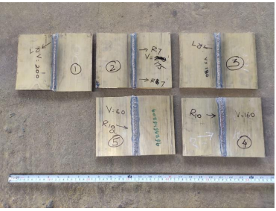
FIGURE 1. Welded specimens.

Zinc evaporation during the welding process is the primary issue with these alloys in fusion welding. The weld metal shows porosity after welding. Furthermore, the zinc content in the alloy diminishes because of evaporation. So the welding of brass using Fusion welding causes a lower deposition rate and lower tensile strength of the weld bead. Compared to the above graph, we conducted a hardness test on a Brass (C6782) weld bead of two samples (1, 2) on MicroVicker’s hardness testing machine. The hardness value varies between three samples as shown in Fig 2 shown below. Because the feed rate of gas (argon gas) and voltage value change during welding. Voltage has a direct impact on heat input.

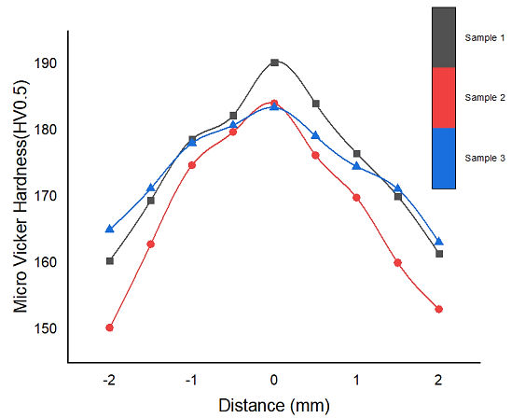
FIGURE 2. Micro hardness evaluation.

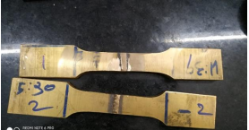
FIGURE 3. ASTM E8 Standard tensile tests specimen

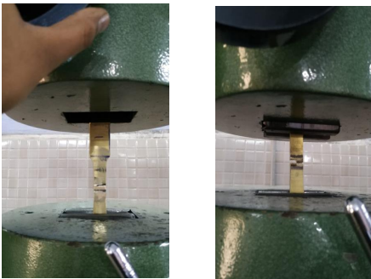
FIGURE 4. Specimen after and before tensile test

A wider bead is deposited, and the arc is fanned out by higher voltage. Undercut can result from excessive voltage, as this weld illustrates. The weld bead will flatten out more and have a wider-to-deeper ratio as the voltage is raised. So, the hardness value of sample 1(210V) –feed rate of shielding gas (15 cu ft/h) weld bead hardness, is higher than sample 2(220V) — feed rate of gas (20 cu ft/h) weld bead, because the lower voltage supply of weld creates a higher weld deposition rate, and it shows effect of greater hardness in weld bead.

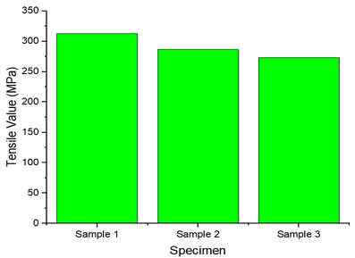
FIGURE 5. Tensile test graphical value

The investigation of tensile strength on TIG welded interface of brass C (6782) using UTM from Fig 4. The testing of samples that generated the graphical results shows the highest yield strength of 338 Mpa. The other sample resulting graph deploys the maximum yield strength of 325 Mpa. Fig 5. The elongation at break rose, but plasticity reduced after welding the fracture surface, which exhibited tear ridges and numerous small dimples, indicative of ductile fracture. It can be inferred that in this fractured zone, characterised by coarse grains, the plasticity was inadequate. This is consistent with the results of the tensile and metallographic tests. The tensile TIG welding strength C6872 was inferior to that of SS304 welded joints. The coarse grain formation in the heat-affected zone resulted in decreased flexibility for the TIG welded C6872.

.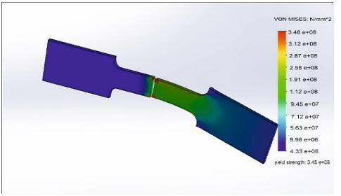
FIGURE 6. Numerical analysis

Consequently, the strain hardening cannot manifest in its entirety. The strength of the tensile TIG welded C6872 is lower than that of the original C6872.
The numerical analysis on investigation of tensile strength on the weld interface of brass (C6782) states that the ultimate value of 338 Mpa from Fig 6 is shown. The results from the preceding study revealed that the best parameters for the elongation and strength the parameters axial force and tool rotational speed, respectively, of the joints. The parameters were optimised, resulting in a maximum strength of 318.5 MPa and an elongation of 54.9% at a rotating 1000 rpm speed 58.4 mm/min traverse speed and axial force of 3kN.
Compared to the above citation, we achieved a better yield strength of 338 MPa by using TIG welding. Because the weld deposition rate is higher in those combined interfaces. The cause of achieving a better yield strength is by varying parameters like voltage and feed rate of gas. The arc length is known as the distance from the melting point in the arc to the molten weld pool of filler wire metal, and is mainly controlled by the welding voltage. The weld bead would tend to flatten out more and have a bigger width to depth ratio with increased voltage. A higher flow gas gives greater protection. In fact, too excessive gas flow produces turbulence concentrically, creating swirling currents that will draw in unwanted airborne contaminants, and it will cause an arc to wander. The results demonstrate that increased argon gas flow rates make the coating more porous and contaminated at the welds by introducing unwanted connections because of increased turbulence. We achieved the better yield strength at 15 cu ft/ hr. Since the welded brass metal composition has an equal deposition rate, our welded interface has attained a better yield strength than the above citation.
An investigation of corrosion behavior on the wielding interface of brass (C6782) is studied and review those similar brasses were welded together using TIG welding. Brass is an alloy of copper that is composed primarily of copper and zinc. It is welded similar to brass but due to the unique properties of the alloying metal, zinc, it requires a slight difference in welding. And due to variety, this study examines the general corrosion behavior of α-brass (C6782) alloy, for its application as structural materials in various industries. The microstructure of six weldments in sulfuric acid was examined before and after corrosion.

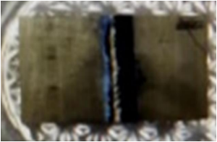
FIGURE 7. Corrosion tested welded sample

TABLE 4. Corrosion Analysis

Duration | Observation on weld zone | Observation on parent metal
0 Hrs. | No rust | No rust
2 Hrs. | No rust | No rust
4 Hrs. | No rust | No rust
6 Hrs. | No rust | No rust
8 Hrs. | No rust | No rust
24 Hrs | Some Pitts observed | Some Pitts observed

The samples that were immersed in the (concentrated H2SO4) as an acidic media, the corrosion did not take place in the weld beads weld interface and minimal corrosion occurred in Cu-30 Zn (brass) weldments. The probable cause is that the welded interface of brass contains the highest zinc concentration (40%), and zinc is prone to oxidation due to its electrode potential. In comparison, the electrode potential of the alloy {Cu-39 Zn-1 Sn} is lower because of its zinc (39%) and tin (1%) content. Additionally, the electrode potential of phosphorous bronze (0.15 Volt) indicates that this weldment was significantly more active. The minimal corrosion observed in the (Cu - 30 Zn) weldment can be attributed to its 30% zinc content. As shown in Table 4. The effect of this corrosion occurred by sulfuric acid was a 0.034 miles per year reduction rate in the welded sample. There is no higher corrosion rate because of the maximum deployment of zinc, tin, and CU. That metal composition is actively high in corrosion resistant behavior.

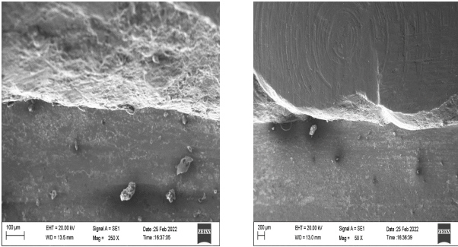
a) b)
FIGURE 8. The Heat Affected Zone's microstructure (HAZ) using a brass interlayer with different process parameters a) 100µ; b) 200µ

The Heat Affected Zone's microstructure (HAZ) using a brass interlayer with different process parameters presented in Fig 5.7 was examined. It was seen that the brass particles dispersed in HAZ in a like manner. The little pieces of brass seen on the left side (LS) and large ones on the right side (RS). This is because more heat is produced in LS compared to RS during welding. The SEM analysis with an electron voltage of 20KV and magnifications of 250x and 10mm wide has been completed, and it was noticed that there was high zinc evaporation at the weld zone and medium evaporation at HAZ (1 and 2). The heat built up in LS is more than in RS is due to having the material flow and deformation initiated from LS causing more heat to be produced from the fast material flow associated with plastic deformation. In addition, with the fluctuations in the voltage and gas flow rates, the zinc (Zn) has dissolved as a result of the high diffusion rate of aluminum in Zn. Both zinc and the brass interlayer showed amalgamation, forming a stable metallurgical bond along the front line between the LS and RS of brass; having accommodated gas feed and voltage fluctuations created a similar stable bond at HAZ.

TABLE 5. EDAX Analysis

Element | Weight % | Atomic % | Error%
C | 22 | 51.7 | 11
Zn | 40 | 17 | 3.3
Cu | 30 | 8.9 | 4.4

FIGURE 9. Graphical Analysis of EDAX

The base material is TIG welded brass, C6872, whose dimensions are 10 mm, 10 mm and 5 mm for the length, thickness and width. The mechanical characteristics and chemical makeup are displayed in Fig 9. It is noted, that fine brass layers have been seen as a dark copper-colored material, while Zinc (Zn) is no longer present by the high rate of zinc diffusion in Brass, and comprise like, a Zncl and Cula solid solution. However, the same fine layers have been documented from the specified parameters in Table 5. It was also noted that Zn and brass intermixed layers provided robust metallurgical bonding at the intersection of the Zn and brass because of the stirring motion on the instrument. It shows the pertinent radiographs of the specimens welded using activated TIG welding. We are able to conjecture that A-TIG welding is capable of producing high-quality defect-free welds and may have applications in industry. Increases in large allocations of the metallic phase leads to reductions of mechanical properties, especially the plasticity of alloys. They affect the hard and brittle allocation properties especially badly. For each tool rotation speed selected, the WNZ showed similar metallurgical bonds from Table It was noticed that copper, zinc, silicon, molybdenum, and aluminium were present.
CONCLUSION
The tensile and hardness tests showed the mechanical properties offered good strength parameters, whether the tensile load was significant and where it ranked in the hardness tests. Potential microstructural variations and differences within the welding environments may contribute to the corrosion behaviour of the brass (C6872) butt joint. The microstructure speaks to the heat-affected zone as having inclusions that have an influence on tensile strength and the grain refinements would be reduced slightly because of high energy density at a normal pace of cooling. In TIG, the process of welding is foremost in providing the weld joint's resistance to corrosion. The microstructural variations for the A316-316L butt joints were dissimilar to the varied C6872 alloys or similar stainless steel alloys, and was better for corrosion resistance in that welded region. A corrosion test is performed in a welded region for the salt spray (8 hours) alkaline etches in an H2SO4 environment. What shows good corrosion resistance through and with respect to H2SO4 solutions? After performing extensive corrosion testing on phosphorus bronze - TIG welded joints, the observations from the results were that exposed areas to acid were greatly increased because of exposed depths beneath the surface. SEM images support the claimed reed arrangements. We observed that samples exhibit varying degrees of sensitization and differences in grain size.
REFERENCES
- Pr, Surya & Manoharan, Manikandan. (2018). ScienceDirect Studies on hot corrosion behaviour of A-TIG welded AISI 316 weldments.
- Lu, Z., Xu, J., Yu, L., Zhang, H., & Jiang, Y. (2022). Studies on softening behavior and mechanism of heat-affected zone of spray formed 7055 aluminum alloy under TIG welding. Journal of Materials Research and Technology, 18, 1180–1190. https://doi.org/10.1016/j.jmrt.2022.03.074
- Lu, Z., Yu, L., Xu, J., Du, C., & Zhang, H. (2022). Influence of secondary thermal cycle on softening behavior and mechanism of heat affected zone in TIG-welded spray formed 7055 aluminum alloy. Journal of Materials Research and Technology, 21, 2118–2132. https://doi.org/10.1016/j.jmrt.2022.10.062
- Ramkumar, K. D., Dev, S., Saxena, V., Choudhary, A., Arivazhagan, N., & Narayanan, S. (2015). Effect of flux addition on the microstructure and tensile strength of dissimilar weldments involving Inconel 718 and AISI 416. Materials & Design, 87, 663–674. https://doi.org/10.1016/j.matdes.2015.08.075
- Liu, L., & Xu, R. (2010). Investigation of the corrosion behaviour of laser-TIG hybrid welded Mg alloys. Corrosion Science, 52(9), 3078–3085. https://doi.org/10.1016/j.corsci.2010.05.030
- Ramkumar, K. D., Goutham, P. S., Radhakrishna, V. S., Tiwari, A., & Anirudh, S. (2016). Studies on the structure–property relationships and corrosion behaviour of the activated flux TIG welding of UNS S32750. Journal of Manufacturing Processes, 23, 231–241. https://doi.org/10.1016/j.jmapro.2016.05.006
- Gao, Q., Shu, F., He, P., & Du, W. (2019). Microstructure and impact mechanical properties of multi-layer and multi-pass TIG welded joints of Al−Zn−Mg alloy plates. Transactions of Nonferrous Metals Society of China, 29(12), 2496–2505. https://doi.org/10.1016/s1003-6326(19)65157-5
- Shi, Y., Cui, S., Zhu, T., Gu, S., & Shen, X. (2018). Microstructure and intergranular corrosion behavior of HAZ in DP-TIG welded DSS joints. Journal of Materials Processing Technology, 256, 254–261. https://doi.org/10.1016/j.jmatprotec.2018.02.019
- Bansod, A. V., Patil, A. P., Verma, J., & Shukla, S. (2018). Microstructure, Mechanical and Electrochemical Evaluation of Dissimilar low Ni SS and 304 SS using Different Filler Materials. Materials Research, 22(1). https://doi.org/10.1590/1980-5373-mr-2017-0203
- Yang, X., Li, W., Li, H., Yao, S., Sun, Y., Sun, Y., & Mei, L. (2018). Microstructures and microhardness for sheets and TIG welded joints of TA15 alloy using friction stir spot processing. Transactions of Nonferrous Metals Society of China, 28(1), 55–65. https://doi.org/10.1016/s1003-6326(18)64638-2
- Sonar, T., Balasubramanian, V., Malarvizhi, S., Venkateswaran, T., & Sivakumar, D. (2021). Maximizing strength and corrosion resistance of InterPulsed TIG welded Superalloy 718 joints by RSM for aerospace applications. CIRP Journal of Manufacturing Science and Technology, 35, 474–493. https://doi.org/10.1016/j.cirpj.2021.07.013
- Matos, I. C., Bastos, I. N., Diniz, M. G., & De Miranda, M. S. (2015). Corrosion in artificial saliva of a Ni-Cr-based dental alloy joined by TIG welding and conventional brazing. Journal of Prosthetic Dentistry, 114(2), 278–285. https://doi.org/10.1016/j.prosdent.2015.01.017

