Analysis of the Effective Model of the Pyrolysis Boiler Plant Separator
Alisher Alinazarov, Sherali Jurayev^{a)}, Ilhom Kosimov, Bahodir Dedaxanov, Shukrullo Xakimov
Namangan State Technical University, Namangan, Uzbekistan

^{a)}Corresponding author: jorayev1981@gmail.com
Abstract. A pyrolysis boiler, also known as a long-burning boiler, operates by burning fuel with a low flame. Initially, the wood begins to burn as it would in a conventional boiler. However, when the temperature reaches 800°C, the oxygen supply to the combustion chamber decreases, triggering the fuel pyrolysis process. During pyrolysis, gas is released and enters the combustion chamber through a special pipe. The gas release process is exothermic, resulting in heat generation. A device that enables gas production through the pyrolysis of wood fuel is called a gas-generating boiler. Its distinctive feature is characterized by the process that occurs due to the interaction between volatile gases and their combustion products. This interaction significantly reduces the emission of heavy substances into the atmosphere. This article provides information on research conducted on a new model of a pyrolysis boiler unit.
Keywords: fuel, firewood, pyrolysis boiler, combustion chamber, gas, heat.
INTRODUCTION
A pyrolysis boiler is one of the types of solid fuel boilers. The fuel used in the boiler house is inexpensive wood and coal. It can be observed that the special organization of the combustion process in these boilers offers several important advantages over traditional solid fuel boilers.
The relevance of efficient use of pyrolysis boilers is associated with the rapid increase in energy prices (oil, gas, and electricity), as well as the rapid growth in the construction of houses and cottages located far from gas pipelines and not fully supplied with natural gas.
A pyrolysis boiler heating system is a suitable solution for rural houses, summer houses, bathhouses, and is beneficial for woodworking enterprises and industrial buildings with large amounts of wood waste. In some cases, not only firewood but also industrial waste can be used as fuel for the boiler[1].
The main challenge with this boiler is the ratio of air flow and the selection of pyrolysis gases after combustion. When this ratio is optimally chosen, minimal pyrolysis gases and oxygen remain in the boiler's chimney, and power output reaches its maximum. In modern pyrolysis boilers, this problem is solved by installing expensive gas sensors in the chimney [2-3].
To reduce the cost of the system, such an expensive solution can be avoided, and with the help of inexpensive temperature sensors, the value of the power generated by the boiler can be effectively utilized. It is also possible to develop an algorithm for finding and controlling the most energy-efficient points of the pyrolysis boiler by adjusting the ratio of air flows at the equilibrium point and monitoring the power output.
The solution proposed in this article has practical significance, as it simplifies the pyrolysis boiler control system and thereby significantly reduces their cost, which creates more convenient opportunities for the population as a whole [4-7].
The obtained results can be implemented in the field of heating systems and hot water supply. It is proposed to eliminate the gas flow in the boiler's return flue and replace it with a temperature flow.
METHODS
The control system of the pyrolysis combustion boiler was selected as the object of the research. The subject of research, in turn, defines the boundaries of the research object. The research subject consists of the combustion control algorithm in a gas generator boiler without a gas sensor in the reverse flue. The research objectives include familiarizing with the operating principle of the pyrolysis boiler, developing a suitable model of the boiler, observing temperature transition processes, developing an operating algorithm, and reviewing and reducing the system cost. This article employs scientific research methods such as analysis, generalization, modeling, progression from abstract to concrete, and description.
Analysis is applied in processing the obtained modeling results. Generalization is used to study the operating principle of pyrolysis boilers, to determine the boiler's characteristics, its advantages, and disadvantages. The dynamics of the pyrolysis boiler operation are modeled based on differential equations. Currently, numerous gas generator boilers of various designs are being manufactured, but the operating mechanism of these boilers is utilized in the same manner. Various designs are illustrated in Figure 1.

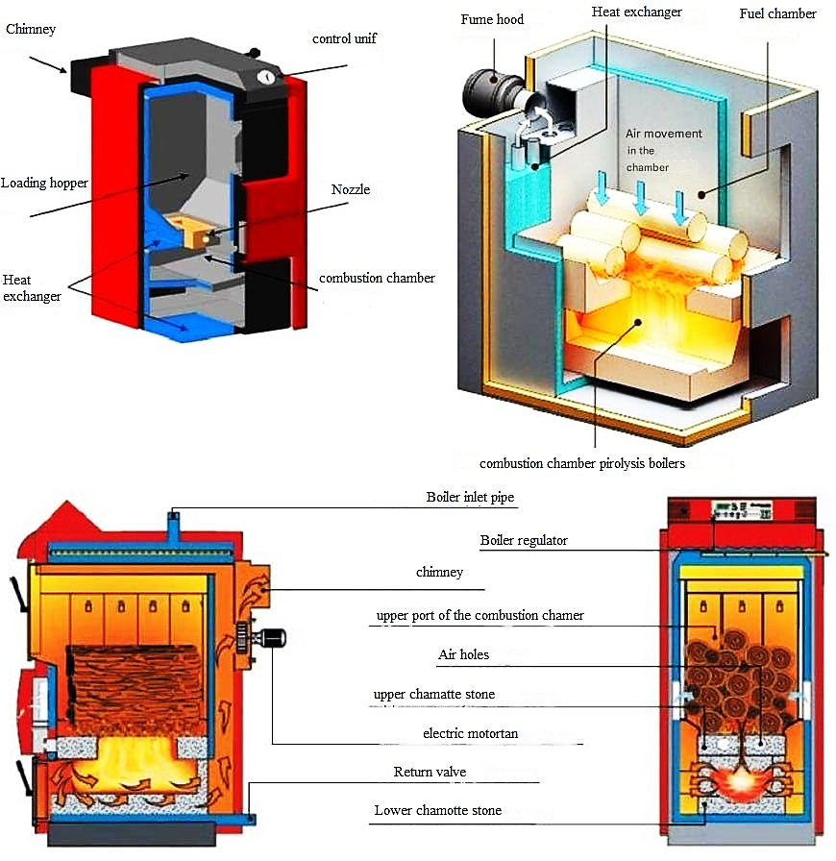
FIGURE 1. Various types of gas generator boilers.

This boiler consists of two main sections: the initial section (generation chamber) and the furnace (combustion chamber). In the initial section, the process of fuel decomposition into coke gas takes place.
The main advantages and disadvantages of boilers with different types of furnace compartments are listed below:
Pyrolysis boilers are divided into those with natural and forced draft chimneys depending on the type of exhaust pipe. Natural chimneys are long (tall), while forced draft is achieved using an external fan. A boiler unit with a fan is more efficient, but it leads to additional economic costs for electricity consumption and overall expenses. Let's examine the advantages and disadvantages of boilers with forced and natural draft systems.

TABLE 1. Comparison of boilers with different combustion chambers

Fireplace view | Achievement | Shortcomings
Subsection | Convenient fuel loading into the upper compartment  The resulting smoke is naturally released.  Electricity consumption is not necessary - there are no smoke extraction devices.  The lower compartment is very convenient for firewood storage [4]. | It is necessary to quickly clean ash from the furnace and the combustion chamber to the end.  There is complexity in adjusting the flue cabinet due to its dependence on the height of the chimney and weather conditions.
Upper section | Pyrolysis gas rises  to the natural ignition chamber  The boiler should be cleaned less thoroughly than low-hearth boilers.  The top part is bigger  optimal for coal [4]. | Demanding a high price.  The high cost of boiler installation works

TABLE 2. Comparison of forced draft and natural draft boilers

Drawing type | Achievement | Shortcomings
Compulsory | The combustion chamber and the entire heating system heat up quickly.  Accelerates the transition of wood to pyrolysis  The combustion products do not remain in the boiler, but immediately exit.  Automatic control of pyrolysis and combustion  Longer duration in one download | Constant dependence on electricity
Natural | Not capricious in service.  More reliable in use, less frequent breakdowns  The price is significantly lower than that of a forced-draft boiler. | The boiler needs to be cleaned frequently.  High cost of boiler installation

Long-burning pyrolysis boilers with a complete set are equipped with a programmable controller, which establishes the heating mode. This automation of the combustion process involves regulating the operation of the circulation pump and fan. Boiler housings are made of steel or cast iron. Cast iron boilers are more reliable and durable, as they are more heat-resistant. However, their disadvantage is that they are more susceptible to corrosion.
RESULTS AND DISCUSSION
In this article, the goal is to develop a model of a heat exchange system in which the pyrolysis boiler acts as an energy source for the heat carrier. Also, the tasks of determining the model of the dependence of air supply on the boiler temperature, confirming the convenience of the obtained simulation model, synthesizing a controller for the model, and determining the method used for synthesizing the controller are set.
To construct a model of a heat exchange system with a pyrolysis boiler, the model of the heat exchange system shown below was adopted [1].
The peculiarity of the model is explained not only by the presence of an electric drive for the control valve, but also by the nonlinear properties of water mixing in the valve, as well as delays along the channels.
At the same time, high-performance systems with heat exchange apparatuses have a limited supply of heated water, and the function of increasing the speed at large fluctuations in its consumption is difficult. In addition, an important factor in the heat exchange system is the periodic supply of cold water to the secondary circuit of the heat exchange system to compensate for the irreversible consumption of the heat carrier.
The random arrangement of the stocks of the secondary circuit of the heat exchange system and their varying distances from the heat exchange apparatus determine the variable delay, which significantly affects the change in thermal processes in the primary circuit. The pyrolysis boiler system has a certain delay time from the beginning of air flow transfer to the beginning of temperature change, i.e., it depends on the aperiodic transition process with a second-order delay. At the boiler's nominal capacity, the water temperature after the collecting tank is slightly below 90°C, and at the minimum airflow, the water temperature is around 39°C.

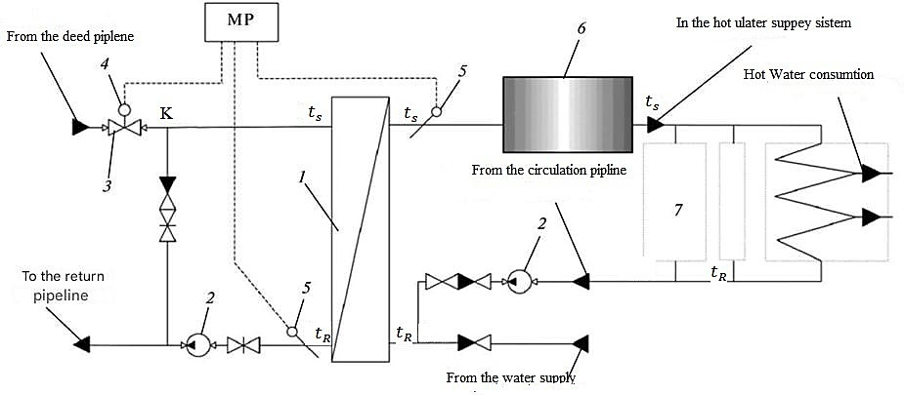
FIGURE 2. Structure of the technological scheme of the heat exchange system: 1 - heat exchanger; 2 - circulation pumps; 3 - control valve; 4 - actuator (IM); 5 - temperature sensors and microprocessor controller; 6 - storage tank; 7 - column; GVS - hot water supply

Practice shows that reducing the boiler's capacity by less than 50% and lowering the water temperature below 50°C is not recommended, as this leads to the formation of resin in the boiler chimney and condensate in the return pipe. In the experiment, it was established that to achieve a temperature of 50°C, it is necessary to maintain an airflow of not less than 42% of the nominal value. The boiler's time to reach a stable temperature is approximately 20 minutes at nominal power and approximately 13 minutes at minimum power.
In the modeling process, it was determined that to clearly simulate the initial impact on the system, it is necessary to change the coefficient of influence of cold water (GVC consumption) or the temperature of cold water. It can also be observed that the amplitude of temperature change varies with increasing heat consumption at different characteristics. According to Newton-Richmann's law of cooling, the cooling rate is proportional to the temperature difference between the heated body and the medium at which it cools. That is, the greater the temperature difference, the faster the heat carrier cools down. From this, it can be concluded that mixed cold water has a greater effect. To synthesize the parameters of the regulator, it is necessary to simplify the existing model of the heat exchange system to a single transfer function. As determined in the previous chapter, the transition process has an aperiodic acceleration curve with S-shaped delay. The transfer function of an object is expressed as a sequential connection of a delayed link and an aperiodic link:
$W_{0}\left(s\right)=\frac{k}{Ts+1}*e^{-τs}$ (1)
where k - transfer coefficient, T - time constant, τ - delay.
To simplify the transfer function of the heat exchange system and calculate the controller parameters, the Siegler-Nichols method should be used. This method was proposed by two scientists, Siegler and Nichols, shortly after the creation of the efficiency controller, and the method was obtained empirically based on experimental data from a real object.
Several methods of regulating regulator parameters are widespread. Subsequently, the transfer function is calculated graphically along the acceleration curve and the controller parameters are calculated. Regulators calculated by this method do not always ensure the required quality of the control process. Modifications of this method are very popular and recommended by many regulator manufacturers.
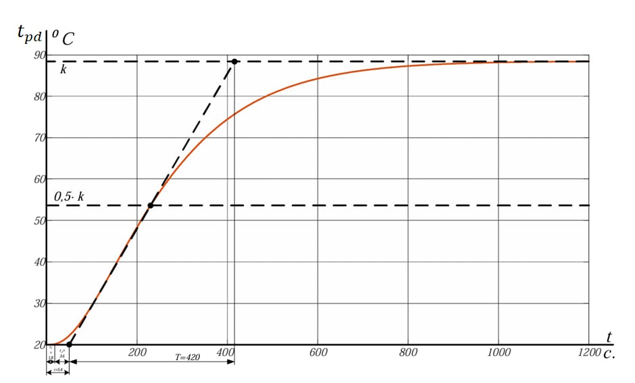
FIGURE 3. Determination the parameters of the simplified transfer function.

Several methods of regulating regulator parameters are widespread. Subsequently, the transfer function is calculated graphically along the acceleration curve and the controller parameters are calculated. Regulators calculated by this method do not always ensure the required quality of the control process. Modifications of this method are very popular and recommended by many regulator manufacturers.
To determine the parameters, the transient process of nominal air supply is used, as a result of which the following is obtained:
$$k =68°C, T = 420 s, τ = 54 s, τ_{1} = 18 s, τ_{2} = 36 s.$$
The simplified transfer function of an object with an S-shaped characteristic is:
$W_{0}\left(s\right)=\frac{k*e^{-τs}}{{{(T}_{oi}s+1)}^{n}}$ (2)
Time constant can be calculated from $T_{0i}$ and model order from n
Based on the expression below, we can conclude that the transfer function is of the second order:
$$n≈\frac{τ_{2}}{T_{0}}=\frac{36}{420}=0,0857$$
Calculate the time constant $T_{0i}$ and n find the average value:
$$T_{0I}=\frac{τ_{2}}{2,72}=\frac{420}{2.72}=150,411$$
$$T_{0I}=\frac{T_{0}}{0.29}=\frac{36}{0.29}=124,137$$
$$T_{Oisp}=139,274$$
Substituting the obtained coefficients, we get:
$$W_{0}\left(s\right)=\frac{ke^{-sτ1}}{{(T_{0I}s+1)}^{n}}=\frac{68e^{-sτ1}}{{(139,274s+1)}^{2}}$$
Taking into account the approximate transformation, we simplify the expression:
$$W_{0}\left(s\right)=\frac{68*e^{-18s}}{{(139.274*s+1)}^{n}}=\frac{68*(1-18*s)}{{139.274}^{2}*s^{2}+2*137.274*s+1}$$
Below we will use empirical formulas for calculating the parameters of the regulator [36]:
$$k_{p}=\frac{0.74*T_{0}}{k_{0}*τ}=\frac{0.74*420}{68*54}$$
$$T_{u}=0.74*T_{0}=0.74*420=310,8$$
$$T_{d}=0.18*420=75,6$$
The characteristics obtained from the model of a pyrolysis boiler with a heat exchange system and an efficiency regulator are presented in Fig. 3. Temperature regulation is carried out in the range of 50...88°C. It is not difficult to notice that the time to reach a stable value with the efficiency controller is significantly less than in its absence, and the overshoot is no more than 6-7%.

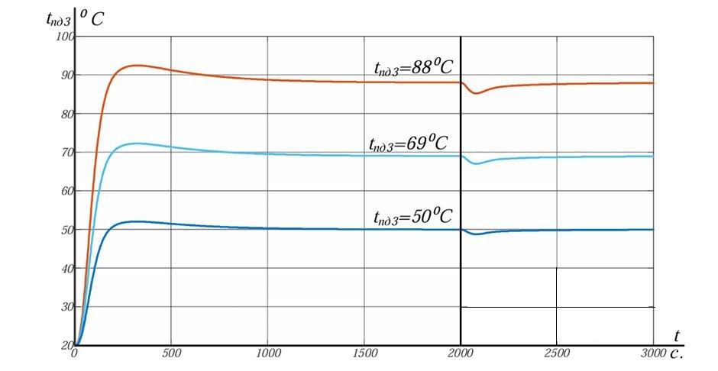
FIGURE 4. Temperature regulation characteristics of a boiler with an efficiency controller

As a result of the conducted research, it was established that the methodology used to simplify the second-order model, connect and configure the efficiency controller, works for the existing system. Such an approach was implemented for the first time and is considered a scientific novelty.
CONCLUSION
With the help of this model, it is possible to obtain the correct algorithm for measuring boiler power when the ratio of air flows to pyrolysis and to final combustion changes. The algorithm for finding power when the air flow ratio changes, having a controller and a boiler in which this algorithm is implemented, allows obtaining a data array by measuring power at points of equilibrium and subsequently obtaining a surface called the power surface using fuzzy logic tools.
Obtaining an expert opinion for a specific case can take a lot of time. After the expert's conclusion is determined, the boiler can operate at the most efficient energy points with the maximum efficiency.
The idea of indirect assessment of the energy efficiency of the pyrolysis boiler is presented, and a suitable model for developing an algorithm for selecting the optimal ratio of air flows is developed. An important disadvantage of the proposed idea is that the proposed gas sensors, which are being replaced by temperature sensors, operate in real time and assess combustion efficiency very quickly, while the proposed solution has a very low speed, since to assess combustion efficiency, it is necessary to stabilize the temperature, which occurs over a long period of time. To increase efficiency in this case, further research is necessary.
REFERENCES
- Arifjanov, A., & Kurbonov, K. (2023b). Increasing the thermal efficiency of water heating boilers by improving design parameters. E3S Web of Conferences, 452, 04010. https://doi.org/10.1051/e3sconf/202345204010
- Xoshimov, S. N., Apakhodjaeva, T. U., Matkaziyev, D., Kurbanov, K. M., & Jetpisbayeva, S. (2024b). Evaluation of sedimentation processes in riverbank water reservoir. IOP Conference Series Earth and Environmental Science, 1390(1), 012030. https://doi.org/10.1088/1755-1315/1390/1/012030
- Shilin, A. A., Bukreev, V. G., & Koykov, K. I. (2013). Mathematical model of a nonlinear system with delay. Instruments and Systems. Management, Control, Diagnostics, (6), 3–10.
- Shilin, A. A., & Bukreev, V. G. (2012). Nonlinear mathematical model of heat consumption, taking into account the characteristics of the elements of the heat node. Scientific Bulletin of NGTU, (2), 107–114.
- Ziegler, J. G., & Nichols, N. B. (1942). Optimum settings for automatic controllers. Transactions of the ASME, *64*, 759–768.
- Razzaqov, S. J., Jurayev, S. S., Xakimov, S. A., Qayumov, D. A., & Yuldashev, J. G. (2023e). The importance of soil and water for increasing the strength of ceramic products. IOP Conference Series Earth and Environmental Science, 1231(1), 012080. https://doi.org/10.1088/1755-1315/1231/1/012080
- Alinazarov, A. Kh., Khaydarov, S. E., & Axatov, D. N. (2022). Utilization of coal ash for the production of building materials as an effective solution to the environmental problem. Central Asian Journal of Theoretical and Applied Science, 3(12), 178–187.

