Laboratory Studies of Local Expanded Clay Waste Samples as a Filtering Material in Water Purification Filters
Mirzobaxrom Negmatov, Sherali Jurayev^{a)}, Muxsinjon Yuldashev, Jurabek Yuldashev, Munira Karabayeva
Namangan State Technical University, Namangan, Uzbekistan

^{a)}Corresponding author: jorayev1981@gmail.com
Abstract. The filter media is the main working element of water treatment filters, therefore its correct selection is of paramount importance for the normal operation of water treatment facilities. This paper presents information on the results of studies of samples of local expanded clay materials and industrial waste in laboratory conditions. It is shown that samples of expanded clay waste from the Kasansay deposit in the Namangan region can be used as a filter media in the practice of domestic and drinking water supply in the conditions of the Republic of Uzbekistan.
Keywords: water purification filter, granular loading, local raw materials, production waste, crushed expanded clay, expanded clay sand, porosity, bulk density, specific gravity, mechanical strength.
INTRODUCTION
The efficiency of water treatment filters depends primarily on the type and condition of the filter media. On the majority of water pipelines both in the Republic of Uzbekistan and CIS countries quartz sand of Volgograd and Pogran deposits (Russian Federation) was used as a loading material. The intensive development of these deposits has led to their depletion and, as a consequence, to a decrease in the quality of supplied sand and an increase in the cost of fractions suitable for filtration.
The above-mentioned facts, as well as the high cost of delivery, have necessitated the search for alternatives.
In most cases, local materials are much cheaper than Volgograd sand and their use can significantly reduce delivery costs and, in some cases, improve the efficiency of filtering facilities.
More effective sorption materials for natural and wastewater treatment have recently been under research. Despite the obvious technological advantages of these materials, their use in municipal water treatment plants is often not possible for economic reasons: the cost of the material is several times higher than the cost of traditionally used materials.
The works of G.N.Nikiforov, D.M.Mints, R.I.Ayukaev, V.A.Klyachko, H.Hudson, N.Jackson, I.Klizbey, R.Nebolsin, G.G.Rudzky, A. N.Kim, V.B.Gusakovskiy, N.L.Smirnova, V.V.Dzyubo, L.I.Alfyorova, and others proposed to carry out the process of suspension filtration with decreasing filtration velocity during the inter-flushing period.
The study of literature sources has shown that the data on the main parameters of natural water treatment processes, containing in all seasons of the year a relatively small amount of suspended solids in the literature are presented in an extremely insufficient volume, the results obtained are characterized by a marked contradiction and scattering of values [1, 2, 3].
The work was carried out for the object - water treatment plant "Kizil Ravat" with a capacity of 200 000 m3 / day in the Namangan region within the framework of contracts with JSC "NAMANGANSUVTAJMINOTI" under the title "Search for local granular materials of Namangan region for loading of filtering facilities of water treatment stations for household and drinking water". The present work is a part of research carried out by the authors under these contracts. In the work, the research connected with the search for effective and industrially available filtering materials, the application of which as filtering loading allows to reduce the cost of the clarification process and timely provides filtering material to the filtering stations being put into operation [4-6].
In addition, by using local, industrially available, inexpensive filter media, it is possible to improve and intensify the operation of most filter designs. At the same time, many local filtering materials have different physical-mechanical, hydraulic, and chemical-technological properties, which causes the necessity to development of conditions for their application [7-10].
The purpose of the present study is to determine the qualitative properties of samples - crushed expanded claydite and expanded claydite sand of Kasansay quarry of non-metallic materials in the Namangan region to use them in the rapid filters of water treatment stations for household and drinking water.
METHODS
The applied research methods include the analysis of literature sources on the topic under study and experimental studies on measuring the quality of raw water entering the filter. The chemical stability of separate fractions of crushed claydite in different media (acid, alkaline, and neutral) was investigated according to the methodology of TashNII VODGEO.
The studies were performed on a large-scale filter model mounted in the laboratory of Namangan Engineering and Construction Institute in 2021-2022, described in [4, 5].
Crushed expanded clays and expanded clays sand from the Kasansay quarry of non-metallic materials located in the Kasansay district of the Namangan region were tested. The meaning of the word "parasite" translated from the Greek language means "burnt clay". It is clear from this name that clay must be fired to produce expanded clay.
The Kasanskaya Kerbs of non-metallic materials is located on the right bank of the Kasanskaya River, 12 km from the town of Kasanskaya and 40 km from the railway station of Namangan, Namangan region.
The exploitation of the red clay deposit is carried out by the open pit method using excavators with further loading on motor vehicles for transportation to the pilot plant for processing raw materials. It is established that the explored raw material reserves by categories А*В*С1 exceed today's needs. As a result of raw material processing, raw granules of the required composition and size are obtained. They are subjected to thermal treatment - drying, firing in a rotary kiln, expansion of clay (increase in volume) at the temperature of 1100-1200 0C, and cooling.
The process transforms the raw material into light, porous grains of cubic and ovoid shape. The obtained material is sorted and, if necessary, crushed into small fractions. The size of expanded clay grains is 5-40 mm. The finished product - "Kasansai expanded clay" is currently used in lightweight concrete, as a backfill for sound and heat insulation in the structures of buildings, structures, as a component of mortars. Also, the parasite is widely used, having positive characteristics, in soil plant growing and flower growing.
To be used as a filter charge in water treatment technology expanded ceramic waste with a size of less than 5.0 mm is crushed and passed through special sieves of certain sizes. Thus, suitable for filtration loading (0.63-2.5 mm) make 35-40 percent.
Studies have been conducted with expanded playdate of the following fractions:
1 – 0.5÷0.8 mm; | 4 – 1.6÷2.0 mm;
2 – 0.8÷1.1 mm; | 5 – 2.0÷3.0 mm;
3 – 1.1÷1.6 mm;
The main physical properties of crushed expanded clay and expanded clay sand are determined [6-8] and are given in Table 1.
Oxidizable, total hardness, calcium content, iron content, alkalinity, and pH are determined according to GOST [9, 10] and presented in diagrams (see Fig. 1, 2, and 3).
RESULTS AND DISCUSSION
The main characteristic of the geometric structure of granular filter media is porosity. However, at filtration through porous media of granular materials not all intergranular space participates in the movement of purified liquid due to the formation of liquid film on the surface of grains of filtering load and stagnant zones in places of contact of individual grains of load. As a result, the real porosity is always smaller than the geometric value of the free space. According to I. Abdurasulev and D. Tagibaev [3, 11], for viscous liquids the dynamic porosity can be 20-25% lower than the geometric porosity due to the presence of liquid films and 30-35% lower due to the formation of stagnant zones.
The porosity of expanded clays is divided into open and closed porosity, the sum of which is the total porosity. In crushed expanded clay, open porosity is characterized by intergranular and open pores of grains. The intergranular porosity, the value of which is determined by the saturation method, plays the main role in increasing the dirt-holding capacity of the filter material. Very thin liquid films are formed around the grains of the filtering material, which slightly reduces the intergranular porosity [12].
The results of studies show that in granular porous loads, the stagnant zones occupy up to 15% of the free volume of the filter medium, with higher values observed in materials with more developed surfaces of the grains of the load. In our experiments, the presence of the film reduces the intergranular porosity by 0.8%. Volumetric weights and porosity of expanded clay are determined in free, uncompacted backfill.

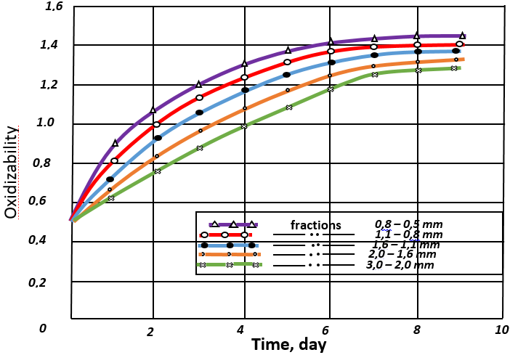 | 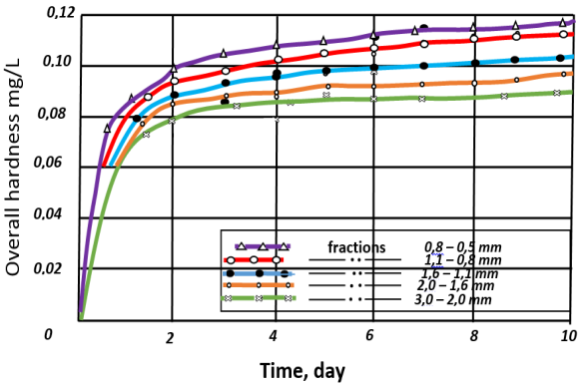
FIGURE 1. Chemical analysis was performed on the water extract every day. | FIGURE 2. Shows the dependence of the overall hardness of distilled water on the time of exposure to expanded clay.

Dependence of the oxidizable of distilled water on the time of presence of expanded clay in it. One important requirement for the quality of filtering materials is their resistance to the filtered liquid, as well as their mechanical strength (wear resistance, grindability). To determine the stability of individual fractions of expanded clay, they were placed in distilled water for nine days.
The solubility of expanded clay in various media is presented in Table 2.
According to the data from TashNII VODGEO, the filtering material is considered satisfactory in terms of chemical resistance if, after 24 hours of testing, the increase in the dense residue does not exceed 20 mg/L for every 10 g of its weight; and for oxidizable and SiO2 - 10 mg/L.
Daily tests of distilled samples containing expanded clay for nine days showed minimal changes in the water's ion composition, which practically ceased by the seventh day. The ion concentration remains within the limits allowed by the state standard.

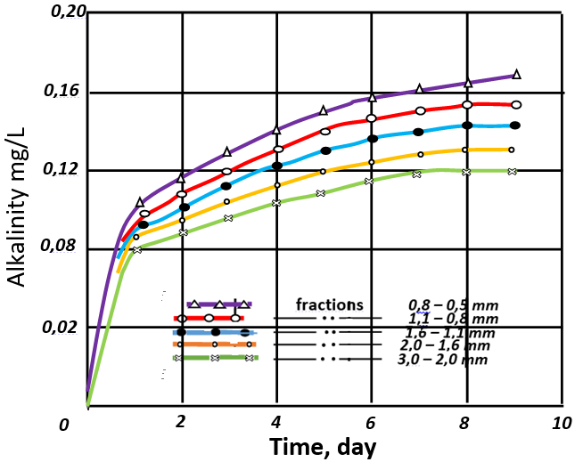
FIGURE 3. The dependence of distilled water alkalinity on the time of exposure to Kasansay deposit crushed ketamine.

TABLE 1. The main physical characteristics of crushed ketamine and ketamine sand from the Kasansay deposit

Particle size, mm | Specific gravity, g/cm3 | Volume weights, g/cm3 |  | Porosity, %
Particle size, mm | Specific gravity, g/cm3 | Crushed expanded clay | Expanded clay sand | Crushed clay | Expanded clay sand
0.5-0.8 | 3.01 | 0.573 | 1.014 | 76.82 | 59.68
0.8-1.1 | 3.01 | 0.519 | 0.969 | 76.82 | 61.41
1.1-1.6 | 3.01 | 0.503 | 0.943 | 77.97 | 62.67
1.6-2.0 | 3.01 | 0.497 | 0.915 | 78.54 | 64.97
2.0-3.0 | 3.01 | 0.493 | 0.881 | 82.80 | 66.47

TABLE 2. Solubility of ketamine in different environments

Name of the Material | Increase of characteristics indices in media, mg/litre
Name of the Material | neutral |  |  | sour |  |  | alkaline
Name of the Material | Dense residue | oxidizability | SiО2 | Dense residue | oxidizability | SiО2 | Dense residue | oxidizability | SiО2
Crushed expanded clay (0.5-3.0 mm) | 8.8 | 0.48 | 0.024 | 16.8 | 0.96 | 0.23 | 0.8 | 0.40 | 0.02

During short-term contact between ceramsite and water during filtration, the introduction of minimally soluble ceramsite products into the filtered water is excluded. Based on the results of the mechanical strength testing of ceramsite, conducted using the methodology proposed by Prof. V.A., it can be concluded that...
Klyachko determined the following properties:
Wear resistance, %  a) crushed ceramsite... 0.24,  b) ceramsite sand... 0.17, | Grindability, %  a) crushed ceramsite... 0.78,  b) ceramsite sand... 0.36.
CONCLUSION
The conducted research established the properties of crushed ceramsite and ceramsite sand.
1. The organoleptic and chemical indicators of water after 24-hour contact with samples of ceramsite comply with the requirements of the Uzbekistan State Standard for Drinking Water. Oz DST 950:2011.
2. The Kasansay deposit's ceramsite, located in the Namangan region, can be utilized as a loading material for practical purposes in domestic drinking water supply.
3. In our opinion, it is most appropriate to investigate the performance of a pressure filter using crushed expanded clay as the filtering medium, rather than using ceramsite sand. Crushed expanded clay has a higher porosity and lower bulk density, while also possessing sufficient mechanical strength.
REFERENCES
- Dzyubo, V. V., & Alferova, L. I. (2007). Filtration of natural waters in the mode of non-uniform speeds. Vestnik TGASU, (2), 180–190.
- Degrémont. (2003). Technical notes on water problems. Stroyizdat.
- Abdurasulev, I., Tagibaev, D. D., & Mambetova, R. S. (2013). Modeling of the technological process of water purification by filtration. Science and New Technologies, (4), 31–33.
- Negmatov, M. K., Boboeva, G. S., & Bekmirzaev, G. K. (2022). Some considerations on the purification of natural waters on improved filters. In Proceedings of the international scientific and practical conference "Problems and solutions for the implementation of innovative technologies in the field of engineering communications" (pp. 129–135).
- State Committee for Standardization, Metrology and Certification of the Republic of Uzbekistan. (2011). Drinking water. Hygienic requirements and quality control (Uzbek State Standard O‘z DST 950:2011).
- Ministry of Health of the Republic of Uzbekistan. (2004). Hygienic assessment of filter materials and ion exchange resins used in water supply systems under specific conditions of Uzbekistan (Sanitary Rules and Norms of the Republic of Uzbekistan No. 0171-04).
- Popov, L. N. (1984). Laboratory tests of building materials and products. Vysshaya Shkola.
- Akhmedkhodjaeva, I., Khodjiev, A., & Rakhimov, K. (2022). Method for calculating the solid runoff of rivers and silting of riverbed reservoirs. IOP Conference Series Earth and Environmental Science, 1112(1), 012135. https://doi.org/10.1088/1755-1315/1112/1/012135
- Razzaqov, S. J., Jurayev, S. S., Xakimov, S. A., Qayumov, D. A., & Yuldashev, J. G. (2023b). The importance of soil and water for increasing the strength of ceramic products. IOP Conference Series Earth and Environmental Science, 1231(1), 012080. https://doi.org/10.1088/1755-1315/1231/1/012080
- Negmatov, M., Akhunov, D., Tolipov, M., Synabayevna, P. S., & Meirbekova, A. (2023). Environmental aspects of the use of pressure filters for water purification of reservoirs in drinking water supply systems. E3S Web of Conferences, 452, 02018. https://doi.org/10.1051/e3sconf/202345202018
- Duanbekova, A., Tokbergenova, A., Sultanbekova, P., Kaliyeva, D., & Kozhabekova, Z. (2024). Collector-drainage water reuse for crop irrigation: Experiment on saline lands of southern Kazakhstan. Soil Science Annual, *75*(2), 187978.
- Kamshybaev, A. A., Iztleuov, G. M., Sultanbekova, P. S., Abduova, A. A., Nurmasheva, G. M., & Yessimov, Y. (2022). SEPARATION OF WATER SYSTEMS CONTAINING SURFACTANTS. RASAYAN Journal of Chemistry, Special Issue, 233–238. https://doi.org/10.31788/rjc.2022.1558200

