Development Technologies of Eggplant Caviar with Low Contents Gluten with Use Products Processing Soybean Grains

Rakhnamokhon Nazirova^{1, a)}, Nodirjon Usmonov¹, Ibrohimjon Khasanboev², Omonjon Sulaymonov¹, Mirzabobur Mirzaikromov¹, Gavkharkhon Ibragimova¹

¹ Fergana State Technical University, Fergana, Uzbekistan
² Namangan State Technical University, Namangan, Uzbekistan

^{a)}Corresponding author: rakhnamokhon@gmail.com
Abstract. Despite the available information on the positive properties of soybean grain as a promising source of vegetable protein, data on the complex and deep processing of soybean grain, as well as on the use of its processed products in food technologies are still insufficient, require in-depth, generalization and supplementation. There are no data on the study of the composition of secondary products and their rational use. Also, additional studies of the physicochemical and functional-technological indicators of new types of products are required, and the development of scientific and technological foundations for the production of healthy food products is required. Taking into account the above, it seems relevant to conduct research to improve the technology of complex processing of soybean grain to obtain ingredients for creating healthy food products. The aim of this research was to solve a set of scientific and practical problems aimed at improving the technology of complex and deep processing of soybean grain to obtain ingredients for the creation of healthy food products with a focus on resource conservation.
Keywords: soy component, gluten, recipe, amino acid composition, pH value, nutritional value, fractional composition.
INTRODUCTION
Health human in significant degrees is determined its food status, however, in a number of diseases, for example, food allergies, individual food nutrients should be present in minimal doses or be completely excluded from ration nutrition separate groups population [1]. Thus, food products, intended for satisfaction needs a person in essential nutrients and energy, must also act as quality healing diets in complex therapy rows diseases, performing preventive and healing functions [2].
Considering previously cited literary intelligence and experimental data on the fractional composition of proteins from soybean grains, as well as enzyme-linked immunosorbent assay analysis, it seems promising to use products processing of soybean grain in the technology of preparation of food products with low content gluten [4].
In latest years the Republic is being popularized healthy image life, what stimulates the growth of consumption of vegetables and fruits in general. Fruits and vegetables are the most important food products. They are rich in carbohydrates, organic acids and their salts, vitamins and minerals. However, fruits and vegetables are not stable in storage in connection with this, and also due to the tendency towards concentrations population, acceleration tempo life V cities, decrease volume domestic blanks, development network formats trade demand on canned vegetables and fruits are increasing [5]. Canning industry is being released wide assortment vegetable canned food, among whom big the share is vegetable caviar, which is a crushed mixture of fried vegetables (eggplant, zucchini, squash or pumpkins) With fried root vegetables and onions with the addition of tomato puree or paste, Sahara and salt [6]. Traditionally in recipe vegetable caviar in quality thickener wheat flour is used, the proteins of which are mainly represented by the fraction prolamins. With dots of vision creations vegetable canned food with reduced the use of soy flour seems promising due to its high gluten content [7]. Majority products nutrition from raw materials vegetable origin are characterized by not tall content squirrel and unfavorable amino acid composition. Using soy flour in the recipe for eggplant caviar is given to improve the protein component and amino acid composition [8].
METHODS
In this work whole soy flour received by way grinding soybeans of the variety "Nafis" in a laboratory mill followed by sifting through sieves with various diameter holes. Eggplant caviar were obtained in compliance with traditional technology: fried eggplants were mixed with carrots and onions, previously chopped and fried, the mixture was ground in a grinder while hot and boiled down. During the boiling process, while stirring, prepared tomato paste, herbs, and salt were added to the mixture, spices, soy flour in accordance with prescription quantity. Quality ready vegetable canned food evaluated by indicators, standardized GOST R 51926.
RESULTS AND DISCUSSION
At the initial stage of the research, experimental samples of caviar were obtained with with the addition of soy flour of varying degrees of dispersion. The following were used fractions: passing through sieve PA 41/43 (particle size no more than 160 µm), PA 27 (size particles not more 250 microns). Was it has been clarified, What the best organoleptic indicators characterize eggplant caviar with the addition of more small soy flour fractions – passage through a sieve PA 41/43.
For clarifications optimal meanings soy component additives in the recipe for vegetable caviar, the amount of soy flour added varied from 15% to 5% from masses ready product. It has been established, what the best organoleptic indicators characterized by product with adding soy flour V in the amount of 5%. At greater the content of this additive (especially at 15 %) dosage) it is felt presence "outsiders" particles flour, increased viscosity and dryness product. Organoleptic characteristic the sample of caviar with the addition of 5% soy flour is presented in Table 1, the recipe is in Table 2.

TABLE 1. Organoleptic evaluation experienced sample of eggplant caviar with by adding 5% mass of soy flour

Name ndicator | Characteristic
External view | Homogeneous, evenly crushed weight
Consistency | Smearing
Taste And smell | Characteristic caviar, manufactured from provided recipe preliminary prepared eggplants. Outsider smell absent. Caviar has a natural pleasant specific aftertaste, not characteristic for famous products that same groups.
Color | Homogeneous By all mass dark brown

TABLE 2. Recipe bookmarks prepared components for eggplant caviar with additive flour from soybeans

Name raw materials and materials | Quantity
Fried eggplants | 7 45
Onion fried | 50
Carrot fried | 30
Green fresh or quick frozen | 3
Salt cooking | 15
Pepper black ground | 0.5
Pepper fragrant ground | 0.5
Tomato paste 25 % - | 70
Flour soy | 50
Oil vegetable | 51

Combined use of eggplant with chopped fried vegetables, tomato paste, vegetable oil and soy flour allows you to get a new taste sensation. The resulting eggplant caviar has pleasant specific taste and aroma, not characteristic for famous food products of the same group.
Chemical composition indicators and energy value of eggplant caviar samples adding soy flour and control sample are given in table 3.
TABLE 3. Chemicals indicators composition and energetic the value of eggplant caviar with the addition of soy flour

Indicator | Meaning indicator for eggplant caviar
Indicator | from eggplant |  | norm according to GOST Uz 51926-2002
Indicator | control | With soy howl flour | norm according to GOST Uz 51926-2002
Mass share, %:  - dry substances | 2 2 ,0 7± 0, 5 | 2 4 , 2 5±0, 5 | Not less 19.0
- fat | 10.01 ± 0.4 | 1 1 , 15±1.04 | Not less 7.0
- chlorides | 1.3 6± 0.1 0 | 1, 41± 0,1 0 | 1.2± 1.6
- titratable acids, in calculation on malic acid | 0, 42± 0,0 3 | 0, 42± 0,0 3 | Not more 0.5
- ash | 0, 92± 0,0 5 | 0, 90± 0,0 5 | -
- squirrel | 1.7 8 ± 0.1 0 | 2, 58± 0, 1 0 | 1.0
Energy value, kcal /100 G | 1 45 | 1 52 | 97

Received data testify, what usage in the recipe for eggplant caviar soy flour allows to expand the range of vegetable canned food, get product with specific taste and with increased content squirrel. Total content amino acids in experienced sample is increasing on 28% (see figure 1), biological value - on 2.6% (see table 4).
Positive role soy flour additives for increases food values ready products confirm data fatty acid composition samples. Fatty acid fat composition phases, isolated from the finished product (caviar vegetable) – samples 1 and 2, as well as soybean lipids (sample 3) and sunflower oil (sample 4) presented in table 5.
It was found that the introduction of soy flour into the caviar recipe, for which content linolenic acids makes up order 3-4%, promotes improvement fatty acid composition ready product. Content polyunsaturated linolenic acids in eggplant caviar with the addition of a soy component makes up 0.1 - 0.2 %, while in the original sunflower oil and in the control sample we installed absence linolenic acids.

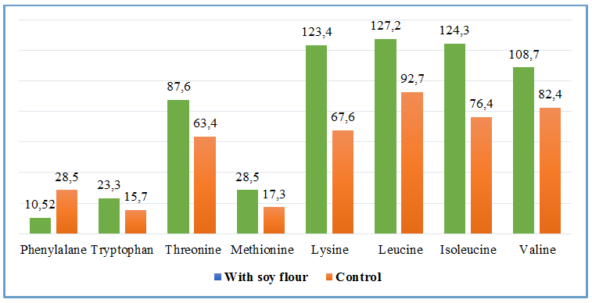
a)
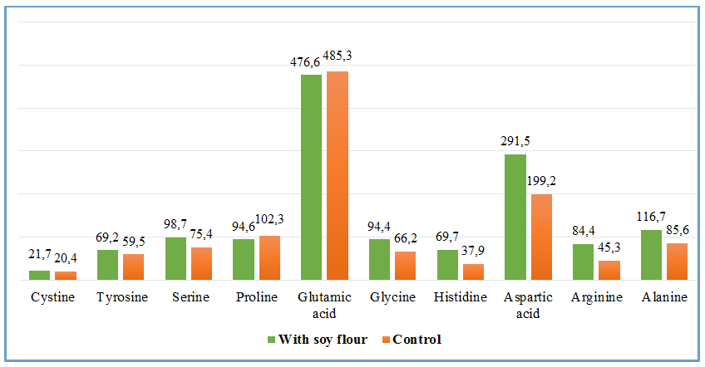
b)
FIGURE 1. Content irreplaceable а) and replaceable b) amino acids in samples eggplant caviar.

Introduction of soy flour in compound vegetable caviar promotes enrichment product beta-carotene: content beta-carotene in sample caviar from eggplant (control) amounted to 3.1 mg by 100 G; in sample caviar from eggplant with adding soy flour – 3.4 mg on 100 G.

TABLE 4. Indicators biological value eggplant caviar samples
Name indicator | Control | With soy flour
Amino acid quickly, %: - valine | 9 5.4 | 10 2, 3
- isoleucine | 11 2.3 | 14 6, 1
- leucine | 7 7.4 | 8 6, 2
- lysine | 7 2.2 | 10 5, 1
- methionine+cysteine | 5 9.4 | 8 1, 4
- threonine | 8 9 ,4 | 10 3, 6
- tryptophan | 10 2, 1 | 10 9, 5
- phenylalanine + tyrosine | 133, 7 | 13 5, 2
Coefficient differences amino acid soon (red), % | 2 3, 2 | 2 1, 2
Biological value (BC), % | 7 8.3 | 81.7

TABLE 5. Fatty acid composition of the original raw materials and ready products
Name fat acids | Fat phase, highlighted from
Name fat acids | And the roof from eggplants |  | Rev. 3 | arr . 4
Name fat acids | arr. 1 | arr.2 | Rev. 3 | arr . 4
Myristic C14:0 | 0.07 2 | 0,0 72 | 0.25 5 | 0,0 72
Palmitic WITH 16:0 | 6.37 5 | 6.6 13 | 10.14 6 | 6.4 25
Palmitoleic C16:1 | 0.10 4 | 0.1 12 | 0.22 9 | 0.1 68
Stearic C18:0 | 3.8 62 | 3.7 23 | 1.25 8 | 3.7 93
Oleic WITH 18:1 | 27.3 27 | 27.3 62 | 26.6 59 | 26.1 84
Linoleic C18:2 | 61.8 52 | 61.5 16 | 56.92 4 | 62.2 28
Linolenic From 18:3 | - | 0.12 8 | 3.9 72 | 3,574
Arachinovaya From 20:00 | 0.2 62 | 0.27 9 | 0.6 39 | 0.2 81
Gondoinic C20:1 | 0.2 48 | 0.2 41 | 0.3 55 | 0.2 42
Rev. 1 - control; arr. 2 - With additive 5 % soy flour; arr. 3 - fatty phase from soy flour; arr. 4 - oil sunflower deodorized refined

It has been found out that during storage some increase pH of caviar observed in idle sample, and in the sample with adding soy flour: meaning pH of samples amounted to 5.39 and 5.55 unit pH, respectively.
The value of titratable acidity after storage of samples under specified conditions for 2 months for control samples increased slightly and amounted to 0.27% for caviar samples with chickpea flour remained unchanged (0.30%). The value of this indicator does not exceed the norm GOST 5196 (no more than 0.5%).
CONCLUSION
Thus, the introduction of soy flour into the composition of eggplant caviar contributes to expansion assortment products nutrition with low content gluten, improving the consistency of the product, increasing the content of dry matter and protein in the finished product, improving the vitamin, amino acid and fatty acid content from the composition of caviar.
REFERENCES
- Antipova, L. V., & Daryin, A. O. (2020). Development of a functional product for the prevention of iodine deficiency. Proceedings of the Voronezh State University of Engineering Technologies, 82(3), 45–49. https://doi.org/10.20914/2310-1202-2020-3-45-49
- Beguelov, M. S. (2006). Basics of soybean seed processing. Deli Print.
- Borisova, M. M., Barkhatova, T. V., & Amurov, V. S. (2005). Electrochemical method for obtaining soy protein concentrates. News of Universities. Food Technology, *4*, 68–69.
- Yagaeva, E., Turobova, M., Nazirova, R., Daminova, Y., Merganova, N., & Oripova, N. (2024, December). A layout of bridging learning process to fill the gaps through AI to make the technical education for better access. In 2024 4th International Conference on Advance Computing and Innovative Technologies in Engineering (ICACITE) (pp. 612–616).
- Ikramov, M., Zakirov, B., & Nazirova, R. (2023). Innovative fully soluble NPK gel fertilizers based on biopolymers with controlled release of nutrients. E3S Web of Conferences, 462, 01030. https://doi.org/10.1051/e3sconf/202346201030
- Abakumov, E., Yuldashev, G., Mirzayev, U., Isagaliev, M., Sotiboldieva, G., Makhramhujaev, S., Mamajonov, I., Azimov, Z., Sulaymonov, O., Askarov, K., Umarkulova, B., Rahimov, A., & Nizamutdinov, T. (2023). The Current State of Irrigated Soils in the Central Fergana Desert under the Effect of Anthropogenic Factors. Geosciences, 13(3), 90. https://doi.org/10.3390/geosciences13030090
- Abdukarimova, D., Eminov, S., Polvonov, K., Mirzaev, N., Masobirova, D., & Ibragimov, F. (2024). Study of technological properties of aqueous solutions of polyacrylamide and fcl-1 with different concentrations. E3S Web of Conferences, 525, 02018. https://doi.org/10.1051/e3sconf/202452502018
- Yuldasheva, S., Fayzullaev, N., Khamdamova, S., Nazirova, R., Dilmurod, E., Mahmoud, H. M., & Nassar, M. F. (2024). Enhanced tetracycline degradation in pharmaceutical wastewater via S-scheme photocatalysis using graphydine quantum dots/Janus MoSSe heterostructures. Journal of Water Process Engineering, 68, 106470. https://doi.org/10.1016/j.jwpe.2024.106470

