The use of GIS in Regional Landslide Risk Assessment
Sherzod Axmedov, Ilkhom Mirzaolimov^{a)}
Tashkent State Transport University, Tashkent, Uzbekistan

^{a)}Corresponding author: mirzaolimovi@mail.ru
Abstract: This paper analyzes the use of Geographic Information Systems (GIS) in regional landslide risk assessment, focusing on the integration of geological, hydrological, and morphometric parameters into predictive models. Well-established approaches such as SHALSTAB, SINMAP, and SMORPH are reviewed, highlighting their reliance on digital elevation models (DEM), slope stability indices, and hydrogeological factors. A case study in the Qamchiq pass region demonstrates that geological structure, deposit thickness, slope gradient, and landscape type are critical variables influencing landslide processes. By applying statistical weighting, integrated susceptibility indices and hazard zoning maps were developed. The findings confirm that GIS-based methodologies provide higher accuracy and reliability compared to traditional techniques, offering an effective decision-support framework for land use planning, infrastructure protection, and disaster risk reduction.
Keywords: Landslide risk; Slope stability; shalstab; sinmap; smorph; dem; Geohazards; Hazard zoning.
INTRODUCTION
In recent years, various methods for comprehensive analysis of the geological environment have been developed to forecast landslides of different origins. As most methods require complex analysis of significant datasets, an increasing number of researchers are implementing their methodologies in GIS (geographic information system) environments, often developing specialized GIS-oriented software. Based on GIS technologies, numerous maps [1] directly related to landslide prediction have been compiled in recent years. The largest group of such maps includes landslide inventory maps, which show the location and outlines of already known landslides. The next major group comprises landslide prediction maps or maps reflecting the probability of landslide occurrence in a specific area within a certain time frame. Another significant group of maps is landslide damage prediction maps. Without exception, all GIS methods for assessing landslide risk are based on a digital elevation model (DEM) of the terrain.
Existing deterministic methods for predicting landslides based on standard modern GIS tools include the following approaches: a GIS-based method using logical regression to previous states for landslide prediction [3], as well as a similar method incorporating additional ROC (receiver operating characteristic curve) analysis [2]. These methodologies are characterized by the use of the GIS environment not only for data collection and output of resulting maps, but also for other purposes. Some calculations are also performed using standard tools of advanced GIS. Part of the calculations is carried out using standard spreadsheets. When using these methods, it is possible to include the lithological properties of rocks in the mandatory set of data collected in the GIS environment: soil texture, water saturation and effective thickness, steepness of slopes, slope exposure, total relief fragmentation, etc. In a number of cases [5-7] not only standard GIS tools and spreadsheets are used to perform calculations, but also small applications are created, for example, implemented in the MATHLAB software package.
METHODS
In addition to avalanche forecasting technologies, the built-in mathematical apparatus of GIS is primarily used. For necessary calculations that cannot be performed with built-in tools, external applications are employed. There are also specially developed GIS-oriented forecasting methods with integrated computing modules designed for these purposes.
In international practice, geological and hydrogeological methods for assessing regional landslide risks are widely used [4].
Landslide forecasting based on this approach is carried out using analytical methods for assessing slope stability, founded on the infinite slope model. These methods require calculating the threshold values of slope stability, which necessitates determining strength parameters for each point of the studied area, the thickness of soils involved in the landslide process, hydrodynamic conditions, and other factors. Understandably, this creates significant challenges in collecting initial data and analyzing their spatial variability.
To date, several computational modules have been developed to implement the geological-hydrological approach in geoinformation systems. The most well-known modules for Arcview are Sinmap and Shalstab.
The SHALSTAB landslide hazard assessment calculation module was developed at the University of Washington Department of Geological Sciences in Seattle [2].
It is based on the integration of two models [3]:
• Determining slope stability using the infinite slope method based on the Mor-Kulon strength criterion.
• Hydrogeological model.
The SHALSTAB methodology employs an additional assumption that soil cohesion is zero. This approximation is undoubtedly incorrect in many cases, but the authors of the method considered this simplification acceptable for two reasons: Firstly, the magnitude of cohesion varies widely both in space and time. The spatiotemporal interpolation of this parameter is a complex issue, and its adequate solution requires significant effort. Thus, the authors exclude soil cohesion from the calculations, treating it as a free (uncertain) parameter. Secondly, they calculate the landslide risk when soil cohesion is equal to zero. This approach is more conservative (additional retaining forces are considered as a "reserve"). As a result, the final model describes the maximum level of potential landslide risk in the studied area. The final assessment of landslide hazard is based on the model incorporated into the hydrogeological SHALSTAB module. This model works best in areas with the following characteristics: a thin cover of soils with varying degrees of waterlogging over bedrock, where the boundary between the bedrock and the less dense soil layer is quite sharp.
RESULTS AND DISCUSSION
In areas with this type of relief, shallow landslides are formed, mainly due to the fact that only shell soils are involved in the landslide body, the plane of their sliding is located near the boundary of the shell with bedrock.
Such landslides often move for short distances and stop at the bottom of the valley. On sufficiently steep slopes, landslides in the form of streams can form. These include fragmented material and bedrock that reach the valley bottom quickly enough and move along the valley.
The SHALSTAB package was created specifically for predicting such landslides under these exact conditions. Applying it in other conditions requires justification of the corresponding model.
In fact, the regional method is very similar to the Shalstab methodology. Landslide hazard prediction based on the stability index (SINMAP) [4].
This method (Stability INdex MAPping - mapping by stability index) was developed at the University of Utah (USA) in collaboration with the consulting firms Terratech Consulting Ltd, C.N. Goodwin Fluvial System Consulting, as well as the U.S. Forest Service, Rocky Mountain Research Station (USA), and Forest Renewal British Columbia (Canada). It is based on calculating the stability of slopes according to a scheme. The method determines the infinite slope coefficient, taking into account the influence of groundwater, by considering the forces that maintain (stabilizing forces) and shift (destabilizing forces) slope stability, according to the relationship (1) [3].
$F_{s}=\frac{C_{r}+C_{s}+\cos^{2}θ\left[ρg\left(D-D_{w}\right)+g\left(ρ-ρ_{w}\right)D_{w}\right]tgφ}{Dρgsinθcosθ}$ (1)

here, F_{s}- is the stability coefficient of the slope, a dimensionless value; C_{r} - vegetative cohesion, N/m²; C_{s} - soil cohesion, N/m²; θ - slope angle, degrees; ρ - soil density, kg/m³; ρw - water density, kg/m³; g - acceleration due to gravity, g = 9.81 m/s²; D - vertical thickness of the soil layer, m; D_{w} - vertical thickness of the water layer, m; φ - internal friction angle of soils, degrees.
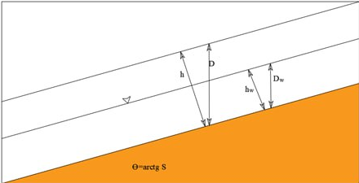
FIGURE 1. Model of an infinite slope scheme for calculating slope stability.

The relationship (1) can be transformed into the following form (2):

$F_{s}=\frac{C+cos\left[1-W_{r}\right]tgφ}{sinθ}$ (2)

where C - is the combined cohesion, dimensionless,
C = (C_{r} + C_{s}) / (hρg), where h = D cosθ, m; W - is the relative wetness,
W = D_{w}/D = h_{w}/h, unit fraction;
h - is the actual thickness of the layer, m; h_{w} - is the thickness of the water-bearing layer, m, h_{w} = D_{w} cosө; r - is the ratio of water density ρw - to soil density ρ, dimensionless, i.e., r=p_{w}/p.
From the practice of engineering and geological research, it is known that wetness is closely related to the hydrogeological characteristics of the area. The operational hydrological criterion, according to the authors of SINMAP, is the relative wetness (3):
$W=min\left(\frac{R}{T} \frac{a}{sinθ},1\right)$ (3)
where T = K_{t} - soil permeability coefficient, m²/day; K - filtration coefficient, m/day; m - aquifer thickness, m; a = A/b - specific area of water collection, calculated per unit length of the topographic profile (Fig. 2); R - effective water supply coefficient per unit area of groundwater, m/day; calculated by the formula:
$R=\left(I-E_{T}\right)K_{sr}$ (4)
Here, $K_{sr}$- is the dimensionless surface runoff coefficient, determined as the ratio of the volume of surface runoff in the catchment area during precipitation to the total volume of precipitation; I - is the indicator of precipitation intensity, m/hour; E_{T} - is the indicator of evaporation intensity, m/hour.

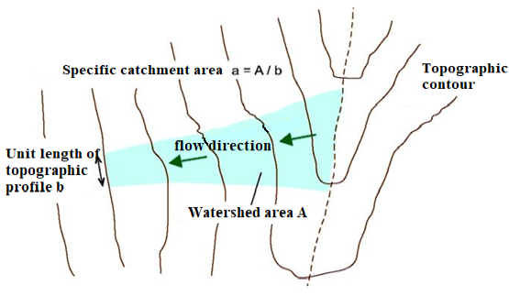
FIGURE. 2. Determination of specific catchment area.

By combining the calculation of slope stability according to the infinite slope scheme (2) with the hydrogeological approach (3), the following relationship is obtained:
$F_{s}=\frac{C+cosθ\left[1-min\left(\frac{R}{T} \frac{a}{sinθ},1\right)r\right]tgφ}{sinθ}$ (5)
The authors of the SINMAP model introduced the concept of the Slope Stability Index (SI), defined for both “unfavorable” and “favorable” parameter combinations.
$SI=F_{S,min}=\frac{C_{1}+cosθ\left(1-min\left[\frac{R_{1} a}{T_{1} sinθ},1\right]r\right)tanφ_{1}}{sinθ}$ (6),
where $F_{S,min}$ - the minimum slope stability factor, dimensionless; C₁ - minimum combined cohesion force N/m²; θ-degree of slope inclination, degrees; φ1 - minimum angle of internal friction of soils, degrees, R₁ - maximum effective water supply coefficient per unit area of groundwater, m/day; T₁ - minimum water permeability coefficient of soils, m²/day.
In a "favorable" combination of parameters (maximum strength properties of soils, minimum precipitation):
$SI=F_{S,max}=\frac{C_{2}+cosθ\left(1-min\left[\frac{R_{2} a}{2 sinθ},1\right]r\right)tanφ_{2}}{sinθ}$ (8),
where $F_{S,max}$ - maximum stability coefficient of the slope, dimensionless; C₂ - maximum combined clutch, N/m²; θ - slope angle, degrees; φ₂ - maximum angle of internal friction of soils, degrees; R₂ - minimum coefficient of effective groundwater supply per unit area, m/day; T₂ - maximum water permeability coefficient of soils, m²/day.
The values of φ, C, and R/T for the "favorable" and "unfavorable" combination of parameters when calculating the stability index of slopes in the Qamchiq pass region are presented in Table 1 - 2 [5].
Table 1 C and R/T values for a “favorable” and “unfavorable” combination of parameters when calculating the stability index of slopes in the Qamchiq pass zone.
TABLE 1. Values off, C, and R/T for "favorable" and "unfavorable" parameter combinations when calculating the slope stability index in the Qamchiq Pass region
Parameter combination | Age of landslide-prone deposits | g, m/s² | ρ_{w}, kg/m³ | ρ, kg/m³ | φ  grad | C | R/T
favorable | T3n-r hg | 9,81 | 1000 | 1982 | 15,2÷30,3 | 0,011÷0,340 | 0,00190÷0,00040
unfavorable | Q | 9,81 | 1000 | 1846 | 6,5÷29,3 | 0,010÷0,260 | 0,00083÷0,00036

In a broad sense, the stability index is a probabilistic concept and is related to the stability coefficient as follows (9):

S₁ = Prob (FS > 1) (9)

The schematic diagram of landslide risk zoning based on SINMAP is shown in Figure 3.
The use of SINMAP gives the best results in assessing the risk of shallow landslides.
A different approach to avalanche risk analysis, based on the morphometric criteria of slopes, was used in the ARCVIEW - SMORPH (slope morphology model) [1] calculation module.
The scientific and methodological aspects of this model are not new. Over the past few decades, geologists and engineers have assessed the important role of morphometric criteria in the development of landslide processes.
At the same time, mathematicians have developed a system of numerical equations for describing the relief of the Earth's surface.
This made it possible to create a landslide risk modeling procedure in a format convenient for use both in scientific analysis and in economic assessment of prospective development of territories [4].
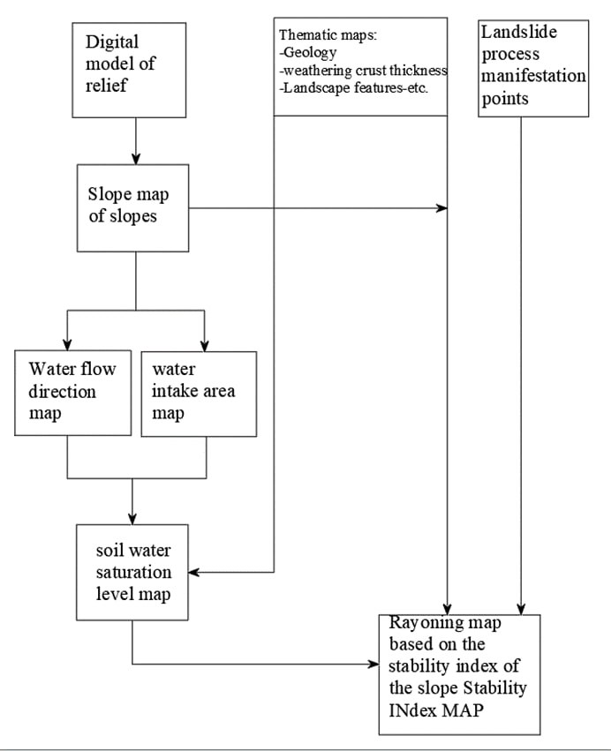
FIGURE 2. Conceptual diagram of landslide hazard zoning based on SINMAP.

The SMORPH computational model for assessing landslide risk is based on the assumption that the morphological characteristics of slopes (i.e., the slope gradient and the shape of surface curvature) are the most crucial factors in the development of small landslides. In this context, the slope gradient, on one hand, determines the ratio of retaining and displacing forces, and on the other hand, along with the thickness of landslide deposits and the shape of slope curvature, influences hydrological processes (the velocity of surface water movement), consequently determining the degree of soil water saturation. Thus, the SMORPH landslide risk assessment model reflects the susceptibility of the terrain to landslide processes.
This assertion is not unequivocal or definitive. However, independent tests of the theory linking morphometric criteria to the development potential of landslide processes, conducted in Washington state, have shown that 90% of all shallow landslides present in this area can be identified using the SMORPH model [5].
Input data for analysis: topographic base and morphometric analysis data of the area susceptible to landslide processes.
To obtain this data, readily available digital elevation models (DEM) are typically used, which is undoubtedly a significant advantage of the method.
Based on the combined analysis of the slope gradient of the hillside surface and its curvature (concave, flat, convex), a "morphometric matrix" of landslide hazard for the territory is compiled.
It is easy to obtain the slope gradient (in percent) of an inclined surface when the angle of inclination in degrees is known. Mathematically, the slope surface can be represented as a function that, in turn, can be approximated by a fourth-order polynomial [3]:
Z=Ax²y²+Bx²y+Cxy² Dx²+Ey²+Fxy+Gx+Hy+I (10)
In this case, the curvature of the slope surface can be taken as the second derivative of the aforementioned polynomial. If it is negative, the slope is convex; if positive, it is concave. The number and gradations of slope gradient classes are initially established based on remote sensing and field research data, or determined by analog objects for each geomorphologically uniform section of the territory. These are then extrapolated to all similar sections within the geological area. In the second stage, each element of the morphometric matrix is assigned a certain level of landslide risk, taking into account field study data.
The SMORPH model works well for predicting shallow landslides (less than 10 m) formed in eluvial-diluvial deposits. It is not intended for predicting the development of flow landslides, deep and complex-structured landslides.
In developing existing methods for assessing regional landslide risk, we will examine an improved approach that is conceptually similar to the geodynamic potential method - the method of assessing a territory's susceptibility to landslide processes.
To determine the area's susceptibility to landslide processes, it is necessary to identify the main factors causing their activation. For the Qamchiq pass region, the following key factors were selected based on remote sensing data:
• geological structure;
• thickness of deposits that may be prone to landslides (for rocky and semi-rocky soils - thickness of the weathering crust);
• steepness of slopes;
• landscape type.
The main criterion for considering a factor as a landslide hazard is the shape of the landslide distribution function, determined by the information classes of the factor under consideration. As an example (Fig. 4), two possible functions of such distribution are shown. As can be seen from this figure, factor 1 with a large dispersion actually poses less landslide risk compared to factor 2. It should be noted that the distribution curve is constructed based on the number of landslide process occurrences in each factor class (for example, in the "geological structure" factor, 6 classes were distinguished, in each of which a certain number of landslide process manifestations were identified).
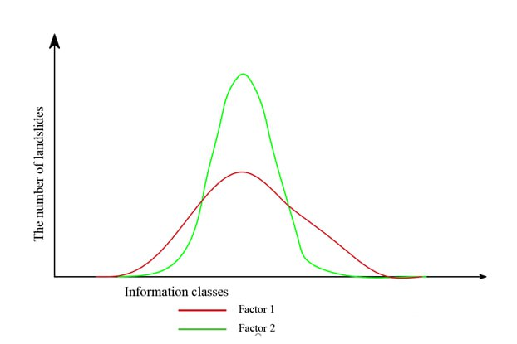
FIGURE 4. Distribution of landslides according to information classes for different influencing factors.
The graph illustrates the variation in the number of landslides associated with Factor 1 and Factor 2, indicating that Factor 2 has a stronger influence on landslide occurrence.

The standard deviation of the distribution function of identified landslides across information classes of the considered factor serves as the basis for determining its weight (w.u.), w_{j}. The weights of all (n) assessed factors are normalized so that their sum equals 1.
$w_{j}=1-\frac{σ_{j}}{\sum_{j=1}^{n}{σ_{j}}}$ (11)
where $σ_{j}$- j-is the standard deviation of the landslide distribution function, determined by the information classes of the j-th factor.
Table 2 shows the weights of landslide risk factors wj for the Qamchiq pass region. In turn, each of these factors is represented by information classes (Table 2).
The weights of information classes xij are normalized relative to the number of identified landslides in such a way that their sum for each factor equals 1:
$x_{ij}=\frac{The number of detected active landslides in this information class}{The number of identified active landslides across the entire studied area}$ (12)

Weights of factors significantly influencing landslide development in the Qamchiq pass region.
TABLE 2. Weights of factors significantly influencing landslide development in the Qamchiq Pass region
Factor | Weight w_{j}, d.b.
Geological structure | 0,337
Thickness of potentially hazardous deposits (for rocky and semi-rocky soils - thickness of the weathering layer) | 0,230
The steepness of inclines | 0,254
Type of landscape | 0,180
Amount | 1,000

The methodology for zoning the territory based on its susceptibility to landslide processes consists of the following. For each elementary plot of the area under consideration, the integral indicator H is calculated according to the following formula:
$H=\sum_{i,j=1}^{n}{w_{j}x_{ij}}$ (13)
Here, H - is an integrated indicator of susceptibility to landslide processes, dimensionless; w_{j} - is the weight of factor j, in units; x_{ij} - is the weight of factor j for class i, in units.
When creating a final map of the area's susceptibility to landslide processes, it is important to select appropriate levels for the H classification indicator.
This issue is resolved by choosing an optimal classification scale (taking into account the identified landslide risk factors for a specific area).
CONCLUSION
This study has confirmed that the integration of Geographic Information Systems (GIS) into regional landslide risk assessment significantly improves the precision, reliability, and interpretability of geohazard analyses. The combination of geological, hydrological, and morphometric parameters through models such as SHALSTAB, SINMAP, and SMORPH enables a detailed evaluation of slope stability and the spatial distribution of landslide susceptibility.
Results from the Qamchiq Pass region demonstrate that geological structure, deposit thickness, slope gradient, and landscape type are the dominant factors influencing landslide activity. Applying statistical weighting to these parameters made it possible to generate accurate hazard zoning maps that reflect real spatial variability in landslide-prone territories.
Overall, GIS-based methodologies outperform traditional analytical techniques by providing a comprehensive, data-driven decision-support framework for land use management, infrastructure safety, and disaster risk reduction. The proposed approach can therefore be recommended as an effective and scalable tool for regional geodynamic monitoring and sustainable territorial planning.
REFERENCES
- Petley, D. (2012). Global patterns of loss of life from landslides. Geology, 40(10), 927–930. https://doi.org/10.1130/g33217.1
- Lee, S., & Choi, J. (2004). Landslide susceptibility mapping using GIS and the weight-of-evidence model. International Journal of Geographical Information Systems, 18(8), 789–814. https://doi.org/10.1080/13658810410001702003
- M. Miralimov, Sh. Sh. Shojalilov, A. Karshiboev, and D. Usmanov, “Calculation method of reinforced concrete structures with account of nonlinear deformation of the material,” AIP Conf. Proc. 3045, 030078 (2024). https://doi.org/10.1063/5.0197797
- Deformation of railway track embankment with loess soil sections in Republic of Uzbekistan. Mirzakhid Miralimov; Abdullaziz Karshiboev; Ruslan Ospanov; Ismoil Mengliev; Dilshod Usmanov. AIP Conf. Proc. 3256, 030004 (2025) https://doi.org/10.1063/5.0266733
- Method for calculating the strength of metro tunnels linings interacting with soil. Abdullaziz Karshiboev; Dilshodbek Kayumov; Xusniddin Ergashev; Jamshidbek Raxmonov; Alimardon Esirgapov. AIP Conf. Proc. 3304, 030007 (2025). https://doi.org/10.1063/5.0269085
- Distinctive features and trends in CAD development highways in the GIS. Abdullaziz Karshiboev; Dilshod Kayumov, AIP Conf. Proc. 3256, 060005 (2025), https://doi.org/10.1063/5.0266988
- Juraev, D., Matkarimov, P., & Mirsaidov, M. (2023). Three-Dimensional stress state of earth dams under static loads. In Lecture notes in civil engineering (pp. 1–11). https://doi.org/10.1007/978-3-031-30570-2_1

