Optimized Impact Mechanism of Inclined Peg Drums for Smart Impurity Separation Systems
D.A. Djurayev¹, O.A. Qorachayeva^{2, a)}
¹ Tashkent Institute of Textile and Light Industry, Namangan, Uzbekistan
²Andijan Institute of Technology, Andijan, Uzbekistan

^{a)}Corresponding author: ismoilovaoltinoy87@gmail.com
Abstract: The article presents the structural scheme and operating principle of drums equipped with inclined rows of spikes and wave-shaped surface planks used in cotton cleaners for removing fine impurities. The impact interaction between the cotton tuft and the wave-shaped surface of the spiked drum plank has been studied. After the impact, the expressions for determining the velocities and deviation angles of the cotton tuft and the separated impurities have been derived. Based on the analysis of the obtained graphical relationships, the recommended values of the main parameters have been established.
Keywords: small impurities, angle, drum, plank, spike, motion trajectory.
INTRODUCTION
The invention relates to the cotton cleaning industry, in particular to the design of machines used for cleaning cotton from small impurities. In the known construction of a cotton cleaning unit, the sections for cleaning cotton from small and large impurities are combined. Under the brush drums, two saw-toothed drums are installed, with grids located beneath them. These grids serve as screens for cleaning the raw cotton from large impurities. In the fine cleaning section, in turn, spiked drums are arranged in sequence, with mesh surfaces placed underneath them.
The main drawback of this design is the low efficiency of cotton cleaning from impurities. In the fine cleaning section, the separated small impurities become mixed with larger impurities and fibers (fly waste), which creates additional difficulties during the recycling and secondary cleaning processes.
In another known construction of a device for cleaning raw cotton from small impurities — types “1XK” (cotton cleaning chamber) and “CCS-2” (cotton cleaning section) — a set of identically structured peg-plank drums arranged in series, four times in number, are used, with horizontal mesh surfaces located beneath them.
The main drawback of this design is also its low cleaning efficiency, since the pegs of the drums act on the cotton fibers along the mesh surface in a uniform and repetitive manner. Moreover, because the geometric and kinematic parameters of the drums are identical, each cleaning zone (drum–mesh pair) has low effectiveness, and as a result, the overall cleaning quality is not high.
To increase efficiency, the number of drum pegs has been increased; however, this leads to damage of cotton seeds and fibers. In addition, the fact that the drum pegs operate under uniform magnitude and direction of force also prevents effective cleaning of small impurities.
In another known design, the cotton cleaning unit section consists of four sequential drums equipped with spikes, planks (plates), and rubber ring-shaped bushings. The thickness of each subsequent drum’s bushing is made 10–15% smaller than that of the previous one (in the direction of cotton movement). Under the spiked-plank drums, mesh surfaces are installed, and in the lower part, there is a pneumatic device for removing separated small impurities. Each subsequent drum additionally performs high-frequency, small-amplitude oscillatory rotation, which ensures more efficient separation of impurities.
The main drawback of this design is its structural complexity and insufficient cleaning efficiency.
The main working element of cotton cleaning machines used for removing small impurities is the spiked-plank drum. To improve cleaning efficiency, in some designs, the drum shells are made multifaceted.
However, this solution is also not efficient, since all drums are identical; as a result, the overall cleaning efficiency remains low. Moreover, the rotation of the multifaceted spikes around their own axes increases the damage to cotton fibers.
In another known design, the fiber material cleaner consists of a fine-cleaning zone with peg-plank drums and meshes beneath them, and a coarse-cleaning zone with saw-toothed drums, grids, brushes, and waste bunkers. The spikes on the drum surface are arranged along a helical line. The helix angle of the first fine-cleaning zone differs from that of the second and third zones. The grids are made multifaceted, and their edges are rotated relative to their axes. The rotation angle for the first, second, and third zones is selected differently. Moreover, in adjacent drums, both the direction of the helix of the spikes and the rotation angle of the grid edges are made opposite.
The main drawback of this design is also its structural complexity and low cleaning efficiency.
The main working element of machines designed to clean raw cotton from small impurities remains the spiked-plank drum. To enhance cleaning efficiency, some designs employ multifaceted drum shells.
However, this approach is also ineffective because all drums are identical, so the overall cleaning efficiency remains low. In addition, the rotation of multifaceted spikes around their axes increases fiber damage.
In another known design, the fiber material cleaner includes a fine-cleaning zone equipped with peg-plank drums and meshes beneath them, and a coarse-cleaning zone equipped with saw-toothed drums, grids, brushes, and waste bunkers. The spikes on the drum surface are arranged along a helical line. The helix angle in the first fine-cleaning zone differs from that of the second, and the second differs from that of the third. The grids are made multifaceted, with their edges rotated relative to their axes. The rotation angles for the first, second, and third zones are selected differently. Furthermore, in adjacent drums, both the direction of the spike helix and the rotation angle of the grid edges are made opposite.
The drawback of this design is that the cleaning efficiency remains low, while the degree of fiber damage is high.
Additionally, in peg-plank drums, the planks do not sufficiently transport the cotton; instead, they only create an air flow in the direction of drum rotation. Therefore, the planks do not effectively participate in the process of loosening the cotton, which reduces the overall cleaning efficiency.
The purpose of the invention is to improve the efficiency of cleaning cotton from small impurities while preserving the natural properties of the fiber to the maximum extent possible. This objective is achieved by improving the design of the cleaner — specifically, by installing twelve spiked-plank drums, which expand the cotton’s motion trajectory and ensure more efficient cleaning.
The essence of the construction lies in the fact that the fibrous material cleaner consists of twelve spiked-plank drums, whose planks and spikes are positioned at an angle relative to the drum axes. The planks and spikes of adjacent drums are arranged in opposite directions, which causes the cotton to move both longitudinally and transversely, improving fiber separation.
The drums are grouped as follows:
The first four drums are set at an angle of 15°, the next four drums at 10°, the last four drums at 5°.
The feeding rollers are located above the third and fourth drums of the first group. The planks of the drums are made in a sinusoidal curved shape, which increases the oscillation amplitude of the cotton during the cleaning process.
The angular velocities of the drums increase step by step:
The first four drums rotate at the same angular velocity, powered by an individual drive;
-The next four drums rotate 10% faster than the first group;
-The last four drums rotate 10% faster than the second group.
The operating principle is as follows:
In the first zone (15°), the less loosened cotton (with two or more attached fibers — is processed. At this stage, the surface layer of cotton is cleaned from external impurities. The planks move the cotton not only in the rotational direction but also transversely, which promotes more efficient fiber separation. As a result, the motion trajectory of the cotton expands, and more small impurities are removed.
In the second zone (10°), the more loosened cotton moves along a wider trajectory on the mesh surface, allowing deeper removal of small impurities. In the third zone (5°), the already loosened cotton fibers are passed over the mesh surface, ensuring effective removal of fine impurities from the inner layers of the fiber mass and their discharge. The gradual increase in the angular velocity of the drums prevents clogging of the working chamber, ensures smooth material flow, and significantly enhances the overall cleaning efficiency.
The design is illustrated with drawings: Figure 1 — General view of the fibrous material cleaner;
Figure 1a — Drum with planks and spikes arranged at an α-angle relative to the drum axis.
The fibrous material cleaner, primarily intended for processing raw cotton, consists of twelve drums with rows of planks and spikes arranged at an angle to the drum axis.
The first four drums (1, 2, 3, and 4) are equipped with sinusoidally curved planks (22) and spikes (19) positioned at an angle of 15°. The next four drums (5, 6, 7, and 8) have planks (23) and spikes (20) installed at an angle of 10°, while the last four drums (9, 10, 11, and 12) are fitted with planks (24) and spikes (21) set at an angle of 5°. Beneath the spiked-plank drums, there are mesh surfaces (14, 15, and 16) designed for separating impurities. Under each group of four drums, augers (17) are installed to remove the collected waste materials.
The drive system of the cleaner is designed in such a way that the first four drums (1–4) rotate with an angular velocity $ω_{1}$. The next four drums (5–8) rotate at an angular velocity $ω_{2},$ which is 10% higher than that of the first group. Hence, the relationship between them is $ω_{2}$ = 1.1$ω_{1}.$The last four drums (9–12) operate at an angular velocity $ω_{3}$= 1.1$ω_{2}$ providing a gradual increase in drum speed along the cleaning path.
The cleaner operates as follows: Raw cotton is fed by the feeding rollers (13) onto the third and fourth drums. The planks and spikes (19) lift the cotton upward and transfer it onto the first drum. The first drum moves the cotton both downward and laterally. The sinusoidally shaped planks (22) and spikes (19), positioned at an angle of 15°, capture the denser cotton tufts (with two or more attached fibers and move them along a complex trajectory, ensuring effective separation of surface impurities.
The partially loosened cotton (with one to two attached fibers) is then drawn by the planks (23) and spikes (20) of the second group of drums, which are positioned at an angle of 10°. In this zone, the cotton is cleaned more deeply from small impurities contained in the inner layers of the fiber mass.
Finally, in the last cleaning zone, the planks (24) and spikes (21) positioned at an angle of 5° act on the mostly single-fiber cotton. These fibers move at high speed along the mesh surface (16), where they are efficiently freed from fine impurities.
The separated waste passes through the mesh surfaces (14, 15, 16) and is discharged by means of the augers (17). The sinusoidal shape of the planks not only ensures smooth transportation of the cotton but also provides a loosening effect, enhancing impurity removal through pulsating air flow generated both in the rotational and transverse directions of the drums.
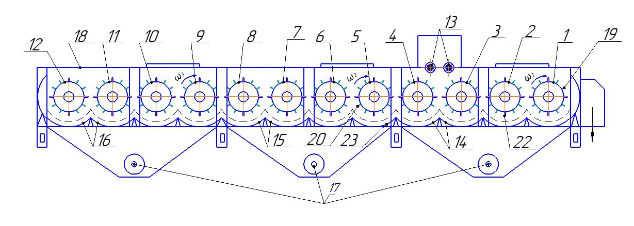
FIGURE 1. Constructive layout of the fibrous material cleaner consisting of twelve spiked-plank drums for fine impurity removal
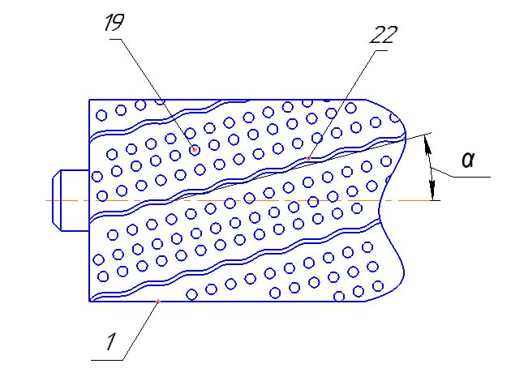
FIGURE 1a. Drum with planks and spikes arranged at an angle α to the drum axis.

Impact Interaction Calculations Between the Cotton Tuft and the Wavy Plank Surface. When the cotton tufts are fed onto the spiked-plank drum by the feeding rollers, they come into contact with the spikes and the wavy planks of the drum. During this interaction, the wavy surface of the plank exerts an impact action on the cotton tuft, causing intensive separation of impurities — especially the fine ones.
The schematic diagram of the impact interaction between the wavy plank surface and the cotton tuft is presented in Figure 2.
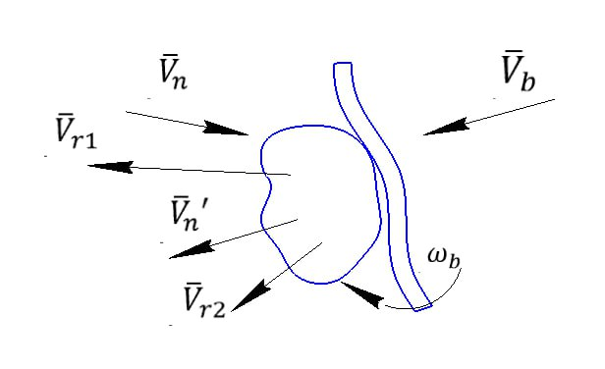

FIGURE 2. Schematic diagram of the impact interaction between the cotton tuft and the wavy plank surface

Here, $V_{b}$– linear velocity of the drum, $ω_{b}$– angular velocity of the drum; $V_{n}$ – impact velocity of the plank; $V_{n}^{ˈ}, V_{r1},V_{r2}$– rebound velocities of the cotton impurities.

As can be seen from Figure 2, when the cotton tuft collides with the wavy surface of the plank, the impurities contained within the tuft acquire different rebound velocities as a result of the impact.
Since the wavy planks are inclined, the velocities and impact forces acting during the interaction between the cotton tuft and the plank surface have spatial components, which are illustrated in Figure 3.

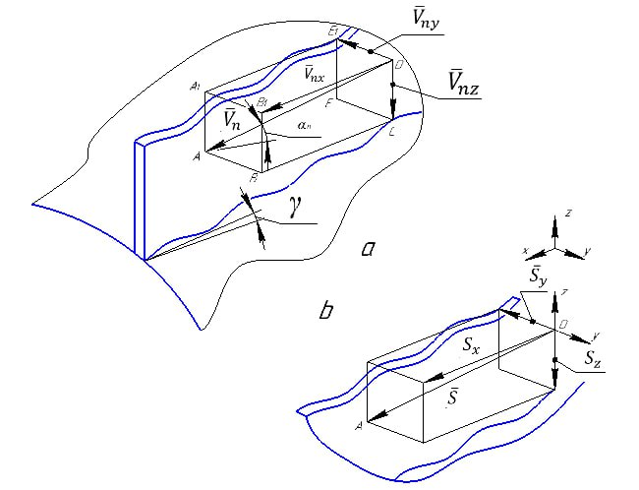

FIGURE 3. Analysis of the spatial components of velocities (a) and impact forces (b) arising from the interaction of a cotton tuft with the wavy surface of the plank.
The relationship between the projections of the impact force under dynamic loading is determined taking into account the coefficient of friction during impact.
According to Raus [6]’s hypothesis, the corresponding analytical expressions are derived.
$S_{X}=f_{1}S_{y}$ $S_{y}=f_{2}S_{z} S_{z} =f_{3}S_{x }$ (1)
Here: $S_{X}$, $S_{y},$ $S_{z}$- the components of the impact force along the respective coordinate axes - $f_{1}$, $f_{2}$ $f_{3}$ are the coefficients of friction between the cotton tuft and the wavy surface of the plank along the corresponding coordinate directions, respectively [7, 8].

$\overline{\overline{S}}$=${\overline{\overline{S}}}_{x}+{\overline{\overline{S}}}_{y}+{\overline{\overline{S}}}_{z}$ (2)
$$S=\sqrt{S_{x}^{2 }+S_{y}^{2}}+S_{z}^{2}$$
Based on the impact theory and taking into account the corresponding calculation scheme, Figure 3. Analysis of the spatial components of velocities (a) and impact forces (b) arising from the interaction of a cotton tuft with the wavy surface of the plank.
$$m_{n}\left({\bar{\bar{V}}}_{n}-{\overline{\overline{V}}}_{n}^{ˈ}\right)={\overline{\overline{S}}}_{;}$$
$m_{r1}=\left({\bar{\bar{V}}}_{n}-{\overline{\overline{V}}}_{21}\right)=S$ (3)
$$m_{r2}=\left({\bar{\bar{V}}}_{n}-{\overline{\overline{V}}}_{22}\right)=S$$
Considering the obtained system (4) along the coordinate axes, for the larger cotton tuft,
$$m_{n}\left(V_{n }cosα_{n}\sin{β_{n}}-V_{n}^{ˈ}cosa_{n}^{ˈ}\sin{β_{n }^{ˈ }}\right)=S_{x}$$
$m_{n}\left(V_{n }cosα_{n} cosβ_{n}-V_{n}^{ˈ}cosa_{n}^{ˈ} {cosβ}_{n }^{ˈ }\right)=S_{y}$ (4)
$$m_{n}\left(V_{n }\sin{α_{n}}-V_{n}^{ˈ}sina_{n}^{ˈ} \right)=S_{z}$$
for the first type of impurity,
$m_{r1}\left(V_{n }cosα_{n}\sin{β_{n}}-V_{r1}cosa_{r1}\sin{β_{n }^{ }}\right)=S_{x}$
$m_{r1}\left(V_{n }cosα_{n} cosβ_{n}-V_{r1}^{ˈ}cosa_{r1}^{ˈ} {cosβ}_{r1 }^{ˈ }\right)=S_{y}$ (5)
$$m_{r1}\left(V_{n }\sin{α_{n}}-V_{r1}^{ˈ}sina_{r1}^{ˈ} \right)=S_{z}$$

for the second type of impurity,
$$m_{r2}\left(V_{n }cosα_{n}\sin{β_{n}}-V_{r2}cosa_{r1}\sin{β_{r2 }^{ }}\right)=S_{x}$$
$$m_{r2}\left(V_{n }cosα_{n} cosβ_{n}-V_{r2}cosa_{r2}^{ˈ} {cosβ}_{r2 }^{ˈ }\right)=S_{y}$$
$$m_{r2}\left(V_{n }\sin{α_{n}}-V_{r2}^{ˈ}sina_{r2}^{ˈ} \right)=S_{z}$$
Where: $m_{n}, m_{r1}, m_{r2}$- the masses of the cotton tuft and the separated small impurities; $α_{n}, β_{n}, α_{r1 }, β_{r2}-$the angles between the corresponding velocity vectors along the coordinate axes. Using the method described in [9, 10], taking into account the velocities resulting from the impact of the cotton tuft and the separated impurities $m_{r1} va m_{r2}$ with the wavy surfaces of the planks, we derive expressions for determining their restitution coefficients.
$K_{n}=\frac{V_{n}^{ˈ}cosa_{n}^{ˈ}sin β_{n }^{ˈ }}{V_{n }cosα_{n}sin β_{n}}$ (6)
$K_{r1}=\frac{V_{r1}cosa_{r1}sin β_{r1 }}{V_{n }cosα_{n}sin β_{n}}$
$K_{r2}=\frac{V_{r2}cosa_{r2}sin β_{r2 }^{ }}{V_{n }cosα_{n}sin β_{n}}$
where: $K_{n}, K_{r1}, K_{r2}-$ for the cotton tuft and the separated impurities $m_{r1} va m_{r2}$ the restitution coefficients of the impurities after impact with the wavy surface.
Taking into account the obtained expressions (6) and based on (5), the Y-axis component of the impact impulse force for the cotton tuft is determined [11, 12].
$$S_{y}=m_{n}V_{n}\left(K_{n}+1\right)sina_{n}sinβ_{n}$$
For the impurities,

$S_{y}=m_{r1}V_{n}\left(K_{r1}+1\right)sina_{n}sinβ_{n}$ (7)
$$S_{y}=m_{r2}V_{n}\left(K_{r2}+1\right)sina_{n}sinβ_{n}$$
In this case, taking into account expression (1),
$$S_{x}=f_{1}m_{n}V_{n}\left(K_{n}+1\right)sina_{n}sinβ_{n}$$
$S_{x1}=f_{2}m_{r1}V_{n}\left(K_{r1}+1\right)sina_{n}sinβ_{n}$ (8)
$$S_{x2}=f_{3}m_{r2}V_{n}\left(K_{r2}+1\right)sina_{n}sinβ_{n}$$
By applying the obtained expressions for the components of the impact impulse (7) and (8) along with the scheme (5), and after a series of transformations, the formulas for calculating the post-impact velocities of the cotton tuft and the separated impurities, as well as their deflection angles, resulting from interaction with the inclined wavy surfaces of the drum planks, were derived [13, 14].

$V_{n}^{ˈ}$=$V_{n}\sqrt{K_{n}^{2} \cos^{2}α_{n}\sin^{2} β_{n}+{\left[ {cosα}_{n } {\sin{β_{n}-f}}_{1} \left(K_{r1}+1\right)sina_{n}sinβ_{n}\right]}^{2}}$

$α_{n}^{ˈ}=arctg\left[\frac{{cosα}_{n}sinβ_{n}-\left(K_{n}+1\right)fsina_{n}sinβ_{n}}{K_{n} cosα_{n}sin β_{n}}\right]$

$V_{r1}^{ˈ}$=$V_{n}\sqrt{K_{r1}^{2} \cos^{2}α_{n}\sin^{2} β_{n}+{\left[ {cosα}_{n } \sin{β_{n}-} f_{2}\left(K_{r1}+1\right)sina_{n}sinβ_{n}\right]}^{2}}$

$α_{r1}^{ˈ}=arctg\left[\frac{{cosα}_{n}sinβ_{n}-f_{2}\left(K_{r1}+1\right)fsinα_{n}sinβ_{n}}{K_{r1} cosα_{n}sin β_{n}}\right]$ (9)

$V_{r2}^{ˈ}$=$V_{n}\sqrt{K_{r2}^{2} \cos^{2}α_{n}\sin^{2} β_{n}+{\left[ {cosα}_{n } {\sin{β_{n}-f}}_{3} \left(K_{r1}+1\right)sina_{n}sinβ_{n}\right]}^{2}}$

$α_{r2}^{ˈ}=arctg\left[\frac{{cosα}_{n}sinβ_{n}-f_{3}\left(K_{r2}+1\right)sinα_{n}sinβ_{n}}{K_{r2} cosα_{n}sin β_{n}}\right]$
Analysis of the obtained system (9) indicates that the post-impact velocities and deflection angles of the cotton tuft and the separated impurities in various directions, after interaction with the wavy plank surfaces, decrease significantly as their coefficients of friction increase. Within the range of parameter variation, it is important to determine the variation laws of the post-impact velocities $V_{n}^{ˈ}$,$V_{r1}^{ˈ},$ $V_{r2 }^{ˈ}$and the corresponding deflection angles $α_{n}, α_{r1},α_{r2}$for the cotton tuft and the separated impurities $m_{r1} va m_{r2}$.
NUMERICAL SOLUTION AND ANALYSIS OF THE PROBLEM
$$m_{n}=\left(0,2։0,8\right){10}^{-3}kg;$$
$m_{r1}=\left(0,6։0,8\right){10}^{-4}kg$;
$m_{r2}=\left(0,9։1,3\right){10}^{-4}kg$;
$f_{1}=\left(0,2։0,4\right);$ $f_{2}=\left(0,1։0,15\right); { f}_{3}=\left(0,08։0,12\right);$
$ω_{b}=\left(44։54\right){c^{-1}; α}_{n}=\left(25°։55°\right)$
$K_{n}=\left(0,2։0,3\right)$; ${ K}_{r1}=\left(0,4։0,5\right)$
${ K}_{r2}=\left(0,55։0,65\right){; β}_{n}=\left(15։30\right){ ; K}_{r2}=\left(0,55։0,65\right)$.

It should be noted that in the formulas for calculating the obtained velocities and deflection angles, when taking into account the centrifugal force due to the angular velocities of the spiked-plank drums, the resulting overall velocities are determined [15, 16].
$$V_{na}^{ˈ}=\sqrt{{(V_{n}^{ˈ})}^{2}+ω_{b}^{2}\frac{D δ+h_{n}}{2}}$$
$V_{r1}^{ˈ}=\sqrt{{(V_{r1}^{ˈ})}^{2}+ω_{b}^{2}\frac{D δ+h_{n}}{2}}$ (10)
$$V_{r2}^{ˈ}=\sqrt{{(V_{r2}^{ˈ})}^{2}+ω_{b}^{2}\frac{D δ+h_{n}}{2}}$$
Here, D$δ$- is the inner diameter of the spiked-plank drum, and $h_{n}$​ is the height of the plank.
Graphs illustrating the dependence of the post-impact velocity of the cotton tuft and the velocities of the separated impurities on the variation of parameters were constructed for the recommended spiked-plank drum of the cotton cleaner, where the tuft interacts with the wavy surface of the plank. Analysis of these graphs allowed the determination of the recommended drum parameters. These results are shown in Figure 4.

FIGURE 4. Graph of the dependence of the cotton tuft and separated impurities velocities on the variation of the drum angular velocity in the cotton cleaner after impact with the wavy plank surface.

Analysis of the obtained graphs shows that when the angular velocity of the pin-plank drum is varied from 36.5 $c^{-1}$to 52 $c^{-1}$and the inclination angle of the wavy surface is 25º, the post-impact velocity of the cotton piece ranges from 1.38 m/s to 1.82 m/s, showing a linear relationship. Meanwhile, the velocity of the secondary cotton-separated waste increases nonlinearly from 1.91 m/s to 3.15 m/s. Correspondingly, the velocity of the primary waste ranges from 3.09 m/s to 4.63 m/s (Figures 4.5, 6-graphs). If the inclination angle of the pin-plank drum is reduced to 15°, the post-impact velocity of the cotton piece increases from 1.7 m/s to 2.42 m/s. The velocity of the secondary waste increases from 2.41 m/s to 3.46 m/s, and the velocity of the primary waste rises from 3.31 m/s to 5.53 m/s in a nonlinear pattern. The main reason for this is that the mass of the secondary waste is not greater than that of the primary waste. Taking into account the faster exit of cotton pieces from the cleaning zone, it is considered optimal for the angular velocity of the pin-plank drum to be in the range of 46–50 $c^{-1}$
It is known that the higher the impact force of the cotton piece on the inclined wavy plank surface, the higher the velocities of the cotton piece and the separated waste, which also increases the cleaning efficiency. Moreover, due to the faster movement of cotton pieces through the cleaning zones, the work productivity significantly improves (see Figure 5).

FIGURE 5. A graph showing the relationship between the rebound velocities of fine impurities separated after the cotton impacts the wavy plank surface in the cleaner and the impact angle of the collision.
It is evident that as the impact angle of the cotton piece on the plank surface increases, the impact force along the transport direction of the cotton also increases. Consequently, the post-impact velocity of the cotton piece decreases.
Specifically, when the impact angle varies from 12° to 40° and the plank inclination angle is 15°, the cotton piece velocity decreases linearly from 2.96 m/s to 1.72 m/s. When the plank inclination angle ${ β}_{n}=25º$, the cotton piece velocity decreases from 2.4 m/s to 1.62 m/s. Similarly, the velocity of the separated waste of mass $m_{r1}$decreases from 4.7 m/s to 3.17 m/s at$β_{n}=15º$ , while for ${ β}_{n}=25º$ $V_{r2}^{ˈ}$ decreases nonlinearly from 5.08 m/s to 3.92 m/s. The velocity of the separated waste of mass $m_{r2}$decreases from 4.1 m/s to 2.67 m/s at $β_{n}=15$°, and for $β_{n}=25ºda$, $V_{r2}^{ˈ}$ decreases from 3.81 m/s to 2.5 m/s.
To ensure the recommended post-impact velocity of the cotton piece, it is advised that the inclination angle during impact $α_{n}$ be within the range of 28$˚$ –35$˚$.
It should be emphasized that the cotton piece attains a high velocity simply because it moves fast enough and interacts with the inclined wavy planks; as a result, its post-impact velocities are correspondingly high.

FIGURE 6. Graphs showing the change in velocities of the cotton and separated waste after the cotton impacts the drum wave surface in the cleaner, in relation to their pre-impact velocities.

According to the analysis of the constructed graph patterns, when the velocity of the cotton piece exiting the drum increases from 3.1 m/s to 7.4 m/s, and the drum angle is $α_{n}=20˚$, the values of $V_{na}$ increase from 1.61 m/s to 2.36 m/s.
It should be noted that the velocity of the separated waste $m_{r1}$ at $α_{n}=20˚$ increases from 1.81 m/s to 2.89 m/s, while at $α_{n}=35˚$, the $V_{r1}$ values rise from 2.24 m/s to 3.34 m/s in a non-linear relationship (see Fig. 6, Graphs 2 and 5).
Similarly, the velocities of the second type of waste, $m_{r2}$ increase from 2.51 m/s to 4.53 m/s, and at $α_{n}=35˚$, from 2.4 m/s to 4.16 m/s, also showing a non-linear trend (see Fig. 6, Graphs 3 and 6). The recommended velocity for the cotton piece to reach the impact point is $V_{n}≥(6,2÷6,8)$

FIGURE 7. Graph of the acceleration of the cotton piece and the separated waste after impact with the wavy surface of the recommended pegged-plank drum, depending on the coefficient of friction with the plank surface.
As a result of the research, Figure 7 shows the graphs of the velocities of the cotton piece and the separated waste after impact with the wavy surface of the pegged-plank drum, depending on the coefficient of friction with the plank surface.
1-$V_{na}=f\left(f_{1}\right)$; 1-$V_{r2}=f\left(f_{3}\right)$; 1-$V_{r1}=f\left(f_{2}\right)$;
The coefficient of friction between the cotton piece and the plank surface is significantly higher than that between the waste and the plank. Analyzing the obtained graph patterns, it can be noted that when $f_{1}$ values increase from 0.15 to 0.40, the velocity $V_{na}$ decreases from 4.2 m/s to 2.23 m/s in a non-linear relationship (Figure 7, Graph 1).
Similarly, the post-impact velocity of the $m_{r2}$massed waste decreases from 3.9 m/s to 2.76 m/s in a non-linear trend, while the velocity of the $m_{r1}$massed waste decreases from 4.74 m/s to 3.61 m/s (Figure 7, Graphs 2 and 3).
Therefore, to ensure higher post-impact velocities of the cotton piece and the separated waste with the plank, it is advisable to keep their coefficients of friction with the plank surface low.
$$f_{1}≤0,26; f_{2}≤0,15; { f}_{3}≤0,1;$$
The restitution coefficient is calculated as the parameter that expresses the loss of velocity of the cotton piece during impact with the wavy-surfaced inclined planks. Figure 8 shows the graphs of the velocities of the cotton piece and the separated waste in the pegged drum with inclined planks, after impact, depending on their restitution coefficients at impact in the cotton cleaner for removing fine impurities.

FIGURE 8. Graph of the accelerations of the cotton piece and the separated waste after impact with the inclined planks of the pegged drum in the cotton cleaner for fine impurities, depending on their restitution coefficients at impact.

$V_{na}=f\left(\frac{K_{r1}+K_{r2}}{2K_{n}}\right)$ $V_{r2}=f\left(\frac{K_{r1}+K_{r2}}{2K_{n}}\right)$ ${ V}_{r1}=f\left(\frac{K_{r1}+K_{r2}}{2K_{n}}\right)$
It should be noted that the restitution coefficients of the waste are significantly higher than those of the cotton piece. This is because the fibers in the cotton piece have a high ability to absorb impact energy. According to the analysis of the constructed graphs, as the restitution coefficients increase, when their ratio values grow from 1.9 to 5.7, the absolute velocities of the cotton piece after impact increase from 1.23 m/s to 2.4 m/s, while $V_{r1}$rises from 2.5 m/s to 4.6 m/s (Figure8, Graph 3).
Similarly, the absolute post-impact velocities of the $m_{r2}$massed waste separated from cotton increase in a non-linear relationship from 2.05 m/s to 3.94 m/s (Figure 8, Graph 2). The main reason is that the higher the mass of the waste, the lower its restitution coefficient at impact.
The recommended values of the restitution coefficient ratio are …
$$\frac{K_{r1}+K_{r2}}{2K_{n}}≥\left(2,9÷4,0\right)$$
In the recommended pegged drum, the planks are installed at an inclined angle, causing the cotton pieces to move in a complex manner within the cleaning zone. In this case, the horizontal movement of the cotton piece depends on both the inclination angle of the planks and the velocity parameters. Among these factors, the inclination angle of the planks has a more significant influence on the movement speed.

FIGURE 9. Graphs of the velocities of the cotton piece and the separated waste after interaction with the wavy-surfaced planks in the cleaner, depending on the inclination angle of the planks.
Analysis of the plotted data shows that increasing the tilt angle of the pegged drum’s wavy plates from 12° to 36° produces a nonlinear decrease in post-impact absolute velocities. Specifically, the cotton fragment’s speed falls from 2.35 m/s to 1.17 m/s; the residue of mass $m_{r1}$ decelerates from 4.05 m/s to 2.50 m/s; and the residue of mass $m_{r2}$ decreases nonlinearly from 3.09 m/s to 1.73 m/s after impact with the plate surface.
CONCLUSION
These results indicate that a larger plate tilt increases the horizontal components of the velocities for both cotton fragments and residues while reducing their absolute velocities in the cleaning direction. For effective separation performance, a recommended plate inclination is therefore ${ β}_{n}≤\left(20˚-25˚\right).$ An efficient structural scheme of the pegged drum cleaner equipped with inclined wavy-surfaced plates for removing small impurities from cotton has been examined. Based on theoretical studies, graphs were obtained to determine the absolute velocities of cotton pieces and residues of different masses after impact. From the numerical solutions and analysis of the constructed graphs, the recommended values of drum and plate parameters were determined.
REFERENCES
- Peng, Q., Li, C., Kang, J., & Shi, G. (2020). Research and experiments on a separation mechanism for Film-Impurity aggregates using a pneumatic cylinder sieve. Transactions of the ASABE, 63(5), 1361–1370. https://doi.org/10.13031/trans.13959
- Mukhamadieev, D. M., & Ergashev, I. O. (2023). Calculation of radial and tangential velocities of the raw cotton roller in the working chamber of a saw gin. Izvestiya Vysshikh Uchebnykh Zavedeniĭ. Seriya Tekhnologiya Tekstil'noi Promyshlennosti, (2), 191–195. https://doi.org/10.47367/0021-3497_2023_2_191
- Amonov, A., Djuraev, A., Kuryozov, U., Shokirova, S., & Korabayev, S. (2023b). Determination of the friction force between the roller of the polymer composition coating equipment on the seams of tarpaulin materials and the surface of the tarpaulin. AIP Conference Proceedings, 2789, 040053. https://doi.org/10.1063/5.0145792
- Ren, X., Dai, F., Zhao, W., Shi, R., Chen, J., & Chang, L. (2025). Progress in mechanized harvesting technologies and equipment for minor cereals: a review. Agriculture, 15(15), 1576. https://doi.org/10.3390/agriculture15151576
- Zhao, J., Guo, M., Lu, Y., Huang, D., & Zhuang, J. (2020). Design of bionic locust mouthparts stubble cutting device. International Journal of Agricultural and Biological Engineering, 13(1), 20–28. https://doi.org/10.25165/j.ijabe.20201301.5031
- Ergashev, I., Primov, B., & Abdusalomov, M. (2023). Study of the 125 mm diameter seed-removing tube performance. E3S Web of Conferences, 390, 06017. https://doi.org/10.1051/e3sconf/202339006017
- Ghosh, J., Repon, M. R., Pranta, A. D., Rupanty, N. S., Khan, F., & Noor, T. (2025). Bioactive component integrated textiles: A promising source of medicine and healthcare. Journal of Engineered Fibers and Fabrics, 20. https://doi.org/10.1177/15589250241308561
- Mukhammadiev, D., & Ergashev, I. (2023). Investigation of seeds mechanical extraction through the seed-removing device from saw gin. E3S Web of Conferences, 390, 06011. https://doi.org/10.1051/e3sconf/202339006011
- Nasirian, K., & Taheri, H. (2019). EPRA International Journal of Research & Development (IJRD). EPRA International Journal of Research & Development (IJRD). https://doi.org/10.36713/epra2016
- Djuraev, A., Sayitkulov, S., Rajabov, O., Kholmirzaev, J., & Haydarov, B. (2022). Analysis of the impact effect of a piece of cotton with a flat surface with a multi-sided grates slope. Journal of Physics Conference Series, 2373(2), 022048. https://doi.org/10.1088/1742-6596/2373/2/022048
- Djuraev, A., Rosulov, R., Kholmirzaev, J., Diyorov, H., & Berdimurodov, U. (2021). Development of effective construction and justification of parameters of the cleaner of fibrous material. E3S Web of Conferences, 304, 03031. https://doi.org/10.1051/e3sconf/202130403031
- Djuraev, S., & Tursunov, A. (2025). Effect of particle size and concentration on multicyclone device efficiency. AIP Conference Proceedings, 3304, 030049. https://doi.org/10.1063/5.0269110

