Kinematic Analysis of a Newly Designed Adjustable Joint

Bakhtiyor Haydarov^{a)}, Mukhammadziyo Ismanov, Hakim Abdullayev, Azizbek Askarov, Rustamjon Rakhimov

Namangan State Technical University, Namangan, Uzbekistan

^{a)}Corresponding author: bahtiyorhaydarov944@gmail.com
Abstract: This article investigates the kinematic analysis of a newly designed adjustable joint for the BR1825A robot manipulator. Using the classical and modified Denavit–Hartenberg (D–H) methodologies, a complete mathematical model of forward and inverse kinematics was established. Simulation in MATLAB software substantiated the accuracy of the model, which, as can be seen, provides a theoretical basis for trajectory optimization and control algorithms in production applications.
Keywords: robot manipulator, Denavit-Hartenberg, joint, kinematics, BRTIRPZ1825A, MATLAB simulation, industrial automation, mathematical, model, parameter.

INTRODUCTION
In industry, robotic manipulators are key components of modern manufacturing systems. Their accurate and reliable operation depends on accurate mathematical models that drive their motion. [1] The Denavit–Hartenberg (D–H) convention is one of the most widely used methods for describing the spatial states between successive links. [2] The BR1825A robotic manipulator manufactured by BORUNTE includes five joints: four rotary and one prismatic, which provide complex spatial motion. This study aims to create a complete kinematic model and verify it through computational simulation. [3]
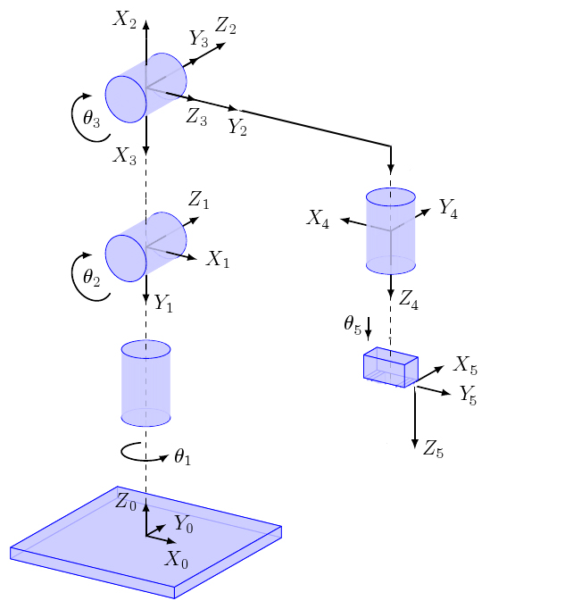
FIGURE 1. Kinematic drawing of a robot manipulator
The performance requirements of a robot manipulator depend on repeatability, accuracy, and speed. The BR1825A model has a payload capacity of 25 kg, a reach of 1800 mm, and repeatability of ±0.08 mm. Understanding its kinematic structure is a prerequisite for developing control strategies, path planning, and optimization algorithms.
The values of the robot manipulator are shown in Figure 2.
The BORUNTE robot manipulator model BRTIRPZ1825A is a multi-joint (usually 6 or 5+1) manipulator used in industrial production, with a load capacity of up to 25kg, a working radius of 1800mm. The repeatability of this model is around ±0.08mm and it operates with a power consumption of 7.33kW. The total weight of the robot is about 256kg, and the rotation (or displacement) limits and maximum speeds of the joints are clearly indicated in the catalog. BRTIRPZ1825A can be mainly used in various automated processes such as welding, assembly, painting, palletizing.

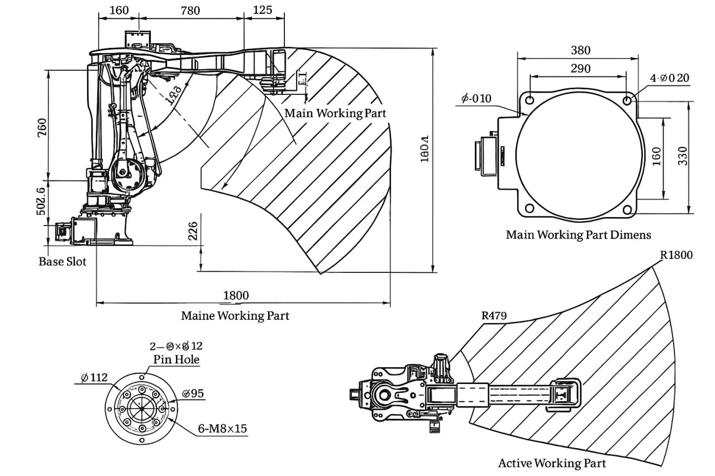
FIGURE 2. Dimensions of the main working parts of the BR1825A Robot Manipulator
The kinematic diagram of the BR1825A Robot Manipulator is shown in Figure 1. The robot manipulator has four rotary and 1 prismatic joint, the axis of each joint and the angles θ i representing it are shown. Rotation around each joint serves to control the position and orientation of the robot's working body (end effector). The joints are arranged in the following order: In Table 1 below 5‐jointli robot DH parameters are provided to generate the forward kinematics equation of the manipulator.

TABLE 1. DH parameters for the kinematic model of the BR1825A robot manipulator.
Joint | $$a_{i}$$ | $$a_{i}$$ | $$d_{i}$$ | $$θ_{i}$$
1 (turnover) | 0 | 0 | 502 | $$q_{1}$$
2 (turnover) | $$π/2$$ | 180 | 0 | $$q_{2}$$
3 (turnover) | 0 | 760 | 0 | $$q_{3}$$
4 (turnover) | $$π/2$$ | 885 | 0 | $$q_{4}$$
1 (prismatic) | 0 | 0 | 90 | $$q_{5}$$

MATHEMATICAL MODEL OF THE PROBLEM
According to the standard DH formula, the transition matrix for each link is expressed as follows:
$A_{i}=\left[\begin{matrix}cosq_{i} & -sinq_{i}cosα_{i} & sinq_{i}sinα_{i} & a_{i}cosq_{i} \\ sinq_{i} & cosq_{i}cosα_{i} & -cosq_{i}sinα_{i} & a_{i}sinq_{i} \\ 0 & sinα_{i} & cosα_{i} & d_{i} \\ 0 & 0 & 0 & 1\end{matrix}\right]$ (1)
Below we write the matrices for each term:
A₁ (1-joint: α₁ = 0, a₁ = 0, d₁ = 502, θ₁ = q₁) when
$A_{1}=\left[\begin{matrix}cosq_{1} & -sinq_{1} & 0 & 0 \\ sinq_{1} & cosq_{1} & 0 & 0 \\ 0 & 0 & 1 & 502 \\ 0 & 0 & 0 & 1\end{matrix}\right]$ (2)
A₂ (2-joint: α₂ = π/2, a₂ = 180, d₂ = 0, θ₂ = q₂)
$A_{2}=\left[\begin{matrix}cosq_{2} & 0 & sinq_{2} & 180cosq_{2} \\ sinq_{2} & 0 & -cosq_{2} & 180sinq_{2} \\ 0 & 1 & 0 & 0 \\ 0 & 0 & 0 & 1\end{matrix}\right]$ (3)
A₃ (3-joint: α₃ = 0, a₃ = 760, d₃ = 0, θ₃ = q₃)
$A_{3}=\left[\begin{matrix}cosq_{3} & -sinq_{3} & 0 & 760cosq_{3} \\ sinq_{3} & cosq_{3} & 0 & 760sinq_{3} \\ 0 & 0 & 1 & 0 \\ 0 & 0 & 0 & 1\end{matrix}\right]$ (4)
A₄ (4-joint: α₄ = π/2, a₄ = 885, d₄ = 0, θ₄ = q₄)
$A_{3}=\left[\begin{matrix}cosq_{4} & 0 & sinq_{4} & 885cosq_{4} \\ sinq_{4} & 0 & -cosq_{4} & 885sinq_{4} \\ 0 & 1 & 0 & 0 \\ 0 & 0 & 0 & 1\end{matrix}\right]$ (5)
A₅ (5-joint: α₅ = 0, a₅ = 0, d₅ = 90, θ₅ = q₅)
$A_{3}=\left[\begin{matrix}cosq_{5} & -sinq_{5} & 0 & 0 \\ sinq_{5} & cosq_{5} & 0 & 0 \\ 0 & 0 & 1 & 90 \\ 0 & 0 & 0 & 1\end{matrix}\right]$ (6)
The forward kinematics transformation matrix $T_{0}^{5}$​ generated as follows:
$T_{0}^{5}=A_{1}A_{2}A_{3}A_{4}A_{5}$ (7)
Although the expression resulting from this multiplication is very complex to express symbolically, the following abbreviated result can be used to express the position and orientation of the robot end-effector: [4]
By calculating the products step by step using (2), (3), (4), (5), (6), the end-effector position (x,y,z) can be expressed as follows:
$x=cos⁡(q_{1}+q_{2})\left\{180+760cosq_{3}+885\left[cosq_{3}cosq_{4}-sinq_{3}sinq_{4}\right]+90\left[cosq_{3}sinq_{4}+sinq_{3}cosq_{4}\right]\right\}$,

$y=sin⁡(q_{1}+q_{2})\left\{180+760cosq_{3}+885\left[cosq_{3}cosq_{4}-sinq_{3}sinq_{4}\right]+90\left[cosq_{3}sinq_{4}+sinq_{3}cosq_{4}\right]\right\}$,

$z=502+760sinq_{3}+885\left[sinq_{3}cosq_{4}+cosq_{3}sinq_{4}\right]+90\left[sinq_{3}sinq_{4}-cosq_{3}cosq_{4}\right]$ (8)
here,
$cos⁡(q_{1}+q_{2})$ va $sin⁡(q_{1}+q_{2})$-1- and the combined effect of the 2nd syllable (their combination $φ=q_{1}+q_{2}$​ is taken as),
180 mm, 760 mm, 885 mm va 90 mm – in line 2-joint, 3-joint, 4-joint va 5-joint dimensions related to,
q₃ and q₄ through expressions on 3 and 4- the effects of joint rotation are shown.[5]
1-va 2- combination of jointes $φ=q_{1}+q_{2}$ horizontal orientation is given, 5-joint (q₅) provides rotation of the last flange. Thus, the total rotation part is expressed as follows.
$R_{0}^{5}=R_{z}(q_{1}+q_{2})R_{effektor}(q_{3},q_{4})R_{z}(q_{5})$ (9)
here,
R_{z}​(q) – z- the matrix of rotation about the axis by q,
$R_{effector}(q_{3},q_{4})$ – 3-va 4 the orientation resulting from the kinematic interaction of the joints (the expression is shown in the simplified forms above).[6]
In the expanded expression, the final transformation matrix is $T_{0}^{5}$​ is expressed as follows:
$T_{0}^{5}=\left[\begin{matrix}cos⁡(q_{1}+q_{2})cosq_{5} & -cos⁡(q_{1}+q_{2})sinq_{5} & sin⁡(q_{1}+q_{2}) & x \\ sin⁡(q_{1}+q_{2})cosq_{5} & -sin⁡(q_{1}+q_{2})sinq_{5} & -cos⁡(q_{1}+q_{2}) & y \\ sinq_{5} & cosq_{5} & 0 & z \\ 0 & 0 & 0 & 1\end{matrix}\right]$ (10)
where x,y,z are the end-effector positions given above.
Using (8) and (10), the full forward kinematic equation of a 5-joint robot manipulator is calculated:
$T_{0}^{5}=\left[\begin{matrix}cos⁡(q_{1}+q_{2})cosq_{5} & -cos⁡(q_{1}+q_{2})sinq_{5} & sin⁡(q_{1}+q_{2}) & cos⁡(q_{1}+q_{2})L_{e} \\ sin⁡(q_{1}+q_{2})cosq_{5} & -sin⁡(q_{1}+q_{2})sinq_{5} & -cos⁡(q_{1}+q_{2}) & sin⁡(q_{1}+q_{2})L_{e} \\ sinq_{5} & cosq_{5} & 0 & H_{e} \\ 0 & 0 & 0 & 1\end{matrix}\right]$ (11)
here,
$L_{e}=180+760cosq_{3}+885\left[cosq_{3}cosq_{4}-sinq_{3}sinq_{4}\right]+90\left[cosq_{3}sinq_{4}+sinq_{3}cosq_{4}\right]$.
$$H_{e}=502+760sinq_{3}+885\left[sinq_{3}cosq_{4}+cosq_{3}sinq_{4}\right]+90\left[sinq_{3}sinq_{4}-cosq_{3}cosq_{4}\right]$$
This expression completely describes the kinematic state (position and orientation) of the robot from the base (0) to the end-effector (5 joints). In practice, these expressions can be further simplified and used for numerical calculations using MATLAB, Python, or other symbolic computing programs. Figure 3 shows the simulation of expression (11) in the Matlab program. [7-10]

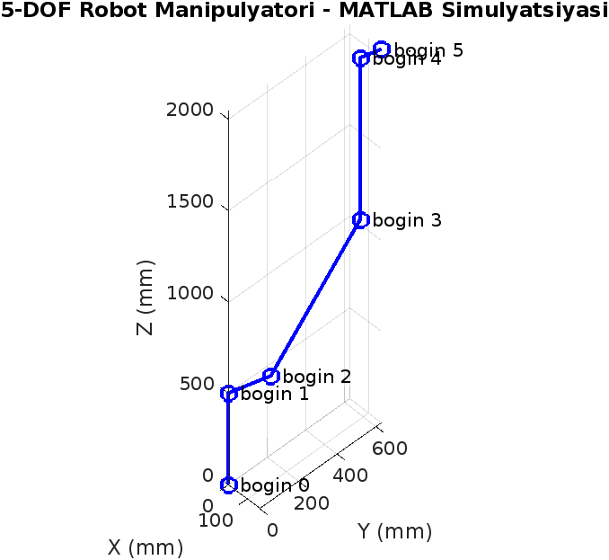
FIGURE 3. Forward kinematic simulation model of a 5-joint robotic manipulator

PROCESSING THE EXPERIMENT RESULTS
To validate the kinematic model, a MATLAB simulation was conducted. The computed end-effector trajectory was compared to theoretical results. Figures 1-3 show the structure of the robot manipulator, how it moves in space, and the results of modeling using a computer program.
The obtained parameters confirmed that the results of the errors did not exceed ±0.08 mm and corresponded to the manufacturer's specifications. This accounts for the accuracy of the forward and inverse kinematic models.
The proposed mathematical model allows the control algorithms to generate smooth and accurate motion paths. The motion planning can be improved by using optimization techniques such as efficient optimization-based or slower algorithms.

CONCLUSION

A full forward and reverse kinematic model for the BR1825A robot manipulator was developed with parameter accuracy using the Denavit-Hartenberg method. The results provide a solid foundation for trajectory control, workspace optimization, and efficiency improvement in industrial robotics. Future research will focus on integrating the model with dynamic-based control systems.

REFERENCES
- Craig, J. J. (2018). Introduction to Robotics: Mechanics and Control (4th ed.). Pearson Education. https://marsuniversity.github.io/ece387/Introduction-to-Robotics-Craig.pdf
- Sanz, P. (2009). Robotics: Modeling, Planning, and Control (Siciliano, B. et al; 2009) [On the Shelf]. IEEE Robotics & Automation Magazine, 16(4), 101. https://doi.org/10.1109/mra.2009.934833
- Sharibaev, N., Jabborov, A., Rakhimov, R., Korabayev, S., & Sapayev, R. (2024). A new method for digital processing cardio signals using the wavelet function. BIO Web of Conferences, 130, 04008. https://doi.org/10.1051/bioconf/202413004008
- Mirzabayev, B., et al. (2025). Controlling tensile strength in yarn using an ultrasonic water vaporizer. AIP Conference Proceedings, 3304, 030047. https://doi.org/10.1063/5.0269506
- Djuraev, A., Sayitkulov, S., Rajabov, O., Kholmirzaev, J., & Haydarov, B. (2022). Analysis of the impact effect of a piece of cotton with a flat surface with a multi-sided grates slope. Journal of Physics Conference Series, 2373(2), 022048. https://doi.org/10.1088/1742-6596/2373/2/022048
- Djuraev, A., Sayitkulov, S., Kholmirzaev, J., Haydarov, B., & Mustafaev, N. (2024). Substantiated parameters of multifaceted grates in the coarse cleaning zones of a cotton gin. AIP Conference Proceedings, 3033, 050027. https://doi.org/10.1063/5.0190707
- Ismanov, M., & Karimov, A. (2024). The action of shock waves on cylindrical panels. AIP Conference Proceedings, 3045, 030101. https://doi.org/10.1063/5.0197285
- Qodirov, D., & Ismanov, M. (2024). Stable algorithms for the identification of delayed control objects based on input and output signals. AIP Conference Proceedings, 3045, 030103. https://doi.org/10.1063/5.0197284
- Karimov, A., Ismanov, M., & Bahriddinov, S. (2024). Theoretical study of the law of distribution of non-stationary heat flux in vertical and horizontal layers of raw cotton (stored in a cotton riot). AIP Conference Proceedings, 3122, 100005. https://doi.org/10.1063/5.0217431
- Juraev, D., Matkarimov, P., & Mirsaidov, M. (2023). Three-Dimensional stress state of earth dams under static loads. In Lecture notes in civil engineering (pp. 1–11). https://doi.org/10.1007/978-3-031-30570-2_1

