Results of the Study on the Properties of Surfaced Excavator Bucket Tooth Samples
Karimjon Qosimov¹, Ulug’bek Haydarov², Xalimjon Xashimov^{1, a)}, Shuhratbek Yuldashev¹, Akbarali Ruziyev¹
¹Andijan State Technical Institute, Andijan, Uzbekistan
²Namangan State Technical University, Namangan, Uzbekistan

^{a)}Corresponding author: xoshimov1989@bk.ru
Abstract. This study is aimed at increasing the wear resistance of excavator bucket teeth, and the effectiveness of coating their working surfaces with welding based on various alloys and heat treatment was studied. The results showed that coatings with a high content of chromium and carbon exhibited the highest strength. Especially, samples coated under flux showed wear resistance 3.9 times higher than Hadfield steel. It has been established that the wear process increases proportionally to the increase in pressure and friction velocity, but with high layer hardness, wear decreases. The research results serve as a scientific basis for the selection of the optimal material and technology for mechanisms operating under operating conditions. This will also allow the introduction of local coating technologies at production enterprises instead of foreign spare parts, which will contribute to energy saving, reducing production costs, and extending the service life of equipment.
Keywords: Excavator teeth, wear resistance, hardness, abrasive wear, mechanical strength.
INTRODUCTION
In this area, both foreign and domestic researchers have conducted studies aimed at improving the strength, impact toughness, and wear resistance of working body components of machines widely used in fields such as road and building construction, extraction of mineral and non-mineral resources, and loading and transportation operations [1]. As a result, various new designs have been developed, and existing working bodies have been improved. However, these studies have not given sufficient attention to the application of surfacing and heat treatment using advanced materials with high wear resistance and hardness, which play a vital role in prolonging the service life of working components [2-4].
In addition, in our republic, the supply of spare parts for replacing rapidly wearing machine components is typically carried out through imports or purchases from local manufacturers [3]. However, spare parts produced by foreign companies are of high quality but very expensive, while local parts are of lower quality and service life due to the unjustified choice of materials and manufacturing technologies [4]. Therefore, the development and production of spare parts for machine working bodies based on scientifically justified material selection and manufacturing processes is a pressing issue [5].
METHODS
In the process of restoring worn excavator bucket teeth, under-flux welding and welding in a protective gas environment are used to create a high-quality metal compound and improve the operational properties of the coating layer. These methods allow optimizing the boundaries of the heat-affected zone in the melting layer of the metal, reducing the granularity of the metal structure, as well as ensuring a high degree of adhesion and homogeneous structure of the coating layer. The method of submerged arc welding is distinguished by high power, stable arc formation, and complete protection of the metal bath from atmospheric influences, which reduces the oxidation processes of the metal and improves the mechanical properties of the weld [6-7].
Welding in a protective gas environment (argon, carbon dioxide, or their mixtures) allows for controlled chemical reactions occurring during metal heating, as well as preventing the formation of pores and defects in the weld. As a result, the bucket teeth of the excavator, restored by these two methods, have high wear resistance to impact and dynamic loads [8-13].
RESULTS AND DISCUSSION
To enhance wear resistance and thus extend the service life of excavator bucket components, a series of experimental studies were conducted. The experimental program included the investigation of the composition, structure, hardness, and wear resistance of both the base and surfaced layers of the excavator bucket’s working components. The results of these investigations are presented below [7].
Laboratory tests examined the chemical compositions, macro- and microstructures, hardness, and abrasive wear resistance of a range of materials, both base and surfaced using submerged arc welding, applied to excavator bucket components used in rock and soil excavation [8].
For surfacing the bucket teeth, a "Device for Surfacing Shaped Surfaces" was used [9]. In the experiments, the friction surfaces of the excavator bucket components were surfaced using electrodes with specific types of coating and wear-resistant hard materials mixed with flux in predetermined ratios.
The hardness values of the fabricated samples are provided in Table 1 below.
TABLE 1. Hardness of the Samples
№ | Sample Type | 1 | 2 | 3 | 4 | 5 | Average Hardness, HRC
1 | Sample made of Hadfield steel | 47 | 51 | 48 | 49 | 51 | 50
2 | Surfaced with Sv-08G2S wire + AN-348-A flux + 50% PG-SR-4 + 50% PG-FBX-6-2 | 57 | 59 | 57 | 58 | 59 | 58
3 | Surfaced with 45G wire and quenched in water | 55 | 53 | 55 | 56 | 53 | 54
4 | Surfaced with Sv-08G2S wire + AN-348-A flux + 50% PG-SR-4 + 50% PG-S27 | 53 | 54 | 55 | 56 | 55 | 55
5 | Surfaced with T-590 electrode | 51 | 55 | 53 | 55 | 52 | 53
6 | Surfaced with 45G wire and quenched in oil | 45 | 49 | 47 | 47 | 48 | 47
7 | Sample made of Chinese steel | 46 | 41 | 43 | 45 | 48 | 45
8 | Surfaced with 45G wire without quenching | 27 | 33 | 29 | 31 | 29 | 30

It is well known that the primary cause of wear on excavator bucket teeth is abrasive wear, which occurs due to friction against materials such as sand, gravel, and stone. One of the main methods to combat abrasive wear in machine components is to ensure a high surface hardness, which must exceed the hardness of the abrasive material. Studies on the relationship between the hardness of materials and abrasives have led to the conclusion that, in order to increase the resistance of bucket teeth to abrasive wear, the hardness of their working surface must be greater than 45 HRC (see Table 1).
According to the data presented in Table 1, samples 1 to 6 meet this requirement, although sample 6 shows relatively lower wear resistance.
To determine the reasons for the high hardness of these samples, their chemical composition was analyzed. It was found that the samples exhibiting higher hardness contained greater amounts of carbide-forming elements such as carbon, chromium, silicon, and manganese compared to the others (see Table 2). Existing literature indicates that the hardness of chromium carbide with carbon is significantly higher than the hardness of typical abrasives composed of sand and stone.
Based on the above, it can be concluded that increasing the content of chromium carbide in the layer deposited by submerged arc surfacing on the working surface of excavator bucket teeth ensures the required increase in hardness and, consequently, high resistance to abrasive wear.

TABLE 2. Chemical Composition of the Samples (%)
№ | Sample Type | C | Si | Mn | Cr | Ni | Cu | B | Ti | W | Fe
1 | Sample made of Hadfield steel | 0.9–1.4 | 0.8–1.0 | 11.5–15 | 1.0 | 1.0 | 0.30 | 0 | 0.03 | 0 | 82
2 | Sample made of Chinese steel | 0.05 | 0.79 | 0.98 | 0.89 | 0.03 | 0.02 | 0.003 | 0.007 | 0.01 | 94.37
3 | Surfaced sample with 45G wire | 0.42–0.5 | 0.17–0.37 | 0.7–1.0 | 0.3 | 0.3 | 0.3 | – | – | – | 97
4 | Surfaced sample with T-590 electrode | 2.94 | 1.12 | 1.18 | 19.4 | 0.01 | 0.23 | 0.08 | 0.05 | 0.04 | 74.94
5 | Surfaced with Sv-08G2S wire + AN-348-A flux + 50% PG-SR-4 + 50% PG-FBX-6-2 | 1.13 | 1.10 | 1.01 | 18.29 | 6.96 | 0.20 | 0.10 | 0.007 | 0.01 | 76.30
6 | Surfaced with Sv-08G2S wire + AN-348-A flux + 50% PG-SR-4 + 50% PG-S27 | 0.64 | 1.68 | 1.03 | 16.34 | 2.03 | 0.38 | 0.10 | 0.009 | 0.01 | 77.79

These samples were tested for comparative abrasive wear resistance using a special wear-testing machine patented by the authors. Quartz sand was used as the abrasive medium. The wear magnitude was determined based on the ratio of mass and dimensional loss of the samples over the experiment duration.
As a reference sample, a specimen cut from the bucket tooth made of Hadfield steel manufactured in China was used.
The relationship between the wear magnitude of these samples and the hardness of the surfaced layer, made of various compositions, is presented below.

FIGURE 1. Relationship Between Sample Wear and Their Hardness
As shown in Figure 1, abrasive wear of the working body material decreases with increasing hardness, following a specific pattern.
Wear testing of the samples was conducted in an abrasive environment, taking into account the applied surface pressure and frictional speed. The samples were weighed before and after the experiment using MH-696 digital scales with an accuracy of 0.01 g. The results of the wear tests are presented in Table 3.

TABLE 3. Average Wear Values and Comparative Wear Resistance of Samples
Sample Description | Applied Load, N | Total Wear, g | Comparative Wear Resistance (times)
 | 10 | 20 | 30
Hadfield steel | 0.02 | 0.04 | 0.08
Surfaced with wire Sv-08G2S + flux AN-348-A + 50% PG-SR-4 + 50% PG-FBX-6-2 | 0.03 | 0.05 | 0.09
Surfaced with 45G wire, quenched in water | 0.05 | 0.08 | 0.14
Surfaced with Sv-08G2S + AN-348-A + 50% PG-SR-4 + 50% PG-S27 | 0.06 | 0.12 | 0.20
Surfaced with electrode T-590 | 0.10 | 0.16 | 0.24
Surfaced with 45G wire, oil quenched | 0.12 | 0.18 | 0.30
Chinese steel sample | 0.15 | 0.24 | 0.38
Surfaced with 45G wire, without quenching | 0.20 | 0.36 | 0.52

From the obtained results, it can be observed that as the applied pressure on the working element increases, the wear also increases following a parabolically rising pattern.

FIGURE 2. Graph of the wear of samples as a function of applied pressure
It should be noted that the trends shown in Figure 2 indicate that the higher the wear resistance of the samples, the slower the increase in wear rate with increasing applied pressure. At the same time, it is evident that under constant pressure, the wear of the samples increases in a parabolic pattern as the wear resistance decreases, depending on the material type and the type of heat treatment (see Fig. 2).
It is well known from the studies of many of the aforementioned researchers that the wear rate of frictional components is directly proportional to the sliding speed of friction, and this relationship is typically expressed as: i = k·vⁿ. It has been noted that at sliding speeds up to 5 m/s—commonly encountered in the machinery used under our studied conditions—the exponent n in this proportional relationship is equal to one. Laboratory investigations conducted to clarify this relationship have confirmed that the wear rate of frictional pair components depends on the sliding speed in the manner shown in Figure 3.

FIGURE 3. Graph of the dependence of the wear rate of two types of samples on sliding speed
In this particular case, the sliding speed ranges from 1.0 to 5.0 m/s. The graph shows that as the sliding speed increases, the wear rate of the samples can increase up to 4 times, following a linear dependence described by the equation y = ax + b. For both sample types, the specific linear equations are:
y₁ = 0.063x + 0.063 — for samples surfaced under flux;
y₂ = 0.073x + 0.083 — for samples surfaced with 45G steel electrode without quenching.
The graph, based on experimental results, demonstrates that the wear of samples surfaced under flux is significantly lower than that of the samples surfaced with 45G electrode without post-heat treatment.
Test results indicate that the wear resistance of excavator bucket teeth against abrasive wear can be increased by 1.2 to 3.9 times compared to Chinese steel, depending on the surfacing material used.
At the same time, the wear process of the samples depends on various patterns influenced by the applied pressure, sliding speed, and material hardness, as shown in the following generalized graph (Fig. 4).

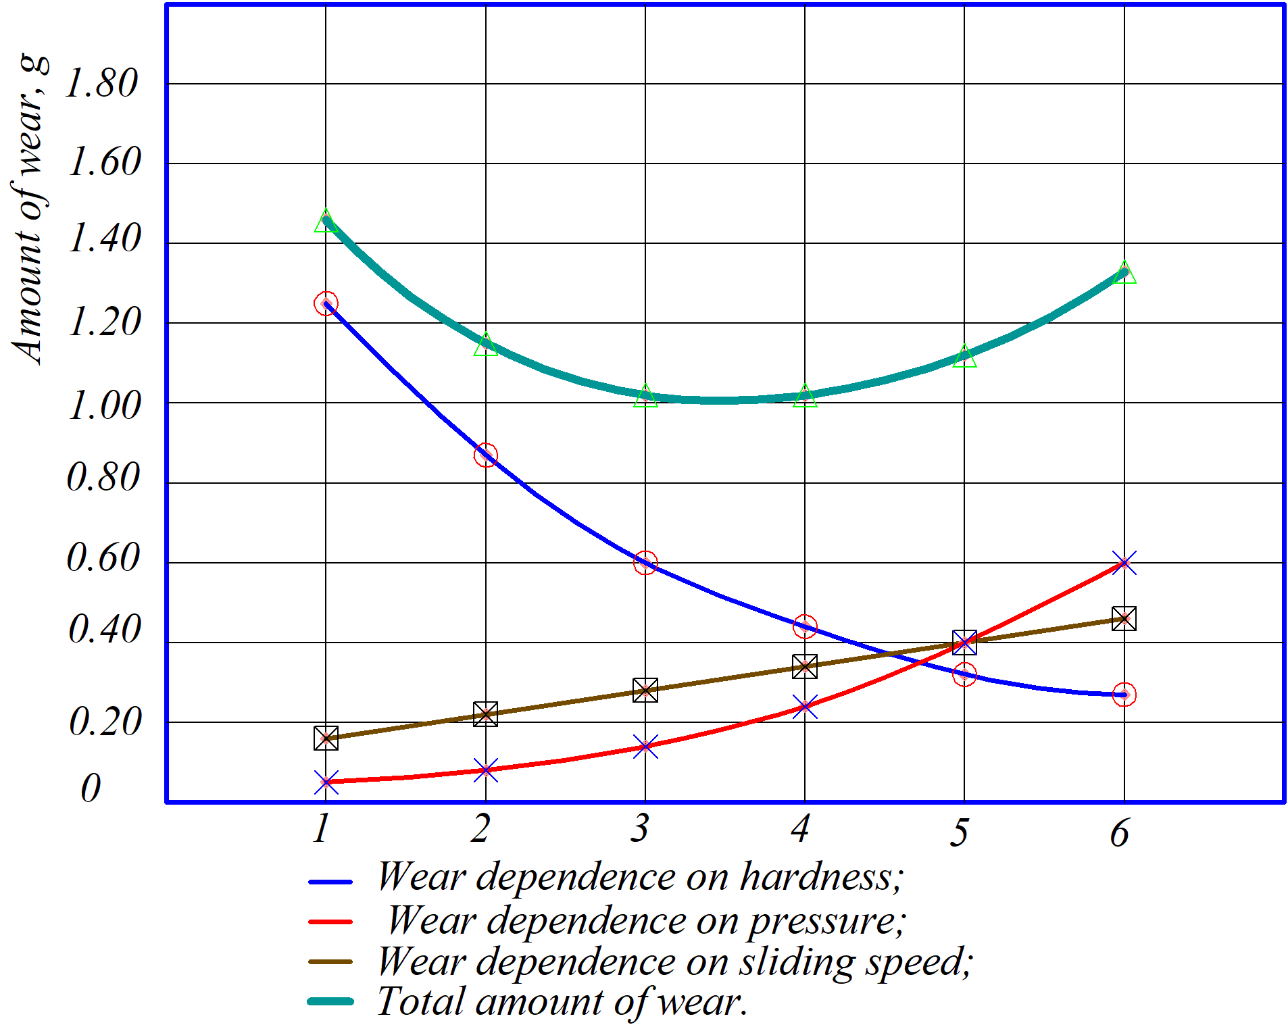
FIGURE 4. Generalized graph of sample wear depending on applied pressure, sliding speed, and material hardness.
CONCLUSION
Under laboratory conditions, the wear of samples taken from the excavator bucket teeth and the layers surfaced on their working surface under flux was studied. It was established that, depending on the chemical composition of the surfaced layer, their resistance to abrasive wear is 1.2 to 3.9 times higher than the untreated sample composed of Chinese steel.
Studies carried out on the wear resistance of samples surfaced under flux in an abrasive environment showed that with an increase in the hardness of the surfaced layer material and the content of hard alloys in its composition, the wear rate decreases. Meanwhile, with an increase in the applied pressure on the friction surface and the sliding speed, the wear rate increases, following a specific pattern in each case.
REFERENCES
- Abdulkhaev, K. G., & Barlibaev, S. N. (2023). Substantiation of the parameters of the rotary ripper of the machine for pre-seeding treatment of ridges. IOP Conference Series: Earth and Environmental Science, 1154(1), 012058. https://doi.org/10.1088/1755-1315/1154/1/012058
- Abdusalim, T., Gafurovich, A. K., & Nakibbekovich, B. S. (2020). Determining the Appropriate Values of Compactor Paramaters of the Enhanced Harrow Leveller. Civil Engineering and Architecture, 8(3), 218–223. https://doi.org/10.13189/cea.2020.080304
- Fan, X., Jin, Q., Yang, Z., Wu, W., Li, G., & Luo, Z. (2025). High permeability and low magnetic loss of Fe–Si/BN soft magnetic composites with layered structure. Journal of Materials Science, 60(19), 8015–8025. https://doi.org/10.1007/s10853-025-10937-z
- Karimova, K., Ismailov, K., Shermukhamedov, A., & Yuldashev, Sh. (2024). Influence of particles formed resulting from wear of automobile brake mechanisms on human health. E3S Web of Conferences, 508, 07013. https://doi.org/10.1051/e3sconf/202450807013 f
- Stroganov, V. F., Amel’chenko, M. O., Mukhametrakhimov, R. Kh., Vdovin, E. A., & Tabaeva, R. K. (2022). Increasing the Adhesion of Styrene–Acrylic Coatings Modified by Schungite Filler in Protection of Building Materials. Polymer Science, Series D, 15(2), 162–165. https://doi.org/10.1134/S1995421222020277
- Stroganov, V. F., Amel’chenko, M. O., Vdovin, E. A., & Stroganov, I. V. (2023). Concrete and Metal Protection against Aggressive Environments by Styrene-Acrylic Filled Compositions. Steel in Translation, 53(7), 614–621. https://doi.org/10.3103/S0967091223070112
- Zhu, Z., Liu, J., Wang, P., & Zhang, J. (2025). Influence of FeSi magnetic particle size distribution on the microstructure and magnetic properties of its composites. Journal of Materials Science: Materials in Electronics, 36(11), 681. https://doi.org/10.1007/s10854-025-14777-0
- Xoshimov, X., Yuldashev, S., Muydinov, A., & Kosimov, K. (2024c). Analysis and results of the conducted research work to increase the resource of the ginning rib. AIP Conference Proceedings, 3045, 040029. https://doi.org/10.1063/5.0197316
- Djuraev, S., & Tuxtasinov, D. (2025). Fractional-order moments method for monitoring and diagnosing electric motor conditions. AIP Conference Proceedings, 3304, 030050. https://doi.org/10.1063/5.0269113
- Djuraev, S., & Tursunov, A. (2025). Effect of particle size and concentration on multicyclone device efficiency. AIP Conference Proceedings, 3304, 030049. https://doi.org/10.1063/5.0269110
- Ergashev, I., Primov, B., & Abdusalomov, M. (2023). Study of the 125 mm diameter seed-removing tube performance. E3S Web of Conferences, 390, 06017. https://doi.org/10.1051/e3sconf/202339006017
- Mukhammadiev, D., & Ergashev, I. (2023). Investigation of seeds mechanical extraction through the seed-removing device from saw gin. E3S Web of Conferences, 390, 06011. https://doi.org/10.1051/e3sconf/202339006011
- Mirzabayev, B., et al. (2025). Controlling tensile strength in yarn using an ultrasonic water vaporizer. AIP Conference Proceedings, 3304, 030047. https://doi.org/10.1063/5.0269506

