Machine Research Applications for Predicting and Reducing Vibrations in Smart Mobility Systems
Shukrullo Mardonov^{1, a)}, Bakhromjan Djalalov²,
Mukhabbatkhon Mamasaidova^{2, a)}, Dilfuzakhon Zakirova²,
Mukhammadsokhib Abdumannopov², Tolibbek Najmiddinov³
¹National Institute of Pedagogy and Character Education named after Kori Niyozi, Tashkent, Uzbekistan
²Fergana State University, Fergana, Uzbekistan
³ISFT Institute, Tashkent, Uzbekistan
^{a)}Corresponding author: 4research2023@gmail.com
Abstract: Smart-mobility Compared with environmental disturbances like poor asphalt or moderate road misalignment, structural vibrations are relatively easy to tackle. The vibrations generated may upset the stability of the system, impinge on passengers ‘comfort and cause disorder in the system [1]. To alleviate these impacts, artificial intelligence (AI) turns out to be a hopeful path. Machine research approaches—from classical algorithms to deep networks with many hidden layers—enable systems to learn data and in turn predict, control and stabilize vibrations [2]. The ever-changing social, economic and environment drivers have prompted classes to research on topics such as smart mobility, automotive vibration prediction & control systems based on deep research. Of many contributions, fore filtered studies frequently have ignored the feature selection as well as preprocessing step in predicting and controlling prospective vibrations for smart mobility systems that rely on important initial features. In the absence of affordable, dependable and accurate computer-based prediction programs for vibration predictions, integrity of the system and passenger wellbeing are jeopardized. It has been proved in this paper that machine research can improve the reduction of vibration effectively under the smart mobility solution, and a couple of such methods outperform classical methods.
Keywords: Cargo vibrations, affecting logistic chains, cargo dynamics, vehicles transporting, railway freight transportation.
INTRODUCTION
Vibrations have a critical influence on the design and implementation of smart mobility systems for freight trip planning. Methods able to accurately predict such disturbances are therefore needed to improve system efficiency and reliability [1]. This study investigates the use of different machine research algorithms to predict vibrations in smart mobility environments and support their reduction. A dataset collected from a relevant scenario is employed to build several models and compare their effectiveness. Results show the capacity of such techniques to achieve a high accuracy rate in vibration prediction and contribute to overall system improvements.
The ongoing development of new technologies fosters the widespread adoption of smart mobility systems, which are currently regarded as a key element for smart cities. The applications span several fields, including freight trip planning, disaster evacuation, pedestrian routing, and e-tourism. The design of such systems calls for an accurate control of the vibrations encountered during the operation, as their presence is generally undesired and severely affects the performance.
The characteristics of smart mobility vibrations can be learnt from a dataset obtained from a real-world application. Machine research algorithms are then utilized to produce predictive models and quantitatively estimate the related magnitudes. In particular, three different approaches are considered: multi-layer perceptron, support vector machine, and random forest. Experimental results outline the underlying benefit of correctly predicting vibrations and the potential for their reduction. Additionally, they provide an objective view of the relative quality of the investigated machine research strategies [3].
METHODS
Smart mobility systems comprise integrated components that enable safe and efficient transportation of people and goods [1]. Such systems monitor vehicle locations, surrounding environments, transport challenges, and available transit alternatives. Similarly, each infrastructure analyzes its own status to inform cooperative, safe, and efficient mobility. Currently, smart mobility systems employ various sensing technologies—such as ultrasonic sensors, LIDAR, cameras, and inertial measurement units (IMUs)—to assess the status of both infrastructure and vehicles. The collected data is treated through sophisticated modeling and optimisation algorithms (e.g., machine research) to compute optimal routes or speeds aiming at reducing vibrations [2].
Vibration reduction smart mobility systems are a challenging design problem. High levels of vibration can discomfort passengers and wear components [3]. And to combat this, these vibration prediction model from past data have been constructed. These models are developed using machine research algorithms (neural networks, support vector machines and decision tree) to predict vibration amplitude from easily measurable input parameters. Good vibration prediction model can be used to optimize operation strategy of the system and improve safety and comfort.
Smart mobility systems are characterized by ubiquitous sensing, interconnection, and intelligence throughout their various components, which include the driver, vehicle, and surrounding environment. These factors ultimately influence vibrations. The strong coupling among physical components, along with the complex systems integrated with transportation, creates a complex environment that poses challenges for vibration control and assessment. To address these challenges, artificial intelligence1 particularly machine research1 has emerged as an effective approach due to its capability to analyze data and uncover patterns without explicit programming [4].
Continuous advancements in smart mobility systems Srithar et al., has demanded stringent constraints, such as for vibration reduction, durability and safety. Safety capabilities may be increased further by active control measures of reducing vibrations and running vibrations. Vibration monitoring is recognized as a key technique in technical diagnostics for early fault detection, fault location and life-time prediction of devices to which it is applied. Vibrations are generated by mechanical vibrations during operation, some parts serving as vibration exciter. The standards place the machine in either class by vibration levels and measurement characteristics. Comprehensive monitoring helps to detect the faults as soon as possible, is conducive to plan for preventive maintenance, and ensures safe/reliable system operation. Thus, the need for sensitive sound vibration signal processing using intelligent methods is essential [5].
Vibrations transmitted to passengers by the vehicle both impact its performance and the comfort of its passengers. Correct labeling and categorization of road defects like potholes and manholes are important in improving condition assessment of roads. Smart mobile phones containing high-precision inertial sensors has offered a viable approach to scalable road anomaly detection. Although device placement is crucial for accurate measures of vibration, different placements have been tested. Pocket data, for example, achieved a 30% increase in classification rate and overall better accuracy compared with windshield and console placement in a benchmarking SVM algorithm. Efforts to enhance classification accuracy, selecting features with high Pearson correlation between data sets, led to a higher quality of pocket data at the expense of other positions. These results emphasize the importance of detecting orientation-invariant and accurate features. Such an approach would facilitate the promotion of GPS routing and suspension structure analysis beyond simple pothole identification, perhaps utilizing better roadway roughness-indexing on larger datasets and phones at different orientations [6].
Machine research is a class of algorithms for pattern recognition and decision making with data, which learn from the data using general principles rather than task-specific instructions [7]. Large datasets of complex relationships enable machine research models to generalize beyond the training set and make predictions in new circumstances. Compared to traditional rule-based automation in which behaviour of the system is pre-specified by explicit rules, machine research provides a level of autonomy by determining decision policies for specific knowledge problems. Analytical application spans diverse fields, such as media processing, manufacturing, robotics and security. It is a broad label that includes operations in supervised or unsupervised framworks, Bayesian reasoning, stochastic processes, statistical inference, evolutionary models and algorithms, support vector machines (etc.), reinforcement research, and artificial neural networks [1]. The acquired knowledge through these various paradigms has become a corner stone of research in areas such as robotics, multiagent systems, adaptive control and optimization.
In smart mobility systems, vibrations are created from multiple sources with distinct frequency and amplitude. The ability to anticipate vibration levels in such components will improve system performance and the user experience, overall. However, adopting effective machine research systems for this domain is subjected to several challenges such as collecting a large number of labelled data and discovering the informative features.
Although numerous data sources are capable of capturing vibrations in smart mobility environments, many are affected by hardware interference and network issues. High-end acceleration sensors can be vulnerable to sensor shaking and detachment, compromising data integrity. Moreover, the volume of data obtained from these sensors is typically limited. For instance, constraint forces between passenger compartments and suspensions, sourced from the MBD system, experience noumenal divergences that increase as vehicle speed approaches 40 km/h. A commercially available four-axle transportation vehicle logs data from 19 different channels whose vibrations cannot be accurately predicted using a single channel. Most of these channels exhibit abrupt fluctuations along the axes and significant peaks across all measurement frequencies [2]. Table 3 presents the 19 channels provided by the commercial transportation vehicle.
RESULTS
Both Support Vector Machines (SVM) and Convolutional Long Short-Term Memory (C-LSTM) have been proposed for real-time classification of vibrational signals, demonstrating strong potential despite differences in input dimensionality and temporal feature extraction methodology. Application of C-LSTM networks to automatic labeling of large-scale vehicle dynamic-response datasets collected on highway bridges revealed the presence of vibrational contamination from high-frequency components in rear wheels, which can be mitigated by low-pass filtering to improve detection accuracy of travel sections on bridges [2]. A machine- and configuration-agnostic framework addressing generalization challenges in classical supervised research models has been introduced for vibration monitoring in CNC machining, exploiting widespread availability of vibration sensor data and a hybrid tech-informed/statistics-driven approach for feature extraction to enhance data robustness [3].
The resulting tools detect tool wear and chatter with over 95% accuracy, effectively supporting the identification and rectification of vibration-related issues in high-speed machining and contributing to improved surface quality, dimensional accuracy, and tool lifespan. Given that Prognostics and Health Management (PHM) applications inherently involve abundant time-series data, the integration of temporal modeling techniques is particularly well-suited to leverage temporal dependencies within such datasets and consequently boost the prognostic capabilities of the system. In the domain of drilling operations, bidirectional recurrent neural networks feasible for real-time spatial sequence modeling of internet-of-things data have been introduced to accommodate long-term dependencies and extensive historical information, avoiding negative-conditioning effects caused by incorporating irrelevant (distant) data in sequential modeling [1].

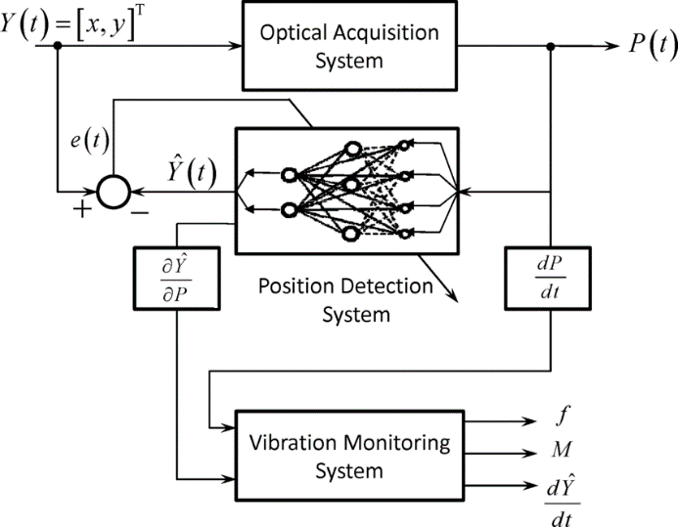
FIGURE 1. Physical Layer

Parallelized implementations on GPUs and multi-core CPUs enable online deployment without incurring model accuracy penalties, providing a competitive alternative to lighter single-layer architectures, with potential applicability to analogous monitoring systems exhibiting spatially sampled time-series data. The cross-validated prediction performance is analysed with evaluation criteria such as correlation coefficient and average absolute percentage error for the actual measurement and its statistical counterpart from actual values, respectively; highly fine-tuned hyperparameter settings are significantly improving predictive accuracy in automatic parameter search loops.

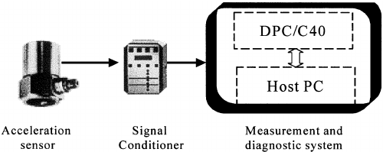

FIGURE 2. Sensor and IoT level

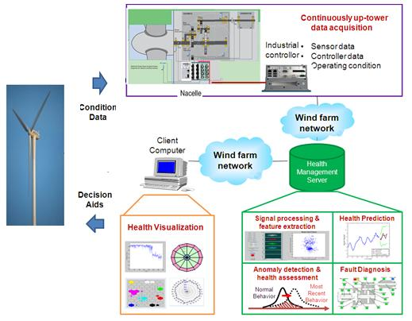

FIGURE 3. Signal preprocessing

The preprocess stage is used to pre-process the collected vibration data in order to build the predictive model effectively. This phase is important since the quality of input data has a major effect on model accuracy. Additionally, noise can be present in the vibration signal due to sensor noises or environmental variances that can compromise analysis. To overcome these challenges, there are techniques such as Empirical Mode Decomposition (EMD) which is an algorithm used to remove noise from the signals without loss of important information [8]. Normalisation or standardisation of the data ensures that all variables are weighted equally during model research after noise removal. It is also critical to detect and exclude artifacts (abnormal peaks or patterns which do not reflect the real vibration characteristic) in order not to mislead the research algorithms. Through the systematic cleaning and normalization of the data set, the pre-processing step improves on the signal-to-noise ratio and promotes a robust feature detection. This would ensure that any future predictive model is made based on legitimate, representative inputs, and then improve the accuracy and robustness of future prediction.
Vibration data from smart mobilities are informative, however raw signals are hardly interpretable for machine research methods. Feature engineering is needed to make relevant information explicit and speed up the research task. In bearing fault diagnosis, domain knowledge-based feature engineering can improve the prediction accuracy under low computational effort and high interpretability. A good set of features lead to strong performance even with relatively simple algorithms (such as random forests), indicating that highly non-linear deep neural networks are superfluous for the problem under consideration, in particular when we are not dealing with big data sets [9].
Well-chosen features, rather than the specific type of classifier, strongly influence model performance. Data sets comprising 24 (artificial faults) and 48 (natural faults) feature samples per instance based on short-time Fourier analysis yield the best results and highest generalization. Adopting this approach for smart-mobility applications is advisable.
Machine research algorithms are applied to feature sets to determine the correlation between features and faults; data classified as 'Faulty' or 'Normal' based on everyday-machine operation. Design of suitable features highly affects the model’s accuracy [10].

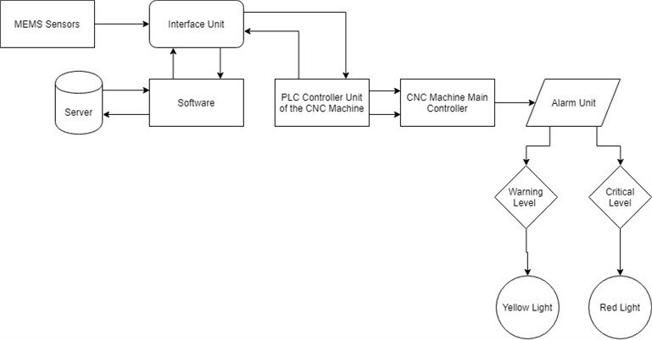
FIGURE 4. Intelligence Layer

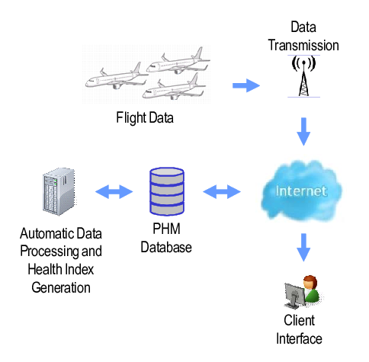
FIGURE 5. Prognostics and Decision Support (PHM)

Vibration prediction can be framed as either a regression or classification problem, depending on whether continuous vibration levels or discrete classes (e.g., low, medium, high vibrations) are modeled. Consequently, various machine research models for regression and classification have been applied to the prediction of vibrations in smart mobility systems, including neural networks, support vector machines, and decision trees. The performance of the models is measured using some metrics like root mean square error for regression and accuracy, precision, recall and f1 score for classification task.
A variety of theoretical and experimental studies show that the artificial intelligence (AI)-research-based techniques can be used to accurately predict and attenuate vibrations as well as its negative effects in SM systems 3. Besides these predictive capabilities, the use of electromagnetic actuators in environmental-friendly vibrations reduction schemes presents interesting perspectives for improving system robustness and energy efficiency.
Several types of regression methods have been proposed to accurately model vibrations in intelligent mobility systems. Linear regression models offer a straightforward relation between the input parameters and the vibration amplitude: however, it may not reflect its nonlinear intricacies that exist. To tackle nonlinearities, support vector regression (SVR) based on mapping the inputs into a high-dimensional feature space where we look for a linear fit has been applied and improved prediction accuracy for drilling vibrations and sensor data [1].
For example, ensemble approaches like random forests make predictions based on multiple decision trees trained on sub-samples of data and as a result model complex relationships in the data while reducing overfitting. XGBoost further improves prediction by iteratively training an ensemble of weak learners to predict the precise vibration amplitudes. Probabilistic methods such as Gaussian process regression, furthermore, offer the following advantages: not only can a probabilistic characterization of uncertainty be provided with point-estimates when using such methodologies, but it plays a key role in assessing confidence in vibration predictions and in supporting decisions on the measures to undertake.
The classification of vibration events, key to intelligent decisions regarding vibration reduction in smart mobility systems [2] , is realized by Neural Networks (NN) and Support Vector Machines (SVM). Multilayer Perceptrons (MLP), trained by backpropagation, and Radial Basis Functions (RBF), trained by Orthogonal Least Squares (OLS) and Sequential Forward Selection (SFS), represent the main NNs considered. The evaluation of performance as a function of input features identifies optimal feature subsets for each architecture [12]. This determination of these subsets — together with an overall performance comparison — facilitates the selection of the optimal technique for the classification of vibration events [13]. With regard to membership function construction — a fundamental constituent of fuzzy algorithms — the Fuzzy C-Means (FCM) cluster method, based on the iterative optimization of a cost function, is employed. Investigation of the influence of the number of clusters on the accuracy of various classification methods yields a preferable number of clusters to ensure effective classification and highlight potential for future optimization.
Different machine research techniques have been introduced for prediction of vibration in smart mobility systems by capturing the complex non-linearity between input features and vibration data [1]. ANNs are able to learn non-linear mappings and may provide a flexible way of solving the multi-target output problem, for both regression and classification problems. Kernel methods and structural risk minimization can be used in Support Vector Machines (SVMs) with both computable forms as well consistent generalization on many tasks. Decision trees are a simple and interpretable approach that allows us to investigate hierarchical interactions among variables and can also be extended with ensemble research methods like Random Forests and Extra Trees. These algorithms have been tested by historical vibration data, including the accelerations and gyroscope angles and input features are time domain, frequency domain and market data. Standard performance measures such as accuracy, precision, recall and RMSE enable the comparison between regression and classification settings [14].
In the context of drilling induced vibrations, several machine research based methods were applied to construct an auto-detection model using real-time continuous streaming sensor data in a work by itsekson et al. Sensor observations were aggregatedwise based on recorded time stamps in fixed intervals and priors over aggregations were imposed to enable scalable modelling and rapid predictions. The main statistical indices used for assessing the performance of the regression and classification models were the correlation coefficient and average absolute percentage error (AAPE). Support Vector Machines yielded great for vibration magnitude regression prediction and for classification of vibration mode. Automated parameter optimization improved substantially the predictive accuracy, with a search for model parameters conducted at great depth to maximize model output.
In CNC machining, monitoring vibration is crucial to achieve accuracy, reliability and productivity. Support Vector Machines and Support Vector Regression have been applied in predictive maintenance, fault detection and tool wear prediction using machine research. A number of methods have been developed to expand the predictive possibilities for multi-sensor data, translating these into invariance differences and variant components, allowing a perfect categorization of the state of tools and early detection to defects [3].
Neural networks are members of supervised research methods, which contain several layers of interconnected neurons [15]. Neurons sum their inputs with weighted and apply an activation function, like the sigmoid. The layers are interconnected by weight matrices, making it possible to represent complex function families that map multi-dimensional input vectors to output probabilities. During the training process, these weights are adjusted so as to allow the network to learn associations between inputs and outputs in a given domain. And after training, the network can predict output with a small amount of computation. The deep research is to use neural network of many layers to increase the expressive power of model, and improve fitting and generalization performance [16]. Building on this concept, the study applies machine research to predict current and future acceleration to assess system criticality and support the evaluation of control strategies aimed at reducing vibrations during smart mobility operations.
Vibration phenomena pervade daily life, encompassing rolling mills, trains, fans, helicopters, buses, and multifarious industrial equipment. In critical processes, vibration impacts strongly influence global performance. It is essential to detect, measure, and classify operational sources to mitigate these effects and preserve structural integrity and user comfort. Aerospace structures, sports aerodynamics, automotive vehicles, wind turbines, and health monitoring applications exemplify areas where accurate vibration characterization is paramount. The complexity of the phenomenon demands precise analysis to anticipate potential faults and identify further insights. Analytical solutions remain challenging, due to the involvement of multiple parameters, including rotating speed, pipe diameter, and rotor eccentricity. Experimental investigations can elucidate principal parameters for analytical reformulation.
Support vector machines (SVMs) have been applied for tool wear prediction, tool status identification, and fault diagnosis in vibration monitoring [3]. Multi-sensor signals are often processed through independent component analysis and wavelet packet transform before modeling. SVR is used for wear estimation with limited data. In a route of vibration-based fault diagnosis, the corresponding machine conditions have its particular architectural characteristics and thus it is commendable to use machine-research methods for state recognition [14]. SVMs, K-nearest neighbors and Gaussian Naive Bayes on the extracted vibration features exhibit high accuracies in diagnosing machine states, which validates their capability of monitoring mechanical systems.
Decision tree is a supervised research method used in classification and regression. The approach is straightforward and easy to interpret, effectively capturing nonlinear patterns with relatively little data wrangling or feature generation. The process of splitting data using feature values to maximize the distance between different classes (classification) or to minimize variance (regression) results in a model containing internal decision nodes and final leaf terminal nodes. These trees have been used as the building blocks for ensemble methods, such as AdaBoost and Random Forests, which are generative frameworks that employ many decision trees to both improve prediction accuracy and reduce overfitting [1, 18]. When predicting vibration, decision trees use properties related to the modal behavior to determine patterns and best splits which will predict accurately.
Performance evaluation criteria are necessary for comparing machine research models in vibration prediction. In the context of classification systems, accuracy is a measure of the quality of class assignments and attempts to represent an overall degree of actual correctness. Precision reflects what the fraction of the true positive predicted to all predicted as positive that is, how much we can trust a prediction for being positive. Recall measures the ratio of true positive samples that a model correctly detects, indicating the ability to detect positives. These indices make a global assessment on the efficiency of vibrational state classification results obtained by a given model. In the regression analysis, we have calculated RMSE which is a measure of how much the predicted value deviates from actual one by an average squared difference between prediction and actual observation for all samples; values close to 0 implies better performance of model [19]. The choice of anamidated performance metrics then allows the comparison and optimization of models as decision trees, support vector machines or neural networks for vibration prediction in smart mobility systems [14] [3].
CONCLUSION
An efficient and data-centric method for research to understand and manage vibration in smart mobility systems is machine research. Smart mobile architectures and their physical elements are drawn and vibration source is depicted. Key ideas of machine research are presented, particularly supervised research: regression and classification. These approaches are capable of capturing the velocity and vibration acceleration relationship, which can be used to estimate and reduce vibratory behaviour in the smart mobility systems concept. Development of appropriate models is discussed, as well as the practical aspects of obtaining adequate training data. The chapter also provides an overview of data collection methods, including those for pre-processing and feature engineering. Research machines for vibration analysis are subsequently considered. Finally, the model is compared to vibration estimation and control according to several performance metrics.
Future research will explore the use of unsupervised approaches—particularly clustering—to identify similar road types and traffic conditions based on vibration-sensor data, thereby streamlining the analysis and management of vibration in smart-mobility contexts [17] [2].
REFERENCES
- Saadeldin, R., Gamal, H., & Elkatatny, S. (2023). Machine research solution for predicting vibrations while drilling the curve section. ACS Omega, 8(39), 35822–35836. https://doi.org/10.1021/acsomega.3c03413
- Shin, R., Okada, Y., & Yamamoto, K. (2022). Application of C-LSTM networks to automatic labeling of vehicle dynamic response data for bridges. Sensors, 22(9), 3486. https://doi.org/10.3390/s22093486
- Rustamov, K. J., & Rustamova, N. R. (2025). Advanced hydraulic drive systems in multi-purpose machinery: Enhancing efficiency and performance in modern engineering. AIP Conference Proceedings, 3304, 030093. https://doi.org/10.1063/5.0269688
- Apostolou, G., Ntemi, M., Paraschos, S., Gialampoukidis, I., Rizzi, A., Vrochidis, S., & Kompatsiaris, I. (2024). Novel framework for quality control in vibration monitoring of CNC machining. Sensors, 24(1), 307. https://doi.org/10.3390/s24010307
- Liang, L., Ye, H., & Li, G. Y. (2018). Toward intelligent vehicular networks: A machine research framework. IEEE Internet of Things Journal, 6(1), 124-135. https://doi.org/10.1109/JIOT.2018.2872122
- Kamoliddin, R., & Nodira, R. Determination of the main parameters of the mechanisms of a two-stage compressor and their kinematic analysis. In AIP Conference Proceedings (Vol. 2789, No. 1, p. 040001). https://doi.org/10.1063/5.0145477.
- Raiyn, J., & Toledo, T. (2014). Real-time road traffic anomaly detection. Journal of Transportation Technologies, 4(3), 256-266. https://doi.org/10.4236/jtts.2014.43023.
- Abdallah, M., Joung, B. G., Lee, W. J., Mousoulis, C., Raghunathan, N., Shakouri, A., ... & Bagchi, S. (2023). Anomaly detection and inter-sensor transfer research on smart manufacturing datasets. Sensors, 23(1), 486. https://doi.org/10.3390/s23010486
- Kafeel, A., Aziz, S., Awais, M., Khan, M. A., Afaq, K., Idris, S. A., ... & Mostafa, S. M. (2021). An expert system for rotating machine fault detection using vibration signal analysis. Sensors, 21(22), 7587. https://doi.org/10.3390/s21227587
- Bienefeld, C., Becker-Dombrowsky, F. M., Shatri, E., & Kirchner, E. (2023). Investigation of feature engineering methods for domain-knowledge-assisted bearing fault diagnosis. Entropy, 25(9), 1278. https://doi.org/10.3390/e25091278
- Magar, R., Ghule, L., Li, J., Zhao, Y., & Farimani, A. B. (2021). FaultNet: A deep convolutional neural network for bearing fault classification. IEEE access, 9, 25189-25199. https://doi.org/10.1109/ACCESS.2021.3056944
- Maheshwari, S., Tiwari, S., Rai, S., & Singh, S. V. D. P. (2024). Comprehensive Study Of Predictive Maintenance In Industries Using Classification Models And LSTM Model. arXiv preprint arXiv:2403.10259. https://doi.org/10.48550/arXiv.2403.10259
- Aburakhia, S., Tayeh, T., Myers, R., & Shami, A. (2022, December). Similarity-based predictive maintenance framework for rotating machinery. In 2022 5th International Conference on Communications, Signal Processing, and their Applications (ICCSPA) (pp. 1-6). IEEE. https://doi.org/10.48550/arXiv.2212.14550
- Rustamova, N. R. (2025, July). Vitagenic chemistry: Unveiling life-enhancing energies in chemical reactions. In AIP Conference Proceedings (Vol. 3304, No. 1, p. 040056). AIP Publishing LLC. http://doi.org/10.1063/5.0271016.
- Jobi-Taiwo, A. A. (2014). Data classification and forecasting using the Mahalanobis-Taguchi method. https://doi.org/10.1080/10170660409509440
- Atmaja, B. T., Ihsannur, H., Suyanto, & Arifianto, D. (2024). Lab-scale vibration analysis dataset and baseline methods for machinery fault diagnosis with machine research. Journal of Vibration Engineering & Technologies, 12(2), 1991-2001. https://doi.org/10.48550/arXiv.2212.14732
- Rustamova, N. R. (2025, July). The role of vitagenic technologies in revolutionizing machine design and functionality. In AIP Conference Proceedings (Vol. 3304, No. 1, p. 030095). AIP Publishing LLC. https://doi.org/10.1063/5.0269690
- Korabayev, S., Ergashev, O., Mahsudov, S. A., & Mamatova, S. (2024). Exploring common technical issues in modern technology. BIO Web of Conferences, 145, 03016. https://doi.org/10.1051/bioconf/202414503016
- Pirnaev, S. A., Rustamov, K. J., Mukhitdinov, A. S., Nurtas, M., & Rustamova, N. R. (2025, July). Influence of milling depth and angle of attack on parameters of power device. In AIP Conference Proceedings (Vol. 3256, No. 1, p. 060019). AIP Publishing LLC. https://doi.org/10.1063/5.0267773

