IoT-Enabled Monitoring of Vibration Dynamics in Urban Smart Logistics Networks
Jamoliddin Fozilov¹, Abror Sanakulov^{2, a)}, Ulugbek Maksudov³, Odina Fozilova³, Otabek Toshtemirov³, Sobirjon Kochkarov³
¹National Institute of Pedagogy and Character Education named after Kori Niyozi, Tashkent, Uzbekistan
² Tashkent University of Information Technologies named after Muhammad al-Khwarizmi, Tashkent, Uzbekistan
³Fergana State University, Uzbekistan
^{a)}Corresponding author: r.n.r198407@gmail.com
Abstract: In modern urban environments, transitions between different locomotion modes are increasingly frequent, resulting in more complex transportation systems. Monitoring urban traffic infrastructure is crucial for evaluating the overall performance of a city and ensuring smooth movement of cargoes and people. Smart logistics networks constitute a significant part of urban mobility, and various physical infrastructures are used to support their operation. In the current COVID-19 context, timely supply of medicines through effective logistics delivery networks is critical for maintaining stable social operations. Hence, exploring the vibration dynamics of smart logistics infrastructure and the vehicles using them is of great importance. Towards this goal, an Internet of Things (IoT)-enabled monitoring system for vibration sensing is developed. Deployment considerations include the general package of measurement hardware and software and a generic yet representative vibration dynamics model. Simulation results are used to extract insights for efficient logistics infrastructure design and smart city optimization.
Keywords: IoT, vibration dynamics, smart logistics, sensor networks, data analysis, urban monitoring.
INTRODUCTION
The expansion of urban economies and increasing numbers of city dwellers have contributed to a rapid increase in the demand for urban logistics services. Efficient urban logistics requires timely and sufficient support for city populations, considering the needs of retailers and manufacturers in environments characterized by requirements for a low carbon footprint, availability, goods diversity, and traffic management and congestion. Urban city logistics are part of a wider smart transportation and smart city operation, where Internet of Things (IoT) technology can provide suitable paradigms to support the development of smart logistics and improve current city logistics monitoring approaches [2].
Monitoring characteristics and parameters, such as traffic parameters, Jabatan Kerja Raya (JKR) R5 road safety parameters, traffic jam prediction, and travel time, provide trade-off parameters for controlling urban traffic flow, enhancing road safety, modeling urban logistics, and supporting urban traffic management [1]. IoT technology for detecting vibration characteristics along an urban logistics network is expected to be a valuable tool for providing detailed micro-data on vibrations that impact logistics. This data is necessary for monitoring the integrity of the urban system and the performance of activities carried out by the network.
METHODS
Sensing technology plays a crucial role in smart city applications, such as monitoring urban infrastructures, drug circulation, and logistics distribution. Vibration monitoring is essential for assessing the health of transport infrastructures and tracking vehicle driving conditions, also aiding traffic dynamics monitoring via IoT-enabled solutions.
An IoT monitoring system based on vibration sensing enables long-term and broad-area traffic data acquisition through a set of accelerometer sensing nodes, a gateway for data collection and transfer, and a cloud platform. Accelerometer-based sensing nodes arrange accelerometers transversely across lanes to capture pavement vehicle vibrations. Once deployed, nodes collect vibration data locally at a 500 Hz sampling frequency, with the gateway transmitting data to a remote server via 4G. Continuous monitoring facilitates real-time traffic data analysis and online visualization, contributing to the development of smart logistics systems with vibration sensing and IoT sensing technologies for urban logistics networks [1].
Urban logistics focuses on the efficient distribution of goods throughout a city. Italian e-commerce grows rapidly, with a compound annual growth rate of 20 %. To meet such demand, a multichannel omnipresent supply chain is necessary along with complex intermodal transportation supporting multiple carriers and shippers. Demand fluctuations and fragility of the supply chain demand effective monitoring of logistic orchestrators and traffic flows to address challenges promptly.
Traffic sensing technologies capable of instrumenting the smart city offer new opportunities to capture vibrations generated by passing vehicles, an additional source of traffic-related information. However, the historic lack of cost-effective equipment for sensing pavement vibrations at large scale has hindered development of such platforms [2]. Commercial accelerometer sensing platforms typically require complex installation procedures and power supply, making them costly to deploy and manage for city-scale monitoring. Consequently, dedicated vibration monitoring systems are not routinely employed in the context of smart logistics.
Research on IoT-enabling smart logistics networks offers only limited attempts to monitor vibration dynamics of infrastructures on an urban scale. Existing approaches typically conduct data collection and analytics at selected locations owing to the prohibitive costs of wide deployment. A lowcost mobile device sensing system integrates seamlessly into an IoT ecosystem to monitor goods distribution routes. Sensors embedded in mobile terminals collect time-stamped location and movement data, enabling the mining of user activity patterns and supporting operational optimization in urban goods distribution logistics [2]. Pavement vibration monitoring is technologically feasible by integrating sensor networks and IoT techniques. A modelling framework augments physical component reliability models by incorporating empirical observations of transmission risk at multiple levels, using real data to assess logistics-relevant policies under uncertainty and improve supply chain resilience [3]. Cost and benefit are evaluated in a framework to measure the impact of IoT applications on spare parts logistics operations, based on which policy decision for investing or adopting IOT technology for machine health monitoring can be facilitated. Real-time monitoring allows for the early detection of state-changes, which in turn minimizes downtime. The system of pavement vibration IoT monitoring is in favor of the acquisition and transportation of traffic data in real-time with higher efficiency. Wireless acceleration sensors are buried in pavement to monitor the real-time traffic information with IoT organization for smart calculation, which is superior to conventional traffic monitoring methods. [1]
The Internet of Things (IoT) enables the creation of pervasive wireless sensor networks delivering unprecedented sensing power for data collection, storage, and analysis [2]. IoT applications exploit the convenient deployment of low-power, cost-efficient, and cooperative wireless sensor nodes to build infrastructure-free, intelligent, and self-organized systems. These systems integrate large-scale sensing, collaborative information processing, access services, and construction management [1]. Traditionally, IoT has been utilized for cost-efficient environmental monitoring and health-care systems. Specialized sensor nodes measure physical and chemical parameters such as water/air quality, temperature, humidity, chemical vapors, and accelerations. Collaborative sensing of air pollution, noise levels, and radiation intensity can provide acceptable accuracy by employing a low-cost sensor network rather than expensive, single-source equipments. IoT has also been applied to smart homes, where several sensors distributed throughout the home monitor parameters like movement of persons and doors, smoke, temperature, and light levels, thereby potentially contributing to energy conservation and quality of life.
Vibration monitoring techniques serve the purpose of analyzing and investigating vibration processes in machinery, civil engineering structures, and the human body [1]. The effectiveness of vibration data analysis hinges upon obtaining clear measurements to guide further interpretation. Among various methods, vibration monitoring systems employing transducers are frequently utilized due to their inherent characteristics and operational principles. The development of low-cost wireless sensor nodes facilitated the deployment of wireless sensor networks dedicated to vibration monitoring.
A diverse array of long-term vibration monitoring systems has been established to address diverse needs. For instance, vibration monitoring methods provide a straightforward approach for monitoring structural integrity under ambient vibration . Furthermore, micro electromechanical accelerometer vibration sensors find application in monitoring the downhole drilling environment, yielding insights into temperature and pressure fluctuations . Throughout the design of vibration monitoring systems, sensor technology represents a pivotal element, and traditional accelerometers have been widely employed as the primary components.
The maturation of technologies encompassing acceleration measurement, microprocessors, and wireless communication has enabled vibrational monitoring of structures via the deployment of numerous wireless acceleration sensor nodes at remote sites.
Wireless acceleration and magnetic induction sensors have been implemented in real-time and efficient vehicle classification, vehicle counting, vehicle speed detection, and pavement vibration monitoring applications. In certain configurations, some sensors were positioned roadside to transfer data for offline processing. Nevertheless, wireless pavement sensors typically encounter operational challenges, frequently losing functionality due to cyclic vehicle loading and power supply issues. To enhance both the durability and efficiency of the system, an IoT-enabled pavement vibration monitoring framework was proposed. The IoT paradigm integrates various sensors, actuators, and network connectivity, supplemented with embedded intelligence for real-time monitoring capabilities. This integration supports distributed computational resources, device integration, and enhanced system scalability, thereby conferring substantial advantages over conventional traffic monitoring systems.
Recent developments and applications in IoT technologies enable the study and modeling of vibration dynamics in urban smart logistics networks. To support efficient urban transport, data collection, data processing, analysis, and modeling are needed. The design and implementation of an IoT architecture supports vibration-aware monitoring, and a mathematical model describes the vibration dynamics of an urban smart logistics network [2, 3, 4, 5].
Urban logistics describes the myriad activities required to distribute raw materials, semi-finished products, and finished products within an urban area. Goods distribution activities are subject to constant time pressure from freight customers for faster delivery; industry trends toward “just-in-time” manufacturing and “just-in-time” retailing; macroeconomic growth in imports/exports, which increases the volume of goods; spatial restructuring of logistics activities and land-use; the increasing development of e-commerce and consumer demands for fast delivery; and the negative externalities of urban goods distribution, such as pollution, noise, congestion, and accidents (localized parking). These issues motivate the research and development of an IoT-enabled system to monitor vibration dynamics in urban smart logistics networks.
Data acquisition devices include dedicated sensors and also mobile devices, such as smartphones or tablets, which have many integrated sensors that can be used to obtain information about motion, positioning, and the surrounding environment. These sensors therefore provide an alternative source of information for urban goods distribution logistics tracking, with several advantages, including ubiquitous coverage, real-time data availability, and relatively low deployment and maintenance costs. Therefore, an IoT system monitors vibration dynamics, using available services for visualizing the data, for functional testing, and to assess the impact of the phenomenon on the operational efficiency of the logistics network.
The article designs an IoT sensor network for gathering empirical data on vibration dynamics in different parts of the urban logistics system. IoT-based sensor platform support effective collection of traffic data on major logistics corridors and in urban freight facilities [1]. An urban goods distribution logistics monitoring system is proposed that processes GPS signals and data from the accelerometer and magnetometer of mobile devices to study transit times, driving styles, road conditions and loading/unloading operations [2, 6, 7]. These techniques are only possible due to the reduced cost of mobile data communication in urban areas and the increasingly common use of smartphones, which pave the way for real-time data collection, retention, and analysis in the cloud services' ecosystems. Also, these data can be modelled to obtain vibration dynamical episode which is used by predictive maintenance and vibro-monitoring applications.
An experimental data collection system was fabricated for the investigation. The sensor apparatus, shown in Figure 1, was composed of an XR-3 shaker, 3-axis accelerometer, dynamometer, amplifier, and data acquisition system from National Instruments. An iPhone was employed to audiorecord the session for the identification of the excitation condition. The vibration signals were measured with a sampling rate of 10 kHz, and the excitation frequency ranged from 10 to 500 Hz.
The Intensity-Vibration IoT Sensor Module (IV-ISM) is an open hardware monitoring device that was originally developed from open-sourced hardware, Arduino, for monitoring potential rockfall hazards. This slim and versatile sensor module has been specially adapted and enhanced for deployment in urban smart logistic networks in order to efficiently collect the vibrational signals generated by heavy vehicles and aggressive urban conditions.
The well-designed picking-up module transforms vibrational motions and shocks into a lightning electrical signal; a sampling module then samples the signal with a very high sampling rate and retains the crest value of the sample to a 16-bit flash memory until the original signal becomes invalid. When triggered by a cut-off threshold, the alarm module informs the 32-bit controller to send a data reading request to the sampling module; the controller then transmits the collected vibrational data to the cloud server through an industrial 4G network. The power management module dynamically manages the IV-ISM into three states according to the intensity of vibrational motion: an operating state, where data is sampled and transmitted continuously for heavy vibration; a low-power state, where the data is sampled and transmitted intermittently when medium vibration is present; and a deep-sleep state, where the data acquisition is completely suspended in light or chaotic vibration. Such smart power management further optimizes power consumption and greatly extends the service life of the system and its sensors [8, 9].
The monitoring of vibration dynamics through IoT sensing networks represents a major technological breakthrough for the future of urban smart city logistics. The first task of a research strategy aimed at real-time monitoring of the vibration dynamics of urban logistics networks concerns the study of the mathematical tools required for the analysis and characterization of the acquired vibrations. The design and development of an IoT infrastructure for the collection of vibration data, leveraging IoT devices equipped with vibration sensors, and the development of the data analysis algorithm for interpreting the dynamics of an urban network of smart logistics are also addressed. Data analysis focuses on the interpretation of information gathered by the IoT-enabled sensing infrastructure in real time. Data acquisition is realized through the deployment of a large-scale network of sensors, the output of which is used to understand and characterize the vibration mechanisms within the network [1].
The IoT-enabled system investigated herein targets the acquisition and analysis of vibration dynamics as a keystone of a ubiquitous smart urban logistics monitoring framework. The manageable complexity and subtle coupling of the measured physical quantities render these dynamics extraordinarily sensitive to pervasive physical activity: airborne collisions, perturbations induced by the transportation of materials inside and between the containerized volumes and the surrounding environment, ambient disturbances, preparation and conditioning operations, and much more. Provided a suitable network of IoT sensors, this physical sensitivity allows for an indirect sensing of a host of activities of interest to monitoring urban smart logistics operations with a single, dynamically stable real-time data acquisition principle. As the logistically relevant activities evolve on very different timescales—from the maintenance of the containerized volume and internal organization (days/weeks/months) to the transportation of materials (hours) to the peculiarities of the relevant refurbishment and conditioning operations (minutes/seconds)—this indirect sensing paradigm is remarkably flexible, convenient, and non-invasive, obviating the need for multiple direct sensing systems with complementary operational ranges.
The underlying multi-sensor network framework replicates those recently introduced and experimentally validated for the quasi-real-time and accurate remote collection of vibrational data inside multiple vast operational domains separated by far-field distances [1]. Detailed design, hardware and software implementation, as well as preliminary vibration data monitoring results illustrate the potential and global rationale of the approach.
The impetus to monitor vibration dynamics in urban smart logistics networks originates from the nature of the network itself. Urban logistics networks are responsible for the distribution and storage of commercial goods and also form an essential part of the urban infrastructure used by households, hospitals, and other establishments. Since these networks are depended upon for the effective operations of many entities, there is a need to monitor their dynamics and structural integrity. The complex construction of constituent structures and the intricate use of structural materials require the introduction of smart systems and adaptive monitoring devices for the early identification of damages and deteriorations within the network. As a consequence, such smart frameworks need to be supported by new systems and technical tools that integrate data processing and analysis strategies for the characterization of the vibration dynamics within the network [1]. Within the context of urban logistics infrastructure, this chapter explores the modeling of vibration dynamics through the use of an Internet-of-Things (IoT) system. The proposed framework aims to investigate the feasibility and applicability of an IoT strategy as a potential smart-monitoring solution for the identification of vibration dynamics within typical urban logistics networks. An IoT system is designed to permit the acquisition and processing of experimental data as obtained from realistic vibration tests. The collected data not only underpin the definition of vibration models that can be validated through both numerical and hybrid simulations, but also provide an important basis for the characterization of the measured vibration within interconnected smart logistics networks.
In a smart urban logistics system built on the Internet of Things, a distinct collaborative framework is provided for goods and people moving in the network. A structural model offers a practical basis to analyze collaborative processes and evaluate the impacts of various factors. A framework for building smart cities on the IoT forms the backdrop for the system. Goods movement as a collaborative process in such a system is examined, and a logistic model incorporating real-life constraints is proposed to quantify the use of smart goods services. Goods flows and travel practices are investigated.
Numerous communication protocols have been proposed and standardized in the quest of connecting massive amounts of diverse IoT devices. These are such as WBAN, WSN, RFID 3GPP, VoLTE and waaW [1]. At the application level protocols like MQTT and AMQP are also interesting. WBAN nodes are intended to work in low-rate short range, with a reduced topology. WSN nodes come before IoT nodes, and they have extended range and data rates in larger star or mesh topologies. The IoT capabilities are supplemented by the possibilities offered by RFID such as low cost tags, energy harvesting and real-time authentication that WSNs do not offer.
To enable Short-Range Communications, 3GPP has developed protocols like LTE eMTC, EC-GSM and NB-IoT. LTE Cat M1 is aimed at higher throughput, medium bandwidth IoT applications and offers data rates of up to 1 Mbps suitable for deep indoor/-outdoor connected IoT devices that require broadband connectivity. It is targeted to offer the smoothest possible integration into LTE/LTE-A networks. EC-GSM is deployed in the existing GSM bands with up to 10 km outdoor and up to 1 km indoor coverage. 4G (NB-IoT), which was jointly defined by 3GPP and GSMA, is positioned to providing the Narrow Band IoT (Internet of Things) with more affordable price, better performance and more reliable. NB-IoT co-exists with GSM in 5 MHz band using a narrowband of 200 kHz per channel.
NB-IoT also underpins kwan.io, an ultra-low-power wide-area network designed to provide nationwide coverage, GPS tracking, and superior penetration, along with extended battery life and low device costs. While various communication alternatives exist, lack of common standards remains a concern, potentially hindering innovation and market growth.
In the literature, mobile applications are increasingly employed in logistics to optimize urban deliveries and improve operational results [2]. IoT enhances measurement and control, impacting internal operations, warehousing, transportation, last-mile delivery, operational efficiency, safety, track-and-trace, customer experience, and business models.
Pavement vibration measurement is a vital method for acquiring precise and dependable traffic information in intelligent transportation systems (ITS). Sensors such as wireless acceleration and magnetic induction sensors have been employed to detect vehicle count, monitor vehicle arrival and departure, estimate vehicle speed, and measure pavement vibration caused by vehicles. The data collected by these sensors are often processed offline. Furthermore, sensor deployment faces challenges like sensor failure from cyclic vehicle loading and power issues. To enhance durability and efficiency, a pavement vibration monitoring system utilizing Internet of Things (IoT) technology is in development. IoT enables real-time monitoring, embedded intelligence, and system scalability by integrating various sensors and actuators with ubiquitous internet connectivity, compatible communication protocols, and artificial intelligence for distributed computing. This IoT-based system offers significant advantages over traditional commercial traffic monitoring systems [1].
This network generates a substantial volume of valuable vibration data to characterize the dynamic response of structural entities. Data analysis methods address these needs, and system architecture underpins the data storage solutions. Two MEMS-based data logger prototypes and a cloudbased data analysis system, Pak-TrackTM-I and Pak-TrackTM-II, have been formulated. Pak-TrackTM-I wirelessly records and reports real-time information about packaged products during transit, including GPS location, accessible via a secured website or mobile device. Pak-TrackTM-II stores measurements on internal memory without network communication. The system provides the ability to assess transport and handling damage on products. The sensors, real-time monitoring, data visualization and analysis are confirmed by field experiments. The analysis of the vibration measurements confirms the correctness of validation of the FFT algorithm. It is also important to understand environmental hazards of temperature, humidity, shock and vibration encountered in shipping for packaging evaluation. Conventional data loggers are capable of recording large information but do not have cheap and graduated recording of scatted events on impact/shock. These systems help in better data capturing and analysis for enhancing packaging design and risk assessment [4].
After deployment, work focussed on reflection analysis to identify early-time reflections and accurately estimate time of arrivals that are important for subsequent processing and inversion. A high order fluid-structure interaction computational model for the pipe-transition joint was built and a stretching scheme was proposed to study the theoretically and numerically stress trapped vibration chevrons featured by an attached section. Simulation results show that with the hydrate depositing at the external wall of pipe, coupling structural vibration is enhanced in low-frequency region but weakened at high frequency section and then translated to a shortening of space between chevrons in the flow-induced vibration. On the other hand, internal hydrate formation reduces low-frequency vibration components and increases higher frequencies with a {higher} spacing of the vibration chevrons 1.
Therefore, the digital twins adapt themselves to particular intents: operational efficiency, process optimization or system R&D. Looking backward, the existing SC digital twins (e.g., Ford Motor Company, Amazon, Nike) have focused on network flow with an aggregate level of analysis and optimization mainly related to inventory management. Despite their potentials, these systems are not equipped to handle complex dynamics such as cyberattacks, labor crisis, natural disasters and pandemics. This modern context requires scaling up models that take into account highly connected and multi-tier supply chain systems developed from the IoTsensing, in order to tackle unmodeled challenges as such [1]. Complex supply chain interactions can be mathematically modeled by integrating multiple dynamic network flow models [2, 4, 5]. Tablet app-based construction—a newly presented digital twin development model—eliminates extra coding knowledge and a solid background in digital programming, making engineers the sole creators. This approach integrates two hidden deep learning modules which can further map field data to model parameters and dynamical systems, consequently improving the accuracy and generalization ability of the models.
Simulation methodologies are the backbone for research into a wide range of phenomena and facilitate analysis of essential parameters, scrutiny of various operational strategies and comparison with alternative approaches [1]. Two-dimensional (2D) modeling has been commonly used to simulate vibration behaviors in smart logistics networks, which have offered useful information under given assumptions. The network topology is simplified in such simulations on a network map, and links between nodes represent the roads of interest each road being discretized into grid cells describing vibrations of logistics assets. But 2D models might not be accurate enough for some applications.
In order to improve the accuracy of vibration motion models, methods which involve extra spatial dimensions are required. High-fidelity 3D simulations enable a more realistic description of vibrations, including vertical and lateral oscillations that are generally ignored in 2D models. Such types of simulations are especially beneficial for smart logistics networks, in which accurate simulation of the vibrations is necessary due to structural health monitoring. A potential middle ground are so-called 25D models, which interpolate between full 3D and 2D simulations: they promise some of the advantages of 3D simulations but ultimately their utility depends on the geometric characteristics of the transport setting at hand.
RESULTS
The adoption of Internet of Things (IoT) technology in logistics provides high resolution, real-time information of vehicle and infrastructure conditions during journey. The resulting network represents a valuable support for traffic modelling, road maintenance, and mechanical analysis.
Detailed monitoring of power grid loads for the suppression of rapid fluctuations and peak demand control represents a priority for the modern utility. The implementation of controlled exports from customer-located solar photovoltaic (PV) arrays is thus an important step in this direction [6].

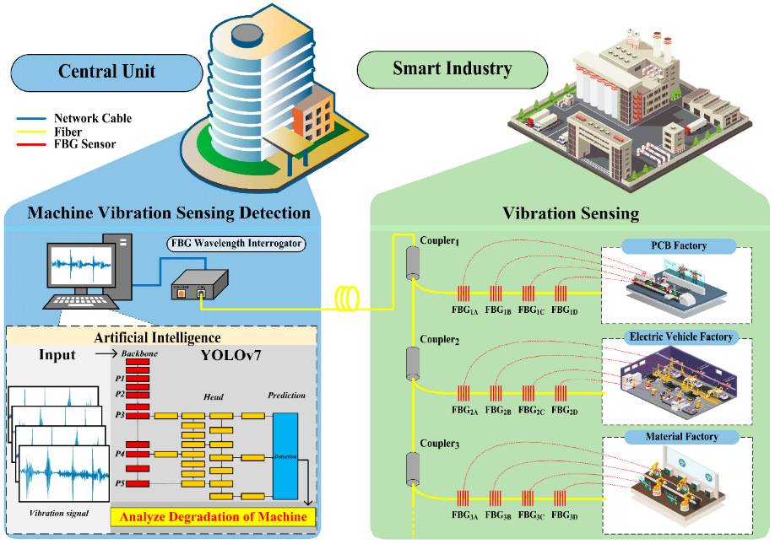
FIGURE 1. Physical Layer – Urban Infrastructure
A pavement vibration IoT monitoring system is proposed, coupled to an Intermittent Ignition Algorithm, to reproduce the daily traffic flow used as input for a Finite Element (FE) model. Interpreting accelerations in terms of velocities, high- and low-frequency components are eventually combined to synthesize acceleration time series over the entire range of operational frequencies. The approach sheds light on the potential of low-dissipation sensing networks for the support of urban infrastructures and, at the same time, provides a deeper insight on the challenges associated with the deployment of large-scale IoT frameworks.
The monitoring of the vibration dynamics in smart logistics networks, particularly when situated within urban environments, is an inevitable first step for further assessment. Results from raw acceleration data indicates distinctive relationships between riding behaviour and traffic status. Indeed, dynamic Pavement Vibration due to traffic loadings also shows daily variations that are almost coincident with actual traffic volumes. As an example the recorded time-series profile on August 10, 2020 (Figure 2) where we can already observe four separated vibration peaks for the following times : 7:00 a.m., then at noon; followed by one around 6:00 p.m. and finally another one around or a bit after 10:00 p.m. Intentionally, the largest growth during reported morning rush hours occurs just after 7 am and is observed for all diffusion-equation-solution techniques. These findings stress the relevance of IoT-based infrastructure for collecting data on infrastructure-related parameters which also hold valuable information about urban mobility dynamics [7].

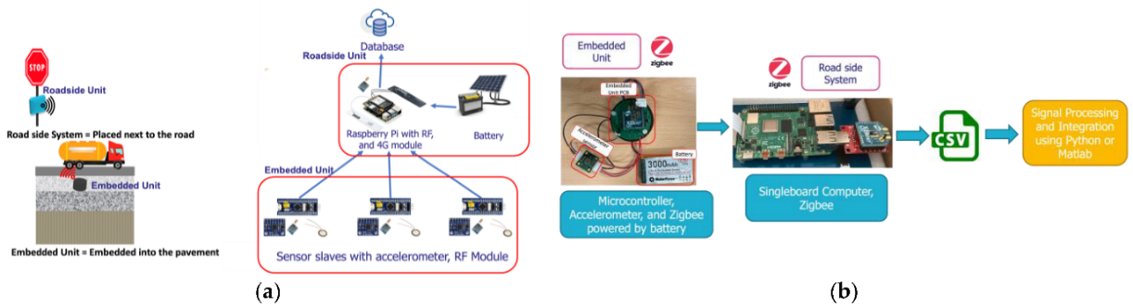
FIGURE 2. Sensing Layer (IoT Accelerometer Network)
The concept of smart logistics has attracted the attention of supply chain management practitioners, as well as managers who are interested in adopting innovative technologies. Truck fleets in cities are confronted with issues including accessibility, security, traceability, optimization and regulation. The number of logistic sensors used, and thus the monitoring capabilities, has accordingly increased.
Hybrid sensor networks, linked with an IoT server platform, facilitate the online building of logistic processes. By exploiting data flow generated by sensor-based networks—capable of detecting traffic dynamics and vehicle properties—urban smart logistic systems can monitor, control, and optimize supply chain performance, including last-mile city delivery status and urban traffic congestion behavior [8].
Monitoring the dynamic behavior of smart logistics networks enables the real-time assessment of critical network components when subjected to external loads. IoT accelerometer data provides a real-time depiction of network acceleration, from which velocity and displacement data can be extracted through integration. High time-resolution data collected during logistics operations can be analyzed to infer critical transport information related to the logistics chain.
In the logistics field, fixed sensors of traditional vibration monitoring approaches are easy to use and are provided with abundant power. Machinery cabinets for smart logistics are networked cabinet to monitor equipment health usually with wired vibration sensors; however, the cost of deployment, stability of data and scope of fast remote access are limited. In the case of vehicle or container-mounted sensors, it is not practical to have a hard power source, thus battery powered wireless solutions are popular - but these pepper with limited operational lifespan detrimental to overall performance. As a result, in order to acquire effective data for monitoring dynamic characters of the vibration systems in smart logistics networks, information should be collected with various types of sensors simultaneously 1.
However, as we enter the urban smart logistics industry to consider the prospects of IoT-enabled vibration monitoring, there still exist challenges and limitations. The heterogeneity of IoT devices, machines, communication protocols and platforms generates a broad commercial (or technological) dissociation that hinders integration and interoperability on the level of data, processes and business. Fast progression will only add to the incompatibility between generations. Privacy and security concerns arise as personal data volumes increase and are distributed across heterogeneous platforms. Elasticity and scalability issues also persist, complicated by the heterogeneity of networks, data, and devices [9]. Consequently, a mix of different technologies, platforms, standards, and protocols is required for vibration characterization at multiple levels, complicating design and operation. An IoT system for universal vibration characterization comprises measurement, data acquisition, preprocessing, transmission, storage, and post-processing elements, each of which confronts technological challenges that must be addressed before deployment.

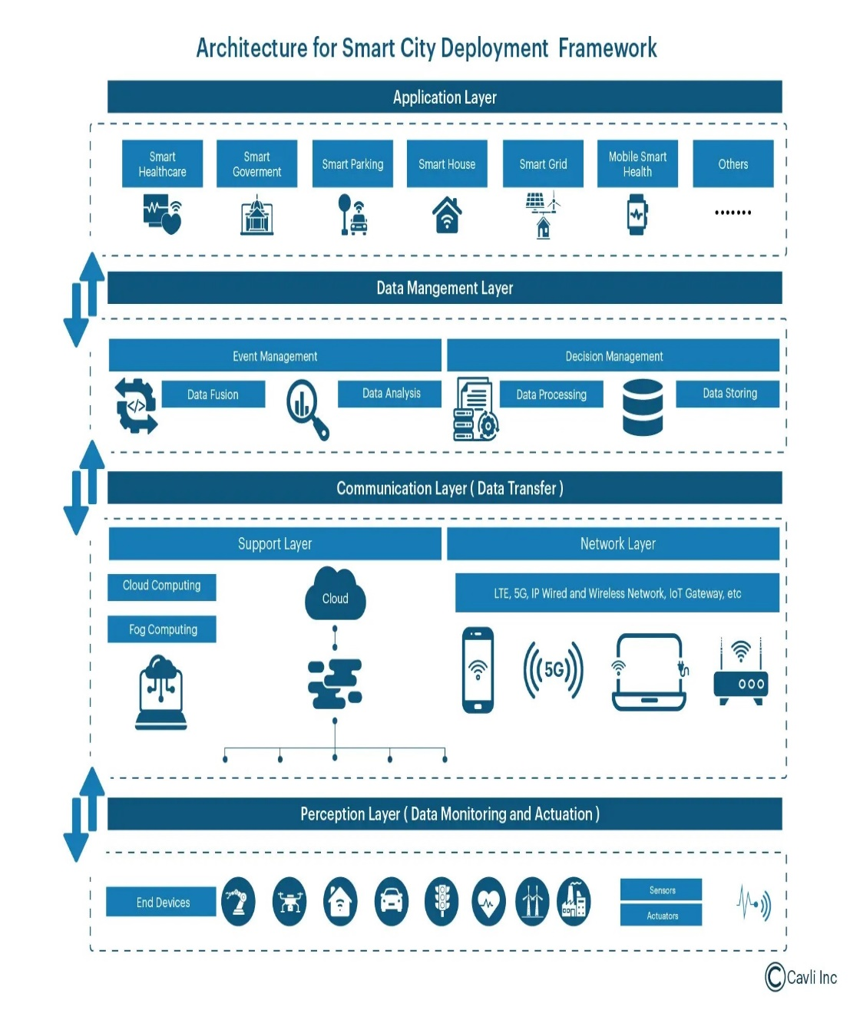
FIGURE 3. Architecture for Smart City Deployment Framework

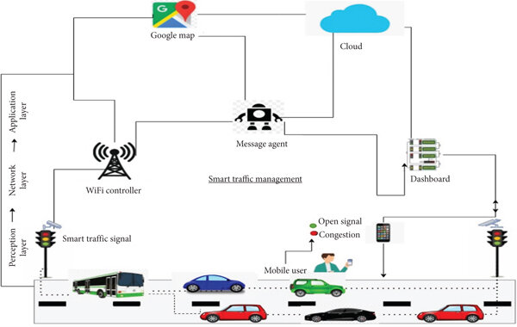
FIGURE 4. Smart traffic management
Integration of an IoT-enabled vibration monitoring system with signal-processing methods yields enhanced insights on the dynamic load responses of bridges subjected to vehicle-bridge interactions. The low-cost system, comprised of nodes containing MEMS accelerometers, a ZigBee wireless communication module, and a microcontroller, is deployed to collect pavement vibration data. Real-time vibration data supports dynamic load identification and urban traffic analysis within smart logistics networks [11]. Multiple features characterize urban coyotes’ elimination of other mesocarnivores, with solitary behavioral tendencies and social overlap contrasting with the cooperative hunting habits of wolves, thereby sculpting urban carnivore community structures. The configuration of sensor networks is a critical process for vehicle-road interaction monitoring, which is also dependent on accurate vehicle positioning. Traffic-supportive pavement structures exhibit higher bearable stress when impaired by utility trenches and asphalt concretes compared to conventional flexible pavements [12]. Although real-time urban monitoring offers physiological and logistical benefits during disaster relief, it also introduces vulnerabilities compromising urban sovereignty and security. Measuring large quantities of urban data without advanced correlation and prediction techniques limits the utilization and underestimates the social potential of urban environments. The framework also maintains both the opportunity and the challenge of designing urban infrastructures intended to become sensor nodes in smart dynamic networks.

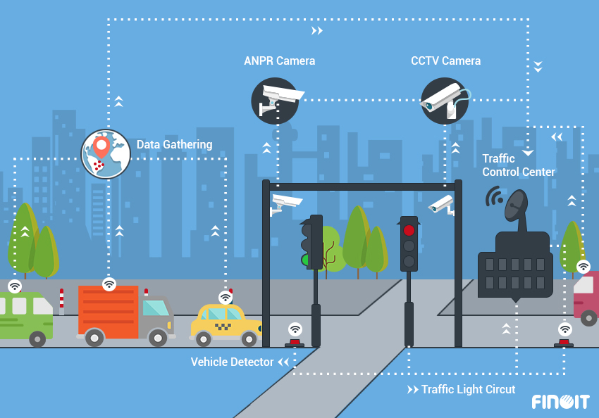
FIGURE 5. Logistics impact
The overarching value of IoT thus relies strongly on its potential to enhance the management of dynamic resources, real-time processes, and interconnected communities. By enabling seamless and dynamic real-time access to distributed information, IoT paves the way for a variety of applications within smart cities. The opportunities include the ability to: i) create autonomous building structures that can adapt and self-organize according to prevailing conditions; ii) design infrastructures characterized by dynamic capabilities and constant adaptability; and iii) develop applications capable of investigating, monitoring, and coordinating the diverse actions of urban resources.
Smart logistics networks acquire and analyse sensitive data. They therefore also face data privacy hazards. The primary concern stated is limited access control. The source data owners cannot control which processes are finally granted access to their data and how this access is converted to better access privileges. Furthermore, the shared data may contain information on a non-participant; wise privacy state therefore also represents that the shared data do not allow exploitation of information for the non-participants. The device with a direct connection to the sources can monitor the data transmitted and therefore compromise the source participant’s privacy. Data released at an earlier instance may expose the data privacy at a current time instance, whenever an adversary has access to both instances. Data analysis can also compromise data privacy. In particular, the execution of either Data Mining or Knowledge Discovery leads to faithful privacy leakage. These processes produce a model that can be deliberately or accidentally used to reveal information on the original data.
Further ICT challenges with smart logistics include data security, though these are not directly related to the project aims. The challenges impeding the realisation of an efficient and scalable IoT-based pavement vibration monitoring system are analysed. Most of the data collected by sensors are processed offline locally, and some sensors on the roadside often fail after installation due to cyclic vehicle loading and insufficient power. IoT technology enables real-time monitoring, intelligent computation, and system scalability by integrating various sensors, actuators, and communication protocols. Real-time acquisition of traffic information can be guaranteed with low latency, and sensing coverage can be widely expanded based on the distribution of the monitored network [1].
Scalability poses significant challenges in designing a vibration IoT monitoring system for urban smart logistics networks. The combination of long-term and continuous monitoring across multiple streets requires frequent replacement of energy supplies for numerous sensing nodes unless unobstructed solar access is available, limiting node placements to locations with direct visibility to sunlight [1]. There is also a need for wide-ranging and seamless communication coverage capable of supporting multiple protocols and carrier frequencies to interconnect the gateway with numerous sensing nodes, and to enable rapid data transmission from the gateway to the cloud platform through a mobile network. In the context of unsecured post-collection communication and system management, the widespread deployment of interconnected IoT sensing nodes introduces significant privacy and security concerns, especially within scale-limited smart cities.

CONCLUSION
Addressing the challenges of urban traffic by leveraging advances in the IoT is a core objective of Li-Fi research [1]. A smart logistics network approach enabled through a developed IoT system is presented that captures pavement vibration dynamics to analyse urban smart logistics flow. Each network component is equipped with a vibration sensor to monitor a range of measured elements, with the communication between sensors modelled by a self-developed model to characterise output vibration signals, support continuous vibration monitoring, and improve implementation efficiency [2]. An IoT system has been developed accordingly to illustrate how real-time monitoring of vibration dynamics is achieved within a smart logistics network operating in urban metropolitan areas.
REFERENCES
- Rustamov, K. J., & Rustamova, N. R. (2025). Advanced hydraulic drive systems in multi-purpose machinery: Enhancing efficiency and performance in modern engineering. AIP Conference Proceedings, 3304, 030093. https://doi.org/10.1063/5.0269688
- Ye, Z., Yan, G., Wei, Y., Zhou, B., Li, N., Shen, S., & Wang, L. (2021). Real-time and efficient traffic information acquisition via pavement vibration IoT monitoring system. Sensors, 21(8), 2679. https://doi.org/10.3390/s21082679
- Rezac, F. (2020). Addressing conceptual randomness in iot-driven business ecosystem research. Sensors, 20(20), 5842. https://doi.org/10.3390/s20205842
- Korabayev, S., Ergashev, O., Mahsudov, S. A., & Mamatova, S. (2024). Exploring common technical issues in modern technology. BIO Web of Conferences, 145, 03016. https://doi.org/10.1051/bioconf/202414503016.
- Khankelov, T. K., Rustamov, K. J., Irisbekova, M., & Sabirova, D. K. (2024). Substantiation of the main parameters of a hammer crusher for grinding municipal solid waste. In E3S Web of Conferences (Vol. 515, Article 03019). https://doi.org/10.1051/e3sconf/202451503019
- Rustamova, N. R. (2025, July). Vitagenic chemistry: Unveiling life-enhancing energies in chemical reactions. In AIP Conference Proceedings (Vol. 3304, No. 1, p. 040056). AIP Publishing LLC. http://doi.org/10.1063/5.0271016
- Kamoliddin, R., & Nodira, R. Determination of the main parameters of the mechanisms of a two-stage compressor and their kinematic analysis. In AIP Conference Proceedings (Vol. 2789, No. 1, p. 040001). https://doi.org/10.1063/5.0145477.
- Rustamova, N. R. (2025, July). The role of vitagenic technologies in revolutionizing machine design and functionality. In AIP Conference Proceedings (Vol. 3304, No. 1, p. 030095). AIP Publishing LLC. https://doi.org/10.1063/5.0269690
- Mutambik, I. (2025). IoT-Enabled Adaptive Traffic Management: A Multiagent Framework for Urban Mobility Optimisation. Sensors, 25(13), 4126. https://doi.org/10.3390/s25134126
- Rustamova, N. R., & Rustamov, K. J. (2025, July). Vitagen information and hydraulic drive systems in multi-purpose machinery: Enhancing performance and innovation. In AIP Conference Proceedings (Vol. 3304, No. 1, p. 030097). AIP Publishing LLC. https://doi.org/10.1063/5.0269692
- Pirnaev, S. A., Rustamov, K. J., Mukhitdinov, A. S., Nurtas, M., & Rustamova, N. R. (2025, July). Influence of milling depth and angle of attack on parameters of power device. In AIP Conference Proceedings (Vol. 3256, No. 1, p. 060019). AIP Publishing LLC. https://doi.org/10.1063/5.0267773
- Sarmonov, A., & Rustamov, K. (2024). RETRACTED: Implementing energy-saving technologies in hot asphalt production: A comprehensive review. In E3S Web of Conferences (Vol. 538, p. 01029). EDP Sciences. https://doi.org/10.1051/e3sconf/202453801029

