Human-Centric Smart Transportation: Passenger Comfort and Vibration Optimization
Nodira Rustamova^{1, 2, a)}, Yunusbek Makhmudov², Ikromjon Yuldashov³, Zulfiya Kholmatova³, Kibriyo Maraimova³, Farrukh Siddikov³
¹ISFT Institute, Tashkent, Uzbekistan
²National Institute of Pedagogy and Character Education named after Kori Niyozi, Tashkent, Uzbekistan
³Fergana State University, Fergana, Uzbekistan
^{a)}Corresponding author: rustamovanodira19@gmail.com
Abstract: In recent years, vibration has emerged as a key factor influencing passenger comfort in transportation systems, leading to widespread interest and research efforts. Vibration can directly affect passengers’ physiological and health conditions. Consequently, the transportation community is committed to reducing vibration and noise to enhance overall comfort. Smart systems have begun to integrate pervasive Internet of Things (IoT) technologies and data analytics to achieve this objective more effectively. This paper presents a vibration optimization framework that combines a human-centric perspective with smart transportation technologies, offering practical assurance of passenger comfort. The framework leverages theoretical insights linking human-centered design with vibration effects and draws upon empirical studies demonstrating the influence of vehicle motion and passenger physiology on comfort levels. By optimizing vibration through mechanisms informed by these studies, the approach enables human-centered smart transportation systems to maximize passenger comfort. Inspired by AI and IoT innovations, the research proposes an end-to-end monitoring solution that integrates vibration sensing, human-centric comfort assessment, data analytics, and active control of the transportation apparatus. The framework anticipates a new generation of smart transportation systems capable of safeguarding passenger well-being and comfort in harmony with Artificial Intelligence, IoT, and Big Data technologies.
Keywords: Passenger comfort; Vibration; Smart transportation; Human-centric design; Internet of Things.
INTRODUCTION
Vibration transmitted via vehicles causes discomfort and annoyance among passengers. However, the restrictions implemented to fulfill the comfort levels implied by passenger-carrying entities often cause a surprisingly significant reduction in the overall performance of the vehicle. In the last years, an effort has been made to strictly comply with those comfort requirements and overcome such a reduction. Human satisfaction plays a principal role in commercial transport and it currently constitutes a key competitive advantage. As a result, the present document compiles a series of technologies and methodologies appearing as promising candidates in the improvement of transport systems from a human-centric perspective: a holistic strategy primarily focused on and dedicated to passenger satisfaction and welfare [1]. Across several scientific disciplines and technologies, a passenger can be conveniently ensured with the utmost comfort without any compromise in the remaining non-human subjects [2].
METHODS
Passenger comfort and vehicle vibration are fundamental issues for people-oriented smart vehicle design. It is difficult to realize smart transportation without a human-centric perspective. Here, a human-centered smart transportation with passenger comfort and vibration optimization is provided, along with a basic principle for human-centered transportation and a study of both passenger comfort and vehicle vibration. Humans, passengers, vehicles, interactions between human and vehicle, multi-source heterogeneous transportation data, and systems are described, from data acquisition and transmission to processing, modeling, analysis, and optimization. In this way, a framework is proposed for sensing, communication, and data fusion, as well as the dynamic scheduling of transportation resources and traffic flow based on multi-source heterogeneous transportation data. The proposed human-centered smart transportation framework could potentially boost the development of autonomous vehicles and intelligent transportation systems [3].
Over the last decade, smart transportation is one of the most important elements of major state projects in many countries; many strides and advances have been made based on information and communication technology, cloud computing, the Internet of Things, and big data technology. While most of the efforts have focused on the infrastructures and the support of applications, some recent research concerns have started to shift toward human-centered smart transportation, the critical issue of passenger comfort, and vehicle vibration perception [1]. Thus, a human-centered smart transportation with passenger comfort and vibration optimization is provided with the basic principle on human-centered transportation, as well as a study on both passenger comfort and vehicle vibration. Humans, passengers, vehicles, interactions between human and vehicle, multi-source heterogeneous transportation data, and systems are introduced, from data acquisition and transmission to processing, modeling, analysis, and optimization. A framework is then proposed for sensing, communication, and data fusion, as well as the dynamic scheduling of transportation resources and traffic flow based on multi-source heterogeneous transportation data. The proposed human-centered smart transportation framework will potentially assist the ongoing development of autonomous vehicles and intelligent transportation systems.
The analysis of ride comfort is one fundamental issue for the design of smart vehicles. Ride comfort is typically related to the optimization of transportation systems. Transportation scheduling requires different objective functions when it is focused primarily on passengers or goods. In automated control where the controlled objects may be considered as multiple dynamic agents, the application of multi-objective optimization needs to take both driving efficiency and individual comfort into account, highlighting the important aspects and characteristics of each and providing a mechanism to weigh and balance the objectives appropriately, both from the perspective of vehicle dynamics and driving behavior [2]. Transportation modes consist of human-driven, semi-autonomous or fully autonomous driving, each of which should have its proper objective functions. The selection of the appropriate objective functions and associated optimization methods occurs only after a careful examination of the primary sources of discomfort, including transportation-intensive factors and those closely related to human feelings and perceptions.
Transportation is a key part of the public infrastructure, and any improvements to the system would make life easier, more efficient, and more productive for everyone living and working in cities. Transportation is very important, but it still imposes a lot of inconvenience and discomfort on the users.
Smart transportation infrastructure has become one of the major initiatives worldwide, with its applications ranging from on-road vehicles and rail systems to urban air mobility platforms [4]. Today’s smart transportation tackles all aspects of the system: scheduling, routing, economy, energy, and environment. Yet from a human-centric perspective, a key requirement remains to enhance passenger comfort. Vibration is one of the significant factors that cause discomfort and can even lead to health issues if not properly mitigated. Understanding the relationship between vibration and comfort provides a pathway to substantially improve the overall experience.
On the one hand, as pervasive wearables allow us to continuously and in real-time map the passengers comfort level across a network of traveling individuals, on the other hand we argue that the large networked infrastructure is itself an ideal substrate for active vibration control (in its physical layer). Solving this task requires a combined strategy, which links rider comfort and the methods of optimizing vibrations. The present intelligent transportation system (ITS) pr oduces large quantities of heterogeneous data, providing opportunities for better addressing passenger comfort and safety in mobility.
Theoretical Framework
The following section deals with theoretical background including the basic theory of human‐centric smart transportation systems that combines passenger comfort and vibration control. Humanity-centered SCMP: The principle of human centrality dominates in smart transportation, and people are always at the center. Human-oriented smart transponders are designed to enhance side effects caused by environmental stimuli, such as vibration, while personalizing human comfort and taking into account the special requirements of humans on moving platforms, thereby improving the quality of transportation experience.
Passenger comfort design in transport systems strives to make passengers feel relaxed and relieved from physical or mental stress on their entire journey [5]. The design philosophy aims to increase satisfaction based on a thorough understanding and accurate prediction of passenger needs in terms of comfort conditions. Passenger velocity and acceleration fluctuate highly in the actual transportation environment, causing various upset feelings. Therefore, reducing the impact of vibration increases comfort during transportation.
Vibration has a detrimental influence on human activities, particularly while individuals are engaged in whole-body standing or sitting working positions [1]. Machine tools, transport systems, and other machines transmit vibrations to their users. When the transmitted vibration frequency coincides with the human body's natural frequency, resonance effects may reduce work rate, increase body strain, and cause discomfort or health problems. Vibrations are transmitted to the human body through the seat, footrest, and floor. For comfort analysis, the vibrations reaching the neck and head region are crucial, as humans perceive them directly, while vibrations through legs and feet have a minimal direct perception on a vehicle traveling on a highway. Specialized measurement mechanisms, such as the WBV (Whole Body Vibration) measurement mechanism, and sensory evaluations on the occupant provide data for assessing ride quality.
Passenger comfort is a complex concept involving feelings of pleasure, contentment, and satisfaction, but interpreted differently in transport context [2]. According to the Brain University-building Standard, the sensation of comfort is produced by the amygdala in the brain, i.e., the feeling of comfort is the feeling of safety and peace in the brain, so the condition to generate the feeling of comfort is that the body is in a “safe and stable” state. In transportation systems, the human body can be affected under the influence of the external environment/vehicle operation, resulting in a change of the body state. The influence of the external environment on the human body is caused by light, sound, smell, heat, humidity, etc., which also affects the comfort state; the influence of the vehicle operation is to cause changes in the speed and angle of the body, which leads to changes in the contact force between the body and the car seat and energy conversion. The change of the mechanical state affects the degree of comfort. Relating to the comfort sensation, different researchers have found several factors that influence it, such as thermal comfort, noise comfort, visual comfort and vibration comfort. Thermal comfort refers to the exchange of heat between the human body and the environment. Noise comfort is related to the impact of noise on the human body. It causes symptoms such as loss of hearing and physiological and psychological discomfort. Visual comfort refers to the reaction of the human eye after the visual behaviour, and the irritate of the yellow and green wavelength leads to high visual comfort. Vibration comfort is related to the impact of the vibration on the human body and expressed by numerical values. Thermal, noise and visual comfort are transient and vague concepts, while vibration comfort can be transformed into accurate data and designed and controlled. Usually, passenger comfort is combined with vibration comfort [3].
Passenger comfort in transportation is an indicator of how well human physiological and psychological needs are satisfied. It has large influences on transportation mode choice and travel motivation. For instance, car transportation exhibits great flexibility, but motorcycles and bicycles are exposed to a higher degree of vibration. Smart transportation systems (STS) combine sensor information with various information and communication technologies to fulfil a number of aims like improving safety and comfort levels. A human-centric system seamlessly connects people with the environment, devices, and services. Such systems apply comprehensive datasets to implement human behaviour modelling, which supports decision-making and facilitates adaptation to more individualised and intelligent responses.
More and more research is focusing on the comfort of passengers within STS, particularly in the context of vibration. Recent studies have analysed the comprehensive influence of vehicle operating parameters and passenger physiological characteristics on comfort under different motion conditions and have established comfort-prediction models that consider these factors [2]. Various control strategies—including adaptive cruise and automatic obstacle avoidance systems for longitudinal acceleration and deceleration; curve path planning; and lane-changing models for lateral operation—have been developed to improve comfort by reducing maximum acceleration and jerk. An improved collision-avoidance system based on vehicle communication, which sets deceleration at 4 m/s2 as the comfort threshold, has been shown to enhance passenger comfort while maintaining safety. Similarly, lane-change trajectory-planning models that limit lateral acceleration and jerk generate smoother trajectories, further enhancing comfort. A continuous-variable transmission (CVT) plays an important role in adjusting engine torque and revolution to mitigate vibration impacts on the vehicle and passengers.
Vibrations constitute one of the main factors affecting passenger comfort during transit. Current research is focusing on the measurement and evolution of vibrating force in a vibration environment, accelerated degradation scenarios, accelerated degradation models, and Bayesian estimation, drawn from various fields. The analysis of ride comfort in railway passenger cars underscores the critical impact of vibrations and oscillations on the human body; such vibrations influence health by increasing exhaustion or causing damage. Ride comfort assessments utilize indices based on environmental parameters and measured acceleration signals from specific locations. When vibrations act on the human body, they can induce forced oscillations—particularly at frequencies near the body's eigenfrequencies, which range from 1 to 6 Hz depending on direction—with resonance oscillations in this range potentially affecting vital organs and systems. Consequently, signals of accelerations acting on the body constitute primary parameters for evaluating ride comfort relative to vibrations [6].
A definition is provided for passenger comfort along with a discussion on factors affecting comfort and methods of evaluation. In addition to Lovecraft's concept of a universal model of comfort, Birch's partitioning of comfort factors into physical, psychosocial, and physiological categories is described, and relevant measurement approaches are introduced. The issue of vibration in vehicles is described, focusing upon the vibration sources, impact upon passengers, and methods of measurement. The human-centric design perspective is outlined, with consideration given to user-centred design, ergonomic design, human factors engineering, and inclusive design. The approach to smart transportation analysed in this work is presented, describing the role of the Internet of Things (IoT), big data analytics, and real-time monitoring. Concepts of vibration optimisation are explained, and techniques for vibration optimisation discussed, including active control, passive damping, and structural design adjustments. The Research Design for the investigation is detailed [2].
Passenger’s comfort is the referring to one’s subjective assessment of his feelings and physiological conditions in terms of travel. Seating, stability, control interfaces, internal space and capacity as well as ventilation and temperature are all related to comfort in this environment: noise levels, design of facilities and catering services. With excessive vibration levels, with vibrations exceeding a limit which is acceptable to passengers, discomfort becomes uncomfortable. Passenger ride comfort includes thermal, acoustic and air quality as well as vibration. The most harmful stimulation from a biological point of view is coming through seats or floors, there having had harmful effects on health, standing fatigue and physiological functions [3].
Vibration characteristics, as well as frequency and acceleration magnitude, exhibit a marked impact on ride comfort [2]. Analyses of vibration signals are often conducted using a three-way accelerometer positioned at the seat or floor. Typically, the signals undergo bandpass filtering and are weighted according to the human body’s frequency response to vibration. Considering the human body as a superposition of elements each exhibiting damped oscillations, forced vibrations arising when external frequencies coincide with the natural frequency of a body element produce resonance. Resonance frequencies for human organs typically span 4–6 Hz in the vertical direction and 1–3 Hz horizontally. Sensitivity to vibrations also varies with seat position; heels demonstrate significantly higher tolerance than backs or buttocks. These differences necessitate distinct thresholds for vertical and horizontal oscillations. Hence, the direct human body influencing acceleration signals are used as the main input parameters for ride comfort assessments.
Vibration in Transportation Systems
Vehicle vibrations have a large impact on passenger comfort during transportation and simple descriptions of acceleration or velocity can be used as first estimates. Using the root mean square (RMS) and weighted RMS value as metric results in a more global evaluation since several parameters are involved on vibration transmitted to passengers. Analysis of acceleration signals along several axes, using frequency band spectrums, can help to locate levels of vibration most detrimental to comfort [4, 7].
Within automotive systems, vehicle-related sources of vibration potentially affect passenger comfort and safety. The vibration predominantly stems from road profiles and vehicle speed. The principal internal sources of vibration are caused by components that rotate, reciprocate, or otherwise oscillate, including the propellers, shafts, drive components, gears, chains, drive belts, pumps, piston engines, coolant pumps, and tire rotations [1]. Alongside the mechanical vibration, other sources include suspension systems and structural resonances.
Vibration induced by transportation adversely affects passengers’ psychological and physiological well-being. Vibration levels from rail and road conveyances usually fall within the frequency range of one to 80 hertz, which coincides with the resonance frequencies of the human organs, hence producing discomfort and even health damage. Often, passenger cars exhibit intense vibrations due to the roughness of the rails and the short wheelbase of the cars, which greatly cause diminished performance of passengers [3, 8]. Normally, humans can withstand vibration frequencies for short periods [1]. Therefore, comfortable environments must be maintained to minimize psychological stress, fatigue, and health problems. Transportation systems also cause intense vibrations, which arise from variations in asphalt, degrading the riding quality for passengers and inducing harmful accidents at high speeds.
Vibration is the periodic and oscillatory motion of a material or system. It is ubiquitous and can be found in our daily surroundings. By assessing the production, transmission, and consumption of energy, understanding vibration can aid in journal bearing design, failure identification, and wear determination. Vehicles are subject to different vibration forces transmitted through the power unit and road surfaces. To assess vibration system and security in passenger and freight cabins, arranging equipment and tools on massive multi-frequency vibration exercising equipment is common [1, 9]. Reviewing the technical state of platform vehicles and conducting vibration tests on freight cars involves inspecting major components and instruments, conducting static load tests, and detailing the tests and instrumentation used, along with analysis and results. High equipment vibration induced by irregularities can lead to fatigue failure, necessitating precise analysis of vibration sources. Gearboxes represent a significant share in transmission systems; thus, studying their vibration is critical. An automotive chassis γbox-end test aims to analyze combined vibration signals for a rough road characterization. Although a car suspension system is supposed to insulate you from the jolts of rough roads, it doesn’t totally eliminate mechanical vibration. The vibrations have been studied historically to provide passengers with better comfort, discussed as ride comfort because of mechanical vibrations that are transmitted contacturally from pavements to tyres/motorcycle, and frame/occupant. These vibrations are usually measured using a vibration meter equipped with an accelerometer or transducer, and acceleration is commonly in the form of milli-g (m/s²).
Human-Centric Design Principles
In the field of smart transportation research, human-centric design in particular focuses on users bringing convenience, safety and a healthy life They also include early consideration of users' abilities and limitations in product design and testing, considering ergonomics when creating new technologies that are rapidly emerging [10].
The most important aim in smart transportation is to improve passenger comfort by incorporating requirements into the design. Achieving a human-centric approach necessitates integrating ergonomic considerations like those in into design processes. As the field moves toward smart transportation, human-centric design principles at all organizational levels aim to create vehicles and environments that enhance passenger well-being, respect individual comfort preferences, optimize human-environment compatibility, and ultimately boost overall productivity.
User-centered design enhances products, systems, and services focusing on productive and healthful activities, user inspiration, humor, and enjoyment. It integrates ergonomics’ focus on the activity and environment with user experience’s emphasis on user needs and perception [5, 11]. Comfort is defined as the state of mind expressing anticipatory satisfaction with a product, achieved through harmony between physiological, psychological, and environmental aspects. A user-centered approach systematically addresses bodily, emotional, and psychological needs, maximizing user experience by satisfying functional and emotional expectations while minimizing discomfort. The tenets include the importance of user needs and characteristics, early involvement, iterative design, and multi-disciplinary perspectives. Outer body measures, such as pressure, size, and temperature, and subjective metrics, including discomfort, stiffness, and fatigue, determine human comfort. The approach combines subjective and objective measures in human motion, accommodating, model, and measurement variability to characterize comfort on a population level [12].
Vehicle dynamics and associated ride comfort depend on mass, suspension components, and tires. Vibration measures relate closely to human perception and potential health hazards. The study of seated occupants’ ride comfort under whole-body vibration is complex, involving multiple factors. Whole-body vibration transmits mechanical vibrations to the body through a supporting surface, such as a vehicle seat, when traveling on rough surfaces. Assessments of ride comfort include subjective methods, requesting participants to rate discomfort; objective measurements, employing accelerometers to record vibrations; and mathematical models predicting discomfort based on vibration data. Combining a multi-body biomechanical model of a seated occupant with a backrest, representing thighs, legs, and feet, with a vehicle model, allows comparison of simulated accelerations with standards. Vibration perception peaks in the 3–6 Hz range, especially affecting the pelvis region. The methodology aids evaluation of protective measures and may reduce seated occupants’ musculoskeletal disorders [1]. In addition, passenger assistance systems incorporating rudimentary information, such as drowsiness warnings and distance indications, can reduce discomfort and enhance the driving experience. Incorporating passengers into the design process and developing assistance systems beyond traditional infotainment present significant opportunities.
The study of ride comfort for seated occupants under whole-body vibration is a complicated issue which includes many influencing factors. Whole-body vibration is transmitted to the whole body when driving on rough roads through a seat of a vehicle. Ride comfort evaluations comprise subjective ratings, objective accelerometer data and a mathematical model. Perceptual judgments are based on participant ratings, and objective measures use accelerometers to capture vibrations. However, the vibrational data can be used to predict discomfort levels using mathematical models. A multi segment biomechanical model of a seated occupant and backrest, which includes the thighs, legs and foot is developed for previously unresearched areas. A multi-objective firefly algorithm is used for estimating biomechanical parameters including mass, stiffness and damping. Using these parameter values, segmental transmissibilities are evaluated and compared with experimental data. When the model is attached to a vehicle representation, ride comfort analysis can be conducted according to applicable standards. One of the conclusions we can draw from this analysis is that vibration perception is at its highest within frequencies of 3–6 Hz and designers should concentrate on the pelvis to increase comfort. Understanding these results is relevant for protective assessment and to decrease the presence of musculoskeletal disorders in seated occupants [13].
Human-centric inclusive design was proposed to identify and remove physical and social obstacles to comfort, well-being, and energy conservation [1]. The intention was to foster the development of smart transportation by prioritizing passenger comfort and well-being in a world of increasing physical and social constraints. Despite growing awareness of the issue, insufficient research has focused on the effects and causal factors influencing vibration comfort. With interest growing in smart transportation as a key enabling technology of smart cities, regulations and policies are not exerting a strong enough influence on innovation. Smart transportation remains a technology that awaits a dominant design. New smart transportation technologies can all be implemented within a human-centred smart transportation paradigm, achieving an optimal balance between innovation and use, as well as gains in passenger comfort. The data and software developed are available at github.com/Henry-mjtsai/Vibration-Comfort
The development of transportation technology gives rise to significant breakthroughs that enable improvements in the quality of passenger life in terms of convenience and safety [2]. With the fusion of Internet of Things (IoT) into smart transport systems, the health and comfort status of passengers can be monitored in real-time and multi-dimensions to achieve intelligent and human-oriented transportation services. Intelligent transportation promotes the connectivity of vehicles, roads and people, providing safe, stable and efficient travel services. Despite the beneficial aspects of 5G and intelligent manufacturing, its introduction has also provoked discussions about the societal impact of autonomous systems. The broadly accepted notion of smart transportation is particularly concerned with the development of intelligent and efficient travels, emphasizing the importance of people-centered concepts in this ever-changing domain. Progress in this area will need to take into account not only technical goals, but also human factors if we are to encourage sustainable and equilibrated development.
The theme of service is basic in the modern civilisation for holding economic activity and national life. As a result, issues like traffic jams, accidents and environmental problems have also risen, leading to a trend toward smart transport policies. The best guidance techniques have been created however many of the least expensive ones rely heavily on factors and do not necessarily take into consideration passenger comfort. One of the most important considerations in human-centered design is that, this can determine under what conditions users are able to perform at their best in a given use case. Passenger surveys corroborate this concern by placing comfort as a top priority and thus the development of less intrusive methodologies to improve global comfort under safety constraints is crucial.
Fatigue free and fresh emotion is the feeling of being comfortable with transportation. Maximizing the physical well-being of passengers upon reaching their destinations contributes to human-centeredness. Developing a way to ensure that the passenger experience is as enjoyable as possible involves determining and mitigating conditions that cause rider discomfort. The combination of vibration control, active techniques and robust methodologies enables enhanced comfort and a reduction in adverse effects. Theoretical concept studies such as vehicle dynamics, occupant kinematics and cabin acoustics reveal more deep-rooted nature of comfort and vibration, paving the way to further implement research works.
The IEE standard SF-1943 requires that passengers flying for one minute or more will choose the most comfortable condition to sleep. This level of performance is the target facilitate by a human-centered approach, multi-sensory human factors being paramount. It is this goal that guides our review of the theoretical tools behind next generation transportation systems, with the focus on passenger comfort and safety.
Transportation is a critical element of daily life, with smart transportation becoming a significant infrastructure development worldwide. Passengers remain central to the system, and ensuring their comfort is a leading concern, especially since vibration constitutes the most prevalent disruption [2]. Various vibration sources exist, including the vehicle itself and the road surface; these vibrations transmit through the vehicle structure, can cause resonances, lead to discomfort, and may be linked to health problems. Consequently, the safety constraints arising from vibration have been a longstanding concern for researchers, with human-centric IoT technologies providing new opportunities to address this issue and, subsequently, enhance passenger comfort in daily commuting.
Data analytics for passenger experience in smart transportation is predicated on a human-centric approach, simultaneously fulfilling essential roles in passenger comfort and vibration optimization. Embracing a human-centric perspective ensures that smart transportation systems—those involving the Internet of Things (IoT)—are designed to benefit people and advance society. Vibration optimization functions primarily to control the mechanical excitation of the vehicle body identified in the review. Passenger comfort thereby encompasses strategies to diminish the influence of undesirable vibration levels on the human body within the vehicle. Optimization techniques are focused on reducing the vehicle body's vibration level. The linkage between passenger comfort and vibration is established through the human-centric and ergonomic principles of smart transportation, which are embodied in such definitions and confined within their respective scopes. Maintaining focus on passengers during the development of smart transportation is essential. Much of the relevant literature emphasizes the human comfort aspect, with vibration optimization generally treated as part of vehicle design.
Some previous efforts have studied optimal vehicle configurations considering the vibration transmissibility in a simulated cabin model, developed methods that maximize ride comfort subject to design constraints, and applied machine-learning based on ride comfort rating records to quantify car ride comfort. The use of modern sensor technology has resulted in large amounts of vehicle vibration information. In the current technology, these data sets are used for vibration evaluation, for assessment, and sometimes even to predict. From a human comfort point of view, data analysis can solve the following questions in particular: where to feel discomfort is and when it happens, at what range level it is. An alternative approach is the human-in-the-loop vibration analysis that uses human comfort feedback to look at the vibrations from a human centred perspective, but the gathering of such data and responses by humans is limited as well as expensive. Vibration readings, on the other hand, are plentiful and can be taken in real time, but their relevance for humans decreases. This limitation could be especially onerous for large-scale intelligent travel lines, such as nationwide high-speed rails and subways. These shortcomings drive the present work, where passenger comfort data is initially evaluated to reveal those factors which affect passengers’ discomfort and then determine the vibration influence on passenger comfort.
Real-time monitoring systems constitute a vital component for automating data collection and analysis within passenger-vehicle environments. Such systems not only gather data on measurements, but also process information and provide real-time feedback to ensure compliance with design criteria [3]. Effectively implemented monitoring systems facilitate prompt decision-making, thereby optimizing passenger comfort [1].
Many of devices have been developed to improve vibration and to improve the comfort of passengers in transit. The active vibration control is to use actuators to reduce the vibrations. It is based on a vibration isolation model that is the inverse of the affected system [1]. Another frequently used method is passive damping, which uses components such as shock absorbers to lower the amount of vibration [3]. Design considerations are also prominent: suspension systems and seats could be designed to minimize or dissipate angles of vibrational transmission to the rider. These two strategies are generally utilized to complement each other in order to find an effective vibration control solution. In smart transportation context the use of these techniques is discussed in next section.
Active vibration control is an essential aspect of vibration optimization, where a secondary force is applied to a system to balance or compensate external excitations and reduce the system’s response [6]. This additional actuator-generated force is designed explicitly to counteract the vibrations induced by external forces. The control strategies developed for vehicle seats are applicable to other targets; for example, active suspension systems can attenuate floor vibrations in tractor cabins. The selection of a specific approach depends on the characteristics of the target response; active suspension control methods often concentrate on acceleration or displacement of the corresponding target location.
Passive vibration damping techniques utilize components like damping materials, isolators, and tuned mass dampers to absorb vibrational energy and reduce transmitted forces on the vehicle frame [6]. Low-frequency, large-amplitude vibrations are particularly hazardous to occupants and require effective mitigation. Although passive suspensions feature simple construction and low cost, their stiffness and damping properties are fixed and therefore ineffective when road input varies [1]. As the final link in the transmission path, the seat suspension substantially influences overall vibrational comfort and is a prime candidate for the integration of damping solutions.
Based on the transportation demand, the critical vibration at the pelvis area of an automobile passenger is between 3 and 6 Hz [1] [3]. To reduce vibration, the rail track of the car transportation system analyzed in the previous work was modified.
An optimum vibration assessment system is designed based on the principle of a comfortable vehicle. The vibration isolation device is set up on standing passengers to reduce the discomfort of the passengers and maintain a more stable posture.
According to the vibration dispersion model, an empirical mode decomposition (EMD) combined with limited memory recursive projection kurtosis (L-OMPRK) method is put forward to improve abnormal vibration detection efficiency. A Six Degrees of Freedom (6-DOF) parallel platform can simulate vehicle vibration, which verifies the vibration isolation device and abnormal vibration detection method by the designed optimized strategy [2]. The measurements of vibration can be used for real-time assessment of the human vibration system. Passengers are the object of vibration isolation and Human-Centric Smart Transportation (HCST) is the ultimate goal.
Transportation systems, like automobiles and buses, have become essential. Many studies aim to improve passenger comfort and safety, addressing problems such as ride discomfort and air quality. Vibration significantly influences these aspects. A smart transportation environment that optimizes vibration to enhance passenger comfort has been developed by integrating human-centric perspectives with intelligent environmental monitoring technologies. This system contains a set of vibrating devices, sensors, The Internet of things (IoT) and a data analytics module. Vibration enhancement is attained by three controlling methods that are active, semi-active and passive control. The evaluation results validate the system’s effectiveness. The combination of human-centric consideration and vibration-optimization is in tune with the expansion of IoT market and implies that the penetration of smart transportation systems will grow even faster [7].
The monitoring process involves four types of events which are uncomfortable for the passenger: rapid acceleration, abrupt breaking, pass over pothole and high-speed cornering. Sensitivity criteria for these events are derived from test runs involving several passengers.
Despite variations in individual preferences, the system applies the lowest threshold to satisfy most users. A 5 m/s² acceleration threshold is specified. The influence of lateral acceleration on comfort is also assessed, revealing that lower y-axis accelerations correlate with improved passenger well-being. As a result, passenger comfort is evaluated automatically using smartphone inertial measurement unit (IMU) data. The system is validated through threshold-determination experiments, with future work planned to detect pothole-induced vibrations via vertical-axis acceleration analysis.
Data analysis techniques play a pivotal role in optimizing vibration to enhance passenger comfort in human-centric smart transportation systems. For example, multi-source data analysis models have been proposed to correlate passengers’ physiological characteristics and the temporal effects of vibration with comfort measures. Principal component analysis (PCA), least squares support vector machine (LSSVM) and other methods are used to build comfort assessment models which can objectively evaluate the impact of vibration factors [2]. Such models may be used to develop real time vibration optimization techniques to enhance passenger ride comfort. The grain structure-based techniques such as the GB information method are combined with insider Vibration Limiting Strategies (VLS) for additional comfort related problems. The algorithms inspired by naive Bayes and fuzzy mathematics are adopted to automatically recognize the sources of vibration data in time-frequency domain (spectrogram), so that the parameters can be ensured for further data processing and extension analysis. In-built additional hardware, tablet terminals and personal comfort tuning system allow the on-the-fly vibration suppression, which supports human centred approach. With the aid of IoT platform, real-time monitoring, data sharing and intelligent controlling are realized for vibration influencing factors to promote resource saving and comfort optimization. Stability of solutions during lateral power transmission as well as the development of real-time condition monitoring equipment are recognized to be of utmost importance for future research and applications.
RESULTS
The research community acknowledges vibration to be a major source of traffic discomfort. Nonetheless, human-centric smart transportation and comfort-related vibration optimization remain underexplored. An examination of passenger comfort demonstrated that vibration indeed influences the human factor in transportation systems. Therefore, a vibration-optimization-oriented human-centric smart transportation concept was proposed and substantiated by a technology survey, with Internet of Things applications in vibration optimization highlighted as an example. The study also featured a vibration experiment on public transport vehicles. The growing interest in passenger comfort, alongside attention to vibration-induced discomfort, indicates that smart transportation systems should address vibration optimization from a human-centric perspective.
Continuous improvements in transportation provide passengers with greater mobility, but comfort levels have not kept pace; in fact, they have decreased, with many passengers frequently feeling uncomfortable. Transportation is also a main source of environmental vibration, which affects the comfort of passengers inside vehicles and residents near transportation systems. Specifically, a considerable number of passengers suffer from travel sickness, and the ability of the elderly population to travel is decreasing. Selective vibration as an indicator of comfort level in vehicles reveals that vibration perception varies among individuals and types of transportation. Consequently, vibrations generated by the transportation system require optimization. Among the various comfort indicators, vibration is the most apparent.
Passenger comfort represents one of the most important factors for assessing the quality of travelling by various means of transport. Excessive vibration is one of the key factors that affect human comfort during the ride.
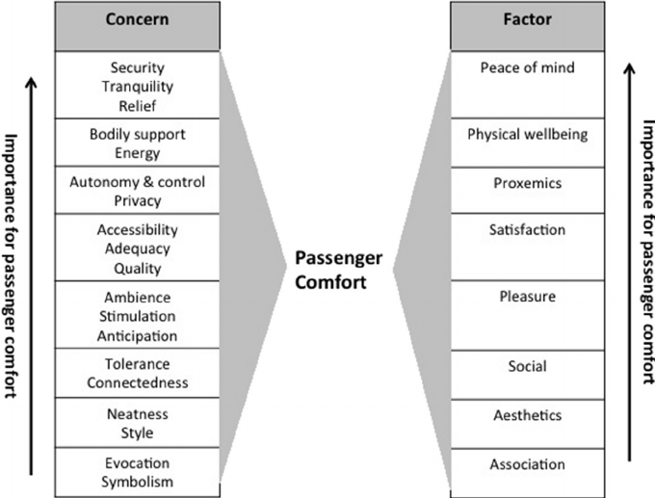
FIGURE 1. Factors Influencing Passenger Comfort in Transportation Systems
Comfort can be generally defined as the state of mind which expresses satisfaction with the surrounding environment. A more interpreted definition considers comfort as a syndrome of pleasant conditions that leads to the psychological, physical and physiological harmony of an individual. It results from a complex interaction of several aspects related to human feelings, expectations, the environment and a built environment. Comfort level can be evaluated by subjective or objective methods. The subjective evaluation relies on the criterion of individual wishes and preferences. The objective evaluation is based on physiological parameters or physical parameters of the environment conditioned inside the space. The physical parameters can be measured, for example, with an accelerometer or noise level meter. With the use of biometric technology, physiological parameters can also be measured. From the overview of the previous research, the temperature, humidity, PM 2.5, PM 10 and CO 2 in the cabin (car, train, aircraft) are the primary factors that have a significant effect on passenger comfort. Owing to confinement within the travelling cabin, passengers might experience “cabin fever syndrome” due to insufficient psychological relaxation and contact with outside physical stimuli. This phenomenon specifically cause discomfort in passengers when the travelling duration is long. In general, the main aspects of comfort include acoustic comfort, thermal comfort,.Html viewinair quality and vibration comfort [3].
Vibration is a mechanical oscillation about an equilibrium point that is transmitted into the human body by a surrounding medium. Transport systems (rail, road and air) can generate longitudinal, lateral or vertical vibration that significantly reduces ride comfort. Vibration can occur in time and frequency domain. Vibrations are a bodily stress factor, exposure to which is considered health-threatening when it exceeds a certain intensity level. Humans can discriminate a number of different vibrations; many vibrations do not cause any effect [1]. Examples of health damage caused by vibration include arthritis, damage to other musculoskeletal components, nerve damage and internal organ dysfunction. It can also lead to a decrease in attention and a reduction in vision, which can cause unsafe behaviour. The perception of vibration is based primarily on mechanical sensors in the human body. One of the largest of these is the Pacinian sensor, which acts as a fast-adapting receptor and is sensitive to vibration with frequencies ranging from approximately 10 to 1 000 Hz. The human body can detect weak vibration accelerations from products of 10-8 m / s 2 at frequencies above 50 Hz; at low frequencies around 1 Hz, the limit is 10-4 m / s 2 or even higher. The perception of vibrations in the vertical and horizontal directions is maximum at frequencies of about 4–8 Hz and 1.5–2 Hz, respectively [2].
Again, the subject of vibrations must be considered only in the sense of comfort and ergonomic conditions for the passengers. The subject area involves seated occupants’ ride comfort under whole body vibration transmitted through a supporting surface such as a vehicle seat. Current related studies show that ride comfort assessment involves three main kinds of approaches: subjective assessments, objective measurements, and mathematical models [1].
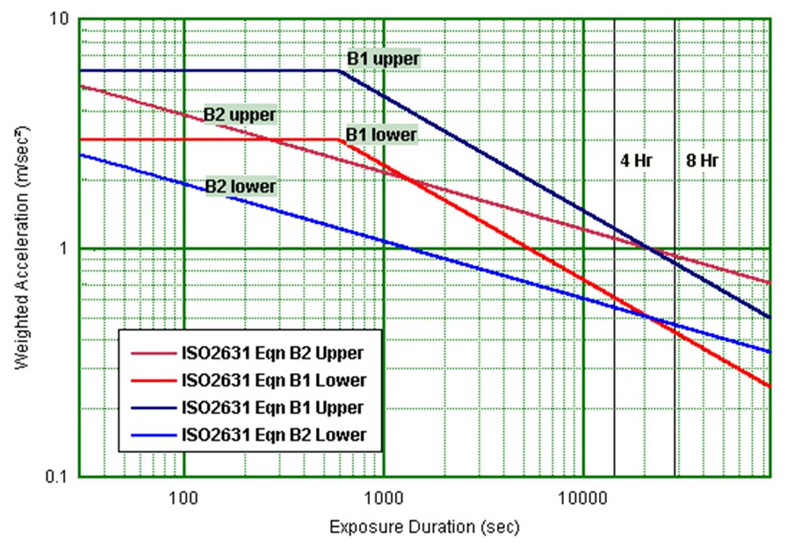
FIGURE 2. Human Perception of Vibration and Health-Related Effects
Subjective assessments commonly ask participants to rate their perceived discomfort during the procedure, often based on the aggregation of a standard such as ISO discomfort-guidelines. Meanwhile, objective measurements tend to measure the actual vibration signals with equipment such as accelerometers. Mathematical models, on the other hand, refer mainly to equations and/or assistance tools that evaluate ride comfort based on the vibration data collected during the relevant studies; an example is a multi-body biomechanical model of a seated occupant with a backrest including only the thighs, legs, and feet, supported by a multi-objective firefly algorithm evaluating the parameters of mass, stiffness, and damping. Rider-comfort-relevant vibration data can be collected and compared in order to conduct effective analyses.

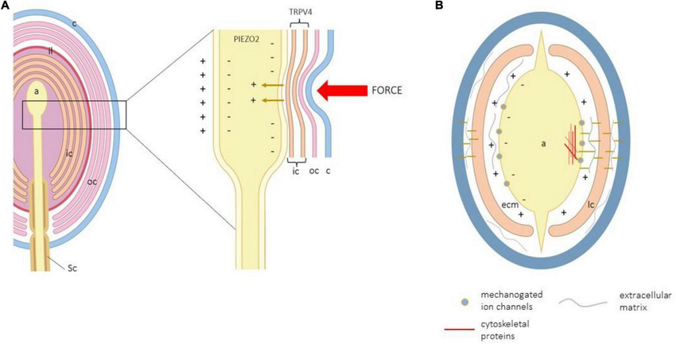
FIGURE 3. Human Perception of Vibration and Health-Related Effects
The human-centric smart transportation approach relies on passengers adopting the system. Passenger comfort strongly influences the acceptance and penetration of various modes. Ergonomic design and inclusive design contribute to the comfort of the general populace, while smart transportation technologies enable seamless and long-distance travel, redefining the meaning of vibrations. As a result of these considerations, vibration optimization becomes the primary concern. The combination of passenger comfort and vibration optimization offers a further research direction, as well as a thought process for incorporating vibration reduction strategies [2, 1, 3].
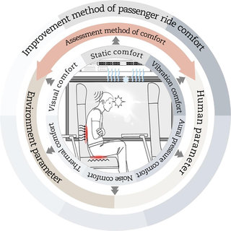 | 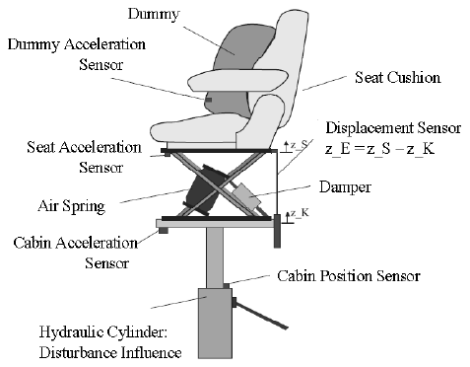 | 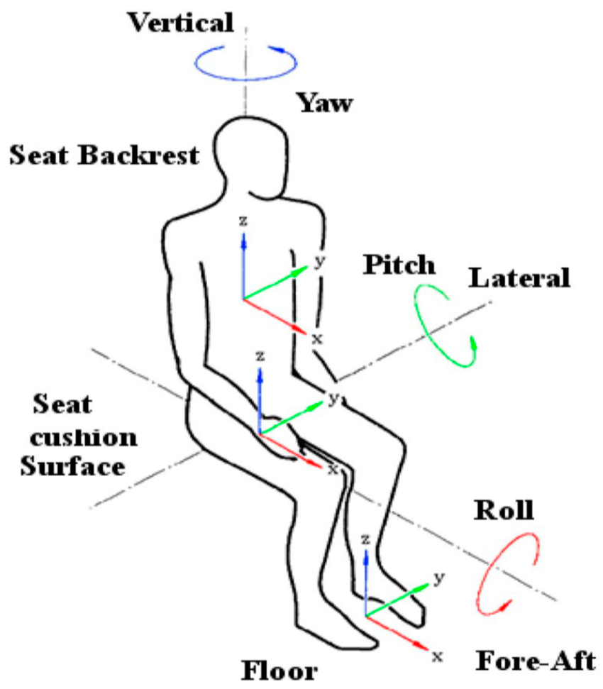

FIGURE 4. Framework for Ride Comfort Assessment and Vibration Reduction
CONCLUSION
Passengers experience vibrations during all modes of travel, at various frequencies that vary with speed and with the particular components and structure of the vehicle in which the passenger is sitting. Vibrations can prompt a feeling of discomfort, and have long been studied.
Many existing studies approach their subjects from the mechanical perspective of the vehicle. Contemporary scholars are aware of the human-centric aspect of travel and suggest that the human body and mind are among the most significant factors affecting passenger comfort, requiring further investigation. The development of transportation technology expands on the concept of human-centricity, building on ergonomic design and universal design and extending to the Internet of Things (IoT). This motivates research into smart transportation [2].
A vibration model can be constructed to identify mea-surements affecting passengers, based on the conditions under which vibration signals are received and using multichan-nel signals. Smart transportation systems collect these meas-urements, then transmit vibrations appropriate to the passeng-ers. In this approach, real-time monitoring and vibration opti-mization are achieved, making noticeable improvements in comfort possible.
REFERENCES
- Guruguntla, V., Lal, M., Ghantasala, G. S. P., Vidyullatha, P., Alqahtani, M. S., Alsubaie, N., Abbas, M., & Soufiene, B. O. (2023). Ride comfort and segmental vibration transmissibility analysis of an automobile passenger model under whole body vibration. Scientific reports, 13(1), 11619. https://doi.org/10.1038/s41598-023-38592-x
- Maksudov, Z., Khankelov, T., Rustamov, K., Khudainazarov, S., Pirnaev, S., Kudaybergenov, M., ... & Karimovaa, K. (2025). Development of a Methodology for the Formation and Standardization of a Machine System for Road Construction and its Implementation. Engineered Science, 37, 1733. http://dx.doi.org/10.30919/es1733.
- Wang, C., Zhao, X., Fu, R., & Li, Z. (2020). Research on the Comfort of Vehicle Passengers Considering the Vehicle Motion State and Passenger Physiological Characteristics: Improving the Passenger Comfort of Autonomous Vehicles. International Journal of Environmental Research and Public Health, 17(18), 6821. https://doi.org/10.3390/ijerph17186821
- Rustamova, N. R. (2025, July). The role of vitagenic technologies in revolutionizing machine design and functionality. In AIP Conference Proceedings (Vol. 3304, No. 1, p. 030095). AIP Publishing LLC. https://doi.org/10.1063/5.0269690
- Dižo, J., Blatnický, M., Gerlici, J., Leitner, B., Melnik, R., Semenov, S., Mikhailov, E., & Kostrzewski, M. (2021). Evaluation of Ride Comfort in a Railway Passenger Car Depending on a Change of Suspension Parameters. Sensors, 21(23), 8138. https://doi.org/10.3390/s21238138 .
- Burdzik, R. (2018). Analysis of vibration propagation in the human body. Journal of Measurements in Engineering, 6(4), 271-276. https://doi.org/10.21595/jme.2018.20425
- Ittner, S., Mühlbacher, D., Vollrath, M., & Weisswange, T. H. (2023). Development and evaluation of passenger assistance system concepts to reduce passenger discomfort. Frontiers in psychology, 14, 1024540. https://doi.org/10.3389/fpsyg.2023.1024540.
- Rustamova, N. R. (2025, July). Vitagenic chemistry: Unveiling life-enhancing energies in chemical reactions. In AIP Conference Proceedings (Vol. 3304, No. 1, p. 040056). AIP Publishing LLC. http://doi.org/10.1063/5.0271016
- Rustamov, K. J., & Rustamova, N. R. (2025). Advanced hydraulic drive systems in multi-purpose machinery: Enhancing efficiency and performance in modern engineering. AIP Conference Proceedings, 3304, 030093. https://doi.org/10.1063/5.0269688
- Korabayev, S., Ergashev, O., Mahsudov, S. A., & Mamatova, S. (2024). Exploring common technical issues in modern technology. BIO Web of Conferences, 145, 03016. https://doi.org/10.1051/bioconf/202414503016.
- Rustamova, N. R., & Rustamov, K. J. (2025, July). Vitagen information and hydraulic drive systems in multi-purpose machinery: Enhancing performance and innovation. In AIP Conference Proceedings (Vol. 3304, No. 1, p. 030097). AIP Publishing LLC. https://doi.org/10.1063/5.0269692
- Xie, P., Che, Y., Liu, Z., & Wang, G. (2022). Research on Vibration Reduction Performance of Electromagnetic Active Seat Suspension Based on Sliding Mode Control. Sensors (Basel, Switzerland), 22(15), 5916. https://doi.org/10.3390/s22155916
- Machaj, J., Brida, P., Krejcar, O., Petkovic, M., & Shi, Q. (2020, March). Development of smartphone application for evaluation of passenger comfort. In Asian Conference on Intelligent Information and Database Systems (pp. 249-259). Singapore: Springer Singapore. https://doi.org/10.48550/arXiv.1912.07218

