Effect of Drying Drum Flights on Heat and Mass Transfer in Hot Asphalt Production
T.I. Askarxodjayev, A.Kh. Sarmonov^{a)}, B. Halimov
Tashkent State Transport University, Tashkent, Uzbekistan
^{a)}Corresponding author: sarmonov1985@gmail.com
Abstract: This paper investigates the reduction of energy consumption in hot asphalt production by optimizing the heating process occurring inside the drying drum, which represents the most energy-intensive component of an asphalt mixing plant. The main objective is to decrease fuel and thermal energy usage without compromising asphalt quality. To achieve this, the influence of the geometry, shape, and arrangement of flights inside the drying drum—responsible for lifting and cascading inert aggregates—on heat and mass transfer efficiency is examined using fundamental thermodynamic principles. The interaction between the hot gas flow and inert materials within the drum is analyzed through dimensionless criteria, particularly the Nusselt and Reynolds numbers, to quantify convective heat transfer intensity. The results demonstrate that rational selection of flight geometry significantly enhances thermal efficiency and contributes to reduced energy consumption during asphalt production.
Keywords: Hot Asphalt, Drying Drum, Flights, Energy Efficiency, Nusselt Number.
INTRODUCTION
The depletion of conventional energy resources and the consequent need for alternative fuels stimulate further development across various sectors of the economy. However, sustainable economic growth cannot be achieved without implementing effective energy-saving technologies. Despite the increasing application of cement concrete pavements in road construction, the use of asphalt concrete mixtures remains dominant. As a result, the demand for hot asphalt has not diminished [1].
This study focuses on reducing energy consumption in the drying drum of asphalt mixing plants, which constitutes one of the most critical components in terms of thermal efficiency. The influence of thermodynamic processes governing heat and mass transfer within the drying drum is investigated with respect to the geometry and operational positioning of drum flights [2].
At present, improving fuel efficiency, reducing heat losses, and optimizing thermal balance in drying drums remain pressing engineering challenges. Special attention is given to the rational design of drum flights and their interaction with aggregate materials of various fractions. Moreover, factors such as temperature distribution within the drum, aggregate motion velocity, and moisture evaporation dynamics play a crucial role and must be carefully considered [3].
Thermodynamics only deals with the transfer of heat between equilibrium states, and does not consider time dependence. In engineering the heat transfer rate is more important because it has a direct effect on energy consumption. Consequently, this paper presents energy balances relationships and combines convection and conduction heat transfer mechanisms of the drying drum.
Heat conduction is the transfer of energy because of atomic or molecular diffusion and flow: 9 * Energy flow due to atomic/molecular diffusion (gas, liquid – momentum transfer) and/thread flow (solids - space lattice/vibrational waves). Convection itself, on the other hand, is a process of heat transfer from a solid surface to a fluid or gas at an adjacent rising temperature gradient and induced by the coupled effects of conduction and fluid movement.
METHODS
There are multiple modes of heat transfer within the drying drum in which the asphalt is dried. The anatomy of a typical DRUM MIX ASPHALT PLANT product in the market is as illustrated:

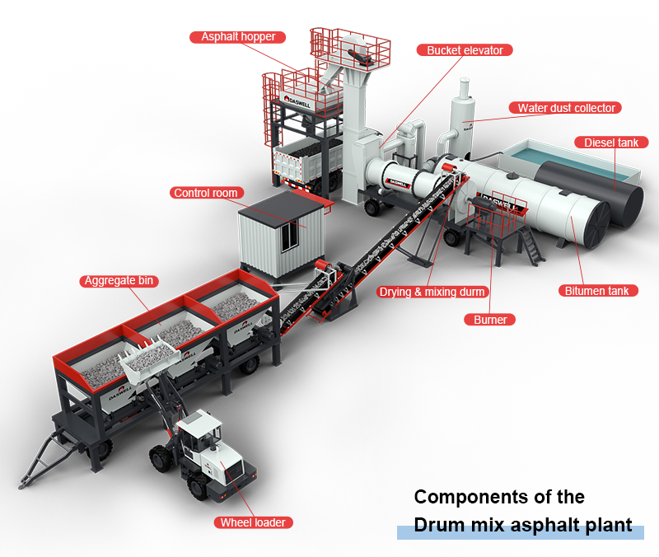
FIGURE 1. Components of the Drum mix

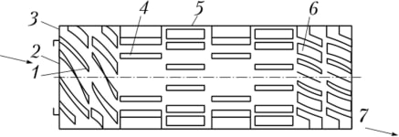

FIGURE 2. Drying drum of an asphalt mixing plant: 1 – Initial lifting flights; 2 – Feeding zone; 3 – Drying drum boundary; 4 – Central lifting flights; 5 – Uniform distribution flights; 6 – Discharge guiding flights; 7 – Heated material discharge zone.

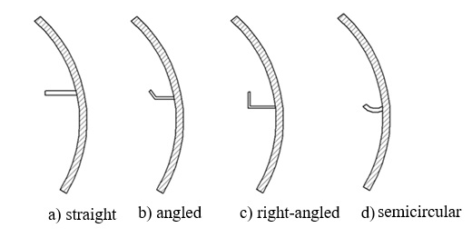
FIGURE 3. Functional Zones of the Drying Drum

- Feeding zone: Cold and wet aggregates are introduced into the drum. Initial heating begins and partial moisture evaporation occurs.
- Drying zone: Aggregates intensively exchange heat with hot gases. Flights lift and cascade the material, maximizing the heat transfer surface and removing most of the moisture.
- Heating zone: The mixing temperatures for a hot mix using an existing plant operation are shown.
- Discharge zone: Heated aggregates are discharged from the drum and directed toward the mixing unit.
To ensure consistent performance despite variations in aggregate fraction size, the proper selection of drum flight geometry is essential.
The primary function of drying drum flights is to lift, cascade, and redistribute aggregates within the hot gas flow, thereby increasing contact between solid particles and the gas medium [4, 5, 6]. The arrangement of flights can be divided into four main sections: spiral flights near the inlet to initiate motion and distribution, drying flights, heating flights, and guiding flights near the outlet.
Common drying drum flight designs used for cascade rotary dryers are illustrated in Figure 3.
• Type (a): Wet, sticky materials can be handled, clinker can break up attached layer; for crushing dlouhy and pockets, simple in construction but smaller heat transfer.
· Bent-edge flights are used in Type (b) to integrate or entrain material flows with gas streams, creating more efficient heat transfer.
· Type (c): The right-angle flights have good raising ability for the coarse and heavy particles to approach gas well.
· Type (d): Semi-circular flights this type of flights cause the fine materials to gently ride up and over other particles of a similar size without creating a constant cycle.
The semi-circular flight (Type d), which is suggested by Purcell, [7] is easy to fabricate like (b) and (c).
Two other advanced designs—equal-angle distribution (EAD) and centrally shifted distribution (CSD) followed flights—were suggested by Kelly [6] in order to improve the performance of a dryer, but the geometries are more complicated.
Figure 4 depicts these flight patterns which utilize a dual-tooth pattern and an incline edge to increase material dispersion and hollow zone densities within the drum.

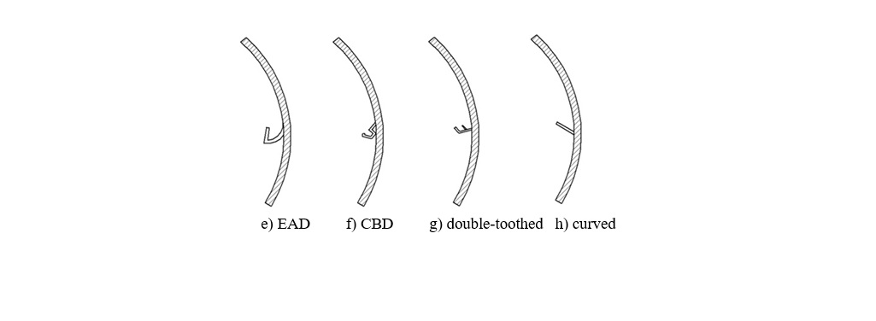

FIGURE 4. Types of Drying Drum Flights

RESULTS
Convective heat transfer represents the dominant mechanism within the drying drum. Hot combustion gases flow turbulently inside the drum, while lifted aggregates interact dynamically with the gas stream, resulting in intense convective heat exchange [7, 12, 13].
The convective heat transfer rate can be expressed as:
$Q_{konv}=h A(T_{g}-T_{s})$ (1)
where: h is the convective heat transfer coefficient (W/m²·K),
A is the surface area of aggregates,
T_{g} is the gas temperature,
T_{s} is the aggregate surface temperature.

The heat conduction controls the internal temperature field of the aggregates. The longer amount of time required for larger granulate diameters suggests that heat-up times are important factors for drying efficiency. This is modeled by the transient heat conduction equation:
$\frac{∂T}{∂t}=α∇^{2}T$ (2)
where $\frac{∂T}{∂t}$ is the thermal diffusivity::
$α=\frac{λ}{ρc}$ (3)
Here, λ is thermal conductivity, ρ is density, and c represents specific heat capacity.
The performance of heat exchange in the drying drum is quantified by Nusselt number:
$N_{u}=\frac{h*L}{λ}$ (4)
Larger Nusselt number signifies larger convective heat transfer. N_{u} is considerably enhanced by the convective motion of gas and leads to large amount of gas permeation with turbulence, in contrast to low rates of heat transfer due to a laminar flow.
Some well-accepted empirical correlations for the analysis of drying drum are:
$N_{u}=CRe^{m}Pr^{n}$ (5)
where Re is the Reynolds number, Pr is the Prandtl number and C, m and n are experimentally fitted constants.
Larger Nu increases correspond to the decrease of fuel consumption and reducing in drying times while smaller values result in an inadequate heating and more energy consumption..
Drying and mixing drumSimulation results of the drying and mixing drum were obtained by using SolidWorks Flow Simulation [8]. Visualisation of the 3D gas flow,temperature and heat transfer behaviour facilitated detailed scrutiny of boundary conditions and solution convergence [8].

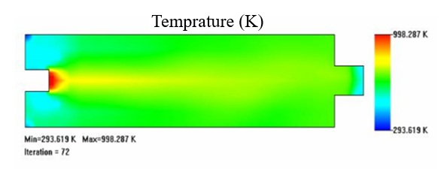

FIGURE 5. Initial stage of heat distribution inside the drying drum
Figures 5, 6, 7 illustrates gas flame trajectories, thermal conductivity distributions, and specific heat variation within the drum. Simulation results confirm that optimal flight geometry significantly improves heat transfer uniformity and energy efficiency.

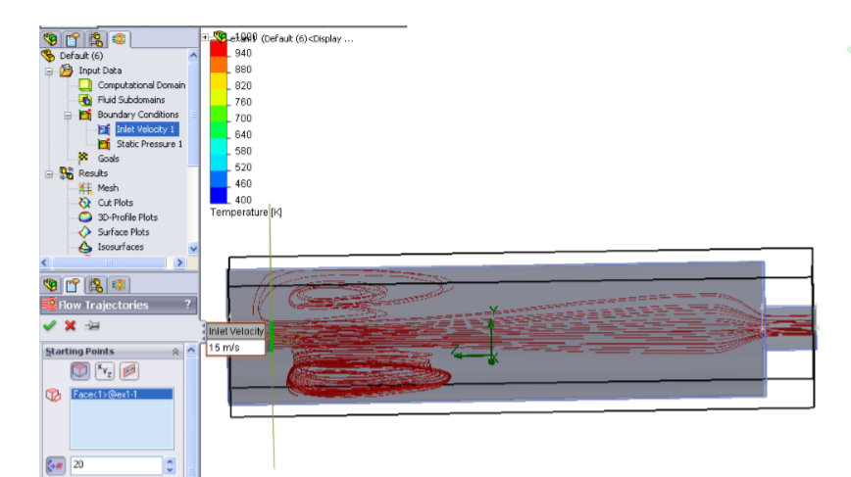

FIGURE 6. Motion of the high-pressure gas flame inside the drying drum simulated in SolidWorks

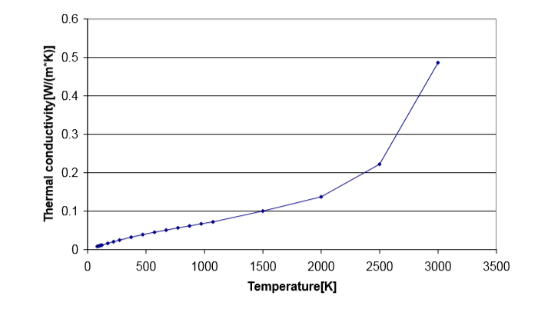

FIGURE 7. Thermal conductivity distribution graph inside the drying drum
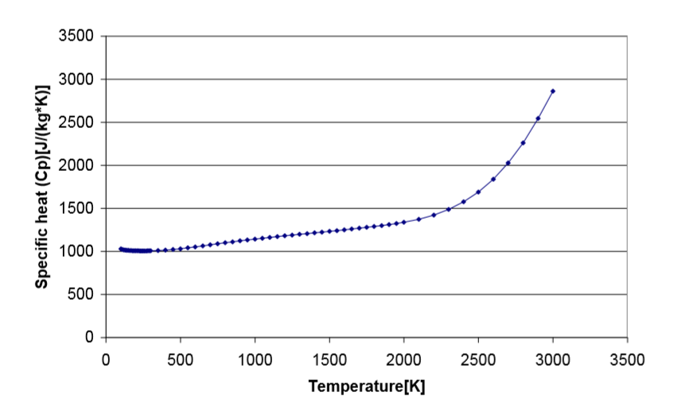

FIGURE 8. Variation of specific heat ratio during the drying and heating process

Experimental and numerical analyses reveal that flight inclination angles between 35° and 55° yield varying performance. The optimal angle of 45° ± 2° maximizes gas–particle contact area by 18–22%, resulting in a 12–15% increase in heat transfer efficiency. Angles above 50° reduce residence time, while angles below 40° cause material accumulation and increased fuel consumption by up to 10–12% [9, 10, 11].
CONCLUSION
The geometry and orientati on of drying drum flights are key factors for improving heat/mass transfer during hot mix production process with asphalt plant. Appropriately designed flights enhance gas–particle contact, promote drying, and minimize fuel consumption.
Failure to effectively lift... setImage Incorrect and/or worn flight patterns do not effectively lift fines, thus increasing retention time and fuel burn. When the flight is too much complicated or wrongly formed, resistance to flow becomes excessive and consequently fans or turbines have to consume more electrical energy.
In general, rationalization of the flight geometry, in particular for the inclination angle and dimension proportions is a major aspect when it comes to energy saving and an increase in efficiency of asphalt drying drums.
REFERENCES
- Krokida, M., Marinos-Kouris, D., & Mujumdar, A. S. (2007). Rotary drying. Handbook of Industrial Drying, 1, 151-172. https://doi.org/10.1201/9781420017618.ch7
- Maksudov, Z., Khankelov, T., Rustamov, K., Khudainazarov, S., Pirnaev, S., Kudaybergenov, M., ... & Karimovaa, K. (2025). Development of a Methodology for the Formation and Standardization of a Machine System for Road Construction and its Implementation. Engineered Science, 37, 1733. http://dx.doi.org/10.30919/es1733.
- Wang, C., Zhao, X., Fu, R., & Li, Z. (2020). Research on the Comfort of Vehicle Passengers Considering the Vehicle Motion State and Passenger Physiological Characteristics: Improving the Passenger Comfort of Autonomous Vehicles. International Journal of Environmental Research and Public Health, 17(18), 6821. https://doi.org/10.3390/ijerph17186821
- Rustamova, N. R. (2025, July). The role of vitagenic technologies in revolutionizing machine design and functionality. In AIP Conference Proceedings (Vol. 3304, No. 1, p. 030095). AIP Publishing LLC. https://doi.org/10.1063/5.0269690
- Poersch, W. (1971). Berechnung der Verweilzeit in Gleich-oder Gegenstromtrocknern (Teil I). Verfahrenstechnik Bd, 5, 160. https://doi.org/10.1002/cite.200390071
- Vargas, A. R., García, L. P., Guillen, C. S., AlJaberi, F. Y., Salman, A. D., Alardhi, S. M., & Le, P. C. (2023). Performance evaluation of a flighted rotary dryer for lateritic ore in concurrent configuration. Heliyon, 9(11). https://doi.org/10.1016/j.heliyon.2023.e21345
- Rustamova, N. R. (2025, July). Vitagenic chemistry: Unveiling life-enhancing energies in chemical reactions. In AIP Conference Proceedings (Vol. 3304, No. 1, p. 040056). AIP Publishing LLC. http://doi.org/10.1063/5.0271016
- Rustamov, K. J., & Rustamova, N. R. (2025). Advanced hydraulic drive systems in multi-purpose machinery: Enhancing efficiency and performance in modern engineering. AIP Conference Proceedings, 3304, 030093. https://doi.org/10.1063/5.0269688
- Korabayev, S., Ergashev, O., Mahsudov, S. A., & Mamatova, S. (2024). Exploring common technical issues in modern technology. BIO Web of Conferences, 145, 03016. https://doi.org/10.1051/bioconf/202414503016.
- Rustamova, N. R., & Rustamov, K. J. (2025, July). Vitagen information and hydraulic drive systems in multi-purpose machinery: Enhancing performance and innovation. In AIP Conference Proceedings (Vol. 3304, No. 1, p. 030097). AIP Publishing LLC. https://doi.org/10.1063/5.0269692
- Khankelov, T. K., Sarmonov, A. K., & Kadirov, A. G. (2023). The analytical dependence of the resistance force to digging with a bulldozer blade on the main influencing factors. In E3S Web of Conferences (Vol. 458, p. 10001). EDP Sciences. https://doi.org/10.1051/e3sconf/202345810001
- Khankelov, T. K., Askarkhodzhaev, T. I., & Aslanov, N. R. (2023). Modeling of segmental excavator working tool for soil compaction. In E3S Web of Conferences (Vol. 401, p. 02052). EDP Sciences. https://doi.org/10.1051/e3sconf/202340102052
- Askarxodjayev, T., Pirnaev, S., Dzhumabаeva, F., Yangiboev, G. I., & Idiev, A. (2022, June). Development of wear-resistant material for strengthening. In AIP Conference Proceedings (Vol. 2432, No. 1, p. 030098). AIP Publishing LLC. https://doi.org/10.1063/5.0091543

