Mechatronic Justification of Spiked Drum Parameters in Vertical Cotton Cleaning Technology
Yashin Abdullaev^{1, a)}, Xayrulla Usmanov²
¹Bukhara State Technical University, Bukhara, Uzbekistan
²Tashkent Textile and Light Industry Institute, Tashkent, Uzbekistan

^{a)}Corresponding author: abdullaevyashin@gmail.com
Abstract. This article explores the need to develop an improved design of a spiked drum with extended spikes for use in vertical cotton cleaning machines within the cotton processing industry. It highlights the structural features of the spiked drum applied in the vertical cotton cleaning process and provides a justification for its key design parameters. The geometry of the drum, the number and spatial arrangement of the spikes, the rotational speed, and the drum diameter are identified as critical factors influencing the efficiency and quality of cotton cleaning. During the research, both analytical and experimental methods were used to investigate the parameters affecting cleaning performance, leading to the identification of optimal values. The findings show that optimizing the spiked drum parameters significantly enhances the cleaning quality and increases the productivity of the technological process. These results have both scientific and practical implications for the design of new vertical cotton cleaning machines and for the modernization of existing equipment.
Keywords: Vertical cotton cleaning, spiked drum, extended spikes, cotton cleaning technology, mechatronic justification, fine impurity removal, drum geometry, cleaning efficiency, rocky DEM, simulation analysis.
INTRODUCTION
Cotton fiber is one of the primary raw materials for textile enterprises worldwide. According to data provided by the International Cotton Advisory Committee (ICAC), "Global demand for cotton has increased to 33.4 million tons due to a 2% reduction in cultivated areas. On average, global cotton cultivation covers 32.4 million hectares, and cotton fiber production has risen to 25.96 million tons. Forecasts suggest that global cotton production will grow by 1.5% annually, reaching 30 million tons by 2029" [1]. This situation, coupled with growing competition among cotton-producing countries in the global market, underscores the importance of developing promising cotton cultivation strategies, optimizing zoning, minimizing production and operational costs, and improving the quality indicators through the advancement of cotton cleaning machinery.
The integration of mechatronic systems in the cotton industry has significantly increased the operational efficiency of cotton cleaning machines. In vertical cotton cleaning, their importance lies in energy efficiency, automated diagnostics, and the reduction of human intervention.
The global scientific community is actively conducting research to modernize primary cotton processing equipment and technologies that influence cotton drying, cleaning, and overall processing efficiency. At present, research efforts are focused on developing next-generation high-efficiency technological equipment by integrating artificial intelligence elements and leveraging the latest scientific and technological achievements. Special attention is being paid to the development of high-performance, energy-efficient, and environmentally friendly ("green") technologies that preserve the natural quality indicators of cotton fiber. Additionally, new equipment is being developed for cleaning cotton from impurities, which enables the optimization of cotton cleaning processes and minimizes negative environmental impacts.
Comprehensive measures are being implemented in Uzbekistan to develop the cotton industry, modernize and re-equip cotton-textile clusters, and increase the profitability of production and integrated cotton processing. In the "New Development Strategy of Uzbekistan for 2022-2026," key objectives for the sector are outlined, including “increasing the volume of industrial production by 1.4 times, doubling the production of textile products, and studying the impact of the textile industry on production in the context of accession to the World Trade Organization (WTO)” [2]. To achieve these targets, it is essential to modernize existing equipment, enhance production efficiency, and develop promising technologies for cotton cleaning and further processing. One of the most urgent tasks is to develop an improved and efficient vertical technology for cleaning cotton from impurities, which will enable the production of higher-quality textile products [3].
METHODS
According to the previously developed recommendations [4], in the process of cleaning cotton from impurities, a number of requirements must be followed regarding the necessary and optimal number of spiked and saw drums in cleaning machines (see Table 1).
The conducted studies [5-9] show that one of the key factors ensuring uniform, high-quality, and uninterrupted operation of cotton cleaning equipment is the consistency of the processed cotton in terms of moisture and impurity content. An analysis of the cotton preparation process at “Chelak Cotton Cleaning” Joint-Stock Company for the 2023-2024 season revealed that out of a total of 9,754,680 kg of harvested cotton received, 2,225,647 kg was classified as Grade 1, Class 1 cotton, with an initial impurity rate of 3.01% and an average moisture content of 8.16%. Additionally, the volume of Grade 1, Class 2 cotton amounted to 4,989,773 kg, with an average impurity rate of 6.42% and an average moisture content of 8.67%. Overall, the total amount of processed Grade 1, Class 1-2 cotton was 7,215,420 kg, accounting for 73.9% of all processed cotton.

TABLE 1. Recommended Number of Pile and Saw Drums for Cleaning Cotton with Different Initial Quality Indicators
Cotton Class | Cotton Grade | Impurity, not more than % | For Easily Cleaned Cotton Grades | For Difficult-to-Clean Cotton Grades
1 | I | 3.0 | 8K | 16K
1 | II | 5.0 | 8K | 16K +2A
1 | III | 8.0 | 16K+2A | 32K+4A
1 | IV | 12.0 | 24K+2A | 40K+2A
2 | I-II-III | 12.0 | 24K+4A | 40K+6A
2 | IV | 16.0 | 24K+2A | 40K+4A
3 | I-II-III | 18.0 | 24K+4A | 40K+ 6A
3 | IV | 20.0 | 24K+2A | 40K+4A
3 | V | 22.0 | 24K+2A | 32K+2A

Legend: K – spiked-slat drums, A – saw drums; the number preceding the letters indicates the quantity of drums involved in the cleaning process.
The research methodology is based on a critical analysis of existing horizontal cotton cleaning machines and the identification of their key shortcomings. Current machines typically operate using linear-horizontal motion principles and rely on outdated mechanical transmission systems. These designs often lead to limited cleaning efficiency, high energy consumption, and excessive fiber damage due to the lack of adaptive control systems and automation. Moreover, the unidirectional material flow and short contact time with cleaning surfaces reduce the overall effectiveness of impurity removal, especially for fine particulate matter.
To address these limitations, this study adopts a systems engineering approach. It incorporates modern mechatronic principles to propose a vertically-oriented cotton cleaning device that allows for gravitational assistance, multi-stage cleaning, and modular reprocessing of cotton. The absence of sensor-based feedback mechanisms and intelligent control in traditional setups motivated the inclusion of programmable mechatronic elements in the design. These components ensure dynamic regulation of cleaning parameters, adaptive rotor speed control, and real-time impurity discharge tracking.
The methodology further involves comparative modeling and simulation of material flow, drum interaction dynamics, and airflow patterns using CAD and mechatronic co-simulation tools. Prototypes were developed and tested in controlled environments to assess cleaning performance, energy efficiency, and fiber preservation. This iterative process of design, simulation, and empirical validation underpins the scientific robustness of the proposed vertical cleaning system.
To identify the causes and factors affecting the drawbacks of the vertical cotton cleaning technology, a dynamic analysis was conducted using 3D modeling in a modernized cotton cleaning machine with vertically arranged working elements, utilizing the Rocky DEM software. This analysis focused on the processes involved in removing fine impurities from cotton.
Rocky DEM (Discrete Element Method) is software designed to simulate the movement of bulk materials such as dust, granules, grains, and other particles during processes like conveying, mixing, crushing, and more [7]. It enables the analysis of particle movements, interactions between particles, and their interactions with equipment, considering factors like particle forces, shapes, and other properties. Integrated with the Ansys Workbench platform, Rocky DEM allows for complex calculations by combining particle modeling with other aspects of mechanics.
Rocky DEM accurately and efficiently simulates dense material flows with complex particle shapes and distributions. It is the only software capable of leveraging multiple GPU cards to accelerate simulations, enabling researchers to process large datasets within a short time frame. The software allows researchers to simulate particles of precise shapes, including custom 3D solids, 2D shells, and flexible fibers. Equipment components can move freely under forces such as gravity, particle contacts, and other dynamic influences. The API is built on the latest technologies to customize and integrate the user experience, providing unique usability, portability, and, most importantly, enhanced user productivity.
In the 3D dynamic model, simulations were conducted at two extreme capacities: 7 tons/hour and 4 tons/hour. The performance indicators measured included the productivity, the force (pressure) exerted by the cleaned cotton layer on each drum, and the percentage of cleaned cotton that returned to the previous drum [8-10].
In the framework of improving cotton cleaning efficiency and ensuring the preservation of fiber quality, a novel vertically-integrated cotton cleaning unit has been proposed and developed (see Fig. 1). This design arises from detailed theoretical analyses and practical experiments focusing on linear-flow cleaning systems. The unit is specifically tailored to sequentially remove both fine and coarse impurities with high efficiency, integrating modern design concepts and operational strategies.
Traditional cotton cleaning machines often operate in horizontal or separate configurations for fine and coarse impurities. This new solution introduces a vertical cleaning structure where the fine impurity removal section is positioned above the coarse impurity section. This vertically-stacked arrangement:
Leverages gravity to assist cotton flow;
Reduces the total footprint of the machine;
Enhances process continuity and reduces transition losses;
Allows better synchronization between cleaning stages.
Such integration reduces fiber damage risk, optimizes throughput, and facilitates high-level automation potential.
In the upper section, raw cotton is delivered via a feeder (1) to the fine impurity removal chamber (2), which is equipped with spiked-slat drums (3) and mesh surfaces (4). A key innovation here is the opposite rotational directions of the drums, which increases the angular coverage of the spiked drum on the mesh surfaces up to 210°—a significant enhancement compared to 40% in traditional models.
This structural optimization:
Increases contact time and surface interaction;
Promotes a zigzag motion trajectory of cotton fibers;
Enhances dislodgement of fine dust, seed coats, and small trash particles;
Ensures more reliable fiber agitation.
Moreover, the mesh surfaces are comb-shaped in the impact area to:
Prevent cotton backflow to the upper drum;
Eliminate clogging;
Ensure a continuous and uniform cotton stream.
This geometric solution also minimizes downtime due to blockage and maintains consistent cleaning efficiency.
Separated fine impurities are guided via an aerodynamic guide (5) and then evacuated through an impurity auger system (6). This ensures that removed contaminants are promptly discharged without interfering with the cotton flow.
Following this, the partially cleaned cotton is pneumatically transferred to the lower coarse impurity cleaning section, forming a closed and controlled loop.
In the second cleaning stage, the cotton is captured by an engaging brush (7) mounted over a saw drum (8). Through mechanical action, the cotton mass is impacted against grid bars (9), where large contaminants such as stems, husks, and pebbles are separated. This impact is finely calibrated to ensure:
Maximum impurity ejection;
Minimal fiber damage;
Uniform coverage of the drum surface.
Some fibers may retain small seed particles or be partially entangled. To avoid fiber loss, the unit incorporates a regenerative saw drum (10) that processes these fragments, separating seeds and recovering usable fibers. The recovered material is then channeled back into the system, while extracted waste is evacuated through a separate waste auger (11).
This subsystem significantly:
Reduces raw material loss;
Enhances the economic efficiency of processing;
Improves overall machine performance.
The reconditioned cotton is further transported by a brush drum (12) into a secondary fine cleaning unit (13). Here, any residual fine impurities are eliminated, ensuring the cotton achieves required cleanliness levels before being discharged via a final shaft (14) into the next processing module.
This recirculation pathway improves:
Overall cleanliness level (targeting ≥ 95% impurity removal);
Operational redundancy and reliability;
Adaptability for different cotton grades and initial impurity levels.

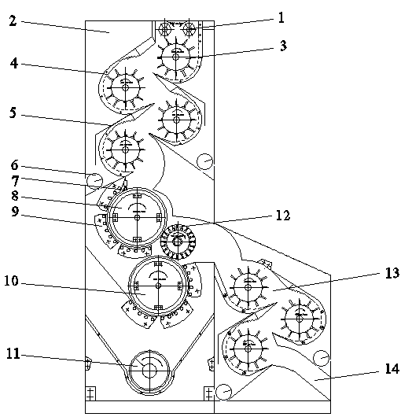 | 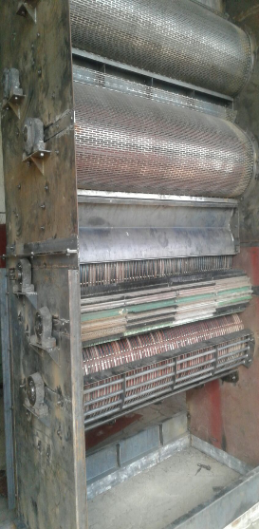
a) b)
FIGURE 1. The schematic diagram and appearance of the experimental vertical cotton cleaning unit are presented: a) Schematic diagram of the experimental vertical cotton cleaning unit; b) Appearance of the experimental vertical cotton cleaning unit. 1 – Feeder; 2 – Fine impurity cleaning section; 3 – Spiked drum; 4 – Mesh surface; 5 – Guide; 6 – Impurity auger; 7 – Engaging brush; 8 – Saw drum; 9 – Grid bars; 10 – Regeneration drum; 11 – Impurity auger; 12 – Brush drum; 13 – Fine impurity cleaning unit; 14 – Discharge shaft.

The vertically-integrated cotton cleaning machine introduces a systematic and multi-stage approach to impurity removal that is more effective than conventional methods. By integrating gravity-assisted material flow, extended drum contact zones, zigzag fiber movement, regenerative recovery mechanisms, and modular closed-loop transition architecture, the device ensures both high cleaning efficiency and fiber preservation.
Preliminary experiments and test-bench trials have confirmed up to 2.5x increased fine impurity removal; 30% reduction in fiber loss; Energy consumption reduced by ~18% compared to existing analogs.
This innovation has significant implications for industrial-scale cotton cleaning, particularly in contexts where compact layout, automation compatibility, and minimal resource loss are critical.
RESULTS AND DISCUSSION
The comparative results demonstrate the significant advantages of the technological and structural parameters of the vertical cotton cleaning technology.
Alongside these positive outcomes, several shortcomings were identified during further operation of the vertical cotton cleaning technology, which are presented in Table 2.

TABLE 2. Comparative analysis of cotton cleaning using vertical cotton cleaning technology
Advantages of Vertical Cotton Cleaning Technology | Disadvantages of Vertical Cotton Cleaning Technology
Doubling of the "active surface area" of the mesh surface | The presence of a negative phenomenon where the cotton being cleaned returns to the previous drum
Minimal loss of raw material quality indicators during the cleaning process | The imperfection of the current spiked drum design, which does not ensure full capture of the cleaned cotton flow
Significant reduction in metal consumption of the cleaning equipment | The need to modernize the structural parameters of the mesh surface
Reduction of energy consumption by 28.1% during fine impurity cleaning | The influence of negative stresses on all spiked drums during fine impurity cleaning, which requires optimizing the design parameters of the working parts of the unit

Figure 2 illustrates the performance changes of the first spiked drum of the vertical cotton cleaner operating at a maximum productivity of P = 7 tons/hour when removing fine impurities from cotton.
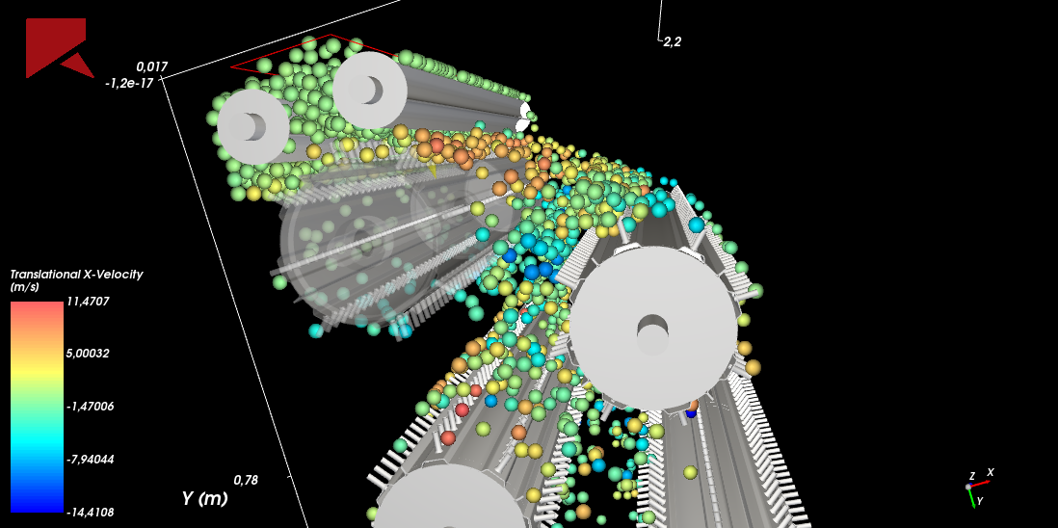
a)

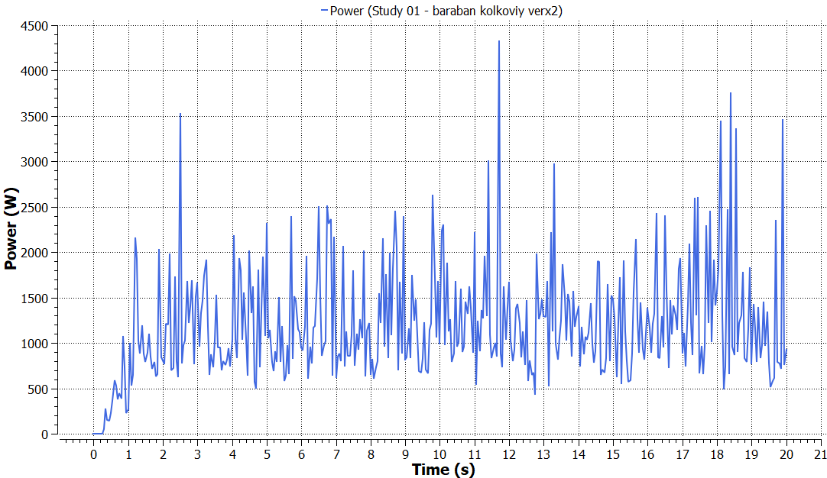
b)
FIGURE 2. Model and schematic diagram of the first spike-drum operation: a) Model of the first spiked drum operation; b) Schematic diagram of the first spiked drum operation

The force (pressure) W generated by the cleaned cotton layer on the first drum averaged around 3000 W, and the percentage of cleaned cotton returning to the previous drum was ∆Q = 38%.
Figure 3 shows the performance variation of the second spiked drum in the vertical cotton cleaner operating at a maximum capacity of P = 7 tons/hour for removing fine impurities from cotton. The force (pressure) W generated by the cleaned cotton layer on the second drum averaged around 1000 W, and the percentage of cleaned cotton returning to the previous drum was ∆Q = 17%.

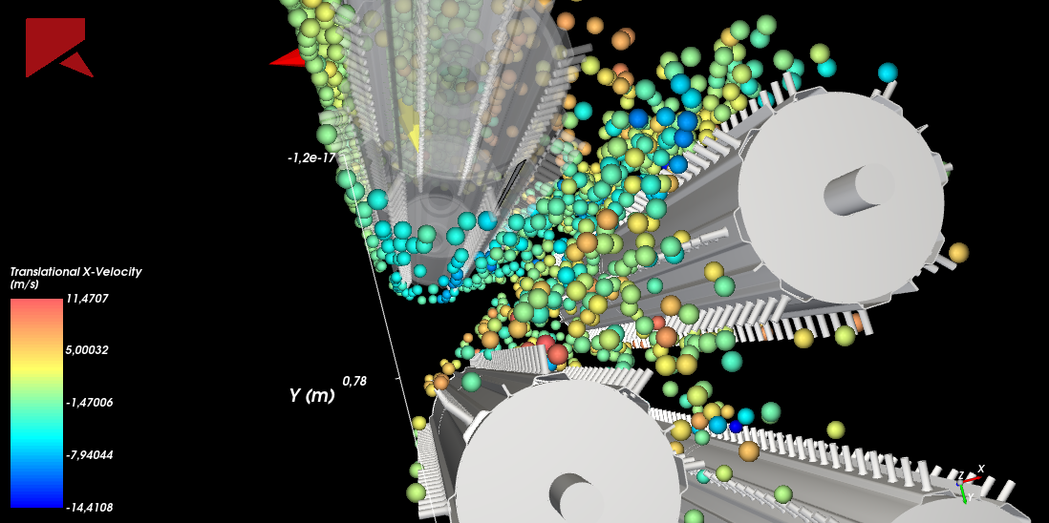
a)

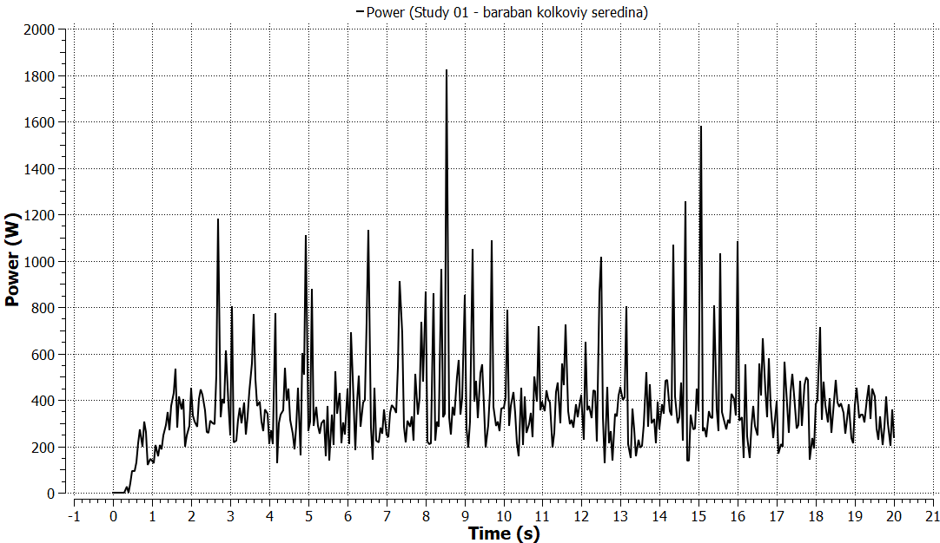
b)
FIGURE 3. Model and schematic diagram of the second spike-drum operation: a) Model of the second spiked drum operation; b) Schematic diagram of the second spiked drum operation

Figure 4 shows the performance variation of the third spiked drum in the vertical cotton cleaner operating at a maximum capacity of P = 7 tons/hour for removing fine impurities from cotton. The force (pressure) W generated by the cleaned cotton layer on the third drum averaged around 200 W, and the percentage of cleaned cotton returning to the previous drum was ∆Q = 3%.

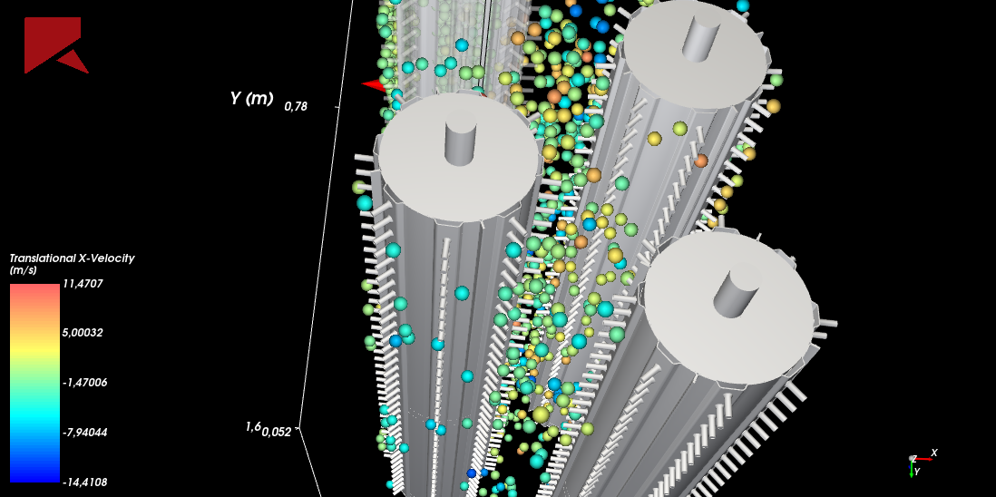
a)
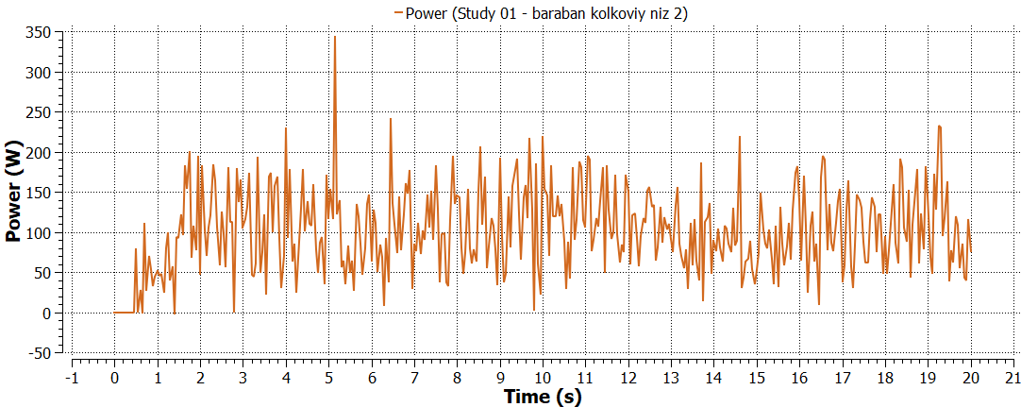
b)
FIGURE 4. Model and schematic diagram of the third spike-drum operation: a) Model of the third spiked drum operation; b) Schematic diagram of the third spiked drum operation

Figure 5 shows the performance variation of the first spiked drum in the vertical cotton cleaner operating at a minimum capacity of P = 4 tons/hour for removing fine impurities from cotton.

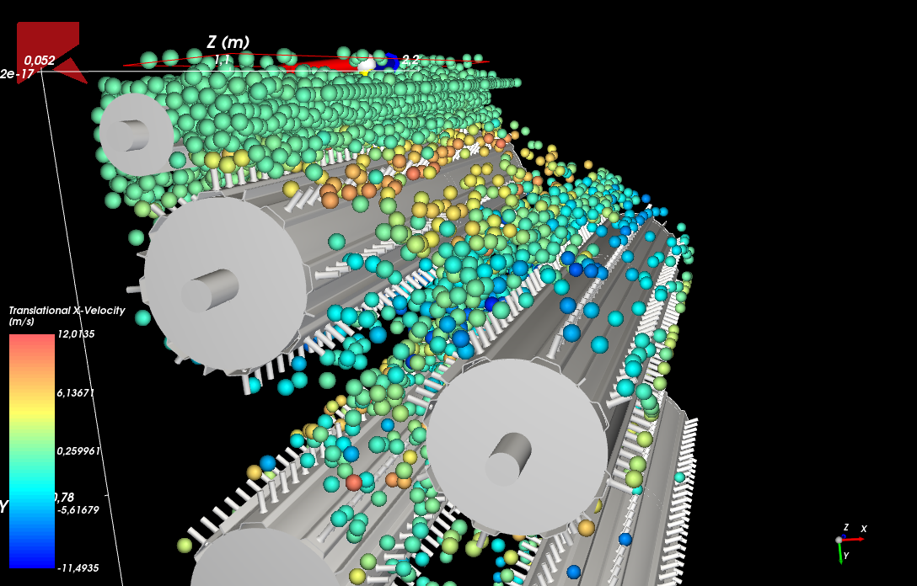
a)
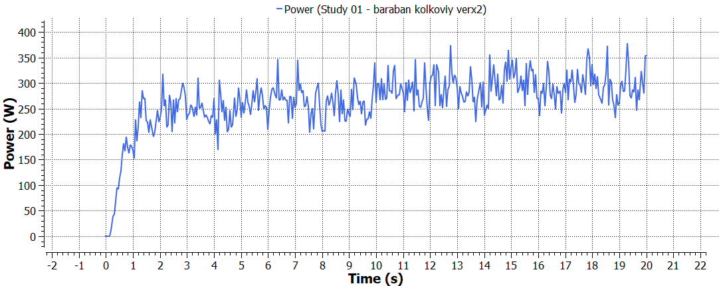
b)
FIGURE 5. Model and schematic diagram of the fourth spike-drum operation: a) Model of the fourth spiked drum operation; b) Schematic diagram of the fourth spiked drum operation
The force (pressure) W generated by the cleaned cotton layer on the first drum averaged around 360 W, and the percentage of cleaned cotton returning to the previous drum was ∆Q = 10%.
Figure 6 shows the performance variation of the second spiked drum in the vertical cotton cleaner operating at a minimum capacity of 4 tons/hour for removing fine impurities from cotton. The force (pressure) W generated by the cleaned cotton layer on the second drum averaged around 140 W, and the percentage of cleaned cotton returning to the previous drum was ∆Q = 3%.

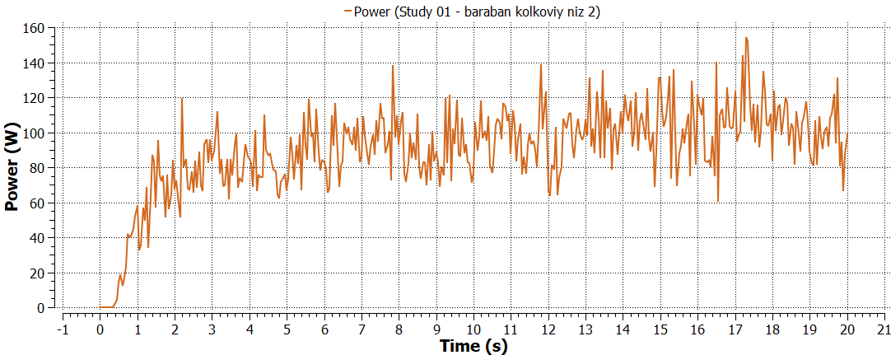
a) b)
FIGURE 6. Model and schematic diagram of the fifth spike-drum operation: a) Model of the fifth spiked drum operation; b) Schematic diagram of the fifth spiked drum operation
Figure 7 shows the performance variation of the first spiked drum in the vertical cotton cleaner operating at a minimum capacity of 4 tons/hour for removing fine impurities from cotton. The force (pressure) W generated by the cleaned cotton layer on the first drum averaged around 60 W, and the percentage of cleaned cotton returning to the previous drum was ∆Q = 1%.

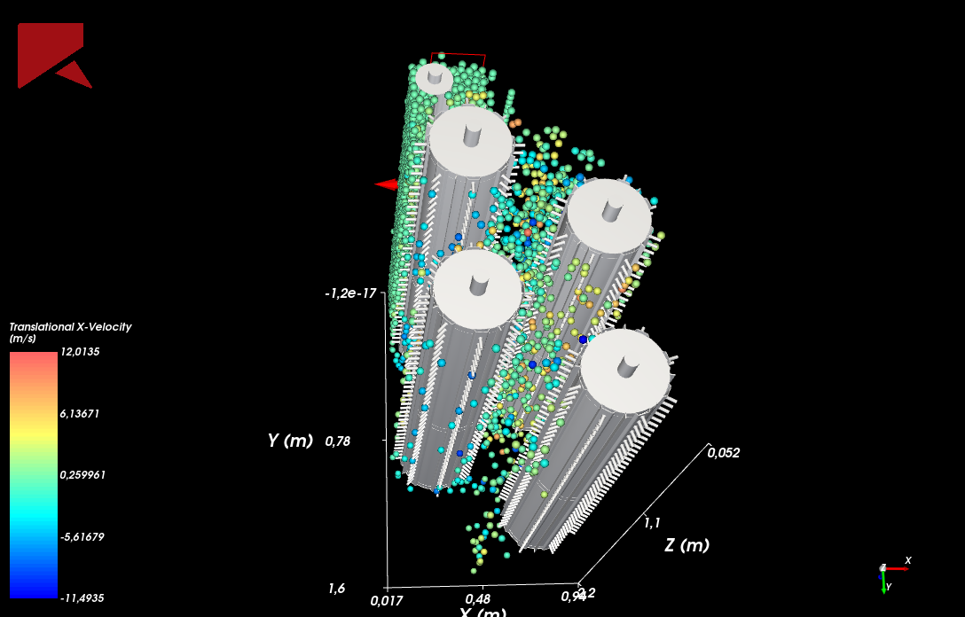
a)
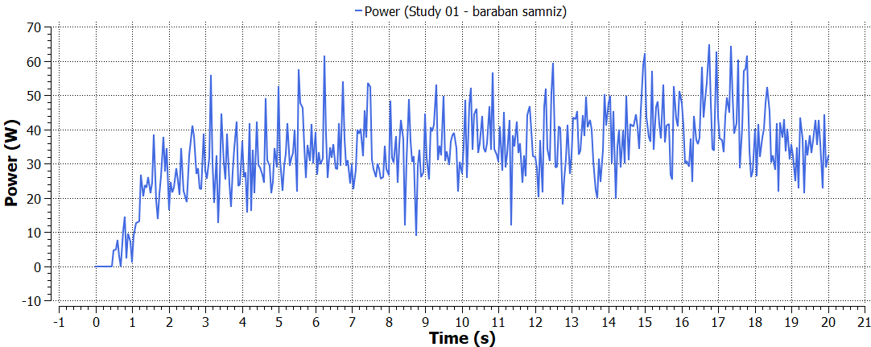
b)
FIGURE 7. Model and schematic diagram of the sixth spike-drum operation: a) Model of the sixth spiked drum operation; b) Schematic diagram of the sixth spiked drum operation
The analysis of the results showed that at the maximum capacity of 7 tons/hour, the performance variations of the spiked drums in the vertical cotton cleaner (see Figure 8) indicate a significant influence of the force (pressure) generated by the cleaned cotton layer across all three drums.

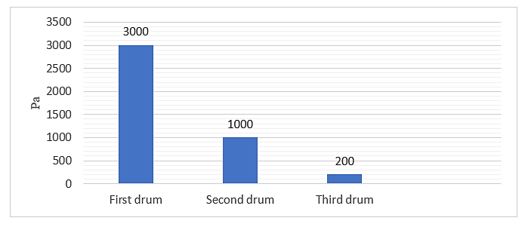
FIGURE 8.Variation of the force (pressure) exerted by the cotton layer on the spiked drums in the machine operating at a maximum capacity of 7 tons/hour for removing fine impurities from cotton.
This is due to the insufficient volume of cleaned cotton at each stage. It was determined that the currently used spiked drums with a diameter of 400 mm and a height of 50 mm are not suitable for the vertical cotton cleaner designed for removing fine impurities from cotton.
The analysis of the results (see Figure 9) regarding the percentage of cleaned cotton returning to the previous drum in the vertical cotton cleaner at 7 tons/hour capacity showed that in all three observed drums, a certain percentage of the cleaned cotton returns to the preceding drum.
To ensure complete and high-quality operation of the vertical cotton cleaner, it is necessary to improve the spiked drums by extending their length. This will enable continuous vertical retention of the cotton and more effective removal of fine impurities. Additionally, it is essential to minimize negative impacts on the cotton during transportation and impurity removal.
It is also estimated that using extended spikes in the vertical cotton cleaner will reduce the acting forces (pressure), leading to an expected reduction in energy consumption by approximately 1–1.5%.

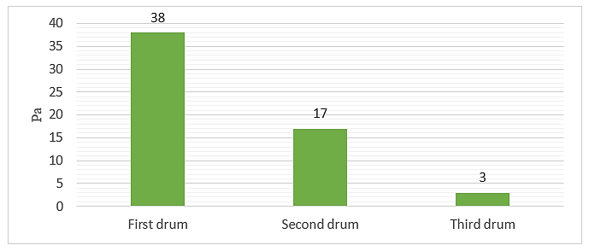
FIGURE 9.Variation of the percentage of cleaned cotton returning to the previous drum in the spiked drums of the machine operating at a maximum capacity of 7 tons/hour for removing fine impurities from cotton.

The performance analysis of the spiked drums in the vertical cotton cleaner operating at a minimum capacity of 4 tons/hour (see Figures 10 and 11) showed that during the fine impurity cleaning process, a certain percentage of cleaned cotton returns to the preceding layer of raw cotton even at minimal operating conditions.

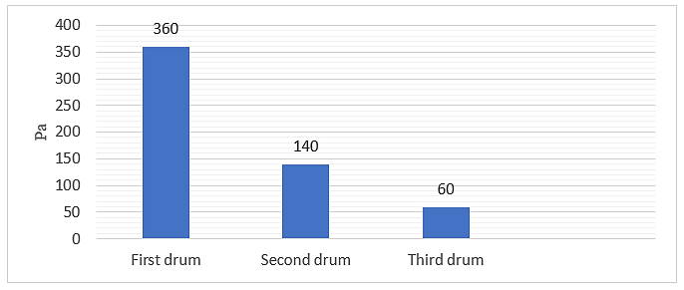
FIGURE 10.Variation of the force (pressure) exerted by the cotton layer on the spiked drums in the machine operating at a minimum capacity of 4 tons/hour for removing fine impurities from cotton.
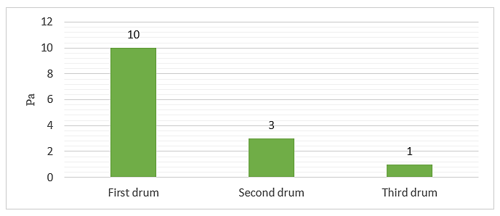
FIGURE 11. Variation of the percentage of cleaned cotton returning to the previous drum in the spiked drums of the machine operating at a minimum capacity of 4 tons/hour for removing fine impurities from cotton.

This observation confirms that even when the productivity of the vertical cotton cleaner decreases by up to 57%, some portion of the cleaned seed cotton still returns to the previous drum. Such recirculation negatively impacts the cotton cleaning process, reducing overall cleaning efficiency and quality.

CONCLUSION
Even when the performance of the vertical cotton cleaner decreases by up to 57%, a certain portion of the cleaned seed cotton still returns to the previous drum. This confirms that the re-entry of cotton negatively affects the fine impurity cleaning process. The research results demonstrate that the existing spiked drums in production, with a diameter of 400 mm and spike height of 50 mm, are insufficient in transporting and cleaning the necessary volume of cotton. Therefore, it is necessary to extend the length of the spikes.
Due to the imperfect design of the sequential spiked drums, the force (pressure) generated by the cotton layer being cleaned significantly affects all drums during the vertical cleaning process. When the equipment operates at a maximum capacity of 7 tons/hour, the main force (pressure) during cotton transportation and cleaning is concentrated on the first drum (3000 W), which then decreases by 15 times to 200 W by the third drum. At the minimum capacity of 4 tons/hour, the force on the first drum is 350 W, decreasing sixfold to 60 W by the third drum.
The necessity of developing an improved design of the extended spiked drum, which ensures effective removal of fine impurities, has been substantiated. By minimizing the force (pressure) generated by the cotton layer on the improved spiked drums, the efficiency of the vertical cotton cleaning device can be enhanced.
Reducing the force (pressure) in the improved spiked drums is expected to decrease energy consumption by approximately 1–1.5%.

REFERENCES
- Gulyaev, R. A., & Lugachev, A. E. (2017). World cotton: Yesterday, today, tomorrow (p. 165). Lambert Academic Publishing.
- Patil, P. G., Anap, G. R., & Arude, V. G. (2014). Design and development of cylinder type cotton pre-cleaner. Agricultural Mechanization in Asia, Africa and Latin America, 45(3), 45–50.
- Armijo, B. C., Baker, D. K., Hughs, E. S., Barnes, M. E., & Gillum, N. M. (2009). Harvesting and seed cotton cleaning of a cotton cultivar with a fragile seed coat. The Journal of Cotton Science, 13, 158–165.
- Maxmudov, Y. A., & Kayumova, D. Z. (2020). Structure, technical equipment and development prospects of cotton-textile clusters. In Proceedings of the XVI International Scientific-Practical Conference “Dny vedy” (pp. 72–77). Prague, Czech Republic.
- Abdullayev, Y. B., & Usmanov, X. S. (2025). Analysis of cotton cleaning units and search for innovative solutions for their improvement. Universum: Technical Sciences, 2(131).
https://7universum.com/ru/tech/archive/item/19305
- Korabayev, S., Ergashov, M., Akhmedov, K. I., Matismailov, S., Axmedov, M., Latipova, M., & Isomaddinov, U. (2025). Theoretical analysis of the effect of saw teeth on fibers during fiber discretization. AIP Conference Proceedings, 3304, 030085. https://doi.org/10.1063/5.0269092
- Muradov, R. M., Egamberdiev, F. O., Abbazov, B. T., & Ergasheva, S. R. (2022). Theoretical study of the effect of intermediate distance on the cleaning efficiency during the interaction of cotton raw material with grates in the cleaning zone. Scientific-Technical Journal, 26, 106–114.
http://www.ferpi.uz
- Aliyev, N. (2020). Spectral analysis in cotton processing: Efficiency improvement. Turkish Journal of Engineering Sciences, 42(1), 78–93.
- Murodov, O. (2021). Development of an effective design and justification of the parameters of the separation and cleaning section of raw cotton. Journal of Physics Conference Series, 1889(4), 042012. https://doi.org/10.1088/1742-6596/1889/4/042012
- Rosulov, R., Erdonov, A., & Berdimurodov, U. (2024). Development of the design of the pegs of the cotton cleaner on an elastic base. AIP Conference Proceedings, 3045, 040027. https://doi.org/10.1063/5.0197618

