Induction Motor Fault Resistance and Adaptation Analysis for Industrial Application
Ruzimatjon Sultonov^{1, a)}, Saboxat Shukurova², Nozimjon Rustamov², Alibek Jabborov³
¹Fergana State Technical University, Fergana, Uzbekistan
²Tashkent State Transport University, Tashkent, Uzbekistan
⁴Tashkent State Technical University, Tashkent, Uzbekistan

^{a)}Corresponding author: ruzimatjonsultonov@gmail.com
Abstract. In industrial and commercial sectors, where voltage irregularities are a constant source of frustration for engineers, this resilience becomes even more critical. When under-voltage occurs—whether due to grid instability, unbalanced loads, or brief supply interruptions—the motor triggers a series of reactions: abrupt current spikes, loss of torque, overheating, and a significant drop in efficiency. Ignoring these stressors is essentially a blueprint for long-term mechanical breakdown. Our study prioritized three crucial performance metrics: rotor speed, electromagnetic torque, and stator current. These parameters act as a window into how the motor struggles to adapt during a fault and its capacity to recover once the supply stabilizes. We analyzed voltage reductions of 20%, 40%, and 60%. From a physics standpoint, while Ohm’s law describes the initial compensatory current rise—essentially how the system lowers effective resistance to stay in motion—this survival tactic has a hard ceiling. These results offer a clear definition of the adaptive limits for induction motors and underscore why sophisticated protective frameworks are indispensable for grids vulnerable to voltage swings.
Keywords: induction motor, under-voltage, fault, rotor speed, electromagnetic torque, stator current, simulation, MATLAB/Simulink.
INTRODUCTION
Asynchronous motors frequently called induction motors—are the backbone of modern industry. Their dominance stems from a combination of rugged durability, minimal maintenance needs, and cost-efficiency, all while being perfectly suited for standard power grids [1]. These machines are the "workhorses" behind auxiliary systems in massive industrial plants, powering everything from pumps and fans to conveyors and gearboxes where the work environment is rarely static [2, 3]. Evaluating how these motors perform hinges on several variables, with the manufacturer’s rated capacity being a primary benchmark.
The health of a motor is also inseparable from the quality of its power source. Both overvoltage and undervoltage can hamper efficiency and throw off stable operation [4-6]. When you add improper loading, poor installation choices, or even subtle manufacturing flaws into the mix, the risk of unexpected failure spikes. These breakdowns aren't just technical issues they translate directly into spiked maintenance bills, lost production time, and costly unplanned outages that hurt the bottom line [6].
Maintaining reliability requires a proactive approach through smart monitoring, diagnostics, and control frameworks [7, 8]. The list of common hurdles for induction motors is long: overloads, phase-to-phase shorts, voltage imbalances, and the dreaded "single-phasing" in three-phase systems, which causes lopsided current flow and rapid overheating. Ground faults are also statistically more common in motors than in other power grid hardware. Beyond electrical issues, mechanical failures like broken rotor bars and worn-out bearings are frequent culprits.
Generally, motor failures are categorized by where they hit: the stator or the rotor. Statistically, the stator is the most vulnerable point. Stator winding faults represent roughly 37% of all asynchronous motor breakdowns, a figure that underscores why keeping a close eye on stator health is so critical for industrial uptime.
METHODOLOGY
The whole process started with a deep dive into what’s already out there regarding three-phase induction motor performance. I focused specifically on the tug-of-war between winding resistance shifts and the motor's ability to keep its cool during a fault. By picking apart previous studies and finding those nagging technical bottlenecks that haven’t been solved yet, this review helped me set a solid theoretical anchor. It wasn't just about reading; it was about drawing a line in the sand to see exactly where my research could add something new to the field.
Once I had a clear path, I moved on to the simulation phase. I didn't just grab a generic motor model; I selected a specific three-phase unit that actually mimics what you’d find in a real-world industrial plant. To get the digital twin just right, I spent a good deal of time tweaking parameters like rated power, torque, and resistance, making sure the simulation wasn't just a mathematical exercise but a reflection of actual hardware.
For the heavy lifting of the analysis, MATLAB/Simulink was my go-to platform. It’s hard to beat when it comes to dissecting the messy, non-linear dynamics of electromechanical systems. The real advantage here was the specialized toolboxes, which let me weave together control logic and signal processing into a single, cohesive setup—something that’s much harder to pull off in simpler environments.
The actual building of the model meant integrating all the variables through specific function blocks. This involved in putting the nitty-gritty details like stator and rotor inductances and various load profiles. The result, as shown in Fig. 1, was a high-fidelity digital twin that behaved remarkably like a real machine under stress.
With the model locked and loaded, I ran a series of rigorous tests to see how the motor would hold up under different types of "what-if" fault scenarios. The big question was: how much does motor resistance actually dictate the machine’s ability to survive a disturbance? Throughout these tests, I kept a very close eye on the core metrics—stator current, electromagnetic torque, and overall stability—to see exactly when and where the motor would reach its limit.
The final stretch involved crunching the numbers and doing a side-by-side comparison of the results. It’s one thing to see a motor struggle, but it’s another to measure its true "adaptive resilience." To make sense of it all, I’ve laid out the findings in graphical plots. These charts offer a clear visual roadmap of how these industrial workhorses behave when they’re pushed to the absolute edge.
ANALYTICAL MODELLING OF SCIM
In the world of industrial power, the squirrel cage induction motor (SCIM) is the undisputed king. Think of it as an AC machine where the rotor—even under heavy load—is constantly chasing a synchronous speed it can never quite reach. This slight lag is exactly where the electromagnetic induction kicks in, bridging the gap between the stator's rotating field and the rotor's conductors. Because these motors are everywhere, engineers have spent decades dissecting their steady-state behavior. In fact, we’ve seen a flood of research lately focused on how to tweak their internal designs just to wring out a bit more efficiency [1].
But how do we actually calculate what’s happening inside? Analyzing these motors isn't a walk in the park. To make the math manageable, we usually drag the voltage equations into the $dq0$ reference frame. Why go through the trouble? Because it’s a clever way to turn those nightmare-inducing, time-varying inductances into simple stationary or rotating variables. Essentially, it’s the best mathematical shortcut we have to define the core relationships in equations (1)-(4)
$v_{ds}=R_{s}i_{ds}\frac{dλ_{ds}}{dt}-ω_{e}λ_{qs}$ (1)
$v_{qs}=R_{s}i_{qs}\frac{dλ_{qs}}{dt}-ω_{e}λ_{ds}$ (2)
$v_{dr}=0=R_{r}i_{dr}\frac{dλ_{dr}}{dt}-(ω_{e}-ω_{r})λ_{qr}$ (3)
$v_{qr}=0=R_{r}i_{qr}\frac{dλ_{qr}}{dt}-(ω_{e}-ω_{r})λ_{dr}$ (4)
where $d$ is the direct axis, $q$ is the quadrature axis, $v_{ds}$is the d-axis stator voltage, $v_{qs}$ is the $q-axis$ stator voltage, $v_{dr}$ is $d-axis$ rotor voltage, $v_{qr}$ is q-axis rotor voltage, $i_{ds}$ is the d-axis stator current, $i_{qs}$ is the q-axis stator current, $i_{dr}$ is d-axis rotor current, $i_{qr}$ is q-axis rotor current, $R_{s}$ is the stator resistance, $R_{r}$ is the rotor resistance, $ω_{e}$ is the angular velocity of the reference frame, $ω_{r}$ is the angular velocity of the rotor, and $λ_{qs}$, $λ_{ds}$, $λ_{qr}$, and $λ_{dr}$ are flux linkages. It is assumed that the induction motor analyzed is a squirrel cage machine, leading to the rotor voltage in (3) and (4) being zero. The flux linkages in (1-4) can be written as:
$λ_{ds}=L_{s}i_{ds}+L_{m}i_{dr}$ (5)
$λ_{qs}=L_{s}i_{qs}+L_{m}i_{qr}$ (6)
$λ_{dr}=L_{r}i_{dr}+L_{m}i_{ds}$ (7)
and

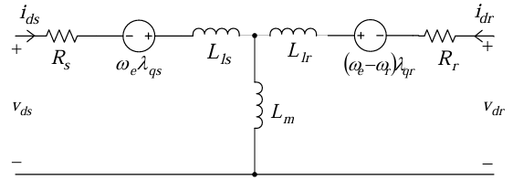

a)

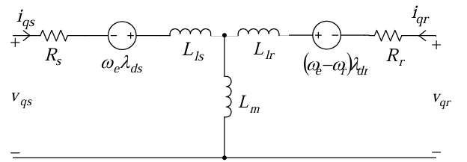

b)
FIGURE 2. d-q equivalent circuit of the induction motor [26]: a) d-axis equivalent circuit; b) q-axis equivalent circuit

$λ_{qr}=L_{r}i_{qr}+L_{m}i_{qs}$ (8)
Where $L_{r}$ is the rotor self-inductance, $L_{s}$ is the stator self-inductance, $L_{m}$ is the magnetizing inductance, $L_{Ir}$ is the rotor leakage inductance, and $L_{Is}$ is the stator leakage inductance. The self-inductances in (5-8) can be expressed as:
$L_{s}=L_{m}+L_{Is}$ (9)
and
$L_{r}=L_{m}+L_{Ir}$ (10)
The currents equations can be written as:
$i_{ds}=\frac{λ_{ds}-L_{m}i_{qr}}{L_{s}}$ (11)
$i_{qs}=\frac{λ_{qs}-L_{m}i_{qr}}{L_{s}}$ (12)
$i_{dr}=\frac{λ_{dr}-L_{m}i_{ds}}{L_{r}}$ (13)
and
$i_{qr}=\frac{λ_{qr}-L_{m}i_{qs}}{L_{r}}$ (14)
After making substitutions, the currents can be expressed in terms of flux linkages as:
$i_{ds}=\frac{L_{r}}{L_{r}L_{s}-L_{m}^{2}}λ_{ds}-\frac{L_{m}}{L_{r}L_{s}-L_{m}^{2}}λ_{dr}$ (15)
$i_{qs}=\frac{L_{r}}{L_{r}L_{s}-L_{m}^{2}}λ_{qs}-\frac{L_{m}}{L_{r}L_{s}-L_{m}^{2}}λ_{qr}$ (16)
$i_{dr}=\frac{L_{s}}{L_{r}L_{s}-L_{m}^{2}}λ_{dr}-\frac{L_{m}}{L_{r}L_{s}-L_{m}^{2}}λ_{ds}$ (17)
and
$i_{qr}=\frac{L_{s}}{L_{r}L_{s}-L_{m}^{2}}λ_{ds}-\frac{L_{m}}{L_{r}L_{s}-L_{m}^{2}}λ_{qs}$ (18)
Three-phase voltages can be converted to the two-phase stationary frame using the following relationship:
$\left[\begin{aligned}v_{qs}^{s} \\ v_{ds}^{s}\end{aligned}\right]=\left[\begin{matrix}1 & 0 & 0 \\ 0 & \frac{-1}{\sqrt{3}} & \frac{1}{\sqrt{3}}\end{matrix}\right]\left[\begin{matrix}v_{an} \\ v_{bn} \\ v_{cn}\end{matrix}\right]$ (19)
where the superscript $s$ in (19) refers to the stationary frame. The voltages can be converted from the two-phase stationary frame to the synchronously rotating frame using the following:
$v_{qs}=v_{qs}^{s}cos{}_{e}-v_{ds}^{s}sin{}_{e}$ (20)
and
$v_{ds}=v_{qs}^{s}sin{}_{e}+v_{ds}^{s}cos{}_{e}$ (21)
The current variables are given as:
$i_{qs}^{s}=i_{qs}cos{}_{e}+i_{ds}^{s}sin{}_{e}$ (22)
$i_{ds}^{s}=i_{qs}sin{}_{e}+i_{ds}^{s}cos{}_{e}$ (23)
The current equation will now become:
$\left[\begin{matrix}i_{a} \\ i_{b} \\ i_{c}\end{matrix}\right]=\left[\begin{matrix}1 & 0 \\ \frac{-1}{2} & \frac{-\sqrt{3}}{2} \\ \frac{-1}{2} & \frac{\sqrt{3}}{2}\end{matrix}\right]\left[\begin{matrix}i_{qs}^{s} \\ i_{ds}^{s}\end{matrix}\right]$ (24)
The electromagnetic torque equation is given by:
$T_{e}=\frac{3}{2}\frac{p}{2}L_{m}(i_{ds}i_{dr}-i_{ds}i_{qr})$ (25)
Where $P$ is the number of poles and $T_{e}$ is the electromagnetic torque. And the mechanical system equation is given by:
$\frac{d}{dt}ω_{m}=\frac{1}{j}(T_{e}-T_{l}-B_{ωm}$ (26)
Where:
$ω_{r}=\frac{p}{2}ωm\frac{d}{dt}ω_{r}=\frac{p}{2j}(T_{e}-T_{l}-B_{ωr})$ (27)
From table 1, the relationship between load torque ($T_{l}$) or shaft torque$T_{sh}$ in Nm, power output ($p_{output}$) in (W) and angular velocity ($ω$) in rad/secs is given by:
$T_{l} or T_{sh}=\frac{p_{output}}{ω}$ (28)
The expression for motor power is derived by the following relationship
$p_{output}=T_{s}*ω$ (29)

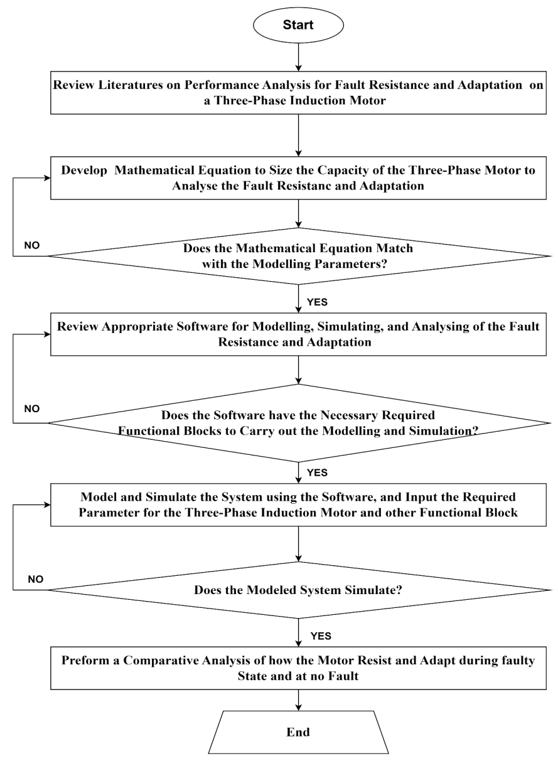
FIGURE 1. Flow chart of the research work

TABLE 1. Specification of the Asynchronous Machine Rated Parameters
Number | Parameters | Value
1 | Input power of the motor | 7.5Kw
2 | Motor input voltage | 400V
3 | Frequency | 50Hz
4 | Motor speed | 1440 RPM
5 | Mechanical power | 7.5Kw
6 | Stator resistance | 0.7384$Ω$
7 | Stator inductance | 0.003045 $mH$
8 | Rotor resistance | 0.7402$Ω$
9 | Rotor inductance | 0.003045 $mH$
10 | Mutual inductance | 0.1241H
11 | Inertia(J) | 0.0343 (kg.m²)
12 | Friction factor(F) | 0.000503 $(N.m.s)$
13 | Number of pole pair | 4
14 | Initial condition | 10000000

Where the motor output power is given as 37000w, and angular velocity is defined by the following expression
$(ω)=\frac{2*π*N}{60}$ (30)
Where the value of $π$ in radians is given as 3.142 and speed of the asynchronous motor is rated at 1440RPM. The angular velocity can be calculated as follows
Angular velocity
$$(ω)=\frac{2*π*N}{60}$$
Angular
$$\left(ω\right)=\frac{2*3.142*1440}{60}=151 rad/secs$$
Given the motor output power to be 7500w and $ω$ = 151rad/secs, the full load torque can be calculated as follows:
$$T_{l}=\frac{7500}{151}=49.7 N-m$$

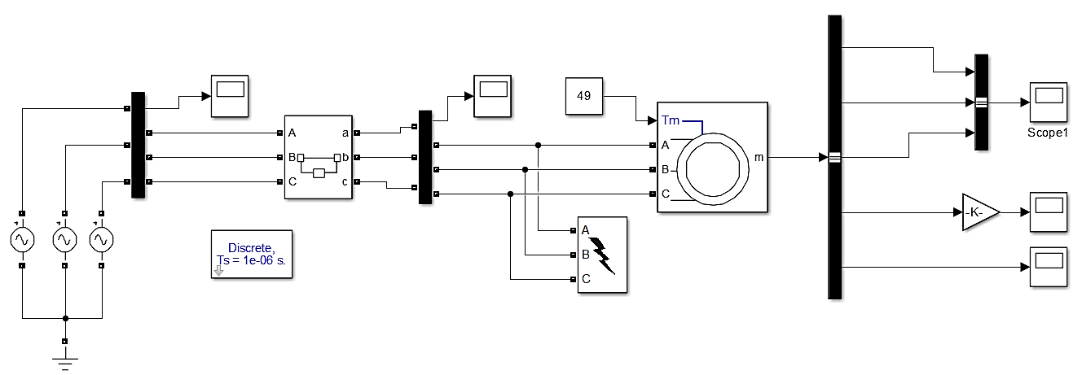
FIGURE 2. SIMULINK model of asynchronous motor for fault resistance and adaptation analysis

The modeled was simulated and their output waveform was studied and improve upon where it is necessary. The Simulink model of asynchronous motor for fault resistance and adaptation analysis is shown in Fig. 2.
RESULTS AND DISCUSSION
To analyze fault adaptability, under-voltage conditions were applied in a controlled manner, with each voltage level representing a practical operating disturbance. These conditions were used to progressively stress the motor and observe its dynamic behavior during and after the fault. The obtained results illustrate the motor’s response, stability, and recovery characteristics under electrical stress. The applied voltage variations are summarized in Table 2.

TABLE 2. Under-Voltage Percentage Variations

S/N | % Variations | Voltage drops (V) | New voltage value (V)
1 | 10 | 0.1 * 325 = 33 | 325 – 33 = 292
2 | 20 | 0.2 * 325 = 65 | 325 – 65 = 260
3 | 30 | 0.3 * 325 = 98 | 325 – 98 = 227
4 | 40 | 0.4 * 325 = 130 | 325 – 130 = 195
5 | 50 | 0.5 * 325 = 163 | 325 – 163 = 162
6 | 60 | 0.6 * 325 = 195 | 325 – 195 = 130
7 | 70 | 0.7 * 325 = 228 | 325 – 228 = 97
8 | 80 | 0.8 * 325 = 260 | 325 – 260 = 65
9 | 90 | 0.9 * 325 = 293 | 325 – 293 = 32
10 | 100 | 1.0 * 325 = 325 | 325 – 325 = 0

From table 2, recall that when dealing with a three-phase voltage supply to a start connected induction motor, the given voltage is in rms which typically refers to the line-to-line voltage. To find the maximum voltage $V_{max}$ for the star-connected system, we need to determine the phase voltage first. The relationship between line-to-line voltage $V_{LL}$ and line-to-neutral (phase) voltage $V_{LN}$ in a three-phase system is given by:
$V_{LN}=\frac{V_{LL}}{\sqrt{3}}$ (31)
Given that $V_{LL}=400V$
$$V_{LN}=\frac{400}{\sqrt{3}}=230 V$$
Now, we can calculate the peak voltage $V_{max}$ from the phase voltage $V_{LN}$
$$V_{max}=V_{LN}*\sqrt{2}$$
So,
$$V_{max}=230*\sqrt{2}$$
$$V_{max}=230*1.414$$
$$V_{max}=325V$$
Therefore, the maximum voltage $V_{max}$ for a star-connected three-phase induction motor with a 400 V three-phase supply is approximately 325 volts. The analysis will cover no under-voltage variation (normal condition), 20% under-voltage variation, 40% under-voltage variation, and 60% under-voltage variation. Single line-to-ground (SLG) and three line-to-ground (LLLG) faults are also analyzed in this study.
Under normal voltage conditions, the induction motor operates at its designed input power level, leading to stable performance in rotor speed, electromagnetic torque, and stator current. Figs 3a, 3b, and 3c present the simulation result with normal operating condition
As shown in Fig. 3a, under normal voltage conditions, the rotor speed remains close to the synchronous speed, with only a small slip characteristic of induction motor operation. This slight difference from synchronous speed is required to produce torque.
The current waveform is smooth and free from the surges or fluctuations typically seen during voltage disturbances. This voltage drop introduces an unbalanced condition, impacting the motor's performance and causing asymmetric magnetic flux in the stator, which in turn affects rotor speed, electromagnetic torque, and stator current. Fig 4a, 4b, and 4c present the simulation result with 20% under-voltage variation.
As seen in Fig. 4a, with a 20% voltage drop in a single phase, the rotor speed experiences a slight reduction in speed. Although the rotor speed decreases during this period, it generally stays within the normal operational range, with minor fluctuations caused by uneven torque generation.
As seen in Fig. 4b, electromagnetic torque becomes uneven and less stable. The single-phase voltage drops results in fluctuating torque because the reduced magnetic field affects one phase differently, causing oscillations in torque production. The fluctuating torque under this condition causes vibrations and potential mechanical stresses within the motor.

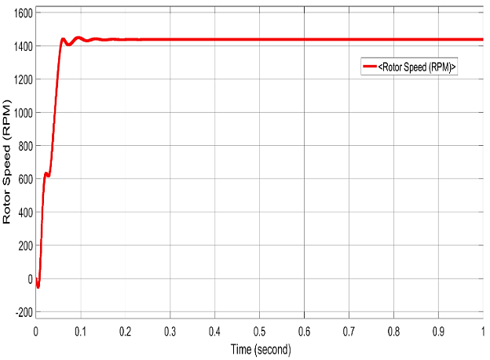 | 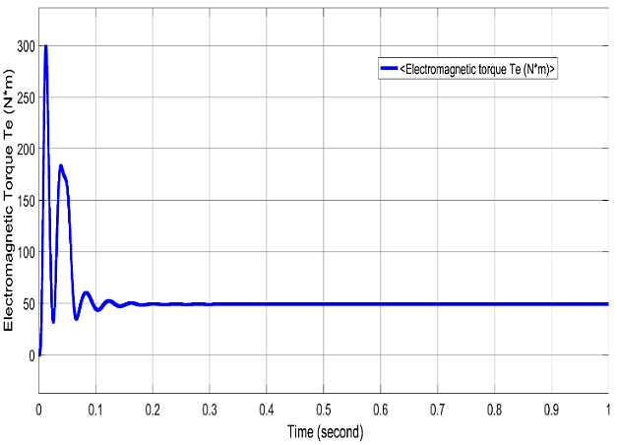
a) (b)
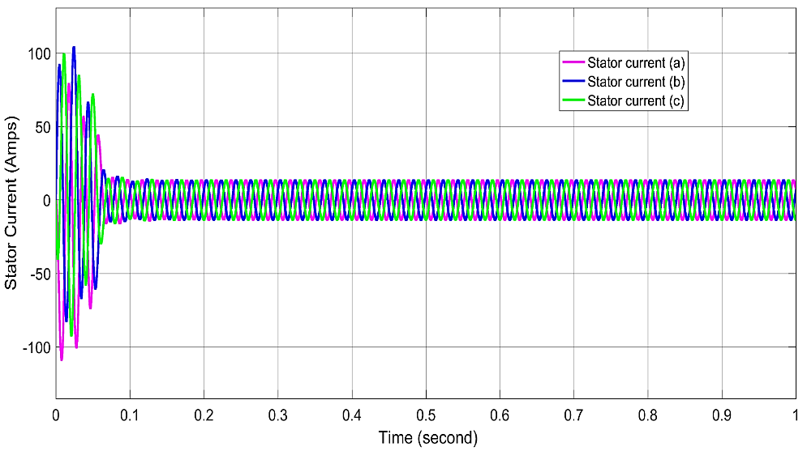
c)
FIGURE 3. a) Rotor speed simulation result at normal operating condition; b) Electromagnetic torque simulation result at normal operating condition; c) Stator currents simulation result at normal operating condition.

As shown in Fig. 4c, the stator current rises significantly in the affected phase to compensate for the voltage drop. This uneven current distribution causes unbalanced heating in the stator windings, increasing the risk of insulation stress in the impacted phase.

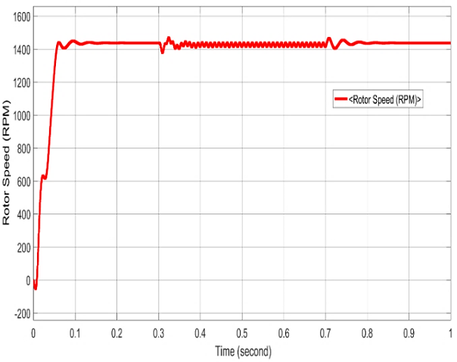 | 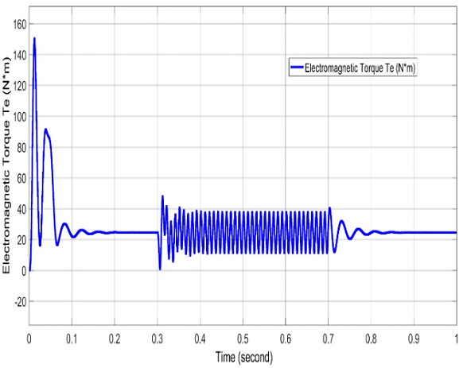
a) b)
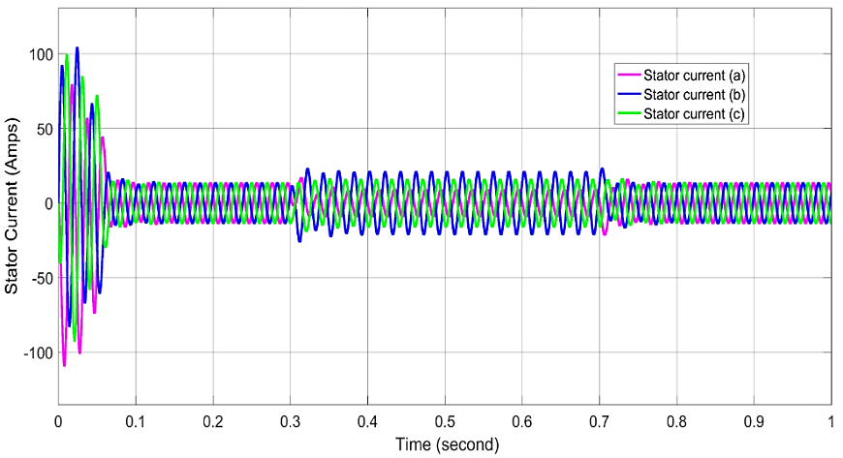
c)
FIGURE 4. a) Rotor speed simulation result at 20% under-voltage variation (LG); b) Electromagnetic torque simulation result at 20% under-voltage variation (LG); c) Stator currents simulation result at 20% under-voltage variation (LG).

This section examines how the rotor speed, electromagnetic torque, and stator current respond to and adapt under these fault conditions.

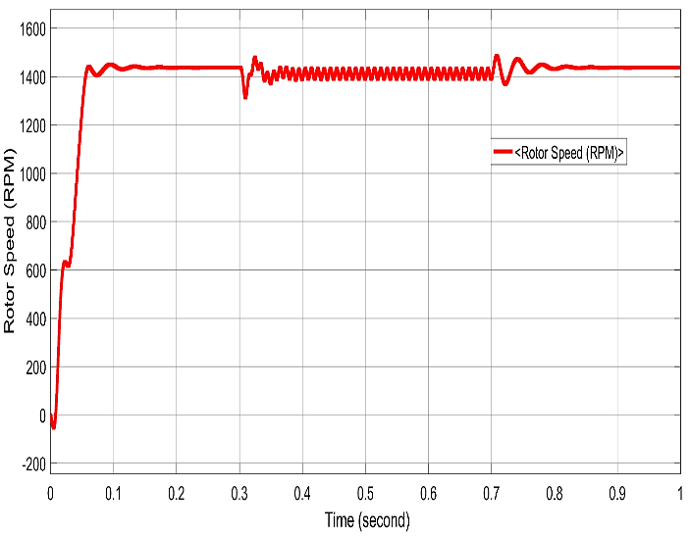 | 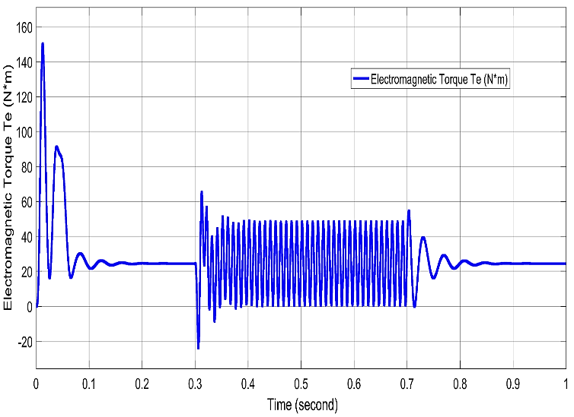
a) b)
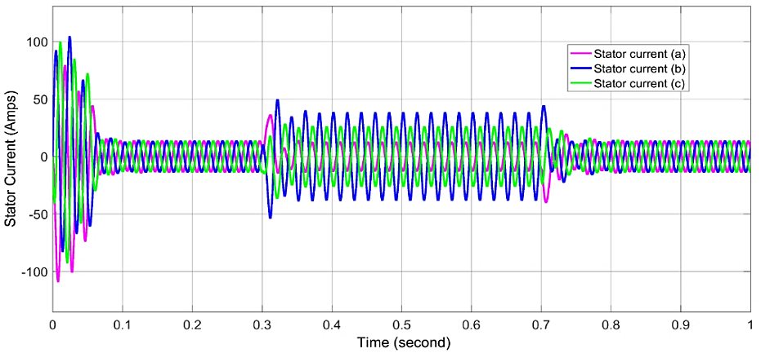
c)
FIGURE 5. a) Rotor speed simulation result at 40% under-voltage variation (LG); b) Electromagnetic torque simulation result at 40% under-voltage variation (LG); c) Stator currents simulation result at 40% under-voltage variation (LG).

As shown in Fig. 5a, a significant reduction in the voltage of one phase weakens the motor’s magnetic field and disrupts the balance required for synchronous operation. This disturbance increases slip, causing the rotor speed to decrease noticeably, with ongoing fluctuations as the motor attempts to maintain stability.
This severe under-voltage condition creates substantial imbalance in the motor’s electrical parameters. Figures 6a, 6b, and 6c illustrate the corresponding effects on rotor speed, electromagnetic torque, and stator current in detail.

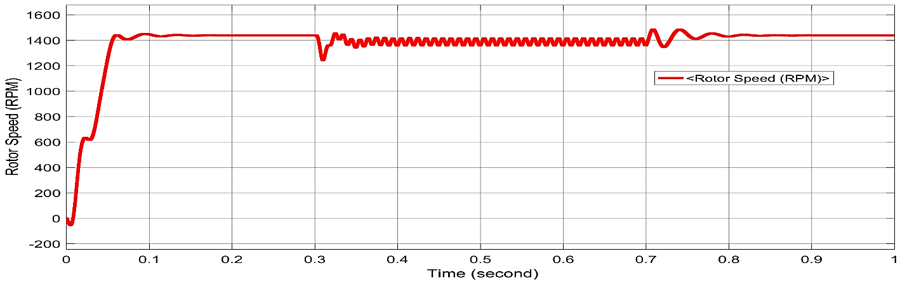 | 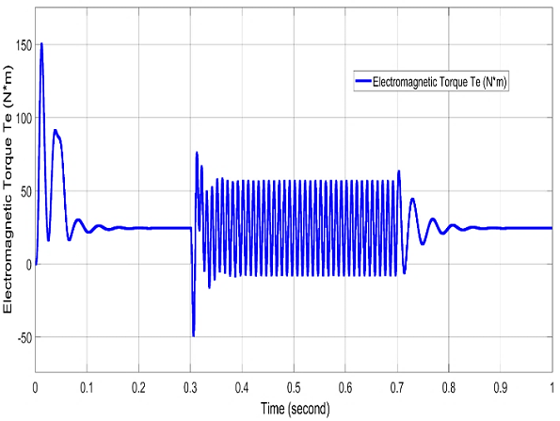
a) b)
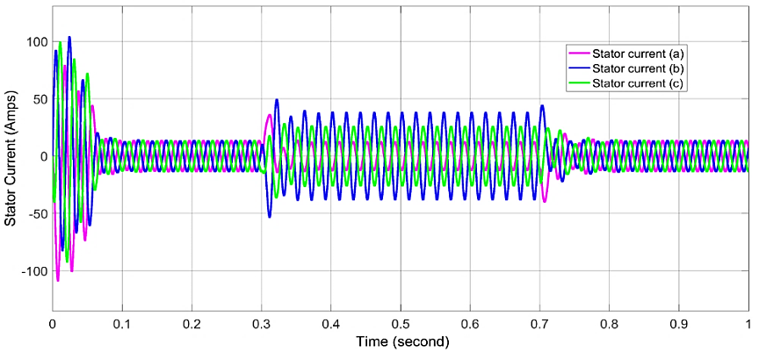
c)
FIGURE 6. a) Rotor speed simulation result at 60% under-voltage variation (LG); b) Electromagnetic torque simulation result at 60% under-voltage variation (LG); c) Stator currents simulation result at 60% under-voltage variation (LG).

The relationship between voltage, current, and resistance based on Ohm’s law provides a foundational understanding of how the motor adapts to different under-voltage conditions. The adaptive table and graphical representation are presented in table 3 and Fig. 10 respectively.

TABLE 3. Fault Adaptation and Resistance Table

S/N | % Variations | Voltage drops (V) | Current (amps) | Resistance (ohms)
1 | 20 | 325-260 | 30 | 8.7
2 | 40 | 325-195 | 45 | 4.3
3 | 60 | 325-130 | 70 | 1.9

FIGURE 10. Graph of Voltage, Current and Resistance

As shown in Fig. 10, at a 20% voltage reduction, the motor current increases while the effective motor resistance decreases.
CONCLUSION
According to the research, it can be concluded that three-phase induction motors have been found to exhibit different levels of tolerance to low-voltage faults, with the ability to adapt depending on the severity of the voltage drop. According to MATLAB/Simulink simulations, at voltage levels of 20% and 40%, the motor compensates for the reduced voltage by increasing the current. Under extremely low voltage conditions, for example, when the voltage drops by 60%, the motor is found to exceed the adaptation limits.
Using Ohm's law, it was confirmed that the voltage drop, together with the compensation current, temporarily reduces the effective resistance of the motor. However, in extreme cases, excessive current increases the risk of thermal damage and prevents the system from recovering. Based on the results obtained, it is possible to determine the protection limits and introduce fault-tolerant designs in motor systems. In conclusion, this research work demonstrates the need for advanced motor protection strategies.
References
- Yaabari, N., Okoro, O. I., & Akpama, E. J. (2023). Matlab-based simulations of a three-phase induction motor for dynamic studies. Nigerian Journal of Technology, 41(6), 1000–1007. https://doi.org/10.4314/njt.v41i6.10
- de Almeida, T., Greenberg, S. F., & Rao, P. (2016). Electric motor systems efficiency. In F. Kreith (Ed.), Energy management and conservation handbook (2nd ed., pp. 343–370). CRC Press.
- Okpo, E. E., Okoro, O. I., Awah, C. C., & Akuru, U. B. (2020). Investigating the Dynamic Behaviour of a Six-Phase Induction Motor under Unbalanced Faults. 2020 IEEE PES/IAS PowerAfrica, 5, 1–5. https://doi.org/10.1109/powerafrica49420.2020.9219819
- Xiao, Y., Zhou, L., Wang, J., & Liu, J. (2018). Design and performance analysis of magnetic slot wedge application in double‐fed asynchronous motor‐generator by finite‐element method. IET Electric Power Applications, 12(7), 1040–1047. https://doi.org/10.1049/iet-epa.2017.0730
- Sunday, A. B., Okpo, E. E., & Ekpo, D. D. (2024). Load rejection effects analysis on synchronous generators with ANN. American Journal of Engineering Research (AJER), 13(7), 57–65.
- Lee, C. Y. (1999). Effects of unbalanced voltage on the operation performance of a three-phase induction motor. IEEE Transactions on Energy Conversion, 14(2), 202–208.
- Dehina, W., Boumehraz, M., & Kratz, F. (2021). Diagnosis and Detection of Rotor Bars Faults in Induction Motor Using HT and DWT Techniques. International Conference on Engineering Technologies and Applied Sciences (ICETAS). https://doi.org/10.1109/ssd52085.2021.9429381
- Mahmood, F. M., & Hashjin, M. R. (2022). Starting Analysis of Squirrel Cage Induction Motors 1000 kW by Variable Frequency Drive in Power System, Case study: Tabriz Pump station. NTU Journal of Engineering and Technology, 1(4). https://doi.org/10.56286/ntujet.v1i4.369

