Justification Of Shock-Absorbing Parameters Separator Plates For Fiber Material
Anvar Djurayev¹, Baxtiyordjan Davidbaev², Sultanali Zulpiyev³,
Yunus Mirzaxanov², Nargiza Davidbaeva²
¹Tashkent Institute of Textile and Light Industry, Tashkent, Uzbekistan
²Fergana Polytechnic Institute, Fergana, Uzbekistan
³KITEP BatSU, Kyrgyzstan

^{a)}Corresponding author: baxtiyor52627@gmail.com
Abstract. Abstract. The article presents a literature study of various designs of separators for fibrous material. The design scheme and operating principles of the modernized separator for fibrous material are given, which increase the efficiency of separating fibrous material from the air flow at different ratios of the mixture concentration - fiber and air flow, as well as reducing wear, eliminating deformations and friction of the opposite wall from the air supply zone with cotton. The analytical method is used to solve the problems of oscillations of a plate shock absorber. The obtained laws of plate oscillations from changes in the process load from raw cotton, at different values of the stiffness coefficient of the elastic supports of the plate, as well as graphic dependencies of changes in the amplitude of oscillation of the plate shock absorber from the load of elastic-dissipative properties of the shock absorber, testing of the proposed separator of fibrous material. Based on the results of theoretical studies of the recommended modernized separator, a prototype was manufactured and the results of production tests of the modernized separator are given.
Keywords: Separator, raw cotton, shock absorber, plate, vibrations, amplitude, deformation, load.
INTRODUCTION
In cluster production during pneumatic production, transportation of raw cotton is carried out under air pressure. At the same time, before the technological processes of processing raw cotton, it is necessary to separate the air from the cotton, which is carried out in a separator [1].
The well-known design of the CC-15A separator contains a separation chamber, a vacuum valve, a perforated mesh and a scraper shaft [1, 2]. The disadvantage of this design is the insufficient separation of raw cotton from the air, as well as high wear and reduced service life of the chamber due to the impact interaction of raw cotton, especially large impurities (stones and other heavy impurities) on the walls of the chamber. In this case, the wall heats up, it deforms, and cracks may also appear, which leads to a sharp decrease in pressure in the chamber.
In another design, the separator for fibrous material contains a separation chamber, inlet and outlet pipes, a screen drum installed in front of the outlet pipe, and a vacuum valve mounted in the lower part of the separation chamber. The chamber is made expanding in a horizontal plane from the inlet pipe to the mesh drum. A reflective partition is installed inside the chamber, dividing the chamber into a pneumatic pipe located in the upper part of the chamber, and a fiber pipe in its middle part. In the fiber duct towards the vacuum valve, guide ribs are installed like a fan. In this case, the guide ribs are installed on the upper wall of the fiber duct, or on the lower wall, or on the upper and lower walls. The height of the guide ribs is from 1/4 to 1/3 of the height of the cross-section of the fiber duct [3]. The disadvantage of this separator design is that the separation chamber is made expanding, in which guide ribs of a certain thickness and width are installed. At the same time, in the direction of air movement with fibrous material, the distance between the ribs increases significantly, which leads to a violation of the rectilinear movement of cotton, allowing for their uneven distribution along the circumference of the chamber cross-section at any given time, and in some cases, to the slaughter. In addition, in the existing design, when separating air from fibrous material in the mesh drum zone due to their cylindrical holes, cotton fibers acting on the edges of the holes can be subject to mechanical damage.
In the design of the separator for fibrous materials, the reflector is made as a composite of two parts installed between each other with a gap forming an additional horizontal air outlet channel, while the lower part of the reflector has a limit switch for the suction system and a sensor for filling the fiber outlet channel, made in the form of a cantilever comb plate, installed pivotally with adjustment of its rotation angle and having a protrusion when interacting with the limit switch [4]. The disadvantage of this separator is the complex design, low separation effect when changing productivity, as well as changing the percentage of air and raw cotton in the mixture.
In order to increase the efficiency of separating fibrous material from the air flow at different ratios of the concentration of the mixture - fiber and air flow, as well as to reduce wear, eliminate deformations and friction of the opposite wall from the air supply zone with cotton, it is recommended that the separator for fibrous material contain a separation chamber, a vacuum valve, a perforated mesh and a scraper shaft [5, 6]. In this case, the scraper shaft is made composite from a shaft, an external bushing with scraper blades installed on it by means of elastic (rubber) bushings, and on the opposite wall of the separation chamber from the cotton supply zone with air, a shock-absorbing plate is installed by means of a rubber gasket.
The separator for fibrous materials contains a separation chamber 1, a vacuum valve 2, a perforated mesh 3, a scraper shaft 4 made as a composite of a shaft 4 with external bushings with scraper blades 8 installed on it by means of elastic (rubber) bushings 9. At the same time, a shock-absorbing plate 6 is installed on the opposite wall 5 of the separation chamber 1 by means of a rubber pad 7 (see Fig. 1, 2).
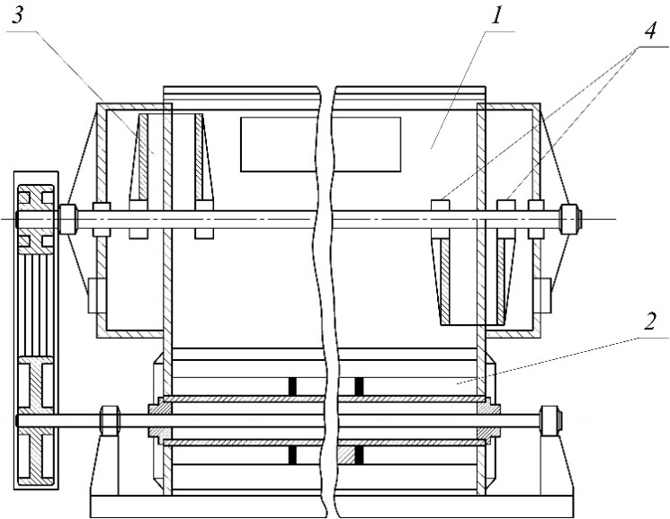 | 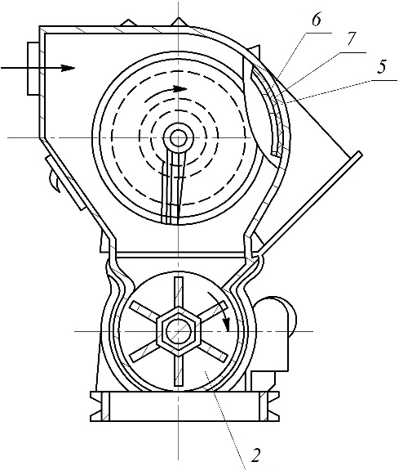
FIGURE 1. General view of the separator from the front | FIGURE 2. General view of the separator from the side in section

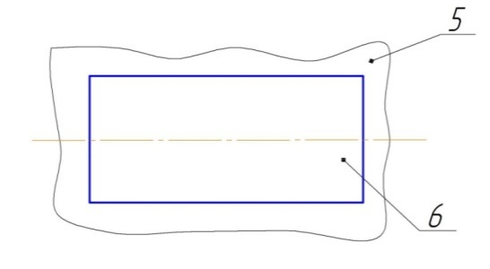 | 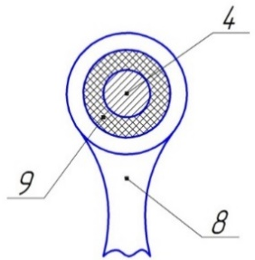
FIGURE 3. Shock absorbing plate by means of separator wall | FIGURE 4. Scraper shaft in section

The separator for fibrous materials operates as follows. Raw cotton together with the air transporting it enters the separation chamber 1 via the suction pipeline, slides along its surface, is fed to the vacuum valve 2 and is discharged from the separator by its impeller. Individual flaps of raw cotton adhering to the perforated nets 3 of the separation chamber 1 are scraped off them by scrapers 8 of the shaft 4 and are also discharged into the vacuum valve 2.
When raw cotton enters the separation chamber 1 under pressure at high speed, heavy large impurities, together with cotton, hit the surface of the plate 6 and are absorbed by deformation by an elastic (rubber) gasket 7. This significantly reduces damage to the plate 6, as well as the corresponding part of the scraper shaft 4 The elastic sleeve 9 of the composite scraper shaft 9 provides effective cleaning of the perforated mesh 3 from cotton due to additional vibrations of the outer sleeve with the blades 8.
The design allows for an increase in the efficiency of separating fibrous material from the air flow with changes in the air flow pressure and the mass of the incoming fibrous material, reduces damage to the walls 5 and the scraper shaft 4, and also allows for an increase in the service life of the bearing supports of the scraper shaft 4. Elastic (rubber) bushings 9 (see Fig. 4) reduce the loads on the shaft 4 and thereby on the bearing supports arising from the unbalanced inertial forces of the outer bushings with blades 8.
METHODS
Mathematical model of angular and vertical oscillations of the separator shock-absorbing plate. During the separator operation, the plate is affected by parts of cotton. In this case, the plate performs both vertical and angular oscillations, depending on the zone of impact, the frequency of the cotton, and the elastic dissipative characteristics of the shock absorbers.

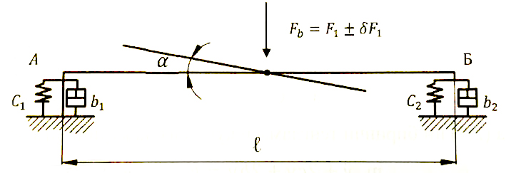
FIGURE 5. Calculation diagram of the separator shock-absorbing plate
At the same time, assuming that the shock absorber is located at the edges of the plate, we will draw up a calculation diagram, which is shown in Fig. 5.
To compose the vibrations of the plate, the Lagrange equation of the 11th kind is used [7-8]
(1)
Where, Т, П, Ф - kinematic and potential energies, Rayleigh dissipative function, y - generalized coordinate, Q(q) - generalized force.
In a general oscillatory system, taking into account C₁±C₂, we can replace
(2)
Where, α is the angular displacement of the plate; C₁, C₂ are the rigidity coefficients of the elastic supports of the separator plate; b₁, b₂ are the dissipation coefficients of the elastic supports.
In this case, according to (1), we obtain the following system of differential equations describing the motion of the plate.
(3)
Where, l is the length of the plate, the distance between the supports; $Fц$, М_{T}ц, δ_{Max} - technological resistance force and its moments, a random component of the moment of resistance.
Let us consider the case when the coefficients of rigidity and dissipation of elastic supports are the same:
(4)
Taking into account (4), the first differential equation of system (3) will take the following form:
(5)
Using the well-known analytical method [6], the solution to equation (5) has the form:
(6)
Taking into account the initial conditions, determining the integration constants at t=0, the patterns of oscillations of the separator plate were obtained by numerical solution of the problem.
The obtained laws of plate oscillations from changes in the technological load from cotton, for different values of the rigidity coefficient of the elastic supports of the plate, are presented in Fig. 6.

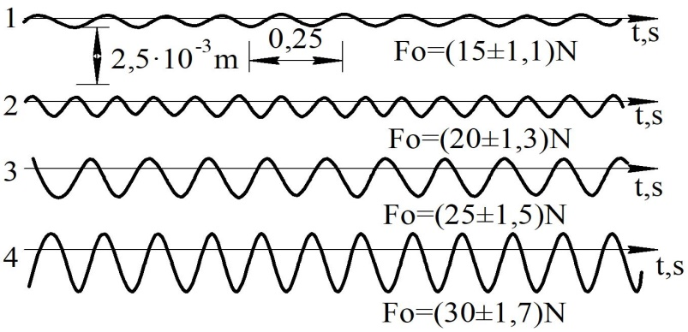
а)
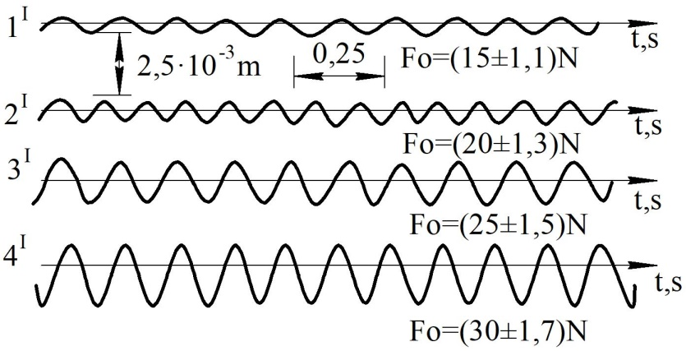
b)
FIGURE 6. Vibrations of the plate when the load and the rigidity coefficient of the elastic supports change: а) at С=4,5 10 N/m; b) at C=2,5 10 N/m

Based on the results of theoretical studies of the recommended separator, a prototype was manufactured [2, 7].
RESULTS AND DISCUSSION
Results of production tests of the modernized separator. Comparative production tests were carried out in cluster production. The test results are presented in Tables 1 and 2.
Results of comparative production tests of a separator with an elastic shock absorber
TABLE 1. Comparative results of cotton contamination using different separators (%)
Separator brand | Cotton contamination |  |  |  |  |  | Average  %
Separator brand | 1 | 2 | 3 | 4 | 5 | 6 | Average  %
Separator СС15 | 2,19 | 2,20 | 2,20 | 2,21 | 2,19 | 2,22 | 2,21
Modernized separator | 2,12 | 2,11 | 2,14 | 2,10 | 2,13 | 2,11 | 2,11

TABLE 2. Comparative results of seed damage using different separators (%)
Separator brand | Seed damage |  |  |  |  |  | Average  %
Separator brand | 1 | 2 | 3 | 4 | 5 | 6 | Average  %
Separator СС 15 | 0,53 | 0,56 | 0,57 | 0,55 | 0,53 | 0,56 | 0,55
Modernized separator | 0,33 | 0,35 | 0,38 | 0,36 | 0,34 | 0,36 | 0,35

Analysis of the data in Table 1 shows that the recommended modernized separator allows an increase in the contamination of raw cotton by 0.12%. According to the data, Table 2 shows that the recommended separator leads to a decrease in the damage of cotton seeds by 0.21%.
CONCLUSION
- An effective design of a cotton separator with a plate reflector and a shock absorber has been developed.
- Based on theoretical studies, the law of oscillatory motion of the shock absorbing plate has been determined.
- Reduces seed damage by at least 0.21% and contamination by 0.11%;
- The service life of the bearing supports of the scraper shaft and the wall of the working chambers is more than 15-20%.
REFERENCES
- Muradov, R., Karimov, A., Makhkamov, A., & Mamatkulov, O. (2018). Investigation of the regularities describing the process of cotton separation from air flow and its mathematical modeling. Namangan Publishing House.
- Khodzhiev M.T., Kodirov B.G., Shodiev Z.O., Rakhmonov Kh.K. (2001). Separator for fibrous material (Uzbek Patent No. IDR 04998). Agency of Intellectual Property of the Republic of Uzbekistan.
- Djurayev A., Alimov O., Davidbayev B., Davidbayeva N.. (2020). Separator for fibrous materials (Uzbek Patent No. IAP 06300). Agency of Intellectual Property of the Republic of Uzbekistan.
- Juraev, A. D., Davidbayev, B. N., Juraev, N. N., & Beknazarov, J. K. (2023b). Results of dynamic analysis of double-inlet screw conveyor machine assembly. E3S Web of Conferences, 417, 06005. https://doi.org/10.1051/e3sconf/202341706005
- Djuraev, A., Davidbaev, B., & Davidbaeva, N. (2020). Influence of the interaction between the flying cotton mass and a shock-absorbing plate of a separator on the quality indicators of raw cotton. Collection of Scientific Papers ΛΌΓOΣ, 72–76.
- Guo, H. F., Yang, C., & Li, L. (2017). Study on the dynamics of chitosan/cotton fiber in an airflow around two rotating cylinders. Textile Research Journal, 88(18), 2035–2043. https://doi.org/10.1177/0040517517715082

