Mathematic Model of a Metal-Cutting Machine Drive
Ruzikhuja Ulugkhojaev^{a)}, Tirkash Turaev, Bahrom Madaminov, Artur Yakupov, Abdurashid Mamirov, Sodiq Xamdamov
Fergana State Technical University, Fergana, Uzbekistan

^{a)}Corresponding author: ruzixuja.ulugxojayev@fstu.uz
Abstract. Evaluation of the accuracy and performance of technological equipment for metal cutting at the design stage allows for a comparative analysis of design options and choose the best one, as well as optimize design parameters. This task can be performed only by means of mathematical modeling on a PC. Mathematical modeling of machine tools and machine tool complexes makes it possible to estimate the relative static and dynamic movements of machine components, tools and parts, on the basis of which accuracy indicators can be determined. Mathematical modeling also makes it possible to determine the static and dynamic loads of machine components and, based on the results of strength calculations, reasonably select design parameters. The article presents separate mathematical models of the electrical part, the mechanical part, the gear transmission and the traction mechanism of the metal-cutting device. In addition, the operating functions of the electric motor, gearbox, bearing, gearbox, transmission and gears in the mechanical part of the drive and the types of parts are described. The mechanical resistance in the gearbox is given, and the feed mechanism of the metal-cutting machine is given. The boundaries of each mathematical model are shown separately. Mathematical models are generalized and presented. Construction of the calculation scheme of the spindle. The equations of system interaction have been developed. The control system is modeled.
Keywords: metal-cutting machine, drive, mathematical model, electric motor, transmissions (reducers, couplings), feed mechanism, control systems, mechanical resistance, feed dynamics, bearings, spindle, transmission, couplings.

INTRODUCTION
Mathematical modeling of machine tools and machine tool complexes allows to estimate relative static and dynamic movements of machine units, tools and parts, on the basis of which accuracy indicators can be determined. Mathematical modeling also allows to determine static and dynamic loads of machine units and, based on the results of strength calculations, to reasonably select design parameters [1-4].
Model of the drive of a metal-cutting machine tool is an abstraction that describes the dynamic behavior of the system using mathematical equations and physical laws. Such a model allows analyzing the operation of the drive, conducting simulations, optimizing the operating parameters, and developing methods for diagnostics and failure prediction [5-7].
The drive of a metal-cutting machine consists of several key elements: an electric motor, a transmission (reducers, couplings), a feed mechanism and a control system. To create a mathematical model of the machine drive, it is necessary to take into account the interaction of all these components [8].

METHODS
The electric part of the drive consists of an electric motor, a control device (for example, an inverter or frequency converter), and a power supply system. The basic equation for the model of the electric part of the drive motor can be represented through differential equations that take into account the parameters of the motor.
For synchronous and asynchronous electric motors, the models may be different, but for simplicity, let's consider an asynchronous motor with constant parameters.
The power supplied to the motor shaft can be described by the equation [2]:
$Р_{m}=M_{m}∙ω_{m}$ (1)
Where:
P_{m} — mechanical power on the shaft,
M_{m} — moment of force on the shaft,
ω _{m} — angular velocity of the shaft.
The differential equation for an asynchronous motor can be written as [2]:
$J∙\frac{dω_{m}}{dt}=T_{et}-T_{load}-B∙ω_{m}$ (2)
Where:
J — moment of inertia of rotating parts,
ω _{m} — angular velocity of the shaft,
T_{et} — electromagnetic torque generated by the engine,
T _{load} — moment of resistance (for example, from a mechanism),
B is the coefficient of viscous friction.
To obtain an expression for the mechanical moment T_{em}, an electrical model is used that relates the voltage, current and torque of the motor.

RESULTS AND DISCUSSION
The mechanical part of the drive includes gearboxes, bearings, couplings and other mechanisms that transmit motion to the working parts of the machine. The mathematical model of the mechanical system will depend on the type of transmission mechanism.

The mechanical part of the drive of a metal-cutting machine is a key component that transfers motion from the electric motor to the working parts of the machine, such as the spindle, tool and feed mechanism. It includes such elements as gearboxes, couplings, bearings, feed mechanisms and transmissions. All these components must work together to ensure the accuracy, reliability and efficiency of the machine. The main components of the mechanical part of the drive of a metal-cutting machine.

FIGURE 1. Calculation diagram of the drive

An electric motor is a source of mechanical energy, converting electrical energy into mechanical movement. It can be asynchronous, synchronous, stepper or servo motor depending on the requirements for accuracy and power. The electric motor transmits rotation to a gearbox or direct drive.
A gearbox is a mechanical device designed to change torque and angular speed of rotation. Typically, a gearbox is used to reduce the speed of rotation of the output shaft while increasing the torque. Gearboxes can be single- or multi-stage and consist of gears, pinions, shafts, and bearings.
Mathematically, the gearbox can be described through the gear ratio i:
Gearboxes are used to change torque and angular velocity. The mechanical resistance in a gearbox can be modeled through an equation that relates the output and input torques [2]:
$T_{out}=\frac{T_{in}}{i}$ (3)
Where:
T _{out} — output moment,
T _{in} — input moment,
i — gear ratio of the gearbox.
If the gearbox is complex and includes several stages, then its model can be described through a system of equations that takes into account each element of the transmission.
For a more accurate description of mechanical resistance, we use the differential equation of motion in a mechanical system, which can take into account friction and inertia [2]:
$J∙\frac{d^{2}θ}{dt^{2}}=T_{in}-T_{friction}$ (4)
Where:
J— moment of inertia,
θ— rotation angle,
T_{in} — input moment,
T_{friction} is the frictional moment proportional to the rotation speed.
The feed mechanism in a metal-cutting machine is responsible for moving the tool or workpiece along the axes, which is necessary to perform cutting. Depending on the type of machine (milling, turning, drilling, etc.), various feed systems can be used, such as linear drives with screw pairs, rack or belt transmissions.
The feed mechanism can be used to move along the X, Yand Z axes, or along one axis, if it is, for example, a lathe.
The feed mechanism of a metal cutting machine transfers motion to the tool, moving it along the axes of the machine. Often the feed has a constant or variable speed, and this part of the model will depend on the type of machine.
The following differential equation can be used to describe the feed [2]:
$M_{p}∙\frac{d^{2}x}{dt^{2}}=F_{cut}-F_{resist}$ (5)
Where:
M_{p} — feed mechanism,
x — displacement,
F_{cut} — cutting force (depends on the material and geometry of the tool),
F_{resist} — feed resistance (e.g. friction or inertia of the mechanism).
Bearings are used to reduce friction and ensure shaft rotation with minimal resistance losses. Different types of bearings are used in metal-cutting machines - ball, roller, sliding, depending on the design and load requirements.
Bearings play an important role in the accuracy and durability of a machine tool. For example, milling machine spindles often use high-precision bearings to ensure minimal play.
The spindle is the main element of the drive, which is directly connected to the tool or workpiece. It transmits torque and ensures high rotation accuracy. The spindle can be equipped with bearings and couplings for correct operation under high speed conditions.
Spindles can be either straight (transmission via a gearbox) or with the ability to adjust the rotation speed (for example, using variators or frequency converters). It is important that the spindle has minimal backlash and high rigidity to ensure processing accuracy.
It can be seen from the figure that there are 12 nodal points in this diagram, with points 5.10 and 11 being concentrated masses. According to the general drawing, point 2 is the gear wheel, and point 9 is the spindle flange. The parameters of the rods are determined by geometric dimensions according to the general drawing [10]. In this calculation scheme of the spindle assembly, both the spindle with bearing supports and the mandrel with the tool are taken into account. Bearing supports are represented by springs. In this case, the initial nodal points of such a spring are located on the centerline of the spindle, and the final node is attached to a rigid seal ("bed"), and its number is always zero.
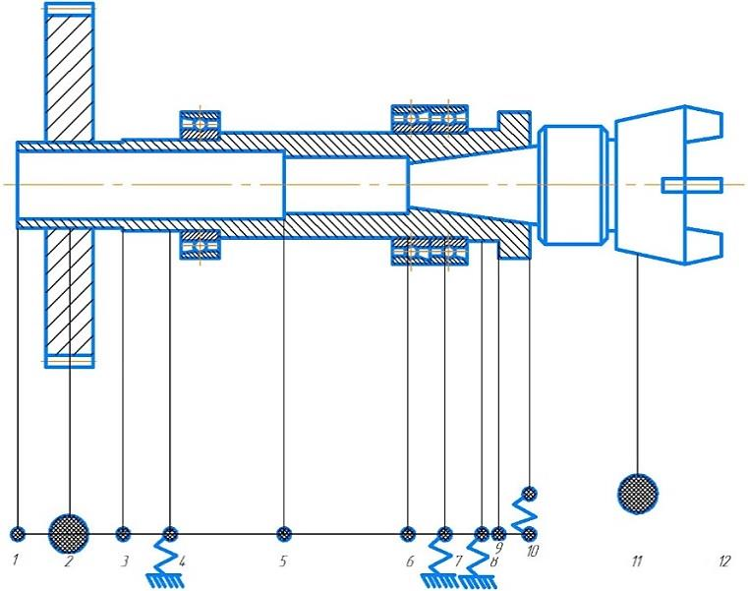
FIGURE 2. Division of the milling machine spindle into final elements.

For radial and thrust bearings, the spring mounting assembly is located on the centerline of the spindle in the middle of the support, and for radial thrust bearings, the assembly must be located at the intersection of the reaction vector of the support and the centerline of the spindle. The value of the contact angle α is taken from the bearing reference (for example, 12, 15, etc.).
Transmission and gears in the mechanical part of the drive perform the functions of transmitting motion from one mechanism to another, for example, from an electric motor to a gearbox or from a gearbox to a spindle. These transmissions can be performed both through gear transmissions and through chain or belt drives.
Belt drives are often used to reduce vibration and noise, and to regulate rotation speed. Gear drives provide precise torque transmission and can be used where high power transmission is required.
Couplings are used to connect two shafts, providing the transmission of torque from one element to another. Couplings can be rigid (when connecting two shafts without the possibility of relative movement) or flexible (when allowing small angular deviations and compensating for shocks and vibrations).
For a complete mathematical model of the drive of a metal-cutting machine, it is necessary to take into account the interaction of the electrical and mechanical parts of the system. The drive torque of the engine is transmitted to the gearbox and then to the tool through the feed mechanism. Mathematically, this can be represented by a system of interrelated equations [2]:
$j_{e}∙\frac{d^{2}ω_{m}}{dt^{2}}=T_{et}-T_{load}-B∙ω_{m}$ (6)
$j_{m}∙\frac{d^{2}θ}{dt^{2}}=T_{in}-T_{fristion}$ (7)
$M_{P}∙\frac{d^{2}x}{dt^{2}}=F_{cut}-F_{resist}$ (8)
where j_{e} is the moment of inertia of the electric motor, j_{m} is the moment of inertia of the feed mechanism, T_{in} is the input torque transmitted from the motor to the gearbox.
For the control system of the machine tool drive, control theory can be used to optimize the drive operation. The basic control equation can be represented by the feedback between the desired and actual speed or position.
To simulate the control system, you can use standard methods, such as a PID controller, which will monitor deviations from the set values.

CONCLUSION
The mathematical model of a metal-cutting machine drive is a complex system of differential equations that describes the dynamics of the electrical and mechanical parts of the system. To develop it, it is necessary to take into account the parameters of the engine, gearbox, feed mechanism, as well as the interaction of these components. Models of this type allow not only to analyze the operation of the equipment, but also to optimize, predict breakdowns and improve the efficiency of the machine.

REFERENCES
- Push, V. E. (Ed.). (1985). Metal-cutting machine tools. Mashinostroenie.
- Levin, A. I. (1978). Mathematical modeling in the research and design of machine tools. Mashinostroenie.
- Glubokiy, V. I., Yakimovich, A. M., & Glubokiy, A. S. (2013). Design and calculation of machine tools: Calculation of feed drives and guideways (Methodical manual for practical classes for students of mechanical engineering specialties). Belarusian National Technical University (BNTU).
- Mirodilovich, T. T. U. R. S. M. B. (2024). Technological features hardening of the case of the roller track of the transport machine by ball knurling tool and cartooning with microballs. bpasjournals.com. https://doi.org/10.48165/bapas.2024.44.2.1
- Fayzimatov, S. & FerghanaPoliytechnic Institute. (2016). Research Methodology and Applications of Automatic Devices with the Usage of Aerodynamic Effects. In International Journal of AdvancedResearch in Science, Engineering and Technology: Vol. Vol. 3 (Issue Issue 4). http://www.ijarset.com/upload/2016/april/21_IJARSET_shuhrat.pdf
- Kozochkin, M. P., Maslov, A. R., Sabirov, F. S., & Porvatov, A. N. (2021). Diagnostics and certification of metal-cutting equipment (2nd ed.). Innovative Machine Engineering Publishing House.
- Zavistovsky, V. E. (2019). Reliability and diagnostics of technological equipment. RIPO Publishing House.
- Kolesnikov, L. A. (2017). Investigation of static and dynamic characteristics of machine tool spindle units in computer-aided design. Belarusian National Technical University (BNTU).

