Determination of the Energy Efficiency of a Combined Device based on a Solar Photovoltaic System and a Microhydroelectric Power Plant
Feruza Yusupova^{a)}, Omadjon Urishev, Erkinjon Xolmatov, Sherzod Axmedov,
Shavkatjon Sayitov, Jasurbek Ibrokhimov
Fergana State Technical University, Fergana, Uzbekistan

^{a)}Corresponding author: feruzaxon.yusupova.ferpi@gmail.com
Abstract. The article is devoted to determining the energy efficiency of a combined solar photovoltaic installation and micro-hydroelectric power station. Methods for increasing energy efficiency when combining a solar photovoltaic installation and a micro-hydroelectric power station are analyzed. The alternating connection method is used when combining a solar photovoltaic installation and a microhydroelectric power station. Using this method, a simulation model of solar photovoltaic plant and micro hydroelectric power station was developed in MATLAB. When the solar photovoltaic plant and the micro-hydroelectric power plant were connected in parallel, the combined power source generated 20577 J of energy, resulting in an energy loss of 3440 J. To overcome this energy loss, a time-varying switching scheme was proposed. When using this structural diagram, there were no energy losses of 18,380 J when operating a solar photovoltaic installation and 5,637 J when operating a microhydroelectric power station, that is, 24,017 J with a combined energy source. The energy efficiency of the combined energy device is increased by 14%. In addition, to determine the energy efficiency of the combined energy device, the ballast resistor R3 was disconnected from the circuit, resulting in 16270 J of solar PV and 2930 J of microhydroelectric power, for a total of 1920 J of energy achieved. 1377 Joules of energy was achieved by regularly monitoring the power and directing the excess to the ballast load.
Keywords: solar photovoltaic station, microhydroelectric power station, ballast load, energy, solar radiation, water consumption, battery, monitoring, power system.
INTRODUCTION

Along with the rapid increase in electricity costs throughout the world, which is followed by the high price of fossil fuels, it requires all parties to conduct research in order to find alternative energy sources that are sourced from nature and are environmentally friendly. The development of environmentally friendly energy sources has been carried out since ago by applying various models [1-5]. By reducing dependence on petroleum energy sources through verified energy sources including the development of alternative energy that is cheap, available in abundant quantities, flexible and environmentally friendly [6-8]. According to the energy outlook by IEA based on the stated policies, the development of renewable energy is an important choice for the future energy of theworld which will meet 80% of the growth in global electricity demand to 2030 [9].

Micro hydropower is primarily a tiny hydro technology system with its own set of constraints. It does come with its limitations. The drawback is that the hydro potential is located far off from where the demand is concentrated. To enhance the supply according to demand, funds need to be spent towards connecting the microhydro to the grid system. Hydropower plants can be large, small, mini, and micro, depending on the ability of water supplies and water flow by the force of gravity [10-12]. Photovoltaic (PV) is the direct use of solar radiation to generate electricity. Different types of PV installations have been exploited for several decades in Europe, which has proven the reliability of the technology itself [13]. However, large-scale diffusion of PV installations in Uzbekistan is still very limited. It is, therefore, of strategic importance to figure out whether solar PV is really (can be) a sustainable option for Uzbekistans energy transition. Life cycle sustainability assessment (LCSA) was selected in this study with the aim to analyze the sustainability of the PV system in Uzbekistan on the project level.

Using alternative energy sources has its drawbacks. When using solar photovoltaic power plants, the opportunity to obtain electricity in the evening is small, and since when using microhydroelectric power stations the level and pressure of running water changes, microhydroelectric power stations do not operate in a uniform manner throughout the entire period of operation. seasons, so their combination is one of the urgent tasks [14].
METHODS
It uses a parallel and series connection method to interconnect renewable energy sources. When using the parallel connection method in the process of combining a microhydroelectric power station and a solar photovoltaic installation, energy is obtained from the source with the highest voltage. Energy is not extracted from the low voltage source, resulting in reduced efficiency of the combined energy device. To improve the efficiency of the device, we use a method of alternating connection of micro-hydroelectric power station and solar photovoltaic installation over time.

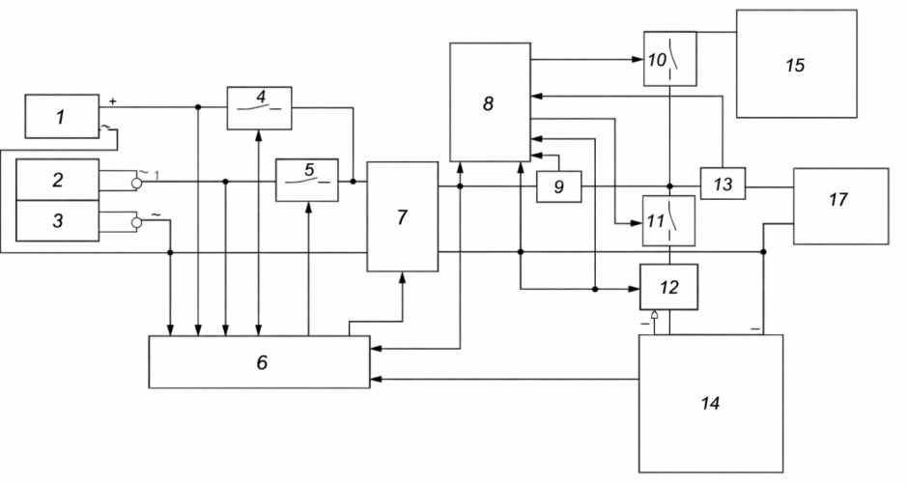
FIGURE 1. Block diagram of a combined energy device consisting of a solar photovoltaic plant and a microhydroelectric power plant: 1-solar power plant, 2-microhydroelectric power plant, 3-rectifier, 4 and 5-controlled switches, 6-first control device, 7-boost converter, 8-second control device, 9 – current measuring device, 10 and 11 - controlled switches, 12 and 13 - a device for measuring current, 14 - battery, 15 - ballast load, 16 - inverter and 17 – load.

The power plant works as follows. Electricity will be produced by solar photovoltaic power plant (solar energy) and microhydroelectric power plant 2 (water flow energy). Rectifier 3 adjusts the voltage of the micro-hydroelectric power station to constant. The first control unit 6 measures voltages and generates pulses, the duration of which is determined by their magnitude. These pulses are supplied to switches 4 and 5, which operate alternately, and to boost converter 7, which does not operate sequentially. As a result, the boost converter receives energy from sources through open switches and generates a stable voltage at its output.
RESULTS AND DISCUSSION
MATLAB software was used to calculate the energy efficiency of the combined device. Let us connect in parallel a solar photovoltaic installation and a micro-hydroelectric power station (See Fig. 2). In the model, the solar PV system operates from the first controllable voltage source (orange), and the microhydroelectric power plant operates from the second controllable voltage source (blue). Their control inputs are provided after the signals from Signal Builder 1 and Signal Builder 2 are converted to electrical voltages using MATLAB Function 1 and MATLAB Function 2 blocks.
The output of renewable energy sources depends on solar radiation and water flow. Taking into account the change in these quantities over time, the controlled voltage sources in the model include internal resistances (resistor VR1 in orange and resistor VR2 in blue). The values of internal resistances depend on the voltages E1 and E2 of the sources, which are transferred to resistance values using MATLAB Function 3 and MATLAB Function 4 blocks. In addition, diodes (D1 and D2) are connected in series to each source, protecting them from switching to consumer mode.
The red resistor R1 is used as the main load and the green resistor R2 is used as the ballast load.
The operating period of the model is set to 12 seconds, which allows us to simulate the 12-hour operating mode of a real device.

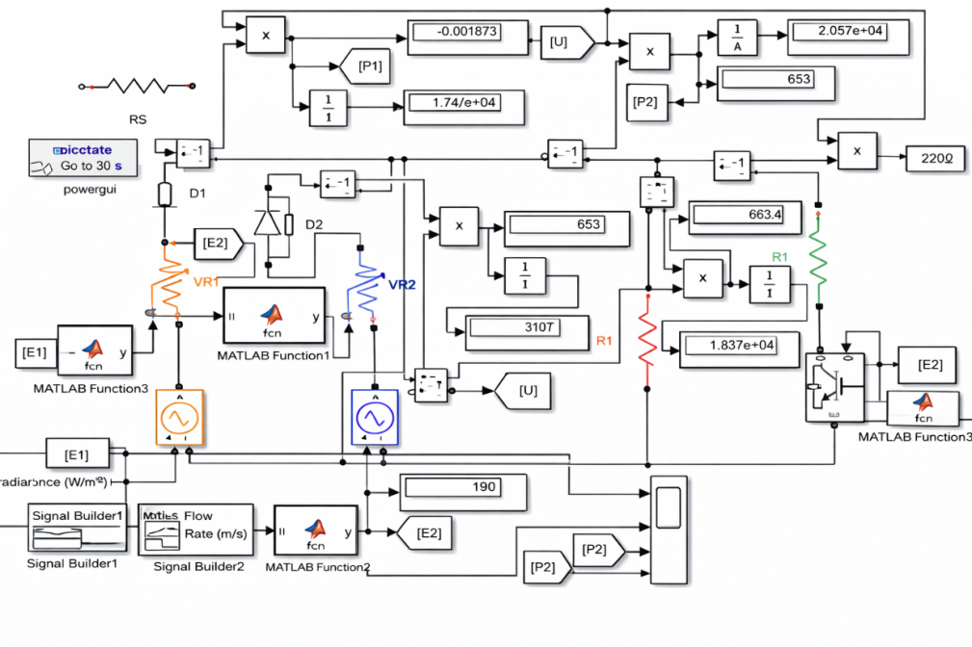
FIGURE 2. Diagram of parallel connection of solar photovoltaic station and micro-hydroelectric power station
The model in Figure 2 is activated and the energy is measured using meters. The solar power plant produced 17,470 J of energy, and the microhydroelectric power plant produced 3,107 J.
$E= E_{1}+ E_{2}=17470+3107=20577 J$ (1)
We will see the operating status of the solar station. In this case, resistor R3 with a high resistance is connected to the second micro-hydroelectric power source in series (See Fig. 3).

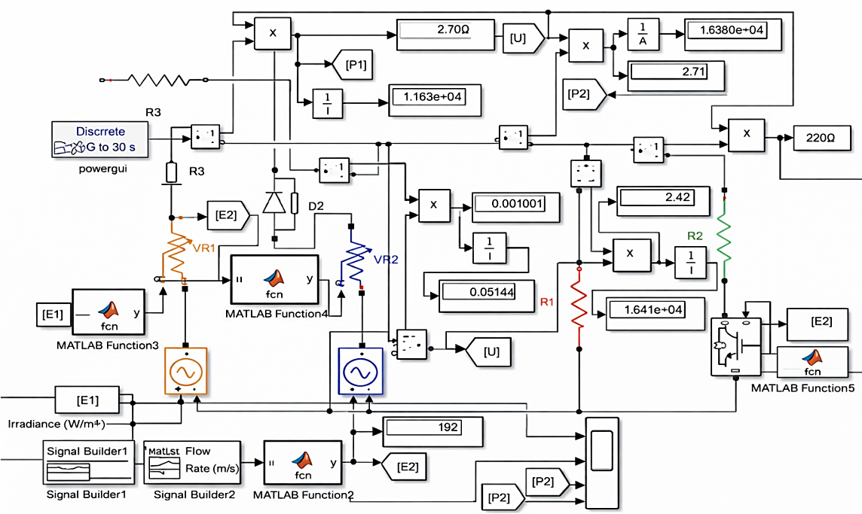
FIGURE 3. Diagram of a solar power plant in working order

During operation of the solar power plant, the microhydroelectric power plant produced 18380 J and zero energy.
$$E_{I}= E_{1}+ E_{2}=18380+0=18380 J$$
Let's see how micro-hydroelectric power station works. Resistor R3 with a high resistance is connected in series to the first controlled source of the solar installation (see Fig. 4).

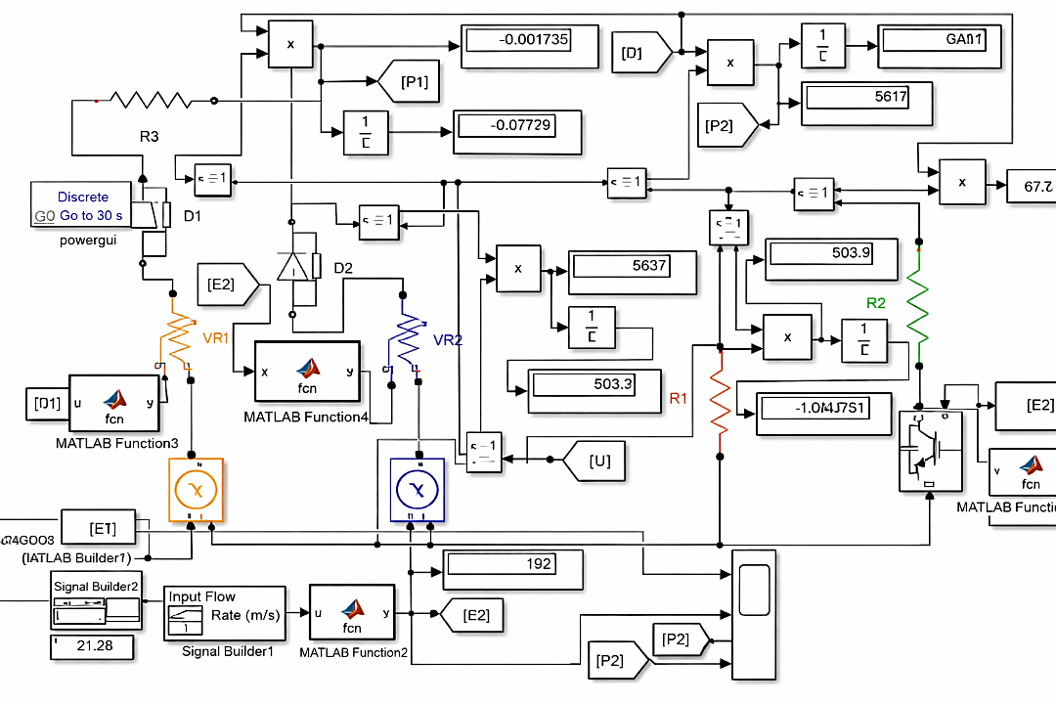
FIGURE 4. Diagram of micro-hydroelectric power station in working condition

When the micro hydro power plant was operating, the solar power plant produced zero cost and the micro hydro power plant produced 5637 J of energy.
$$E_{II}= E_{1}+ E_{2}=0+5637=5637 J$$
We analyze three cases. In the first case, when two sources were connected in parallel, the generated electricity was 20577 J. In the second and third cases, when each source worked separately, the electricity generated was as follows.
$E_{III}= E_{I}+ E_{II}=18380+5637=24017 J$ (2)
When connecting sources in parallel, energy losses occur, i.e.
$ΔE=E_{III}-E=24017-20577=3440 J$ (3)
will be equal.
In our proposed structural diagram of a combined energy system, when solar panels and microhydroelectric power plants are alternately connected, no energy losses occur.
Let's determine energy efficiency from the following expression:
$$η_{1}^{*}=\frac{ΔE}{E_{III}}=\frac{3440}{24017}=0.1435$$
The developed combined unit contains a boost converter and has energy losses. The efficiency of the boost converter is $η_{O‘}=0.98$.
$η_{1}=η_{O‘}∙η_{1}^{*}=0.98∙0.1435=0.14$ (4)
Or if you calculate it as a percentage, the energy efficiency of the combined energy device was 14%.
We calculate the energy efficiency of a power system by collecting the energy produced by the combined energy complex in a battery and regularly monitoring the load power and directing the excess to the ballast load. To do this, disconnect the ballast resistor R3 from the circuit shown in Fig. 5.
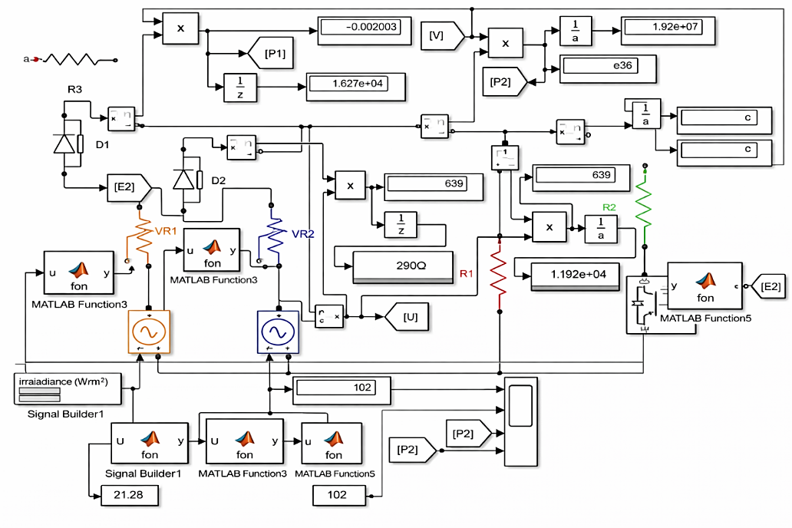
FIGURE 5. The case of operation of two sources without ballast resistance

According to the diagram in Fig. 5, when operating without ballast resistance, the solar photovoltaic installation generated 16270 J of energy, and the microhydroelectric power station generated 2930 J of energy.
$E_{I}= E_{1}+ E_{2}=16270+2930=19200 J$ (5)
When using a solar photovoltaic system and a micro-hydroelectric power plant, a parallel connection scheme
$E_{II}= E_{1}+ E_{2}=17470+3107=20577 J$ (6)
energy was produced (see Figure 5).
Additionally, by regularly monitoring power and directing excess power to the ballast load.
$ΔE=E_{II}-E_{I}=20577-19200=1377 J$ (7)
energy is obtained.
The energy efficiency of the power system by collecting the energy generated by the combined energy device in the battery and regularly monitoring the load power and directing the excess to the ballast load is as follows:
$$η_{2}=\frac{ΔE}{E_{II}}=\frac{1377}{20577}=0.067$$
or 6.7% as a percentage.
CONCLUSION
When two or more renewable energy sources are connected in parallel, the energy efficiency of the combined unit is reduced. In order to increase the energy efficiency of this device, a scheme for alternating connection of a microhydroelectric power station and a solar panel was proposed. The parallel connection diagram of solar photovoltaic plant and micro-hydroelectric power plant was created using MATLAB program. In the developed model, when connecting sources in parallel, energy losses amounted to 3440 J. When connecting sources alternately over time, no energy losses occur, but its energy efficiency increases by 14%.
When the ballast resistor was disconnected from the combined power system circuit, the solar photovoltaic plant generated 16,270 J, the micro-hydro plant produced 2,930 J, for a total of 19,200 J. An additional 1,377 J of energy was achieved by regularly monitoring the power and directing the excess to the ballast load.
By collecting the energy generated by the combined energy complex in a battery and regularly monitoring the power supplied to the load and directing the excess to the ballast load, the energy efficiency of the power system is increased by 6.7%.
REFERENCES
- Jaiswal, K. K., Chowdhury, C. R., Yadav, D., Verma, R., Dutta, S., Jaiswal, K. S., SangmeshB, N., & Karuppasamy, K. S. K. (2022). Renewable and sustainable clean energy development and impact on social, economic, and environmental health. Energy Nexus, 7, 100118. https://doi.org/10.1016/j.nexus.2022.100118
- Virah-Sawmy, D., & Sturmberg, B. (2024). Socio-economic and environmental impacts of renewable energy deployments: A review. Renewable and Sustainable Energy Reviews, 207, 114956. https://doi.org/10.1016/j.rser.2024.114956
- Yuan, X., Su, C., Umar, M., Shao, X., & Lobonţ, O. (2022). The race to zero emissions: Can renewable energy be the path to carbon neutrality? Journal of Environmental Management, 308, 114648. https://doi.org/10.1016/j.jenvman.2022.114648
- Silinto, B. F., Van Der Laag Yamu, C., Zuidema, C., & Faaij, A. P. (2024). Hybrid renewable energy systems for rural electrification in developing countries: A review on energy system models and spatial explicit modelling tools. Renewable and Sustainable Energy Reviews, 207, 114916. https://doi.org/10.1016/j.rser.2024.114916
- Javed, M. S., Song, A., & Ma, T. (2019). Techno-economic assessment of a stand-alone hybrid solar-wind-battery system for a remote island using genetic algorithm. Energy, 176, 704–717. https://doi.org/10.1016/j.energy.2019.03.131
- Chen, C., Liu, H., Xiao, Y., Zhu, F., Ding, L., & Yang, F. (2022). Power generation scheduling for a Hydro-Wind-Solar Hybrid System: A Systematic Survey and Prospect. Energies, 15(22), 8747. https://doi.org/10.3390/en15228747
- Kanoğlu, M., Çengel, Y. A., & Cimbala, J. M. (2020). Fundamentals and applications of renewable energy. McGraw-Hill Education.
- Dostonbek Yusufjonov (2024). Development of an experimental sample of Archimedes screw turbine designed for low pressure. Research Focus International Scientific Journal. (2025, June 16). https://refocus.uz/
- Kuchkarov, A. A., & Urishev, O. M. (2024, June). Methodology of technical and economic justification of micro HPP based on the study of the population demand for electricity. Journal of Engineering and Technology (JET), 14(1), 33–44.
- Yu, M., & Halog, A. (2015). Solar Photovoltaic development in Australia—A Life cycle Sustainability Assessment study. Sustainability, 7(2), 1213–1247. https://doi.org/10.3390/su7021213
- Zakhidov, R. A., Tajiyev, U. A., Kiseleva, E. I., Yusupov, D. T., Yusupov, D. T., Saliev, G. S., & Gorobtsov, S. I. (2022). On the Possibility of Sustainable Energy and Water Supply of Low-Rise Residential Buildings Located in Areas with an Arid Climate using Combined Wind and Solar Photovoltaic Power Complexes of Low Power. Applied Solar Energy, 58(1), 159–164. https://doi.org/10.3103/s0003701x22010200
- Hutasuhut, A. A., Rimbawati, N., Riandra, J., & Irwanto, M. (2022). Analysis of hybrid power plant scheduling system diesel/photovoltaic/microhydro in remote area. Journal of Physics Conference Series, 2193(1), 012024. https://doi.org/10.1088/1742-6596/2193/1/012024
- Simarmata, R., Bukit, F., & Fahmi, F. (2024). Design and economic analysis of integrated power systems with solar cell-diesel-battery-micro hydro off-grid (a case study of pinal village samosir district). E3S Web of Conferences, 519, 02007. https://doi.org/10.1051/e3sconf/202451902007
- Ahmad, N., Rehman, J. U., Shahzad, H. K., & Kamran, H. (2024). Sustainable Green Irrigation: A Comparative Economic and Environment Analysis of Solar VS Micro-Hydroelectric Tube Wells. Journal of Asian Development Studies, 13(3), 346–359. https://doi.org/10.62345/jads.2024.13.3.28

