Methodology of Correcting Defects in the Technology of Obtaining Rolling Sheet and Belted Materials with High Quality Indicators
Tirkash Turaev^{a)}, Bahrom Madaminov, Akmal Gafurov, Talibjan Sabirjanov, Ruzikhuja Ulugkhojaev, Sharifjon Raximov
Fergana State Technical University, Fergana, Uzbekistan

^{a)}Corresponding author: tirkash.turayev@fstu.uz
Abstract. A methodology for correcting defects in the production of rolled steel sheets and tapes is proposed. A new method based on plastic deformation of the rolled surface of the material with the integration of steel and glass balls was used to eliminate defects. They were designed to apply regular rifle relief to the surface of the rolled product. At the same time, cracks, hairlines, captivity and others were smoothed out. An increase in the microhardness of the surface layer of steel material using heat treatment at low temperatures is also considered. The machining is carried out on a vertical milling machine with a cantilever table, and tools such as a knurler with a steel and glass ball head are fixed to the spindle. Materials used for processing are steel grade SHX15 and glass balls with the addition of titanium. The technology improves the quality of steel surfaces by eliminating defects in shape and surface.
Keywords: method, defect, steel, sheet, belt, knurling, screw, ball, heat treatment, glass, crack, rupture, stresses, hairlines, on - and– decarburization.
INTRODUCTION
When rolling sheet and belt materials made of steel st.5с. (calm) the state All-Union standard (GOST) 380 ( $\frac{ВхН-h11 GOST 19903-74}{steel st.5 с-В-Т GOST 380}$). Foreign analogues of the steel 5c grade: 1005, G10050, G10060 – USA; 11300, 11301 – Czech Republic; UC6 – Austria; CA4 – Australia; 1.0314, Ck5, D5-2, D6-2, DG-2 – Germany; SWRM6 – Japan, refers to branded steels and alloys.

TABLE 1. The chemical composition of steel grade st.5c is given in

Mass fraction of the main chemical elements, %
C - carbon | Mn - manganese | Si - silicon
0,28-0,37 | 0,50-0,80 | 0,15-0,30

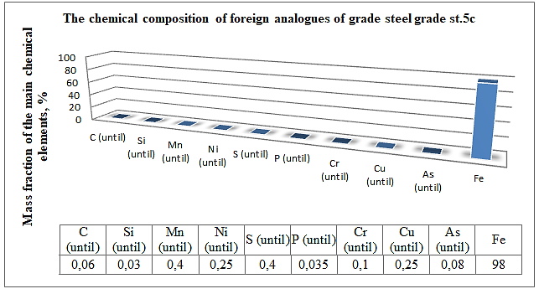
FIGURE 1. The chemical composition of foreign analogues of grade steel grade st.5c

TABLE 2. The temperature and technological properties of welding steel grade st.5с are presented in.

Temperature of critical points, °S
Ac₁ | Ac₃ |  | Ar₁ | Ar₃
730 | 825 |  | 690 | 815
Technological properties
Rolling |  | Rolling temperature, °S: beginning 1260, end 750. Sections up to 800 mm are cooled in air.
Weldability |  | Limited weldable. Welding methods: manual arc welding, automatic arc welding, electroslag welding. Heating and subsequent heat treatment are recommended. Contact (friction welding) welding without restrictions.
Machinability by cutting |  | In the hot-rolled state at HB 158 & σ_{в} = 640 МPa;  K_{v hard alloy} = 1,2; K_{v fast cut.}= 1,2
Phloken sensitivity |  | Not sensitive
A tendency to holiday fragility |  | Not inclined

Additional information about the material of vintage steel, st. 5c.
Heat treatment: Delivery status
Temperature, ⁰C. The beginning 1280, The end 850
Hardness of the material: HB 10 ⁻¹ = 111 - 131 МPа
Temperature of critical points: Ac₁ = 720 , Ac₃(Ac_{m}) = 880 , Ar₁ = 700
Weldability of the material: without restrictions: manual arc welding, argon arc welding under flux and gas protection, Contact spot welding, argon arc welding, friction.

TABLE 3. Mechanical properties of steel st. 5c

Rolling | Size | σ_{в}(МPа) | δ₅ (%)
Hot rolled sheet | 4 | 255-370 | 27-30
Cold rolled sheet | 4 | 255-370 | 30-34

During the rolling process at the procurement operation, a stress concentration occurs between the fiber and the sheet or belt material under pressure and it causes various kinds of defects.

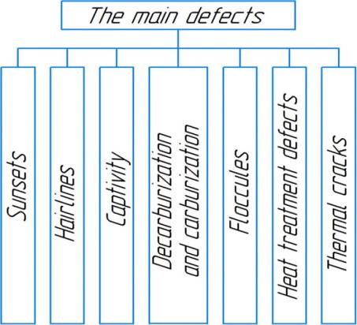
FIGURE 2. The main defects are the technology of obtaining rolled sheets and belts:

They appear in appearance as: internal and surface cracks, as well as ruptures. The reason is that during rolling, significant stresses appear in the metal during deformation. Hairline tears can occur, which can lead to tensile internal stresses and lead to metal cracks in areas weakened by ingot defects, and sometimes to the destruction of areas that have not been affected. Further, during rolling, the metal is subjected to multiple heating and cooling, which leads to thermal stresses that contribute to the formation of internal tears and cracks. The main defects of the rolling technology are manifested in the form of a hairline - this is the result of deformation of gas bubbles and small metal inclusions, in the second column of FIG. 1. under the name of the hairline. It has the appearance of straight thin lines ranging in length from fractions of a millimeter to several centimeters.
Further, delaminations are defects in the violation of the internal non-continuity of orientation in the direction of the fiber (FIG. 1, in the first and third graphs), occurs during pressure treatment of the ingot, which had looseness and shrinkage shells, and even when rolling the sheet, flattening large non-metallic inclusions and gas bubbles.
Sunsets are defects in the form of burrs with a depth of more than 1 mm, rolled up diametrically opposite to the direction that occurs when there is an excess of metal in the rolls (calibers).
Captivity - occurs when rolling out splashes of liquid steel, which have frozen on the surface of the ingot and rolled out during rolling in the form of films detached from the surface.
Floccules are defects that manifest themselves in very thin, sinuous cracks, which are spots on the fracture with a characteristic silver-colored surface [1-3].
Thermal cracks are defects that occur due to sudden heating or cooling. Then stresses appear in the metal from the temperature difference along the cross section, as well as structural stresses, structural transformations along the section of the part occur simultaneously. And as a result of the imposition of thermal stresses on structural ones, quenching cracks of various sizes and orientations can begin in the quenched part. Cracks can begin on the surface and spread deep into it, also occur inside the part in its core and spread laterally.
Heat treatment defects are defects that occur during heat treatment due to non-compliance with the holding time, temperatures, cooling and heating speed of the part. It consists in burning, which causes the formation of coarse grains and melting of grain boundaries. And also in overheating, which leads to the formation of a coarse-grained structure of oxide and sulfide precipitates along the grain boundaries [4-8].
Decarburization is the essence of the defect, in that it leads to the formation of cracks. The defect is more dangerous for steels with a high carbon content (C > 0.5). When steel products are heated in an environment containing excess water vapor, carbon dioxide or hydrogen. At the same time, carbon will burn out in the outer layers. This reduces the strength of the rolled steel material. Due to tensile stresses caused by the fact that low-carbon martensite with a smaller volume is formed in the decarbonized layer during quenching than in the core.
Carburization - will be observed when products are heated in an environment with an excessive content of carbon monoxide. This will lead to saturation of the surface "layers" with carbon, which in turn will increase brittleness and tendency to cracking.
The formation of cracks will lead to saturation of the surface layer of rolled steel with hydrogen under the action of alkalis, acids and special solutions during electrochemical processing and etching. Saturation of the upper layer with hydrogen reduces plasticity and leads to damage, which begins with microcracks, on the surface of the part.
The presence of hydrogen in the contact zone of the ball (deforming tool) from the surface (deformable part) forms oxides and the combination of oxygen in the air: The chemical formula of the carburization process of rolled metal is written as [5]:
$\begin{matrix}WО3 + 3Н2 → W + 3Н2О; \\ T_{i2}O_{3} +3Н2 → 2դ +3Н2О; \\ O_{2}→ 2Н_{2}→2Н2O\end{matrix}$ (1)
The introduction of hydrogen from the technological medium into the deformation zone, as well as into the shear zone of the molecular structure, causes dislocation of atoms of crystal lattices. The dislocation of the latter reduces defects such as thermal cracks, and hairlines on the surface and subsurface layers improves quality indicators, due to the formation of regularization of the relief with a ball deforming tool.
EXPERIMENTAL METHODOLOGY
The formed defects after rolling are successfully eliminated by integration treatment of surface plastic deformations (SPD) with steel balls – heat treatment - and subsequent caricature with glass balls. SPD with a steel ball and caricature with a glass ball on the same tool head with successive replacement of balls.
A schematic diagram of the installation for conducting an experimental study is presented (see Fig. 2).

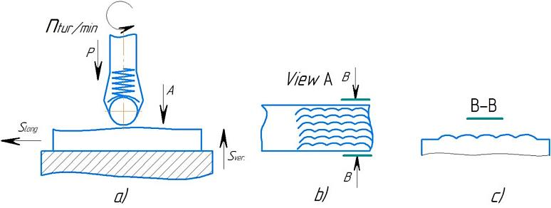
FIGURE 3. Schematic diagram of the experimental setup: a) the schematic diagram of the installation; b) the type of regular relief according to the arrow "A"; c) the profile of the regular relief according to the section "B-B".

Experimental installation scheme (Fig.2). For applying regular relief to the surface of rolled sheets or belts, it is schematically placed on a vertical milling machine, with a cantilever table arrangement. The equation of the kinematic balance of a ball deforming tool and a table with a rolled sheet (belt) material for applying a regular microrelief is generally written as:
1 is the rotation of the forming spiral regular relief ↔ by 1 is the step of the spiral regular relief in the directions of movement of the table.
The kinematic relationship of the two final (executive) links is established taking into account the obtained parameter of the regular helical relief, the rolled steel grade, and the technical requirements.
RESULTS AND DISCUSSION
The amount of roughness and the nature of the microrelief are one of the main characteristics of the surface layer, which have a significant impact on the level of technological stress concentration on the surface of rolled sheet and belts (belts) of steel material. Individual defects, in the form of hairlines, sunsets, captivity, vials, thermal cracks, especially transverse risks on the surface of rolled products, appear to be the origin of fatigue cracks. Defects after rolling were eliminated by regular helical microrelief applied with a ball deforming tool. The latter is mounted on a tool head mounted on a vertical milling machine spindle to console table arrangements. The profilogram and surface roughness parameters taken on an electronic digital device of the ROTE 1001 model shown in Fig. 3 and in Table 5 showed that the lowest numerical value of roughness according to parameter Ra was obtained on the surface of the rolled material (Fig.3, a) after processing on a rolling mill in hot form. Then, it is processed with a blade tool (a milling cutter on a milling machine) to a roughness of Ra = 5-125 microns (Fig.3, b). Next, the surface was rolled with a steel ball to form a regular helical relief, the microhardness of this surface was reached HV 49-53, Ra =2.5 - 0.32 and lower (Fig.3, c). In order to increase the microhardness and relieve internal stress, the material was heat treated. The view of the warped layer after removal by the device is Ra = 10 - 5 microns (Fig. 3. d). The view of the helical relief is shown (Fig. 3. e), the microhardness of which was reached after caricature HV 61-63 [1, 4].

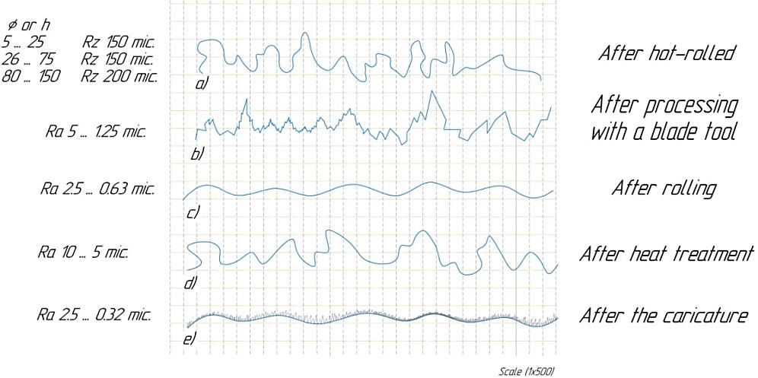
FIGURE 5. Profilogram of the surface layer of the rolled sheet according to the processing sequence: a) – roughness after rolling; b) - roughness after blade and tool; c) – rolling with ball deforming tools; d) – roughness after heat treatment (annealing - quenching – tempering or normalization); e) roughness after caricature with glass balls.

TABLE 5. Roughness parameters of the surface layer of rolled steel

Processing method | R_{a}, microns
Work piece (After hot-rolled) | R_{z} 150  R_{z} 150  R_{z} 200
After processing with a blade tool | R_{a} 5-1,25
After rolling | R_{a} 2,5-0,63
After heat treatment | R_{a} 10-5
After the caricature | R_{a} 2,5-0,32

The Ra value decreased from 0.32 to 0.33 microns. The deterioration of the Ra value when caricaturing by 0.01 microns compared to rolling is that when caricaturing there are no deep risks, and not looking at this surface gloss is achieved to a glossy level.
CONCLUSION
This study investigated the technological defects that occur during the rolling of st.5c (calm) steel sheets and belts, as well as methods for their elimination. The results showed that stress concentrations arise between fibers and sheets under pressure during rolling, leading to various defects such as internal and surface cracks, delaminations, “sunset” burrs, flocculations, thermal cracks, and carburization-related cracks. These defects reduce the mechanical properties of the steel and can initiate fatigue and failure in the material.
To mitigate these defects and improve surface quality, surface plastic deformation (SPD) using steel and glass balls was found to be effective. Application of a regular helical microrelief with a ball deforming tool significantly reduced technological stress concentrations on the material surface. Hot-rolled steel surface hardness increased to HV 49–53 after rolling with the ball tool, and further rose to HV 61–63 after the caricature process. Profilometry results and Ra parameters showed that surface roughness could be reduced to 0.32–2.5 microns.
In conclusion, the combined approach of applying a regular spiral microrelief with a ball deforming tool, followed by heat treatment and caricature, provides an optimal solution for eliminating technological defects in st.5c steel sheets and belts. This method enhances the mechanical properties, reduces surface stress concentration, and extends the service life of the rolled steel material.

REFERENCES
- Nozhnitskiy, Y. A., Fishgoit, A. V., Tkachenko, R. I., & Teplova, S. V. (2006). Development and application of new methods for strengthening gas turbine engine parts based on surface plastic deformation (review). Vestnik Dvigatelestroeniya, (2), 8–16.
- Petukhov, A.N. (1993). Fatigue resistance of gas turbine engine parts. Moscow: Mashinostroenie, 240 pp.
- Shneider, Y.G. (1982). Operational properties of parts with regular microrelief. Leningrad: Mashinostroenie.
- Turaev, T., Ulugkhozhaev, R. S., & Madaminov, B. M. (2024). Technological features hardening of the case of the roller track of the transport machine by ball knurling tool and cartooning with microballs. Library Progress International, *44*(3), 7709–7719.
- Teshaboyev, A., Rubidinov, S., Tursunov, S., & Madaminov, B. (2023b). Processing of cutting parts of agricultural machinery. E3S Web of Conferences, 462, 01034. https://doi.org/10.1051/e3sconf/202346201034
- Khudainazarov, S., Mavlanov, T., Umarova, F., Sabirjanov, T., & Ulugova, M. (2023). Evaluation of the dynamic characteristics of complex multiply connected, structurally inhomogeneous systems. E3S Web of Conferences, 365, 03035. https://doi.org/10.1051/e3sconf/202336503035
- Fayzimatov, S., & Tojiyev, B. (2023). Determination of device construction design and parameters for copper wire extending methods. E3S Web of Conferences, 460, 10009. https://doi.org/10.1051/e3sconf/202346010009
- Fayzimatov, S., & Abdullaev, B. (2023). Ensure the quality of the surface layer of parts in high-speed end milling of hardened steels. E3S Web of Conferences, 383, 04067. https://doi.org/10.1051/e3sconf/202338304067

