Clogging of the Wells by Salts and Corrosion Products
Anvar Juraev^{a)}, Abror Gadayev, Dilnora Ganiyeva, Sevara Usanova

Samarkand State Architectural and Construction University, Samarkand, Uzbekistan

^{a)}Corresponding author: barnoshka4675@icloud.com

Abstract. The decline in well productivity occurs due to the clogging of water inflow pathways by complex composite and cement-like structures called colmatants, formed by the combination of salts, corrosion elements from the metal equipment, and the small sand particles carried by water. Additionally, the stable operation of wells is often disrupted by irregular functioning of water-lifting devices (pumps), unexpected power outages, clogging of water pathways in the layers forming the filter and pre-filter zones, resulting in a decrease in filtration coefficient, deterioration of water quality, and localized or widespread drops in water levels. These issues create significant problems in regions that rely on groundwater resources. This article is dedicated to addressing this problem.

Keywords: Groundwater, well, productivity, colmatation, filter, solid particles, clay particles, layer, water resources.
INTRODUCTION
In the context of the Republic of Uzbekistan, the uneven distribution and limited availability of water resources have led to severe shortages of potable water resources. The state of groundwater is influenced by climatic factors such as air temperature, atmospheric precipitation, and the duration of high-temperature periods, which cause glacier melting and rising river water levels. These changes affect the operation of water abstraction wells and the overall performance of water supply systems. In Uzbekistan, 81–83% of water supply systems rely on groundwater resources. Currently, more than 48,000 artesian wells are in use across the country, and 10–12% of them are not operating at their designed efficiency levels annually. Introducing advanced technologies to enhance the efficiency of artesian wells, which serve as water extraction facilities from underground sources, is undoubtedly essential.
METHODS
In scientific studies, the colmatant, which significantly impacts well efficiency, is recognized as having a complex composition and unique structural properties. For research purposes, we classify it as solid particles. The movement of such particles is subject to certain limits, gradually creating problematic conditions. Suspensions of solid particles pass through the pores into the filter, a process that leads to the formation of colmatation around artesian wells.
The hydrostatic pressure of a well at a specific depth exceeds the pressure of the fluid filling the drilled layer. As a result, water begins to filter through the well. This process causes clay particles to settle and form a clay layer within the well. A similar phenomenon occurs during cementation, which leads to the closure of existing openings in the well.
The resulting filter and clay layers are porous and permeable. However, their porosity and permeability generally depend on the pressure drop across the layer, as these layers are usually compressible. If the size of the particles is smaller than the average pore thickness of the surface where the filter is applied, some of these particles penetrate the internal environment.
Mathematically, the sedimentation process of these particles can be described as follows: The total volume V_{J} of a homogeneous mixture (suspension) is equal to the sum of the volumes of the liquid and solid particles, V_{t}​. Thus, the fraction of the layer occupied by solid particles can be expressed by the following equation: (1).
$f_{T}=\frac{V_{T}}{V_{T}+V_{J}} , (1)$
Due to filtration and sedimentation of particles, V_{t} decreases over time by the amount of dt and dVt, let's assume that the composition of the mixture (suspension) V_{J} does not change dV_{J}, then the value of F_{t} remains constant, that is, we get the following expression.
$dV_{T.}=\frac{f_{T}}{1+f_{T}}dV_{J}, (2)$
During filtration, solid particles accumulate in the pores of the filter or on its outer surface in the form of a shell. We denote the area elements in which the deposition of solid particles occurs by δA and by dX_{K}, and we determine the increase in the thickness of the layer of these particles over time by dT. If the particles are deposited inside the filter, they can occupy only a part m of the layer δAdX_{K}, where m is the porosity of the filter medium. In this part of the layer, they form a pore (structure), the porosity of which is denoted by μk. The resulting particles are all equal to the following, i.e.
$dVT.=m\left(1-m_{k}.\right)δAdX_{K} , (3)$
The fluid flows through the area δA in a certain time dt. Denoting the normal component of the fluid flow over the area δA by V_{n}, we obtain the following expression:
$$dVj=-υ_{n} δAdX_{K}, (4)$$
The expression is given a minus sign because the fluid estimated from the area δA is assumed to be directed towards the outside. From equations (3), (4) and (2), we obtain an equation for the growth rate of the shell thickness.
$$\frac{dX_{k}}{d_{T}}=-\frac{f_{T}}{m\left(1-m_{k}.\right)\left(1-f_{T}\right)}υ_{n}, (5)$$
This is different from equation (5) in the corresponding equation in (2).
For a filter layer deposited on the outer surface of the filter, we obtain the same equation, where we must set m=1.
Multipliers
$$ω_{B}=\frac{f_{T}}{m(1-m_{k}.)(1-f_{T})} , (6)$$
$$ω_{H}=\frac{f_{T}}{(1-m_{k}.)(1-f_{T})} , (7)$$
They are called internal and external coefficients, respectively. Since the shell is always weakly compressed, the porosity of the shell changes with decreasing pressure, therefore the coefficients of subsidence are not constant values, if subsidence occurs at a constant pressure drop, then the coefficients ωB and ωH can be considered constant.
The settling of solid particles and the flow of liquids obey Darcy's law. In the outer shell, the permeability layer is K_{k}, and in the case of internal sedimentation, the permeability is less than the value. It can be approximately taken as mK_{k}. The compressibility of the layer, the permeability K_{k}. In the case of internal sedimentation, the permeability is less than this value.
It can be taken approximately equal to mKk. The compressibility of the Earth's crust also depends on the pressure drop due to its permeability K_{k}.

RESULTS AND DISCUSSION
To show how the above quantities can be measured and to reveal the microscopic properties of the described filtration process, we will consider a straight-line flow.
A suspension (mixture) is poured into a vertical cylindrical vessel with a permeable porous bottom (1). Let us assume that only external sedimentation occurs, in which case the filter and the filtered layer are not compressed. We write Darcy's law for this case.
$$q=-\frac{K_{K}A}{µ}\left(\frac{∂ρ}{∂x}-gρ\right), (8)$$
Where a is the bottom area p and m are the density and viscosity of the filter q is the estimated flow rate along the positive x axis of the filter The fluid moves downward, i.e. flows, as shown in Figure 1. An equation of the same form (with K instead of K_{k}) occurs at the bottom of the pore.

FIGURE 1. Scheme for studying the formation of the soil crust
1–air, 2–suspension (mixture), 3–filtration layer, 4–pore bottom, 5–filtrate
Since the fluid is considered incompressible, the continuity equation takes the form formula (9)
$$\frac{∂ρ}{∂x}=0. (9)$$
So everywhere
∂ρ∂x$\frac{∂^{2}ρ}{∂^{2}x}=0. (10)$
The boundary conditions for the situation are written as follows:

p=ax+b for - X_{K}<x<0

$p^{'}$=$a^{'}$x+$b^{'}$ for 0<x<L (11)

$$- K_{K}{(\frac{∂ρ}{∂x}-ρg)}_{x=0}=-K{(\frac{∂p^{'}}{∂x}-ρg)}_{x=0}$$

Here P_{v} is the air pressure above the suspension, h is the height of the layer column above the shell surface, and P_{C} is the suspension density.
Using these boundary conditions, we can determine the constants a, b, a¹ and b¹. As a result, we obtain the following expression, i.e.
$$p=-\frac{p_{B}+p_{c} gh+\left(1-\frac{K_{K}}{K}\right)pgL}{X_{K}+\frac{K_{K}}{K}L}x+b , (12)$$

Here, using (12), we find the following.
$$q=-\frac{K_{K}A}{µ}\left[\frac{p_{B}+p_{c} gh+pg\left(L+X_{K}\right)}{X_{K}+\frac{K_{K}}{K}L}\right] , (13)$$

From this equation and equation (5), taking into account that the beginning of the shell is at the point x=-x_{k}, we obtain the following expression:
$$\frac{dX_{K}}{dt}=\frac{K_{K}}{µ}\left[\frac{p_{B}+p_{c} gh+pg(L+X_{K})}{X_{K}+\frac{K_{K}}{K}L}\right]\frac{f_{T}}{(1-m_{k}.)(1-f_{T})} , (14)$$

h and f_{T} result in
$$h=h_{H}-X_{K}-\frac{Q}{A\left(1-f_{T}\right)} , (15)$$
$$h=\int_{0}^{t}{qdt} , (16)$$
Given the volume of liquid filtered over time T, the initial value of h_{H}, and the fact that Q=0 at t=0, integrating equation (5), we find the following.
$$Q=\frac{A(1-f_{T})(1-m_{k}.)}{f_{T}} X_{K} , (17)$$
We substitute Q from (17) into equation (15) and the resulting expression h into equation (14). Then we integrate equation (14) with the condition that P_{b}= const.
In this calculation, we usually calculate P_{b} as pressure. It is very good compared to pressure due to its own weight. We can determine that for large values ​​of P_{b}, and the equation is approximately correct.
$$\frac{{dx}_{K}}{dt}=\frac{X_{K}{ p}_{B} ω_{H}}{µ(X_{K}+\frac{K_{K}}{K}L)} , (18)$$
We obtain this equation at the time t=0 by integrating Xk=0.
$$x_{K}=-\frac{K_{K}}{K}L{\left[{\left(\frac{K_{K}}{K}L\right)}^{2}+\frac{{2K}_{K}{ p}_{B} ω_{H}}{µ}t\right]}^{\frac{1}{2}} , (19)$$
Given the values ​​of Q and X_{k}, we can simultaneously find t and then use equation (17) to find an expression for W_{H}.
$$ω_{H}=\frac{Q}{{AX}_{K}} , (20)$$
This value can be used to calculate K_{k}, knowing the values ​​of L, P_{b}, K, M, X_{k}, and T, using equation (19).
From this formula
$$K_{K}=\frac{X_{K}^{2} µK}{2({ p}_{B} K ω_{H} t-µX_{K} L)} , (21)$$
Note that the value of Q includes not only the volume of filtrate flowing through the bottom of the pore, but also the volume of filtrate that saturates the bottom. It is possible to saturate the bottom with filtrate before starting the process.
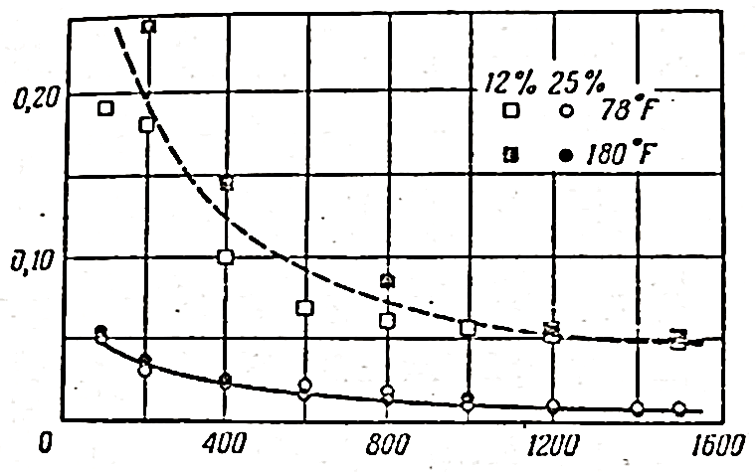
FIGURE 2. Permeability of the filter layer as a function of pressure drop for various bentonite cement slags (Binkley et al. 1958)
Along the axis of the abscess: pressure drop (pounds/gram m2=0.0703kg/cm2)
On the ordinate axis: permeability of the filtered layer, k (md)
For small values ​​of L, both values ​​X_{k} and Q increase proportionally (correspondingly) N_{t}. The dependence of these quantities on time is often repeated in the literature for large values ​​of time. Some of the results obtained using the described method are shown in Figures 2–3. These figures show graphs of the dependence of the values ​​of K_{k} and Wn, and W_{n} is the pressure difference for two cement suspensions (mixtures). One of the suspensions consists of water and 12% bentonite clay. The second contains 25% bentonite clay (clay). It can be seen from the graphs that, although the permeability of K_{k} varies significantly with changing pressure drop, the coefficient ω_{H} remains almost constant.
In the analysis and solution of sedimentation problems, the boundary condition between the filter layer and the suspension has the following form:
$$\frac{ds}{dt}=-ω_{H} vn , (22)$$
Here ds/dt is the velocity of the hill boundary in the direction perpendicular to the boundary, and V is the volume flow.
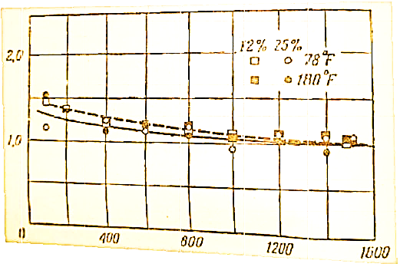
FIGURE 3. Dependence of the external coefficient of bentonite clay (sludge) cement suspensions (mixtures) of different compositions (Binkley et al. 1958).
On the abscissa axis: pressure drop (pounds/gram²) On the ordinate axis: sedimentation coefficient Wn. Filter along the boundary, N is the unit vector in the outer transverse direction of the boundary. Therefore, it is possible to advance the boundary of the filter layer shell of any shape.
CONCLUSION

1. The mathematical expressions for the settling of solid particles above represent the settling of the colmatant formed in the fluid as it moves around the well;
2. If the fluid movement in long-running wells and the parameters of its movement medium (density, porosity, velocity) are known, it is possible to determine the changes in the filtration medium around the well due to the sedimentation of solid particles;
3.If the level of clogging due to the deposition of solid particles in the pre-filter and filter areas of the well is determined, then it becomes possible to determine the change in flow rate and decrease in efficiency;
4.The importance of these theoretical conclusions makes it possible to construct a mathematical module for declogging technologies, which is the reverse process of solid particle deposition;
5.This, in turn, accelerates the removal of settled solids and makes it possible to use various chemical compounds in the treatment of wells.
REFERENCES
- A. N. Gadaev, A. Juraev, and G. Boboeva, Sustainable water resources management in Uzbekistan: Transboundary issues
- A. N. Gadaev and A. K. Juraev, “Sustainable groundwater using by water well rehabilitation,” in AIP Conference Proceedings 2432, 030032 (2022). https://doi.org/10.1063/5.0091870
- A. N. Gadayev, A. X. U. Jurayev, S. S. Saidov, and O. Kasimov, Issledovaniya po vosstanovleniyu debita vodozabornykh skvazhin v naturnykh usloviyakh, Universum: Tekhnicheskie nauki 10–2(91), 27–31 (2021).
- A. N. Gadaev and A. Zhuraev, “Use of chelators to restore the flow rate of water wells,” JournalNX, 526–529 (2020).
- A. Gadaev, I. Niyazov, A. Juraev, and N. Alibekova, “Water related environmental issues in Central Asia,” (2019), available at:
- A. Gadaev, A. Juraev, and S. Usanova, “Water wells: Sustainable usage and rehabilitation technology,” E3S Web of Conferences 417, 02017 (2023).
- G. Abror, G. Dilnora, J. Anvar, and U. Sevara, “Specificity of using a group of wells,” Universum: Tekhnicheskie nauki 7–4(112), 45–49 (2023).
- A. N. Gadayev and A. K. Jorayev, “Stabilization of vertical wells in rural areas and their effective use,” Journal of Engineering, Mechanics and Modern Architecture 2(5), 1–6 (2023). https://jemma.innovascience.uz/index.php/jemma/article/view/69

