Adsorption Isotherms of Ca²⁺ Ions onto an AK–M–KK-Based Hybrid Ion Exchanger

F.I. Ostonov^{a)}, A.Ya. Akramov

Bukhara State Technical University, Bukhara, Uzbekistan

^{a)}Corresponding author: firuzostonov916@gmail.com

Abstract: In this study, a hybrid ion exchanger based on acrylic acid, urea, and colloidal silica was synthesized. The infrared (IR) spectrum of the synthesized ion exchanger was recorded using a SHIMADZU spectrometer and analyzed to confirm its structural features. The sorption behavior of Ca²⁺ ions by the ion exchanger was investigated under static conditions at temperatures of 20, 30, and 40°C. Based on the obtained experimental data, the Freundlich and Langmuir sorption isotherm models were calculated and evaluated.
Keywords: sorption capacity, colloidal silica, Freundlich isotherm, Langmuir isotherm, acrylic acid, urea, sorbent.

INTRODUCTION

At present, ion exchangers possessing active ion-exchange properties, polymers capable of forming complexes with metal ions, and polymer matrices are well known in science. The main methods for synthesizing such materials include the polymerization, polycondensation, and copolymerization of monomers containing specific functional groups, as well as the preparation of various compositions involving organic (poly)oligomers and inorganic substances.
Ion exchangers synthesized based on synthetic polymers exhibit high selectivity and sorption capacity due to the high content of functional groups. However, the low mechanical strength and insufficient thermal stability of such ion exchangers limit their practical industrial applications. Therefore, researchers worldwide have focused on improving these properties by incorporating silicon-containing compounds into the structure of polymer ion exchangers, achieving significant progress in this direction.
The main reason for this improvement lies in the lower electronegativity of silicon (1,8) compared to that of carbon (2,5). As a result, silicon is capable of forming stronger bonds with highly electronegative elements than carbon, which enhances the mechanical strength and stability of the material. Overall, the development of adsorption materials based on this approach represents a new and rapidly advancing research direction. In many cases, silicon-containing polymers are used as matrices for the preparation of such sorbents [1].
Sorbents prepared from silicon-containing compounds are capable of sorbing metal ions through complex formation or ion-exchange mechanisms. This is due to the occurrence of donor–acceptor, electrostatic, hydrophobic, and other types of interactions between the sorbent and metal ions. Although silicon-containing compounds can be functionalized with organic moieties, many researchers prefer sorption materials in which covalent bonding is not involved. The main reasons for this preference are the multistep nature of the synthesis processes, the non-uniform distribution of functional groups, and the relatively low sorption performance of covalently bonded systems. During modification, the introduced substances interact with silicon-containing compounds mainly through non-covalent interactions such as donor–acceptor, electrostatic, and similar forces [2].
At the same time, adsorbents based on silica as a matrix have also been developed. In these materials, part of the polyhexamethyleneguanidine interacts with silanol groups, while another part forms complexes with metal ions. [3].
METHODS

A three-necked flask was mounted on a magnetic stirrer with a heating mantle. The flask was equipped with a reflux condenser, a thermometer, and a dropping funnel (Figure 1). Acrylic acid and urea, dissolved in distilled water, were added to the flask and heated at 60–70 ⁰C for 2–3 hours. During heating, colloidal silica was added dropwise. The resulting viscous mass was washed three times with distilled water to remove impurities. The purified product was then dried in an oven at 150–200 ⁰C.

.

FIGURE 1. Laboratory setup for the synthesis of the hybrid ion exchanger.

The infrared (IR) spectrum of the obtained product was recorded using a SHIMADZU spectrometer to identify the functional groups present (Figure 2).
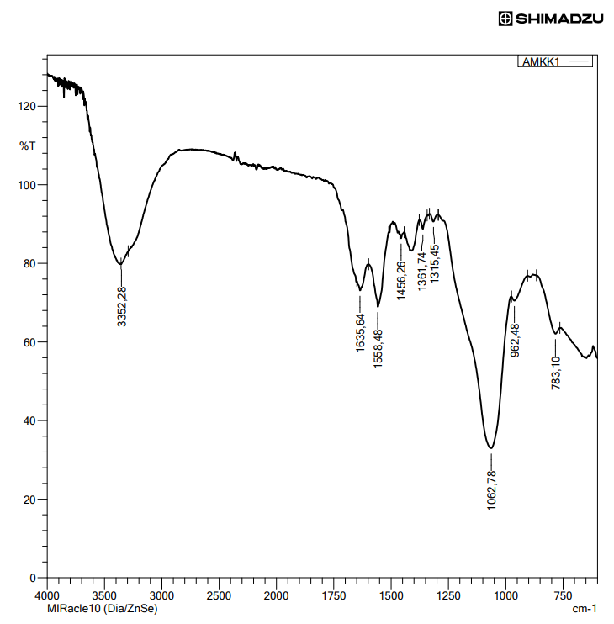

FIGURE 2. IR spectrum of the hybrid ion exchanger

To determine the sorption properties of the dried material, 1 g of the synthesized sample was weighed and placed into six flasks containing solutions with concentrations of 10, 30, 50, 100, 250, and 500 mg/L, which had been prepared in advance. The solutions were maintained in contact with the sorbent until equilibrium was reached. The same experiment was carried out at temperatures of 20, 30, and 40 °C, and the obtained data were used to calculate the sorption isotherms. The adsorption capacity of the ion exchanger was calculated using the formula A_{S} =$\frac{{(C}_{d}-C_{m})*V }{m_{i}}$ (where Cd- ​ is the initial concentration of ions in the solution, Cm -​ is the equilibrium concentration of ions, mi – is the mass of the ion exchanger, and V- is the volume of the solution).
The linear form of the Freundlich isotherm was used to calculate the sorption parameters according to the equation A= KF$∙$ Cm^{1/n} . The Langmuir isotherm was evaluated using the equation A=$\frac{{\text{A}}_{\text{max.}}\text{*}{\text{K}}_{\text{L}}\text{*}{\text{C}}_{\text{m}}}{\text{1+}{\text{K}}_{\text{L}}\text{*}{\text{C}}_{\text{m}}}$ . Graphical methods were employed to determine the constants of the Langmuir isotherm. For this purpose, the Langmuir equation was rearranged into the linear form $\frac{1}{A}$=$\frac{1}{{\text{K}}_{\text{L}}*{\text{A}}_{\text{max.}}}∙$ $\frac{1}{{\text{C}}_{\text{m}}}$ +$\frac{1}{{\text{A}}_{\text{max.}}}$. The separation factor RL ​ was calculated using the formula RL = $\frac{1}{1+C_{d}∙K_{L}}$ [4-6].
RESULTS

Analysis of the IR spectrum revealed that the broad absorption band at 3552,2 cm⁻¹ corresponds to the –OH group with medium intensity, indicating the preservation of hydroxyl groups in the silica gel obtained via the sol–gel method. The peak observed at 1635,64 cm⁻¹is attributed to physically adsorbed water within the ion exchanger. The band at 1558 cm⁻¹ corresponds to the N–H group characteristic of C=N amides, formed during the polycondensation reaction between acrylic acid and urea. The asymmetric stretching vibrations of the Si–O–Si framework are observed at 1062,78 cm⁻¹, confirming the formation of the siloxane network. The peak at 924 cm⁻¹ is associated with the Si–O–C bond, indicating the linkage between organic and inorganic components [7].

FIGURE 3. Freundlich isotherms of Ca²⁺ ions on the AK–M–KK ion exchanger at 20 °C.

FIGURE 4. Freundlich isotherms of Ca²⁺ ions on the AK–M–KK ion exchanger at 30 ⁰C.

Temperature | 1/n | K_{f} | R²
20 ⁰C | 0,1287 | 1,8348476 | 0,7018
30 ⁰C | 0,1561 | 1,432518 | 0,7888
40 ⁰C | 0,1485 | 2,112516 | 0,8578

FIGURE 5. Freundlich isotherms of Ca²⁺ ions on the AK–M–KK ion exchanger at 40 ⁰C.

FIGURE 6. Langmuir isotherms of Ca⁺² ions on the AK–M–KK ion exchanger at 20 ⁰C .

FIGURE 7. Langmuir isotherms of Ca⁺² ions on the AK–M–KK ion exchanger at 30 ⁰C .

FIGURE 8. Langmuir isotherms of Ca⁺² ions on the AK–M–KK ion exchanger at 40°C .

Temperature | A_{max} | K_{L} | R_{L} | R²
20 ⁰C | 3,828484 | 0,140174 | 0,124864 | 0,9856
30 ⁰C | 4,347826 | 0,12013 | 0,142725 | 0,9821
40 ⁰C | 4,770992 | 0,146697 | 0,119979 | 0,9809

CONCLUSION

When studying the Freundlich isotherms of the synthesized ion exchanger, it was observed that the values of 1/n at all three temperatures were less than 1. This indicates that the ion exchanger exhibits a high affinity for sorption of Ca⁺² ions. The minimum value of 1/n was observed at ⁰C, suggesting that sorption is most favorable at this temperature and that the surface is relatively homogeneous. As the temperature increases, the value of 1/n rises, indicating increased surface heterogeneity at higher temperatures.
The Freundlich constant K_{f} ​ reaches its maximum value of 2,11 at ⁰C, compared to other temperatures. This increase in K_{f} ​​ with temperature demonstrates that the sorption capacity of the sorbent improves at elevated temperatures. These observations suggest that the sorption of Ca⁺² ions on the synthesized ion exchanger is an endothermic process. Consequently, the sorption capacity of the ion exchanger increases with temperature.
The correlation coefficient R² at 40 ⁰C is 0,8578, which is higher than the values obtained at other temperatures. The high R² value indicates a strong relationship between the adsorption process and temperature, confirming that the adsorption of Ca²⁺ ions is more effective at 40 ⁰C.

Analysis of the results obtained from the Langmuir isotherm indicates that the maximum adsorption capacity A_{max} increases with rising temperature. This observation rules out the possibility of an exothermic process and confirms that the adsorption of Ca⁺² ions is endothermic. The increase in A_{max} at higher temperatures suggests that the ion exchanger is capable of binding more ions under these conditions.
In addition, the Langmuir constant K_{L} ​ also increases with temperature, indicating stronger interactions between the adsorbent and the adsorbate, which is consistent with an endothermic adsorption process. The separation factor R_{L} ​ was found to be in the range of 0,11–0,12, indicating highly favorable adsorption. At ⁰C, R_{L} ​ equals 0,1199, confirming that sorption is most effective at this temperature. The correlation coefficient R² for the Langmuir model is 0,98, demonstrating excellent agreement between the experimental data and the Langmuir model.
When comparing the R² values of the Freundlich and Langmuir isotherms, it is evident that the Langmuir model provides a better fit. This suggests that the adsorption of Ca⁺² ions on the ion exchanger follows the Langmuir model, indicating monolayer coverage, uniform active sites, and an ion-exchange mechanism.

REFERENCES

- Ayub A. et al. Development of sustainable magnetic chitosan biosorbent beads for kinetic remediation of arsenic contaminated water //International journal of biological macromolecules. – 2020. – Т. 163. – С. 603-617.
- Chung H. K. et al. Application of Langmuir and Freundlich isotherms to predict adsorbate removal efficiency or required amount of adsorbent //Journal of Industrial and Engineering Chemistry. – 2015. – Т. 28. – С. 241-246.
- Ragadhita R., Nandiyanto A. B. D. How to calculate adsorption isotherms of particles using two-parameter monolayer adsorption models and equations //Indonesian Journal of Science and Technology. – 2021. – Т. 6. – №. 1. – С. 205-234.
- Kurbanov F. P. et al. Investigation of the degree of inhibitor protection relative to conditions at different depths //AIP Conference Proceedings. – AIP Publishing LLC, 2025. – Т. 3304. – №. 1. – С. 040081.
- Niyozov E. et al. Investigation of physicochemical properties of guanidine-based corrosion inhibitor //E3S Web of Conferences. – EDP Sciences, 2024. – Т. 587. – С. 03004.
- Muattar X., Firuz O., Bobir O. Synthesis and properties of ionites with target properties //Universum: технические науки. – 2023. – №. 8-4 (113). – С. 28-31.
- Khollieva M., Zhumaeva M., Ostonov F. Synthesis of ionites based on N-vinylmorpholine and craton aldehyde //AIP Conference Proceedings. – AIP Publishing LLC, 2025. – Т. 3304. – №. 1. – С. 040066.

