Chromatographic–Mass Spectrometric Study of Heavy Hexane Used in the Polyethylene Production Process

Behruz Mansurov^{a)}, Ruslan Khaitov
Bukhara State Technical University, Bukhara, Uzbekistan

^{a)}Corresponding author: bexa130050693@gmail.com
Abstract. This study presents a chromatographic–mass spectrometric investigation of heavy hexane used in the polyethylene production process. The analysis revealed that the spent sample contains no residual original hexane, with the majority of the composition comprising high-molecular-weight hydrocarbons and their isomers. Oxidation products and other oxygen-containing compounds were not detected, indicating the stability of the hydrocarbon phase under the given operating conditions. Based on the obtained data, it was decided to purify the spent solvent using adsorption to isolate and preserve the high-paraffin hydrocarbons. The conducted study enables a more rational utilization of hydrocarbon fractions, enhancing the efficiency of processing and the cost-effectiveness of the polyethylene production process.
Keywords: heavy hexane, high-molecular-weight paraffinic hydrocarbons, gas chromatography–mass spectrometry, helium, retention time, adsorption, zeolite.

INTRODUCTION

In the technological scheme for the production of high-density polyethylene at SP LLC “Uz-Kor Gas Chemical,” the use of high-purity 98% hexane plays a crucial role. This hydrocarbon functions as an organic solvent necessary for the preparation of the catalyst system—facilitating its transport, dispersion, and transition into a suspension state. Due to its physicochemical properties, hexane ensures the stability of the reaction medium and promotes uniform polymerization processes [1].
However, as a result of repeated use and exposure to technological factors, the composition of the solvent undergoes significant changes. The spent hexane loses its original properties, transforming into a mixture of high-molecular-weight hydrocarbons and their isomers. These changes necessitate a detailed study of its component composition to determine the possibilities for further use or processing.
One of the most informative methods for analyzing the composition of such hydrocarbon systems is gas chromatography–mass spectrometry (GC–MS), which allows for the detailed identification of individual components and the determination of their nature. The obtained results can serve as a basis for selecting rational purification methods, in particular adsorption-based technologies aimed at isolating valuable high-paraffin compounds and minimizing waste [2–4].
Thus, the study of spent hexane using chromatographic–mass spectrometric analysis represents a relevant task that contributes to enhancing the efficiency and environmental sustainability of polyethylene production processes.

METHODS

The object of the study was spent hexane generated during the high-density polyethylene production process at SP LLC “Uz-Kor Gas Chemical.” The annual volume of this waste reaches approximately 90,000 tons, highlighting the relevance of analyzing and potentially recycling it.
To determine the individual component composition and assess the degree of solvent degradation, gas chromatography–mass spectrometry (GC–MS) was employed. Analysis was conducted using an Agilent 7890B/5977A GC–MS system (or an equivalent instrument, with the exact model specified if necessary). A capillary column with a non-polar stationary phase, HP-5MS type, 30 m in length, 0.25 mm internal diameter, and 0.25 μm film thickness, was used. Helium was employed as the carrier gas at a flow rate of 1.0 ml/min. The column temperature program ranged from 40°C (held for 3 min) to 280°C at a heating rate of 10°C/min. The injection volume was 1 μL, with the injector operated in split mode at a ratio of 1:20. Detection was carried out over a mass range of m/z = 20–550. Compound identification was performed using the NIST mass spectral library and by comparison with reference standards [5].

RESULTS AND DISCUSSION

The analysis results are presented as follows: the chromatogram is shown in Figure 1, while the qualitative and quantitative composition of the spent heavy hexane is summarized in Table 1, reflecting the changes in the chemical composition of the spent hexane. Particular attention was paid to the identification of high-molecular-weight hydrocarbons, their isomers, and potential products of thermal or catalytic transformation.
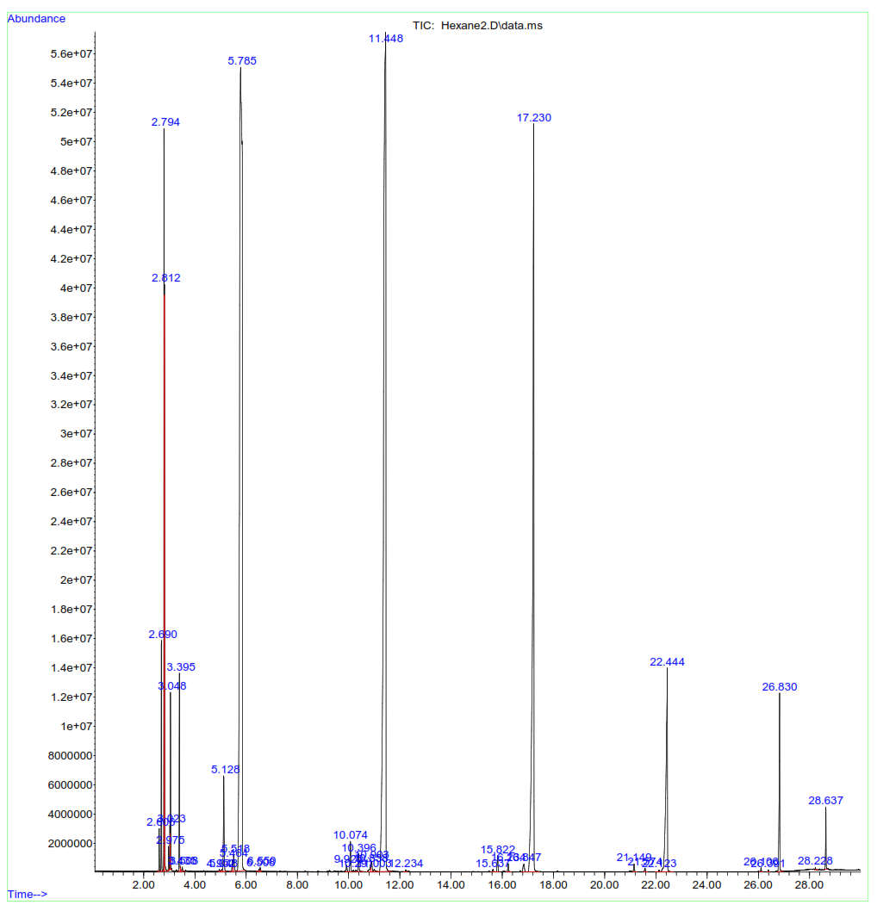
FIGURE 1. Chromatogram of spent heavy hexane
TABLE 1. Qualitative and quantitative composition of spent heavy hexane
№ | Component Name | Amount, %
1. | Pentane | 1,80
2. | 2-Ethyl oxetane | 8,02
3. | Cyclopentane | 1,82
4. | Cyclohexane | 1,54
5. | Hexane | 0,34
6. | Heptane | 1,08
7. | Octane | 31,67
8. | Nonane | 0,63
9. | 1-Decene | 0,04
10. | Decane | 30,65
11. | Undecane | 0,11
12. | 2,6-Dimethyl decane | 0,21
13. | Dodecane | 15,01
14. | Tridecane | 0,16
15. | Cyclotetradecane | 0,03
16. | Tetradecane | 4,65
17. | Pentadecane | 0,02
18. | Hexadecane | 1,73
19. | Heptadecane | 0,49
Total: |  | 100

Chromatographic–mass spectrometric analysis of the spent hexane used in the polyethylene production process revealed a complete absence of the original hexane (0.34%) and a predominance of high-molecular-weight hydrocarbons and their isomers. This indicates a substantial transformation of the hydrocarbon composition of the solvent as a result of repeated interaction with the catalyst system and the process media.
To isolate and concentrate the heavy paraffinic hydrocarbons from the spent solvent, adsorption purification was performed using CaA-type zeolite (5 Å). This adsorbent possesses a well-developed porous structure and high selectivity toward normal alkanes, making it effective for the separation of paraffinic hydrocarbons [6-8].
The experiments were carried out by passing 100–120 mL of the sample through 25–30 g of zeolite at a flow rate of 1 drop/sec. After the adsorbent became saturated, it was regenerated using ethanol. The paraffinic hydrocarbons were then extracted from the saturated zeolite by dissolving them in ethanol. Subsequently, the paraffinic hydrocarbons dissolved in ethanol were separated by washing the ethanol with warm purified water.
Results from a subsequent chromatographic–mass spectrometric analysis (Figure 2, Table 2) demonstrated that the composition of the analyzed sample had significantly changed following adsorption treatment.
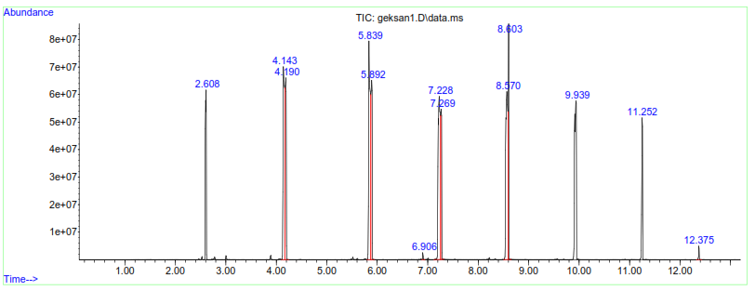
FIGURE 2. Chromatogram of paraffinic hydrocarbons isolated from spent heavy hexane
TABLE 2. Qualitative and quantitative composition of paraffinic hydrocarbons isolated from spent heavy hexane

№ | Component Name | Amount, %
1. | Hexane | 3,24
2. | Heptane | 3,28
3. | Octane | 11,36
4. | Nonane | 9,13
5. | Decane | 13,43
6. | Undecane | 8,45
7. | Dodecane | 13,11
8. | Tridecane | 5,57
9. | Tetradecane | 12,44
10. | Pentadecane | 5,01
11. | Hexadecane | 10,46
12. | Heptadecane | 4,52
Total: |  | 100

Thus, adsorption purification using CaA-type zeolite (5 Å) has demonstrated its effectiveness as a method for the selective isolation of paraffinic hydrocarbons from spent hexane. The obtained results confirm the feasibility of further utilizing the purified fraction as a valuable hydrocarbon feedstock and highlight the potential of adsorption-based methods for the regeneration and reuse of organic solvents in petrochemical processes.

CONCLUSION

Chromatographic–mass spectrometric analysis of the spent heavy hexane used in the high-density polyethylene production process revealed the absence of the original hexane and a predominance of high-molecular-weight hydrocarbons and their isomers. To isolate these compounds, adsorption purification was carried out using CaA-type zeolite (5 Å), which proved highly effective: the purified fraction contained paraffinic hydrocarbons ranging from C6 to C17. The results confirm the potential for the repeated use of hydrocarbon fractions and the appropriateness of applying adsorption-based methods in the processing of hexane-containing wastes.
REFERENCES
- Uz-KorGas Chemical LLC. Technological Regulations for High-Density Polyethylene Production. Karakalpakstan, 2022.
- Kurbanov F. P. et al. Investigation of the degree of inhibitor protection relative to conditions at different depths //AIP Conference Proceedings. – AIP Publishing LLC, 2025. – Т. 3304. – №. 1. – С. 040081.
- Niyozov E. et al. Investigation of physicochemical properties of guanidine-based corrosion inhibitor //E3S Web of Conferences. – EDP Sciences, 2024. – Т. 587. – С. 03004.
- Lurie, A.A. Gas Chromatography in the Analysis of Organic Compounds. Moscow: Khimiya, 1989. 432 pp.
- Kiselev, A.V., Yashin, Y.I. Gas Adsorption and Gas Chromatography. Moscow: Khimiya, 1990. 480 pp.
- Rebinder, P.A., Yashin, Y.I. Physicochemical Methods for the Analysis of Organic Substances. Moscow: Nauka, 1998. 352 pp.
- ASTM D5134-20. Standard Test Method for Detailed Hydrocarbon Analysis (DHA) of Petroleum Naphthas through n-Nonane by Gas Chromatography. ASTM International, 2020.
- Ikramov, U.Kh., Khodzhaev, F.F. Zeolite Adsorbents and Their Application in Petroleum Refining. Tashkent: Fan, 2018. 224 pp.

