Preparation and Properties of Furan-Based Ion Exchangers

Vohid Akhmedov, Mizrobjon Zaripov, Niginabonu Jamilova^{a)}

Bukhara State Technical University, Bukhara, Uzbekistan

^{a)}Corresponding author: jamilova0807@mail.ru

Abstract: the article emphasizes the importance of methods for using furfural, a product of the hydrolysis industry, as the main monomer in the synthesis of ion exchangers. Based on the above, a methodology for synthesizing new ion-exchange polymers based on furfural - a secondary raw material, studying their sorption and operational properties, as well as determining the molecular mass of the resulting ion exchanger, is presented. Static and dynamic sorption absorption was studied, the results were verified by chromatogram and IR spectrum. The identification of effective and practical objects for the treatment of waste and clean water from various chemical industry productions, including hydrometallurgy, is of great scientific, technical and practical importance.
Key words: furfural, 1-(furanyl-2)penten-4-yn-2-ol, acrylic acid, DAK, KOH, cryoscopic method, oligo(polymer), molecular mass, vinylacetylene, potentiometric titration, chromato-mass spectrum, IQ spectrum.

INTRODUCTION

Due to the growing demand for industrial organic products worldwide, given limited oil and gas reserves, the challenge of exploiting new natural resources arises. Furan rings are known to be found in natural compounds and pharmaceuticals (fluorofuran, etc.). They are used as "green" solvents in the production of acrylates and epoxy resins, and are components of environmentally friendly diesel fuel and industrial detergents. In this regard, the use of natural, renewable raw materials is particularly important, including the development of new types of furan-based polymer composite materials formed from a combination of components possessing chemical properties, physical, mechanical, magnetic, optical, electronic, and other textural properties[1-3].
Research is underway worldwide to develop the composition of furan-based polymer composites and the selective modification of alcohols to enhance their practical applications. Particular attention is being paid to the vinylation of furan compounds with acetylene, the synthesis of vinyl ethers containing a furan moiety, the production of hybrid composites using green chemistry to serve as templates for designing multifunctional furan structures, and the development and validation of technologies for producing materials based on these compounds for targeted industrial applications[4-6].
In our republic, special attention is being paid to the production of high-molecular products from combinations of chemically modified, harmless components based on compounds containing furan rings, and their use in energy- and resource-saving systems. Certain scientific achievements have been achieved in this area. The development strategy of the New Uzbekistan identifies important objectives, including “further development of the export potential of local industries by maximizing existing capabilities, and the implementation of standards that meet foreign market requirements and align with international standards.” In this regard, research into the production of hybrid polymer systems based on sol-gel synthesis products involving vinyl derivatives of heterocyclic compounds containing furan rings, as well as the production of organic matrices for sorbents, proton-conducting membranes, emulsifiers, and pharmaceuticals, is of particular importance[7-9].

METHODS

Furfural is the main product of the hydrolysis of pentosan raw materials, which are represented by agricultural waste, in addition to deciduous trees. The world production of furfural is 250,000 tons per year, and the price is $ 1,000 per ton [10-12]. Today, this compound can replace crude oil in basic organic synthesis. Furfural is hydrogenated to obtain industrial solvents, fuel additives, and various biodegradable polymers. For example, furfural is mainly used to obtain furan resins, adhesives, and paints. Tetrahydrofurfuryl alcohol is recognized as a “green” solvent for industrial use in the production of acrylates and epoxy resins, and is also used in the production of tetrahydrofurfuryl oleate-type plasticizers[13].
There is very limited information on the direct vinylation of furfural with vinylacetylene. Pure furfural was chosen, taking into account the fact that furfural undergoes the Cannizzaro reaction in alkaline media. The Cannizzaro reaction is the disproportionation of aldehydes under the influence of alkalis to form primary alcohols and carboxylic acids. In this case, one molecule of the aldehyde is reduced to an alcohol, and the other molecule is oxidized to an acid. When the reaction proceeds in an alkaline medium, not an acid is formed, but its salt.
In a strong base system, DMSO forms an intermediate dimsyl complex, which ensures the yield of the reaction. Also, the choice of vinylacetylene as the vinylizing agent was based on its reactivity and physical properties compared to acetylene. The dimsyl ion attacks the carbon atom of the polar hydroxyl group in furfural in reaction, and the coupling reaction occurs.
One layer of the extraction mixture contained unreacted and ether-soluble substances (KOH+DMSO+furfurol), and the second layer contained the ether-insoluble synthesized product formed by the reaction, 1-(furanyl-2)penten-4-yn-2-ol-1. After 1-(furanyl-2)penten-4-yn-2-ol-1 was introduced into the chromato-mass spectrometer, under the selected conditions, a molecular ion of 1-(furanyl-2)penten-4-yn-2-ol-1 with m/z 148 was formed between 3.573 and 3.597 minutes.

TABLE 1. Effect of pH on cation exchange resins that adsorb copper ions

Cation formation | Copper ion sorption, mg-eq/g (C_{init.} CuSO4 = 1g/l)
Cation formation | pH =5,5 | pH =9 | pH =11
H-form | 2,20 | 2,44 | 3,08
Na-form | 3,27 | 3,65 | 4,50

In addition to the static exchange capacity, we also studied the sorption of copper ions under dynamic conditions, which depends on the ion form of the cation exchanger, the flow rate and other factors. The sorption capacity of copper ions at the same flow rate in the Na-form is greater than in the H-form, i.e. 170.6 mg/g and 148 mg/g, respectively. The desorption of the adsorbed copper ions was carried out by applying two normal solutions of sulfuric acid to the adsorbed copper ions through the ion exchange layer. The desorption of copper ions was 92%.

RESULTS AND DISCUSSION

The data obtained on the study of the sorption of certain metal ions indicate the possibility of using the obtained cationite in the processes of sorption of these etal ions from various waters.
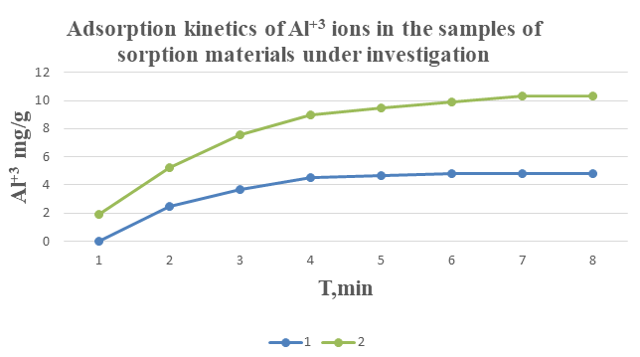
FIGURE 1. 1) 1-(Furanyl-2)penten-4-in-2-ol-1-acrylic acid;
2) 1-(Furanyl-2)penten-4-in-2-ol-1 -acrylic acid -polysilicate acid;

As can be seen from the graph, the increase in the sorption of aluminum ions over time is consistent with the laws and is explained by the fact that in the ion exchanger consisting of 1-(furanyl-2)penten-4-yn-2-ol-1-AK-PSK, it is higher than in other systems due to the hydrogen of the hydroxyl group in the carboxyl and polysilicic acid.
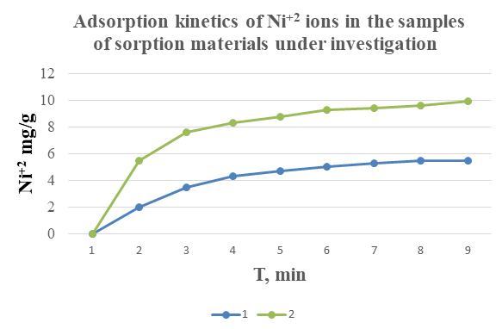

FIGURE 2. 1) 1-(Furanyl-2)penten-4-in-2-ol-1-acrylic acid;
2) 1-(Furanyl-2)penten-4-in-2-ol-1 -acrylic acid -polysilicate acid;

As can be seen from the graph, the increase in the sorption of nickel ions over time is consistent with the laws, and in the ionite consisting of 1-(furanyl-2)penten-4-yn-2-ol-1 -AK-PSK, it was higher than in other systems due to the hydrogen of the hydroxyl group in the carboxyl and polysilicic acid, as well as the formation of complexes with the electron pair of the empty cell of d-elements, and a higher sorption was observed compared to aluminum.
As can be seen from this article, when the dependence of the amount of reacting monomers on the yield was analyzed using a mathematical program, the fact that the value of R in the regression equation obtained from the mathematical processing of the results approaches unity not only indicates the consistency of the results with their mathematical treatment, but also confirms the reliability of the obtained results.
In addition, the inverse proportionality between the regression equations and the corresponding lines obtained for each monomer also confirms the validity of the results. It was shown that the variation in the amounts of both monomers follows the same equation. The theoretical calculations complement the experimental results.
The identification of the synthesized oligomer was carried out using modern analytical methods. The obtained substance was examined by IR spectroscopy, and it was confirmed that its composition corresponds to the expected structure (Figure 3).
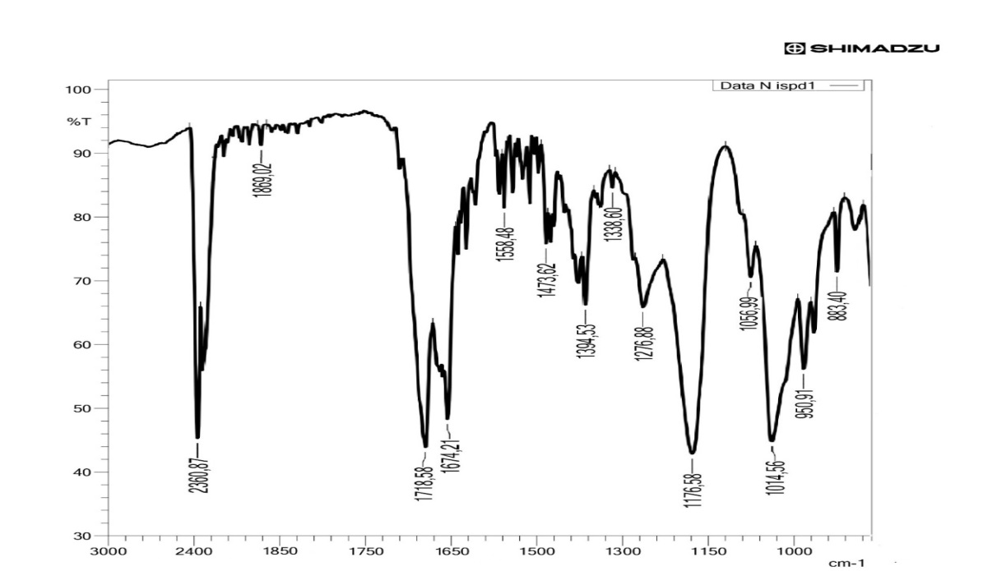
FIGURE 3. IQ spectrum of the synthesized compound

As can be seen from this figure, the broad band at 1176 cm⁻¹ corresponds to the non-uniform bending vibrations of hydroxyl (OH) groups, including intermediate OH groups, as well as hydroxyl group vibrations and C–O bonds. The strong absorption band at 1014.56 cm⁻¹ is attributed to Si–O–Si vibrations. The intense band at 1276.88 cm⁻¹ corresponds to aromatic and vinyl groups (=C–O–C–) and strong ring vibrations. The absorption band at 1718 cm⁻¹ is characteristic of unsaturated carboxylic acids, while the band at 1674.21 cm⁻¹corresponds to asymmetric C=C vibrations in unconjugated macromolecules, confirming that the synthesized substance is consistent with the proposed composition.

CONCLUSION

Organo-inorganic hybrid composites were obtained based on polysilicic acid via the sol–gel method in the presence of a copolymer of 1-(furan-2-yl)pent-4-yn-2-ol and acrylic acid. The composites are formed within a three-dimensional silicon dioxide matrix in which the organic copolymers are firmly immobilized, providing high thermal and chemical stability. New copolymers of 1-(furan-2-yl)pent-4-yn-2-ol-1-acrylic acid were synthesized via radical copolymerization in DMSO solution at 85 °C for 3 hours in the presence of an initiator, achieving a yield of 78%. It was found that cyclic monomers exhibit higher reactivity compared to their comonomers, and that the initial monomer concentration significantly affects the yield. Hybrid composites based on 1-(furan-2-yl)pent-4-yn-2-ol-1-acrylic acid and polysilicic acid (PSA) exhibit high sorption activity toward calcium, magnesium, and copper ions in both acidic and alkaline media. The highest values of sorption capacity and phase distribution coefficient were observed in the 1-(furan-2-yl)pent-4-yn-2-ol-1-acrylic acid–PSA system, where the presence of carboxyl and hydroxyl groups contributes to ion-exchange properties. In this system, the static sorption uptake coefficient increased by 1.25 times, and the mechanical strength improved by 1.24 times. The synthesis of the prepared copolymers was used to develop a technology for obtaining a new hybrid composite based on the hydrolytic polycondensation products of polysilicic acid, possessing cation-exchange material properties. The effect of temperature on the mechanism of metal ion adsorption by composites based on 1-(furan-2-yl)pent-4-yn-2-ol-1-acrylic acid and PSA copolymer was investigated.

REFERENCES

- Li, B., Chen, M., Pan, Y., & Yang, L. (2025). Insights into the pyrolysis/gasification mechanism of cation ion exchange resins based on ReaxFF simulation and DFT computation. Thermochimica Acta, 180091.
- Chavez-Sifontes, M. H., Domine, M. E., & Valencia, S. (2015). Synthesis of furan derivatives via cascade-type reactions catalyzed by solid acids. Catalysis Today, 257, 305-317.
- Mori, M., Tanaka, K., Satori, T., Ikedo, M., Hu, W., & Itabashi, H. (2006). Influence of acidic eluent for retention behaviors of common anions and cations by ion-exclusion/cation-exchange chromatography on a weakly acidic cation-exchange resin in the H+-form. Journal of Chromatography A, 1118(1), 51-55.
- Khollieva M., Zhumaeva M., Ostonov F. Synthesis of ionites based on N-vinylmorpholine and craton aldehyde //AIP Conference Proceedings. – AIP Publishing LLC, 2025. – Т. 3304. – №. 1. – С. 040066.
- Ostonov F., Akhmedov V., Olimov B. Preparation of hybrid composites by sol-gel method and analysis of its properties //Scientific Collection «InterConf». – 2022. – №. 123. – С. 256-259.
- Zuhriddin, R., & Niginabonu, J. (2022). Production of polyethylene terephthalate. Universum: технические науки, (5-11 (98)), 58-62.
- Ulugbek Bekov, Firuz Rakhimov, Voxid Axmedov, Akmalxon Rakhimov; Differential thermal analysis of organic silicon compound based on carbolic acid. AIP Conf. Proc. 21 July 2025; 3304 (1): 040067. https://doi.org/10.1063/5.0270303
- Zuhriddin, R., Niginabonu, J., Aminjon, V., & Temurbek, D. (2022). Mechanisms of eterification of tereftalic acid with etylenglycol. Universum: технические науки, (5-11 (98)), 63-67.
- Nigina J., Mizrob Z. Production of vinyl ethers of furfuryl alcohol //Universum: химия и биология. – 2023. – №. 9-2 (111). – С. 57-62.
- Kurbanov F. P. et al. Investigation of the degree of inhibitor protection relative to conditions at different depths //AIP Conference Proceedings. – AIP Publishing LLC, 2025. – Т. 3304. – №. 1. – С. 040081.
- Niyozov E. et al. Investigation of physicochemical properties of guanidine-based corrosion inhibitor //E3S Web of Conferences. – EDP Sciences, 2024. – Т. 587. – С. 03004.
- Tanaka, K., Ohta, K., Haddad, P. R., Fritz, J. S., Miyanaga, A., Hu, W., ... & Sarzanini, C. (2001). High-performance ion-exclusion/cation-exchange chromatography of anions and cations in acid rain waters on a weakly acidic cation-exchange resin. Journal of Chromatography A, 920(1-2), 239-245.
- Venegas-García, D. J., Mir, M., Steiger, B. G., & Wilson, L. D. (2024). Furfuryl-pyridinium-functionalization of flaxseed gum for effective methylene blue removal from aqueous solution. Canadian Journal of Chemistry.

