Fabrication of SnSe Alloys and Study of Its Structural, Optical, and Photoelectric Properties for the Prepared Thin Films
Enas Falih Mahdi ^{1, a)} and Sarmad Mahdi Ali ^{1, b)}
¹Department of Physics, College of Education for pure science / Ibn Al-Haitham, University of Baghdad, Baghdad, Iraq
ª Inas.Naji2204m@ihcoedu.uobaghdad.edu.iq
^{b} Corresponding author: sarmad.m.a@ihcoedu.uobaghdad.edu.iq
Abstract: Thermal vapor deposition was utilized in this study to create 400 nm-thick SnSe alloy thin films. Thermal treatments were applied to the films at temperatures ranging from room temperature to 300°C. Their optical, optoelectronic, and structural characteristics were thoroughly examined. To evaluate the films' quality and make sure they adhered to ASTM criteria, the structural features were examined using X-ray diffraction (XRD). We also looked at other structural factors such as crystallite size, interplanar spacing, and the full width at half maximum (FWHM) of diffraction peaks. The material's energy band gap was estimated via optical analysis and was discovered to vary depending on the annealing conditions, ranging from 1.4 eV to 2.12 eV. The I–V characteristics under illumination showed that annealing at 300°C resulted in a significant increase in the short circuit current density (J_{sc}) due to improved light absorption, but caused a decrease in the open circuit voltage (V_{oc}), indicating the need to optimize the annealing conditions to achieve an optimal balance between J_{sc} and V_{oc} to enhance the overall conversion efficiency.
Keywords: SnSe, thin films, XRD, heterojunction, structural properties.
INTRODUCTION
Given their distinct physical and chemical properties, the Group IV–VI elements, particularly tin selenide (SnSe), are semiconductors. It is a promising material for electrical and optical applications. Due to its exceptional thermal and electrical properties, as well as its relatively low energy gap, SnSe can be used in a variety of applications such as sensors, thermoelectric generators, and solar cells [1], [2].
The orthorhombic phase (α-SnSe), which is stable at ambient temperature and has a bandgap between 1.1 and 1.3 eV, is the most notable of the phases in which SnSe crystallizes. It is distinguished by its dominating p-type charge carrier behavior and excellent photon absorption (α = 10⁵ cm⁻¹). Because of this, it can be used in photodetector and solar cell applications. Furthermore, it is perfect for usage in thin films for optoelectronic devices due to its chemical stability and capacity to be deposited on both rigid and flexible substrates [3–5]. Numerous studies have shown that by varying the preparation methods, film thickness, element ratios, and heat treatment conditions, the optical and electrical behavior of SnSe materials can be modified, providing broad opportunities for their use in energy conversion and sensing systems. Tin selenide (SnSe) has two known stoichiometric phases: SnSe and SnSe₂. SnSe is a p-type semiconductor with a two-layer orthorhombic crystal structure. SnSe₂ is an n-type material with a hexagonal structure consisting of layers bonded by van der Waals forces [6], [7]. A study by Ahmed et al. (2021) looked at nanocrystalline (SnSe) thin films that were made by thermal vapor deposition and then annealed at 100, 150, and 200 °C. A polycrystalline orthorhombic structure with a preferential orientation along the (111) plane was shown by XRD data. With an increase in the post-deposition heating temperature, the nanocrystal size grew from 14.8 nm to 24.5 nm. A direct band gap that changed from 1.5 eV to 2.2 eV as the annealing temperature rose was discovered by optical analysis (UV-VIS). [8] Additionally, the investigation demonstrated that (SnSe) thin-films were applied using a spray method at substrate temperatures ranging from 250°C to 325°C. All of the produced films, according to XRD examination, have an orthorhombic crystal structure that is mostly orientated along the (111) plane. Within the energy range of 1.14 to 1.24 eV, a direct allowed band gap was found through analysis of the optical response. [9] Their adjustable electrical conductivity and high absorption coefficient (~10⁵ cm⁻²) make them appropriate for thin-film solar cell applications. [4], According to a study, annealing at 275°C can harm the crystal structure and reduce the cell's photovoltaic efficiency at higher temperatures [10]. SnSe thin films have been created using a variety of physical and chemical techniques with the goal of improving their structural, electrical, and optical qualities to satisfy the demands of various applications. The most well-known of these techniques include sputtering [16], chemical molecular beam deposition (CMBD) [4], chemical bath deposition (CBD) [14,15], vacuum evaporation [6,11–13], and spray pyrolysis [7, 9].
The objective of this work is to create SnSe thin films from elemental sources by thermal evaporation and examine their optical, structural, and photoelectrical characteristics. XRD analysis will be used for structural characterization, while UV-Vis spectroscopy and illumination studies will evaluate optical and photo-response properties. The objective is to improve the films' suitability for use in optoelectronic devices by correlating their structural characteristics with their functional performance. Although previous studies have addressed various properties of SnSe thin films, the effect of annealing at high temperatures up to 300°C on the photovoltaic response under illumination remains an underexplored area. This study addresses this gap by systematically investigating the relationship between annealing conditions, compositional changes, and optoelectronic performance, to enhance the efficiency of SnSe-based optoelectronic devices.
EXPERIMENTAL
The SnSe alloy was prepared from its high-purity elemental constituents (selenium and tin) with precise weights: Sn = 1.8015 g and Se = 1.1982 g. The measurements were carried out using a highly sensitive four-decimal-place electronic balance. The elements were mixed and placed into a heat-resistant quartz tube with a length of 30 cm. The tube was evacuated for half an hour to achieve a vacuum pressure of (2.2 ×10⁻² mbar). It was then tightly sealed and placed in a furnace, where the temperature was raised to 900°C for one hour. The quartz tube was subsequently cooled using a slow cooling method to solidify the melt. The alloy was then extracted, as illustrated in Fig. 1, and then ground using a laboratory mill to obtain a homogeneous powder of the SnSe compound.
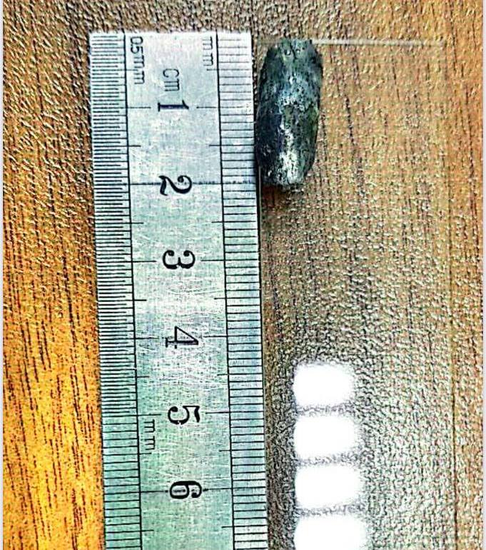
FIGURE 1. The SnSe alloy
A thermal evaporation system was used to prepare SnSe films with a thickness of 400 nm under a vacuum pressure of 4.5 × 10⁻⁵ mbar. The films were deposited onto glass substrates and silicon wafers fixed on a sample holder at a distance of 18 cm from the molybdenum boat. The deposition rate was maintained at 1.160 nm/s at room temperature. The film thickness was verified using the gravimetric method, based on the deposited mass and substrate area. Post-deposition annealing was conducted at 300°C for a fixed duration of one hour in a programmable furnace, a period selected based on preliminary trials to ensure thermal stability without inducing structural degradation. The crystalline structure properties of the annealed films were then analyzed. Annealed and non-annealed SnSe films were studied using X-ray diffraction techniques with the (SHIMADZU Japan XRD 600-system). The analysis employed CuKα radiation (λ=1.5418) A˚ under operating conditions of 40 kV voltage and 20 mA current. (2θ) values were recorded over a range of 20∘to 80∘.The interplanar spacing (d) for the Miller indices (hkl) was calculated using Bragg's Law. [17,18]
2d Sin(θ) = n λ (1)
To calculate the crystalline size of the films, the Scherrer equation was employed, following the approach in [19,20].
C.S = 0.94λ / β Cos(θ) (2)
In the formula, λ stands for the X-ray wavelength, β refers to the FWHM of the observed peaks, and θ is the Bragg diffraction angle. The dislocation density (δ) was calculated according to the methods outlined in [20,21].
δ = 1 / (C.S)2 (3)
The optical band gap (Eg, in eV) was determined using the Tauc relation, while the absorption coefficient (α, in cm⁻¹) was derived from Lambert’s law [22,23].
αhυ = B (hυ – Eg )n (4)
α=2.303 A/t (5)
The optical absorbance spectra of the SnSe thin films were measured using a UV–Vis spectrophotometer (UV-Visible 1800 spectra-photometer) over the wavelength range of 300–1100 nm. Here, B is a constant related to the material, hν refers to photon energy, A stands for absorbance, and t indicates the sample thickness. The value of (r) determines the type of electronic transition 1/2 for direct allowed and 2 for indirect transitions [24].
RESULT AND DISCUSSION
Figure 2 presents the XRD patterns of (SnSe) thin films synthesized through thermal evaporation under vacuum conditions, before and after annealing at room temperature and 300°C for 60 minutes. Distinct diffraction peaks appeared at 2θ angles of 29.51°, 30.49°, and 37.76°, which are attributed to the (011), (111), and (311) crystallographic planes, respectively. These peaks match the standard ASTM card No. 32-1382, confirming that the films exhibit an orthorhombic crystal structure with no secondary phases.
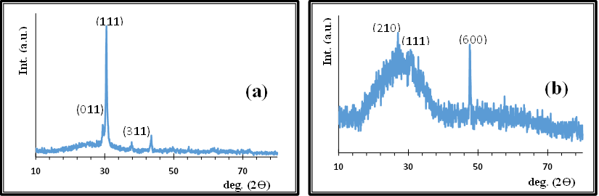
FIGURE 2. XRD patterns of the prepared SnSe thin films: (a) as-deposited at RT., (b) annealed at 300 °C.
Table 1 presents the structural parameters of the prepared thin films. Evaluation of diffraction peak width (FWHM) and crystallite size average (C.S) shows a clear improvement in crystallinity after annealing at 300°C. Specifically, the FWHM of the (111) peak decreased from 0.3552 to 0.225, while the crystallite size increased from 42.24 nm to 66.76 nm, indicating grain growth and enhanced atomic ordering. This is consistent with the research [8]
Despite shifts in some peak positions such as the disappearance of certain peaks and the emergence of new ones like (210) and (600), as seen in Fig. 2-b these changes are attributed to preferred orientation modifications rather than structural degradation.
Additionally, the dislocation density (δ) and number of crystallites (Nₒ) showed a significant decrease, confirming a reduction in structural defects and improved film quality after annealing. These results indicate that thermal annealing at 300°C enhances crystallinity, reduces defects, and induces changes in crystallographic orientation, in agreement with previous studies [9–11].
Table 1. Parameters of the XRD properties of SnSe thin films.
SnSe | (hkl) | 2Ɵ | FWHM | d (Å) | C.S nm | δ×10¹⁴ /m² | N_{o} x10¹⁵ /m²
RT | (011) | 29.51 | 0.4353 | 3.024 | 34.39 | 8.46 | 9.84
RT | (111) | 30.494 | 0.3552 | 2.928 | 42.24 | 5.60 | 5.31
RT | (311) | 37.76 | 0.3953 | 2.379 | 38.70 | 6.68 | 6.89
300$℃$ | (210) | 27.05 | 0.3188 | 3.293 | 46.70 | 4.59 | 3.93
300$℃$ | (111) | 30.99 | 0.225 | 2.883 | 66.77 | 2.24 | 1.34
300$℃$ | (600) | 47.66 | 0.3745 | 1.906 | 42.26 | 5.60 | 5.30

In order to evaluate the annealing-induced changes in the optical properties of SnSe thin films, the data presented in Fig. 3 were analyzed, the absorption spectrum of these films was measured before and after annealing at a temperature of 300°C, within the spectral range of 300–1100 nm. The films show high absorption at shorter wavelengths (300–500) nm which gradually decreases at longer wavelengths, indicating their potential use as a window layer in solar cells. The decrease in absorption at longer wavelengths is attributed to the fact that the photon energy becomes insufficient to excite electrons from the valence band to the conduction band, as it is lower than the energy bandgap [13]. Annealing significantly reduced the absorbance, particularly between (400–800) nm, which is attributed to improved structural order, reduced surface defects, and possible rearrangement of localized states within the bandgap [14].
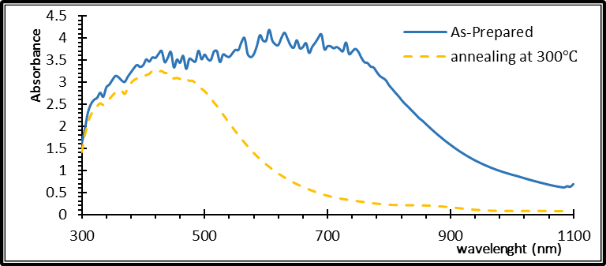
FIGURE 3. Absorption Spectrum verse wavelength Before and After Annealing

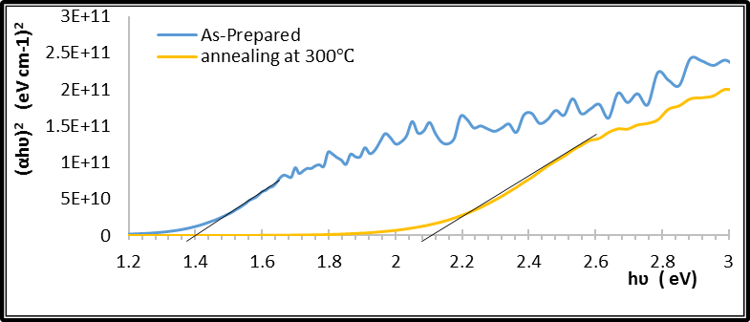
FIGURE 4. Variation (αhν)² versus (hν) of SnSe thin film Before and After Annealing.
The optical band gaps were determined based on the Tauc relation, as depicted in Fig. 4, which shows the (αhν)² versus hν plots before and after annealing at 300 °C. The data presented in Fig. 4 indicate that annealing led to a noticeable increase in the optical energy gap, rising from 1.4 eV to 2.12 eV. This increase in the energy gap values of the annealed films may be attributed to the fact that annealing improves the crystalline structure of the deposited films by eliminating defects and distortions in the crystal lattice, which in turn enhances the electronic properties and leads to an increase in the energy band-gap.
Figure 5-a illustrates the current–voltage characteristics of the p-SnSe/n-Si heterojunction dark conditions, both before and after annealing at 300 °C. Before annealing, a high reverse current is observed, which is attributed to the high density of defects and recombination centers that contribute to significant leakage current. After annealing, a noticeable reduction in reverse current and an increase in forward current are observed, indicating an improvement in junction quality and a reduction in defects. This is a positive outcome, as it enhances the junction characteristics and reduces energy losses caused by dark current [1],[4].
Figure 5-b shows the I–V characteristics under illumination conditions., annealing at 300°C results in a significant increase in the short-circuit current density (J_{sc}), due to improved light absorption and charge separation within the junction, which is considered a positive effect. However, a reduction in the open-circuit voltage (V_{oc}) is observed, which is a negative indicator for cell performance. This may be attributed to increased charge carrier recombination or a reduction in built-in potential due to changes in the junction structure [2], [3]. Therefore, although the current is enhanced, the decrease in V_{oc} may limit the overall improvement in power conversion efficiency, highlighting the need to optimize annealing conditions to achieve a better balance between J_{sc} and V_{oc} [5].
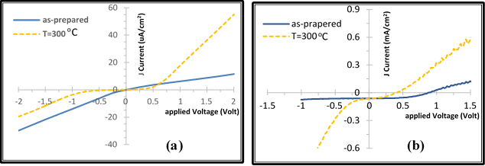
FIGURE 5. I-V characteristics of the heterojunction (p-SnSe / n-Si) before and after annealing (a) in the dark (b) under illumination.
CONCLUSION
This work involves the fabrication of SnSe thin films using thermal evaporation under vacuum, with a focus on examining how annealing at 300 °C influences their structural, optical, and optoelectronic characteristics. XRD results confirmed an orthorhombic structure with enhanced crystallinity and reduced defects after annealing, with the crystallite size increasing from 42.24 nm to 66.77 nm. UV–Vis analysis showed an increase in the optical band gap from 1.4 eV to 2.12 eV and reduced absorbance at longer wavelengths, indicating improved film quality. Electrical measurements revealed improved p-SnSe/n-Si junction performance with increased short-circuit current (J_{sc}) and decreased reverse current, though the open-circuit voltage (V_{oc}) slightly dropped. Overall, annealing improved film quality and performance, making SnSe films promising for photovoltaic applications. Future research should focus on improving annealing conditions to achieve a better balance between short-circuit current and open-circuit voltage.
ACKNOWLEDGMENTS
We thank the Thin Film Lab., Department of Physics/ College of Education for Pure Science ibn Al-Haitham, University of Baghdad.
REFERENCES
- Zhao, Li-dong et al. “Ultralow thermal conductivity and high thermoelectric figure of merit in SnSe crystals.”Nature 508 (2014): 373-377. DOI: 10.1038/nature13184
- J. Carrete, N. Mingo, and S. Curtarolo, "Low thermal conductivity and triaxial phononic anisotropy of SnSe," Applied Physics Letters 105, no. 10, (2014):101907. DOI:10.1063/1.4895770
- Cui, Zhen, Xia Wang, Yingchun Ding and Meiqin Li. “Exploration work function and optical properties of monolayer SnSe allotropes.” Superlattices and Microstructures 114 (2017): 251-258. DOI: 10.1016/j.spmi.2017.12.039
- Razykov, T. M. et al. “Characterization of SnSe thin films fabricated by chemical molecular beam deposition for use in thin film solar cells.” Solar Energy 159 (2018): 834-840. https://doi.org/10.1016/j.solener.2017.11.053.
- K. Al Abdullah, F. Al Alloush, A. Jaafar, and C. Salame, “Investigation of the monocrystalline silicon solar cell physical behavior by AC impedance spectra,” Energy Procedia 57, (2014).
- El-Menyawy, E. M. et al. “Influence of annealing temperatures on the structural, optical and electrical properties of SnSe films. ” Journal of Materials Science: Materials in Electronics 29 (2018): 8354-8363. DOI:10.1007/s10854-018-8846-1
- Martinez-Escobar, Dalia et al. “Optical and electrical properties of SnSe2 and SnSe thin films prepared by spray pyrolysis.” Thin Solid Films 535 (2013): 390-393. DOI: 10.1016/j.tsf.2012.12.081
- Ahmed, Ghuzlan Sarhan et al. “Annealing Effect on the SnSe Nano crystalline Thin Films and the Photovoltaic Properties of the p-SnSe/n-Si Heterojunction Solar Cells.”Iraqi Journal of Industrial Research 8 (2021): 41–49. DOI:10.53523/ijoirVol8I2ID68
- Kumar, P., R. K. Sangeetha, R. Sivakumar and Lourdusamy Amalraj. “Effects of substrate temperature on structural and optoelectronic properties of SnSe thin films by nebulized spray deposition for solar cell applications. “Materials Today: Proceedings 37 (2020): 2763-2769. DOI: 10.1016/j.matpr.2020.08.642
- Fadaam, Suha A., Hiba M. Ali, and Auday H. Shaban. "The effects of annealing on SnSe thin films for solar cells applications. “TEST Engineering & Management 83 (2020): 8814-8820.‏
- G. S. Ahmed and B. K. H. Al-Maiyaly, "Annealing effect on characterization of nano crystalline SnSe thin films prepared by thermal evaporation," AIP Conference Proceedings, vol. 2123, no. 1, p. 020074, 2019. DOI: 10.1063/1.5117001
- G. S. Ahmed and B. K. H. Al-Maiyaly, "Cu doping effect on characterization of nano crystalline SnSe thin films," AIP Conference Proceedings, vol. 2190, no. 1, p. 020019, Dec. 2019, DOI:10.1063/1.5138505.
- N. Shahzad, N. Ali, I. Haq, S. W. Shah, S. Ali, Q. S. Ahmad, F. Azlullah, A. A. Kalam, and A. G. Al-Sehemi, "Annealed tin selenide (SnSe) thin film material for solar cell application," Chalcogenide Letters, vol. 17, no. 7, pp. 347–351, Jul. 2020, DOI: 10.15251/CL.2020.177.347.
- K. Al Abdullah, F. Al Alloush, A. Jaafar, and C. Salame, “Study of the effects related to the electric reverse stress currents on the mono-Si solar cell electrical parameters,” Energy Procedia 36, 104–113 (2013).
- L. N. Maskaeva, E. A. Fedorova, V. F. Markov, M. V. Kuznetsov, and O. A. Lipina, "Composition, structure, and semiconductor properties of chemically deposited SnSe films," Semiconductors, vol. 53, pp. 853–859, 2019. DOI:10.1134/S1063782619060113
- Khudhair, N.H., Jasim, K.A., Preparation and study the effective of Sb on the energy density of states of Se60Te40, AIP Conference Proceedings, 2023, 2769, 020056.
- S. M. Ali, A. A. Shehab, and S. A. Maki, “Study of the Influence of Annealing Temperature on the Structural and Optical Properties of ZnTe Prepared by Vacuum Thermal Evaporation Technique”,IHJPAS, vol. 31, no. 1, pp. 50–57, May 2018, DOI:10.30526/31.1.1851.
- B. K. H. Al-Maiyaly, S. M. Ali, B. H. Hussein, and H. K. Hassun, "Influence of copper on zinc oxide films and solar cell performance," Chalcogenide Letters, vol. 21, no. 8, pp. 605–613, Aug. 2024, DOI:10.15251/CL.2024.218.605.
- B. K. Al-Maiyaly and Duaa Muneer Sadiq, “Synthesis and Characterization of SnS: 3%Bi thin Films for Photovoltaic Applications”,IHJPAS, vol. 36, no. 2, pp. 113–123, Apr. 2023, DOI:10.30526/36.2.2930.
- Ahmed, B.A., Mohammed, J.S., Fadhil, R.N., ...Shaban, A.H., Al Dulaimi, A.H., The dependence of the energy density states on the substitution of chemical elements in the Se6 Te4-xSbx thin film, Chalcogenide Letters, 2022, 19(4), pp. 301–308.
- S. H. Salman, S. M. Ali, and G. S. Ahmed, "Study the effect of annealing on structural and optical properties of indium selenide (InSe) thin films prepared by vacuum thermal evaporation technique," Journal of Physics: Conference Series, vol. 1879, no. 3, p. 032058, 2021 DOI:10.1088/1742-6596/1879/3/032058.
- S. M. Ali, H. K. Hassun, A. A. Salih, R. H. Athab, B. K. H. Al-Maiyaly, and B. H. Hussein, "Study the properties of Cu₂Se thin films for optoelectronic applications," Chalcogenide Letters, vol. 19, no. 10, pp. 663–671, Oct. 2022, DOI:10.15251/CL.2022.1910.663.
- Abdulateef, A.N., Alsudani, A., Chillab, R.K., Jasim, K.A., Shaban, A.H., Calculating the mechanisms of electrical conductivity and energy density of states for Se85Te10Sn5-xInx glasses materials, Journal of Green Engineering, 2020, 10(9), pp. 5487–5503.
- S. A. Maki and H. K. Hassun, “The Structural and Optical Properties of Zinc Telluride Thin Films by Vacuum Thermal Evaporation Technique”,IHJPAS, vol. 29, no. 2, pp. 70–80, Mar. 2017, Accessed: Jun. 05, 2025. [Online]. Available: https://jih.uobaghdad.edu.iq/index.php/j/article/view/86

