Optical Properties Study of CdO Thin Films Before and After Cesium Irradiation at Fixed Concentration and Temperature, with Varying Nozzle-Base Distances and a Mobile Substrate
Shaimaa T. Aldabag ^{1, a)}
¹Department of Medical Physics, Science College, University of Mosul, Mosul, Iraq
^{a)} Corresponding author: shaimaa.talal.atalla@uomosul.edu.iq
Abstract. This study investigates the optical properties of cadmium oxide (CdO) thin films before and after cesium-137 (Cs-137) gamma irradiation, deposited using the Chemical Spray Pyrolysis (CSP) method. The CdO films were synthesized on glass substrates with varying nozzle-to-substrate distances to examine the impact of this parameter on optical characteristics. The films underwent irradiation at a dose of approximately 1.2 Gy to assess changes in key optical properties, including transmittance, absorbance, energy band gap, and extinction coefficient. Results indicate that irradiation significantly enhanced optical transmittance across all deposition distances, with values rising by up to 2.6% at 760 nm. The optical band gap narrowed post-irradiation, ranging from 2.224 eV to 2.498 eV, suggesting improved electronic properties for applications in optoelectronic devices. Additionally, the distance between the nozzle and substrate influenced film morphology, with longer distances leading to improved transmittance due to more uniform film deposition. This study underscores the potential of CdO thin films for solar cell applications, as the improvement in transparency and reduced band gap contribute to better light absorption and enhanced electrical conductivity, making them promising for renewable energy technologies.
Keywords: CdO Thin Films, Chemical Spray Pyrolysis, Optical Properties, Cesium Irradiation
INTRODUCTION
Ultra-thin material layers, particularly thin films, have gained significant attention in modern technology because of their unparalleled optics, electrical, and mechanical characteristics. This type of thin films is no more confined to be applied in integrated circuits but has gone further to occupy fields of optical instruments, protective stains, renewable energy systems [1][2]. A number of deposition methods are adopted to create high-quality thin films to suit certain applications on the one hand they include physical vapor deposition (PVD) and on the other hand there is solution processing [3][4]. Cadmium oxide (CdO) is one such material that perform well in the thin-film technology. CdO is highly valued for its excellent electrical and optical properties. It is an attractive transparent electrochromic electrode owing to its very strong optical transmittance and high electrical conductivity, and is of relevance to advanced electronics applications, optoelectronic devices and gas sensors [5][6][7]. Another commonly-known transparent conductive oxide ( TCO ) material is indium tin oxide ( ITO ), which has found such widespread application due to its good conductivity and transparency. Nonetheless, CdO is relatively expensive, which may limit its widespread application despite its favorable properties despite its low toxicity and exceptional properties [8]. CdO is usually in form of poly-crystals, however crystals size and the quality of the material strongly depend on the mode of synthesis and post deposition processing. CdO is exceptionally transparent with optical transmissions peaking at 73 percent and optical band gap spanning 2.14-2.61 eV [11][12]. CdO thin films are manufactured with the help of a variety of deposition methods. They are the sputtering that is used to obtain structure uniformity, the sol-gel technique to obtain thickness and composition control, and the chemical vapor deposition or CVD, that is used to obtain coating high resolution. Chemical spray pyrolysis (CSP) is another well-known and a relatively low-cost technique with the simplicity of use and film deposition speed [15]. It has been established that the deposition method that involves the movement of the substrates can increase crystalization and structural stability of CdO thin films. This movement promotes grain growth, enhances film uniformity, and reduces the density of structural defects. Previous studies have also indicated that the optical transmittance of CdO films increases and that the optical gap band moves within the range of 2.34 to 2.44 eV as a result of incorporation of movement of the substrates in the deposition [17]. The study of optical properties of CdO thin films before and after cesium irradiation reveals significant changes influenced by various parameters such as film thickness, irradiation type, and substrate conditions. CdO thin films prepared via spray pyrolysis and subjected to gamma irradiation from Cs-137 show a decrease in optical band gaps, with values dropping from 2.32 to 2.27 eV for 400 nm films and from 2.30 to 2.12 eV for 500 nm films, indicating increased absorption post-irradiation[18]. Similarly, another study confirms that gamma irradiation leads to a reduction in the optical band gap, alongside increases in extinction coefficient, extinction coefficient, and optical conductivity, suggesting enhanced optical activity with prolonged exposure[19]. In contrast, proton irradiation at 1.5 MeV results in increased optical band gaps and absorbance, with these properties being directly proportional to the proton fluence and film thickness, highlighting a different modification pathway compared to gamma irradiation[20].
This study is impactful due to its enhancement of the optical properties of CdO thin films in cadmium oxide (CdO) thin films, which can be used in solar cells. This will enhance the optical permeability of the films which makes the passing of light to sink more which is essential towards enhancing the functionality of various devices such as solar cell and thin film technologies. The paper also examines how beneficial gamma irradiation may be to these films. This treatment significantly enhances their performance, making them a cost-effective and promising alternative to the traditional materials.
EXPERIMENTAL PART
Cadmium oxide (CdO) thin films were prepared in this paper via Chemical Spray Pyrolysis (CSP) in order to investigate its optical characteristics. To an empty 25-mL beaker, 2.292 grams of cadmium chloride (CdCl 2 ) was added with 25 mL of distilled water. At the same time, we are to dilute potassium hydroxide (KOH) in distilled water to a concentration of 0.02 M. A 0.28-grms. quantity of KOH is to be weighed and dissolved in distilled water to a total of 20mls. The two solutions were stirred gently or mixed slowly to ensure complete dissolution and dissolve the solid substances completely. The deposition was done on 25.4 x 76.2 mm size glass substrates and the substrate thickness was ranged between 112 mm and 1.2 mm. The substrates were thoroughly cleaned prior to the deposition process, it is important to note that the film thickness varied with the nozzle-to-substrate distance, as confirmed by gravimetric measurements. Longer distances generally led to thinner films due to increased spray dispersion and reduced material deposition rate. This variation in thickness is an inherent consequence of the deposition geometry and was considered during the analysis of the optical properties. This entailed soaking in analytical grade acetone solution (five minutes) to wash off organic contaminants after which it was washed using double distilled water. Lint-free wipes were used to dry the cleaned substrates to remove all dust so that the deposition of thin films was obtained on a clean surface. Deposition of the substrates was done on a moving base where dynamic system provided a control to guarantee a uniformity of the film. Spring of a nozzle of 0.5 mm in diameter and a spray rate of 1.5 mL/min was utilized to apply the spray solution. To have a uniform coverage of the spray on the surface, the speed of the substrate was held at 6 cm/s. In order to maintain temperature and reproducibility, the temperature of the substrate was carefully maintained at 200 ºC during the deposition by digital temperature controller. Four different cases of the sample configuration gave values of distance between the nozzle and the substrate as 15 cm, 20 cm, 25 cm, and 30 cm. This was varied to look at how the distance between the nozzle and the substrate influenced the optical features of the CdO films. The deposition process comprised 15 spray cycles where each cycle of spraying took 10 seconds and a waiting period of 2 minutes was given to allow the evaporation of solvents to avoid sudden changes in the temperature profile at the substrate surface. A mixture of the CdCl₂ and KOH solutions was obtained by mixing the two at 80 ºC, and 20 minutes with the help of a magnetic stirrer which has a hot plate so that a homogeneous mixture of the reactants is formed. Reaction led to the deposition of cadmium oxide (CdO) thin films on the created glass substrates. The deposited films were characterized with regard to optical parameters. Once the process of deposition is performed, the thickness of the deposited films is measured based on the gravimetric approach to determine the film thickness based on the following equation [21] :
$$t=\frac{m_{2}-m_{1}}{A.ρ} (1)$$
Where t is the film thickness, (m₁,m₂) represent the sample weights before and after the deposition process, respectively, A is the sample area, and ρ represents the density of the film material. The transmittance (T) of the material was measured to determine the ratio of radiation transmitted through the film. This property is essential in understanding how much light passes through the material, and it was calculated using the equation [22]:
$$T=\frac{I_{T}}{I_{o}} (2)$$
​​where I_{T}​ represents the transmitted light intensity and I_{o}​ is the incident light intensity. It is affected dependent on a number of factors including the composition of the surface, the weight of the material, temperature, and the intensity of incidence light. After the measurement of transmittance, absorbance (A) was obtained and it is defined as the quotient between the intensity of the absorbed light in the material and the incident light. This was measured in the form of the equation [23]:
$A=\frac{I_{A}}{I_{o}} (3)$
where I_{A}​ is the absorbed light intensity. Absorbance, like transmittance, is affected by the surface characteristics, thickness of the material, and incident light intensity. Next, the reflectivity (R) of the material was determined, related to transmittance and absorbance through the energy conservation law, which is expressed as [24] :
$R+T+A=1 (4)$
The next calculation was that of optical band gap (Eg) which was the energy required to move an electron out of the valence band and into the conduction band. These factors, which affect optical band gap include temperature and existence of impurities in the material. Band gaps of direct electron allowed transitions were identified fitting the expression [25]:
$$αhv = A{(hv - Eg)}^{\frac{1}{2}} (5)$$
where A is a constant and E_{g}​ is the optical band gap of the film. Lastly, the extinction coefficient (K) was measured, which represents the amount of energy absorbed by the film from the incident photon energy. It is given by the equation [26]:
$Ko= \frac{α λ }{4π} (6)$
All of these measurements and calculations provide crucial insights into the optical properties of the material, offering a comprehensive understanding of how the material interacts with light. These parameters are critical for assessing the performance of thin films in optoelectronic applications.
After depositing the thin films of CdO, irradiation using a source of cesium 137 (Cs -137) with the energy of 0.662 MeV was done on the four subjected samples. A controlled set of conditions was used to examine the effect that radiation had on the films through irradiation. To this effect, samples were kept at a distance of 10 cm away to the cesium source to clearly achieve consistency in exposure. The duration of irradiation was properly selected according to the common dosimetry guidance and was determined as 60 minutes. The samples on this period were subjected to a total of about 1.2 Gy. The objective of this irradiation was to examine whether gamma radiation may affect the structural and optical characteristics of the CdO films which may be valuable for integrating these films into radiation-sensitive devices. Irradiation was done in the well shielded facility to reduce the possibility of exposure to the external radiations and upholding the safety standards. The irradiation dose of 1.2 Gy was measured using a calibrated dosimeter (model XYZ), with an estimated uncertainty of ±5%. All samples were positioned at 10 cm from the source to ensure uniform exposure, based on standard dosimetry practices.

RESULTS AND DISCUSSION
Prior to irradiation Figure 1(a), the films deposited at 15 cm exhibited the lowest transmittance, reaching a maximum of approximately 52.3% at 760 nm. As the nozzle-to-substrate distance increased, the transmittance progressively improved, with the 30 cm sample showing the highest value at around 96.4%. This trend indicates that increasing the spray distance facilitates more uniform film morphology and potentially reduced film thickness, thereby enhancing optical clarity. After irradiation Figure 1(b), the improvement in transmittance becomes even more pronounced. The maximum transmittance values for the 15 cm, 20 cm, 25 cm, and 30 cm samples increased to 57.5%, 68.92%, 85.14%, and 98.35%, respectively. The values ​​at the wavelength of 760 nm are listed in the Table 1. as it has the highest transmittance for the highest visible wavelength. The increase in transmittance post-irradiation is attributed to radiation-induced modifications such as defect healing, improved grain ordering, and reduced scattering centers within the film matrix, which collectively enhance the optical transparency of the material [18][19].
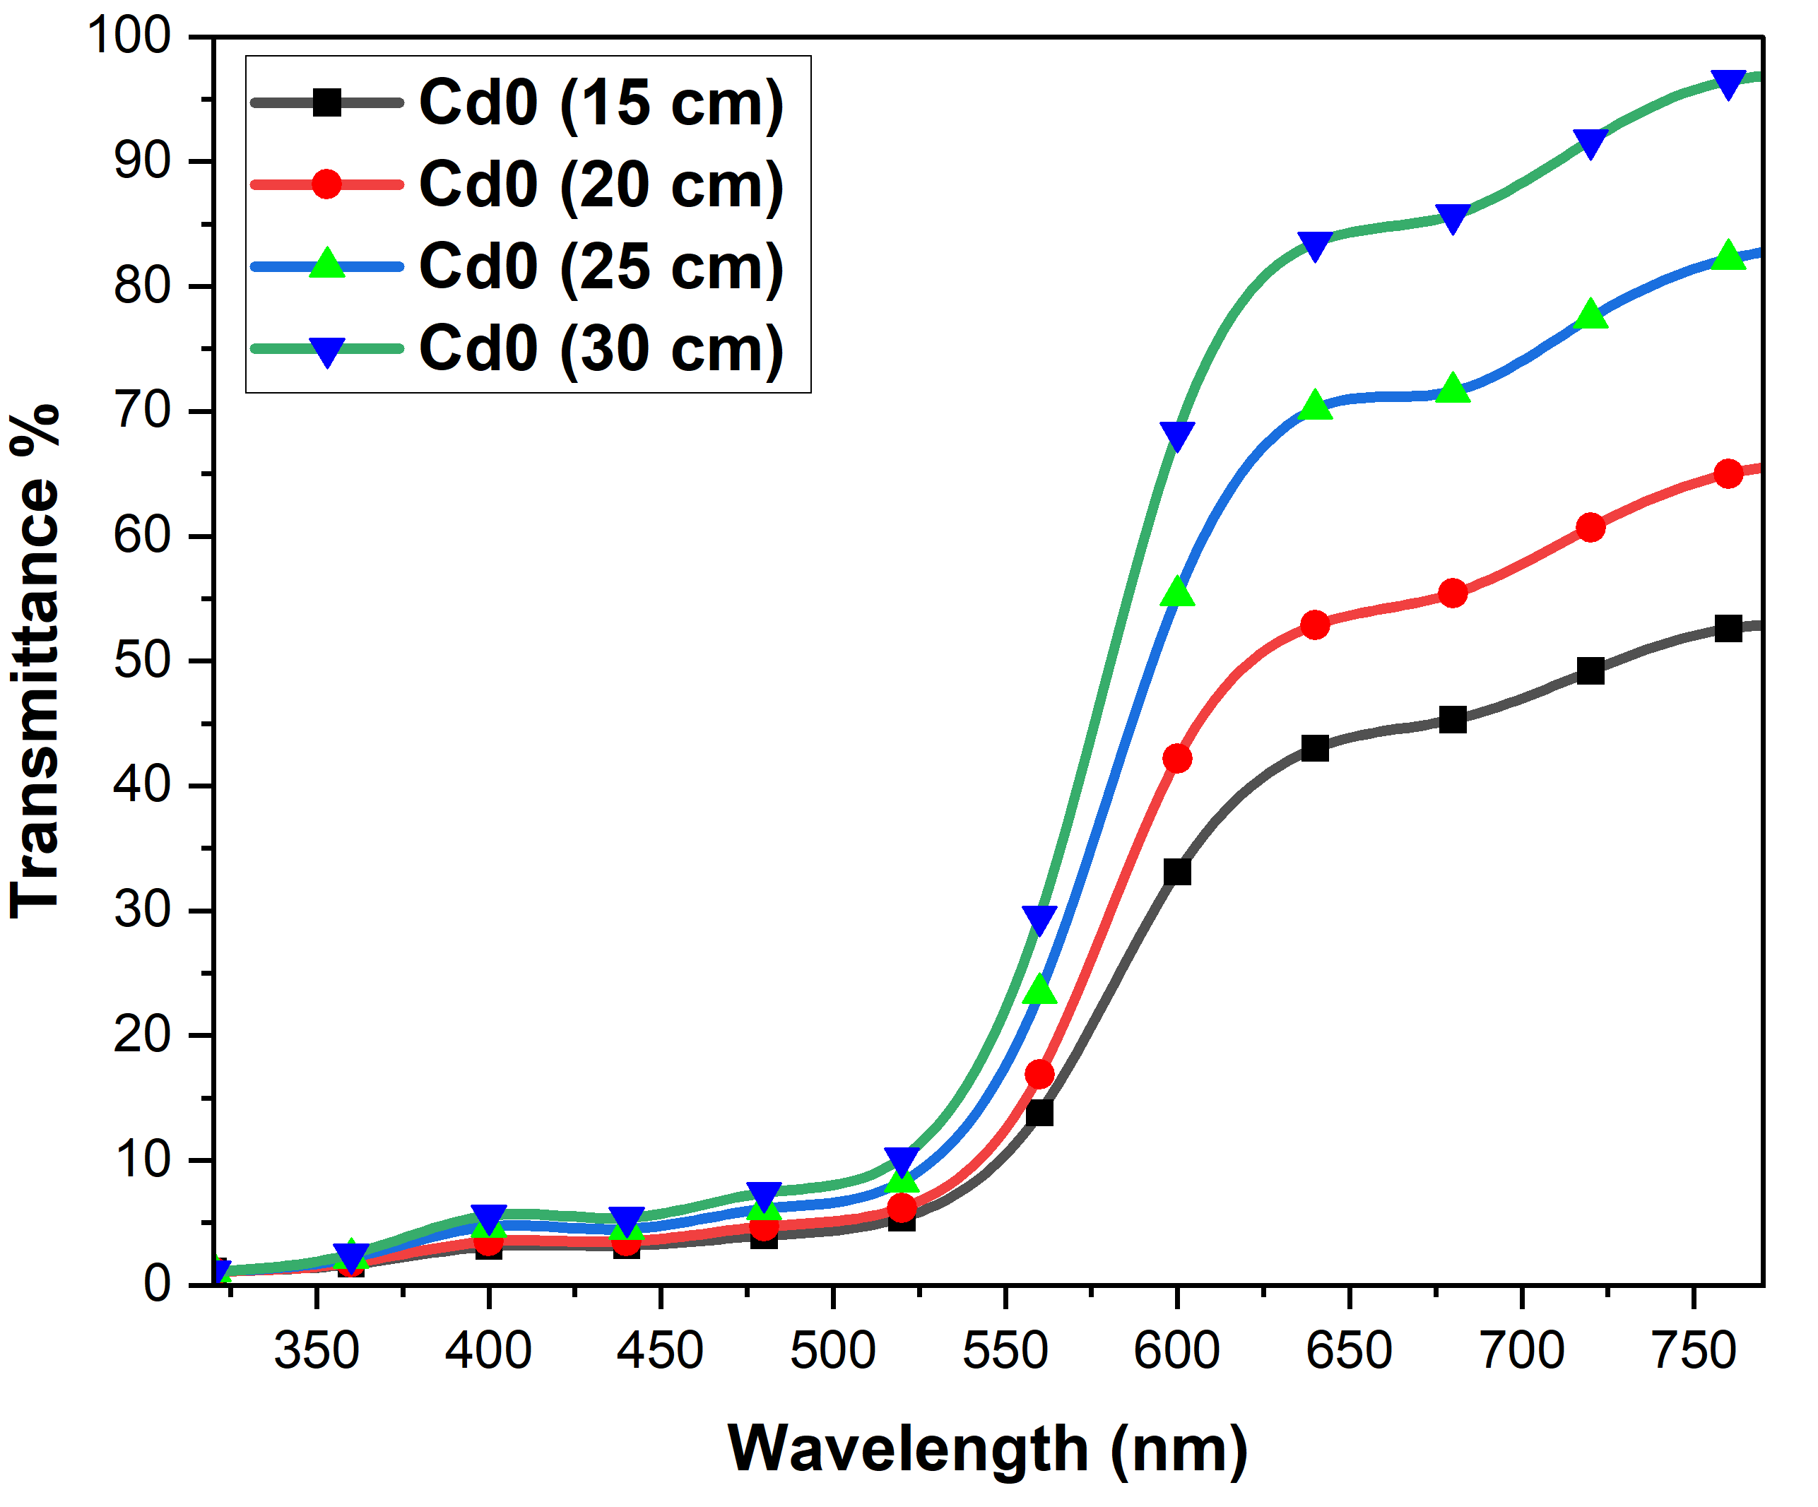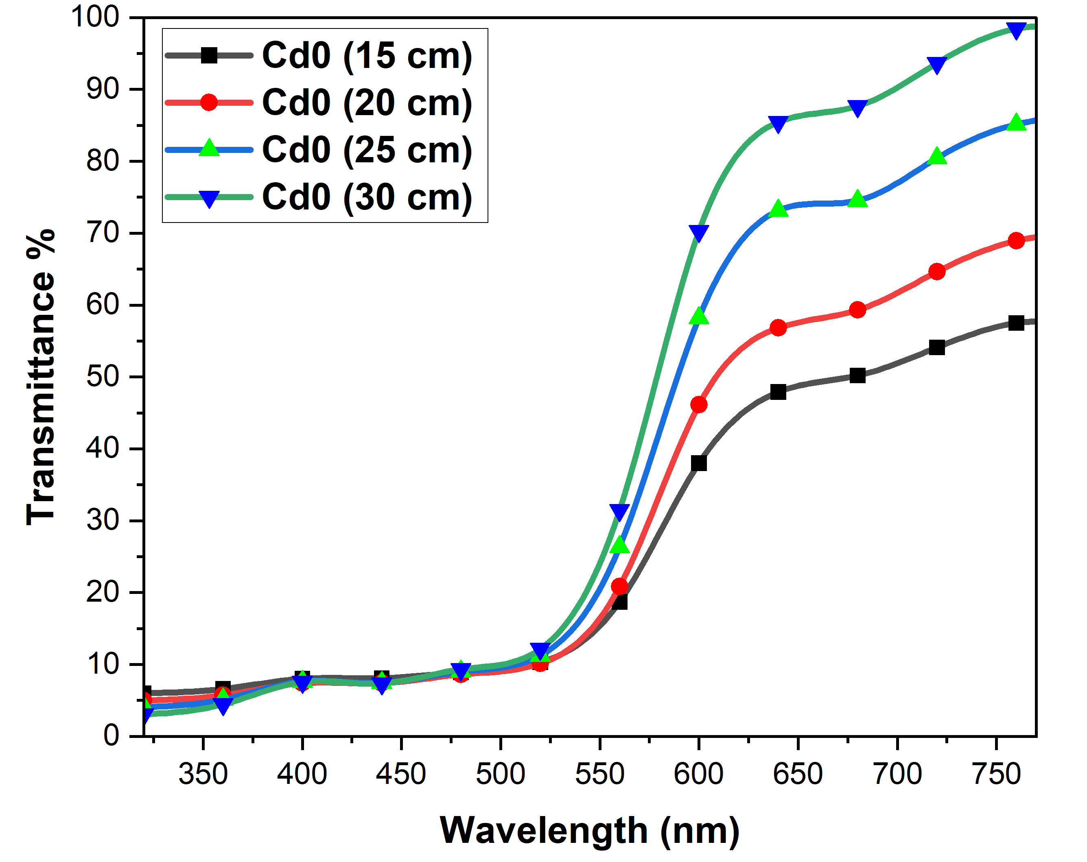
(b)
(a)
FIGURE 1. Effect of Distances (15,20,25,30 Cm) on Transmittance Across the Visible Range (320–760 Nm) : (a) Before Irradiation , (b) After Irradiation.
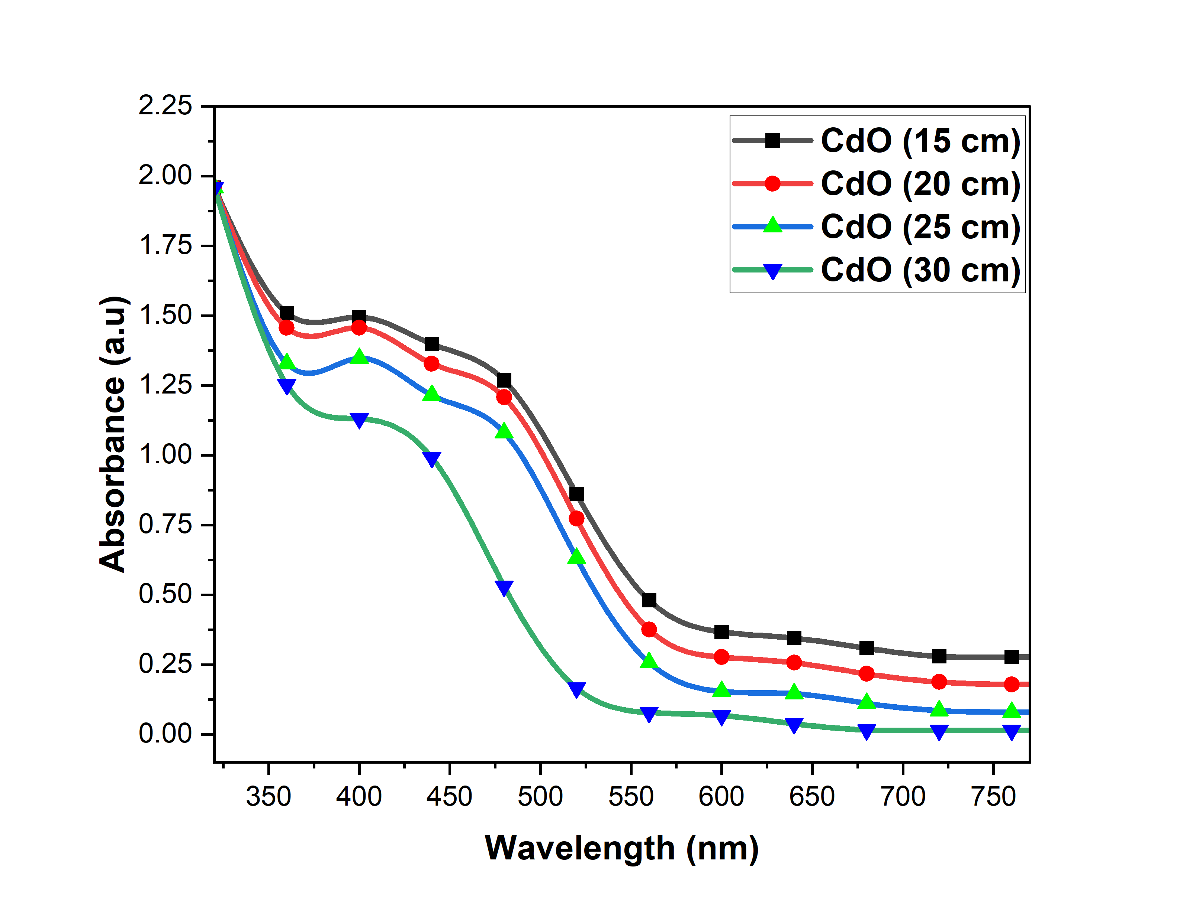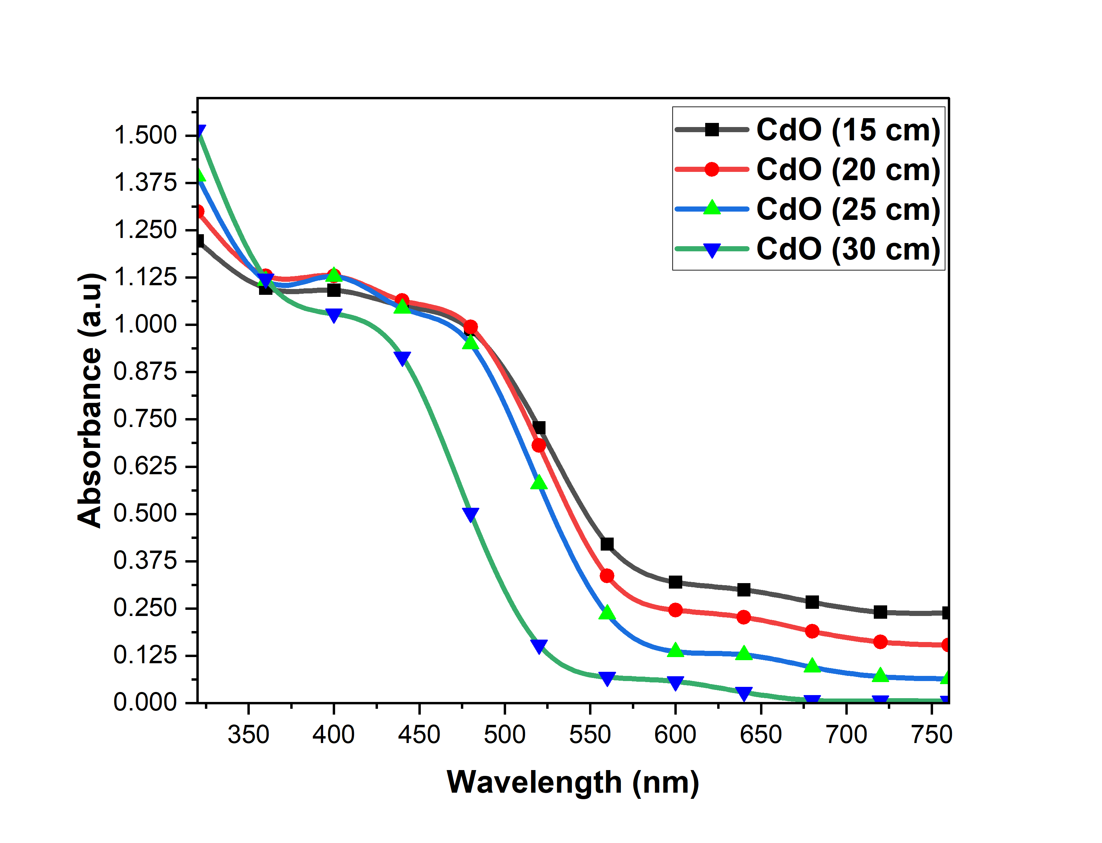
(a)
(b)
FIGURE 2. Effect of Distances (15,20,25,30 cm) on Absorption Across the Visible Range (320–760 nm) : (a) Before Irradiation , (b) After Irradiation.
Figure 3. show the relationship between the energy gap (Eg) and the wavelength (E) for CdO thin films subjected to irradiation. In particular, the energy bandgap (Eg) varies with the distance between the sample and the source of irradiation. Specifically, the Figure 3(a) illustrates how the energy bandgap behaves for four different sample distances: 15 cm, 20 cm, 25 cm, and 30 cm. For each of the samples, the energy bandgap (Eg) is characterized by the values 2.231 eV, 2.272 eV, 2.305 eV, and 2.521 eV, respectively. These values are typical of CdO films with smaller energy gaps in the first three cases (15, 20, 25 cm), indicating a relatively lower energy required for electron transition. On the other hand, the fourth sample (30 cm distance) shows the largest Eg value of 2.521 eV, suggesting a larger energy barrier for electron movement in the sample. When comparing the results obtained after irradiation, as shown in Figure 3(b), a notable reduction in the energy bandgap is observed for all samples. After irradiation, the energy bandgap values for the same samples decrease as follows: 2.224 eV for the 15 cm sample, 2.256 eV for the 20 cm sample, 2.290 eV for the 25 cm sample, and 2.498 eV for the 30 cm sample, as shown in Table 2. These results indicate that the irradiation process causes a narrowing of the energy bandgap [18][19]. This change is significant as it directly impacts the conduction and transparency properties of the material. When the energy bandgap decreases, it becomes easier for electrons to transition from the valence band to the conduction band, which enhances the material's electrical conductivity. The reduction in the energy bandgap post-irradiation can be attributed to the improved electronic properties of the CdO thin films, which are particularly useful for their application in solar cells.
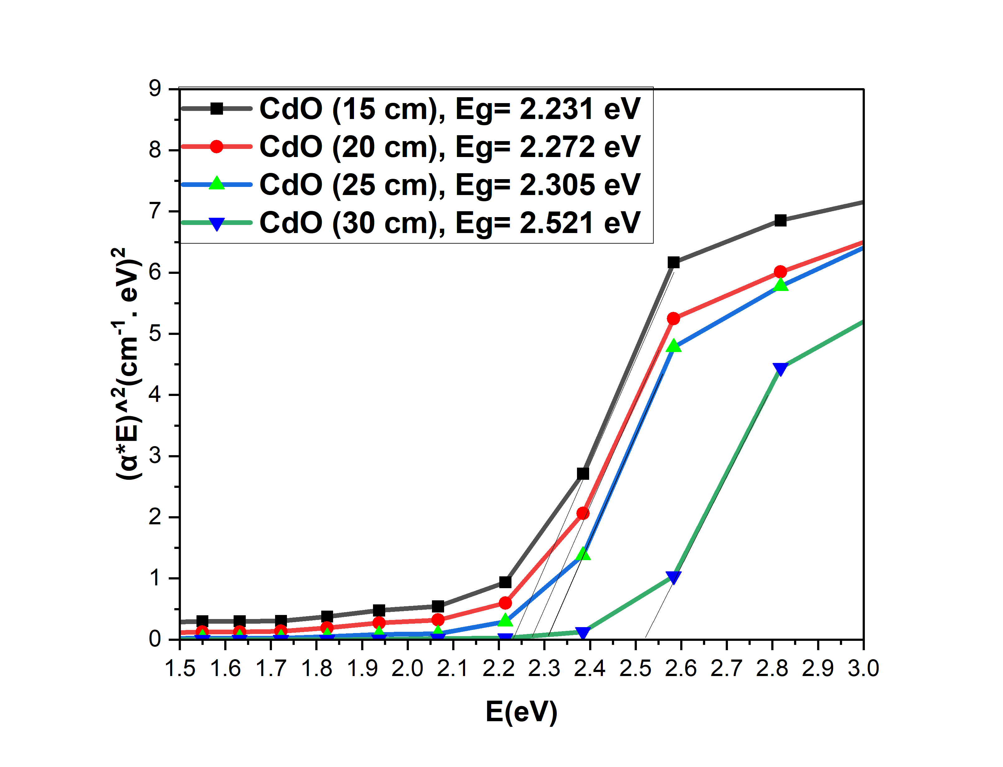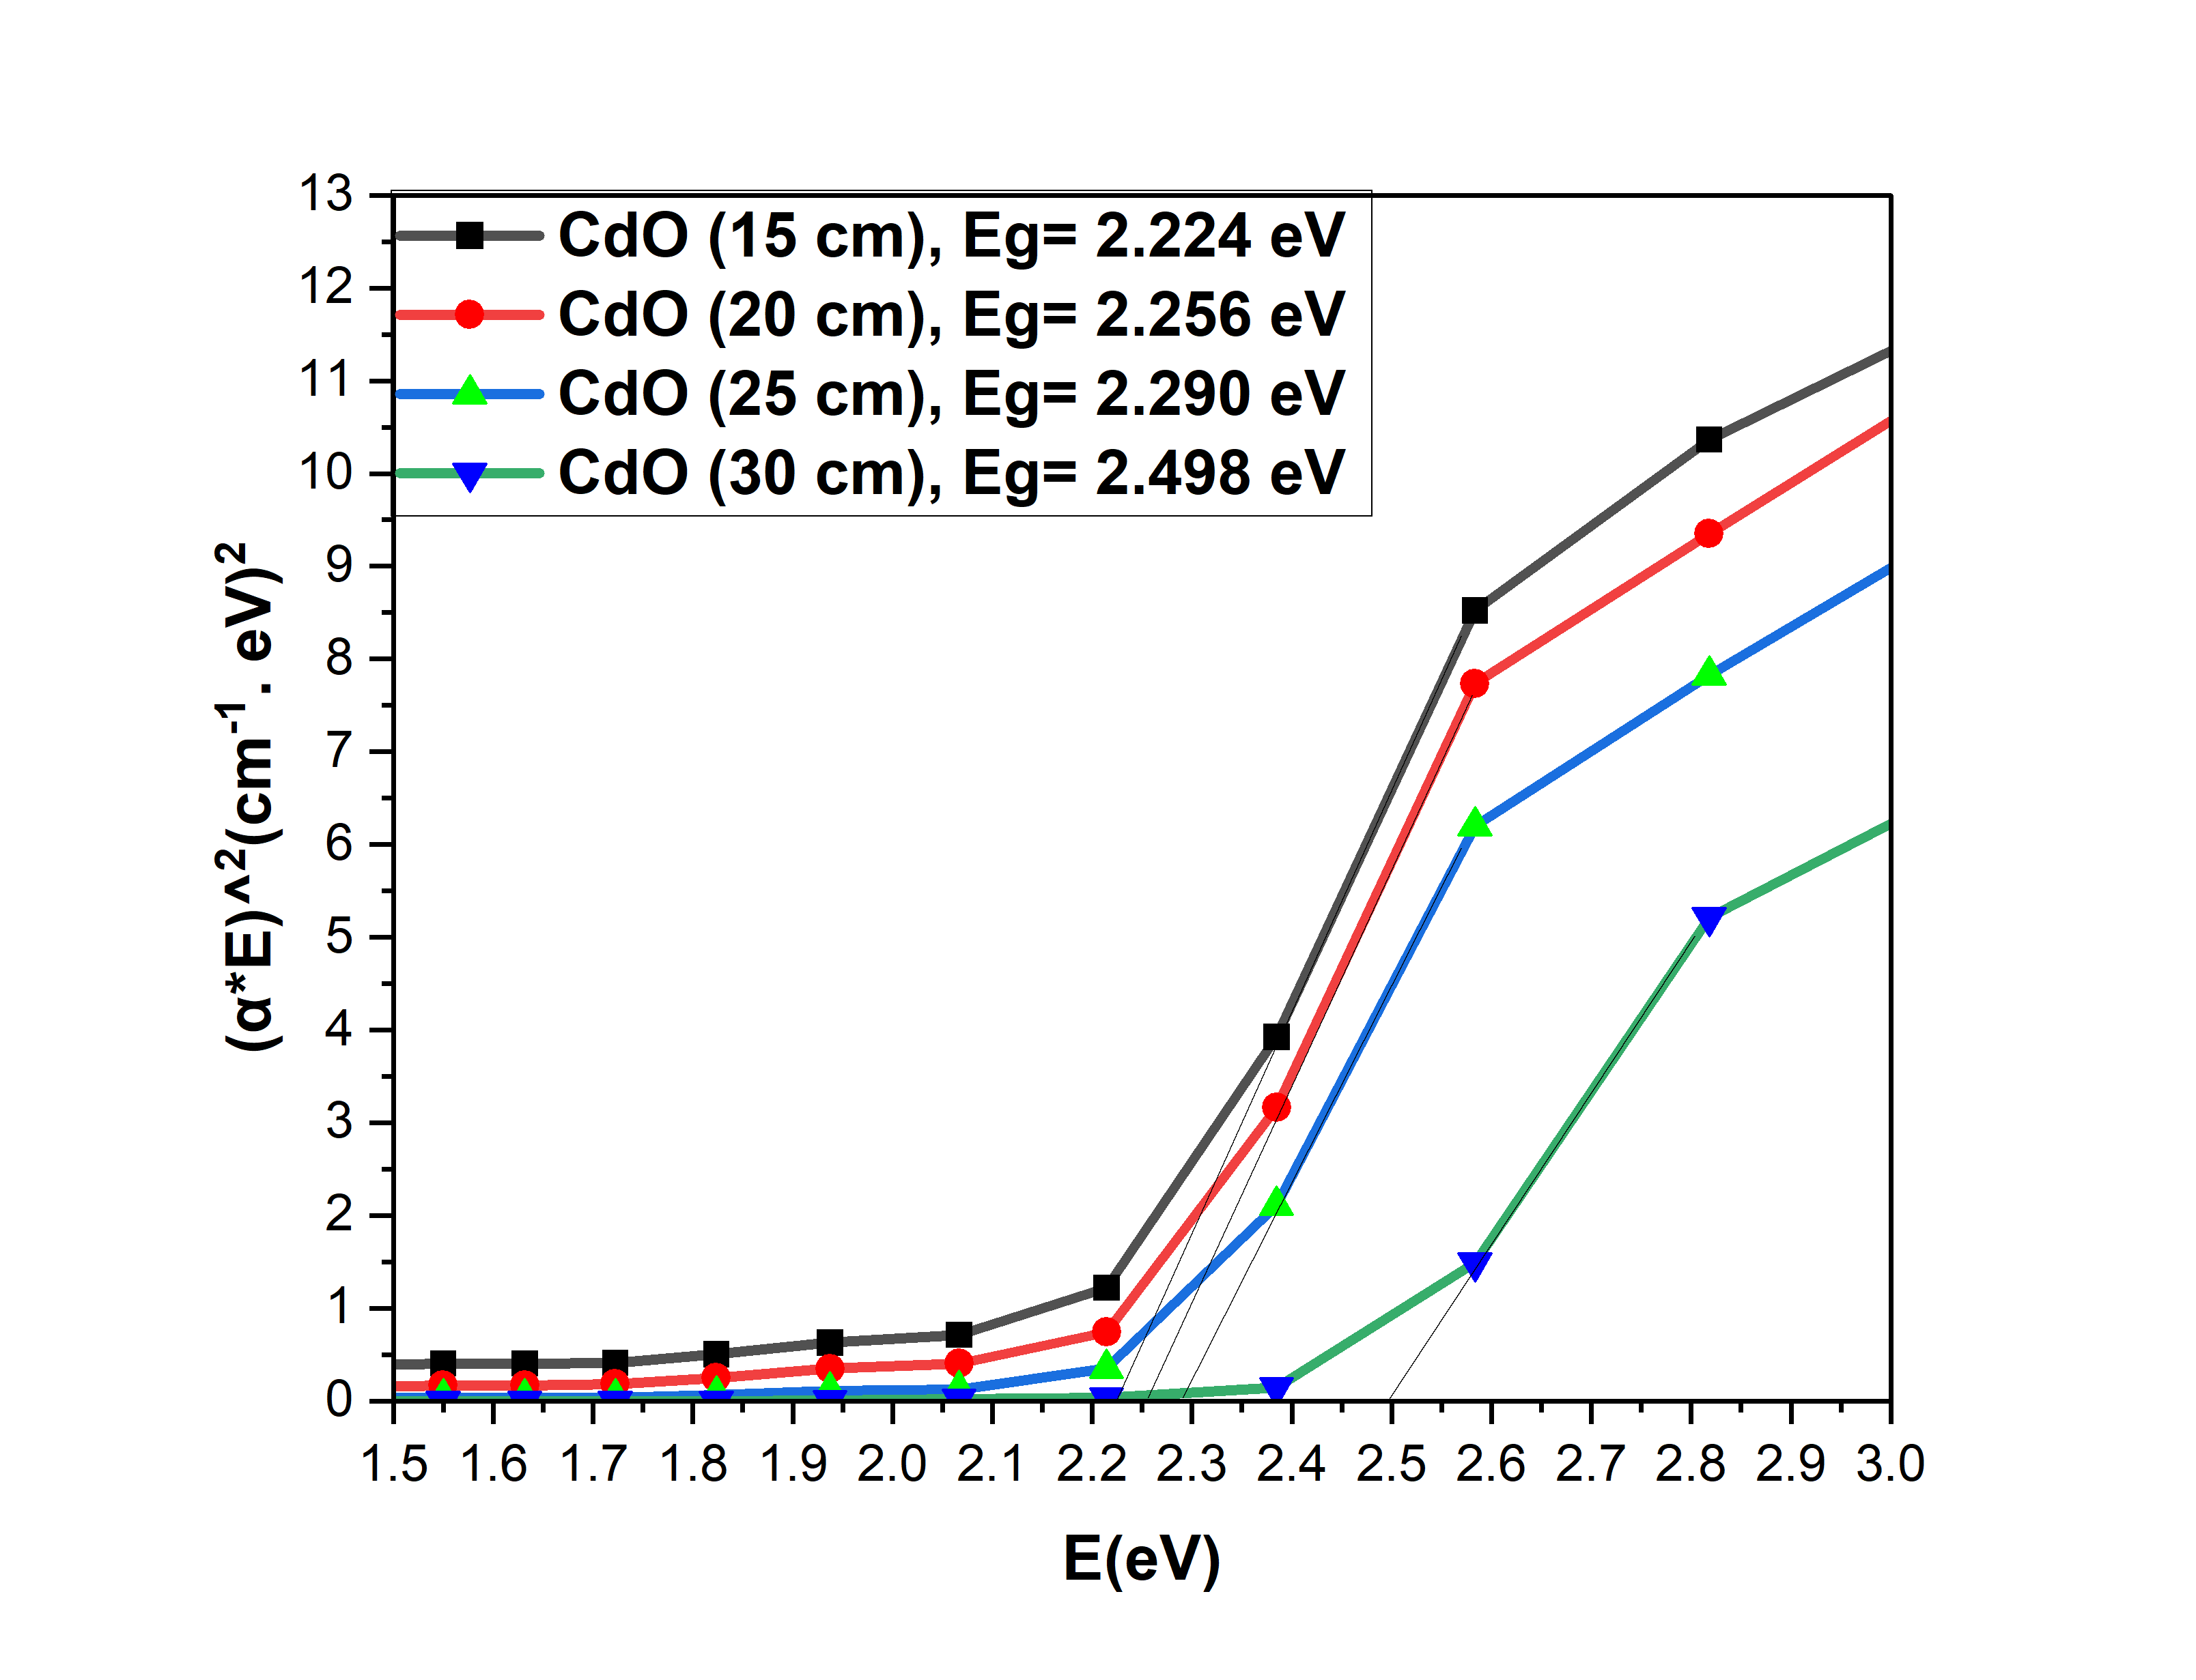
(a)
(b)
FIGURE 3. Distances (15,20,25,30 cm) -Induced Variation of Energy Bandgap (Eg) in the Material : (a) Before Irradiation , (b) After Irradiation.
TABLE 1. Energy Gap (Eg) Results Before and After Irradiation for Four Samples at Different Distances.
Sampls | Distances | Before | After
1 | 15 cm | 2.231 eV | 2.224 eV
2 | 20 cm | 2.272 eV | 2.256 eV
3 | 25 cm | 2.305 eV | 2.290 eV
4 | 30 cm | 2.521 eV | 2.498 eV

Similarly, in both the Reflectivity and the extinction coefficient of the CdO thin films decline with an expansion in the gap between the light source and the sample. This pattern has been explained to be as a result of rise in transmittance with distance which provides more light within the sample. Consequently, the material reflects less light and hence the reduced reflectivity. On the same basis, the higher transmittance also decreases the extinction coefficient which describes the absorbency of the material as decreasing light power is absorbed by the material since more light will pass through the thin film. When irradiated, the Reflectivity, and the extinction coefficient reduce further still, in all distances. The distinct explanation of this is bsed on the increased transmittance arriving as a result of letting more light to pass through the thin film. Moreover, the irradiation allows transfer of electrons in the material, and this causes an additional decrease in Relfexity and extinction coefficient. The efficiency of the light transmission of the film also depends on the irradiation-induced mobility of the electrons; hence the light transmission becomes higher and the energy loss due to absorption will be lesser, thus the Reflectivity and the extinction coefficient Shown in the Figures 4 and 5 also becomes lesser.
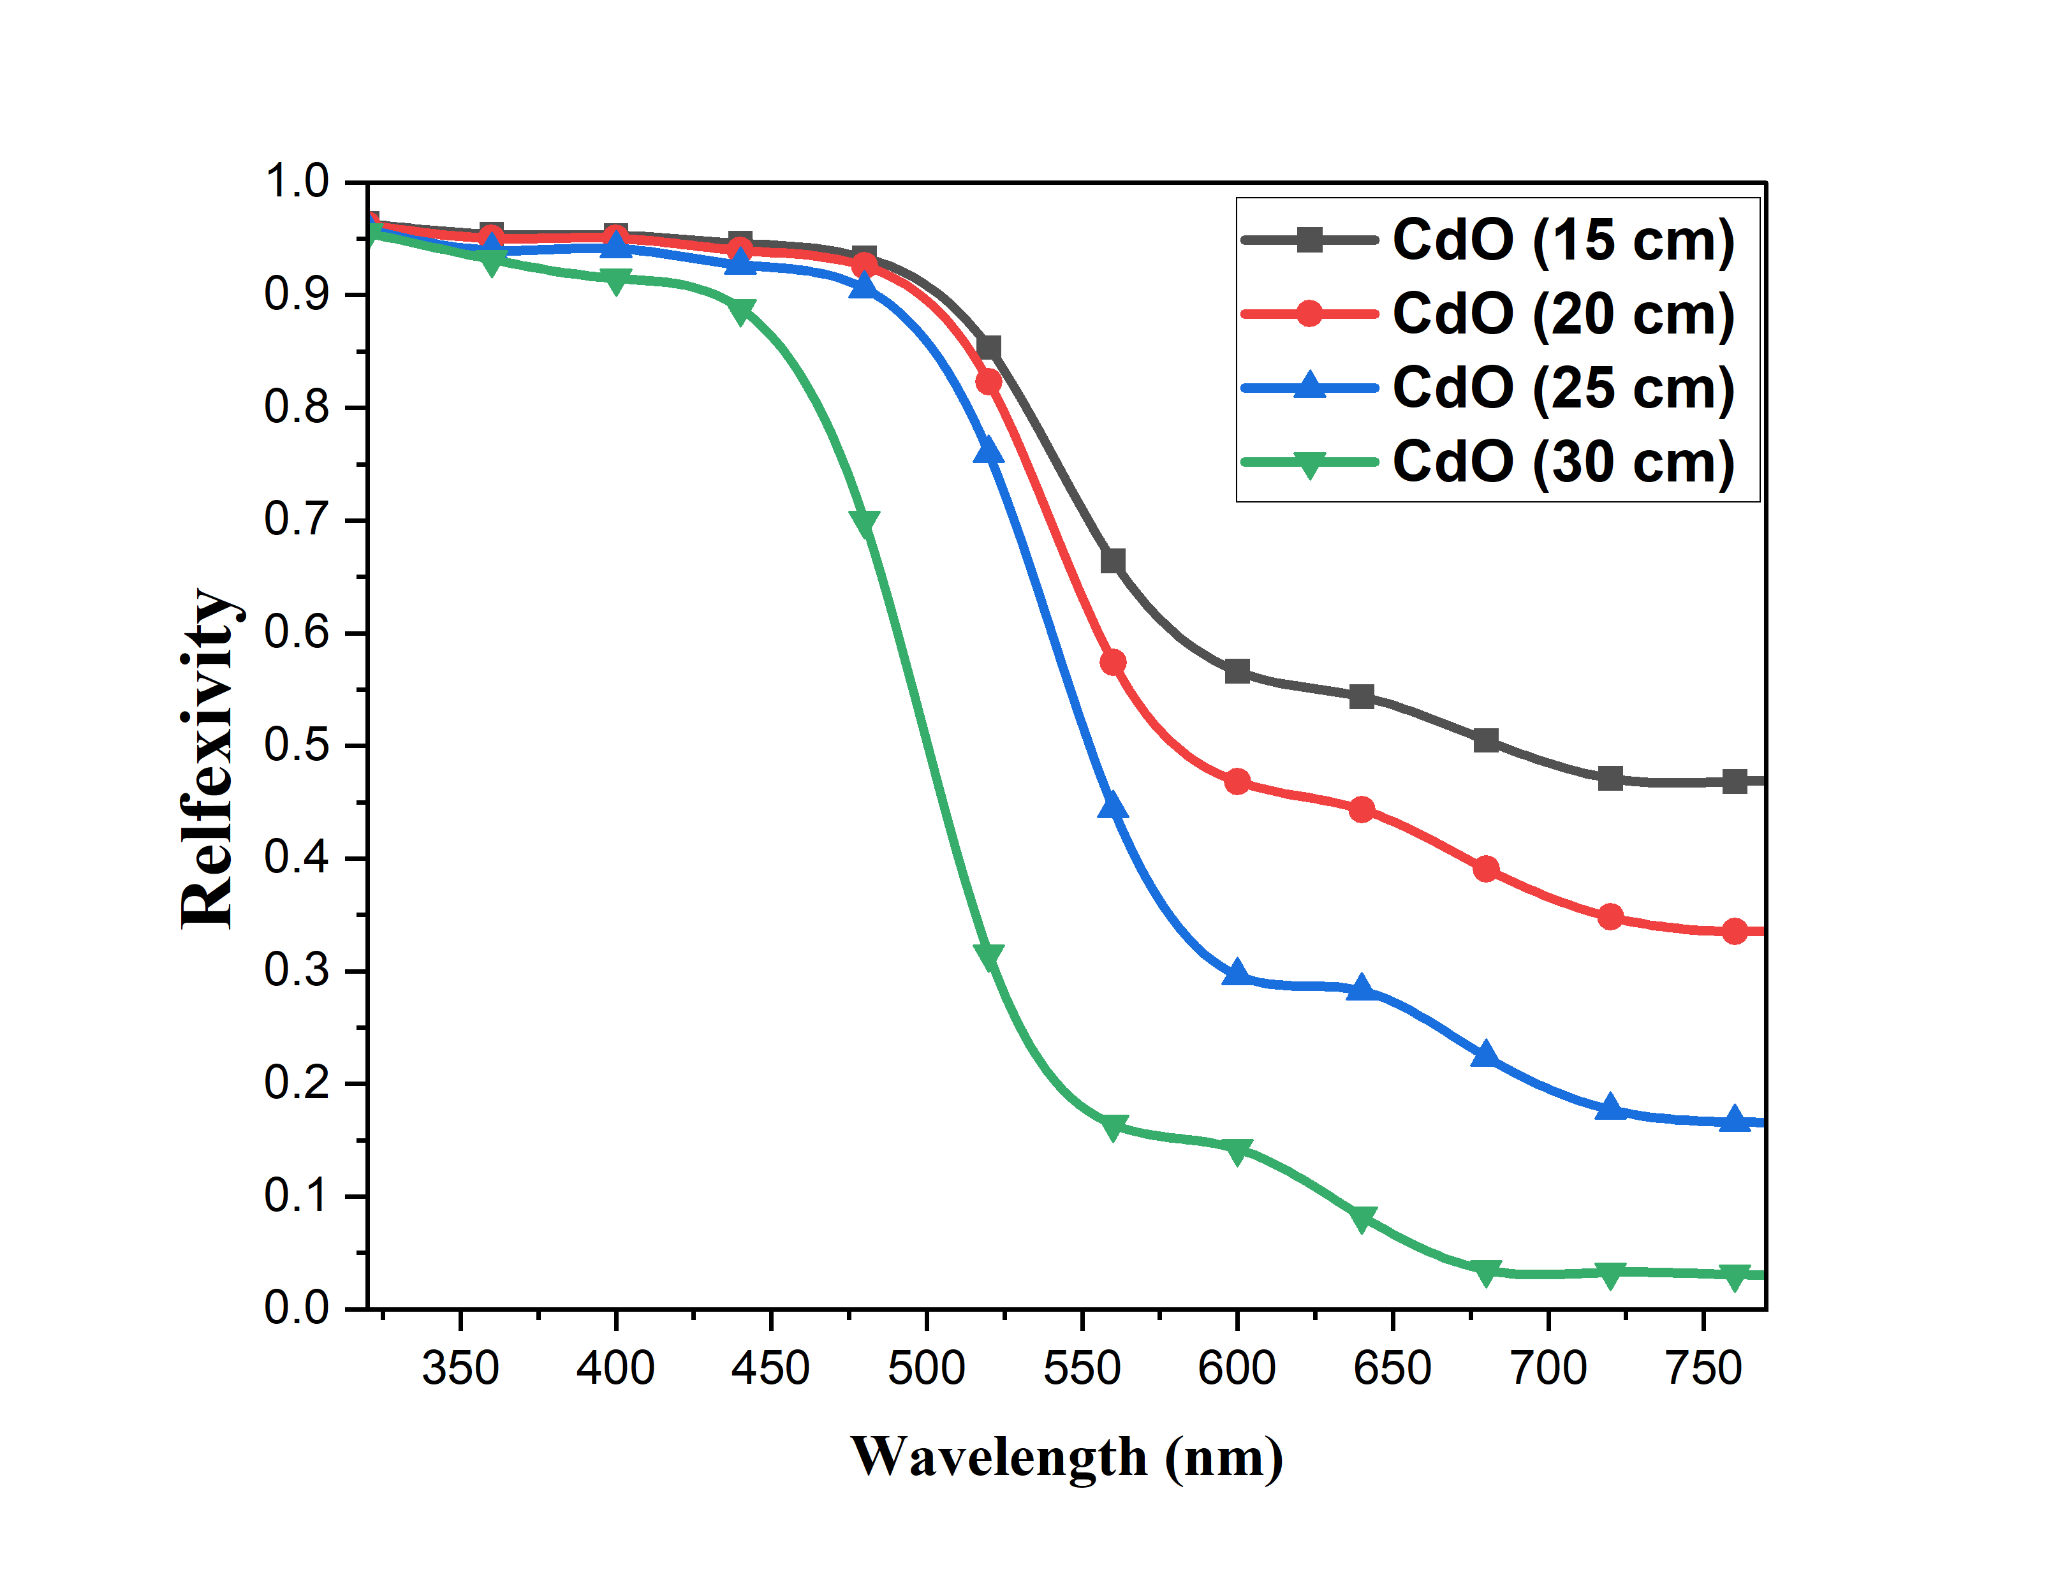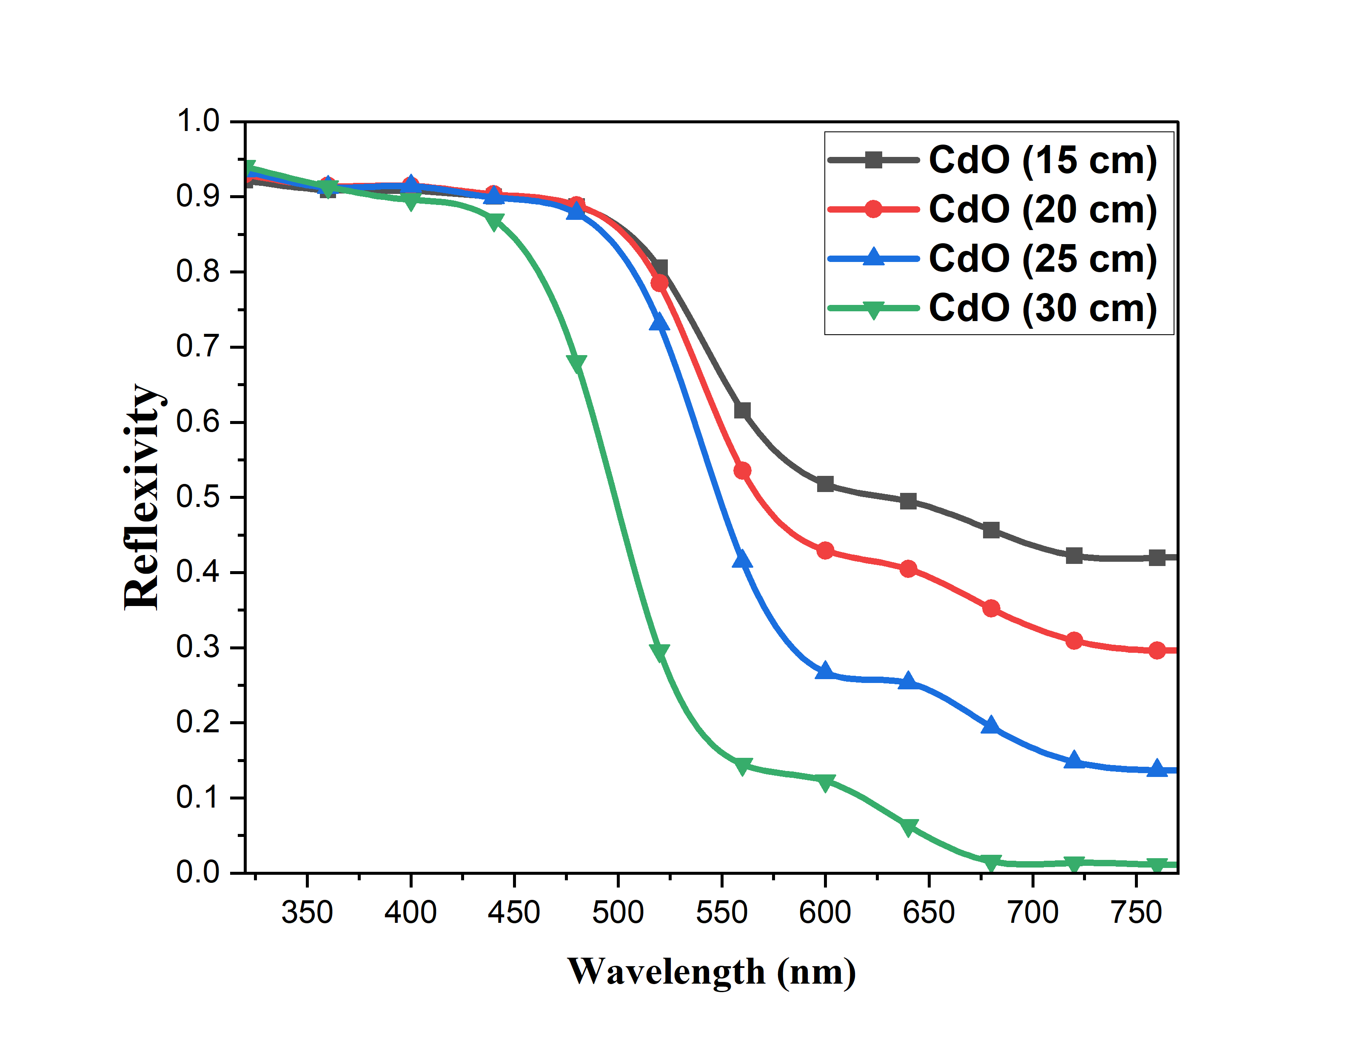
(b)
(a)
FIGURE 4. Distances (15,20,25,30 cm) -Driven Variation in Reflectivity : (a) Before Irradiation , (b) After Irradiation.
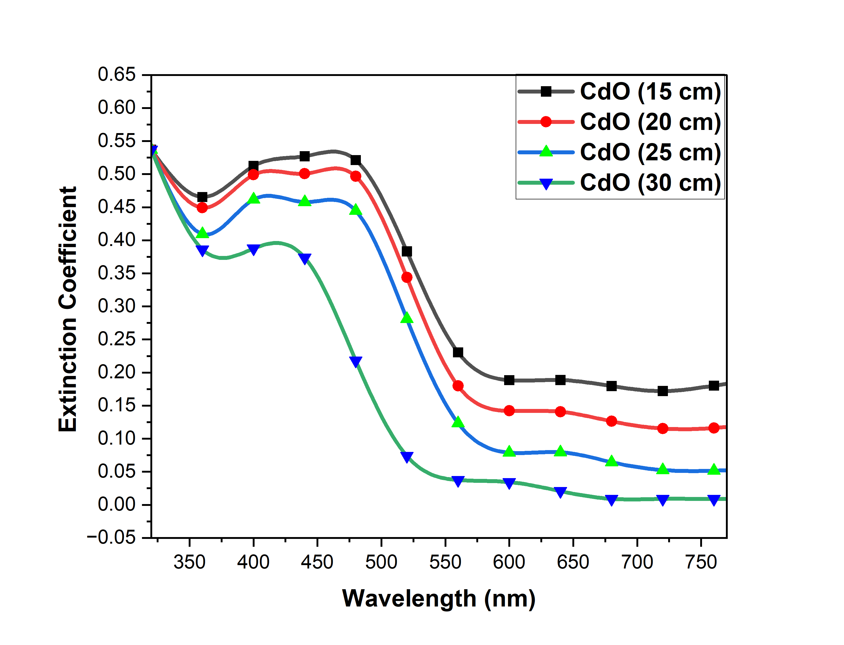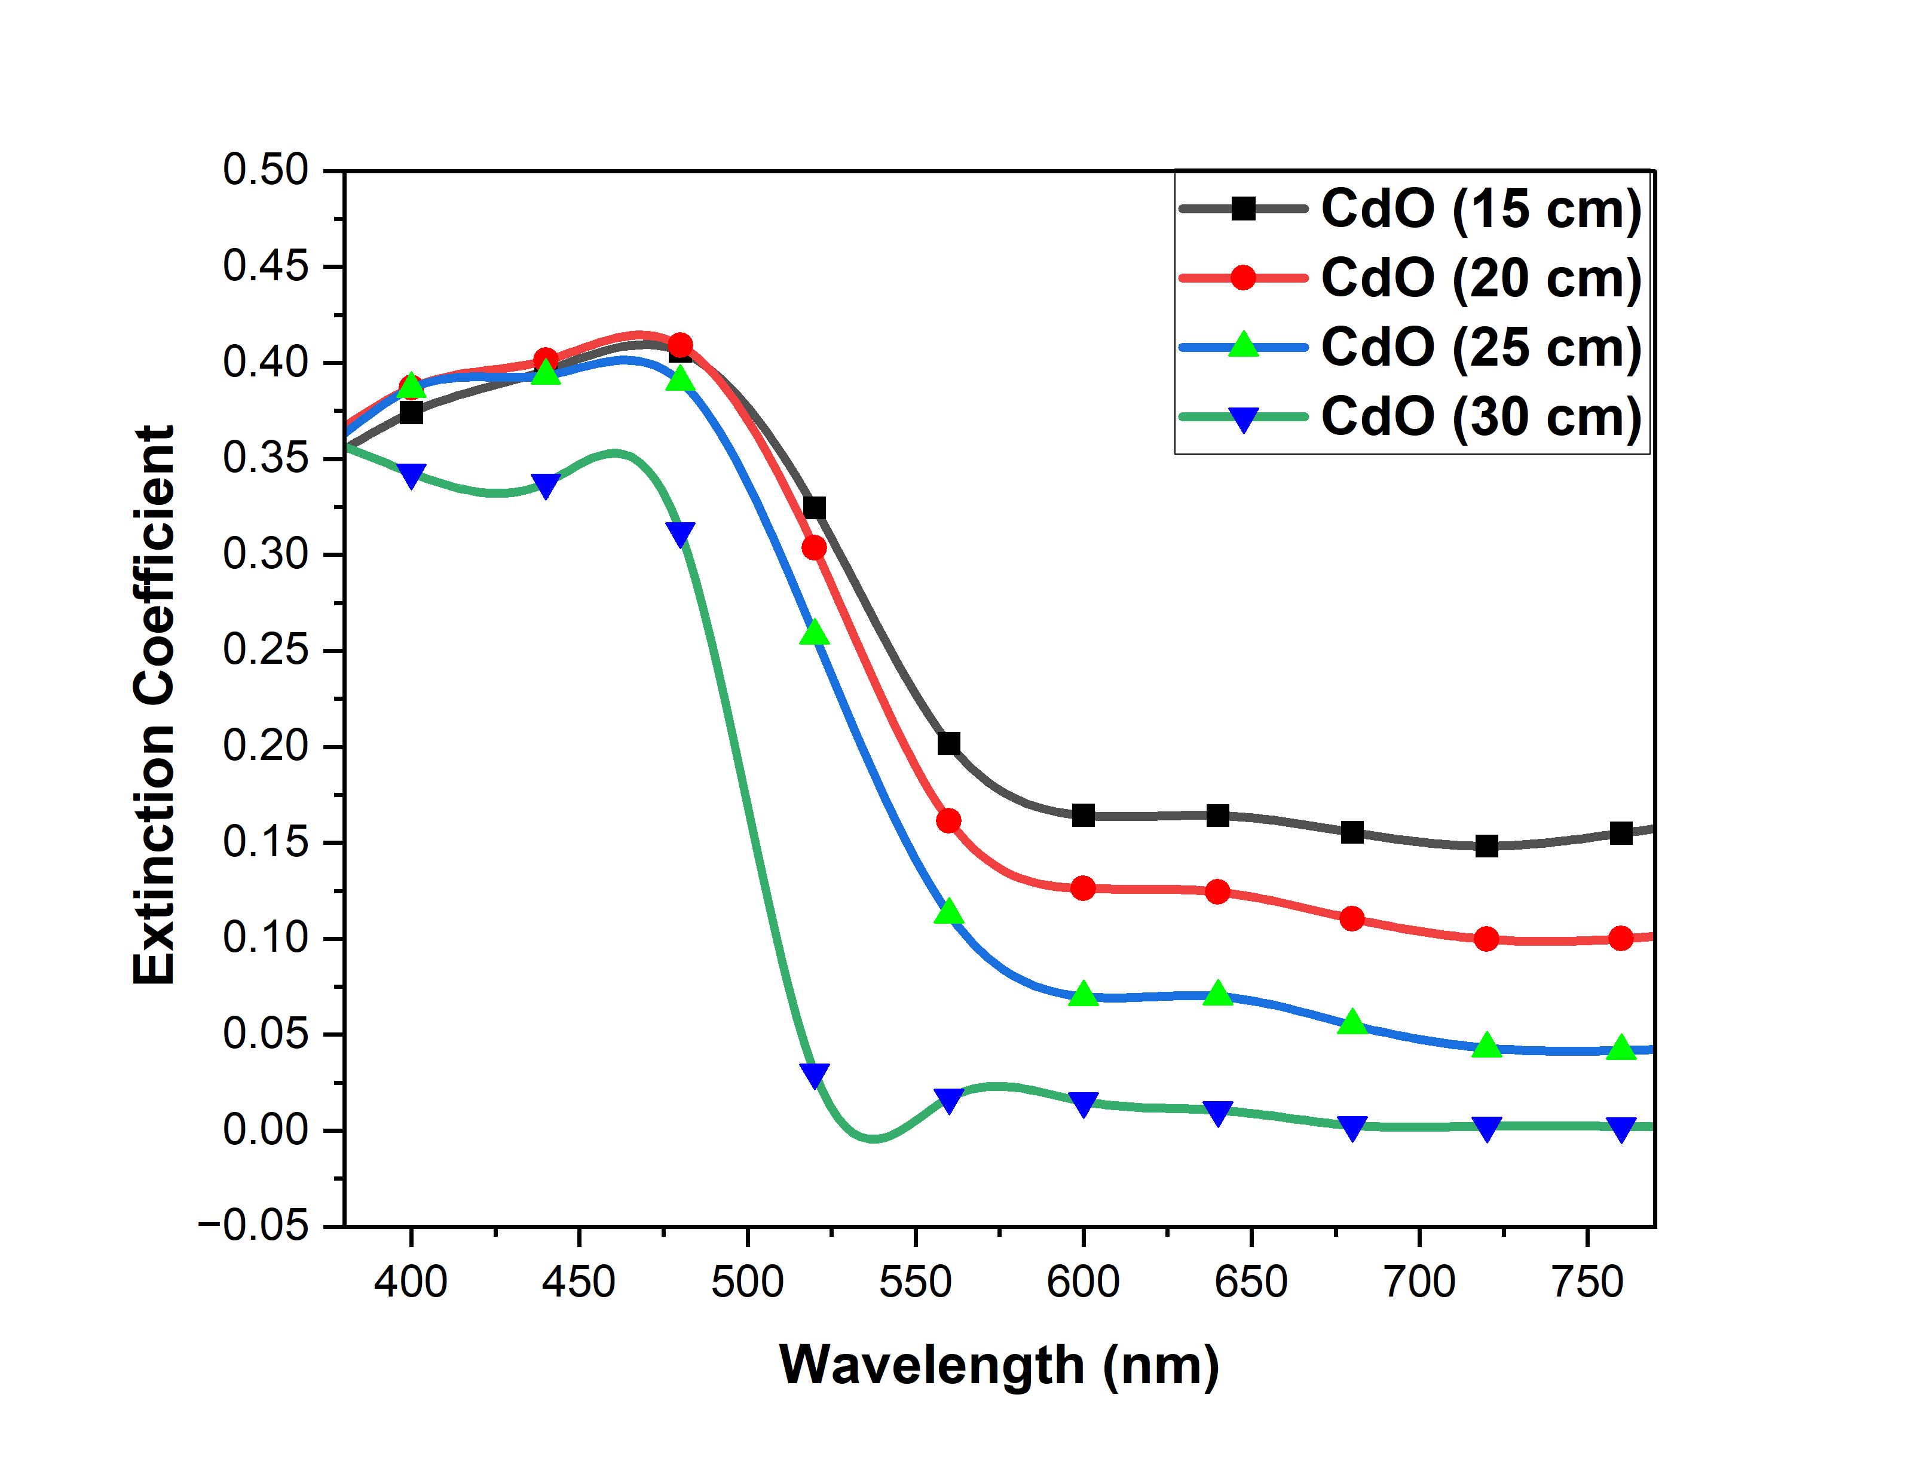
(b)
(a)
FIGURE 5. Distances (15,20,25,30 cm) -Driven Variation in Extinction coefficient : (a) Before Irradiation, (b) After Irradiation.
I examined the optical properties of CdO thin films that were prepared using Chemical Spray Pyrolysis (CSP) and exposed to gamma irradiation. Specifically, I looked at how changes in the nozzle-to-substrate distance during the deposition process affected the films' characteristics. A key innovation in my research is the investigation of this nozzle-to-substrate distance as a variable. I found that it plays a significant role in shaping the film's morphology and optical properties, especially the transmittance [27]. After gamma irradiation, I noticed a marked improvement in the films' optical transmittance, along with a reduction in the optical band gap [28, 29]. This reduction is a sign of enhanced electrical conductivity, which is crucial for applications such as solar cells. The band gap narrowed from 2.231 eV to 2.498 eV after irradiation, a notable difference when compared with previous studies. While similar research, including that by Seham H. S. Ajar and Nadir Fadhil Habubi, also observed a decrease in the band gap after irradiation, I believe that my unique contribution lies in considering the nozzle-to-substrate distance as a factor.
CONCLUSIONS
This study on cadmium oxide (CdO) thin films has shown some exciting potential for their use in optoelectronic applications like solar cells. By using the Chemical Spray Pyrolysis (CSP) method to deposit the films and subjecting them to cesium-137 gamma irradiation, we saw significant improvements in several key optical properties. Specifically, after irradiation, the films displayed a noticeable increase in optical transmittance. For example, at the wavelength of 760 nm, the transmittance values jumped from 52.3% to 57.5% for films deposited at 15 cm, from 64.8% to 68.92% at 20 cm, from 82.1% to 85.14% at 25 cm, and from 96.4% to 98.35% at 30 cm. This improvement is likely due to better grain alignment and fewer defects in the material, allowing more light to pass through. In addition, the irradiation process led to a narrowing of the films' optical band gaps, which is a key factor for improving their conductivity. Before irradiation, the band gaps were 2.231 eV, 2.272 eV, 2.305 eV, and 2.521 eV for films deposited at 15 cm, 20 cm, 25 cm, and 30 cm, respectively. After irradiation, these values dropped to 2.224 eV, 2.256 eV, 2.290 eV, and 2.498 eV. A smaller band gap means it's easier for electrons to move within the material, improving its electrical conductivity. Overall, the combination of cesium irradiation and adjusting deposition conditions like nozzle-to-substrate distance has proven to be an effective way to enhance the optical properties of CdO thin films. These improvements in light transmittance and conductivity make CdO films a promising, cost-effective material for high-performance solar cells and other optoelectronic devices, contributing to the advancement of renewable energy technologies.
ACKNOWLEDGMENTS
Thanks to the Department of New and Renewable Energy at the College of Science, University of Mosul, for facilitating my completion of the research process.
REFERENCES
- R. Khan Sharme, M. A. Quijada, M. Terrones, and M. M. Rana, "Thin Conducting Films: Preparation Methods, Optical and Electrical Properties, and Emerging Trends, Challenges, and Opportunities," Materials, vol. 17, no. 18, p. 4559, 2024, doi: 10.3390/ma17184559.
- Q. Zaman et al., "Dielectric-loaded waveguides as advanced platforms for diagnostics and application of transparent thin films," Langmuir, vol. 37, no. 11, pp. 3248–3260, 2021, doi: 10.1021/acs.langmuir.0c02862.
- M. I. Hossain and S. Mansour, "A critical overview of thin films coating technologies for energy applications," Cogent Engineering, vol. 10, no. 1, 2023, doi: 10.1080/23311916.2023.2179467.
- E. Picavet et al., "Solution-processed Pb (Zr, Ti) O3 thin films with strong remnant Pockels coefficient," ACS Appl. Mater. Interfaces, vol. 16, no. 31, pp. 41134–41144, 2024, doi: 10.1021/acsami.4c07073.
- D. S. Halil et al., "Thin films technology," 2024, doi: 10.58915/bk2023.011.
- S. A.-J. Jassim and E. M. A. Nassar, "Synthesis, structural and optical properties of CdO nanocrystalline prepared by sol–gel method," Nucleation and Atmospheric Aerosols, 2022, doi: 10.1063/5.0124168.
- I. Karim et al., "Effect of silver and cobalt on transparent conducting CdO thin films: tuning the optoelectronic properties," Mater. Adv., vol. 6, no. 2, pp. 703–718, 2025, doi: 10.1039/D4MA00918E.
- K. Al Abdullah, F. Al Alloush, M. J. Termanini, and C. Salame, “Low frequency and low temperature behavior of Si solar cell by AC impedance measurements,” Energy Procedia 19, 183–191 (2012).
- A. Zegaoui, M. Aillerie, P. Petit, J.-P. Sawicki, A. Jaafar, C. Salame, and J.-P. Charles, “Comparison of two common maximum power point trackers by simulating PV generators,” Energy Procedia 6, 678–687 (2011).
- J. Arcot and K. Shaik, "Effect of annealing temperature on structural, optical and electrical properties of CdO nanoparticles for lighting applications," Eur. Phys. J. B, vol. 98, no. 1, p. 20, 2025, doi: 10.1140/epjb/s10051-025-00867-9.
- B. Karthikeyan and R. Vettumperumal, "Optical and electrochemical properties of pure and Ti-doped CdO nanoparticles for device applications," Mater. Sci. Eng. B, vol. 281, p. 115754, 2022, doi: 10.1016/j.mseb.2022.115754.
- C. K. G. Kwok and K. M. Yu, "Highly transparent and conducting In doped CdO synthesized by sol-gel solution processing," J. Mater. Sci., vol. 56, no. 22, pp. 12607–12619, 2021, doi: 10.1007/S10853-021-06087-7.
- F. T. Z. Toma, Md. S. Rahman, K. Md. A. Hussain, and S. F. Ahmed, "Thin Film Deposition Techniques: A Comprehensive Review," J. Mod. Nanotechnol., vol. 4, p. 6, 2024, doi: 10.53964/jmn.2023206.
- K. Sivaramamoorthy, S. Perumal, A. Kalaivanan, and K. R. Murali, "Sol gel deposited CdO: In films," in Int. Conf. on Systems, pp. 91–93, 2011, doi: 10.1109/ICONSET.2011.6167918.
- H. K. R., E. S. M., and S. J. Retnam B., "Review on Spray Coating Techniques," 2023, doi: 10.59544/lurb3625/ngcesi23p64.
- S. Anitha et al., "Synthesis and characterization of NiO-CdO composite materials towards photoconductive and antibacterial applications," Mater. Chem. Phys., vol. 211, pp. 88–96, 2018, doi: 10.1016/j.matchemphys.2018.01.048.
- K. M. Saleh, "Study the Structural Properties and Surface Morphology of CdO thin films prepared by Chemical Spray pyrolysis," J. Kufa - Phys., vol. 12, no. 02, pp. 1–11, 2020, doi: 10.31257/2018/JKP/2020/120201.
- N. F. Habubi, B. A. Abrahim, and E. S. Noore, "Influence of irradiation on some optical properties of (CdO) thin films prepared by spray pyrolysis," Int. Lett. Chem. Phys. Astron., vol. 74, pp. 15–21, 2017, doi: 10.18052/WWW.SCIPRESS.COM/ILCPA.74.15.
- S. H. S. Ajar, E. Y. A. Ahmad, E. A. A. Hussein, and A. A. H. Habib, "Study the effect of irradiation on structural and optical properties of (CdO) thin films prepared by spray pyrolysis," J. Univ. Baghdad, vol. 28, no. 2, pp. 41–51, 2015.
- N. S. Abdel, H. Ihsan, F. T. M. Noori, and J. Pallon, "Modification of spray-deposited CdO thin films by 1.5 MeV proton irradiation," Nucl. Instrum. Methods Phys. Res. B, vol. 511, pp. 57–63, 2022, doi: 10.1016/J.NIMB.2021.11.012.
- T. O. Zinchenko et al., "Preparation of Transparent Conductive Thin-Film Coatings by Spray-Pyrolysis," in Proc. EDM, pp. 300–303, 2024, doi: 10.1109/edm61683.2024.10615175.
- K. M. Wadi, M. A. Hasan, S. H. Aneed, M. G. Faraj, and K. A. Jasim, "Synthesis and Analysis of the Density States and Optical Characteristics of Se₁₀₀₋ₓTeₓ Semiconductors," ARO - The Scientific Journal of Koya University, vol. 13, no. 1, pp. 1-12, May 2025. doi :10.14500/aro.11955.
- D. M. A. Latiff, B. A. Ahmed, S. M. Ali, and K. A. Jasim, "Fabrication and Characterization of Se₆₆S₄₄₋ₓAsₓ Thin Films," Chalcogenide Letters, vol. 22, no. 6, pp. 521-533, Jun. 2025. doi : 10.15251/CL.2025.226.521.
- Ahmed, B.A., Mohammed, J.S., Fadhil, R.N., ...Shaban, A.H., Al Dulaimi, A.H., The dependence of the energy density states on the substitution of chemical elements in the Se6 Te4-xSbx thin film, Chalcogenide Letters, 2022, 19(4), pp. 301–308.
- Al-Khafaji, R.S.A., Jasim, K.A., Dependence the microstructure specifications of earth metal lanthanum La substituted Bi2Ba2CaCu2–XLaXO8+δ on cation vacancies, AIMS Materials Science, 2021, 8(4), pp. 550–559.
- L. M. Al-Taan and A. A. Sulaiman, "Impact of 1.33 MeV-Gamma ray irradiation on the energy gap modification of CdSe thin films prepared by spray pyrolysis at different temperatures," Int. J. Multidiscip. Res. Growth Eval., vol. 5, no. 4, pp. 695–698, 2024, doi: 10.54660/. ijmrge.2024.5.4.695-698.
- L. A. Najam, L. M. Al-Taan, D. Hashim, and A. Refaei, "Preparation and study of the physical properties of CdSe films deposited by a chemical bath method and exposed to neutron irradiation," Jan. 2024.
- E. E. Ghadeer, R. Z. A. Al-Fulayih, and Z. B. Ibraheem, "Study of the effect of adding glass and carbon powders on optical behavior of unsaturated polyester resin," AIP Conf. Proc., vol. 2394, Dec. 2022, doi: 10.1063/5.0121875.
- H. S. Akbar, A. S. Jasim, and Z. S. Ali, "Effect of CO2 Laser Irradiation on the Optical Properties of Cadmium Oxide Thin Films Grown by Chemical Spray Pyrolysis (CSP) Method," IOSR Journal of Applied Physics, vol. 8, no. 4, pp. 01-09, Jul.-Aug. 2016. doi: 10.9790/4861-0804030109.

