Evaluation of Uranium Levels in Dental Glass Ionomer Luting Cement Using Neutron Activation Analysis Technology
Omar Abdul ^{1, a)} and Sameera A. E. ^{1, b)}
¹Department of Physics, College of Ibn Al-Haytham, University of Baghdad, Baghdad, Iraq

^{a)} Corresponding author: omar.Abd1204a@ihcoedu.uobaghdad.edu.iq
^{b)} sameera.a.i@ihcoedu.uobaghdad.edu.iq

Abstract. In this practical laboratory study, the aim was to evaluate and measure the levels of uranium present in glass ionomer cement used in restorative dentistry, utilizing the neutron activation analysis technique. This material contains the naturally occurring heavy element uranium-238 as an impurity, just like other restorative dental materials such as zirconia, amalgam, and acrylic. These heavy elements were an essential part of the manufacturing process in the past but were banned in the early 1980s. Studies continue to prove the presence of very small parts included in their raw materials. The importance of this research lies in determining the extent of exposure of patients and dentists to the radiation emitted by them. Although the expected levels are low, long-term accumulation and exposure to higher levels may have potential health effects. The technique we used is neutron activation analysis, which we chose because it is highly sensitive and accurate for determining uranium concentrations, equivalent and absorbed doses, and hazard index in ten samples of glass ionomer cement. Which we collected from different places in Iraq and explained in the research where we exposed them to a beam of fast neutrons in a neutron generator based on the reaction of (²⁴¹Am - ⁹Be) with an effectiveness of 12 Ci and a neutron flux of 10⁵ n.cm⁻² and then monitored the alpha particles that are released from the uranium through the CR-39 solid trace detector using an optical microscope and we determined the concentrations accurately. The results showed varying levels of uranium in the samples, and they were all within the acceptable limits. The highest concentration we obtained was 0.3435 mSv/y, which is certainly less than the permissible level approved by the International Atomic Energy Agency, which is 1mSv/y.Our research will contribute to increasing awareness about the presence of uranium in restorative dental materials, and we hope that this research now provides a scientific basis for making future decisions regarding the safety of materials used in dentistry and developing alternatives that contain lower levels of uranium.
Keywords: Glass ionomer luting cement, CR-39 detector, etching, uranium concentration.

INTRODUCTION
In the field of restorative dentistry, dental materials play a vital role in providing appropriate and effective treatment, as well as maintaining the health of the mouth and its vital organs. They are a wide range of materials used in fillings, artificial teeth, dental crowns, bridges, sealants, and complete dentures. Aesthetic considerations are given due to their impact on the patient's psychological well-being. A variety of materials are used, including metals, ceramics, polymers, and glass ionomers, such as metal fillings, zirconia, acrylic, and glass ionomer sealants, which are the subject of our research. This type of material originated around 3000 BC[1], when the Phoenicians used gold bands and wires to secure extracted teeth to their original ones. Around 600 AD [2], the Mayan civilization used seashells as implants. In the sixteenth century, the physician Fauchard used tin foil to fill cavities in teeth. This marked the beginning of modern restorative dentistry when he proportions within international safety standards. In our research, we will examine ionomer glass sealants to determine the regulated uranium concentration in these materials. Toothpaste is one of the most important dental materials in restorative dentistry, primarily used to prevent cavities. It fills the gaps between the tooth structure and the surrounding tissues and cells. It has excellent adhesive properties that enable the bonding of bridges and crowns, as well as filling gaps between teeth. It also releases vital fluoride, which preserves teeth and prevents bacterial growth and demineralization of tooth enamel, thus demineralizing natural teeth in the mouth. It was first used in 1972, primarily for cosmetic restoration of anterior teeth. Over time and development, its properties have improved, and it is now used in bonding, in addition to restoring primary teeth, lateral lesions, and the sides of teeth. As for its use, it consists of two parts: a powder part (SiO₃, AlF₃, SrO, Na₃AlF₆)[3], [4] and a liquid part composed of polymerizable groups linked to polyacrylic acid and/or hydrophilic monomers[5], which are added to form a viscous mixture or paste. The adhesive fills microscopic gaps between the tooth and the bone in the jaw or parts of an old tooth, to prevent the spread of oral fluids and bacterial invasion. It works in two stages, the first is the creation of microscopic pores by removing the inorganic material from the tooth or the original bone in the jaw[6]. The second is the penetration of the resin monomers into these pores, thus achieving mechanical interlocking. The inorganic material is replaced by these synthetic resins, which are affected by the following factors (wetting, surface energy, interference, chemical bonding). In practice, we collected ten samples from local sources in Baghdad, authorized agents, and hospitals, of the glass ionomer adhesive used in the field. Restorative dentistry for bonding artificial teeth, crowns, and complete dentures. This material has unique properties, including releasing fluoride, an anti-caries agent, and is highly bonded for long periods and resistant to humid environments. We used a method to determine the proportion of structured uranium in these samples using neutron activation analysis (NAA) using a CR-39 solid trace detector[7], [8]. We bombarded the samples with fast neutrons using a neutron generator located at the University of Baghdad, College of Education, Ibn Al-Haytham[9],[10] [11]Advanced Nuclear Physics Laboratory. The neutron generator is based on the reaction of ²⁴¹Am-⁹Be, with an effectiveness of 12 Ci giving it a neutron flux rate of 10⁵ n.cm⁻².sec⁻¹ and a neutron flux of 6.048×10¹⁰ n.cm⁻² for seven days[11], [12]. We relied on neutron activation analysis (NAA) technology. This technique is considered one of the most important analytical tools due to its many advantages, which we will mention. It is used in fields such as chemistry, physics, environmental sciences, forensics, geology, archaeology, and others. This technique is based on the principle of exciting elements with neutrons. Samples to be studied are bombarded with fast or thermal neutrons, as desired, using accelerators, generators, nuclear reactors, or other neutron sources. Some elements transform into unstable emits radiation. Therefore, this radiation can be identified and measured in multiple ways. This method is characterized by its comprehensive accuracy, making it superior to chemical analysis, as it measures element concentrations as small as one part per billion, even if these samples contain a wide spectrum of heavy or light elements. It is also a non-destructive technique, making it suitable for studying high-value samples, such as artefacts, without affecting their physical and chemical properties. Detailed information about the chemical composition of the samples is available. We used this method in our practical laboratory research for the reasons mentioned above. It saved us time and was highly accurate. Our research attempts to determine whether the amount of regulated uranium in the materials we selected is within international standards. the first is that the effective dose be less than 1 mS/y[13]. The second standard, set by the International Organization for Standardization, sets the maximum radiation limit for dental materials, which should not exceed 1Bq/g[14]published a treatise in 1728 detailing dental restoration materials. He then developed a method for taking mouth impressions and fabricating teeth using plaster of Paris. The pace of discoveries and developments continued until 1919, when the US Army established specifications for evaluating and selecting dental sealants. In 1928, the American Dental Association took over scientific research in the field of restorative dentistry. Until the 1980s, all of these materials contained heavy elements such as uranium to give them strength, hardness, and a shape similar to natural teeth. Their use was then banned[15]. To date, numerous studies have confirmed the presence of these nuclei, but in control.

METHOD AND MATERIAL

As for the samples in our research, we collected them from authorized agents in Baghdad and some hospitals, totaling 10 samples from different origins and companies, as shown in Table 1

Table .1 Glass ionomer luting samples by company, origin and location
Sample no. | Manufacturer | Origin | Sample collection location
 | Medicem | Germany | Iraq/Baghdad/Bab Al-Muadham/High Summit Office for Dental Supplies
 | Meron | Australia | Iraq/Baghdad/Bab Al-Muadham/High Summit Office for Dental Supplies
 | Pyrax | India | Iraq/Baghdad/Bab Al-Muadham/High Summit Office for Dental Supplies
 | Master dent | U S A | Al Dora area / Abu Tayyara Street / Dubai Dental Center
 | Riva | U S A | Iraq/Baghdad/Bab Al-Muadham/High Summit Office for Dental Supplies
 | D line | Lithuanian | Iraq/Baghdad/Bab Al-Muadham/High Summit Office for Dental Supplies
 | Promida | Turkey | Iraq/Baghdad/Bab Al-Muadham/High Summit Office for Dental Supplies
 | Master dent | U S A | Iraq/Baghdad/Bab Al-Muadham/High Summit Office for Dental Supplies
 | Micron Luting Glass ionomer Cement | U S A | Iraq/Baghdad/Bab Al-Muadham/High Summit Office for Dental Supplies
 | AHlute Glass Ionomer Luting Cement | United Kingdom | Iraq/Baghdad/Bab Al-Muadham/High Summit Office for Dental Supplies

All of these samples were two parts, one part powder and one part liquid, which included a reaction. After that, we homogenized them to simulate the nature of the adhesive inside the mouth. After hardening, we ground them using an electric grinder and then a manual grinder to ensure homogeneity, smoothness, and small size of the grains so that they would not disintegrate after the pressing process, which we carried out using a hydraulic press in the laboratories of our college, Ibn Al-Haytham, University of Baghdad, in molds made of metal with a diameter of one and a half cm and a weight of one gram for each sample. The result was that we obtained solid discs that did not disintegrate. We placed them and stuck them on the CR-39 detector as shown in figure 1.b after cutting it into squares with a side length of one and a half cm. After that, we entered them into the neutron generator in the advanced nuclear laboratory of Ibn Al-Haytham College of Education, which depends on the reaction Americium beryllium as in figure1. It gives a neutron flux of 10⁵ n.cm-2.sec-1 and a neutron flux of 6.048×10¹⁰ n.cm⁻² for a period of seven days after which we lifted the samples and removed them and then washed the detector well with distilled water and dried it. Then we carried out the chemical scraping process using a sodium hydroxide solution in a heat bath at a temperature of 60 degrees Celsius for three hours. Then we washed the samples and placed them on a light microscope to read the traces present in these samples and we took an average of ten readings for each sample. This method is the same that we followed with the standard samples, where we took five samples and added known uranium concentrations from the uranium stat solution for the purpose of knowing the slope in the equation through which we calculate the concentrations of the purified uranium in our unknown samples.
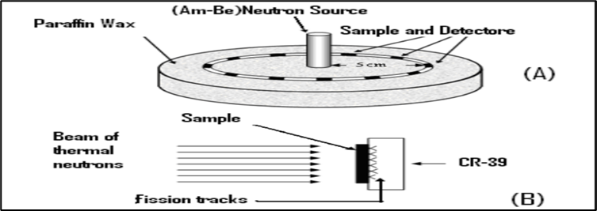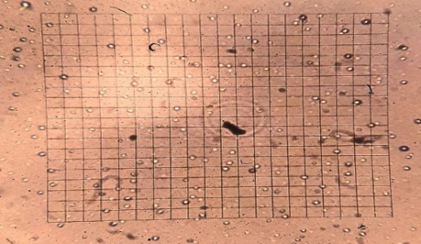
a b
Figure .1 a.The irradiation of the detectors and samples by the neutron source b. CR-39 detector Under the microscope

CALCULATIONS
In order to calculate the concentrations of purified uranium in the unknown samples, first we make six samples of standard samples, the first is zero, and the remaining five we add uranium statins as a solution to the powder after we grind it to concentrations of 2, 8, 12, 16, and 20 parts per million(ppm), respectively. After that, [16][17][18] we dry it and press it as we mentioned previously and explained about it, and we made a graph between the density of these samples and the concentration of uranium in them, and we obtained the slope, which is the key to [19][10][11][9][20] the mathematical equations that we will use and shown in figure. 2.
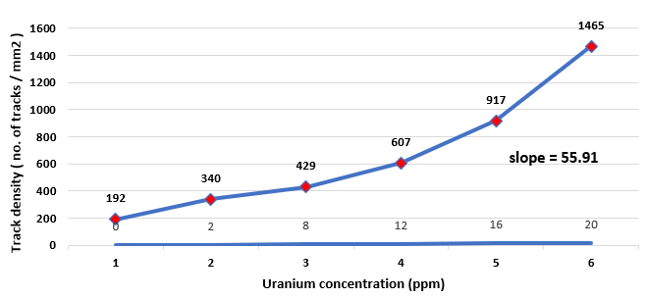
Figure .2 Relationship of trace density with uranium concentration for the standard models luting ionomer

Using equations No. we calculated the uranium concentration, density [21, 23].
$\frac{C_{x}}{C_{s}}= \frac{ρ_{x}}{ρ_{s}} \frac{I_{s}}{I_{x}} \frac{R_{s}}{R_{x}}$ (1)
$C_{x}= \frac{c_{s}}{ρ_{s}} ρ_{x} \frac{I_{s}}{I_{x}} \frac{R_{s}}{R_{x}}$ (2)
$C_{x}= \frac{ρ_{x}}{slope} \frac{I_{s}}{I_{x}} \frac{R_{s}}{R_{x}}$ ($SEQ Equation \backslash * ARABIC$$3$)

C_{x} = Uranium concentration for unknown samples, C_{s} = Uranium concentration for standard samples

$ρ$_{x} = The density of the effects of the unknown models is represented., $ρ$_{s} = The density of the effects of the standard models is represented., R_{x,} R_{s} = The range of the fragments is approximately equal to one. I_{x} = Isotopic abundances of uranium-235 and uranium-238 Content on depleted uranium for unknown samples [24].

I_{s} = Isotopic abundances of uranium-235 and uranium-238, containing natural uranium for standard samples
$I_{x}= \frac{{238}_{U }}{{235}_{U}}= \frac{99.27}{0.201}=495.25$ (4)
$I_{s}= \frac{{238}_{U }}{{235}_{U}}= \frac{99.27}{0.72}=137.87$ (5)
$C_{x(ppm)} =\frac{ρ_{x}}{ slope} ×0.278$ (6)
$ρ_{x}=\frac{N_{ave}}{A}$ (7)

N_{ave}= The rate of quantitative effects within the area., A = area =0.0676 mm²
$D_{Ti }= 1.6×{10}^{-10}×S.A×E_{r}$ (8)
$H_{Ti}=D_{Ti}×W_{R}$ (9)
$E_{Ti}=ΣW_{Ti}×H_{Ti}$ (10)
$H_{ex}=\frac{{(S.A )238}_{U}}{185}≤1$ (11)
$D_{Ti}=Absorbed dose (mGy/y)$ (12)

(S.A) = specific activity Bq/kg, (Hex) = Hazard index, H_{Ti} =The Equivalent Dose, E_{Ti} = effective doses (mSv/y)
Table .2 Symbols used in equations and their values
The symbol | Meaning | value
E [21] | Alpha Energy | 4.2 MeV
W_{R} [22] | Alpha Radiation Weighting Factor | 20
W_{Ti} [22] | skin, bone surface Weighting Factor | 0.01

Using equation 6 we were able to calculate the concentration of uranium in the samples and equation 7 was used to calculate the density, as shown in table 3
Table .3 glass ionomer luting sample data
luting sample | Traces average | Net traces | traces density ($ρ$) | Uranium concentration (C_{x})  ppm
 | 58 | 39 | 581.14±33.85 | 2.88±0.16
 | 64 | 45 | 669.90±31.62 | 3.33±0.15
 | 64 | 45 | 667.79±13.30 | 3.32±0.06
 | 55 | 36 | 534.65±33.54 | 2.65±0.16
 | 53 | 34 | 507.18±29.23 | 2.52±0.14
 | 48 | 29 | 424.76±66.54 | 2.11±0.33
 | 50 | 31 | 458.57±109.04 | 2.28±0.54
 | 62 | 43 | 631.86±58.37 | 3.14±0.29
 | 51 | 32 | 479.71±61.50 | 2.38±0.30
 | 60 | 41 | 612.84±99.54 | 3.04±0.49

And using equation 12 we were able to calculate the Hazard index and equation 13 to calculate Absorbed dose, equation 11 to calculate the Equivalent Dose and equation 10 to calculate effective doses as shown in table 4.
From table 4 and figure 3.a we notice that the concentration of uranium ranges and specific activity from the lowest value (2.11±0.33ppm) (26.08±4.08 Bq/kg) in sample no.6 to (3.33±0.15ppm) (41.13±1.94 Bq/kg) the highest value in sample no.2, with the origin and company mentioned in table 1, also the effective doses will be the highest for this sample as in figure 3.b.
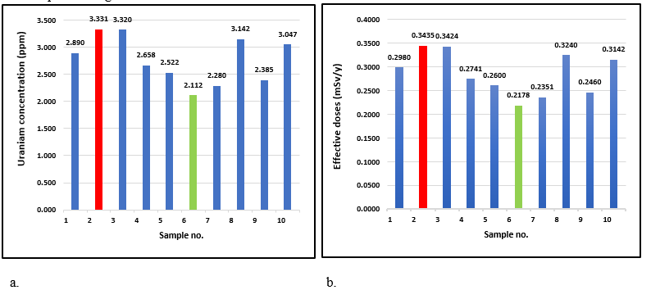
Figure .3 a. Uranium concentration chart in glass ionomer luting sample, b. chart in glass ionomer luting effective doses (mSv/y)
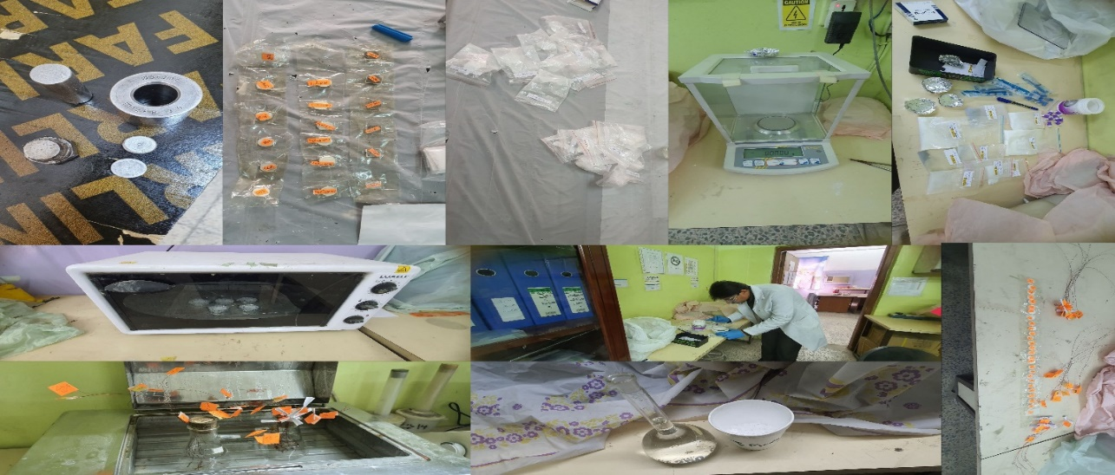
Figure .4 Some of the tools and samples used in the laboratory in this research
Table .4 Specific activity, sustained dose, equivalent dose, absorbed dose, reward, effective dose, and Hazard index
Glass ionomer luting | specific activity (S.A) Bq/kg | Hazard index (H_{ex}) | Absorbed dose (mGy/y)  D_{Ti} | The Equivalent Dose  (H_{Ti}) | effective doses (mSv/y) For bone and skin surfaces  (E_{Ti})
 | 35.68±2.07 | 0.1929 | 0.7449 | 14.8986 | 0.2980
 | 41.13±1.94 | 0.2224 | 0.8587 | 17.1740 | 0.3435
 | 41.00±0.81 | 0.2217 | 0.8560 | 17.1199 | 0.3424
 | 32.83±2.06 | 0.1775 | 0.6853 | 13.7067 | 0.2741
 | 31.14±1.79 | 0.1684 | 0.6501 | 13.0024 | 0.2600
 | 26.08±4.08 | 0.1410 | 0.5445 | 10.8895 | 0.2178
 | 28.16±6.69 | 0.1522 | 0.5878 | 11.7564 | 0.2351
 | 38.80±3.58 | 0.2097 | 0.8099 | 16.1989 | 0.3240
 | 29.45±3.77 | 0.1592 | 0.6149 | 12.2981 | 0.2460
 | 37.63±6.11 | 0.2034 | 0.7856 | 15.7113 | 0.3142

CONCLUSION
In comparison with a study conducted on zirconia, which is one of the dental materials that protect the title (Zirconia and radioactivity: An in vitro study to establish the presence of radionuclides in dental zirconia)[23], it was proven that there are radioactive elements such as uranium within this material, and the highest radioactivity obtained by this study was 11.082 Bq/kg. Also, another study entitled (Natural radioactivity in zirconia-based dental ceramics)[24], which was also conducted on zirconia, found that the radioactivity of uranium-238 was (9.9 Bq/kg). Therefore, such materials still contain uranium and radioactivity levels, despite being within the permissible range. However, patients will be more exposed to radiation risks than others because they carry a percentage of the radiation dose. Generally, this percentage is very small, but it indicates the presence of uranium in fillings made from glass ionomer luting type. It is also below the internationally agreed-upon permissible dose, so it is within safety limits, 1 mSv per year and 1 Bq/g as radioactivity. In our study, the highest effective dose recorded is (0.3435 mSv/y), and activity (41.13±1.94 Bq/kg) which is less than many of the permissible limitsClick or tap here to enter text.

ACKNOWLEDGMENTS

In my research and my practical work in specialized laboratories, I would like to thank those in charge of the Advanced Nuclear Physics Laboratory at the College of Education ibn Al-Haitham, University of Baghdad, Department of Physics.

REFERENCES

- W. Hoffmann-Axthelm, History of Dentistry. Chicago: Quintessence Pub. Co, 1981, Inc.
- M. B. Asbell, “Dentistry: A historical perspective. Bryn Mawr: Penn. Dorrance-Company,” Inc, vol. 45, pp. 52–60, 1988.
- K. J. Anusavice, C. Shen, and H. R. Rawls, Phillips’ science of dental materials. Elsevier Health Sciences, 2012.
- B. A. Ahmed, J. S. Mohammed, R. N. Fadhil, A. H. Shaban, A. H. Al Dulaimi, Chalcogenide Letters, 2022, 19(4), pp. 301–308.
- K. M. Wadi, K. A. Jasim, A. H. Shaban, M. K. Kamil, F. K. Nsaif, Journal of Green Engineering, 2020, 10(9), pp. 6052–6062.
- K. A. Jasim, T. J. Alwan, K. H. Mahdi, H. L. Mansour, H.L., Turkish Journal of Physics, 2013, 37(2), pp. 237–241
- G. Schmalz and D. Arenholt-Bindslev, Biocompatibility of dental materials, vol. 1. Springer, 2009.
- M. V. Frontasyeva, “Neutron activation analysis in the life sciences,” Physics of particles and nuclei, vol. 42, pp. 332–378, 2011.
- B. B.Kadhim, I. H. Khaleel, B. H. Hussein, ...B. K. H. Al-Maiyaly, , S. H. Mahdi, AIP Conference Proceedings, 2018, 1968, 030054..
- D. Abed, S. Sameera, and A. Ebrahiem, “Measurement of Radon Concentration in College of Education for Pure Science / Ibn Al-Haitham Buildings Using CR-39 Detector,” Ibn AL-Haitham Journal for Pure and Applied Sciences, vol. 31, no. 2, pp. 52–59, Sep. 2018.
- A. T. Subhi, “Calculation of the concentrations of depleted uranium in the Diyala River sediment samples using the nuclear track detector CR-39,” Ibn Al-Haitham Journal For Pure and Applied Sciences, vol. 26, no. 3, pp. 122–131, 2013.
- A. T. Subhi, “Calculation of the concentrations of depleted uranium in the Diyala River sediment samples using the nuclear track detector CR-39,” Ibn AL-Haitham Journal for Pure and Applied Science, vol. 26, no. 3, pp. 122–131, 2017.
- K. A. Jasim, R. N. Fadhil, Journal of Physics: Conference Series, 2018, 1003(1), 012082.
- K. Eckerman, J. Harrison, H. G. Menzel, and C. H. Clement, “ICRP publication 119: compendium of dose coefficients based on ICRP publication 60,” Ann ICRP, vol. 41, pp. 1–130, 2012.
- R. A. Hawsawi, C. A. Miller, R. D. Moorehead, and C. W. Stokes, “Evaluation of reproducibility of the chemical solubility of dental ceramics using ISO 6872: 2015,” J Prosthet Dent, vol. 124, no. 2, pp. 230–236, 2020.
- A. Zegaoui, M. Aillerie, P. Petit, J.-P. Sawicki, A. Jaafar, C. Salame, and J.-P. Charles, “Comparison of two common maximum power point trackers by simulating PV generators,” Energy Procedia 6, 678–687 (2011).
- K. H. Mahdi, A. T. Subhi, and N. F. Tawfiq, “Calculation of depleted uranium concentration in dental filling samples using the nuclear track detector CR-39,” 2012.
- N. H. KADIM, “Using of Nuclear Track Detector CR-39 To Measure Depleted Uranium Concentration of Mother’s Milk.,” Baghdad Science Journal, vol. 1, no. 2, p. 8, Dec. 2004.
- K. H. Mahdi, A. T. Subhi, and N. F. Tawfiq, “Calculation of depleted uranium concentration in dental filling samples using the nuclear track detector CR-39,” 2012.
- A. T. Al-Bayati, A. M. Alwan, and H. A. Miran, Malaysian Journal of Science, vol. 42, no. 2, pp. 1–6, Jun. 2023.
- A. Tariq Al-Bayati, “Measurement of uranium concentration in the water samples collected from the areas surrounding in Al-Tuwaitha nuclear site using the CR-39 detector,” J Phys Conf Ser, vol. 1234, no. 1, Jul. 2019.
- Merril. Eisenbud and T. F. Gesell, “Environmental radioactivity: from natural, industrial, and military sources,” p. 656, 1997.
- J. Magill and J. Galy, Radioactivity, radionuclides, radiation, vol. 259. Springer, 2005.
- Brizuela-Velasco, Y. Chento-Valiente, D. Chávarri-Prado, E. Pérez-Pevida, and M. Diéguez-Pereira, “Zirconia and radioactivity: An in vitro study to establish the presence of radionuclides in dental zirconia,” J Prosthet Dent, vol. 126, no. 1, pp. 115–118, 2021.

