Investigation of the Fast Neutron Shielding Properties of Glass-Unsaturated Polyester Composites
Mohammed A. Ibrahim^{1,a)}, Ahmed Fadhil Mkhaiber², Duaa Abed Salim³
¹ Science Department, College of Basic Education, Mustansiriyah University, Baghdad, Iraq
² Physics Department, College of Education for Pure Science, University of Baghdad, Iraq
³ Department of Physics, College of Science, Mustansiriyah University, Baghdad, Iraq

ª Corresponding author: mohammed1994@uomustansiriyah.edu.iq

Abstract. The main principle of radiation protection is to limit radiation exposure or reduce the value of this exposure as much as possible. One of the most important means used to reduce the value of radiation exposure is the use of radiation shield, which are used to contain radioactive sources or create radiation barriers. The design and selection of appropriate materials for radiation shields depend on the type of radiation and its energy. The current work aims to study the fast neutron shielding using unsaturated polyester composite reinforced with glass. Shielding against fast neutrons remains a critical challenge in radiation protection due to their high power and the inefficiency of conventional materials (e.g., concrete, lead) at manageable weights. Polymer-glass composites emerge as a promising solution, combining the lightweight flexibility of unsaturated polyester with the neutron moderation and absorption capabilities of glass reinforcement. Fast neutron shields were manufactured using unsaturated polyester as a base material with different concentrations of ordinary glass and boron-reinforced glass as reinforcement materials with different concentrations (10%, 20%, 30%, 40% and 50%) and a thickness of 1 cm. For this purpose, the Am-Be neutron source with a neutron flux of 3x105(n/cm2.s) was used. Some shielding properties such as the macroscopic cross-section, half-thickness and mean free path, were measured to determine the efficiency of the manufactured shields. The results showed that with increasing the concentration of the reinforcement material, the macroscopic cross-section values increased while the half-thickness and mean free path values decreased. The results also showed that boron-reinforced glass exhibits better shielding properties than ordinary glass due to its content of boron, which is a good neutron absorber.
Keywords: Neutron, shielding, Radiation, Attenuation coefficient, Glass reinforcement, Borated glass
INTRODUCTION
The high penetration power of fast neutrons (1-20 Mev) and the constraints of conventional materials (e.g., lead toxicity, concrete bulk) continue to make radiation shielding a critical challenge [1-2]. While polymers such as unsaturated polyester provide lightweight, environmentally acceptable alternatives, their performance is dependent on optimizing filler component for neutron moderation and absorption [3-4]. Many research has addressed the subject of neutron shielding, for instance, Ogul et al. demonstrated enhanced neutron attenuation in polyester-B4C/Sn composite [5]. Ghule et al. showed bismuth oxide-polyester blends as viable gamma shields [6]. A recent study by Aboud et al. indicates that Bi2O3 –doped Cd-Bi-Pb-Zn- borate glasses are promising materials for ℽ–ray protection application [7]. However, systematic investigations on borated glass-polyester composites for fast neutrons are limited, particularly in terms of filler concentration thresholds (10-50 wt %) and microstructure-property connections [8-9]. This study looks at fast neutron shielding using unsaturated polyester composites reinforced with borated/standard glass (10-50 wt %). Using an Am-Be source and Rad Eye Personal Highly Sensitive Neutron Radiation Detectors, Macroscopic cross-section, mean free path and half-thickness were measured, and boron’s function in neutron absorption and comparative performance versus standard material. Our research closes the gap between material design (lightweight, scalable manufacturing) and functional needs (high neutron attenuation), providing insights for medical, nuclear, and aerospace applications.

MATERIALS AND METHODS
This experimental study examines the neutron shielding properties of glass-unsaturated polyester composites. It focuses on manufacturing radiation shields using unsaturated polyester, borated glass, and normal glass reinforcement [10]. The shields are subjected to neutron irradiation using a calibrated source, and their attenuation qualities are quantitatively assessed using perceptible cross-segment, half-thickness, and mean freeway estimations.
Parameters of Attenuation Coefficients
When a beam of neutrons passes through a substance, there is a chance that they will react with the substance. This possibility is expressed through the macroscopic cross-section. As a result, the intensity of the neutron bunch decreases due to scattering (elastic and inelastic) or absorption. The amount of attenuation can be calculated using the following relationship:
$$\begin{aligned}I_{x}=I_{∘}e^{-∑x}\#\left(1\right)\end{aligned}$$
Where Ix is the intensity transmitted through the shield, I˳ is the initial intensity, Ʃ is Macroscopic cross section, in (cm-1), and x is the shield thickness, in (cm) [11].
The macroscopic cross-section of a reaction measures the likelihood of the reaction occurring. The possibility of neutrons interacting with the nucleus depends on the neutron's energy, not just the type of nucleus involved. Therefore, the probability of thermal neutron absorption by a material is higher than that of fast neutron absorption. The macroscopic cross-section was calculated from the following equation [12]:
$$\begin{aligned}Σ=Nσ\#\left(2\right)\end{aligned}$$
Where N is number of atoms per unit volume, and σ is Microscopic cross section.
It represents the thickness of the material necessary to attenuate the intensity of the incident neutrons to half its original intensity, it was calculated by the following equation [13]:
$$\begin{aligned}X_{\frac{1}{2}}=\frac{0.693}{Σ}\#\left(3\right)\end{aligned}$$
The mean free path is the distance between two successive collisions, the mean free path was calculated using the following equation [14]:
$$\begin{aligned}λ=\frac{1}{Σ}\#\left(4\right)\end{aligned}$$
The density of the manufactured shields was calculated using the following equations:
$$\begin{aligned}W_{c}=W_{f}+W_{m}\#\left(5\right)\end{aligned}$$
$$\begin{aligned}Ψ=\frac{Wf}{Wc}×100\%\#\left(6\right)\end{aligned}$$
$$\begin{aligned}Vf=\frac{1}{1+\left[\left(\frac{1-Ψ}{Ψ}\right)*\frac{ρf}{ρ m}\right]}\#\left(7\right)\end{aligned}$$
$$\begin{aligned}ρ=ρfVf+\left(1-Vf\right)ρm\#\left(8\right)\end{aligned}$$
Where $Ψ$ = fraction weighted for reinforcement materials, $Vf$ = is the volume fraction, ρf, ρm the reinforcement and matrix material density, $Wf$ &$W_{m}$ are the weight of reinforcement and matrix material, respectively, and $Wc$: the weight of the mixture material [15].
EXPERIMENTAL WORK
n irradiation framework has been planned utilizing an iron box, which is shown in Fig.1, with aspects of (10 cm x 20 cm). The container has paraffin wax inside. We have utilized Am-Be as the neutron source with flux of 3×105 n/ (cm2.s), it is placed into the irradiation framework through the upper opening of the container. The shield has been put before the side gap of the case to guarantee that the neutron radiates stream horizontally. The primary reason for this plan is to guarantee the proficient progression of neutron radiates in a horizontal heading.

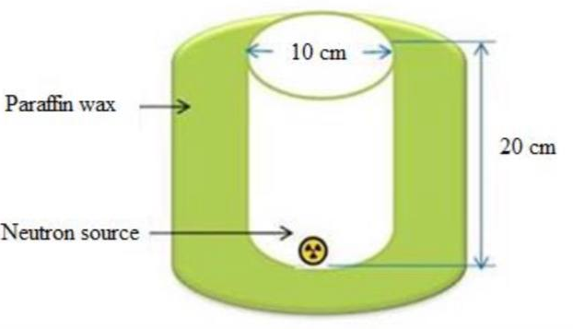
FIGURE 1. Irradiation system [16].
The shields was made involving unsaturated polyester as the matrix material with its hardener, and different focus (10%, 20%, 30%, 40%, and 50%) as reinforcement material (borated and normal glass) at thickness (1cm) as in Fig.(2-a), (2-b) and (2-c). The blending system took 10 minutes to guarantee the combination was homogenized. The blend was then positioned in the shape and left for a day to solidify.
The person al rad iation detector (PM1703GNA) that is made by the Palmister Organization was utilized to quantify the quantity of neutrons. Three readings of neutrons each moment have been chosen, and the average of these readings was calculated .
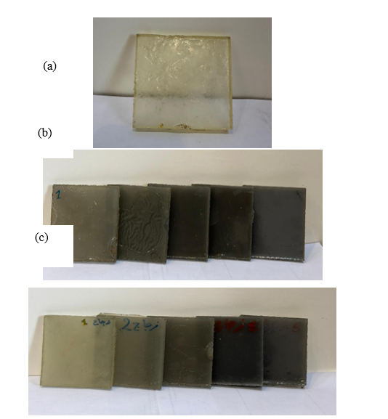
FIGURE 2. Unsaturated polyester shields (a) without reinforcing material, (b) with borated glass as the reinforcing material and (c) normal glass as the reinforcing material.

RESULTS AND DISCUSSION
To evaluate the effectiveness of shielding methods in attenuate radiation, one can calculate their shielding properties such as macroscopic cross-section, half-thickness and mean free path for glass-unsaturated composite.
Fig.3 shows the relation between macroscopic cross-section and reinforcement glass concentration, in which the macroscopic cross section increases with the increase in the concentration of the reinforced material especially when the concentration is >20%. The highest value of attenuation coefficient (∑) was (1.148023 and 0.84953) for borated and normal glass respectively, at a concentration of 50%. In addition to that, we can notice from Figure (3) that the attenuation coefficient values for the borated glass are higher than the values for the normal glass, and this can be related to the fact that the borated glass includes boron, which is considered as an absorption material of neutrons.
TABLE 1. Shows the values of macroscopic cross section, half-thickness, and mean free path for borated. glass.
 | Borated glass
Concentration | Average Count (count\sec) | ∑ (cm-1) | x ½ (cm) | λ (cm)
0% | 63±7.2111 | 0.428065 | 1.618913 | 2.336094
10% | 69.66±1.154 | 0.327478 | 2.116175 | 3.053643
20% | 61.66±3.5119 | 0.449456 | 1.541863 | 2.224911
30% | 44±9.5394 | 0.78701 | 0.880548 | 1.270632
40% | 38±3.605 | 0.933614 | 0.742277 | 1.071107
50% | 30.66±2.516 | 1.148023 | 0.603646 | 0.871062

TABLE 2. Shows the values of macroscopic cross section, half-thickness, and mean free path for normal glass.
 | Normal glass
Concentration | AverageCount (count\sec) | ∑ (cm-1) | x ½ (cm) | λ (cm)
0% | 63±7.2111 | 0.428065 | 1.618913 | 2.336094
10% | 65.33±4.725 | 0.391697 | 1.769223 | 2.552992
20% | 67.66±2.081 | 0.356606 | 1.943321 | 2.804215
30% | 56.66±7.023 | 0.534014 | 1.29772 | 1.872612
40% | 48.33±3.785 | 0.693078 | 0.999887 | 1.442839
50% | 41.33±4.163 | 0.84953 | 0.815745 | 1.177121

Fig.4 shows the relation between the half-thickness and the reinforcement material concentration. The values of the half thickness of the different shields decrease with increasing concentration, as the lowest values of the half thickness were (0.603646 and 0.815745) for borated and normal glass, respectively at the concentration of 50%. In addition to that, it is noted from the figure that the values of the half-thickness of the borated glass are less than those of normal glass [17]. The relation between the mean free path as a function of concentration was plotted as in Figure 5. It was found that there is a negative relationship between the concentration of reinforcement glass and the mean free path. Figure 5 shows that, when the concentration increases, the mean free path will decrease for borated and normal glass. The optimal mean free path value was achieved at a concentration of 50% for both borated and normal glass. The static relation between (∑) and X1\2 has been shown in Figure 6 (a, b) for the two types of glasses. As illustrated in Figure 6 shows the linear relation between the macroscopic cross-section and half-thickness for both borated and normal glass with the same reinforcement glass concentration. The Figure show that the relation was a strong negative relation. The correlation coefficient value for the borated and normal glass was (0.917 and 0.952) respectively.
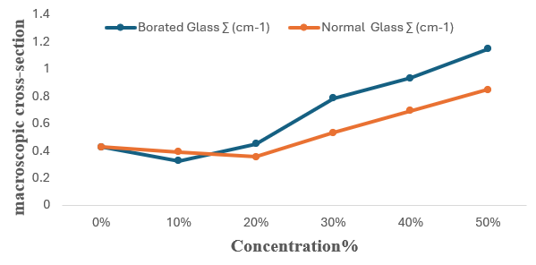
FIGURE 3. The macroscopic cross-section as a function of concentration.

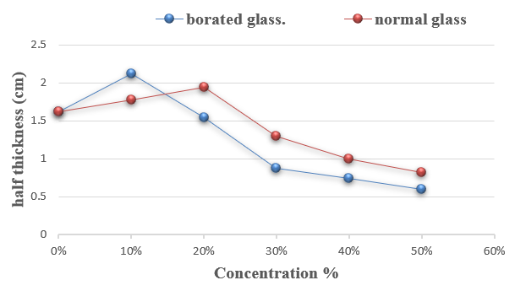
FIGURE 4. Half-thickness as a function of concentration.
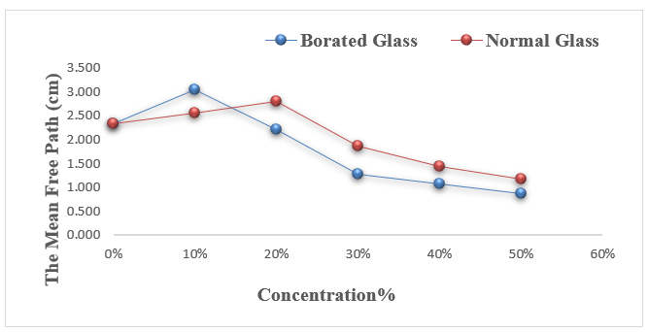
FIGURE 5. The mean free path as a function of concentration.

(a) | (b)
FIGURE (6). The relation between macroscopic cross-section and half-thickness for(a) borated and (b) normal glass.
CONCLUSION
Investigation of the fast neutron shielding properties of glass-unsaturated polyester composites, our review intended to extend how we might interpret their viability as radiation shielding materials. Was carried out Experimental results have shown that boron-reinforced glass gives better fast neutron attenuation than normal glass when used as a reinforcement material with a suitable matrix. This is proven by the values of the different shielding coefficient.
The review highlights the potential of glass-unsaturated polyester composites as radiation shielding materials, offering significant benefits across various uses such as thermal energy stations, medical offices, and industrial settings. By utilizing advanced methodologies, this could enhance safety and productivity in radiation-based advancements.

REFERENCES
- Carroll, Q. B. Radiography in the Digital Age: Physics-exposure-radiation biology. Charles C Thomas Publisher. (2023).
- Lasbury, M. E., & Lasbury, M. E. Deflector Shields: The Best Offense Is a Good Defense. The Realization of Star Trek Technologies: The Science, Not Fiction, Behind Brain Implants, Plasma Shields, Quantum Computing, and More, 103–134. (2017).
- Pentreath, R. J. Radiation protection of people and the environment: developing a common approach. Journal of Radiological Protection, 22(1), 45 (2002).
- Barry, E., Burns, R., Chen, W., De Hoe, G. X., De Oca, J. M. M., De Pablo, J. J., ... & Darling, S. B. Advanced materials for energy-water systems: the central role of water/solid interfaces in adsorption, reactivity, and transport. Chemical Reviews, 121(15), 9450–9501 (2021).
- Oğul, H., Polat, H., Akman, F., Kaçal, M. R., Dilsiz, K., Bulut, F., & Agar, O. Gamma and Neutron Shielding Parameters of Polyester-based composites reinforced with boron and tin nanopowders. Radiation Physics and Chemistry, 201, 110474 (2022).
- Ghule, P. G., Bholane, G. T., Joshi, R. P., Dahiwale, S. S., Shelke, P. N., & Dhole, S. D. Gamma radiation shielding properties of unsaturated polyester/Bi2O3 composites: An experimental, theoretical and simulation approach. Radiation Physics and Chemistry, 216, 111452 (2024).
- Aboud, H., Mkhaiber, A. F., & Alajermi, Y. Radiation shielding properties of Cd-Bi-Pb-Zn-borate glasses: Influence of Bi2O3 activation. Physica Scripta, 79(11), 114001 (2022).
- Ling, T. C., Poon, C. S., Lam, W. S., Chan, T. P., & Fung, K. K. L. Utilization of recycled cathode ray tubes glass in cement mortar for X-ray radiation-shielding applications. Journal of Hazardous Materials, 199, 321–327 (2012).
- Odueke, O. B., Farag, K. W., Baines, R. N., & Chadd, S. A. Irradiation applications in dairy products: a review. Food and Bioprocess Technology, 9, 751–767 (2016).
- Badruzzaman, A., Schmidt, A., & Antolak, A. Neutron Generators as Alternatives to Am-Be Sources in Well Logging: An Assessment of Fundamentals. Petrophysics, 60(01), 136–170 (2019).
- Kratz, J. Nuclear and Radiochemistry. Wiley. (2021). doi:10.1002/9783527831944.
- Murray, R. L., & Holbert, K. E. Nuclear Energy, Eighth Edition. Elsevier. (2020). doi:10.1016/C2016-0-04041-X.
- C. Salame, F. Pelanchon, and P. Mialhe, Act. Passiv. Electron. Compon. 22, 265–282 (2000).
- Lilley, J. S. Nuclear physics: principles and applications. (2001).
- Ibrahim, M. A., & Mahdi, K. H. Design and manufacture of neutron shield from composite materials. (2019). p. 020047. doi:10.1063/1.5138533.
- Abd-Noor, S. J., & Mkhaiber, A. F. J. Phys.: Conf. Ser. 2754, 012011 (2024).
- Hmood, F. M. Study of the attenuation of fast neutrons and associated gamma ray using polymer composites supported by lead (Doctoral dissertation, University of Baghdad, College of Science). (2023).

