Effect of Preparation Parameters on the Structural and Superconducting Phase Properties of Bi₂Sr₂Ca₂Cu₃O₈₊_{δ} at High Temperatures
Fatima Ali Hussein ^{1, a)} and Sabah Jalal Fathi ^{1, b)}
¹Department of Physics/College of Education for Pure Sciences/ University of Kirkuk, Kirkuk, Iraq ¹

^{a)} Corresponding author Scpm24011@uokirkuk.edu.iq
^{b)} prof.sabahjalal@uokirkuk.edu.iq
Abstract: This study investigates the influence of annealing temperature on the structural, morphological, and superconducting properties of the high-temperature superconductor Bi₂Sr₂Ca₂Cu₃O₈₊_{δ} (Bi-2223) synthesized via the solid-state reaction method. Pure oxides and nitrates were mixed, calcined, and annealed at 650°C, 750°C, and 850°C in an oxygen-rich atmosphere. XRD analysis revealed that the Bi-2223 phase purity significantly increased with temperature, reaching 85% at 850°C, accompanied by the highest c/a ratio (6.9) and largest crystallite size (62.3 nm). Electrical measurements showed that the 850°C sample exhibited the highest onset critical temperature (113.8 K) and the narrowest transition width (ΔTc = 4.2 K), with optimal hole concentration (p = 0.1388). SEM observations confirmed improved grain connectivity and reduced porosity at higher temperatures. At the same time, AFM analysis demonstrated a decrease in surface roughness from 9.8 nm at 650°C to 3.2 nm at 850°C, indicating enhanced surface homogeneity. The results confirm that annealing at 850°C optimizes phase formation, crystallinity, and microstructural uniformity, thereby improving superconducting performance. This study highlights the critical role of thermal treatment in tailoring the physical properties of Bi-based superconductors, providing a clear pathway for achieving high phase purity and superior superconducting characteristics suitable for advanced technological applications.
Keywords: Bi-2223, High-temperature superconductors, Annealing temperature, Solid-state reaction, X-ray diffraction (XRD), Critical temperature (Tc) , SEM, AFM, Crystallite size

INTRODUCTION
One of the phenomena that has advanced the study of materials is referred to as superconductivity, which denotes the capacity of certain metals, alloys, and types of ceramics to conduct electricity without resistance at extremely low temperatures. Since the discovery of superconductivity by scientists Ochsenfeld and Meissner in 1933, this phenomenon has attracted the interest of various researchers. Besides exhibiting no resistance, superconductors are also capable of expelling magnetic fields from within themselves as they transition from a normal state to a superconducting state[1], [2]. Superconductors have proven to be beneficial due to two key characteristics: the absence of electrical resistance and the expulsion of magnetic fields from the material[3]. The research aimed to create superconductors that operate at temperatures exceeding the boiling point of nitrogen, which is 77 K, because the critical temperature for superconductivity was quite low and necessitated the use of liquid helium (4.2 K) for cooling, making it costly to achieve and sustain these low temperatures.5,6) In 1986, high-temperature superconductors, a category of ceramic materials with a critical temperature above 90 K, were discovered, marking the beginning of a new era for superconductors[4], [5]. This discovery allowed for the use of liquid nitrogen, which was highly significant for cooling purposes.6) Since cooled liquid nitrogen boils at 77 K and is relatively inexpensive, the discovery of this material has enabled a multitude of experiments and applications [6]. However, the critical magnetic field (Hc), critical current density (Jc)[6], and critical temperature (Tc)[7] are interrelated variables that significantly affect the stability of the superconducting state. Their values are dependent on the material's structural composition and the surrounding cooling conditions[8]. For superconductivity to be achieved, these three parameters (Tc, Hc, Jc) must remain within specific limits. Should any of these limits be exceeded whether due to rising temperature, heightened magnetic field, or excessive critical current density the material loses its superconducting properties and returns to a normal resistive state[2], [9]. Superconductivity represents a fascinating phenomenon within solid-state physics, distinguished by its unusual characteristics that contradict the expected behavior of materials under typical conditions[10], [11]. When certain elements or compounds are cooled to extremely low temperatures, nearing a few kelvins, they exhibit a complete lack of electrical resistance, allowing electrical current to flow without any energy loss or heat generation, making them ideal for high-efficiency applications such as lossless electrical transmission and superconductors[12]. The temperature at which this transition takes place is referred to as the "critical temperature" (Tc), which varies among different materials and is primarily influenced by their electrical structure and bonding configuration. Since then, the periodic table has been frequently updated to identify elements or compounds that exhibit superconducting properties at relatively low or high temperatures[13], [14].

MATERIAL AND METHOD

Materials
Chemicals: Pure chemicals with a purity of 99% were used to prepare the Bi-Sr-Ca-Cu-O system compounds, namely: Bi₂O₃, Bismuth oxide, Sr(NO₃)₂, Strontium nitrate, CaO, Calcium oxide ,CuO, Copper oxide
1. Isopropyl alcohol C₃H₈O (Isopropyl Alcohol): Used as a solvent and aid in the mixing process to achieve complete homogeneity between the powders.
2. Oxygen gas O₂: To provide a saturated oxidizing atmosphere during sintering and annealing processes.

Sample preparation methods
This section offers a detailed examination of the practical aspect of the research, concentrating on the synthesis of superconducting compounds belonging to the Bi-Sr-Ca-Cu-O family, with a particular emphasis on the phase (Bi₂Sr₂Ca₂Cu₃O₈+δ). This synthesis was accomplished using the solid-state reaction method, which involves the precise combination of oxides and nitrates of the primary elements in accurately measured weight ratios, followed by a series of controlled thermal treatments. Pre-sintering and final annealing were performed at various temperatures of 650°C, 750°C, and 850°C in an oxygen-saturated environment to assess the effects of heat treatment on the formation and stability of crystal phases. After the initial sintering, the samples underwent a series of final thermal annealing processes at three distinct temperatures: 650°C, 750°C, and 850°C. Three different crystalline phases were generated: Bi-2212, Bi-2234, and Bi-2235. For each phase, three individual samples were prepared, resulting in a total of nine samples, each subjected to annealing at 650°C, 750°C, and 850°C. The annealing process was carried out with a uniform heating rate of 5°C/min from room temperature to the specified annealing temperature. The final temperature was sustained for 24 hours in an oxygen-saturated (O₂) atmosphere to guarantee the stability of the copper and bismuth oxides, prevent reduction, and promote the formation of the desired crystalline phase. Upon the conclusion of the 24-hour annealing period, all samples were gradually cooled within the furnace at a steady cooling rate of 5°C per minute until they returned to room temperature. This cooling rate was chosen based on the principle of managing interstitial thermal contraction within the crystal lattice of superconducting compounds and avoids reverse phase transitions resulting from rapid cooling. Gradual cooling has also been adopted to maintain the stability of the Cu²⁺ state within the copper layers, which prevents its unwanted reduction and preserves the superconducting properties acquired during annealing.

RESULTS AND DISCUSSION

XRD analysis
Based on the X-ray diffraction results shown in Table 1 and Figure 1, it is clear that the annealing temperature plays a decisive role in determining the crystal phase ratios of the Bi-2223 compound. At a temperature of 650°C, a high proportion of the secondary phase Bi-2201 (45%) and a very low proportion of the Bi-2223 phase (5%) are observed, indicating that the reaction is incomplete at this stage. As the temperature rises to 750°C, the proportion of the Bi-2201 phase decreases significantly to 3%, and the proportion of the Bi-2212 phase increases to 35%, while the proportion of Bi-2223 remains relatively low (6%). At 850°C, there is a clear surge in the formation of the Bi-2223 phase, which reaches 85%, with the secondary phases decreasing to negligible proportions (2% for Bi-2201 and 20% for Bi-2212). This clear transformation reflects the effectiveness of annealing at 850°C in promoting the desired superconducting phase formation and reducing impurities and unwanted phases, confirming that this temperature is the most suitable for preparing Bi-2223 with high crystalline purity. These results are similar to previous research [15], and Figure 2 shows the change in the phase ratio of the Bi₂Sr₂Ca₂Cu₃O₈₊_{δ} compound at different annealing temperatures.
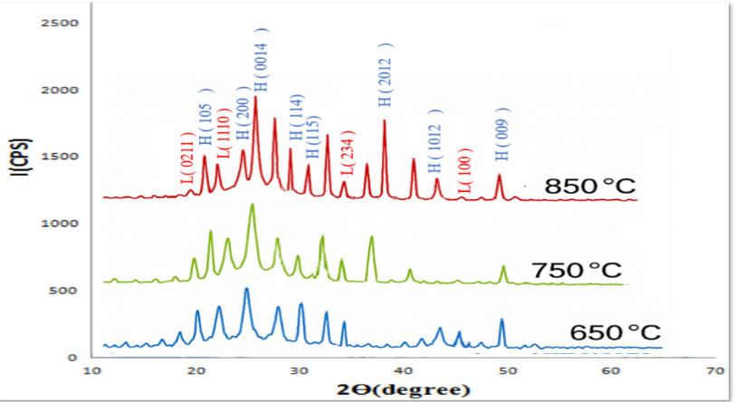
Figure 1. X-ray diffraction results for Bi₂Sr₂Ca3Cu4O8₊δ composite samples at different annealing temperatures

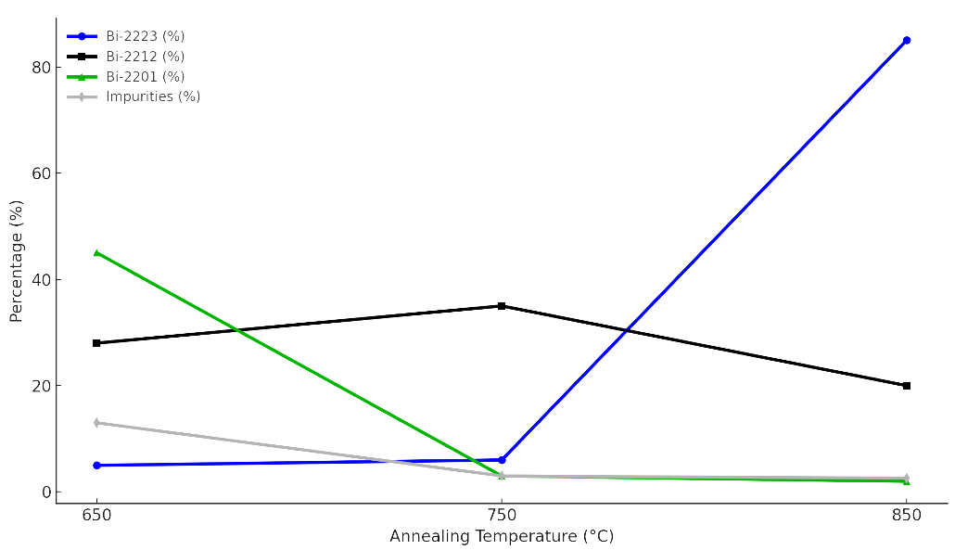
Figure 2. shows the change in phase ratios during the preparation of the compound Bi₂Sr₂Ca₂Cu₃O8₊δ and the impurity ratio as a function of sintering temperature.

From Table 1, it can be seen that the c/a ratio underwent a clear change with the change in the crystal lattice dimensions, increasing from 5.62 to 6.9 as the c-axis length increased from 30.2 Å to 37.1 Å. This clearly indicates the effective formation of this phase in the third sample. The lattice constants a and b also maintained typical values (≈5.4 Å), supporting the structure's conformity with the expected crystal structure of Bi-2223. Thus, the increase in the c/a ratio to 6.9 is a strong indicator of the complete formation of the Bi-2223 superconductor phase in this sample, compared to the other two samples, which showed lower c-axis ratios and lower c/a ratios, suggesting that they contain secondary or incomplete crystalline phases. shows the change in the c/a ratio with changing annealing temperatures.
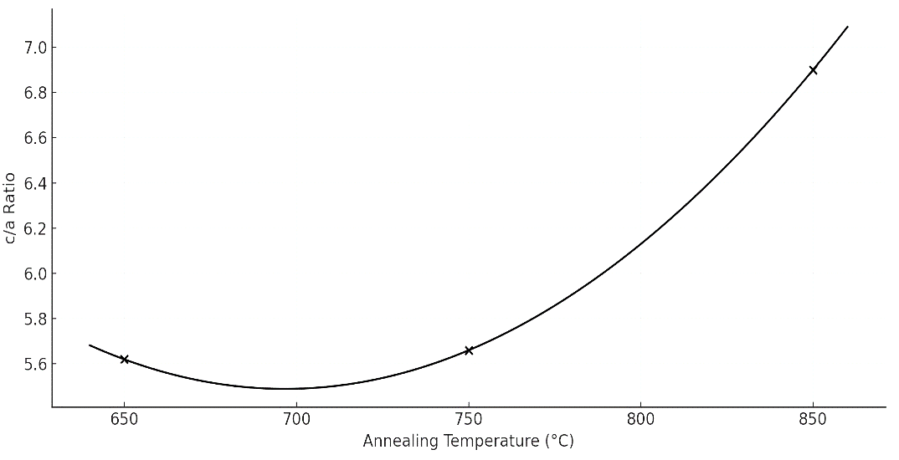
Figure 3. shows the values of c/a as a function of the annealing temperatures used in the preparation of Bi₂Sr₂Ca₃Cu₄O8₊δ composite samples.
Table 1 Structural properties of surface samples (Sdr) for Bi₂Sr₂Ca3Cu4O8₊δ composite samples annealed at different temperatures
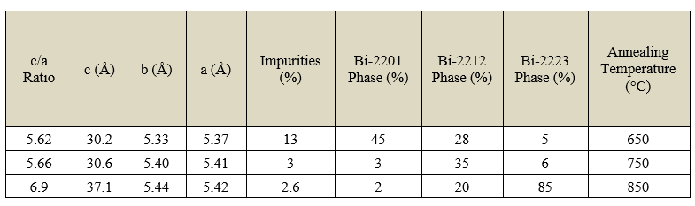

The Debye-Scherer equation was used to calculate the average crystal size D_{sh} for the Bi-2223 phase samples, as shown in Table 2 and Figure 4. the sample treated at 850°C showed the highest average crystal size, which was D_{sh}=62.3 nm, indicating good and large crystal growth, reflecting a high degree of internal order in the crystal lattice and the effective and stable formation of the Bi-2223 phase. This improvement can be attributed to the availability of sufficient thermal energy, which allows atoms to reorganize within the crystal structure and form relatively large crystals. The sample treated at 750°C recorded an average crystal size of D_{sh}=39.5 nm, which is higher than the sample at 650°C but still lower than the value achieved at 850°C, indicating the beginning of the formation of the target phase, but with a degree of partial crystallization. Meanwhile, the sample treated at 650°C showed the lowest average crystal size (28.6 nm), indicating that the temperature was insufficient to achieve uniform crystal growth, which may be accompanied by the presence of undesirable secondary phases. Based on these results, it can be concluded that 850°C is the optimal temperature for stimulating crystal growth and achieving the highest structural quality of the Bi-2223 phase, which positively reflects on the structural and possibly electrical properties of the samples.

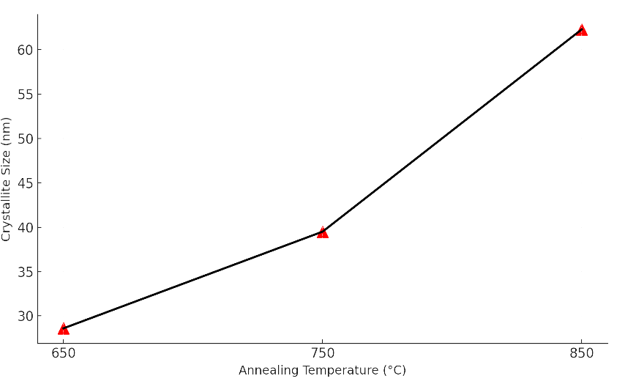
Figure 4. Crystal size as a function of melting temperatures for Bi₂Sr₂Ca₃Cu₄O₈₊δ composite samples

Table 2 Average crystal size of Bi₂Sr₂Ca₃Cu₄O8₊δ samples at different annealing temperatures calculated using the Debye-Scherrer equation.
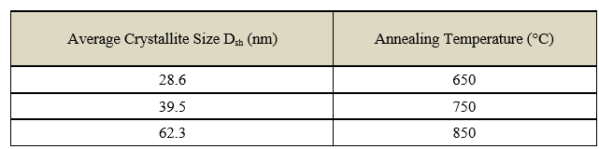

Electrical resistance results and critical temperature of the compound
The relationship between the superconducting transition temperature T_C and the concentration of voids p in Bi-2223 phase samples prepared at different annealing temperatures was studied, where three superconducting transition temperatures were determined. The results shown in Table (3) show that the sample treated at 850°C has the highest onset temperature of 113.8 K and the narrowest transition range (ΔTc = 4.2 K), indicating that the Bi-2223 phase is of high purity and has good structural uniformity. The vacancy concentration in this sample was p=0.1388, which falls within the ideal range indicated by many researchers for stimulating maximum Tc in layered materials such as Bi-2223. The sample prepared at 750°C showed a transition temperature of 110.5 K and a vacancy concentration of 0.13, indicating the formation of a superconducting phase, but to a lesser degree than ideal. The sample prepared at 650°C recorded the lowest transition onset value of 104.2K and a vacancy concentration of 0.12, indicating a low number of carriers (vacancies) and incomplete structural reaction. These results indicate a close relationship between the vacancy concentration p and the supercritical transition temperature T_C, where T_C increases with p up to an optimal point, then begins to decrease if the vacancies exceed the optimal limit. We conclude that a temperature of 850°C is the most suitable for obtaining the best superconducting properties in the Bi-2223 phase. Figure (5) shows the relationship between resistance as a function of temperature for the Bi₂Sr₂Ca₂Cu₃O₈₊δ compound at different annealing temperatures, while Figure (4-19) shows the relationship between the gaps and annealing temperatures of the Bi₂Sr₂Ca₂Cu₃O₈₊δ compound, which is similar to the results of previous studies [16].

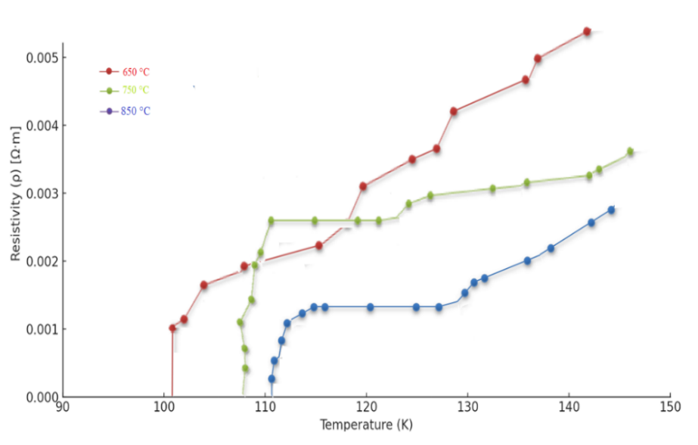
Figure 5. shows the curves of the relationship between electrical resistance and temperature for samples of the Bi₂Sr₂Ca₃Cu₄O8₊δ compound annealed at different temperatures, illustrating the transition to the superconducting state for each sample.
Table 3. Critical temperatures and hole concentrations for Bi₂Sr₂Ca3Cu4O8₊δ composite samples at different annealing temperatures.
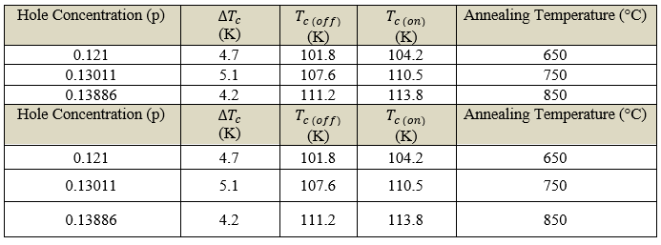
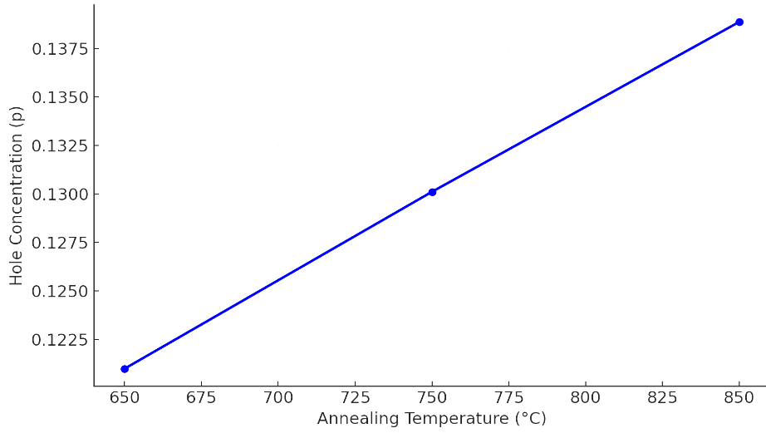
Figure 6. Relationship between hole concentration (p) and melting temperature for Bi₂Sr₂Ca3Cu4O8₊δ composite samples

Results of SEM scanning electron microscope examination of the compound
A detailed microscopic analysis of the Bi-2223 sample was performed using a scanning electron microscope (SEM) after annealing at three different temperatures to study the effect of heat treatment on the microscopic structure of the compound and its relationship to the superconductor properties at 650 °C. The microscopic images showed an irregular structure with small, heterogeneous grains and clear pores, as shown in Figure 7. This indicates that the thermal energy was not sufficient to achieve mature crystal growth, resulting in weak intergranular bonding and the presence of crystal voids, which explains the low superconducting performance and wide superconducting transition width (ΔTc) in this sample. High porosity may also lead to the trapping of impurities or disturbances in oxygen concentration, which weakens the superconducting pathways. In contrast, in the sample prepared at 750 °C, distinctive plate-shaped crystals with sharp edges appeared, with a noticeable increase in grain size and homogeneity, reflecting improved crystal growth and the onset of the more stable Bi-2223 phase. This structural improvement enhances the connection between grains, leading to more pronounced superconductivity and a slight increase in the superconducting transition temperature T_C, as shown in Figure 8. The sample annealed at 850°C showed clearer signs of mature crystallization, as shown in Figure 9, where the grains were larger and more regular with tight intergranular bonding. This is because the high temperature provided sufficient energy to rearrange the atoms within a stable crystal lattice, resulting in a significant improvement in grain density and structural bonding. The textured growth properties of the crystals indicate that the layers crystallized in a direction that allows supercurrent flow along the ab-plane, which is the ideal characteristic for Bi-2223 phase materials. This structural discipline is fully consistent with the electrical results, which showed the highest super transition temperature and narrowest transition width in this sample. the microscopic examination results show that the annealing temperature is a decisive factor in determining the quality of the compound's microstructure, and that annealing at 850°C provides the ideal conditions for the formation of a mature crystal structure that enhances the superconducting performance of the Bi₂Sr₂Ca₂Cu₃O10₊δ compound.

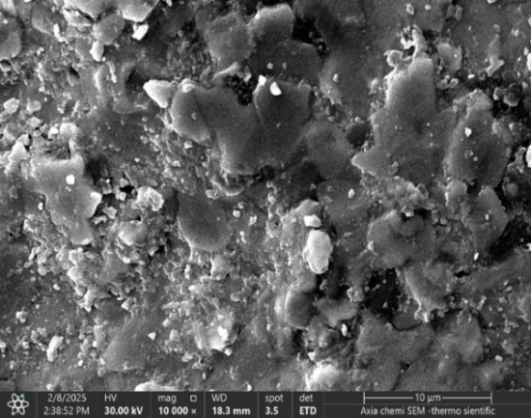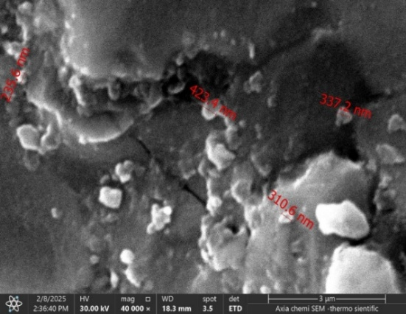
a b
Figure 7. Scanning electron microscope image of the compound Bi₂Sr₂Ca3Cu4O8₊δ at a temperature of 650°C,
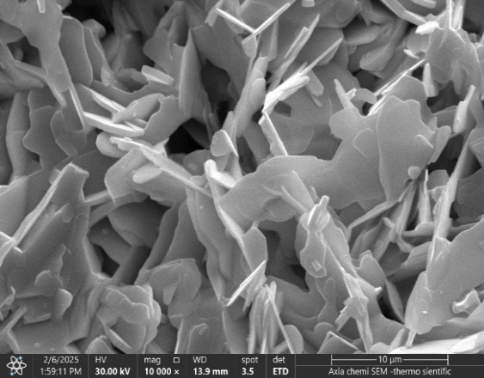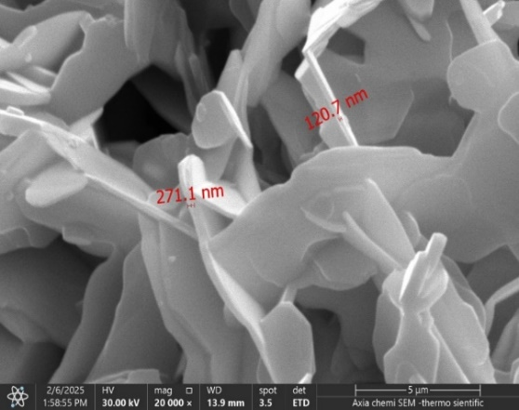
a b
Figure 8. Scanning electron microscope image of the compound Bi₂Sr₂Ca3Cu4O₈₊δ at a temperature of 750°C
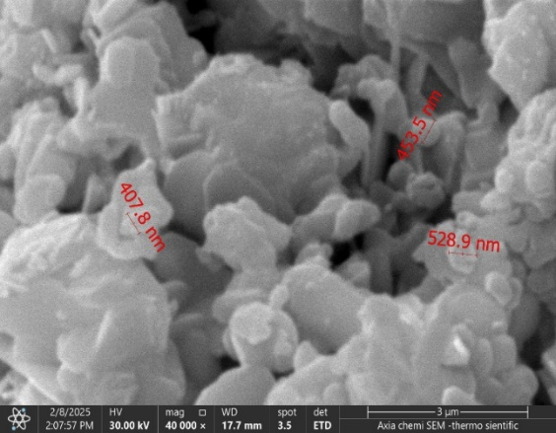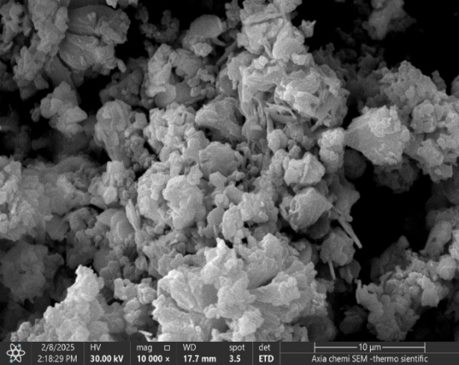
a b
Figure 9. shows a scanning electron microscope image of the compound Bi₂Sr₂Ca₃Cu₄O₈₊δ at a temperature of 850°C.

Results of atomic force microscopy (AFM) examination of the compound
A detailed analysis of the surface topography of annealed Bi₂Sr₂Ca₂Cu₃O₈₊_{δ} samples at three temperatures was performed using an atomic force microscope (AFM), as shown in Figure 10, to evaluate the effect of thermal annealing on the surface structure and nanoscale roughness of the sample. The results showed a clear difference in roughness values and surface development coefficients depending on the treatment temperature. At 650°C, the surface roughness was irregularly medium to high, with an average surface roughness (S_{a}) of about 9.8 nm and a surface development coefficient (S_{dr}) of about 96.2%. These values indicate incomplete crystallization and uneven distribution of nanocrystals, reflecting poor atomic rearrangement during annealing [17], which translates into poor superconducting performance [18], [19]. The sample annealed at 750°C showed a marked improvement in surface regularity, with Sa decreasing to 5.6 nm and S_{dr} reaching approximately 72.4%, indicating the beginning of a more regular crystalline structure. However, some minor variations in the terrain remain, indicating that crystalline growth is not yet complete. In contrast, the sample annealed at 850°C showed a more stable and uniform surface structure, with the surface roughness (Sa) value decreasing to only 3.2 nm, with a further decrease in (Sdr) to 48.9%. These values indicate mature crystallization and uniform distribution of peaks and nanogaps, reflecting a highly organized structure that is closely related to improved electrical performance and a higher supercritical transition temperature (Tc). This behavior is consistent with the SEM and XRD results, which showed a phase transformation to Bi-2223 and clear crystalline stability in the treated samples at this temperature [20]. The AFM results confirm that annealing at 850°C is optimal for achieving a smooth and homogeneous surface structure, which directly contributes to enhancing the superconducting properties of the Bi₂Sr₂Ca₂Cu₃O₈₊_{δ} compound. Figures 11, 12 show the relationship between the surface roughness value and the annealing temperatures used, and Figure 13 shows the relationship between the surface evolution coefficient and the annealing temperatures of the Bi₂Sr₂Ca₂Cu₃O₈₊δ compound, which are consistent with the results of previous research [17].
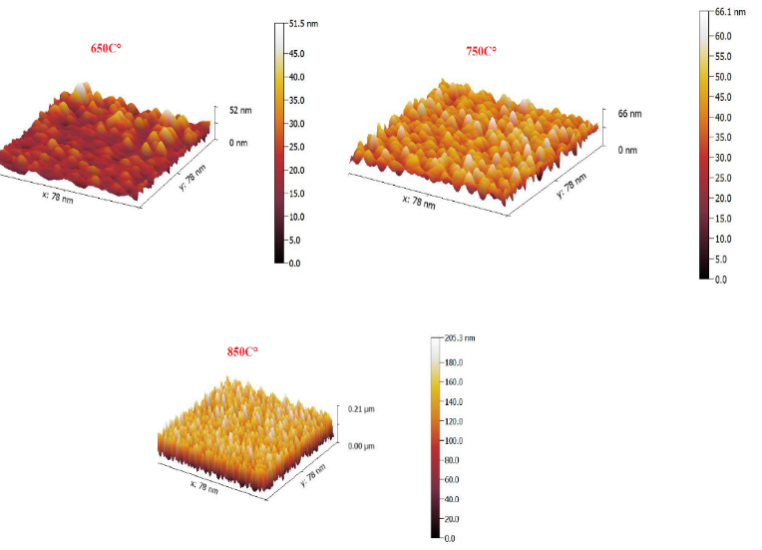
Figure 10. Atomic force microscope images of the Bi₂Sr₂Ca₃Cu₄O₈₊δ compound at different annealing temperatures.

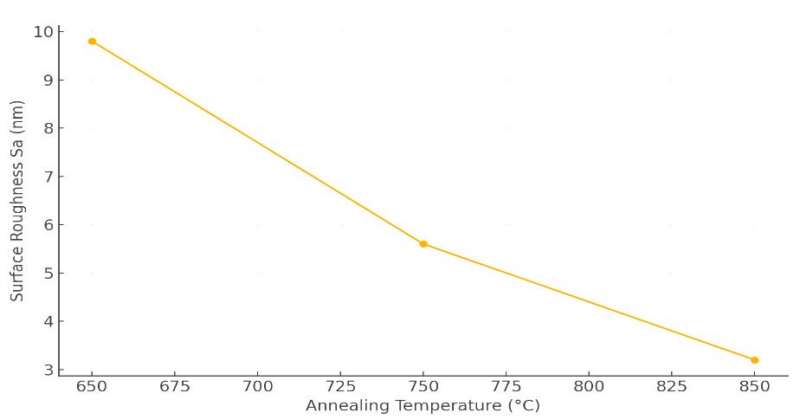
Figure 11. Relationship between annealing temperature and average surface roughness (Sa) for Bi₂Sr₂Ca₃Cu₄O₈₊δ samples as measured using AFM.
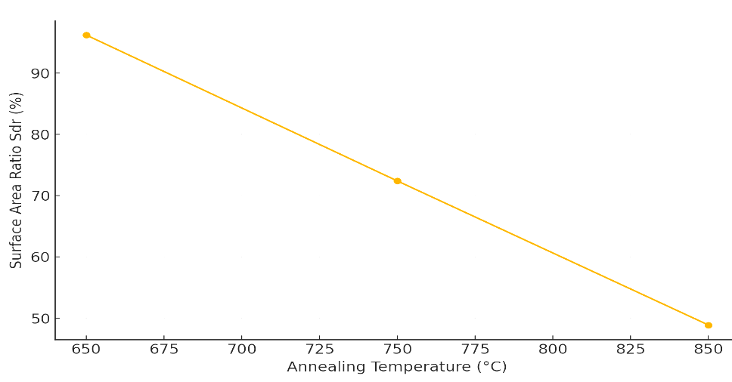
Figure 12. Relationship between the softening temperature and surface complexity ratio (Sdr) of Bi₂Sr₂Ca₃Cu₄O₈₊δ composite samples as measured using AFM

CONCLUSION
The findings demonstrate that annealing temperature is a decisive factor in controlling the structural and superconducting characteristics of Bi₂Sr₂Ca₂Cu₃O₈₊δ. At lower temperatures (650°C), incomplete phase formation, small crystallites, high porosity, and irregular surfaces limited superconducting performance. Intermediate treatment at 750°C improved phase stability and grain morphology, yet residual secondary phases and moderate roughness hindered optimal properties. In contrast, annealing at 850°C yielded a near-pure Bi-2223 phase with superior crystallinity, optimal lattice parameters, and enhanced grain connectivity, supported by SEM, AFM, and XRD data. The concurrent improvement in critical temperature, transition sharpness, and hole concentration at this temperature confirms a strong correlation between microstructural refinement and superconducting behavior. This optimal condition facilitated uniform atomic rearrangement, reduced defects, and favored crystal orientation along the ab-plane—key for efficient supercurrent transport. The study not only reinforces the thermal sensitivity of Bi-based superconductors but also establishes 850°C as the ideal synthesis temperature for maximizing their technological potential in energy transmission, magnetic shielding, and superconducting devices. Future work may focus on fine-tuning oxygen content and exploring dopants to further enhance performance.

REFERENCES
- V. Stepankin and A. Kuznetsov, “Weak link behavior of single grain boundary Josephson junction in BaPb1-xBixO3 bicrystals,” Appl. Supercond., vol. 1, no. 7–9, pp. 947–960, 1993.
- Jasim, K.A., The effect of cadmium substitution on the superconducting properties of Tl1-x Cd x Ba2Ca2Cu 3O9-δ compound, Journal of Superconductivity and Novel Magnetism, 2013, 26(3), pp. 549–552.
- P. Sastry, Y. Li, J. Su, and J. Schwartz, “Attempts to fabricate thick HgPb1223 superconducting films on silver,” Phys. C Supercond., vol.. 335, no. 1–4, pp. 112–119, 2000.
- Al-Khafaji, R.S.A., Jasim, K.A., Dependence the microstructure specifications of earth metal lanthanum La substituted Bi2Ba2CaCu2–XLaXO8+δon cation vacancies, AIMS Materials Science, 2021, 8(4), pp. 550–559.
- M. Cantoni, A. Schilling, H.-U. Nissen, and H. R. Ott, “Characterisation of superconducting Hg-Ba-Ca-Cu-oxides: Structural and physical aspects,” Phys. C Supercond., vol.. 215, no. 1–2, pp. 11–18, 1993.
- S. S. A. Alimardan, A. K. D. Ali, and S. J. Fathi, “Partial substitution Effect of Pb and Mg on the Structural and Electrical Properties of High Temperature (Hg1-xPbxBa2Ca3-yMgyCu4O10+ δ) Superconductor,” Tikrit J. Pure Sci., vol. 24, no. 2, pp. 68–87, 2019.
- K. Al Abdullah, F. Al Alloush, A. Jaafar, and C. Salame, “Investigation of the monocrystalline silicon solar cell physical behavior by AC impedance spectra,” Energy Procedia 57, (2014)..
- M. M. Abbas, L. K. Abass, and U. Salman, “Influences of sintering time on the Tc of Bi2-xCuxPb0. 3Sr2Ca2Cu3O10+ δ high temperature superconductors,” Energy Procedia, vol. 18, pp. 215–224, 2012.
- A. R. Abdulridha, E. Al-Bermany, F. S. Hashim, and A. H. O. Alkhayatt, “Synthesis and characterization and pelletization pressure effect on the properties of Bi1. 7Pb0. 3Sr2W0. 2 Ca2Cu3 O10+ δ superconductor system,” Intermetallics, vol. 127, p. 106967, 2020.
- Kadhim, B.B., Khaleel, I.H., Hussein, B.H., ...Al-Maiyaly, B.K.H., Mahdi, S.H., Effect of gamma irradiation on the TlBa2Ca2Cu3O9-δ superconducting properties, AIP Conference Proceedings, 2018, 1968, 030054.
- B. A. Omar, N. S. Abed, and A. S. Baqi, “Effects of La2O3 Nanoparticles on the Superconducting Behavior of Bi1. 60 Ag0. 40 Sr1. 9 Ba0. 1 Ca2 Cu3 O10+ δ Ceramics,” Sci. Technol. Sci. Soc., vol. 2, no. 6, pp. 75–82, 2025.
- D. A. Cardwell, D. C. Larbalestier, and A. Braginski, Handbook of Superconductivity: Characterization and Applications, Volume Three. CRC Press, 2022.
- Wadi, K.M., Jasim, K.A., Shaban, A.H., Kamil, M.K., Nsaif, F.K., The effects of sustainable manufacturing pressure on the structural properties of the pb2ba2ca2cu3o9+σ compound, Journal of Green Engineering, 2020, 10(9), pp. 6052–6062.
- A. Sergeev and I. Golev, “High-Temperature Superconducting Materials Based on Bismuth with a Low Critical Current,” Mater. Today Proc., vol. 11, pp. 489–493, 2019.
- Mohammed, L.A., Jasim, K.A., Improvement the superconducting properties of TlBa 2 Ca 2 Cu 3x Nix O 9-δ superconducting compound by partial substitution of copper with nickel oxide on the, Energy Procedia, 2019, 157, pp. 135–142.
- B. Liang, C. Bernhard, T. Wolf, and C. T. Lin, “Phase evolution, structural and superconducting properties of Pb-free Bi2Sr2Ca2Cu3O10+ δ single crystals,” Supercond. Sci. Technol., vol. 17, no. 6, p. 731, 2004.
- Jasim, K.A., Alwan, T.J., Effect of Oxygen Treatment on the Structural and Electrical Properties of Tl_{0.85}Cd_{0.15}Sr₂CuO_{5−δ}, Tl_{0.85}Cd_{0.15}Sr₂Ca₂Cu₂O_{7−δ} and Tl_{0.85}Cd_{0.15}Sr₃Ca₂Cu₃O_{9−δ} Superconductors, Journal of Superconductivity and Novel Magnetism, 2017, 30(12), pp. 3451–3457.
- Jasim, K.A., Makki, S.A., Almohsin, A.A. Comparison study of transition temperature between the superconducting compounds Tl0.9 Pb 0.1Ba2Ca2Cu3O9, Tl0.9Sb0.1Ba2Ca2Cu3O9-δ and Tl0.9Cr0.1Ba2Ca2Cu3O9-δ, Physics Procedia, 2014, 55, pp. 336–341.
- L. Forro and J. R. Cooper, “Superconducting transition temperature vs. hole concentration in Bi₂Sr₂CaCu₂O₈ single crystals with varying oxygen stoichiometry,” Europhys. Lett., vol. 11, no. 1, p. 55, 1990.
- R. Kumar, I. Verma, N. Verma, and V. Ganesan, “Effect of Mn on the Surface Morphological Properties of (Bi, Pb)₂ Sr₂Ca₂Cu_{3-x} Mn _{x} O_{10+ δ} (Bi-2223) Superconductor,” J. Supercond. Nov. Magn., vol. 25, no. 4, pp. 1215–1221, 2012.

