The Effect of Beetroot Peel Fibers Particle Size on Physical, Mechanical and Structural Properties of the Natural Composite
Amel J. Abbas ^{1, a)} and Widad H. Jassim ^{1, b)}
¹Department of Physics, College of Education for Pure Science, Ibn Al-Haitham, University of Baghdad, Baghdad, Iraq
^{a)} Corresponding author: amal.jassem1204a@ihcoedu.uobaghdad.edu.iq
^{b)} Widad.h.j@ihcoedu.uobaghdad.edu.iq

Abstract: Beetroot peels (BR) fibers have been employed as a natural reinforcement for Unsaturated Polyester (UPE) due to their low cost, biodegradability characteristics and eco-friendliness. Beetroot peels particulates of about (180 and 75 µm) sieve siz, of different weight percentage (1, 2, 3, 4 and 5 wt.% %) were used as fillers in a (UPE) matrix. The effects of the beetroot particle size on physical, mechanical and structural properties of the final natural composite were determined. The density of (UPE/ 180 MBR) composite increases by increasing weight percentage of beetroot peels powder, but the density of (UPE/ 75 MBR) decreases by increasing weight percentage of beetroot peels powder. The thermal conductivity values of (UPE/ 180 MBR) composites have higher values, by compared with the thermal conductivity values of (UPE/ 75 MBR) composites. The results showed that the best mechanical properties were get by adding (2 Wt.%) to the (UPE)matrix using (180 MBR) and at (4 Wt.%) by adding the (75 MBR). The techniques (EDS) and (SEM) were used to investigate the chemical compositions and the homogeneity degree of both composites.
Keywords: Beetroot peels fibers, Unsaturated Polyester, hardness, impact strength, EDS and SEM
INTRODUCTION
Unsaturated Polyester (UP) resins have been used in construction applications, as wind blades, marine hulls and car components, this because , rapid curing , ease of manufacturing and dimensional stability [1].The natural fibers reinforced composite materials used in many industries applications, this because natural fibers are have no cost and available in nature to get light and strong natural composites [2].The size, quantity and quality of natural fibres effected on the final properties of composites , many researchers have been used natural fibers to changing the physical, mechanical and thermal properties of the natural composite , also these studies focused on employees of environmentally friendly fibers as bio materials [3].The researchers ( Shfiur Rhmn , et. al) in (2016), have been used the calcium carbonate with natural and synthetic form as fillers to reinforce unsaturated polyester, the fillers were added by the ratios (5, 10, 15, 20 and 25 wt %). The weight percentage (10%) of eggshell powder and calcium carbonate with industrial form is the best ratio to improve the mechanical properties as (flexural strength, tensile strength and young models) of unsaturated polyester [4]. In (2019) the researchers (R. O. Mamman and A. M. Ramalan, et. al ) were used orange peels powder with particle size (350 µm) with different weight percentages (3, 6, 9, 12 and 15 % ) as natural fillers to reinforce (unsaturated polyester / 25% E-glass) composite , they found that the final composite have a good improved in both a physical and mechanical properties, the physical properties as water absorption and mechanical properties as (tensile, bending, impact and hardness strengths) were improvement with increase the weight percentage of orange peel power reinforcement ,the values of tensile strength about (50.0 - 62.6 MPa) , Hardness ( 28.6 - 40.8HRB), energy of impact ( 5.0 - 7.4 Joules) and the flexural strength (74.0 - 85.2 MPa). The ratio (15 Wt.%) of orange peels powder is the best weight percentage value to get good improvement in final composite mechanical properties [5]. In (2021) the researchers (Reza Armanda, el. al) have been used the kenaf fibers as natural fillers to reinforce unsaturated polyester matrix, the good tensile properties of kenaf fibers effects on improving the mechanical properties of polyester [6, 7].
In this research, the beetroot peels powder with two different particle size (180 and 75 microns) by different weight percentages (1-5%) were employed as natural fibers, to selected unsaturated polyester reinforced with beetroot with best weight ratio and particle size and used this composite in manufacturing natural gelcoat.
EXPREMENTAL WORK
Matrix
unsaturated polyester resin with name (siropol-8341) made by (Saudi industrial resins limited) was been used, an accelerator (2% cobalt) was added to polyester and adding methyl ethyl ketone peroxide (MEKP) as hardener with concentration (2.5% Wt.). At room temperature, the gelation time was (10 - 15 min).
Filler
Beetroot peels powder was used as fillers, The beetroot was cleaned, washed with water, dry without direct exposure to sunlight for (seven days), to keep natural color, then the peels crushed, as shown in figure (1-b). The crushed beetroot peels were first grinded using a regular mill, then grinding more, using the grinding device a ball mill. (NOM-0.4), to get fine particles with grain size (180 and 75 Microns) as shown in figure (1-c) by saving.
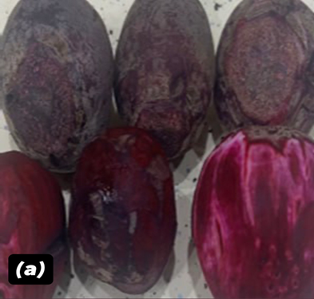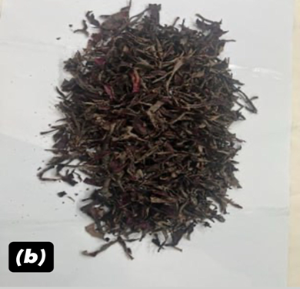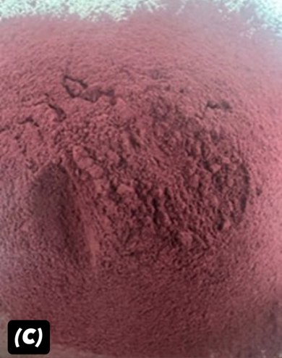
Figure 1 a- beet root b- Beet root peels c -beet root powder
Method
To get unsaturated polyester reinforced by beetroot peel powder specimens (UPE / BR), beetroot peels powder, with weight ratios (0, 1, 2, 3, 4, 5%) were mixed with unsaturated polyester, the mixtures were poured into silicone molds with dimensions matching to ASTM dimensions. The mixtures (UPE/BR) were left to dry well for (9 hours) at room temperature, before carrying any mechanical or thermal tests.
Density Measurement
Density of Beet root peels powders with the different sizes were measured by dividing the sample mass by volume, using piston to make a circular shape, The volume of the circular shape was calculated using the equation (1).
$V=r^{2}πL$ (1)
Where: V disk size, r disc radius. Then calculate the density of the sample using equation (2).
$ρ=\frac{m}{V}$ (2)
Where, m is Sample mass and v is Sample size
Thermal Conductivity
The thermal conductivity of (polyester/beetroot peel powder) composites was determined using Lee’s disk device, the unsaturated polyester resin reinforced with different weight percentages of beetroot peels powder with the size partials (180 and 75 microns). The samples were made in a circular shape with a diameter of 40mm and a thickness of 3mm.
Hardness
The hardness values of unsaturated polyester reinforced by beetroot peels powders have been done, using Shore (D) test model (TH 210), Italy.
Impact Strength
Charpy impact test was carried out on (UPE/MBR) composites according to the international standard (ISO-179) , where the samples having dimensions of (5×10×55 mm).
Scanning Electron Microscopy (SEM)

To determine the homogeneity and microstructure of (UPE/ 180 MBR) and (UPE/ 75 MBR) composites, these samples were coated by gold layer to be photo using scanning electron device (Axia chemi sem Thermo fisher scientific company) manufactured in Holland.
Energy Dispersive Spectroscopy (EDS)
To fixed the chemical compositions of (UPE/ 180 MBR) and (UPE/ 75 MBR) composites, the technique (EDS) that equipped with the (SEM) technique were employed
RESULTS AND DISCUSSIONS
Density Measurement
Using matrix rule (equation 3), the density of (UPE/ BR) composites with different particle sizes and with different weight percentages was calculated [7].
𝝆=𝝆_{𝒎}𝒘_{𝒎}+𝝆_{𝒓}𝒘_{𝒓} (3)
Where: 𝜌_{𝑚} and 𝜌_{𝑟} are the density of matrix and filler, respectively. 𝑤_{𝑚} and 𝑤_{𝑟} are the weight fractions of matrix and filler, respectively.
By adding the power with the big grain size (180 Microns) as indicated in purple in Figure (2) the densities values of (UPE/ MBR) composites by were increased by increasing in weight percentages of powder , but the density values were decreased with increasing the weight percentage of beetroot peels powder by using small grain size ( 75 microns) indicated in pink in figure, this because the value density of powder with grain size (180 Microns) is (1.23 gm/ cm3) , but the density value of beetroot peels powder with the small grain size (75 microns) is about (1.024 gm /cm3) only , that means the grain size of beetroot peels powder will effect on physical and mechanical properties of natural unsaturated polyester composites, these results agreed well with [3].
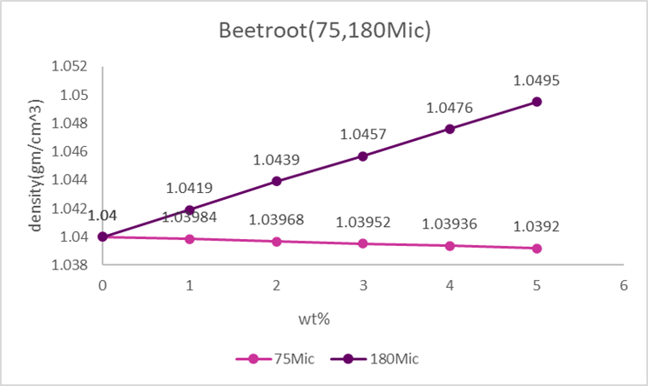
Figure 2 densities values of (UPE/ MBR) composites
Thermals Conductivity
The device was equipped with a voltage of 6volts and a current of 0.25A, Heat flowed from the heater through the sample and the thermal conductivity was plotted as a function of the concentration of beetroot peels as shown in Figure 3 ,where the thermal conductivity values of (polyester / beetroot peels powder) composites increase with increasing the weight percentage of adding beetroot peel powder from 1% to 5% for both sizes, the thermal conductivity values increasing gradually. The thermal conductivity reaches to higher value (0.311 w/m °C) by loading the unsaturated polyester by root peels powder with grain size 180 microns and reach to the value (0.297 w/m °C) by loading the unsaturated polyester with small grain size (75 Microns), this because the density values of (UPE/ 180 MBR) composites have a higher value compared with the density values of (UPE/ 75 MBR), these results agree with the [8-11].
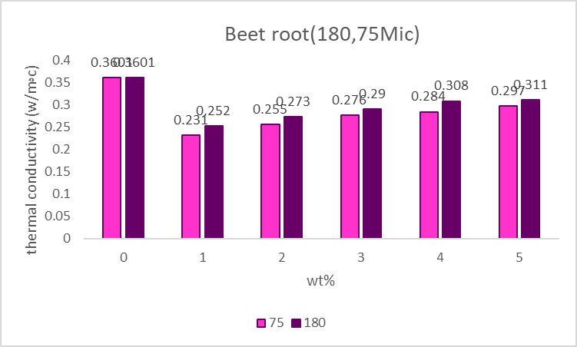
Figure 3: thermal conductivity values of UPE composites
Hardness
The resistance of the composites (unsaturated polyester/ root peels) to indentation is hardness [9 ]. the Figure (4) shows the increased in hardness values of unsaturated polyester by adding the root peels powders, these results agreed well with [12]. The results showed that (UPE/ 4 % 75 BR ) composite have higher value of hardness (80.5) while the higher value of (UPE/ 2 % 180 BR) composite hardness was only (79), this may be due to good dispersion of a smaller particles of beetroot particles through the chain matrix of composite [13].
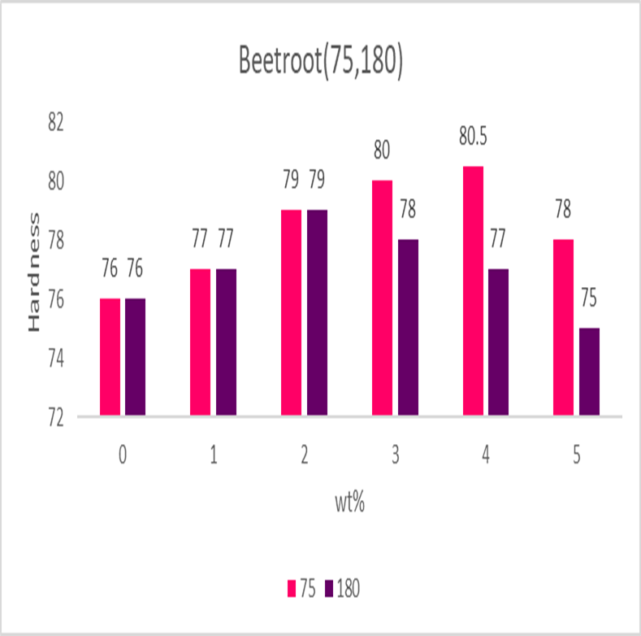
Figure4: Hardness values of UPE composites
Impact Teast
The impact strength of (UPE/ 2% 180 MBR) and (UPE/ 3% 180 MBR) composites have higher values with compared with values of impact strength of anther weight percentages of (UPE/ 180 MBR) composites, as shown in figure5. Also, the impact strength value of the (UPE/ 4% 75 MBR) composite have a higher value of impact strength (7.3 Kg/m2), this because a smaller grain size filler has a higher a ability to dispersion between unsaturated polyester chains, which leads to good bonding between the additives and the matrix [14-16].
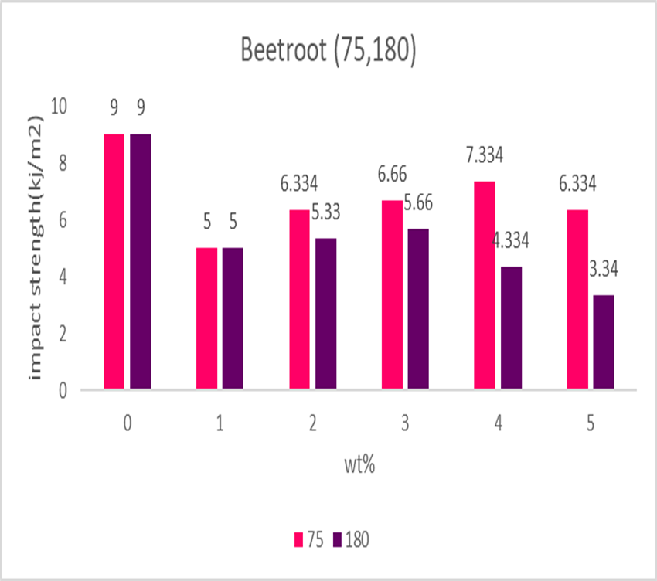
Figure 5: Impact strength values of UPE composites
Energy Dispersive Spectroscopy (EDS)
(UPE/ 180 MBR) and (UPE/ 75 MBR) composites were examined chemically using the (EDS) technique, Table (1) shows that the elements such as carbon and oxygen found in high rates, others such (N, si and Rb) were found in small rates, some elements such as (K, Ca and Ni) were found in (UPE/ 180 MBR) and (UPE/ 75 MBR) composites as traces. (UPE/ 180 MBR) and (UPE/ 75 MBR) composites consists of the same elements but with different weight percentages, which leads to change in densities [17, 18], color , also in other mechanical and thermal properties of final composite, these results agreed well with [15] .Also table (1) shows that the element ( F ) was found in (UPE/ 75 MBR) composite only with ratio (0.5 %) , this a good point in interpretation the darkness of (UPE/ 75 MBR) composites with compared with (UPE/ 180 MBR) composites by adding the same concentration of beetroot peels powder [19].
Table 1 element compositions of (UPE/ 180 MBR) and (UPE/ 75 MBR) composites
(UPE/ 180 MBR) composite |  | (UPE/ 75 MBR) composite
Element | Weight% | Element | Weight%
C | 52.1 | C | 47
N | 4.5 | N | 6.6
O | 36.8 | O | 39.6
Si | 2.4 | Si | 1.5
K | 0.2 | K | 0.2
Ca | 0.6 | Ca | 0.1
Ni | 0.2 | Fe | 0.5
Rb | 3.2 | Ni | 0.4
 |  | Rb | 4.2
Scanning Electron Microscopy
Using scanning electron device (Axia chemi sem Thermo fisher scientific company) with voltage (30 kv ) and magnification power (80) the (UPE/ 180 MBR) and (UPE/ 75 MBR) composites were examined, Figure (6) shows the SEM photos of (UPE/ 180 MBR) and (UPE/ 75 MBR) composites, with magnifications (150 ×). The morphology of the surfaces was showed a good degree of homogeneity for both composites, and also the compatibility between the unsaturated polyester matrix and the beetroot peels microparticles [20].
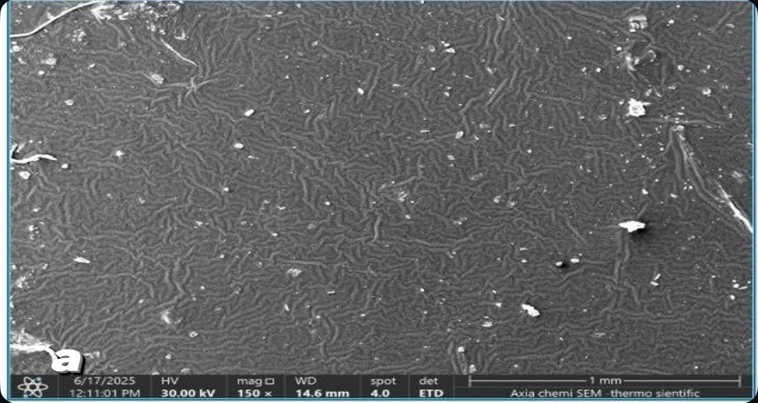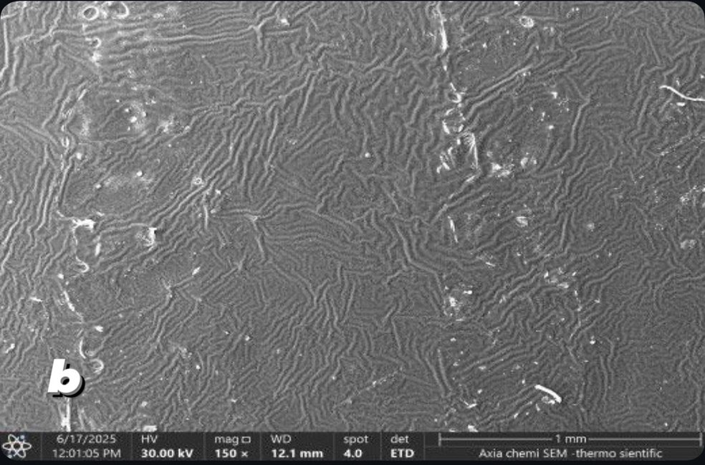
Figure 6 SEM micrographs of a -(UPE/ 180 MBR) composite b- (UPE/ 75 MBR) composite
CONCLUSION
Beetroot peels powder play a good role in reinforcing the Unsaturated polyester, especially to improved its hardness and also to reducing the pollution in the environment. The grain size of beetroot peels particles effects on physical, mechanical and structural properties of unsaturated polyester reinforced with beetroot. EDS and SEM techniques were used to fixed the elemental composition and morphology of final composite respectively, these structural tests are important to interpretation, the change in physical and mechanical properties of unsaturated polyester reinforced with beetroot peels powder by changing the particle size and weight percentage value of beetroot peels powder. The particle size value of beetroot peels particles effected on the concentration of chemical elements in composite compositions, which leads to changes in composite color, and also, the drunkenness in composite color increasing with increase the weight percentage value of beetroot peels powder in composite. The (UPE/ 180 MBR) and (UPE/ 75 MBR) composites are the best choices to make a natural gelcoat with good physical and mechanical properties.

REFERENCES
- R. Manikumar and T. N. Rao, “Unsaturated polyester resin synthesis for enhanced fiber-reinforced composite performance.,” Digest Journal of Nanomaterials & Biostructures (DJNB), vol. 19, no. 3, 2024.
- Bushra H. Musa, Rafah A. Nassif and Enass M. Hadi, “Study of the mechanical properties for unsaturated polyester reinforced by natural fibers,” Al-Nahrain Journal of Science, vol. 13, no. 3, pp. 65–68, 2010.
- Rana jamal mizban, Widad hamdi jassim, “The Compressive Strength of Unsaturated polyester reinforced by natural and synthetic Calcium Carbonate,” in Journal of Physics: Conference Series, IOP Publishing,2024.
- G. M. Shafiur Rahman, Hrithita Aftab, M. Shariful Islam, Muhammad Zobayer Bin Mukhlish, and Farhad Ali, “Enhanced physico-mechanical properties of polyester resin film using CaCO3 filler,” Fibers and Polymers, vol. 17, no. 1, pp. 59–65, 2016.
- Rabiu Onoruoiza Mamman, Aliyu Mohammed Ramalan, “Mechanical and Physical Properties of Polyester Reinforced Glass Fibre/Orange Peel Particulate Hybrid Composite,” Advanced Journal of Graduate Research, vol. 7, no. 1, pp. 18–26, Oct. 2019.
- Reza Arjmandi, Ilknur Yıldırım, Fiona Hatton, Azman Hassan, Christopher Jefferies, Zurina Mohamad and Norhayani Othman. “Kenaf fibers reinforced unsaturated polyester composites: A review,” J Eng Fiber Fabr, vol. 16, 2021.
- W.H. Alhazmia, Y. Jazaab, S. Mousaa, A.A. Abd-Elhadyc , H.E.M. Sallamd , “Tribological and mechanical properties of epoxy reinforced by hybrid nanoparticles,” Latin American Journal of Solids and Structures, vol. 18, no. 03, pp. 361, 2021.
- Seenaa I. Hussein · Alaa M. Abd-Elnaiem · Tesleem B. Asafa· Harith I. Jaafar, “Effect of incorporation of conductive fillers on mechanical properties and thermal conductivity of epoxy resin composite,” Applied Physics A, vol. 124, no. 7, pp. 475, 2018.
- K. Al Abdullah, F. Al Alloush, A. Jaafar, and C. Salame, “Study of the effects related to the electric reverse stress currents on the mono-Si solar cell electrical parameters,” Energy Procedia 36, 104–113 (2013).
- Rahima Baghloul , Laidi Babouri , Houria Hebhoub, Fouad Boukhelf, and Yassine ElMendili, “Assessment of Mechanical Behavior and Microstructure of Unsaturated Polyester Resin Composites Reinforced with Recycled Marble Waste,” Buildings, vol. 14, no. 12, pp. 3877, 2024.
- Rihab Nassr Fadhil, Muna B. Jasim, Zainab Assif Abdullah, Shatha H. Mahdi and Kareem A. Jasim, “Manufacture and study the mechanical, thermal and physical properties of plastic wood,” in Journal of Physics: Conference Series 2857, 2024.
- Jassim, K.A., Thejeel, M.A.-N., Salman, E.M.-T., Mahdi, S.H., Study characteristics of (epoxy-bentonite doped) composite materials, Energy Procedia, 2017, 119, pp. 670–679.
- Aveen ansaif jassim and Widad hamdi Jassim, “Preparation of polyester/micro eggshell fillers composite as natural surface coating,” Ibn AL-Haitham Journal for Pure and Applied Sciences, vol. 36, no. 1, pp. 88–99, 2023.
- Kadhim, B.B., Risan, R.H., Shaban, A.H., Jasim, K.A., Electrical characteristics of nickel/epoxy - Unsaturated polyester blend nanocomposites, AIP Conference Proceedings, 2019, 2123, 020062.
- Przemysław paczkowski, Andrzej Puszka and Barbara Gawdzik, “Green composites based on unsaturated polyester resin from recycled poly (ethylene terephthalate) with wood floor as filler—Synthesis, characterization and aging effect,” Polymers (Basel), vol. 12, no. 12, p p. 2966, 2020.
- Mahdi, S.H., Jassim, W.H., Hamad, I.A., Jasima, K. A., Epoxy/Silicone Rubber Blends for Voltage Insulators and Capacitors Applications, Energy Procedia, 2017, 119, pp. 501–506.
- A.H. Majeed, S.Q. Ibrahim “Mechanical Properties of Unsaturated Polyester Filled with Silica Fume,” Glass Powder and Carbon Black,”, vol. 35, no. 6, 2017.
- Jassim, K.A., Jassim, W.H., Mahdi, S.H., The effect of sunlight on medium density polyethylene water pipes, Energy Procedia, 2017, 119, pp. 650–655.
- Aleabi, S.H., Watan, A.W., Salman, E.M.-T., Kareem Jasim A., Shaban, A.H., Alsaadi, T.M., The study effect of weight fraction on thermal and electrical conductivity for unsaturated polyester composite alone and hybrid, AIP Conference Proceedings, 2018, 1968, 020019.
- Afya Q. Fadhel, Widad H. Jassim, “Fabrication of natural gelcoat from epoxy and submicron carrot fibers (EP/MCF) with high mechanical and thermal specifications,” Technologies and Materials for Renewable Energy, Environment and Sustainability: TMREES22Fr AIP Conf. Proc. 2769 ,2023.

