Study the Physical, Mechanical and Structural Properties of Unsaturated Polyester Reinforced by Lemon Peels
Amel J. Abbas ^{1, a)} and Widad H. Jassim ^{1,b)}
¹ Department of Physics , College of Education for Pure Science-Ibn Al-Haitham, University of Baghdad,
Iraq.
^{a)} Corresponding author: amal.jassem1204a@ihcoedu.uobaghdad.edu.iq
^{b)} Widad.h.j@ihcoedu.uobaghdad.edu.iq

Abstract: Lemon peel fibers with micro particle size (MLP) have been used as an eco-friendly plant reinforcement for Unsaturated Polyester (UPE). Unsaturated polyester was loaded by Lemon peel particles of two different particle sizes (180 and 75 microns) and with different weight percentages (1 - 5 %) to fabricate yellow gelcoat with good properties. The results shows that the density of both (UPE/ 180 MLP) and (UPE/ 75 MLP) composites increases by increasing weight percentage of fibers. The unsaturated polyester reinforced by (4% wt.) of fibers with particle size (75 microns) has higher thermal conductivity value (0.327 watt/ m. c) compared with the thermal conductivity value (0.248Watt/ m. c) for the unsaturated polyester reinforced by (4% wt.) of fibers with particle size (180 microns). The (UPE/ 2% 180 MBR) and (UPE/ 4% 75 MBR) composites shows the best hardness and impact strength values. The techniques (EDS) and (SEM) were used to determine the chemical compositions and the homogeneity degree of the two unsaturated polyester composites.
Keywords: Lemon peels fibers, Unsaturated Polyester, hardness, impact strength, EDS and SEM
INTRODUCTION
Unsaturated polyester (UPE) is one of important thermosetting polymers, it has good resistance to chemical, corrosion, low cost, rapid crosslinking and easy in processing and construction [1, 2]. Some additives such as plant fibers which available in nature, were employed to changing the degree of polymer crystallinity, which leads to increase the mechanical and thermal properties of this resin [3]. In 2021, researcher (Hailay Kidane) has been employed sisal fibers that treated with alkali to improve their adhesion to the Unsaturated polyester. The sisal fibers, were parallel-aligned with a sewing machine, with an axial orientation (004), the (unsaturated polyester/ sisal fibers) composite showed good mechanical properties to use in cars body applications [4]. In 2022 (Mateus Hofmann et al.) Were improved the mechanical properties of (unsaturated polyester/ glass fibers) composite by reinforced this composite with 50% bio materials. The bio-based (UPE/ glass fibers) composite have tensile strength (538 MPa) , compressive strength (210 MPa) and shear strengths ( 52 MPa) [5]. In 2023 (Aveen Ansaif and Widad Hamdi) have been used unsaturated polyester reinforced by eggshell fibers with concentrations (1- 8 wt. %) to fabricate white gelcoat with good mechanical properties and water resistance [6].
In 2024 (Novi Laura Indrayani, et al.) have been used banana tree frond fibers to reinforced unsaturated polyester matrix. Three samples with different in volume fractions of fibers (6, 9, 12%) were prepared, the physical properties as density and water absorption were tested, also the mechanical properties as tensile strength, was improved to higher value (37.28 MPa) at a volume fraction of (12 % fiber) [7]. In 2025 (Henny Pratiwi et al.) have been used the ramie fibers that treated with alkali and oxalic acid as reinforcements to unsaturated polyester. The fibers were added by the ratios (0.5, 0.75 and 1%). The optimum results can be got by loading of unsaturated polyester by the weight percentage (0.75%) of fiber. The values of mechanical properties such as tensile modulus about (33 Mpa), the strength about (27 Mpa) , the flexural modulus about (85 Mpa ) and impact strength was (49.53 Mpa) [8].In this research, the lemon peels fibers have been employed with two different particle size (180 and 75 microns) with different weight percentages as natural reinforcement to unsaturated polyester.
EXPERIMENTAL WORK
Materials
The unsaturated polyester resin known as (Siropol-8341) produced by (Saudi Industrial Resins Company Ltd) has been utilized, the weight fraction (2%) of Cobalt Naphthenates was added to the resin as an accelerator. The unsaturated polyester was transformed from a viscous liquid to a solid by adding (Methyl Ethyl Keton Peroxide) at a weight percentage (2.5%). The gelling time was about (15 minutes) at a temperature of (27°C).
Filler
Lemon peels powder have been added to unsaturated polyester as reinforcement. The Lemon fruits were cleaned with water then dried well, the peels were extracted from the fruits and dried for three weeks, without direct exposure to sunlight, for the completion of drying, peels were placed in an oven for two hours at temperature (60°C). The dry lemon peels were ground for two hours using a ball mill (NOM-0.4) to get micro size powder, as shown in figure (1) . The powder sieved using a sieve (IMPACT LABORATORY TEST SIEVE) to obtain a lemon peels powder with two different particle size (180 and 75 microns).
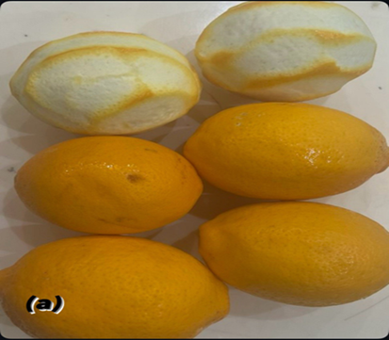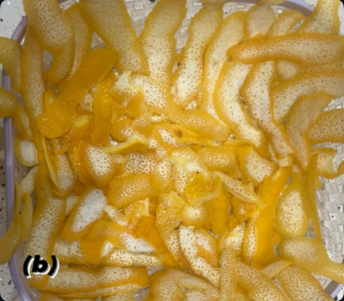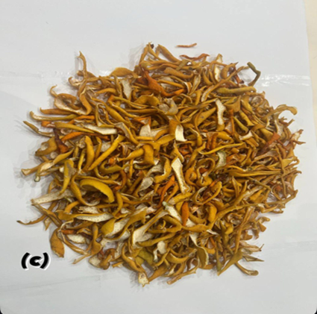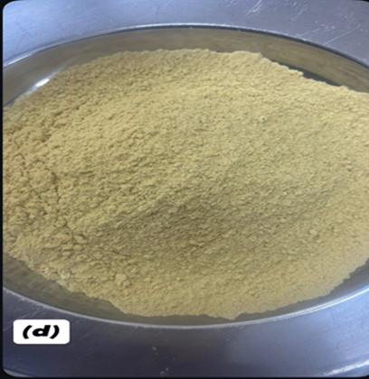
Figure 1: a) Lemon fruits b) Lemon Pells c) dried Lemon peels d) Lemon peel powder
Method
The resin has been mixed with a catalyst firstly without any reinforcements to prepare pure unsaturated polyester, secondly the mixtures of unsaturated polyester and lemon peels powder (with different weight percentages) with catalyst to prepare the (unsaturated polyester/lemon peels powder) composites, The mixtures were poured into silicone molds to casting the composites samples. The mixtures were left to dry well for (two hours) at room temperature, before carrying any mechanical or thermal tests on samples.
Density Measurement
The density of lemon peels powder can be measured by using equation (1)
ρ = m / V (1)
Where the volume of disk can be calculated using equation (2)
$V=r^{2}π L$ (2)
Where r is disc radius and L is Disc thickness
Thermal Conductivity
The thermal conductivity of (unsaturated polyester / lemon peel powder) composites was determined using Lee’s disk device, unsaturated polyester resin reinforced with different weight percentages of lemon peels powder with two different partials sizes (180 and 75 microns). The samples were made in a circular shape with a diameter of 40mm and a thickness of 3mm.
HardnessTest
To fixed the hardness values of different unsaturated polyester/micro-Lemon peels powder (UPE/ MLP) composites, Shore (D) test model TH 210, Italy, has been used, this test carried on three different positions on any samples.
Impact test
Impact tests were carried out on different samples of (UPE/MLP), using a Charpy impact tester. This test was carried out according to the international standard ISO-179, where the dimensions of samples are (5×10×55) mm ,
Scanning Electron Microscopy (SEM)
To determine the microstructure of (UPE/ 180 MLP) and (UPE/ 75 MLP) composites, these samples were coated by gold layer to be photo using scanning electron device (Axia chemi sem Thermo fisher scientific company) manufactured in Holland.
Energy Dispersive Spectroscopy (EDS)
To fixed the chemical compositions of (UPE/ 180 MLP) and (UPE/ 75 MLP) composites, the technique (EDS) that equipped with the (SEM) technique were used. This was done using the device. Axia chemi sem Thermo fisher scientific company) manufactured in Holland.
RESULTS AND DISCUSSIONS
Density Measurement
Using equation (2) , the the density of (UPE/ MLP) composites with different particle sizes and with different weight percentages was calculated [9].
ρ = ρ_{m} W_{m} + ρ_{r} w_{r} (3)
where: ρ_{m}, ρ_{r} : are the density of matrix and filler and 𝑤_{𝑚}, 𝑤_{𝑟}: are the weight fractions of matrix and filler, respectively
Figure 2 shows the increased in densities of (UPE/ MLP) with the increase the percentage of lemon peel powder, this because the density of lemon peel powder with particle size 180 is (1.3 gm/ cm3) and is about (1.22 gm/ cm3) for lemon peels powder with particle size (75microns) , there for the density values of ( UPE/ 180 MLP)composites have a higher values, when compared with ( UPE/ 75 MLP) composites at the same fibers concentration , these results agreed with [10].
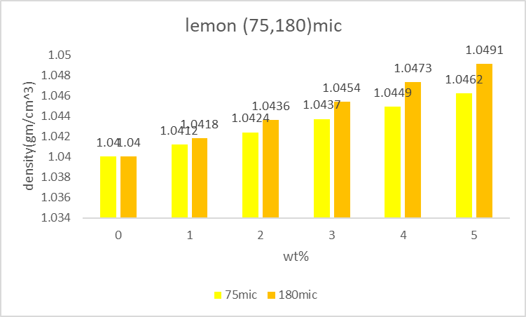
Figure2: densities values of UPE composites
Thermal Conductivity
The thermal conductivity values of UPE composites were determined using Lee’s disk device. The device was equipped with a voltage of 6volts and a current of 0.25A, thermal conductivity was plotted as a function of the concentration of lemon peels as shown in Figure 3, where thermal conductivity values were decreased sadly from higher value (0.36 watt / m. c) for unsaturated polyester to the value (0.316 watt / m. c) for (UPE/ 5% 7.5 MLP) ( indicated in the drawing in light yellow ) and to the value ( 0.248Watt /m. c) for (UPE/ 5% 180 MLP) (indicated in the drawing in dark yellow) , this because the composite material consists of two phases, one for the reinforcing (lemon peels fiber) and the other for the matrix (UPE), where the lemon peels fibers have thermal conductivity value differ than the thermal conductivity value of unsaturated polyester [11].
The values of thermal conductivity of (UPE/ 180 MLP) and (UPE/ 75MLP) are close, by loading the (UPE) with lemon peels powder in small rates (1%, 2% and 3%), but by loading the fibers with high percentages (4% and 5%) the thermal conductivity values of (UPE/ 180MLP) and (UPE/ 75MLP) are too different.
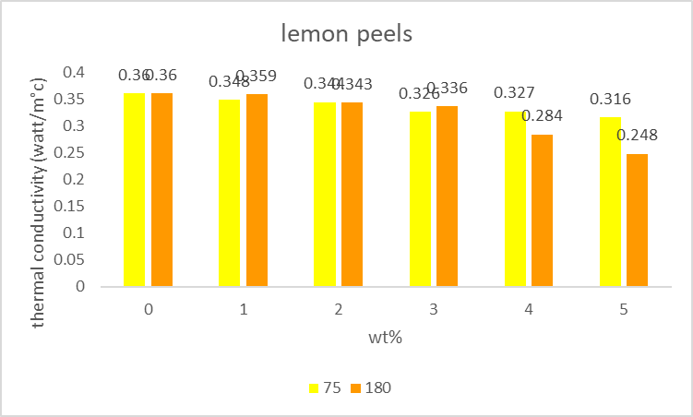
Figure 3 thermal conductivity values of UPE composites
Hardness
The resistance of the composites (unsaturated polyester/ lemon peels) to indentation is hardness [12], [13]. Samples were measured using a device Shore (D) test model TH 210, Italy. Figure 4 shows the relationship between hardness and weight percentage of lemon peel powder in unsaturated polyester, where the values of composite hardness are increased by strengthening the unsaturated polyester with a small particle size ( 75 microns). This result agrees with the research [14]. The hardness values of ( UPE/ 7.5 MLP) composites have a higher values with compared by (UPE/ 180 MLP) in the same values of fibers weight percentage, this may due good dispersion of smaller particles size between matrix chains, which makes a strong bonding between the particles and unsaturated polyester . ( UPE/ 4% 75 MLp) The composite has the best hardness value (80.4), while the composite ( UPE/ 2% 180 MLP) has the highest hardness value (78 ) , these results agree well with the research [15].
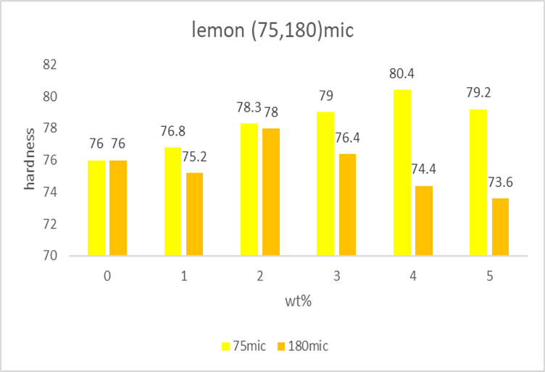
Figure 4 Hardness values of UPE composites
Impact Test
using a Charpy impact tester was carried out on the sample, impact strength values were plotted as a function of lemon peel powder concentration as shown in Figure (5) where the impact strength value of unsaturated polyester decreased when this resin reinforced with different weight percentages of lemon peels powder, these results agreed with research’s [16-18]. Also, the composite (UPE/ 4% 7.5 MLP) has higher impact strength value (4.334 Mpa). The impact strength values of (UPE/ 180 MLP) with low weight percentage (1% and2 %) have a higher value compared with (UPE/ 7.5 MLP), but at high weight percentages as (4%) the (UPE/ 75 MLP) has a higher impact strength value than (UPE/ 180 MLP), that means the particle size and weight percentage are two important factors that effect on the impact strength value of unsaturated polyester composites [21].
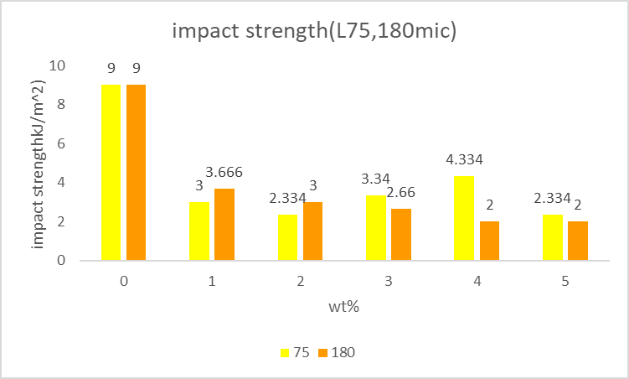
Figure 5: Impact strength values of UPE composites
Energy Dispersive Spectroscopy (EDS)
Checked using a device) Axia chemi sem Thermo Fisher Scientific Company) manufactured in Holland.
Table (1) shows the mineral contain in (unsaturated polyester/lemon peel fibers) composites, where the elements such as (C and O) are consistent in large quantities, while the element such as (N, Ca, Fe, Ni and Rb) in small quantities, some elements such as (Co, Nb, Cl and Bi) appear in small quantities only in (UPE/75MLP) composite, this may due to changes in particles size of lemon peels fibers. The weight percentage of elements such as (C) is too high (62.9 %) in (UPE/180 MLP) composite, with compared with (UPE/75MLP) composite, which is decreased to (36.4%), this result can interpret the light-yellow color of (UPE/75MLP) composite with compared with the dark yellow of (UPE/180 MLP) composite, also the changes in weight percentages of other elements such as (N, Ca, Fe, Ni and Rb) in two composites. The change in kind and weight percentage of elements in composite compositions will cause the change in there mechanical and thermal properties, these results agreed with [10, 22].
Table 1 The element compositions of UPE composites
(UPE/ 180 MLP) composite |  | ( UPE/ 75 MLP) composite
Element | Weight % | Element | Weight %
C | 62.9 | C |  | 36.4
N | 5.6 | N |  | 18.1
O | 19.2 | O |  | 36.0
K | 0.7 | Cl |  | 1.4
Ca | 1.8 | Ca |  | 0.9
Fe | 1.0 | Fe |  | 0.5
Ni | 1.2 | Co |  | 0.2
Rb | 7.6 | Ni |  | 0.5
 |  | Rb |  | 4.7
 |  | Nb |  | 0.3
 |  | Bi |  | 0.9

Scanning Electron Microscopy
SEM photos of (UPE/ 180 MLP) and (UPE/ 75 MLP) composites, with magnifications (150 ×) are represented in figure 6. The images clearly show a significant difference in the morphology of the pure (UPE) and (UPE/180MLP) and (UPE/75MLP) composites. The Lemon particle-UPE matrix interface and the strong bond between the lemon fibers and the UPE play a significant role in improving the mechanical properties of the composites. The morphology of the (UPE/ 180MLP) and (UPE/ 75MLP) surfaces has good homogeneity and compatibility between the unsaturated polyester and the lemon peel fibers [23].
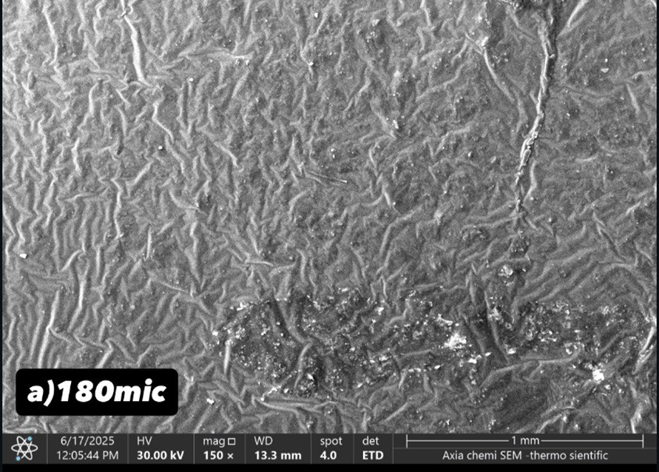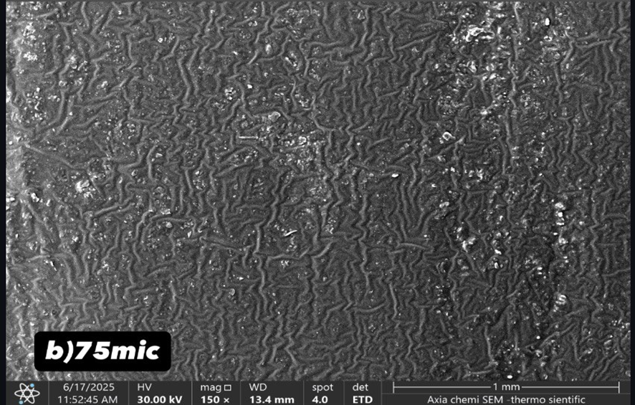
Figure 6 SEM micrographs of a -(UPE/ 180 MLP), b-(UPE/ 75 MLP)
ACKNOWLEDGMENT
The authors thanks and gratitude to the College of Education Ibn AL-Haitham / University of Baghdad and to the University of Technology
CONCLUSION
The particle size and the weight percentage of lemon peels particles effects on physical, mechanical and structural properties of unsaturated polyester composite. The best mechanical, physical and structural properties were get by using the (UPE/ 180 MLP) and (UPE/ 75 MLP) composites which selected for engineering applications. The particle size value of lemon peels particles effected on the kind and number of elements, especially carbon in (unsaturated polyester/ lemon peels fibers) compositions and causes the changes in unsaturated polyester composite color, moreover the brightness in composite color increasing with decrease the particle size of lemon peels powder in unsaturated polyester composite.
REFERENCES
- H. Ku, H. Wang, N. Pattarachaiyakoop, and M. Trada, Compos B Eng, vol. 42, no. 4, pp. 856–873, Jun. 2011.
- RAMAKRISHNA MALKAPURAM, VIVEK KUMAR AND YUVRAJ SINGH NEGI, Recent Development in Natural Fiber Reinforced Polypropylene Composites, Journal of Reinforced Plastics and Composites, vol. 28, no. 10, pp. 1169–1189, May 2009, doi: 10.1177/0731684407087759.
- Piedad Gañán , Jaime Barajas, Robin Zuluaga, Cristina Castro, Daniel Marín, Agnieszka Tercjak y Daniel H.Builes., The Evolution and Future Trends of Unsaturated Polyester Biocomposites: A Bibliometric Analysis, Polymers, vol. 15, no. 13, p. 2970, Jul. 2023, doi: 10.3390/POLYM15132970.
- Hailay Kidane, Ethiopian Sisal fiber and Unsaturated Polyester Composite Panel a Fabrication to Characterize Flexural Properties for Future Opportunities in Car Body Applications, Abyssinia Journal of Engineering & Computing Vol. 1, No. 2, 2021, 47-53 2021.
- Mateus Hofmann, , Abu T. Shahid , Marina Machado a , Mario Garrido, Joao C. Bordado, and Jo ao R. Correia, Gfrp Biocomposites Produced with a Novel High-Performance Bio-Based Unsaturated Polyester Resin, Compos Part A Appl Sci Manuf, vol. 161, p. 107098, 2022.
- Aveen ansaif jassim and Widad hamdi Jassim, Preparation of Polyester/ Micro Eggshell Fillers Composite as Natural Surface Coating, Ibn AL-Haitham Journal for Pure and Applied Sciences, vol. 36, no. 1, pp. 88–99, Jan. 2023, doi: 10.30526/36.1.2889.
- Novi Laura Indrayani, Riri Sadiana, and Dicky Ramdani, Optimization of Unsaturated Polyester Resin Matrix Composite Materials Reinforced Banana (Musa Balbisiana) Fronds Composition Towards Tensile Test, “E3S Web of Conferences, vol. 500, p. 03014, Jan. 2024, doi: 10.1051/E3SCONF/202450003014.
- Henny Pratiwi, Kusmono, and Muhammad Waziz Wildan, Development and characterization of polyester/ramie fiber hybrid composites reinforced with crystalline nanocellulose extracted from durian peel waste, Journal of Materials Research and Technology, vol. 34, pp. 1201–1212, Jan. 2025, doi: 10.1016/J.JMRT.2024.12.159.
- W. H. Alhazmi, Y. Jazaa, S. Mousa, A. A. Abd-Elhady, and H. E. M. Sallam, Tribological and Mechanical Properties of Epoxy Reinforced by Hybrid Nanoparticles, Latin American Journal of Solids and Structures, vol. 18, no. 03, p. e361, 2021.
- A. Zegaoui, M. Aillerie, P. Petit, J.-P. Sawicki, A. Jaafar, C. Salame, and J.-P. Charles, “Comparison of two common maximum power point trackers by simulating PV generators,” Energy Procedia 6, 678–687 (2011).
- S. B. Hassan, V. S. Aigbodion, and S. N. Patrick, Development of Polyester/Eggshell Particulate
Composites, Tribology in industry, vol. 34, no. 4, p. 217, 2012.
- Shaimaa Hilal Kamel Assist, Studying some of the mechanical properties of unsaturated polyester reinforced by re-cycled natural materials., al-Qadisiyah journal for Engineering vol.8, N.2 pp.137-146 , 2015.
- Rahima Baghloul, Laidi Babouri, Houria Hebhoub, Fouad Boukhelf, and YassineElMendili,, Assessment of Mechanical Behavior and Microstructure of Unsaturated Polyester Resin Composites Reinforced with Recycled Marble Waste,Buildings, vol. 14, no. 12, p. 3877, 2024.
- Aleabi, S.H., Watan, A.W., Salman, E.M.-T., kareem Jasim A.,Shaban, A.H., Alsaadi, T.M., The study effect of weight fraction on thermal and electrical conductivity for unsaturated polyester composite alone and hybrid, AIP Conference Proceedings, 2018, 1968, 020019.
- Jassim, K.A., Thejeel, M.A.-N., Salman, E.M.-T., Mahdi, S.H., Study characteristics of (epoxy-bentonite doped) composite materials, Energy Procedia, , 119, pp. 670–679. 2017
- Rihab Nassr Fadhil, Muna B. Jasim, Zainab Assif Abdullah, Shatha H. Mahdi, and Kareem A. Jasim, Manufacture and study the mechanical, thermal and physical
properties of plastic wood, Journal of Physics: Conference Series, IOP Publishing, , p. 012005. 2024
- Zainab, J.N., Jasim, K.A., Kadhum, F.J., Shaban, A.H., Heat treatment at different temperatures and its effect on the optical properties of pure pmma and pmma-coumarin, Key Engineering Materials, , 900, pp. 42–47. 2021
- Sihama Issa Salih, Waleed Bdaiwi Salih, and Husam Sakin Hamad, Iraqi Journal of Physics, vol. 16, no. 37, pp. 136–148, 2018.
- Reem ALaa Mohammed & Marwah Subhi Attallah, Journal of Mechanical Engineering Research and Developments Vol. 43, No. 2, pp. 267-283,2020.
- Kadhim, B.B., Risan, R.H., Shaban, A.H., Jasim, K.A., Electrical characteristics of nickel/epoxy - Unsaturated polyester blend nanocomposites, AIP Conference Proceedings, , 2123, 020062. 2019
- Angaw Chaklu Engidaw, Araya Abera Betelie, Daniel Tilahun Reddaو Science and Engineering of Composite Materials, vol. 31, no. 1, p. 20240001, 2024.
- Seenaa I. Hussein, Alaa M. Abd-Elnaiem, Tesleem B. Asafa, and Harith I. Jaafar, Applied Physics A, vol. 124, no. 7, p. 475, 2018.
- Shangjin He, Keyu Shi, Jie Bai, Zengkun Zhang, Liang Li, Zongjie Du, Baolong Zhang, Polymer (Guildf), vol. 42, no. 23, pp. 9641–9647, 2001.

