Computation of Physical Properties of Perovskite Nano Clusters to Improve Letrozole Impact For Breast Cancer Treatment
Marwa Talib Jaleel^{1,a)}, Shaymaa A. Jaber ^{2,b)} and Bahjat B. Kadhim ^{3,c)}
¹⁾Department of Physics, College of Education for Pure Science-Ibn Al-Haitham, University of Baghdad, Iraq.
²⁾ Department of Physics, College of Science, Sumer University, Iraq.
³⁾ Department of Physics, College of Science, Mustansiriyah University, Iraq.

^{a)} marwa.Taleb1204a@ihcoedu.uobaghdad.edu.iq
^{c )} sci.phy.bbk@uomustansiriyah.edu.iq
^{b)} Corresponding author E-mail: shimaa.aziz@uos.edu.iq
Abstract: Breast cancer is a type of cancer frequently encountered in women, and there is a need for more efficient and safer therapeutic approaches. Letrozole is an aromatase inhibitor that suppresses the growth of estrogen-dependent tumors, but its metabolic stability at high temperatures may restrict its therapeutic activity. In the present theoretical work, based on quantum calculations using the Gaussian software package, we examine the thermodynamic properties of the letrostructure alone and in combination with lead-free perovskite (CaTiO₃)₂ structure. The compatibility of the perovskite was further examined in terms of its biosafety in relation to the hemoglobin molecule. The obtained difference in Gibbs free energy (ΔG) values and displacement of enthalpy (ΔH) towards the more stable side, as well as higher deformation and binding energies of perovskite, were found when combined with letrozole. These signs suggest that more spontaneous tumor growth and tight binding to the cancerous formation were achieved, which did not present any apparent hematotoxicity. Then, lead-free perovskites may serve as a potential mediator for enhancing the efficacy of letrozole in breast cancer treatment.
Keywords: hemoglobin, perovskite, breast cancer, letrozole, computation.

Introduction
Breast cancer is one of the most frequent malignancies in women worldwide, and a leading cause of both morbidity and mortality, particularly for estrogen receptor-positive (ER+) cancers. The global incidence of this lethal disease is about 2.3 million new cases with over 680,000 respective deaths; these figures from GLOBOCAN 2020 are representative of the huge health burden due to the disease [1, 2]. The available epidemiologic data suggest that early detection is the cornerstone of cancer survival [3]. One of the important therapeutic advances is aromatase inhibitor treatment, particularly letrozole, which blocks the activity of CYP19A1 (aromatase), responsible for the transformation of androgens into estrogens. Impaired by letrozole (LT), whose anticancer efficacy has been demonstrated to retard tumor growth and prolong survival [4, 5]. Nevertheless, its heat, light, and pH sensitivity could influence its stability and pharmacological performance [6, 7]. Physics has started using quantum simulations (programs such as Gaussian) to investigate the generic electronic, thermodynamic, and optical properties of molecules. It would have provided a "mental laboratory" in which to learn more about letrozole behavior and its relationship with physical factors before experimental usage [8-10]. In the present work, we suggest an integrated scheme, which starts with the investigation of letrozole as a single molecule by extracting its thermal functions (H, G, S) at physiological temperature (298–315) K and then looks for an optical signature for studying TD-DFT calculations in order to discern a safe region of spectra. It is subsequently tested in a blood-mimicking medium (SMD/Water) for safety. The interaction of letrozole with lead-free perovskite (Ca₂Ti₂O₆). This approach lays the groundwork for developing a therapeutic-physical concept that enhances letrozole efficiency by tailoring its thermo-spectral milieu using safe and promising materials, such as Ca₂Ti₂O₆. It presents a potential front-line view of combining medicine and theoretical physics effectively in the fight against breast cancer [11, 12].

Computational Methods
This theoretical work utilized the Gaussian 16 program to analyze the molecular interaction simulation and investigated the thermodynamic and optical properties of these models. A cancer model was first built using the molecular structure provided in [13]. The molecular steroid defect of this hormone was simulated by fusing two progesterone molecules to create a conglomerate structure, supposed to be the virtual one of growth catechol estroprogestins in breast cancer. The optimized letrozole structure [14] was further retrieved from literature databases and covalently attached to the cancer model, resulting in a complex (cancer-letrozole) as a reference system.
Next, the structure of a lead-free perovskite, Ca₂Ti₂O₆, was prepared using full crystallographic data [15]. Calculations were then performed on its interaction with the deoxyhemoglobin molecule of blood [16] to verify its biosecurity and non-hazardous behavior for human health in contact with blood components. This analysis was also necessary to evaluate the medical suitability of the material for inclusion in the therapy model. The cancer-letrozole complex was subsequently conjugated to perviskite to explore increased stability and efficacy of letrozole in the presence of perviskite compared to the control case.
The thermodynamic properties (free energy ΔG, enthalpy ΔH, and entropy ΔS) changes were computed using the following equation [16], as well as energies of dissociation energies E_{def} [17] and binding energy E_{B} [16] to check the stability model and spontaneity reactions:
 | $$∆G=∆H-∆ST$$  $$E_{def}=\left(E_{Docking}-E_{a}\right)+\left(E_{Docking}-E_{b}\right)$$  $$E_{B}=\left[ \frac{\left(NE_{a}+ME_{b}\right)-E_{Docking}}{N+M}\right]$$ | (1)  (2)  (3)
Where: T, temperature, $E_{a}$ : total energy of first material, $E_{b}$ : total energy of second one, N and M : are number of atoms for a and b, $E_{Docking}$ :is the total energy for docking a with the b.

Results and Discussion
Figure 1 illustrates the process of docking a hemoglobin structure with a Ca₂Ti₂O₆ perovskite crystal. Vibrational analysis confirmed the thermal stability of the final structure, as no phantom vibrational frequencies were detected, thereby meeting the stability criterion. This supports the assumption that perovskite is biocompatible with blood components and does not cause direct toxic effects.
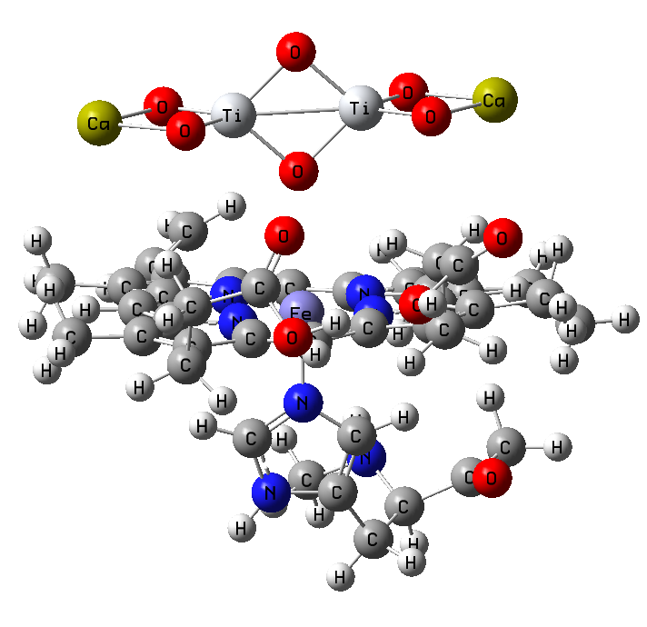
FIGURE 1. Docking of the hemoglobin structure with the perovskite.

Figures 2 and 3 depict the docking model of letrozole with the cancer target, as well as the docking of the ternary cancer-targeting complex, which includes letrozole and perovskite. The results of the calculations confirmed the stability of this complex. This study aims to enhance the therapeutic efficacy of letrozole in the treatment of breast cancer by using lead-free perovskite as a safe adjuvant. This approach improves thermal stability and reduces phototoxicity, all while avoiding hematotoxicity, by achieving optimally stable structures. Figure 1 illustrates the process of docking a hemoglobin structure with a Ca₂Ti₂O₆ perovskite crystal. Vibrational analysis confirmed the thermal stability of the final structure, as no phantom vibrational frequencies were detected, thereby meeting the stability criterion. This supports the assumption that perovskite is biocompatible with blood components and does not cause direct toxic effects.

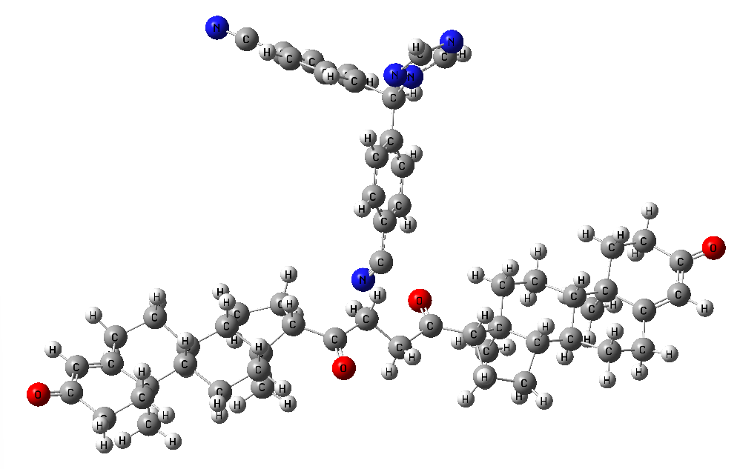
FIGURE 2. Docking letrozole with breast cancer structure.

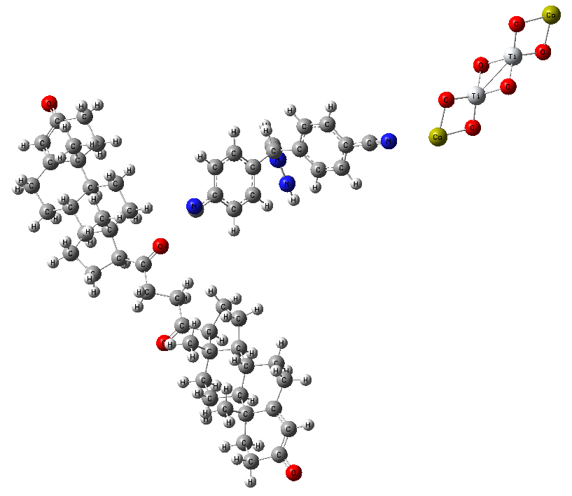
FIGURE 3. The docking of the letrozole structure (liver) to the breast cancer with the perovskite intermediates.

In table (1) All values of OHB selected were from a well-established source and served as the gold standard [16, 18]. OHB should be considered the best blood fitness and functional model. The Gibbs free energy (ΔG) and enthalpy (ΔH) listed for OHB were relatively lower compared with the docking of Pb-free perovskite to deoxyhemoglobin, ((CaTiO₃)₂ - DHB), suggesting that the process is not fully thermodynamically favorable but may represent a stable interaction that does not damage protein structure [19] .
The results for the entropy change (ΔS) revealed that both models presented negative values, indicating a decrease in disorder after bonding. Despite the increase in the number of cells, we did not reach a higher level. Thus, we have a cell amount that could influence the essential biological function of hemoglobin - oxygen transport [20]. In contrast, the dissociation (E_{def}) and binding (E_{B}) energies demonstrated that perovskite’s' contact with DHB is superficial, weak, and non-covalent, revealing that perovskites do not induce structural or functional distortion to hemoglobin [21, 22].
These findings are in accord with the results of earlier clinical research, which have indicated an association between the hemoprotein risk and preserving its free energies and space structure within the normal range[23].Thus, all the values of perovskites (CaTiO₃)₂ – DHB are within an acceptable range as observed to that of the reference value of oxyhemoglobin, and this proves that perovskites is a relatively safe material, showing non-toxic properties with respect to the blood on a molecular contact level.
In Table 1 Thermodynamic and energetic considerations of the letrozole–cancer complex versus the letrozole–perovskite (CaTiO₃)₂ - cancer complex revealed a significant enhancement in all investigated aspects when replacing lead-based perovskite. The Gibbs free energy (ΔG) decreased from 1.53 eV to 0.62 eV, indicating that the reaction was more spontaneous and thermodynamically stable. The enthalpy (ΔH) was also transferred from a high positive value (19.33 eV) to near zero (-0.08 eV), demonstrating the transfer of a state that requires external energy to another with greater stability and lower energy costs. In addition, ΔS had a lower value of 3.59 eV compared to 17.79 eV, indicating a more ordered system due to the presence of perovskite.
The deformation energy (E_{def}) was observed to be less negative after the inclusion of perveskite, implying that the novel material has a low energy requirement for binding. Whereas binding energy (E_{B}) got much better, it has decreased from 5.47 eV to a negative value (−242.69 eV), indicating that letrozole binding with the cancerous model became stronger and more stable in the presence of perveskite. All of these results indicate that the incorporation of perveskite increased its therapeutic effectiveness by enhancing thermal stability and reducing the dissociation probability with letrozole.
These theoretical findings are in agreement with the literature, which reports that the use of stable nanomaterials to enhance the environment of the drug molecule can improve its therapeutic effect and reduce its photo-thermal degradation [21, 24]. Pb-free perovskites (e.g., CaTiO₃ and Ca₂Ti₂O₆) also demonstrate the optical and thermal properties required to be considered for biomedical applications while being less toxic to blood components [25, 26].In clinics, improving drug stability is an essential element for higher efficacy of anticancer drugs, including letrozole, because the drug stability correlates with its therapeutic effect and prevention from relapse [4, 7, 27].
From this, it may be inferred that the activity of perveskite (CaTiO₃)₂ was further improved due to its combination with letrozole, facilitated by the excellent thermal and optical properties, making it a more effective therapy for breast cancer, while enhancing stability and preventing possible adverse effects following thermal or photodegradation.
TABLE 1. Thermodynamic properties and binding energies of the studied models.
Energies,  eV | OHB | (CaTiO3)2 with DHB | Letrozole with Cancer | Letrozole with (CaTiO₃)₂ with Cancer
ΔG | 0.566097644 | 18.35814605 | 1.539707224 | 0.623431221
ΔH | 0.063211153 | 17.17327027 | 19.33692572 | -0.084245256
TΔS | -0.502886491 | -1.184875784 | 17.7972185 | 3.596124127
E_{def} | -103458.6634 | 23162.74595 | -77902.64077 | -69114.19817
E_{B} | 187.4522258 | -499.230869 | 5.47251226 | -242.6955008

Theoretical calculations based on thermodynamic properties reported that the lead-free perovskite (CaTiO₃)₂, when combined with letrozole, resulted in a considerable improvement in its therapeutic stability compared to the previous compound acting alone. The formation of the ternary complex (letrozole–perovskite–cancer) resulted in a significant decrease in Gibbs free energy (ΔG), indicating higher spontaneity. The enthalpy (ΔH) changes from a high positive value towards near-zero or negative values, suggesting improved thermal stability. In addition, the deformations (E_{def}) and binding energies (E_{B}) indicated that the enhanced complex is better able to form stable complexes, as well as requires less energy when variations were made in a favourable environment.Perovskite's binding to hemoglobin was also found not to be toxic or produce significant negative changes in blood proteins, further supporting its safety potential. Therefore, lead-free perovskites are an effective mediator to enhance the stability of letrozole, as well as promote its activity against breast cancer. Nevertheless, these results are speculative and require follow-up with in vitro and clinical trials to ultimately validate their efficacy in vivo.

Conclusion
Theoretical calculations based on thermodynamic properties reported that the lead-free perovskite (CaTiO₃)₂, when combined with letrozole, resulted in a considerable improvement in its therapeutic stability compared to the previous compound acting alone. The formation of the ternary complex (letrozole–perovskite–cancer) resulted in a significant decrease in Gibbs free energy (ΔG), indicating higher spontaneity. The enthalpy (ΔH) changes from a high positive value towards near-zero or negative values, suggesting improved thermal stability. In addition, the deformations (E_{def}) and binding energies (E_{B}) indicated that the enhanced complex is better able to form stable complexes, as well as requires less energy when variations were made in a favourable environment.Perovskite's binding to hemoglobin was also found not to be toxic or produce significant negative changes in blood proteins, further supporting its safety potential. Therefore, lead-free perovskites are an effective mediator to enhance the stability of letrozole, as well as promote its activity against breast cancer. Nevertheless, these results are speculative and require follow-up with in vitro and clinical trials to ultimately validate their efficacy in vivo.

References
- A. Jemal, F. Bray, M.M. Center, J. Ferlay, E. Ward, D. Forman, Global cancer statistics, CA: a cancer journal for clinicians 61(2) (2011) 69-90.
- H. Sung, J. Ferlay, R.L. Siegel, M. Laversanne, I. Soerjomataram, A. Jemal, F. Bray, Global cancer statistics 2020: GLOBOCAN estimates of incidence and mortality worldwide for 36 cancers in 185 countries, CA: a cancer journal for clinicians 71(3) (2021) 209-249.
- C.E. DeSantis, J. Ma, M.M. Gaudet, L.A. Newman, K.D. Miller, A. Goding Sauer, A. Jemal, R.L. Siegel, Breast cancer statistics, 2019, CA: a cancer journal for clinicians 69(6) (2019) 438-451.
- A.S. Bhatnagar, The discovery and mechanism of action of letrozole, Breast cancer research and treatment 105(Suppl 1) (2007) 7-17.
- H.T. Mouridsen, Letrozole in advanced breast cancer: the PO25 trial, Breast cancer research and treatment 105(Suppl 1) (2007) 19-29.
- S. Priyadarsini, S.R. Lahoti, RP-HPLC method development and validation for quantification of letrozole solid lipid nanoparticle, Journal of Research in Pharmacy 26(2) (2022) 421-430.
- M. De Luca, M.A. Occhiuzzi, B. Rizzuti, G. Ioele, G. Ragno, A. Garofalo, F. Grande, Interaction of letrozole and its degradation products with aromatase: chemometric assessment of kinetics and structure-based binding validation, Journal of Enzyme Inhibition and Medicinal Chemistry 37(1) (2022) 1600-1609.
- D.A. McQuarrie, Quantum chemistry, University Science Books2008.
- C.J. Cramer, Essentials of computational chemistry: theories and models, John Wiley & Sons2013.
- A.G. Martynov, J. Mack, A.K. May, T. Nyokong, Y.G. Gorbunova, A.Y. Tsivadze, Methodological survey of simplified TD-DFT methods for fast and accurate interpretation of UV–vis–NIR spectra of phthalocyanines, ACS omega 4(4) (2019) 7265-7284.
- M. Shkoor, H. Mehanna, A. Shabana, T. Farhat, A.D. Bani-Yaseen, Experimental and DFT/TD-DFT computational investigations of the solvent effect on the spectral properties of nitro substituted pyridino [3, 4-c] coumarins, Journal of molecular liquids 313 (2020) 113509.
- I. López‐Fernández, D. Valli, C.Y. Wang, S. Samanta, T. Okamoto, Y.T. Huang, K. Sun, Y. Liu, V.S. Chirvony, A. Patra, Lead‐free halide perovskite materials and optoelectronic devices: progress and prospective, Advanced Functional Materials 34(6) (2024) 2307896.
- M. Feghali, R. Venkataramanan, S. Caritis, Prevention of preterm delivery with 17-hydroxyprogesterone caproate: pharmacologic considerations, Seminars in perinatology, Elsevier, 2014, pp. 516-522.
- T. Cinek, N. Karalı, Histone deacetylase inhibitors providing an epigenetic treatment in cancer, Istanbul Journal of Pharmacy 51(2) (2021) 283-290.
- N.K. Bansal, S. Mishra, H. Dixit, S. Porwal, P. Singh, T. Singh, Machine learning in perovskite solar cells: recent developments and future perspectives, Energy Technology 11(12) (2023) 2300735.
- K. Al Abdullah, F. Al Alloush, M. J. Termanini, and C. Salame, “Low frequency and low temperature behavior of Si solar cell by AC impedance measurements,” Energy Procedia 19, 183–191 (2012)..
- Z. Mahdavifar, R. Moridzadeh, Theoretical prediction of encapsulation and adsorption of platinum-anticancer drugs into single walled boron nitride and carbon nanotubes, Journal of Inclusion Phenomena and Macrocyclic Chemistry 79(3) (2014) 443-457.
- S.A. Jaber, B.B. Kadhim, A.T. Mohi, Simulation of interaction energy and thermodynamics properties of developed nano drug docking with glucose for the diabetes treatment, AIP Conference Proceedings, AIP Publishing LLC, 2025, p. 040020.
- M.F. Perutz, Stereochemistry of cooperative effects in haemoglobin: haem–haem interaction and the problem of allostery, Nature 228(5273) (1970) 726-734.
- Saadon, A.K., Shaban, A.H., Jasim, K.A., Effects of the Ferrits addition on the properties of Polyethylene Terephthalate, Baghdad Science Journal, 2022, 19(1), pp. 208–216.
- N.B. Pham, W.S. Meng, Protein aggregation and immunogenicity of biotherapeutics, International journal of pharmaceutics 585 (2020) 119523.
- M. Rahman, S. Laurent, N. Tawil, L. Yahia, M. Mahmoudi, Protein-nanoparticle interactions, Biophysics 15 (2013) 45-63.
- M. Arakha, S.K. Rath, A.K. Pradhan, B.C. Mallick, S. Jha, Protein–Nanoparticle Interaction and Its Potential Biological Implications, Bioprospecting of Enzymes in Industry, Healthcare and Sustainable Environment, Springer2021, pp. 155-173.
- R. Parveen, T.N. Shamsi, S. Fatima, Nanoparticles-protein interaction: Role in protein aggregation and clinical implications, International journal of biological macromolecules 94 (2017) 386-395.
- H. Bahrom, A.A. Goncharenko, L.I. Fatkhutdinova, O.O. Peltek, A.R. Muslimov, O.Y. Koval, I.E. Eliseev, A. Manchev, D. Gorin, I.I. Shishkin, Controllable synthesis of calcium carbonate with different geometry: comprehensive analysis of particles formation, their cellular uptake and biocompatibility, arXiv preprint arXiv:2106.15974 (2021).
- H. Bahrom, A.A. Goncharenko, L.I. Fatkhutdinova, O.O. Peltek, A.R. Muslimov, O.Y. Koval, I.E. Eliseev, A. Manchev, D. Gorin, I.I. Shishkin, Controllable synthesis of calcium carbonate with different geometry: comprehensive analysis of particle formation, cellular uptake, and biocompatibility, ACS Sustainable Chemistry & Engineering 7(23) (2019) 19142-19156.
- X. Li, X. Gao, X. Zhang, X. Shen, M. Lu, J. Wu, Z. Shi, V.L. Colvin, J. Hu, X. Bai, Lead‐free halide perovskites for light emission: recent advances and perspectives, Advanced Science 8(4) (2021) 2003334.

