Physical Simulation to Evaluate the Impact of Nano Perovskite and 18F-FDG Medical Dye as Intravenous Carriers for Doxorubicin
Shaymaa A. Jaber^{1, a)}, Ali Naji Saleh^{2, b)} and Bahjat B. Kadhim^{3, c)}
¹Department of Physics, College of Science, Sumer University, Iraq.
²Rector assistant office for scientific affairs, Al-iraqia university, Iraq.
³Department of Physics, College of Science, Mustansiriyah University, Iraq.

^{a)} Corresponding author: shimaa.aziz@uos.edu.iq
^{b)} ali.n.saleh@aliraqia.edu.iq
^{c)}sci.phy.bbk@uomustansiriyah.edu.iq

Abstract: The study involved enhancing the targeted delivery of the breast cancer medicament doxorubicin using two new nanosystems: a molecular imaging probe (¹⁸F-FDG) and nano perovskite (CaTiO₃)₂. Molecular simulations and density functional theory were employed to investigate the interaction of the medicament with proteins in cancer cells and blood. The results indicated that the medicament, when docked with ¹⁸F-FDG, could promote selectivity and stability, decrease structural deformation, and thus improve therapeutic efficacy. Nano perovskite offered high electronic stability but decreased biorelease. Optical spectra further indicated no discernible absorption in the visible region, implying its safety for intravenous delivery. These results indicate that nano perovskite is perhaps a permanent carrier, while ¹⁸F-FDG can achieve delivery of medicament accurately if the medicament release rate is manageable.
Keywords: Nano perovskites (CaTiO₃)_{2,} Breast cancer, Doxorubicin, DFT, docking, carriers.

Introduction
Breast cancer is one of the most frequent cancers in women over the world and a challenge to medicine and research, because incidence continues growing up and it's hard to control relapses. Although classical chemotherapy regimens work and doxorubicin has been for long time a poster child of this, it is problematic especially due to uninformed accumulation of the medicament in the body leading to cardiac complications and side effects limiting the effective application in clinics that would eventually deteriorate patients’ life quality [1] .The need for new systems that would allow targeted and safe in vivo administration of this drug is thus emphasized.
¹⁸F-FDG Contrast has become one of the most significant molecular imaging agents currently used in clinical practice, which can be applied to diagnose cancer and visualize cells with high metabolic activity using positron emission tomography (PET) [2, 3]. This routine clinical use proves that the contrast agents could specifically enhanced the distribution of the glucose into tumor cells by imaging increased glucose uptake, for example Warburg effect [4, 5]. Herein, we took this idea a step further by using the dye not only as a detection probe but also as drug carrier for delivering drugs to cancer cells, offering a new prospect for the development of targeted therapy.
Lead-free perovskite, on the other hand, has also been developed as potential nanomaterial for its tunable electronic and surface properties. Herein, the crystalline (CaTiO₃)₂ was selected because of its stability and possible use in drug delivery [6]. This is the first time that this nanocomposite material was have been applied as a nanocarrier for intravenous drug release, with emphasis on confirming blood compatibility prior to therapeutic uses.
Therefore, this theoretical work is based on a double analysis: 1 the ¹⁸F-FDG dye acting as a sugar head for improving drug selectivity and target cancer cell and, (CaTiO₃)₂ are simulated to be an ideal nanocarrier that can propose stable and security base for drug transport in circulating blood system [6]. This is all performed within the framework of thermodynamic analysis and molecular simulations that allows predictions of stability of structures, strength of binding, drug release, etc., under various conditions.
In this spirit, first such approach shall include testing of the ¹⁸F-FDG dye and the nano perovskite (CaTiO₃)₂ on blood elements to determine their safety and biocompatibility that is a new, less developed research ethic in the field [1, 6]. In this light, we seek to create a theoretical model that docks two independent systems: a drug that docks with ¹⁸F-FDG dye when docked through the cancer model, and one docking with nano perovskite when docked against the cancer. It is performed from the point of thermodynamic studies and molecular simulation, to estimate stability, docking strength and behavior of drug release, in order to find whether one of two systems is more prospective for further application as injected drug.

Materials AND Methods
This study used a series of ethically prepared molecular models of known origin. Doxorubicin (DOX) was depicted in its protonated form at physiological pH (7.4) according to PubChem compound 31703. The dye was a non-radioactive glucose analogue (2-DG, pubchem CID: 5950) which played the role of sugar head in theoretical one.
A lead-free perovskite cluster (CaTiO₃)₂ was used as the nanocarrier, published from [7], and then underwent geometric optimization before being incorporated into the calculations. The cancer model was constructed using Gaussian software by combining two progesterone molecules (PubChem CID: 5994) to serve as a hypothetical drug binding site. Finally, the crystal structure of deoxyhemoglobin was adopted from the source [8] to study the interactions related to blood safety.
All molecular models were initially free in geometry optimized for achieving the most stable as well as realistic conditions prior to initiation of docking studies. Next, the initial structure of the dye (18F-FDG) and nanocarrier was also modelled with deoxyhemoglobin to analyze if these materials are biocompatible and safe in a blood medium. The van der Waals docking between the models were weak as depicted on Figures (1) and (2).
After initially confirming the safety of the materials, we proceeded to construct the cancer model Cancer by docking the drug doxorubicin with it to form a reference model representing the tumor docking site, as shown in Figure (3). Based on this reference model, a second docking was performed, where the dye (¹⁸F-FDG) was docked with the cancer-associated drug, as shown in Figure (4). This was followed by a third docking, where the perovskite (CaTiO₃)₂ was docked with the cancer-associated drug, as shown in Figure (5).
These steps enabled a comparative evaluation of the efficacy of both the dye and perovskite in enhancing drug targeting to cancer, in addition to determining their potential future use as promising intravenous drug delivery systems.

FIGURE 1. Optimal geometric representation of the dye (¹⁸F-FDG) docking model with deoxyhemoglobin.

All quantum calculations were performed using Gaussian 16 (Revision C.01) with the Gauss View 6.0.16 interface [9]. The molecular models (doxorubicin, the dye 2-DG/FDG, and the nano perovskite cluster (CaTiO₃)₂ were subjected to initial geometric optimization using DFT/B3LYP with the SDD basis set (Stuttgart/Dresden) [10].
The SDD basis set was chosen for two main reasons: first, the model size increases after docking, and second, computational cost. SDD provides acceptable accuracy with the inclusion of Effective Core Potentials (ECPs) for heavy atoms such as Ca and Ti, which reduces the number of electrons calculated explicitly and significantly reduces computation time [11]. This achieves a suitable balance between accuracy and time cost, making it suitable for this type of theoretical study [10] .
The optical properties of the docking of the dye (¹⁸F-FDG) and the nano perovskite (CaTiO₃)₂ with the cancer - docking drug were computated using TD-DFT. The UV-Vis absorption spectrum showed the absence of strong transitions in the visible range (400–700 nm), a prerequisite for photosafety in clinical applications[12]. Infrared (IR) and Raman spectra were also computated to verify the stability of the structures and the absence of imaginary frequencies, proving that they are located at a minimum point on the potential energy surface [13, 14] .
In addition, the thermodynamic properties were computated by calculating the free energy (ΔG), enthalpy (ΔH), and entropy (ΔS), according to equations previously applied in similar studies [14, 15]. Binding and adsorption energies were also calculated to determine the strength of the drug-carrier/dye interaction, while dissociation and mixing energies were calculated to estimate the stability of the formed complexes, based on equations used in previously published studies [14]. These integrated calculations (optical, vibrational, thermodynamic, and binding) provided a comprehensive characterization of the studied structures to identify the potential of the nano perovskite as promising carriers for intravenous drug delivery, while ensuring stability and biological safety.

FIGURE 2. Optimal geometric representation of the nano perovskite (CaTiO₃)₂ docking model with deoxyhemoglobin.

FIGURE 3. Optimized geometric representation of the cancer docking model with doxorubicin.

FIGURE 4. Optimal geometric representation of the docking model of cancer docking with doxorubicin and the dye (¹⁸F-FDG).

FIGURE 5. Optimal geometric representation of the docking model of cancer docking with doxorubicin and the nano (CaTiO₃)₂.

Results and Discussion
Figure 6 shows a major absorption peak in the near infrared NIR (wavelengths above the visible) range, with no significant peaks between (400–700) nm. This transparency in the visible range implies low photosensitivity and meets safety requirements for intravenous injection; no photosensitization or generation of reactive oxygen species is expected under normal clinical lighting [16, 17]. The shift in absorption away from the visible range is also a favorable behavior for the function of the glycoprotein (FDG), as its role is focused on metabolic guidance to target cells with high glucose consumption rather than photoreaction [16].
Figure 7 shows the electron density spectrum showing the distribution of occupied and empty (virtual) states, with a clear energy gap between their edges; this indicates electronic stability and reduces the likelihood of unwanted transitions under biological conditions. Additional levels are also observed near the edge due to the incorporation of FDG, which explains the peak observed in Fig.7 without compromising the transparency of the fluorescence or destabilizing the overall system [18]. This pattern (wider gap/higher stability) is practically associated with reducing stochastic redox reactions and enhancing the safety of the delivery system within the blood [18].
Binding to the target combining the transparency of the fluorescence (Fig. 5) with the wide electronic gap (Figure 6), it is clear that the Cancer–DOX–FDG system is suitable for safe intravenous delivery: no harmful absorption into the fluorescence, and electronic stability reduces side effects. Functionally, DOX maintains its active structure, while FDG adds selectivity directed through glucose uptake pathways (GLUT/Warburg effect) without introducing unwanted photonic features [16, 17].

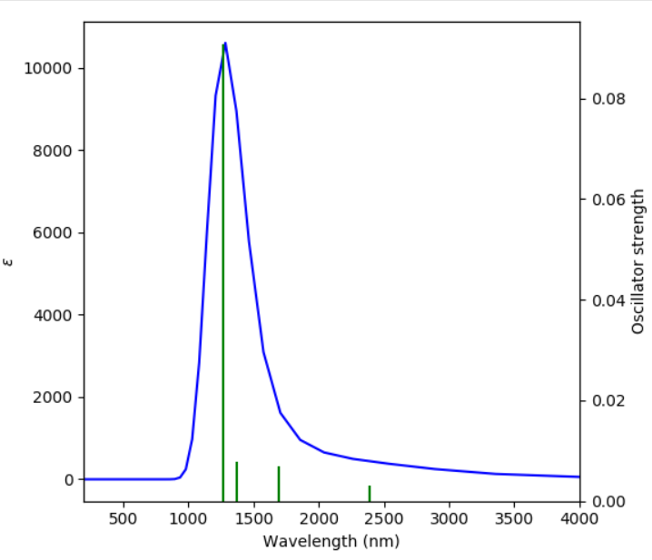
FIGURE 6. Absorption spectrum of the docking model of cancer docking with doxorubicin and the dye (¹⁸F-FDG).

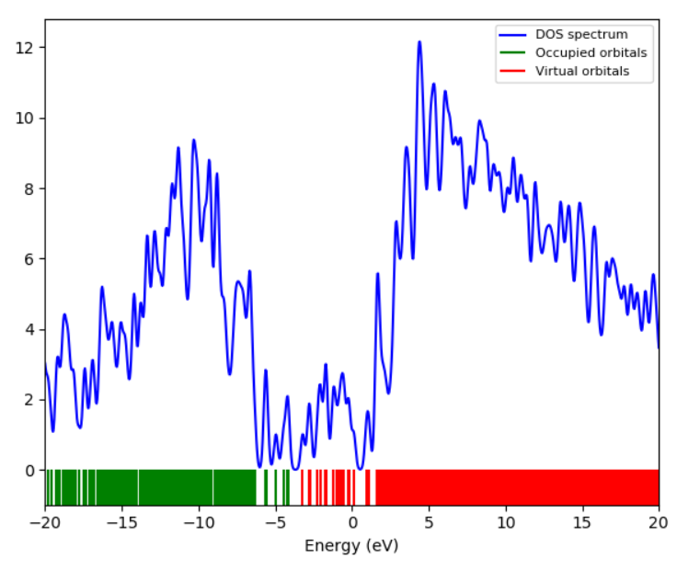
FIGURE 7. Density of states (DOS) spectrum of the docking model of cancer docking with doxorubicin and the dye (¹⁸F-FDG).

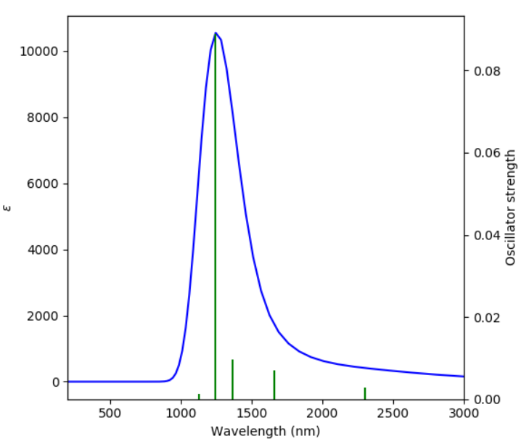
FIGURE 8. Absorption spectrum of the docking model of cancer docking with doxorubicin and the nano (CaTiO₃)₂.
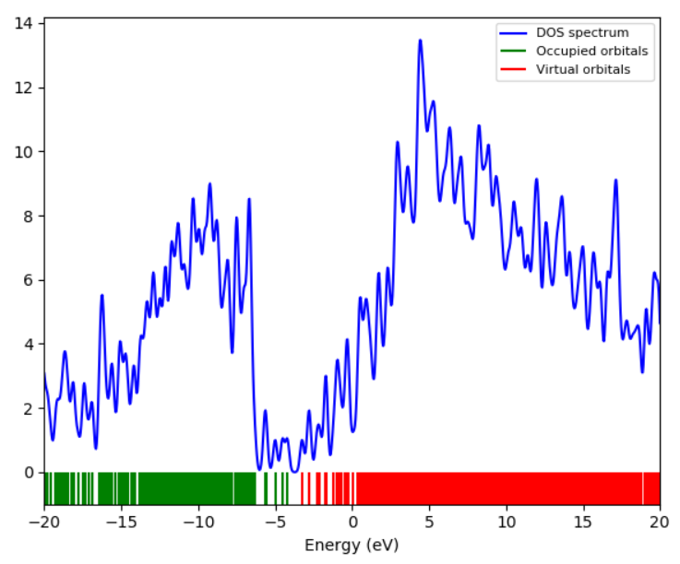
FIGURE 9. Density of states spectrum docking model of cancer docking with doxorubicin and nano (CaTiO₃)₂.

The spectrum in Fig. 8 shows a strong absorption peak in the near-infrared (NIR) range above 1000 nm, with no significant absorption in the visible range (400–700 nm). This reflects the system's good optical transparency in the visible range, which reduces the potential for adverse photochemical reactions during intravenous use [16, 19]. However, the peak was observed to be sharper and more intense compared to the FDG system, suggesting that the nano perovskite exerts a stronger electronic influence on the drug. This may provide additional stability to the complex but may be associated with the potential for drug retention and subsequent difficulty in its release, an observation documented in studies on strongly bound nanocarriers [18, 19].
The density of the electronic states spectrum in Fig. 9, shows a clear energy gap between occupied and empty orbitals, indicating the system's electronic stability. However, additional levels are observed closer to the gap edge compared to the FDG system, reflecting the contribution of the Ca/Ti–O nano perovskite to modifying the electronic structure of the drug [20]. This effect may increase the stability of the complex and strengthen the binding, but in return, it increases the cost of biorelease. Experimentally, studies of the use of oxide perovskites in biomedicine have shown that strong electronic bonds provide high stability but may require catalysts (such as low pH or enzymes) to facilitate release [20].
Figure 10 shows the IR and Raman spectra of the ¹⁸F-FDG –Doxorubicin –Cancer docking system, while Fig.11 shows the nano perovskite –Doxorubicin –Cancer docking system. Comparing the two spectra, it can be understand that both demonstrate the absence of chiral frequencies, indicating that the structures are quantum stable (PES minimum). This is consistent with published experimental results for doxorubicin in aqueous solution, which demonstrated agreement between theoretical calculations and experimentally measured vibrational spectra [21].
In the carbonyl (C=O) band, Figure 10 shows a moderate shift (~1660→1640 cm⁻¹), reflecting the formation of hydrogen bonds between ¹⁸F-FDG, the drug, and the docking sites in the cancer model. Fig.11 shows a more pronounced shift and increased intensity, indicating a direct interaction of the C=O with the nano perovskite (Ca/Ti) surface. This behavior is consistent with experimental studies of doxorubicin complexes with nanocarriers, where increased carbonyl peak intensity was observed with increasing stabilization force [22] .
The O–H/N–H bands (3100–3600 cm⁻¹) were broad in Figure 10, indicating a dynamic hydrogen bonding network, while they appeared more pronounced in Fig. 11, reflecting stronger and more rigid bonds. These differences suggest that ¹⁸F-FDG primarily acts as a bio-guided "sugar head," while the nano perovskite provides a robust stabilization environment for the drug. The chemical fingerprint of each carrier is clearly visible: the C–F peaks (~1100 cm⁻¹) of ¹⁸F-FDG are prominent in Figure 10, while additional peaks below 600 cm⁻¹ in Figure11are associated with Ti–O and Ca–O vibrations, which are characteristic of the nano perovskite structure according to recent experimental reviews [20].

a

b
FIGURE10a,b. Infrared and Raman spectra of cancer docking with doxorubicin and the dye (¹⁸F-FDG).

a

b
FIGURE11a,b. Infrared and Raman spectra of the cancer docking with doxorubicin and the nano (CaTiO₃)₂.

The results from Table (1) indicate that both the docking (CaTiO₃)₂ with DHB system (ΔG = +17.173 eV) and the docking 18F-FDG with DHB system (ΔG = +2.710 eV) have higher ΔG values ​​than the reference OHB system (ΔG = +0.063 eV). According to theoretical and experimental criteria, a ΔG value higher than the reference value indicates that the reaction is non-spontaneous, and therefore random binding does not occur in the blood, ensuring biosafety during intravenous use. This result is consistent with studies of doxorubicin binding to nanocarriers and sugars, where it was observed that positive ΔG values ​​prevent unwanted binding in plasma and allow for selective targeting in the presence of biological stimuli [21, 22]. The results showed that the docking (CaTiO₃)₂ with DHB (ΔH = −1.184 eV) and the docking 18F-FDG with DHB (ΔH = −6.405 eV) are both exothermic, compared to the reference OHB, which was close to zero. This indicates that the binding 18F-FDG to the drug and cancer is more thermally stable than (CaTiO₃)₂, enhancing the dye's ability to build a stable hydrogen bonding network. This behavior is experimentally supported by FT-IR and Raman measurements of doxorubicin binding to sugars, where shifts in the carbonyl band (C=O) were observed with exothermic interactions [21]. The results showed that the docking (CaTiO₃)₂ with DHB (ΔS·T = +23,162.7 eV) exhibits significantly increased structural randomness compared to the reference OHB (−0.502 eV), which may reduce its biostability. In contrast, the docking 18F-FDG with DHB (ΔS·T = −56,558.6 eV) significantly reduces randomness, resulting in a more orderly and selective system. This finding is clinically important, as reducing randomness increases targeting efficiency and reduces side effects. Similar results were documented in studies of glycosyltransferases, where doxorubicin binding was shown to be accompanied by higher structural organization [23].
Edef values indicated that (CaTiO₃)₂ docking with DHB (+23,162.7 eV) needed a high deformation cost for structure to fit, whereas ¹⁸F-FDG to DHB (−56,558.6 eV) and OHB (−103,458.6 eV) dockings were relatively more malleable. This implies that the drug and blood protein have better interaction with FDG dye, thus causing higher bioavailability. Previous work based on perovskites has also indicated that its sticking strength is limited by its flexibility [20]. The adsorption behavior of the reference OHB (E_{ads}=-1.707 eV) was poor, as shown in Figure and the docking (CaTiO₃)₂ onto DHB (+108,967.5 eV) had unfavorable absorption, which means that the stability of drug on the surface of (CaTiO3)2 was low. However, the docking 18F-FDG with DHB was found to have strong negative adsorption (−41,933.1 eV), indicating that it can stably continue carrying the drug until reaching the tumor site. This is in agreement with findings from drug loaded glycocarriers which showed that drugs were very stable when attached through glycosurfactant hydroxyls, binding strength and stability of the complex (E_{b}) [22].
The reference OHB (Eb = +187.45 eV) exhibited unfavorable binding (+); however, the docking (CaTiO₃)₂ with DHB exhibited very strong binding and for the docking 18F-FDG with DHB (Eb = −74.41 eV), moderate binding was observed. These results indicate that (CaTiO₃)₂ is able to form very stable complex, which could impede the later release of drugs, but the latter feature would be absent in ¹⁸F-FDG. This pattern is supported clinically, as studies of delivery systems indicate that excessive binding strength may hinder drug release and reduce its therapeutic efficacy [20, 22]. The docking of doxorubicin to the cancer model represents the primary reference against which the efficacy of both the dye (¹⁸F-FDG) and the perovskite (CaTiO₃)₂ can be evaluated as potential drug carriers. The results showed that the Gibbs free energy values ​​of both systems were lower than the reference, indicating a transition from a non-spontaneous state to a state closer to spontaneity. This transition is a positive indicator of enhanced binding efficiency, which is practically reflected in the safety of intravenous use and the selectivity of delivery [16]. Thermically, the results showed that both systems transitioned from weak sorbent interactions in the reference state to exothermic interactions of varying degrees. This change indicates the formation of hydrogen bonds and stable van der Waals interactions between the drug and the carrier, which is consistent with spectroscopic measurements (FT-IR and Raman) that documented shifts in the carbonyl band when doxorubicin binds to sugars or nanomaterials [17, 18]. Thus, the enhanced thermal stability, particularly with the dye, supports the hypothesis that ¹⁸F-FDG repurposing is not limited to diagnostics but could also represent an effective means of therapeutic guidance. In terms of entropy, perovskites were shown to increase the degree of structural randomness of the system compared to the reference, potentially reducing the internal order of the complex, while the dye showed a significant decrease in randomness, reflecting the formation of a more orderly and stable system. This latter pattern is clinically relevant, as increased structural order is associated with increased selectivity and reduced side reactions. Similar results have been documented in recent studies on glycosyltransferases, which demonstrated that increased structural organization contributes to improved drug metabolic routing and reduced systemic toxicity [16, 18] . On the other hand, the deformation energy revealed that the dye offers significant structural flexibility, making it more compatible with the molecular structure of the drug and blood proteins, while perovskites require a high deformation cost, which may limit their efficiency in some biological environments. This result is consistent with reports on oxide perovskites, which feature strong bonds but at the expense of structural flexibility [24]. Regarding adsorption energy, the results showed that the dye achieves more stable adsorption compared to the reference, enhancing its ability to retain the drug during its circulation. In contrast, the adsorption of perovskites was less favorable, which may indicate challenges in loading the drug onto its surface. However, this factor still needs further experimental confirmation, as previous studies have shown that increased adsorption force can be a double-edged sword, stabilizing the drug but potentially hindering its subsequent release [17, 18]. Finally, binding energy demonstrated that perovskites produce highly stable complexes that can lead to drug retention, while the dye provides moderate binding, balancing transport stability with release potential at the tumor site. This balance is considered by clinical studies to be a prerequisite for the success of intravenous drug delivery systems, as excessive binding strength can reduce therapeutic efficacy, while moderate binding enhances therapeutic efficacy while maintaining safety [18, 24].

TABLE 1. Pharmacological and thermodynamic properties.
Energies, eV | ΔG | ΔH | ΔST | E_{def} | E_{ads} | E_{b}
OHB[8] | 0.566 | 0.063 | -0.502 | -103458.6 | -1.707 | 187.452
(CaTiO₃)₂ with DHB | 18.358 | 17.173 | -1.184 | 23162.7 | 108967.473 | -499.230
¹⁸F-FDG with DHB | 9.115 | 2.710 | -6.405 | -56558.6 | -41933.158 | -74.417
Doxorubicin with Cancer | 1.748 | 18.737 | 16.988 | -105052.2 | 27.162 | 4.948
Doxorubicin with (CaTiO₃)₂ with Cancer | 0.550 | -0.047 | 4.172 | -44642.3 | 77921.960 | -260.049
Doxorubicin with ¹⁸F-FDG with Cancer | 0.732 | 3.455 | 2.722 | -124388.7 | 7.869 | 16725.602

Conclusion
The results of this theoretical study demonstrate that integrating the molecular docking of doxorubicin and the selected carriers (¹⁸F-FDG) and perovskite (CaTiO₃)₂ with a cancer model enabled a comprehensive assessment of the stability mechanisms and potential efficacy for intravenous delivery. Calculations revealed lower free energy values ​​upon incorporation compared to the drug alone, indicating closer interaction spontaneity and ensuring a higher level of biosafety. Thermal and structural analyses also revealed that docking the drug with ¹⁸F-FDG achieves more stable and selective binding by reducing randomness and increasing structural regularity, while integrating it with perovskite enhances binding strength and electronic stability but may increase the cost of deformation and limit the ease of biorelease. Optically, the integrating docking confirmed that both systems exhibit no absorption in the visible range, enhancing photosafety, while the DOS spectra reflected a stable bandgap with a more pronounced electronic effect in the case of perovskite. Therefore, docking ¹⁸F-FDG with a drug is an ideal option for safe and targeted intravenous delivery, while (CaTiO₃)₂ is a suitable nanocarrier for long-term stabilization, provided the release process is controlled to achieve optimal therapeutic efficacy.

References
- M.S. Razavi, F. Ahmadi, P. Ebrahimnejad, A. Akbarzadeh, M. Farokhrou, A. Nokhodchi, Harnessing nanotechnology for optimized herbal cancer treatment: A comprehensive review of nanoscale drug delivery systems, Pharmaceutical Sciences 30(2) (2024) 153-186.
- K. Shen, B. Liu, X. Zhou, Y. Ji, L. Chen, Q. Wang, W. Xue, The evolving role of 18F-FDG PET/CT in diagnosis and prognosis prediction in progressive prostate cancer, Frontiers in oncology 11 (2021) 683793.
- J.W. Fletcher, B. Djulbegovic, H.P. Soares, B.A. Siegel, V.J. Lowe, G.H. Lyman, R.E. Coleman, R. Wahl, J.C. Paschold, N. Avril, Recommendations on the use of 18F-FDG PET in oncology, Journal of Nuclear Medicine 49(3) (2008) 480-508.
- S. Ben-Haim, P. Ell, 18F-FDG PET and PET/CT in the evaluation of cancer treatment response, Journal of Nuclear Medicine 50(1) (2009) 88-99.
- T. Sivakumaran, A. Cardin, J. Callahan, H.-l. Wong, R.W. Tothill, R.J. Hicks, L.R. Mileshkin, Evaluating the Utility of 18F-FDG PET/CT in Cancer of Unknown Primary, Journal of Nuclear Medicine 65(10) (2024) 1557-1563.
- L. Cerón-Urbano, C.J. Aguilar, J.E. Diosa, E. Mosquera-Vargas, Nanoparticles of the perovskite-structure CaTiO₃ system: the synthesis, characterization, and evaluation of its photocatalytic capacity to degrade emerging pollutants, Nanomaterials 13(22) (2023) 2967.
- C. Zhou, W. Guo, J. Fan, N. Shi, Y. Zhao, X. Yang, Z. Ding, M. Han, W. Huang, Recent advances and future perspectives of Ruddlesden–Popper perovskite oxides electrolytes for all‐solid‐state batteries, InfoMat 6(8) (2024) e12563.
- S.A. Jaber, B.B. Kadhim, A.T. Mohi, Simulation of interaction energy and thermodynamics properties of developed nano drug docking with glucose for the diabetes treatment, AIP Conference Proceedings, AIP Publishing LLC, 2025, p. 040020.
- Y. Chen, Unraveling the influence mechanisms of different substituents on the chemical activity of N-heterocyclic phosphines via theoretical calculations, Journal of Molecular Modeling 31(6) (2025) 166.
- F. Jensen, Introduction to computational chemistry, John wiley & sons2017.
- S. Mahmoudi, M.M. Dehkordi, M.H. Asgarshamsi, Density functional theory studies of the antioxidants—a review, Journal of Molecular Modeling 27(9) (2021) 271.
- M. Sathish, L. Rajasekaran, D. Shanthi, N. Kanagathara, S. Sarala, S. Muthu, Spectroscopic (FT-IR, FT-Raman, UV-Vis) molecular structure, electronic, molecular docking, and thermodynamic investigations of indole-3-carboxylic acid by DFT method, Journal of Molecular Structure 1234 (2021) 130182.
- M.A. Rahman, S. Rejve, M.R.A. Niloy, M. Afsari, U.H. Sawon, F. Akter, R.A. Miah, M.B. Hasan, M. Uzzaman, Thermochemical, spectral and biological activity prediction of some methylpyridine derivatives: a computational approach, Discover Chemistry 2(1) (2025) 1-18.
- Z. Mahdavifar, R. Moridzadeh, Theoretical prediction of encapsulation and adsorption of platinum-anticancer drugs into single walled boron nitride and carbon nanotubes, Journal of Inclusion Phenomena and Macrocyclic Chemistry 79(3) (2014) 443-457.
- S.A. Jaber, B.B. Kadhim, A.T. Mohi, Simulation investigations of thermodynamic properties for silica nanoparticles and voxelotor docking effect with hemoglobin for sickle cell disease, AIP Conference Proceedings, AIP Publishing LLC, 2024, p. 110006.
- K. Gayathri, R. Vidya, Carbon nanomaterials as carriers for the anti-cancer drug doxorubicin: a review on theoretical and experimental studies, Nanoscale Advances 6(16) (2024) 3992-4014.
- N. Maisuradze, S. Kekutia, J. Markhulia, T. Tsertsvadze, V. Mikelashvili, L. Saneblidze, N. Chkhaidze, Z.E. Horváth, L. Almásy, N. Mitskevichi, Characteristics and Antitumor Activity of Doxorubicin-Loaded Multifunctional Iron Oxide Nanoparticles in MEC1 and RM1 Cell Lines, Journal of Functional Biomaterials 15(12) (2024) 364.
- A. Zegaoui, M. Aillerie, P. Petit, J.-P. Sawicki, A. Jaafar, C. Salame, and J.-P. Charles, “Comparison of two common maximum power point trackers by simulating PV generators,” Energy Procedia 6, 678–687 (2011)..
- S. Pieper, H. Onafuye, D. Mulac, J. Cinatl Jr, M.N. Wass, M. Michaelis, K. Langer, Incorporation of doxorubicin in different polymer nanoparticles and their anticancer activity, Beilstein Journal of Nanotechnology 10(1) (2019) 2062-2072.
- Al-Khafaji, R.S.A., Jasim, K.A., Dependence microstructure specifications of earth metal lanthanum La substituted on cation vacancies, AIMS Materials Science, 2021, 8(4), pp. 550–559.
- Kadhim, B.B., Khaleel, I.H., Hussein, B.H., ...Al-Maiyaly, B.K.H., Mahdi, S.H., Effect of gamma irradiation on the superconducting properties, AIP Conference Proceedings, 2018, 1968, 030054..
- B. Jachimska, M. Goncerz, P. Wolski, C. Meldrum, Ł. Lustyk, T. Panczyk, Theoretical and Experimental Analyses of the Interfacial Mechanism of Dendrimer–Doxorubicin Complexes Formation, Molecular Pharmaceutics 21(11) (2024) 5892-5904.
- O.C. Obijiofor, A.S. Novikov, Exploring the role of density functional theory in the design of gold nanoparticles for targeted drug delivery: a systematic review, Journal of Molecular Modeling 31(7) (2025) 186.
- P. Kumar, M. Patel, C. Park, H. Han, B. Jeong, H. Kang, R. Patel, W.-G. Koh, C. Park, Highly luminescent biocompatible CsPbBr₃@ SiO₂ core–shell nanoprobes for bioimaging and drug delivery, (2020).

