Determination Optimal Site for Building a Solar-Based Water Desalination Plant in Iraq Using Spatial Analysis Techniques
Zahraa A. Suhail ^{1,a)} and Laith A. Jawad ^{2,b)}
¹Department of Remote Sensing & GIS, College of Science, University of Baghdad, Baghdad, Iraq.
²Remote Sensing Unit, College of Science, University of Baghdad, Baghdad, Iraq.

^{a)} Corresponding author: zahraa.adel2309@sc.uobaghdad.edu.iq
^{b)} laith1910saadi@gmail.com

Abstract. Freshwater represents 3% of the total water on Earth, and the percentage of surface fresh water is 0.3% of Freshwater. Recently, two challenges emerging impact this element. First, surface freshwater levels are decreasing due to reduced rainfall, a result of climate variability caused by global warming phenomenon. Second, the remaining freshwater is becoming less usable due to increased chemical and physical pollutants and rising levels of dissolved salts. One of the solutions for increasing the percentage of freshwater the use of various desalination methods. In this work, spatial analysis techniques were used to find the best area to build a green water desalination plant using solar thermal energy (using point solar energy concentrators to evaporate water). The first phase involved identifying the area with the highest values of net solar radiation during the period (2008-2022), which amounted to 42.99% of Iraq's area. Solar radiation is the primary determinant for the establishment of solar power plants. In the second phase, rainfall and relative humidity were used as parameters to narrow this area (the ideal area for building a plant has the lowest annual rainfall and relative humidity), bringing the percentage for Iraq to 30.98%. In the final phase, the number of annual dust days was used as a parameter to narrow the optimal area. It was found that Diwaniyah Governorate experienced the fewest dust days during the study period due to its vegetation cover. The optimal area for building green solar water desalination plants now represents 0.92% of Iraq's total area.

Keywords: Net Solar Radiation, Inverse Distance Weighted, Rainfall, photovoltaic cells, Relative Humidity

INTRODUCTION
Water scarcity is one of the most significant environmental and development challenges facing Iraq. Iraq relies heavily on surface water resources, particularly the Tigris and Euphrates rivers and their tributaries [1]. Water scarcity is caused by a variety of factors, including natural and human-caused factors. Climate change is the most significant natural factor, leading to reduced rainfall and higher temperatures, which in turn increases evaporation rates. Human factors include declining water supplies from upstream countries (Turkey, Iran, and Syria) due to dam construction and river diversions, as well as increased demand for water resulting from population growth, urban and agricultural expansion, and poor water resource management. This is in addition to the indiscriminate and direct discharge of untreated domestic and municipal waste, and the excessive use of hazardous agricultural chemicals and industrial materials [2][3][4][5]. Particularly noticeable in the Shatt al-Arab River is a significant decrease in water flow, coupled with a radical change in the natural hydrological regime. This is due to the construction of massive water infrastructure projects and extensive river diversions by upstream countries (Turkey, Iran, and Syria) . As a result of this imbalance, saltwater intrusion from the Arabian Gulf into the Shatt al-Arab has increased, exacerbating water salinity and its environmental impacts. These changes have significant negative impacts on human health, reduce the efficiency of water use in agriculture [6][7]. To address the water scarcity and pollution crisis in Iraq, several solutions have been proposed, including the construction of reservoirs and dams to collect rainwater, reliance on groundwater, and desalination using fossil fuels or solar energy. However, the construction of reservoirs and dams is expensive in terms of construction and maintenance, and Iraq's dry climate, high summer temperatures, and low annual rainfall lead to high evaporation rates, causing these to dry out quickly and reducing their effectiveness as a sustainable water source [8][9]. Groundwater, despite its availability, it is expensive to extract and often salty, especially in central and southern Iraq [10][11]. Desalination using fossil fuels, while technically effective, is expensive and polluting. Solar-powered desalination. In return, is the ideal solution in Iraq, given the availability of solar radiation and the fact that it is a clean and sustainable energy source, To get fresh water [12][13]. Solar energy is used in water desalination in two ways: directly and indirectly. In the direct method, the sun's heat directly evaporates salt water, then condenses to produce fresh water, as in solar still systems, or by using point and linear solar concentrators, which focus solar radiation on a point or line to generate high heat used directly in the evaporation process. The indirect method relies on converting sunlight into electricity using photovoltaic cells (PV) or concentrated solar power plants (CSP), which generate electricity from the sun's heat. This electricity is then used to operate desalination systems that rely on electrical energy, such as reverse osmosis (RO), which evaporates and condenses water to obtain fresh waters after separating it from the salts [14][15][16]. This research aims to identify the optimal location for a solar-powered desalination plant in Iraq, using spatial analysis techniques. To achieve this goal, several climatic factors that directly affect the system's efficiency are analyzed, most notably: solar radiation, rainfall amounts, relative humidity, and dust storms [17]. These factors are used to reduce the study area and identify the most suitable site for building a desalination plant.

METHODOLOGY
Iraq is located in West Asia and North Africa (WANA), overlooking the Arabian Gulf. Iraq's geographical area extends from Longitude (38º 45') to (48º 45') East and Latitudes (29º 5') to (37º 22') North This research relied on the use of spatial analysis techniques to find the best site for building desalination plant in Iraq according to specific conditions (the conditions here are determinants ranging in importance from very important to less important), which are as follows: The most important and prominent of these is solar radiation, as the basis for the operation of this plant is the presence of a sufficient amount of solar radiation, which is a clean and sustainable energy that evaporates polluted and salty water, and then condenses this vapor to isolate pure water from sediments and salts. Other determinants that reduce the intensity of solar radiation were then calculated, such as rainfall, relative humidity, and dust storms. To calculate these determinants relied data from the Iraq Meteorological Organization and seismology, specifically from 14 stations, were relied upon, distributed comprehensively to cover the entire area of ​​Iraq for a period of fifteen years, within a time range from 2008 to 2022, as can be seen in Fig. 1.

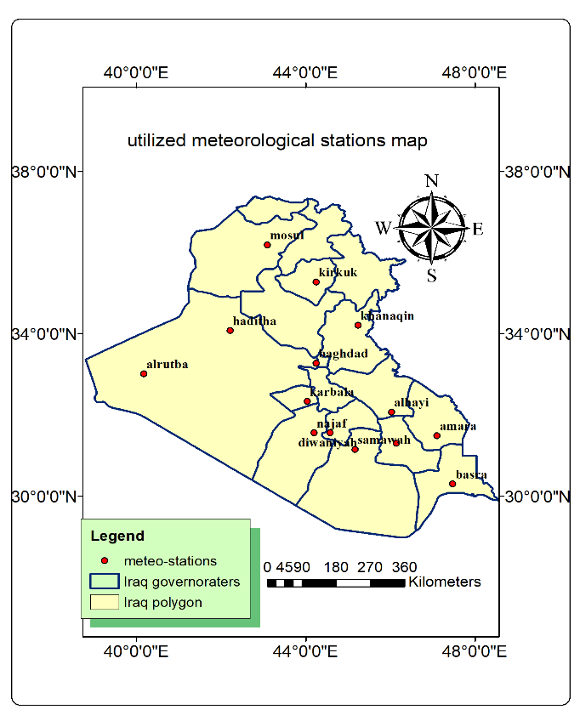
Figure 1. The location map of the utilized meteorological stations in Iraq.

Net solar radiation can be measured using the four-component net radiometer (CNR4)[18]. The second method the calculated net solar radiation experimentally using several equations [19]:

$R_{n}=R_{ns}-R_{nl},R_{n}=\left(1-α\right)R_{s}-R_{nl} (1)$
Where: Rn= Solar radiation at 2 meters above the earth's surface (MJ.m⁻².day⁻¹)
R_{nl} = longwave radiation departs the earth's surface (MJ. m⁻².day⁻¹)
α =The coefficient of solar radiation total reflectance (albedo = 0.23)
R_{s} = shortwave radiation reaching the earth's surface (MJ. m⁻².day⁻¹) calculated by the following equation:

$R_{S}={ K}_{Rs}. R_{a} {(Tmax - Tmin )}^{0.5} (2)$
where, K_{Rs}=0.16
Net long-wave radiation can be calculated using the following equation:

$R_{nl}= \left[\frac{\left(T^{4}max,k+T^{4} min,k\right)}{2}\right]\left(al - bl\sqrt{ea}\right)\left[ac\frac{Rs}{R_{SO}}- bc\right] (3)$
Where:
σ =The constant of Stefan-Boltzmann (4.903 x 10⁻⁹ MJ K⁻⁴ m⁻² day⁻¹)
T_{max} = The temperature maximum
T_{min} = The temperature minimum
e_{a} = Actual vapor pressure (kPa)
(al, bl, ac, bc) = calibration coefficients dimensionless respectively (0.34,0.14,1.35 and ,0.35)
R_{so} = sun radiation in the clear sky (MJ m⁻² day⁻¹),
R_{so} is calculated using the equation:

$R_{so}=\left(0.75 + 2x10-5. h\right). R_{a} (4)$
Where:
h = elevation of the surface above sea level (m)
R_{a} = Solar radiation outside the atmosphere (MJ. m⁻².day⁻¹),
R_{a} is obtained from the equation:

$R_{a}= \left(\frac{24}{π}\right)Gsc dr\left[ωs sin\left(ϕ\right)sin\left(δ\right)+ cos\left(ϕ\right)cos\left(δ\right)sin\left(ωs\right)\right] (5)$
Where:
G_{sc} = constant solar radiation reaching the earth [4.92 MJ.m⁻².h⁻¹]
d_{r} = Earth-Sun inverse relative distance
ω_{s} = Hour angle at sunset [rad]
φ = latitude [rad]
δ = solar deviation [rad]
The Earth-Sun inverse relative distance is obtained from the equation:
$d_{r}=1+0.033cos( 2π\frac{J}{365} ) (6)$
The solar radiation deviation is obtained from the equation:

$δ= 0.409sin\left(\frac{2π}{365} J-1.39\right) (7)$
Where:
J= is any day of the year from (1 to 365 and/ or 366)
The converted latitude in degrees to radians measurement by:

$Radians= \frac{π}{365}Χ degrees latitude (8)$
The sunset hour angle is obtained from the equation:

$w_{s}=arccos\left[-tan\left(φ\right)tan\left(δ\right)\right] (9)$

The value of Rn is calculated using daily measurement equations from 1 January to 31 December, where the monthly meteorological readings are converted to daily readings، To find the of Rn from through calculating other equations are calculated, which are (Ra, Rs, Rso, ea, Rns, and Rnl), as explained in Table 1.
TABLE 1. An illustration of how to compute daily variables to get the Mosul Governorate's Rn value on January 1, 2008.
dr | Φ | δ | ws | Ra | Tmax | Tmin | Rs | Rso | ea | Rns | Rnl | Rn
1.0329 | 0.6316 | -0.401 | 1.2553 | 16.1916 | 12 | -2.2 | 9.7623 | 12.2159 | 0.5198 | 7.517 | 5.1152 | 2.4018

Following the computation of these antecedent equations, daily Rn results were acquired The average annual Rn values for each of the 14 stations in Iraq were the calculated, illustrating example of annual Rn values for the years 2008, 2013, 2018,2021 and 2022, Explained in Table 2.

TABLE 2. The annual average Rn values for the Iraq meteorological stations study in the years 2008, 2013, 2018, 2021, and 2022.
Station | Longitude  (Des.deg.) | Latitude  (Des.deg.) | 2008's Rn  (MJ.m⁻².year⁻¹) | 2013's Rn  (MJ.m⁻².year⁻¹) | 2018's Rn  (MJ.m⁻².year⁻¹) | 2021's Rn  (MJ.m⁻².year⁻¹) | 2022's Rn  (MJ.m⁻².year⁻¹)
Mosul | 43.09 | 36.19 | 10.236 | 10.117 | 10.286 | 10.307 | 10.191
Kirkuk | 44.24 | 35.28 | 9.8185 | 9.9595 | 9.9553 | 10.565 | 10.215
Knanaqin | 45.23 | 34.21 | 10.667 | 10.796 | 10.917 | 11.204 | 10.991
Haditha | 42.21 | 34.08 | 10.356 | 10.195 | 10.238 | 10.875 | 10.752
Baghdad | 44.24 | 33.28 | 10.917 | 10.543 | 10.781 | 11.062 | 11.033
Alrutba | 40.17 | 33.02 | 10.302 | 10.046 | 10.250 | 10.587 | 10.469
Karbala | 44.03 | 32.34 | 10.670 | 10.518 | 10.715 | 11.054 | 10.932
Alhay | 46.02 | 32.08 | 10.762 | 10.593 | 10.808 | 11.376 | 11.158
Najaf | 44.19 | 31.57 | 11.252 | 10.694 | 10.831 | 11.171 | 11.071
Dawaniyah | 44.57 | 31.57 | 11.048 | 11.004 | 10.796 | 11.302 | 11.254
Amara | 47.1 | 31.5 | 11.362 | 10.739 | 11.208 | 11.618 | 11.427
Nasriyah | 46.14 | 31.31 | 11.374 | 11.070 | 11.393 | 11.616 | 11.556
Smawah | 45.16 | 31.16 | 11.179 | 10.910 | 11.091 | 11.487 | 11.367
Basra | 47.47 | 30.31 | 11.558 | 11.098 | 11.671 | 11.775 | 11.700

In this study spatial interpolation technique utilized to convert pointy average annual stable Rn value for each stations studied in Iraq readings into plane readings (raster) to cover all over Iraq region. Two spatial interpolation methods were experimented within geostatistical wizard tool of GIS 10.8; those are:
1-Inverse Distance Weighted method (IDW) It is a spatial interpolation technique that relies on estimating an unknown value at a given location through a weighted average of known values at neighboring locations, where weights are calculated based on the reciprocal of the distance raised to a certain power, giving closer points a greater influence in the estimation than farther points, as it mathematically clarified by the following[20]:
$Z\left(X,Y\right)=\frac{\sum_{i=1}^{n}{[\frac{Z_{i}}{d_{i}^{p}}]}}{\sum_{i=1}^{n}{[\frac{1}{d_{i}^{p}}}]} (10)$
Where Z(X,Y) is the predicted value at the ensample location X,Y; i is the number of measured sample points within the neighborhood defined; Zi is the observed value at location i; di is the distance between the predicted location X,Y ; and p is the power parameter that defines the rate of reduction of the weight as distance increases.

2- Kriging is a geostatistical interpolation technique that considers both the distance and the degree of variation between known data points when estimating values in unknown areas, as it is mathematically clarified by the following:
${Z(}_{S_{0}})=\sum_{i=1}^{N}{λ_{i}{Z(}_{S_{i}}) (11)}$

Where Z(s)= the measured value at the i location؛ λ=an unknown weight for the measured value at the i location؛ S=the prediction location؛ N=the number of measured values.

RESULTS AND ANALYSIS
The next step is to calculate the average annual stable Rn value for each station by sum up the Rn for each year and dividing it by 15, which is the number of years stations for the studied: Mosul, Kirkuk, Khanaqin, Haditha, Baghdad, Alrutba, Karbala, Alhayi, Najaf, Diwaniyah, Amara, Nasriyah, Samawah, and Basra was values 10.18989,10.05473,10.92887,10.45343,10.83913,10.26203,10.80535,10.97355,11.02987,11.14537,11.24162,11.42955,11.20313, 11.14537,11.51163, respectively.
IDW method was preferred to estimate the stable average annual Rn value for Iraq since it has a lower root mean square difference among measured and predicted values, as can be seen in Fig. 2.

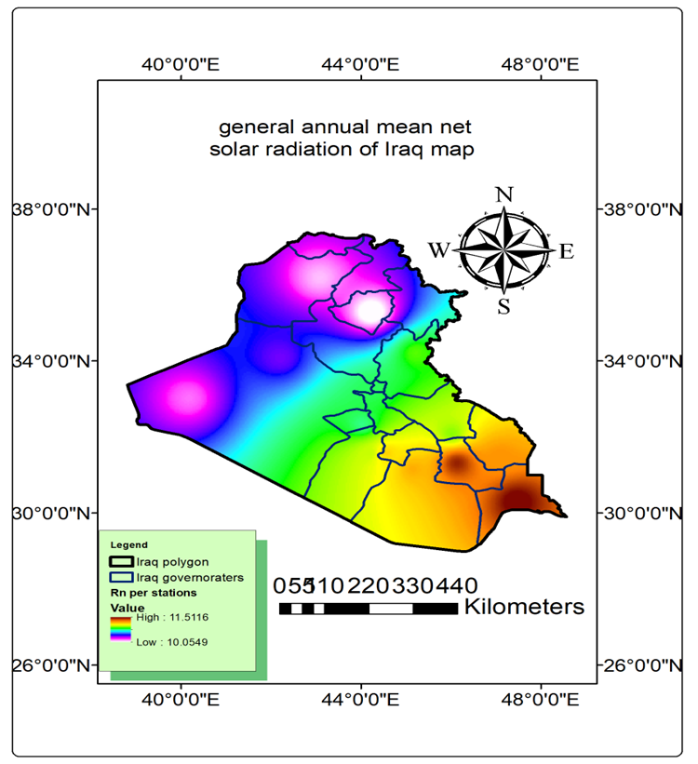
Figure 2. general annual mean net solar radiation of Iraq

After calculating the stable value of Rn for each station, the criterion Rn value for Iraq will be found by sum the stable Rn values for all stations and dividing them by the number 14, which represents the number of stations, where the value is 10.86201 MJ.m⁻².year⁻¹. Here, the condition will be applied (if the Rn value for each station is less than the criterions Rn value for Iraq, we exclude the less value and rely on the value that is equal to or greater than it). This condition is applied to reduce the area of the study area. The area ​​of interest became 42.99% of the area of ​​Iraq, and was determined using the Intersect tool based on the highest net solar radiation values to identify the best solar energy areas, as can be seen in Fig. 3.

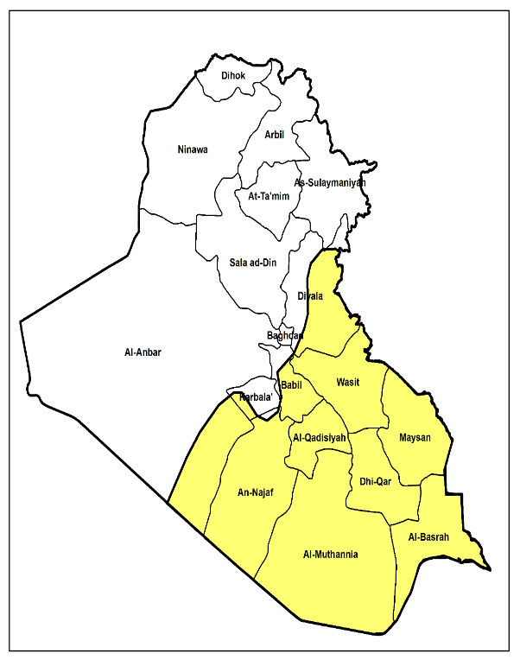
42.99%
Figure 3. The yellow area represents the highest net solar radiation values.

Several determinants reduce the value of solar radiation. These determinants will be calculated:
1-Rainfall determinant: The water absorbs and scatters the solar radiation, which leads to a decrease in the amount of radiation reaching the Earth's surface [21][22]. the stable annual rainfall amount for each station will be calculated by sum the rainfall amount for the (2008 - 2022) years and dividing it by the 15 which is the number of years, for the studied stations: Mosul, Kirkuk, Khanaqin, Baghdad, Alrutba, Karbala, Alhayi, Najaf, Diwaniyah, Amara, Nasriyah, Samawah, and Basra, was amount 320.42, 273.37, 261.66, 132.68, 110.82, 93.46, 134.94 ,83.69, 89.10, 158.11, 104.02, 89.84, and 90.89, respectively. For knowledge the minimum rainfall for each station, we will draw a rainfall line for Iraq, as can be seen in Fig. 4.
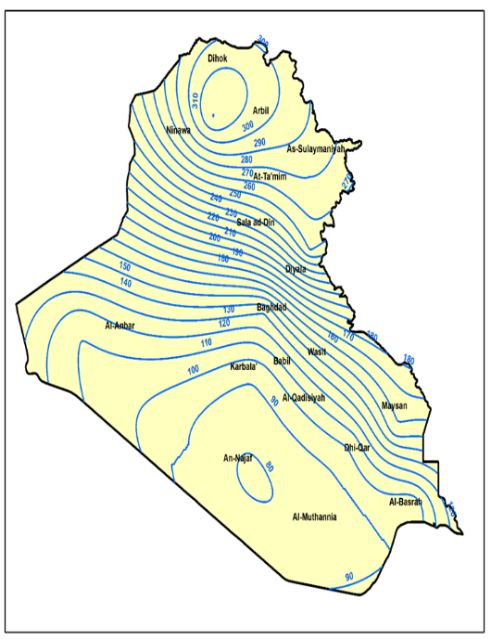
FIGURE 4. The rainfall contour lines for Iraq

After calculating the stable value of rainfall for each station, the criterion rainfall value for Iraq will be found by sum the stable rainfall values for all stations and dividing it by 13, which is the number of stations, where the value is 149.46 mm. The condition will be applied (if the stable rainfall value for each station is greater than the criterion rainfall value for Iraq, we exclude the greater value and rely on the value that is equal to or less than it). This condition is applied to reduce the area of the study area, identified using the Intersect tool based on the intersection of annual rainfall data with net solar radiation region, as can be seen in Fig. 5.

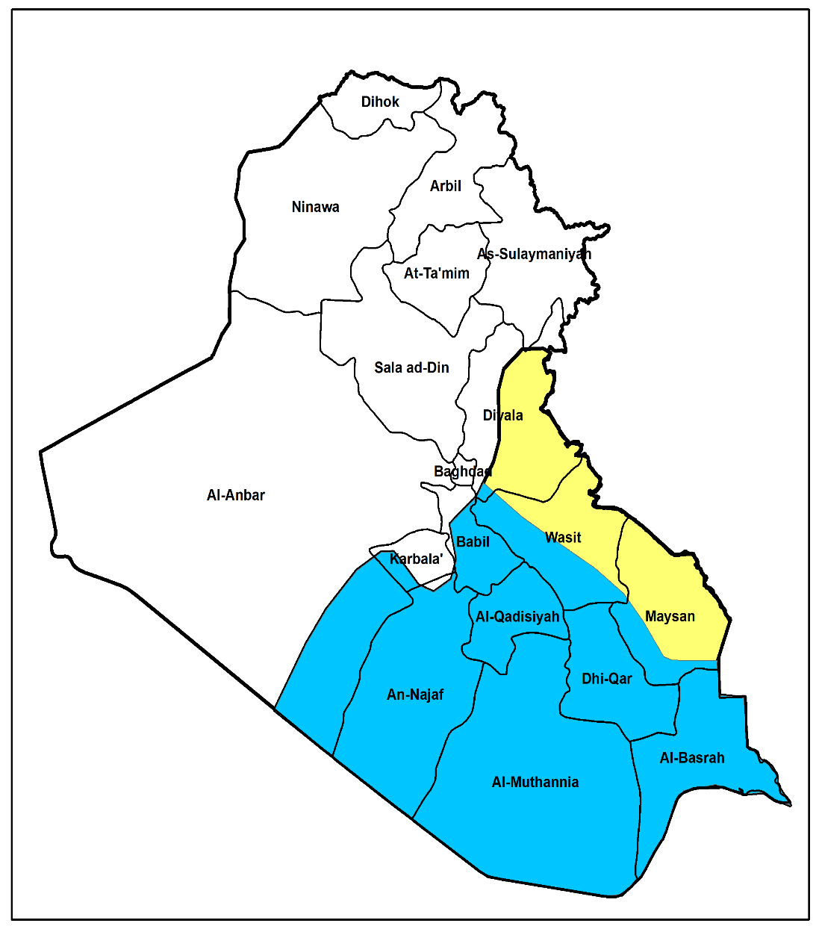
FIGURE 5. The light blue area represents the lowest annual rainfall.

2-Relative humidity determinant: When relative humidity is high, solar radiation decreases due to the scattering of radiation by water vapor in the atmosphere [23][24][25]. The annual stable RH value for the each station will be calculated by sum the RH value for the years (2008-2022) and dividing it by 15, which is the number of years, for the studied stations: Mosul, Kirkuk, Khanaqin, Haditha, Baghdad, Karbala, Alhayi, Najaf, Diwaniyah, Amara, Nasriyah, Samawah, and Basra, was 51.13%, 45.09%, 46.1%, 46.58%, 40.86%, 43.1%, 44.77%, 41.25%, 44.45%, 42.36%, 35.45%, 36.51%, and 38.71%.Using one of the interpolation methods is the Kriging method to find out the lowest relative humidity in Iraq, as can be seen in Fig. 6.
After calculating the stable value of RH for each station, the criterions RH value for Iraq will be found by sum up the stable RH value for all stations and dividing it by 13, which represents the number of stations, where the value is 42.79% , The condition will be applied (if the RH value for each station is greater than the criterion RH value for Iraq, we exclude the greater value and rely on the value that is equal to or less than it), This condition is applied to reduce the area of the study area, determined using the Intersect tool based on the intersection of relative humidity data with net solar radiation region. as can be seen in Fig. 7.
We will take the intersection between the two specified areas as containing the least amount of rainfall and relative humidity, reducing the area of interest so that its percentage becomes 30.98% of the area of Iraq, as can be seen in Fig. 8.
3-Rising dust: Dust reduces the amount of solar radiation reaching solar cells because dust reflects and scatters solar radiation, affecting the overall performance of the panels [26][27]. It has been calculated the total number of rising dust days the 15 years will be calculated for the stations studied, as can be seen in Fig. 9.
Where It was noted that the less rising dust days for all the 15 years were at the Diwaniyah station. We will take an intersection between the area of ​​the Diwaniyah Governorate and the area of ​​the two determinants (rainfall and relative humidity) ، reducing the area of interest so that its percentage becomes 0.92% of the area of Iraq, as can be seen in Fig. 10.

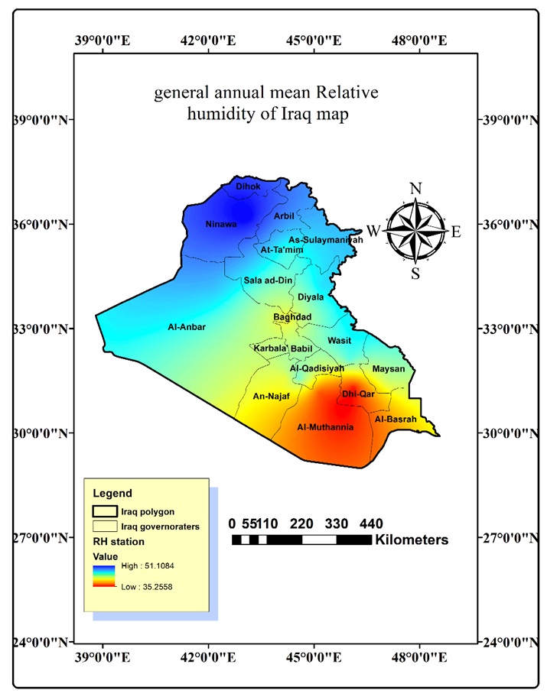
FIGURE 6. general annual mean Relative humidity of Iraq

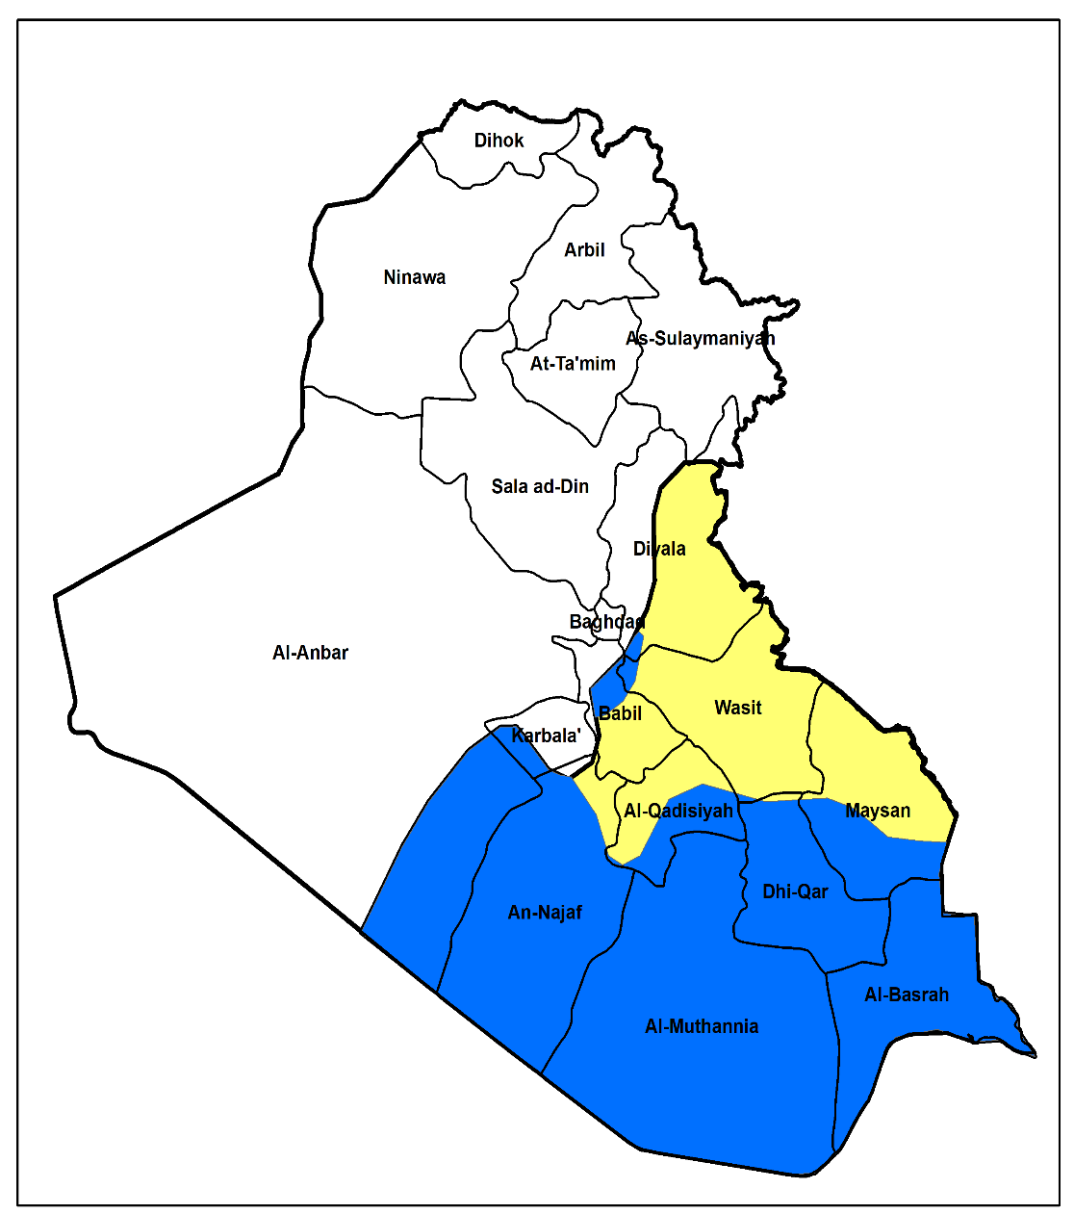
FIGURE 7. The dark blue area represents the lowest relative humidity.

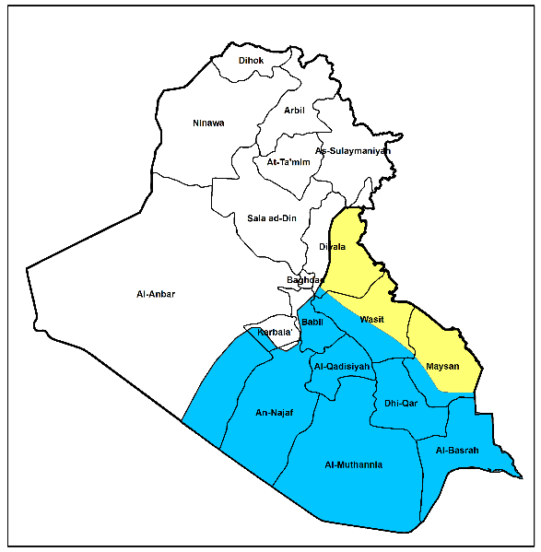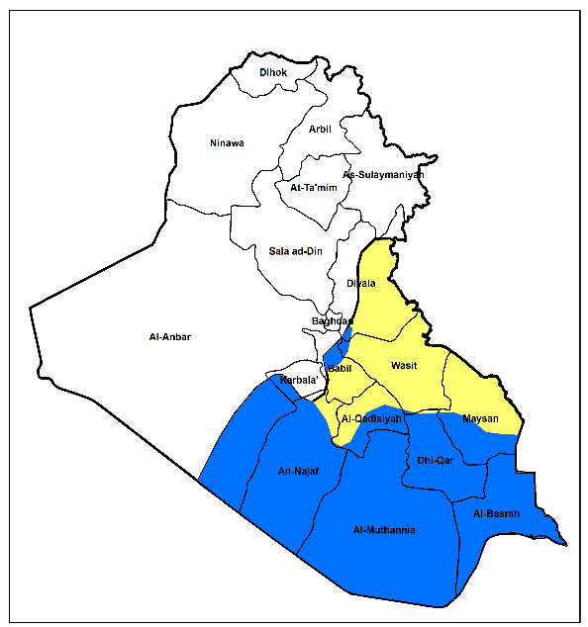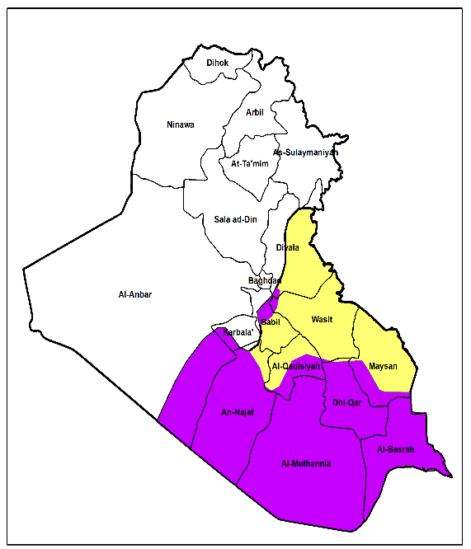
30.98%

FIGURE 8. The purple area represents the intersection of two areas of rainfall and relative humidity.

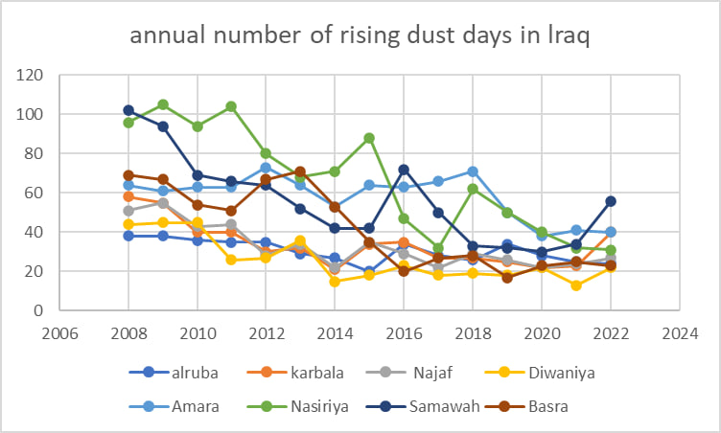
FIGURE 9. Iraq’s annual number of rising dust days.

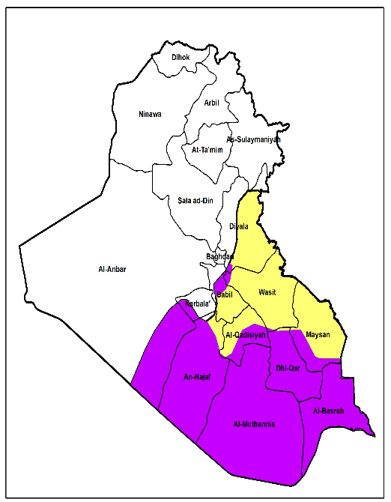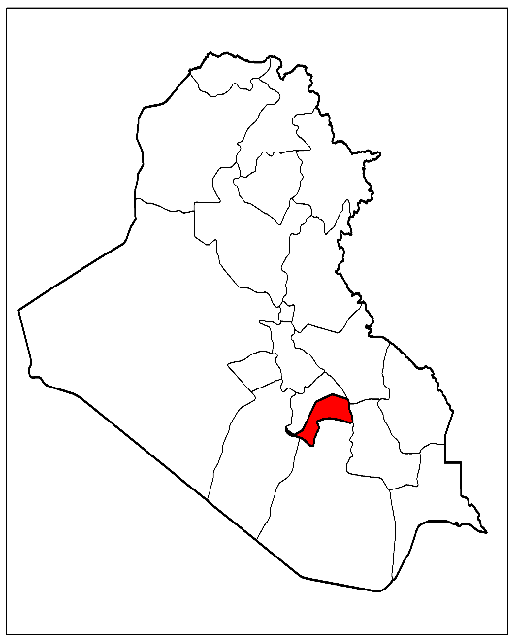
0.92%
FIGURE 10. The red area represents the most suitable area according to radiation, humidity, rain, and dust.

CONCLUSION
In the central and southern regions, the Rn values ​​are greater than in the northern region of Iraq, where their annual rates range between (11.51163-10.05473), and the criterion Rn value for Iraq was used as a determinant to reduce the area of ​​interest to 42.99% of the area of ​​Iraq.
Rainfall and relative humidity are two of the most important factors that reduce solar radiation due to the geometric shape of water droplets that scatter radiation in relation to the first factor and the presence of water molecules that absorb radiation in relation to the first and second factors. We will take the intersection between the two areas of rain and relative humidity that have values ​​less than the criterion value for Iraq to reduce the area of ​​interest to 30.98% of the area of ​​Iraq.The rising dust plays a major role in reducing the efficiency of solar-powered desalination plants due to the low radiation reaching the solar concentrator mirrors. We will take the station with the less days of rising dust per year in Iraq and then reduce the area of interest to 0.92% of the area of Iraq.

References
- H. Alkhafaji, Iraq’s Water Crisis: Challenges and Solutions (Al-Bayan Center for Planning and Studies, Baghdad, 2018).
- N. Al-Ansari, S. Knutsson, V. Sissakian, A. Salman, A. Al Muqdadi, L. Salman, and M. Salman, Eng. 15, 467 (2023).
- N. A.-M. Fawzi and B. A. Mahdi, Marsh Bull. 9(1), 1 (2014).
- M. M. Mekonnen and A. Y. Hoekstra, Sci. Adv. 2(2), e1500323 (2016).
- A. H. Abdullah, Int. Stud. J. 99, 254 (2024).
- A. H. Al-Muhyi, Marsh Bull. 2, 135 (2016).
- S. A. R. Al-Asadi, J. Geogr. Geol. 9(2), 24 (2017).
- C. Petheram and T. A. McMahon, J. Hydrol. X. 3, 100026 (2019).
- R. I. Naif and I. M. Abdulhameed, Anbar J. Eng. Sci. 12(1), 76 (2021).
- M. H. Al-Kubaisi, H. A. Jassam, A. A. Al-Heale, and A. Mechal, Iraqi Geol. J. 58(1), 149 (2025).
- K. Rahi and T. Halihan, Reg. Environ. Change. 18, 1 (2018
- N. Ghaffour, T. M. Missimer, and G. L. Amy, Desalination. 309, 197 (2013).
- V. G. Gude, Water Res. 89, 87 (2016).
- A. A. Al-Karaghouli and L. L. Kazmerski, Desalination, Trends and Technologies (InTech, Croatia,2011),Chapter 8,p.149.
- F. B. Abuaziza, I. Daghari, and H. Daghari, Int. J. Chem. Mater. Environ. Res. 3, 13 (2022).
- A. S. Al-Ghamdi, A. M. Mahmoud, and K. Bamardouf, Am. J. Energy Eng. 10(4), 92 (2022).
- L. Azeez, Iraqi J. Sci. 63(6), 2741–2754 (2022).
- K. Tohsing, C. Phoemwong, C. Uearsri, and P. Saiplang, J. Phys. Conf. Ser. 2431(1), 012021 (2023).
- A. H. Olabintan, E. Lawan, and O. A. Oluwadare, FUOYE J. Pure Appl. Sci. 9(3), (2024).
- Lloyd CD. 2010. Local models for spatial analysis. 2nd ed. Boca Raton (FL): CRC Press.
- O. Asime and C. D. Lawson, Res. Dev. Sci. Technol. 6, 98 (2022).
- J. J. Díaz-Torres, L. Hernández-Mena, M. A. Murillo-Tovar, E. León-Becerril, A. López-López, C. Suárez-Plascencia, E. Aviña-Rodríguez, A. Barradas-Gimate, and V. Ojeda-Castillo, Meteorol. Appl. 24(2), 180 (2017).
- F. K. Abdul-Baqi and K. R. Abdul-Rahman, Diyala J. Human Res. 3(91), (2022).
- V. Demir, Atmosphere 16(4), 398 (2025).
- J. Thombre, A. Kulkarni, and B. Gadgil, Int. Res. J. Mod. Eng. Technol. Sci. 7(4), (2025).
- S. Z. Said, S. Z. Nizam, N. H. Abdul Rashid, M. Ahmad, and M. A. Khan, Energy Rep. 12, 123 (2024).
- A. Geetha, S. Usha, J. Santhakumar, and S. R. Salkuti, AIMS Energy 13(3), 493 (2025).

