Improvement Model in the Overall Equipment Effectiveness in a Lubricant Packaging Line Applying Lean Manufacturing
Kevin Torres^{1, a)}, Josue Gomero^{1, b)}, Percy Castro-Rangel^{1, c)}, José C. Alvarez^{1, d)} and Orkun Yildiz^{2, e)}
¹Universidad peruana de Ciencias Aplicadas, Lima - Perú.
²Izmir Democracy University, Izmir – Turkiye.

^{a)} U201612316@upc.edu.pe
^{b)} U201519131@upc.edu.pe
^{c)} percy.castro@upc.pe
^{d)} Corresponding author: pciijalv@upc.edu.pe
^{e)} orkun.yildiz@idu.edu.tr
Abstract. The present study focuses on enhancing the productivity of a lubricant manufacturing company, specifically within the packaging line for one-liter bottles, in order to meet growing demand and prevent customer value loss. To achieve this, a Lean Manufacturing–based approach is implemented. The first section outlines the current context of the case study, the main challenges faced by the sector, and an overview of common improvement practices. The second section provides a detailed analysis of the key factors affecting profitability and identifies the root causes of inefficiency within the company. The third section reviews recent literature on Lean tools, strategies, and technological advancements, highlighting successful industrial applications. The fourth section presents the proposed model, describing its structure and how it addresses the identified problems. The fifth section validates the model through stochastic analysis and system simulation. Finally, the discussion and conclusions summarize the main findings, managerial implications, and recommendations for future improvement initiatives.

Introduction
Delimiting the panorama in the Latin American sector, according to the World Bank Group, in its economic reports prepared determined a GDP growth in the Latin American and Caribbean sector. Peru is no stranger to this growth, denoting indicators of increase above the average of the region, being the value of 3% for the year 2019 and 4.4% for the next 4 years [1]. Through the data presented, the economic sectors in Peru are part of the GDP growth, therefore, a continuous competitiveness that companies will have to offer the best product based on quality and cost will be reflected. In the Report of Economic America on the profitability of the most influential companies in Peru, we can highlight the remarkable participation of the Oil / Gas sector as one of the most attractive, with a 12.8% share of sales in 2018, and in turn, this figure reflects that this sector is one of the most competitive, therefore, it will require a series of strategies to face a rough market [2]. In addition, data recorded by the INEI in Peru on the sectoral GDP in 2019, the decrease in GDP in the Peruvian Manufacturing sector is observed [3]. Given the characteristics of the business, the improvements that are usually applied have to be structured by a set of tools that help improve the current production process proposed. For this reason, oil companies must establish their manufacturing strategies that offer continuous performance of operations. According to the authors Nhaly, Meddaoui and Bouami asserted that a factor that determines the low efficiency in the equipment is the machine preparation times (Setup), and these when reduced or mitigated can increase and improve the productivity of the system [4]. In addition, Suryaprakash was motivated to carry out a study that is based on discovering a new way to improve productivity in a box company, reducing the time of production stops [5]. On the other hand, Pinto proposed to improve the performance of its production system to improve the procedures and information flows of a maintenance and production system [6]. The authors mentioned focus on the elimination of seedlings in the process, which is recurrently recognized in Oil/Gas manufacturing industries. This case study will focus on the analysis of a petroleum derivative, the lubricant for cars, whose packaging process contains opportunities for improvement that are intended to be addressed through Lean Methodology.
The Lean methodology contains a series of tools that aim to eliminate waste in processes. On this occasion, the tools that are proposed to be used to be able to see an optimal result reflected are SMED and TPM together, eliminating times that do not add value with respect to the efficiency of a machine. According to Vieira et al. [7], in their research work they managed to increase this amount to the OEE indicator using Lean Manufacturing methodology such as SMED and TPM. In addition, Barot carried out the implementation of the TPM tool for the elimination of waste in the production flow line, impacting on the reduction of the wait of 69.04% and the reduction of the time without added value is 34.23% [8].
This article will analyze the improvement of the Packaging process of a Lubricants company. The project will focus on making a substantial improvement in the efficiency of the equipment in that area based on Setup times and downtime, which are times that do not add value to the process. It is intended to improve by 20% the OEE indicator, a way of measuring the improvement to the problem posed. In order to achieve the goal and overcome the 65% barrier, it is proposed in this case study to use Lean tools focused on improving these problems that various authors were motivated to improve their productive system.

Literature Review
Success stories that can be rescued are detailed and are a model to follow for the improvement of a company in the sector under study. An important fact is that Ribeiro [9] is a case of the current scenario, highlighting the relevance of this article in contribution to the research work. This article also develops the Lean Manufacturing methodology and uses tools such as SMED and 5S, addressing the problem in an effective way. While Pinto [6] shares a relationship by using the same methodology to improve the maintenance system in a company in the same sector under study. In this article, the solution of the problem was carried out in a different way, since the problems were analyzed through a prioritization of the problem with greater impact, solving with Lean tools such as 5S and SMED. In both success stories, the same methodology was used.

Problem Analysis
In the company under study, different sizes of lubricants of different presentations are manufactured. The sizes currently produced are: Fourth, Gallon, 2.5-Gal Bucket, 5 Gallon Bucket, Cylinder and Containers. The lubricant production process consists of processes such as Raw Material Storage, Additive Premixing, Mixing, Packaging and Storage of Finished Products. Each process presents several problems to solve, and to assess which problems need to be addressed, they were analyzed using a Holmes Prioritization Matrix. This information was delivered based on the Judgment of Experts (Plant Managers, Operators of the different areas, Line Supervisors, Managers of the different areas). According to the Holmes Prioritization Matrix, it could be concluded that the main problem raised is the "Low operational efficiency in the machines of the Packaging area", predominating with 20% of the total. (Figure 1)

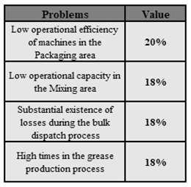

FIGURE 1. Holmes Prioritization Matrix Results. Of the 9 problems defined in the company under study, the 4 Problems shown are predominated.

The Packaging area is characterized by having 8 production lines. To deepen the analysis, it was prepared to analyze the line that presents the greatest need to analyze its low efficiency in its machines and to be able to evaluate a solution that can be standardized in the other lines. The line with the longest time of un-productive time from the period 2019 to 2021 was evaluated, with the results shown in Figure 2.

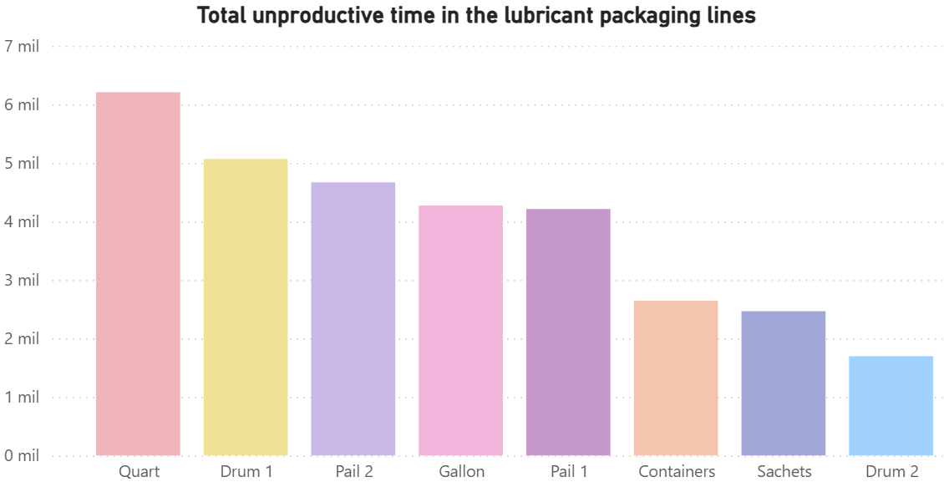

FIGURE 2. Total Downtime of each Packaging Line. The Cuarto Line, products of one-liter presentations, had the highest unproductive time in the period 2019 to 2021.
Given the results presented in the previous graph, it can be seen that the Fourth line presents more unproductive time compared to other lines. According to the records obtained, the following reasons could be recognized for the high unproductive time recorded in the Fourth line (Figure 3).

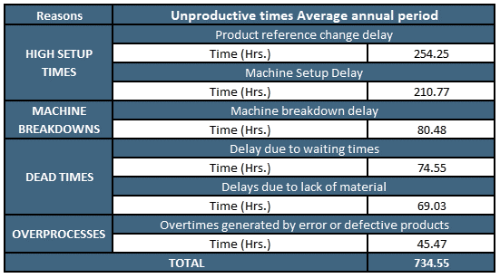

FIGURE 3. Unproductive times of Cuarto Line in the annual period. Times in hours, related to Figure 2.
It was arranged to be able to evaluate this problem and observe in what amount it deviates from the standard established by the sector or classification of the ratio. For the initial analysis, it was determined to use the OEE (Overall Equipment Efficiency) indicator. Currently, as part of the control and monitoring of the company to the Packaging operations and by internal policies of the company, an objective is established to be met based on the OEE Classification, which establishes a minimum objective of 65%. Based on the data analyzed, an average OEE of 36.52% was calculated between the periods of 2019 and 2021. Since the target is 65%, a technical gap of 28.48% is established (Figure 4).

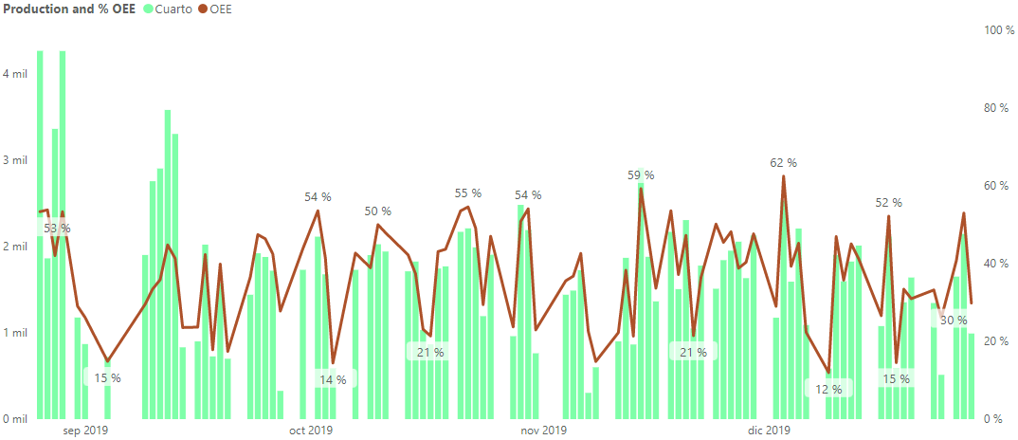
65%

FIGURE 4. OEE registered in the Fourth Packaging line. Behavior 2019 of the OEE in area of Packaging.
The economic impact of the problem obtained is based on the analysis of the projected demand with real production, subsequently evaluating to what extent the unfulfilled demand impacts economically, signifying an economic loss equivalent to $ 1,778,382.00 per year.

Innovative proposal
The model proposed for the case study is presented in Figure 5. In the initial part is the central problem of the investigation. At the heart is the continuous improvement of the central objective, which is the improvement of the efficiency of the machines in the area of packaging of lubricants for cars. The entities that participate are the processes, the machines and people. Given this model, it is proposed to use SMED and TPM together to increase OEE by 20%.

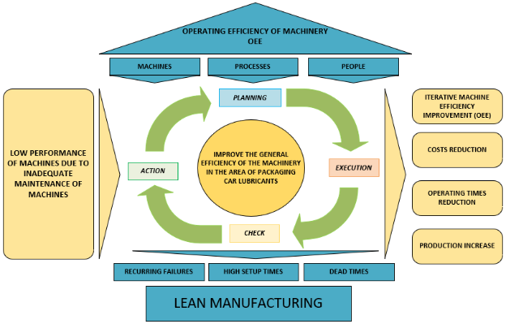

FIGURE 5. Proposed Model of this paper.

4.1 Model Components
Observing the core of the model, in the central part you can see the 4 Components the model, these components are configured to apply the continuous improvement of the central objective. Depending on the explanation of the components, they are defined as: Planning, Execution, Verification, Action. Each component specifies steps in which the tools that would be used for a correct performance of the model are detailed. Needless to say, the core tools will be TPM and SMED, as the improvement will revolve around them.

(b)
(a)

(c)
(d)

FIGURE 5. Flow chart about the activities of each Component. (a) Planning Component, (b) Execution Component, (c) Action Component, (d) Verification Component.

Planning
For the first component, the activities focus on determining the scenario to act, analyzing the existing problems, deepening them by determining the causes of the problem, and ending with the selection of the tool, either SMED or TPM.

Execution
The implementation steps for each tool will be developed. The two selected tools are those that have been detailed above: TPM and SMED. It should be noted that for the TPM tool there will be a previous step to its execution development which will be the evaluation of the pillars that will be used depending on the context to be improved, in other words, depending on the causes that are linked to the problem and are potential pillars of improvement.

Verification
This component details the improvements to be made after you have executed the improvement tools to the core problem. It is important to re-analyze the possible errors that have been executed in the previous phase, and to find a plan to improve it.

Action
As the last component, it will be responsible for correcting the errors found in the previous phase, being variable the subject to be corrected. Some-times the corrective action would be only in the SMED tool, in other cases in TPM, or both. That is the main reason why, in the Verify phase, the problems must be analyzed in depth, so that they do not recur.

CONCLUSION
The application of SMED helped to reduce the washing times of the "Fourth" line and the reduction of the sampling time of the product in the laboratory, having an increase in availability. The application of Total Productive Maintenance (TPM) helped us to reduce maintenance times in the filler and capper of the packaging machine. The application of the Lean Manufacturing tool improves productivity in the packaging machine line in the packaging of lubricant products from one-liter bottles, both in the efficiency and effectiveness of operations on the line. Weekly meetings with packaging operators are recommended to avoid any doubts about the new implementation of the improvement project. Also, complement the development of a change in the work culture of operators. The upgrade project has been implemented at an ExxonMobil industrial engine lubricant production facility. However, it can be applied in other lubricant plants in order to reduce packaging operating times and standardize these times in all plants of this transnational industry. Likewise, it is intended to complement this improvement project with the implementation of a technological system that allows managing packaging operations with the generation of real-time information screens of product packaging and accelerates continuous improvement in production lines.

Acknowledgments
This research work is funded by Dirección de Investigación - Universidad Peruana de Ciencias Aplicadas, through UPC - EXPOST - 2025 - 2, with the knowledge contribution of Izmir Democracy University.

References
- "GDP growth (% annual) - Peru, Latin America & Caribbean | Data." https://datos.bancomundial.org/indicador/NY.GDP.MKTP.KD.ZG?end=2018&locations=PE-ZJ&start=2018&view=bar (accessed Jul. 01, 2025).
- América Economía Intelligence, "Get to know the 2019 Ranking of the 500 Largest Companies in Peru | AmericaEconomy" 2019. https://www.americaeconomia.com/negocios-industrias/conozca-el-ranking-2019-de-las-500-mayores-empresas-del-peru (accessed Oct. 03, 2025).
- J. García Zanabria, A. Sánchez Aguilar, J. Luis Robles, and H. Meza Meza, "Trimestre Bruto Domestic Product," Inst. Nac. Statistics and Informatics, pp. 1–56, 2019.
- A. En-Nhaili, A. Meddaoui, and D. Bouami, "Effectiveness improvement approach basing on oee and lean maintenance tools," Int. J. Process Manag. Benchmarking, vol. 6, no. 2, pp. 147–169, 2016, doi: 10.1504/IJPMB.2016.075599.
- M. Suryaprakash, M. Gomathi Prabha, M. Yuvaraja, and R. V. Rishi Revanth, "Improvement of overall equipment effectiveness of machining centre using tpm," Mater. Today Proc. , vol. 46, pp. 9348–9353, 2021, doi: 10.1016/J.MATPR.2020.02.820.
- G. Pinto, F. J. G. Silva, A. Baptista, N. O. Fernandes, R. Casais, and C. Carvalho, "TPM implementation and maintenance strategic plan – a case study," Procedia Manuf., vol. 51, pp. 1423–1430, Jan. 2020, doi: 10.1016/J.PROMFG.2020.10.198.
- T. Vieira et al., "Optimization of the cold profiling process through SMED" in Procedia Manufacturing, Jan. 2019, vol. 38, pp. 892–899, doi: 10.1016/j.promfg.2020.01.171.
- R. S. Barot, K. Raval, H. S. Berawala, and A. Patel, "Implementation of lean practices in water heater manufacturing industry," Mater. Today Proc., vol. 38, pp. 2227–2234, Jan. 2021, doi: 10.1016/J.MATPR.2020.06.304.
- I. M. Ribeiro, R. Godina, C. Pimentel, F. J. G. Silva, and J. C. O. Matias, "Implementing TPM supported by 5S to improve the availability of an automotive production line," Procedia Manuf. , vol. 38, pp. 1574–1581, Jan. 2019, doi: 10.1016/J.PROMFG.2020.01.128.

