The Effect of Pressure on the Structural and Optical Properties of CdO Thin Films Deposited by Chemical Spray Pyrolysis on a Moving Substrate
Tawfiq M. Amin ^{1,a)} and Mazin A. Abed ^{1,b)}
¹ Department of Physics, Science College, University of Mosul, Mosul, Iraq
ᵃ) Corresponding author: tawfiq.24scp25@student.uomosul.edu.iq
^{b)}mazinahmedabed@uomosul.edu.iq

Abstract. CdO thin films were deposited using chemical spray pyrolysis (CSP) over a dynamic substrate travelling at 6 cm/s, at pressures between 1.0 and 2.5 bar. The research investigated the influence of deposition pressure on the structural, morphological, and optical characteristics of the films. X-ray diffraction (XRD) verified the existence of cubic CdO crystals, exhibiting a principal peak at 33° associated with the (111) plane. Elevated pressure diminished crystallite size from 60.43 nm to 18.49 nm, concurrently augmenting micro strain and lattice distortion as a result of internal stress. Scanning Electron Microscopy (SEM) examination corroborated these findings, demonstrating a transition from big irregular grains to smaller compact grains with increasing pressure. The dynamic substrate improved film transparency by enhancing homogeneity and minimizing agglomeration, resulting in a more uniform grain distribution. Optical investigation demonstrated a clear correlation between structural alterations and optical efficacy. The film deposited at 1 pressure demonstrated 85% transmittance, which diminished to 40% at 2.5 bar as a result of heightened grain density and flaws. The optical band gap decreased from 2.17 eV to 2.00 eV with elevated pressure, due to enhanced crystallinity and a rise in defect states. Fluctuations in the absorption coefficient and refractive index corresponded with structural and morphological analyses. This research emphasizes the significance of pressure regulation in enhancing CdO films for use in transparent conductive oxides, photodetectors, and solar cells.
Keywords: Cdo Thin Films, Chemical Spray Pyrolysis, Physical Properties, Dynamic Substrate, Pressure Effects.
INTRODUCTION
Using ultra-thin layers named thin films brings unmatchable mechanical ele, electrical, and optical features to modern technology, thus making them vital components for contemporary applications. The substance has advanced beyond its basic usage in integrated circuit production to find purposes in optical devices, protective coating development, and renewable energy creation [1,2]. The production of application-specific high-quality thin films happens through deposition methods, which include physical vapor deposition (PVD) and solution processing [3,4]. Cadmium oxide (CdO) attracts considerable attention within thin-film technology because of its excellent electrical and optical properties. High electrical conductivity and excellent optical transmittance found in CdO TCO materials qualifies this material for usage in advanced electronic and optoelectronic applications as well as gas sensing systems [5,6,7]. Indium tin oxide (ITO) stands as the most frequently used TCO material because it keeps remarkable visual transparency while delivering superior conductivity. The high cost of CdO stands against its wide industrial application due to its excellent properties [8]. CdO presents polycrystalline formation yet the sizes of grains and crystalline status depend strongly on the synthesis process and post-deposition treatments [9,10]. CdO represents an excellent choice for transparent electronics because it demonstrates outstanding electric properties with 73% optical transmittance and 2.14 – 2.61 eV optical band gap [11,12].The deposition techniques for CdO thin films consist of sputtering for uniform film structure [9] and the sol-gel method for thickness and composition control [13] and chemical vapor deposition (CVD) for generating high-resolution homogeneous coatings [14]. Because of its affordability together with simple setup and its capability for high-speed depositions chemical spray pyrolysis (CSP) stands as a popular technique [15]. Various investigations show that shifting the substrates throughout deposition results in improved crystallization and enhanced structural stability of CdO thin films which leads to greater grain size formation [16]. When substrates move during deposition reactions they control nucleation processes which creates better surface structures along with less film defects throughout uniform distribution. According to research optical transmittance increases simultaneously with an optical band gap shift between 2.34 to 2.44 eV in CdO film production using substrate movement [17]. A deeper analysis of structural and optical properties of CdO thin films requires study of the pressure fluctuations that emerge during CSP deposition. The development of transparent electric and optoelectronic devices based on CdO will benefit from implementing research findings about how structural quality and optical characteristics are influenced by deposition pressure. This research explores the effects of pressure fluctuations on structural along with optical attributes of CdO thin films developed through chemical spray pyrolysis on mobile substrates as a solution to fill an existing knowledge deficit for improving high-performance transparent conductive materials. This study investigates the effects of pressure during the deposition of CdO thin films using Chemical Spray Pyrolysis (CSP) on a moving substrate. The topic is innovative because it focuses on a parameter combination pressure and substrate motion that has not been widely explored in current literature. These factors significantly affect the quality of thin films in terms of structural and optical properties, providing valuable insights for applications in optoelectronics such as solar cells and photodetectors.
EXPERIMENTAL PART
The films were deposited using Chemical Spray Pyrolysis (CSP) on glass substrates. The spray rate was set at 1.5 mL per minute using a nozzle with a diameter of 0.5 mm. The substrate speed was controlled at 6 cm/s with a dynamic control system to ensure uniform distribution of the spray across the surface. A digital temperature controller was used to maintain a stable substrate temperature of 350°C throughout the deposition process. The nozzle-to-substrate distance was kept at 20 cm during the 15 spray cycles to ensure uniform film thickness and adhesion. These details ensure that the methodology is reproducible by other researchers. The production of thin films took place on glass slides with dimensions 25.4 × 76.2 mm that maintained thicknesses between 1–1.2 mm. A precision glass cutter produced longitudinally cut slides with dimensions of 12.7 × 76.2 mm. QUENCE removal required a multi-step cleaning process that optimized the quality of depositions on the slides. The sample needed a five-minute duration in analytical-grade acetone solution that was stirred while dissolving organic contaminants before an immediate wash with double-distilled water. The slides received drying with lint-free wipes to stop dust accumulation before their placement in a dust-free storage space. A solution of 0.02 M cadmium chloride (CdCl₂) was made by mixing 0.9166 g of CdCl₂ (molecular weight: 183.32 g/mol) in 25 mL of distilled water. An analytical balance provided precise measurements of the mass while gradual stirring led to the solution of the solid material. A volumetric flask contained 25 mL of solution to reach a homogeneous mixture prior to its usage. A solution of potassium hydroxide (KOH) at 0.02 M concentration was made through the process of dissolving 0.0281 g of KOH in a small amount of distilled water in a 25 mL volumetric flask. A magnetic stirrer mixed the solution until its complete dissolution then the final volume settled at 25 mL for effective solution mixing. Spilling the solutions of CdCl₂ and KOH together at 80°C required a magnetic stirrer equipped with a hot plate for 20 minutes. A magnetic stir bar inside a heated solution received power from the magnetic field device to create rotation that uniformly combined chemical components. The investigators utilized thermal spray pyrolysis to distribute cadmium oxide (CdO) thin films uniformly on a moving substrate through operation at a speed of 6 cm/s. The research included four glass slides used to evaluate structural and optical changes in deposited films at different pressure values ranging from 1 to 2.5 bar. Through a digital temperature controller the substrate reached 350°C to keep the temperature stable throughout the deposition process. The experiment adopted a digital timer to control number of sprays while each spray lasted ten seconds and required two minutes for complete solvent evaporation and to avoid sudden substrate temperature changes. A controlled nozzle-to-substrate distance of 20 cm was used during the 15 spray cycles for achieving uniform film thickness and better adhesion as well as morphological quality of deposited layers.
RESULTS AND DISCUSSION
The results were analyzed using XRD, SEM, and UV-Vis to assess the structural and optical properties of the CdO thin films. X-ray diffraction analysis (XRD) evaluated the influence of pressure on crystal properties when making the samples during deposition. Figure 1 show he main diffraction peak occurs at an angle position of 33° which represents the reflection from the (111) crystallographic plane to confirm the crystalline phase formation of CdO.
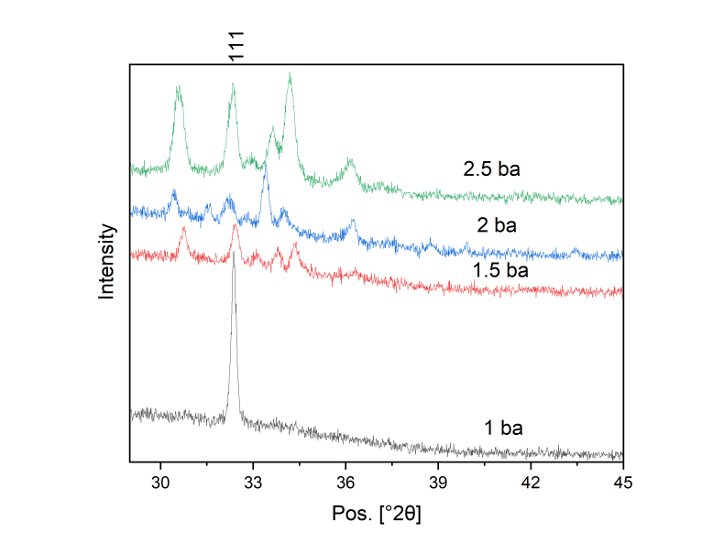
FIGURE 1. X-ray diffraction (XRD) pattern of CdO thin films at different pressures showing the main peak at 33° corresponding to the (111) crystallographic plane.
The results obtained demonstrate the effect of pressure on the structural properties of CdO thin films. The interplanar spacing (d-spacing) was calculated using Bragg's equation [18][19]:
$nλ=2dsin(θ)$ (1)
where λ is the wavelength (1.5406 Å) and θ is the half-angle of 2θ. The results showed that d-spacing decreases with increasing pressure, indicating a reduction in the distance between the crystal planes due to the applied pressure. Additionally, the crystallite size (D) was calculated using Scherrer's equation :
$D= \frac{K⋅λ}{β⋅cos(θ)}$ (2)
where K is a constant (0.9), β is the full width at half maximum (FWHM), and θ is the half-angle of the peak. The results revealed that the crystallite size decreases significantly with increasing pressure, with the crystallite size at 1 bar being 60.43 nm, which reduced to 10.77 nm at 2.5 bars. Furthermore, the micro strain was calculated using the equation:
$ϵ =\frac{b}{4⋅tan(θ)}$ (3)
Microstrain increases with applied pressure as pressure influences the tiny distortions within the crystal lattice. Research data supports theoretical predictions that higher pressure results in smaller crystallites and more lattice distortions. Table 1 highlights how pressure affects the structural aspects of CdO thin films. SEM analysis (Figure 2) shows that pressure directly impacts both the material particles and internal pores. Increasing pressure from 1 bar to 2.5 bars reduces particle size from 47.87 nm to 27.40 nm, indicating that pressure induces a reduction in particle size by altering the crystalline structure of the material. The application of pressure also reduces porosity, from 76.26% at 1 bar to 58.05% at 2.5 bars, suggesting a denser material structure. These changes are seen in both XRD results and crystallite size reductions. The findings indicate that pressure plays a significant role in improving the material’s properties by enhancing its crystallinity and mechanical characteristics. This leads to greater durability and efficiency in various applications. High-pressure treatment is thus a valuable technique in material science, particularly in enhancing the mechanical properties of materials like CdO thin films. Table 1 provides detailed results showing the correlation between pressure, grain size, surface area, and porosity.
TABLE 1. Effect of Pressure on the Structural Properties, Grain Characteristics, and Porosity of CdO Thin Films
Pressure (bar) | Crystallite Size (nm) | Micro Strain (%) | d-spacing (Å) | Grain Size (nm) | Porosity (%) | Area (%) | Medium Size (nm) | Total Area | Number of Grains
1 | 60.43 | 0.00779 | 5.4719 | 47.87 | 76.26 | 23.74 | 13.53 | 917423 | 67827
1.5 | 11.88 | 0.03565 | 5.3777 | 33.02 | 64.76 | 35.24 | 24.29 | 1361950 | 56065
2 | 11.07 | 0.03785 | 5.3302 | 28.03 | 61.72 | 38.28 | 14.14 | 1479312 | 104629
2.5 | 10.77 | 0.03854 | 5.3073 | 27.40 | 58.05 | 41.95 | 19.06 | 1621182 | 85044

As pressure increased from 1 to 2.5 bar, the crystallite size was significantly reduced (from 60.43 nm to 10.77 nm). The microstrain increased due to higher internal stress, which influenced the optical and structural properties, including the decrease in band gap and the increased optical absorption.
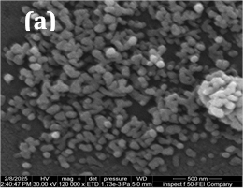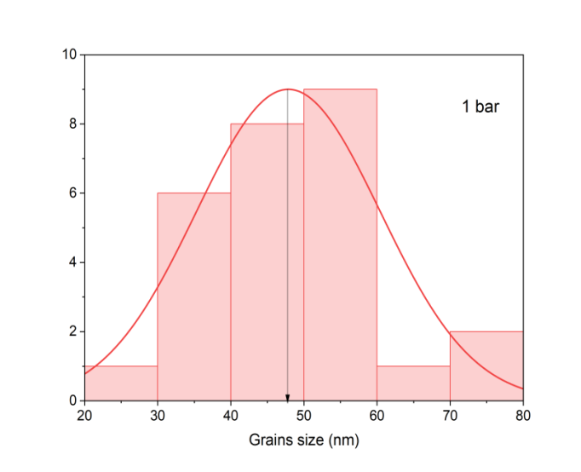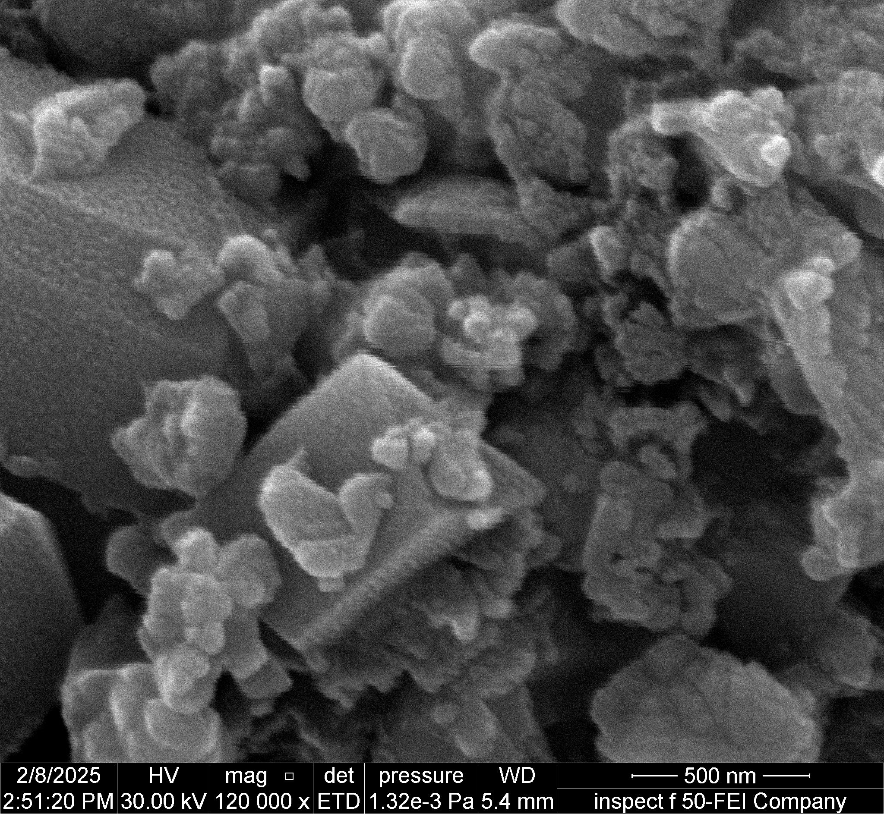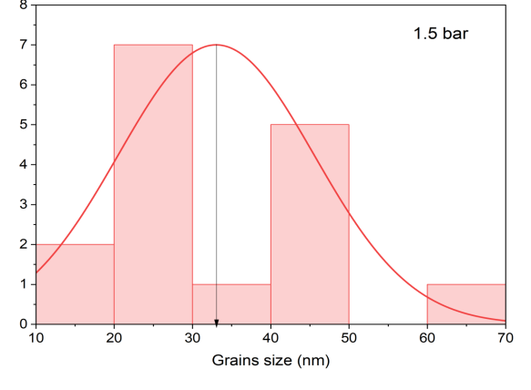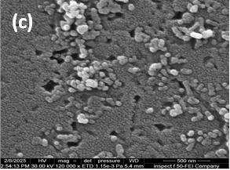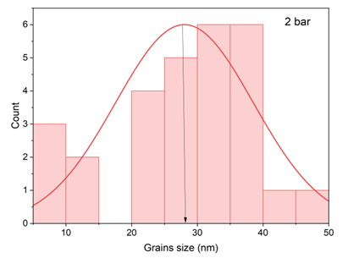
(b)
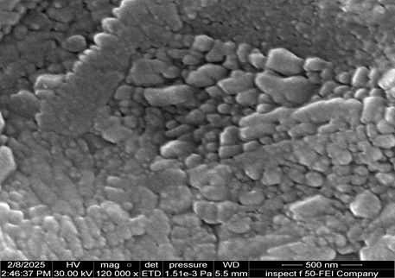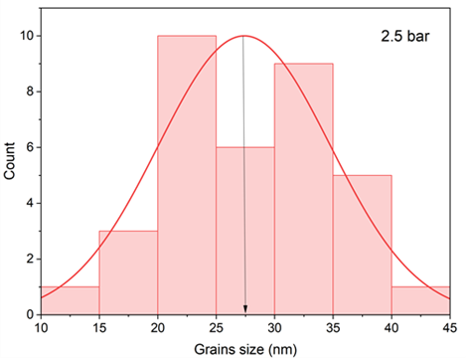
(d)
FIGURE 2. SEM images of CdO thin films at various pressures. (a) 1 bar, (b) 1.5 bar, (c) 2 bar, (d) 2.5 bar, showing the significant effect of pressure on grain distribution and size.
In terms of optical properties, the transmittance results indicate that the samples prepared at a pressure of 1 bar exhibited the highest transmittance (~85%), particularly within the visible range (400–700 nm). However, transmittance gradually decreased with increasing pressure, reaching its lowest value (~40%) at 2.5 bar. This reduction is attributed to the increased density of optical defects and enhanced light scattering caused by structural compression, as illustrated in Figure 3. These findings are consistent with the structural changes observed in the SEM images.
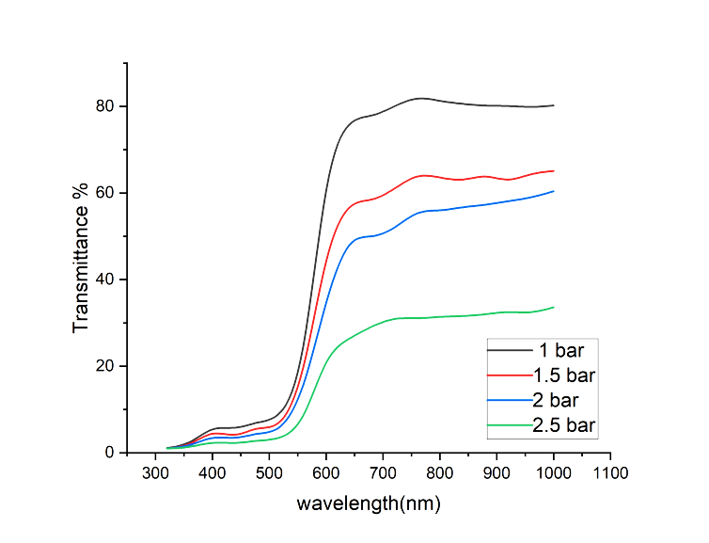
FIGURE 3. Effect of Pressure on Transmittance Across the Visible Range (400–700 nm).
The UV-Vis spectrum presented high absorbance ranges from 300 nm to 500 nm because direct electronic bandgap transitions occurred but lowest absorbance measurements were detected at longer wavelengths. The absorbance measurement rose progressively until it reached its maximum value of 2.5 bar under pressure. Figure 4 demonstrates crystal distortions together with optical scattering as the main cause of this behavior while microscopic images show reduced grain sizes and denser packing distribution.
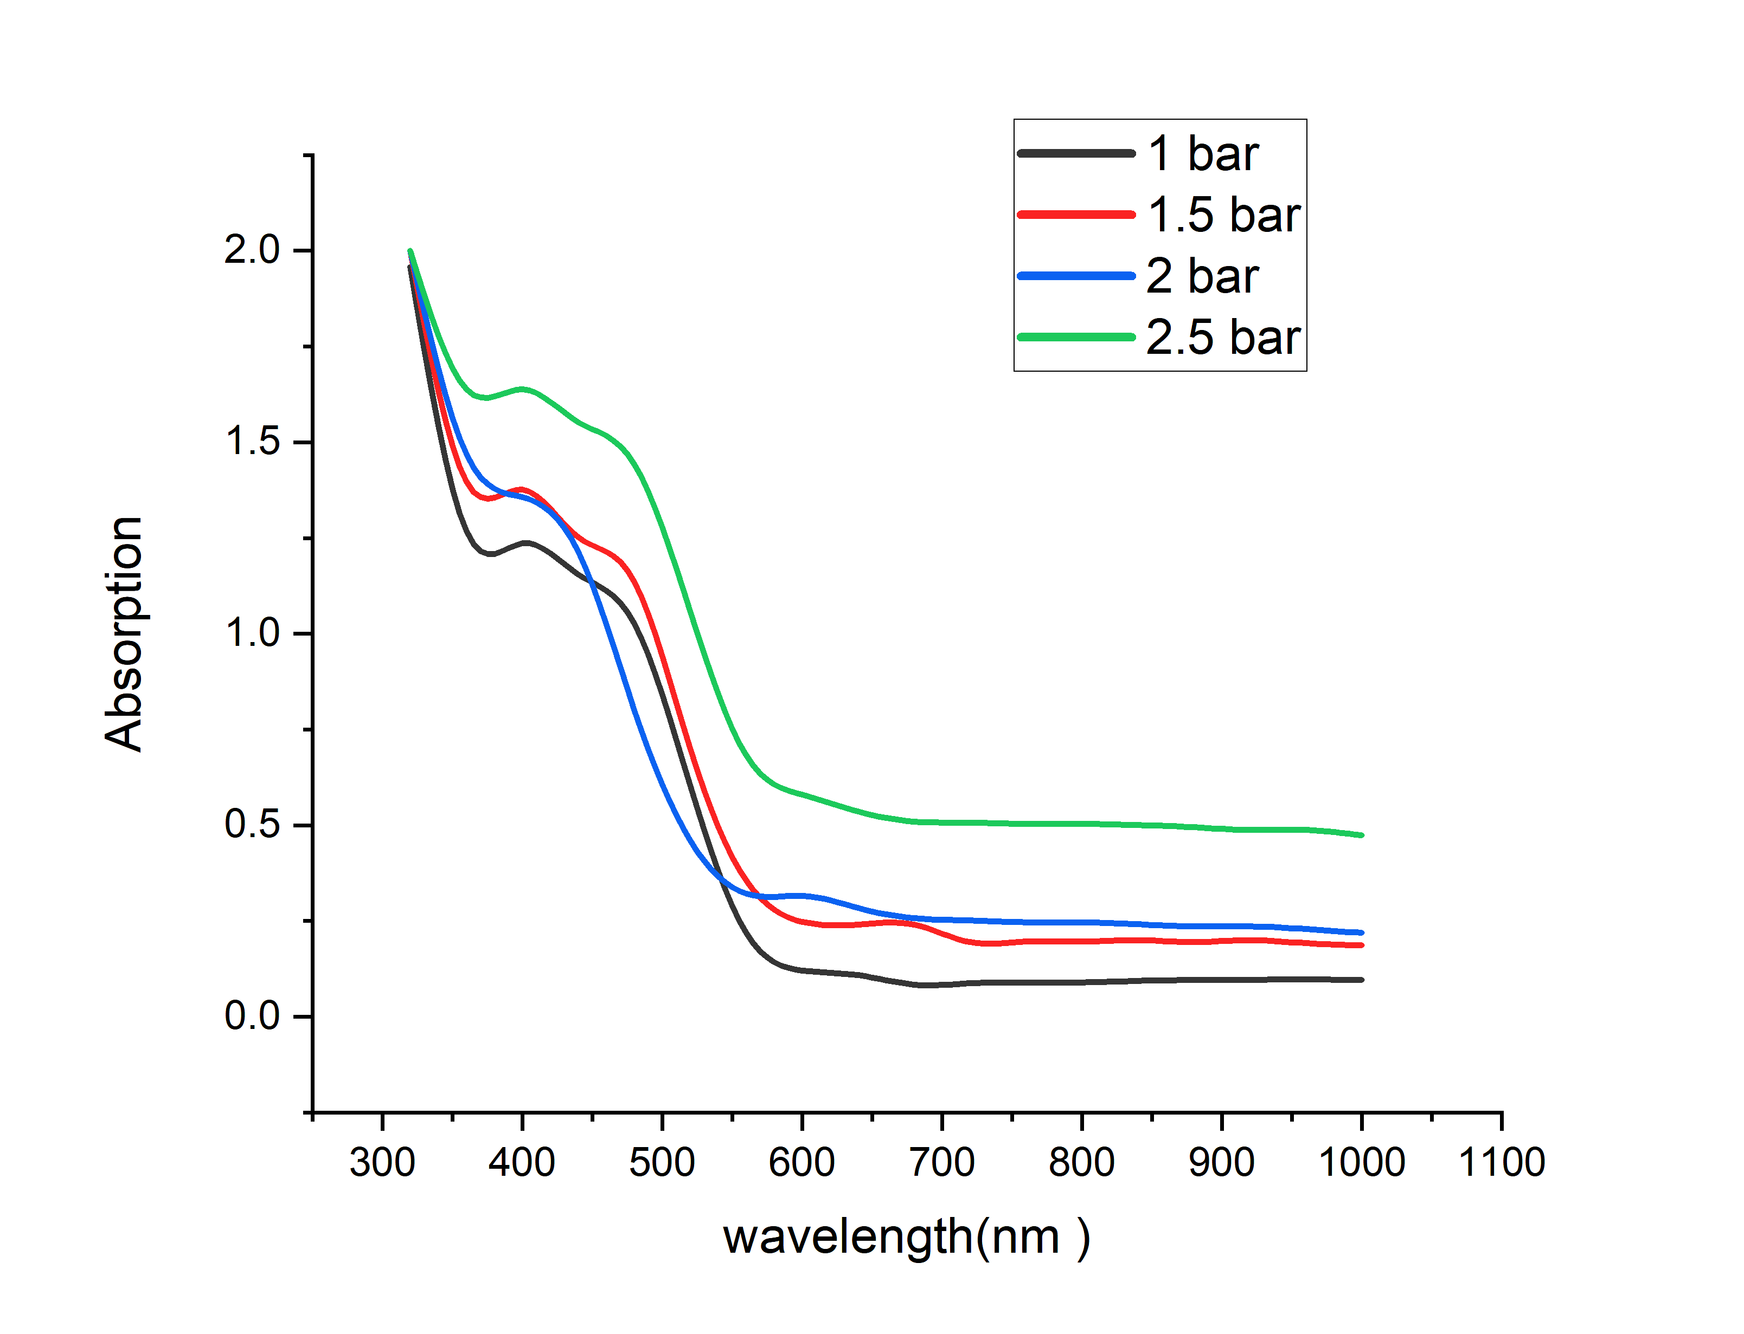
FIGURE 4. Effect of Pressure on Absorption Across the Visible Range (400–700 nm).
The research showed that the energy bandgap reduced steadily when pressure increased from 1 bar to 2.5 bar resulting in an energy bandgap change from 2.17 eV to 2.00 eV. The energy needed for electron transition decreased because crystal defects increased as well as material crystallinity improved (Figure 5). Multiple published research papers including [20][21] support the relationship between heightened pressure levels and reduced bandgap dimensions.
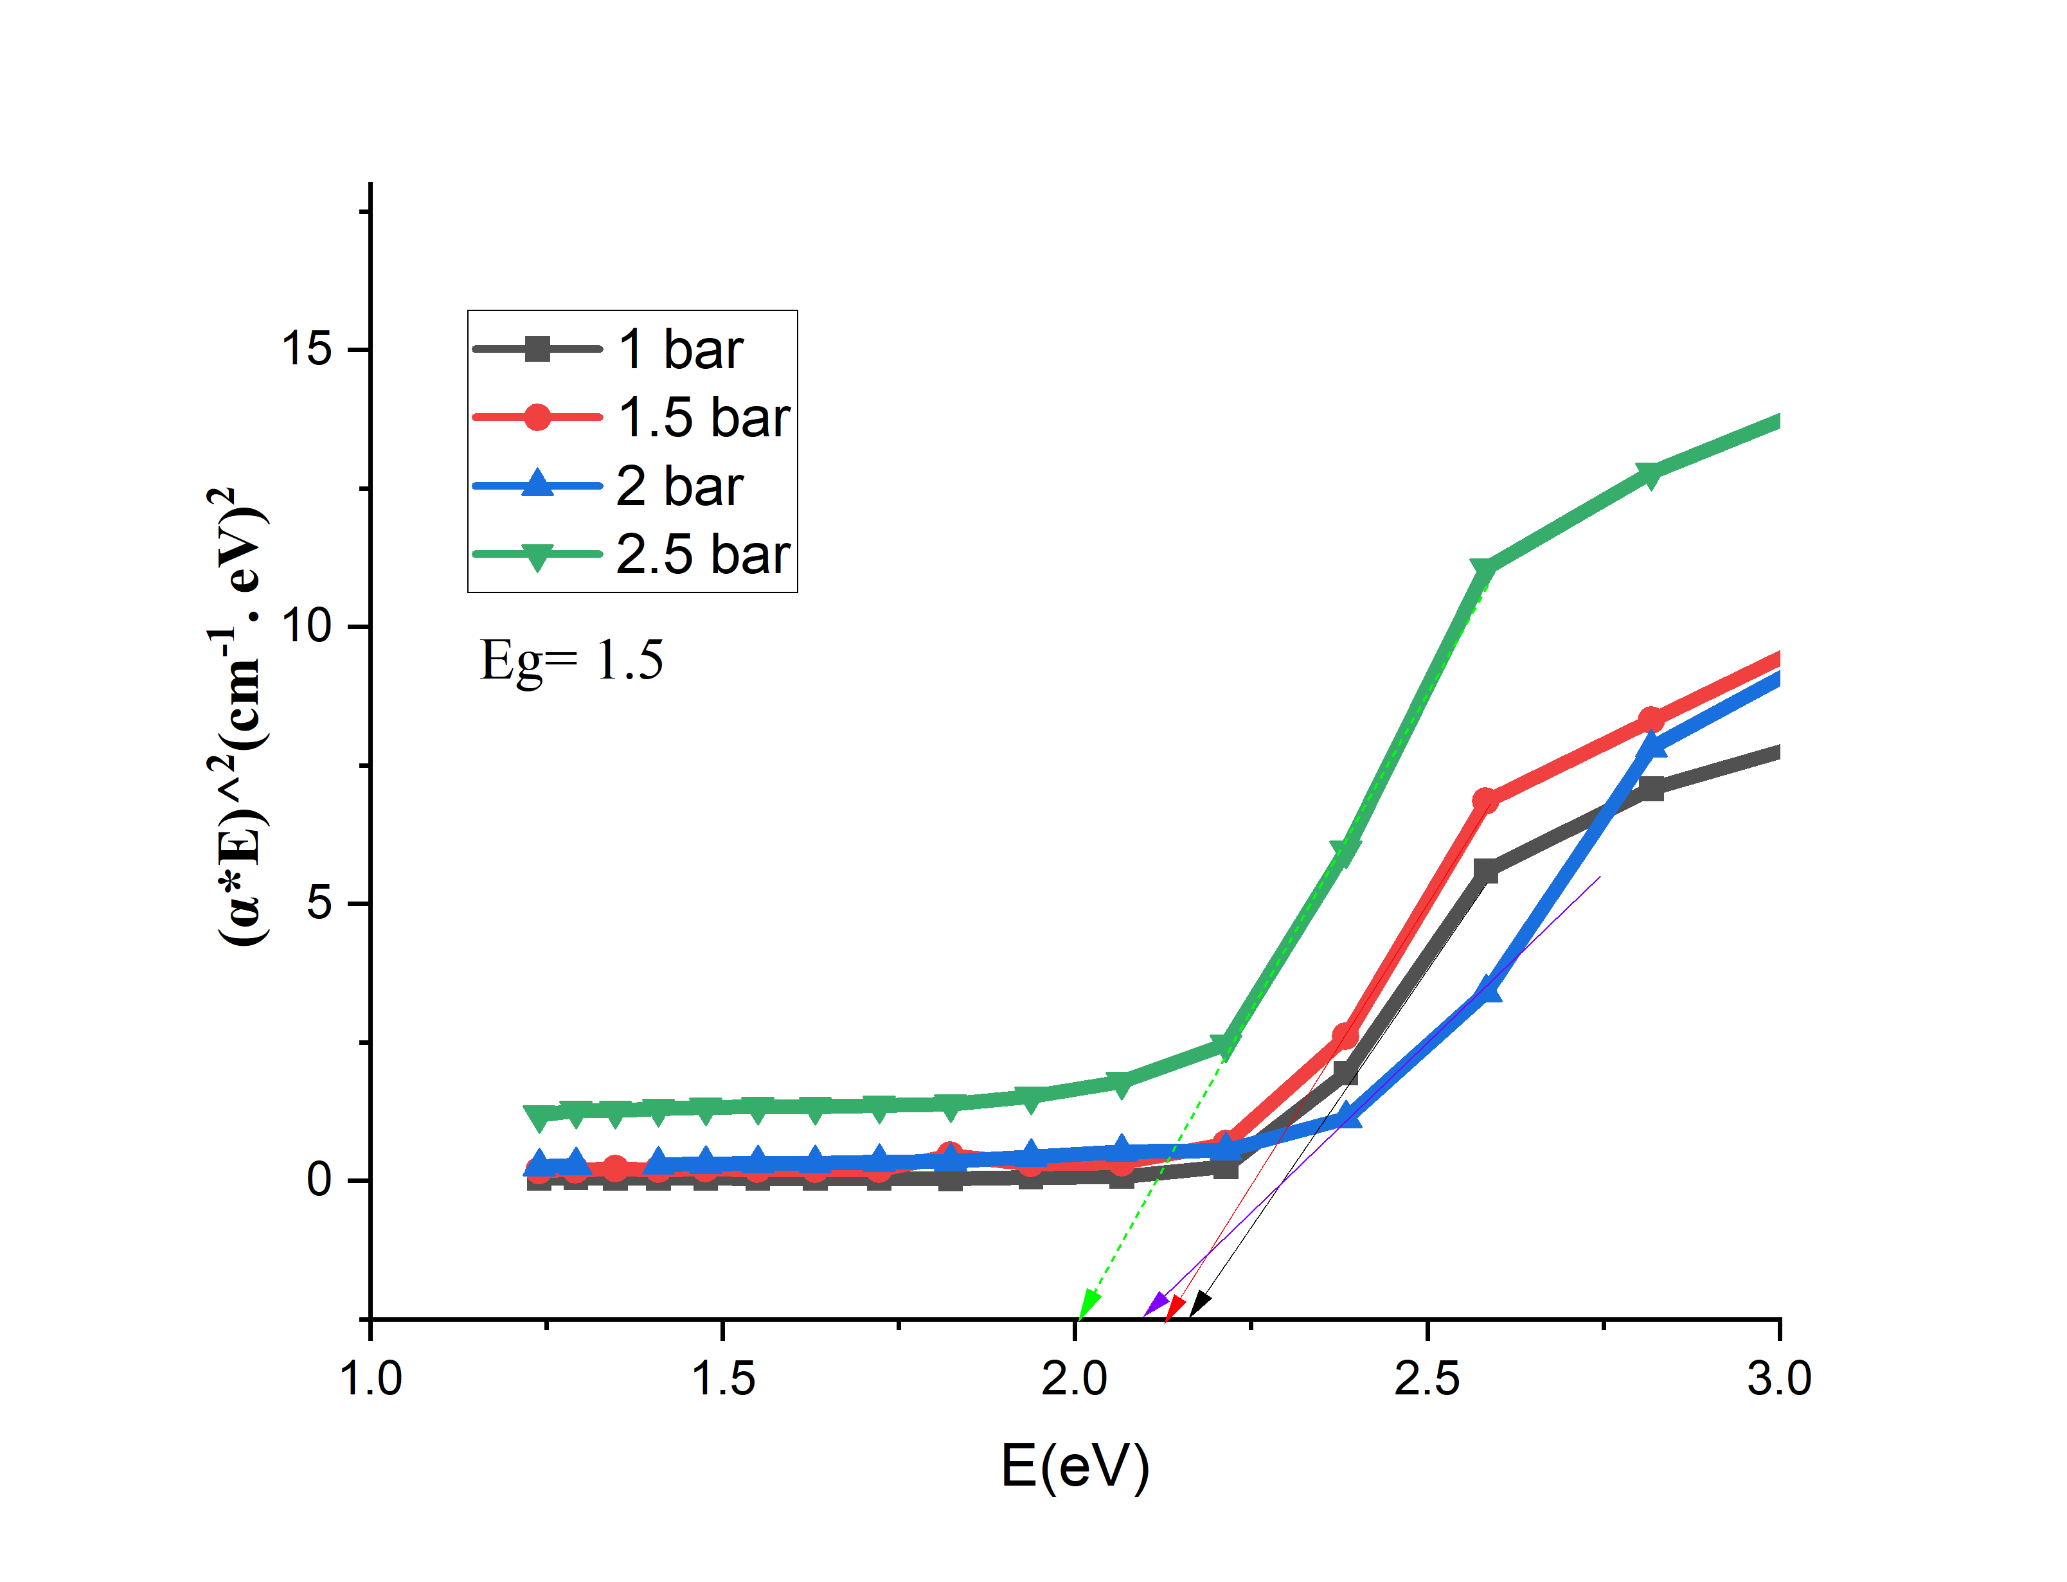
FIGURE 5. Pressure-Induced Variation of Energy Bandgap (Eg) in the Material.
The films demonstrated better absorption of light in optoelectronic applications as pressure increased because of their rising absorption coefficient (Figure 6). An increase in pressure led to a gradual decrease in refractive index value (Figure 7) because the structural uniformity improved and optical density decreased. The reported findings match results that previous studies have established [22].
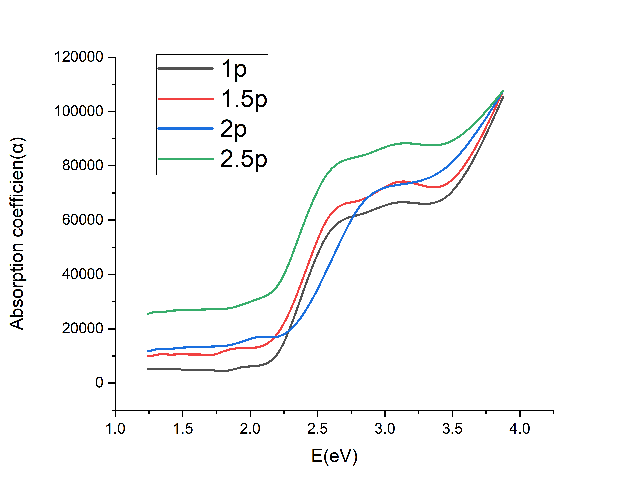
FIGURE 6. Pressure Dependence of Absorption Coefficient.
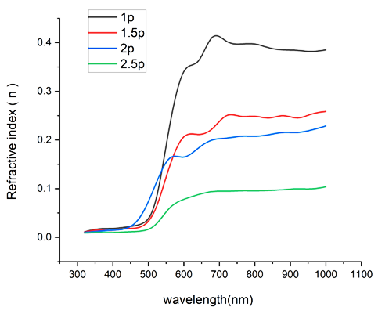
FIGURE 7. Pressure-Driven Variation in Refractive Index.
The research results demonstrate that managing deposition pressure effectively allows researchers to control both the structural and optical properties of CdO thin films, tailoring them for specific applications. At low deposition pressures, transparency increases, making these films ideal for use as transparent conductive oxides (TCOs) in photovoltaic cells and optoelectronic devices. In contrast, higher pressures enhance light absorption, reducing transparency, and making the films suitable for photodetector and thermal device applications. Moderate pressures between 1.5–2 bar strike a balance, combining transparency with optical density, which is ideal for devices that require both conductivity and light absorption. Dynamic substrate handling methods contribute to improved material quality by ensuring even distribution of the substance, optimizing film morphology, and reducing surface defects. CdO thin films are valued for their adjustable band gaps and excellent transmittance, making them promising candidates for applications like transparent conductive electrodes in solar cells, LEDs, and gas sensing systems [23][24].
CONCLUSIONS
The effect of deposition pressure on CdO thin films developed on a moving substrate by chemical spray pyrolysis (CSP) was investigated in this work. Better material distribution and deposition performance resulted from efficient substrate use. By means of internal strain modifications, increasing pressure methodically improved crystalline quality, reduced grain size, and somewhat changed crystallographic peaks. Reduced crystal clumping and improved structural organisation were achieved in part via substrate movement. SEM study verified enhanced structural homogeneity and surface homogeneity, thereby proving the direct consequences of pressure increase and substrate movement. At higher pressures, the dynamic substrate helped to provide smoother surfaces by facilitating uniform droplet dispersion, hence decreasing bulk deposits. Along with a drop in the optical bandgap from 2.17 eV to 2.00 eV, UV-Vis data showed that transmittance dropped while absorbance grew when pressure rose from 1 to 2.5 bar.
REFERENCES
- R. Khan Sharme, M. A. Quijada, M. Terrones, and M. M. Rana, "Thin Conducting Films: Preparation Methods, Optical and Electrical Properties, and Emerging Trends, Challenges, and Opportunities," Materials, vol. 17, no. 18, p. 4559, 2024, doi: 10.3390/ma17184559.
- Q. Zaman et al., "Dielectric-loaded waveguides as advanced platforms for diagnostics and application of transparent thin films," Langmuir, vol. 37, no. 11, pp. 3248–3260, 2021, doi: 10.1021/acs.langmuir.0c02862.
- M. I. Hossain and S. Mansour, "A critical overview of thin films coating technologies for energy applications," Cogent Engineering, vol. 10, no. 1, 2023, doi: 10.1080/23311916.2023.2179467.
- E. Picavet et al., "Solution-processed Pb (Zr, Ti) O3 thin films with strong remnant Pockels coefficient," ACS Appl. Mater. Interfaces, vol. 16, no. 31, pp. 41134–41144, 2024, doi: 10.1021/acsami.4c07073.
- D. S. Halil et al., "Thin films technology," 2024, doi: 10.58915/bk2023.011.
- S. A.-J. Jassim and E. M. A. Nassar, "Synthesis, structural and optical properties of CdO nanocrystalline prepared by sol–gel method," Nucleation and Atmospheric Aerosols, 2022, doi: 10.1063/5.0124168.
- I. Karim et al., "Effect of silver and cobalt on transparent conducting CdO thin films: tuning the optoelectronic properties," Mater. Adv., vol. 6, no. 2, pp. 703–718, 2025, doi: 10.1039/D4MA00918E.
- T. O. Zinchenko et al., "Preparation of Transparent Conductive Thin-Film Coatings by Spray-Pyrolysis," in Proc. EDM, pp. 300–303, 2024, doi: 10.1109/edm61683.2024.10615175.
- K. R. Kadhim and R. Y. Mohammed, "Effect of Annealing Time on Structure, Morphology, and Optical Properties of Nanostructured CdO Thin Films Prepared by CBD Technique," Crystals, vol. 12, no. 9, p. 1315, 2022, doi: 10.3390/cryst12091315.
- J. Arcot and K. Shaik, "Effect of annealing temperature on structural, optical and electrical properties of CdO nanoparticles for lighting applications," Eur. Phys. J. B, vol. 98, no. 1, p. 20, 2025, doi: 10.1140/epjb/s10051-025-00867-9.
- B. Karthikeyan and R. Vettumperumal, "Optical and electrochemical properties of pure and Ti-doped CdO nanoparticles for device applications," Mater. Sci. Eng. B, vol. 281, p. 115754, 2022, doi: 10.1016/j.mseb.2022.115754.
- C. K. G. Kwok and K. M. Yu, "Highly transparent and conducting In doped CdO synthesized by sol-gel solution processing," J. Mater. Sci., vol. 56, no. 22, pp. 12607–12619, 2021, doi: 10.1007/S10853-021-06087-7.
- F. T. Z. Toma, Md. S. Rahman, K. Md. A. Hussain, and S. F. Ahmed, "Thin Film Deposition Techniques: A Comprehensive Review," J. Mod. Nanotechnol., vol. 4, p. 6, 2024, doi: 10.53964/jmn.2024006.
- K. Sivaramamoorthy, S. Perumal, A. Kalaivanan, and K. R. Murali, "Sol gel deposited CdO: In films," in Int. Conf. on Systems, pp. 91–93, 2011, doi: 10.1109/ICONSET.2011.6167918.
- H. K. R., E. S. M., and S. J. Retnam B., "Review on Spray Coating Techniques," 2023, doi: 10.59544/lurb3625/ngcesi23p64.
- S. Anitha et al., "Synthesis and characterization of NiO-CdO composite materials towards photoconductive and antibacterial applications," Mater. Chem. Phys., vol. 211, pp. 88–96, 2018, doi: 10.1016/j.matchemphys.2018.01.048.
- K. M. Saleh, "Study the Structural Properties and Surface Morphology of CdO thin films prepared by Chemical Spray pyrolysis," J. Kufa - Phys., vol. 12, no. 02, pp. 1–11, 2020, doi: 10.31257/2018/JKP/2020/120201.
- M. M. Al-Slivani, M. A. Hammod, and M. A. Abed, "Partial substitution effect of silver on the structural and electrical properties of high-temperature superconductor (Bi₂ − xAgxBa₂Ca₂CO₂Cu₃O₁₀+δ)," Ochrona przed Korozją, vol. 1, no. 3, pp. 15–20, 2025, doi: 10.15199/40.2025.3.2.
- M. M. Al-Slivani, M. A. Hammod, and M. A. Abed, "Double partial substitution effect of silver (Ag) and strontium (Sr) on the structural and electrical properties of high temperature Bi₂₋ₓAgₓBa₂₋ySryCa₂Cu₃O₁₀+δ superconductor," Funct. Mater., vol. 32, pp. 42–49, 2025, doi: 10.15407/fm32.01.42.
- E. Hasani, M. G. Arashti, L. B. Habashi, and M. Kamalian, "Effect of high-pressure annealing on the physical properties of CdTe thin films," Eur. Phys. J. Plus, vol. 136, no. 1, p. 28, 2021, doi: 10.1140/EPJP/S13360-020-00989-2.
- N. Erum et al., "Enhanced mechanical, optoelectronic and thermoelectric properties of binary CdO by under pressure: An ab initio study," Int. J. Quantum Chem., vol. 124, no. 5, 2024, doi: 10.1002/qua.27360.
- M. M. Abood et al., "CdO thin films Grown by Chemical Spray Pyrolysis and Effect of Substrate type on its Optical Properties," Proc. Conf., vol. 57, pp. 53–59, 2016.
- V. Balaprakash et al., "Thin Film Transparent Conducting Oxides and its Anticorrosion and Surface Protection Applications," pp. 109–127, 2024, doi: 10.1002/9781394234318.ch5.
- I. A. Gracia, "CdO synthesis techniques, morphology and some of its application, a review," Nucleation and Atmospheric Aerosols, 2022, doi: 10.1063/5.0121940.

