Simulation of Wave Energy Dynamics for Renewable Power Systems
khaleel Ali khudhur^{1,a)}, Nabeel Muhamedakram Samad ^{1,b)}, Raid W. Daoud^{2,c)}
¹Northern Technical University, Technical Engineering College- Kirkuk, Iraq
²Northern Technical University, Hawija Technical College, Iraq

^{a)}khaleel2012ali@ntu.edu.iq
^{b)}nabeelakram@ntu.edu.iq
^{c)} corresponding author: raid.daoud@gmail.com

Abstract: Clean water is becoming increasingly scarce, endangering both human and environmental health. Since 1970, wave power distillation has been a process under development for creating freshwater. The system's movements must be represented in the time domain for real-time utilization in maritime structures. Due of the multilayer integrals in the model that the Cummins equation describes, this could present difficulties. Additionally, the measurement of amount must be predicted a few seconds in advance for the majority of control techniques designed for wave energy converters. In the field of energy from waves, this makes short-term prediction a crucial issue. Principal research on the impact of latches energy management exchanger in standard waves is among previous research on the subject. For application in irregular waves and in real time, the Latching control method was expanded in this thesis. In order to construct a system model, a It was implemented using a simple time-variant descriptive modeling of the ID-memory system. The quasi-causal stimulation factors were calculated using a particular method. An augmented Kalmar filter was chosen to anticipate the unresolved control variables. Simulations in MATLAB as well as Simulink were used to test structure factors, control schemes, and estimate techniques. It was verified that the unstructured version behaved as it should. The control algorithm further produced appropriate behavior. But neither efficiency nor irregularity were improved as a result of this. It was determined as a result that locking command is an inappropriate controlling technique for the Wave Oasis. With standards differences from the range of = 0.01 0.03 m a marine condition characterized by Hs = 2.5 and Tp = 9.1, the estimate technique performed satisfactorily for medium to low noise levels (noise amplitude of (0.01 -0.1 m)). The later should be examined or improved, though, if it was anticipated that the measurement noise would have higher levels of noise.
Keywords: wave power, energy, time domain, up-down energy.

INTRODUCTION
The need for energy is growing on a global scale. Fossil fuels are currently the primary energy sources; nevertheless, they are non-renewable energy sources that will ultimately run out [1]. The emissions brought on by burning fossil fuels also are contributing to global warming. These energy sources ought to gradually be replaced by better ones in order to preserve a sustainable future [2]. Wavelength Energy Converters, also known (WECs) along with additional renewable energy sources are hoped to play a role as replacements and help build a more environmentally friendly future. WECs, however, are nevertheless in the development stage and face difficulties with regard to cost and power output efficiency [3]. Adjusting the oscillation to get closer to an appropriate connection with the WEC and the incoming wave can increase the power production and, thus, the income from a WEC. However, the majority of the control mechanisms of the various control strategies have turned out to be non-causal. It is necessary to forecast the measurement amounts a few seconds in advance in order to use the control techniques.

Some symbols are shown in the table:
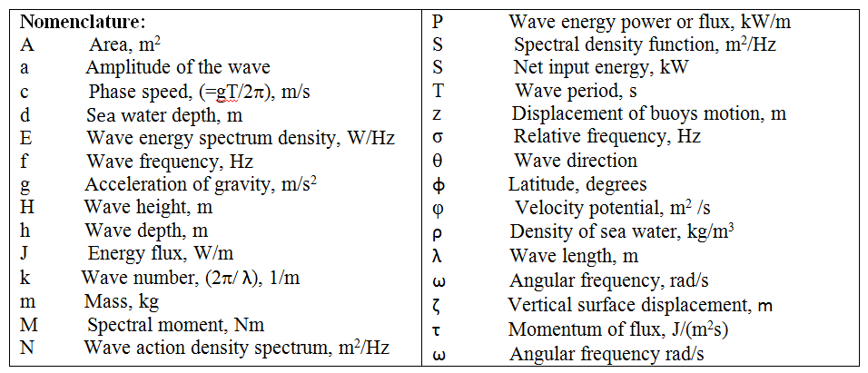
As a result, wave energy researchers must grapple with a critical issue: short-term wave prediction. The benefit might be to get the best efficiency and power consumption of the devices by finding an acceptable answer to these predictions or estimate problem.

WAVES
The frictional drag of the wind over the water is what creates waves. Waves of oscillation: Water atoms travel in nearly circular orbits that get smaller the deeper they go [4]. Water molecule translation waves truly advance. An explanation of waves According to Figure 1:
- A wave's crest is its highest point.
- A wave's depression refers to its lowest point in height.
- The vertical the separation of a wave's through and crest is known as wave height.
- Wavelength is the horizontal separation between a wave's succeeding crests.
- Wave period is the amount of time that passes between successive crests passing by a fixed point.
- Wave base is the deepest point at which waves may move water, and it is equivalent to approximately fifty percent of the wave length.

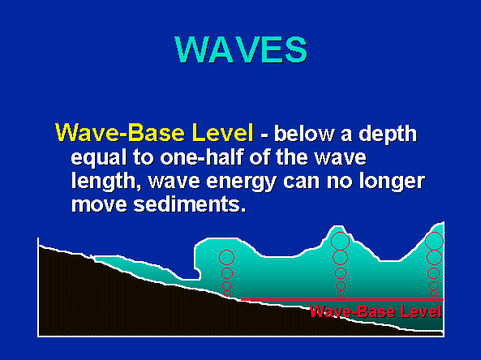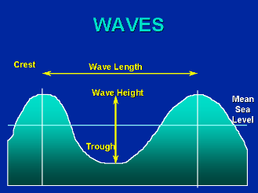
- (b)
Figure 1a,b. Types of waves
Impact of the beach on the waves
- Water molecules in an oscillating wave cannot go upwards or downwards when they collide with the bottom. The bottom's interference with the particles of moving water causes the waves to slow down.
- A slower wave results in shorter wavelengths and a commensurate rise in wave height.
- The upper portion of the wave finally breaks apart from the lower portion as the substrate continues to get shallower. As it breaks, the wave transforms into an ocean of transformation and crashes onto the beach. according to the Figure.2.

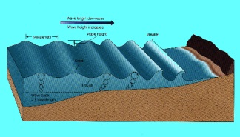
Figure.2. Wave transforms into an ocean

Around headlands, waves are refracted.
In front of headlands, waves can reach low-lying waters more quickly. In advance of the headlands, these waves become shorter in frequency and slower in speed, however in the bays, where they have not yet entered the shallower waters, they remain at the exact same speed and frequency. As a result, the waves are bent (refracted) along the headlands. as depicted in the Figure.3 [5].

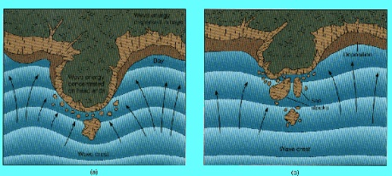
Figure 3. Bent of waves

Extended coast electrical currents and beachfront drift
Translation waves are those oscillation waves that go diagonally upward and downward along the beach when they break at a point parallel to the shoreline [6]. Beach drift, or the movement of material along the beach, is also produced by this horizontal swash and the backwash on the beach, which also causes a longshore current slightly offshore. A rip current develops where two longshore currents meet. To escape a rip current, swim perpendicular to the coast as depicted in the illustration.

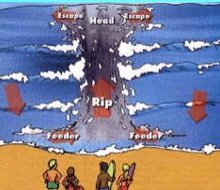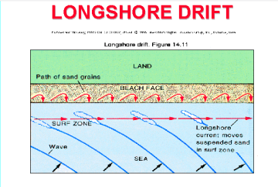
a b
Figure 4.a,b Waves upward and downward along the beach

Wave emotiveness.
Similar to how flowing water in a body of water erodes and moves objects, waves also convey bed loads, suspended loads, and dissolved loads [7]. The suspended load's clay and silt are carried out to sea and end up in the deeper ocean waters offshore. In the course of the beach drift, the bed load of sand and gravel travels down the beach. scratching, which is most prevalent near mountains where wave force is concentrated, is the method used by waves to erode land in the surf zone. Wave erosion-related features include:
Cliff known as "Wave cut" that rises sharply from the water. Platform with a wave-cut surface at the bottom tide level that is virtually horizontal and flat.

Wave encrustation
The transferred material will be dropped when the wave currents' or longshore currents' speed lowers. In bays where wave energy is dissipated, wave deposits is most active [8]. Features caused by wave or long coast current deposition - Beach: A sandbar located along the shore. A continuous, continuous sand accumulation that spans the Baymouth is known as a Baymouth bar spit: A long sandbar with only one end attached to the coast, as seen in the figure.5.

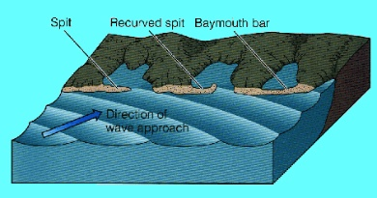
Figure 5. Baymouth bar spit

creations of erratic coasts
The greatest amount of erosion occurs on headlands where wave refraction concentrates wave energy. Because of wave refraction, long coast electrical currents and beaches drift separate from the headlands [9]. The bays scatter wave energy, where maximal deposition occurs. Wave erosion trims back capping cliffs, and grains of sand fill the bays until the shoreline is straight.
Consequences for men
If a dam on a river prevents sand from entering the beach drift, the beaches will erode away. A breakwater's construction prevents beach erosion and permits sand to accumulate in the harbor's protected area [10]. Sand will be able to accumulate on the updraft side of jetties, and on the downdraft side, they will induce beach erosion. Economically, there is little use in attempting to stop the erosion by waves of coastlines and other coastline structures [11].

Evaluation of the Red Sea's wave energy potential.
The intriguing characteristic of seawater is that the wave length and speed are inversely correlated (C=gT/2p). In other words, longer waves move faster while shorter waves move more slowly. Aboobacker and colleagues [12] came to the conclusion that that the wave intensity was computed using the paused wave characteristics throughout 32 years, and the every month, seasonal, and yearly the waves' amplitudes determined in the Red Sea. Wave power is an inconsistent energy source.

METHODOLOGY
According to the findings, deep water has a median wave energy of 4.5 kWh/m2 in the fall. Wave energy can produce up to 6.5 kWh/m2 of power in the winter, 5.0 kWh/m2 in the spring, and 4.5 kWh/m2 in the summer. The mean energy from waves is highest between Dec. and Mar, averaging up to 6.5 kWh/m2, and lowest between Jul. and Aug., averaging up to 4.0 kWh/m2. The Red Sea's bottom is distinguished by the strength of waves that are loaded with powerful energy. The central Saudi Arabian coast has the maximum long-range average wave energy, which is calculated to be 1.6 kWh/m2. The average wave energy along Saudi Arabia's coast is at its maximum during the summer, reaching 1.7 kWh/m2 in the center area. The southern Saudi Arabian shore responds to waves with modest typical energy consumption (up to 0.41 kWh/m2) throughout the year. According to the monthly assessment, the typical wave strength is around greater and consistent throughout January to September in Saudi Arabia's western coast. considerably weaker through October to November. According to their estimates, there has been a 20% average increase in average wave strength across all sites, while under conditions of neutrality, the standard deviation of the annual wave energy arrangement is consistent across all Red Sea sites, which aids wave power Converters (WEC) designers and operators in selecting one. Like the majority of renewable energy sources, including wind, waves, and the sun, it is impossible to accurately foresee the strength of waves and when they will occur at a given time. Solar energy is less erratic than wind energy, which is also less erratic at sea than on land [13–15]. Since the two forms of energy share many physical characteristics, wave energy and wind energy are frequently compared. The circumference of the sea waters with regard to the airplane or the water's surface is the zero constituent during propagation of waves in the x direction since the sea surface is perpendicular to the plane. the sea floor is at 𝑧 = −𝑑𝑊 and the sea surface coincides with 𝑧 = 0. Consequently, an overall characterization of a sea wave depends on how it is $W=Acos(kx-wt)$, where wt is the frequency, that makes a claim about physics and discusses the frequency of a water wave; k is the quantity of waves. ($k=2π/λω$), k is either the phase's duration or the sea waves speed. The free saltwater wave's geometry and amplitude are seen in Figure 6. As a result, the parallel distance H—which is equal to the amplitude A—between the wave's highest point and trough. As illustrated in figure 6, the phase speed of a single fundamental wave traveling in the x-direction can be defined as follows:

$v= [(gh/2π) tanh({2πd}_{w}/λ)]0.5$ (1)
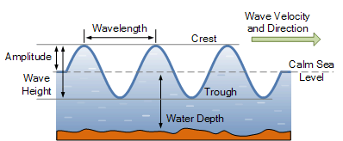
Figure 6: Waveform and amplitude of free seawater wave
If the particle's kinetic energy at width dx is equal to the dynamical energy per meter of length in the x-direction, then:

$dEkdx = 0.5dxdyρ(rω)2 = 0.5ρω2a2e2ydy = ρω2a2/4k$ (2)
A wave has a total power of:

$dEk = 0.5ρa2g = ρa2gλ/4 = ρa2T2/4ω$ (3)
The wave's strength expressed as a function of breadth, (P/h=W/m) is:

$P/h=(1/8π) ρa2g2T$ (4)
Since power stream from waves is the source, the velocity of transformation of the wave the energy frequency E(k) can be expressed by applying the law of conservation of energy [16] as follows:
(5)
And in case of deep-water waves, Equ.5 becomes:
(6)
Equation 6 illustrates the proper explanation of the modification in waveform depending on the proper explanation of the impact of instability in terms of wavelength, including the conversion of short waves into long waves. A link between wave time and length can be discovered using the deep sea's water dispersion relation. One way to express the phase speed that moves in the x-direction is as follows:

$cp =[(λg/2ω) tanh(2ωdW/λ))]0.5$ (7)
According to Faraday’s law, the induced voltage of the wave is:

$Ei(t) = -NdΦ/dt$ (8)
The sea surface is in the xy plane, the wave expands in the x direction, dW is the depth of the ocean in relation to the water surface in the xy plane, and the seabed is at the bottom. According to marine experts, this is a linear wave. 𝑧 = −𝑑_{𝑊}, and the outermost layer of the ocean connects with 𝑧=0 Suppose that the speed of the possibility is specified as., $\left(\frac{gh}{2}ω\right)ekz*sin(kx- ω t),$ The flux variation with respect to time is represented as follows:

$Φ(t) = 2πΦdtr(t)/λ$ (9)
Pressure times velocity, which can be expressed as integrate, give a description of the wave energy flow over the depth and an equation for the influx per meter of waves crest:

(10)

$Jm = 4π2Aw kNΦ/λT = ρg2H2T/(32π)$ (11)
where p denotes pressures and if denotes a value that remains constant ρg²/(32π) Using Equation (11), where it is indicated by, we can write the typical produced electromagnetic flux as follows:
$Jm = ω kEcp = ρg2NΦ/ (16 λ) [(λg/2 ω) tan(h)(2 ω dW/λ)]0.5(t)$ (12)

RESULTS
However, it is possible to produce a wave's duration (T) through the use, T=3.55h0.5 (s), as well as wave length (λ) can be produced with λ =5.12T2 (m), which equals 64.5248h (m). Figure 7 illustrates how energy production and flux are affected by the time and height of sea waves. According to the graph, energy generated by the motion of the waves increase as the wave height grows and reduces as the wave period increases. It should be noted that, in accordance with the laboratory findings of Ernesto et al. [16], the energy of the waves was computed employing the wave information along with the frequency of incidences of each pattern condition. The following can be used to express the energy and power of the sea waves, respectively:

$Ew= 32.3 whga2, Ewd = 0.5ga2$ (13)
And,
$Pw = 0.28h2Ew , Pwd = h2Ewd$ (14)

Figure 7. The generating process of energy is influenced by sea wave levels and time

Where Pw is the amount of energy generated by waves from the ocean, and Pwd is the quantity of power that can be captured per square of the wave, and Ew is the wave energy per area, w is the length of the wave reflector, and Ewd is the pattern energy content per area. When in deep water and assuming certain conditions, k=ω²/g, cg=g/2ω, T=2π/ω Using Equation 14, the overall sea wave force P equals,:
$P =g2H2T/(64 ω) 0.55 H2T$ (15)
Pursuant to the rules for transitory water, the power relating to the wave's height, period of time, and specific power per diameter can be computed as follows in watts per sensor is used to measure:
(16)
Figure 8 illustrates how the wave strength per meter of the wave's crest can be calculated using Equ 16 for a particular wave period and height. The findings demonstrate that the power generated by waves from the ocean is not unchanged, but instead exhibits a range of power values with an estimated maximum of 1.5 kW/m, a minimum of nearly nothing, and an average of roughly 0.43 kW/m. The strength of the wind speed is what causes this variation in wave power. The power created is typically exceeding that of stronger waves, which may be calculated by knowing the wave's length, velocity, and water density. Wave energy, also known as wave energy flow, and wave energy exchange rate are the two variables that wave power equations use to calculate it mathematically. The two researchers believe that in deep oceans, the depth of the water is typically larger than double the wavelength of light. The worldwide wave energy is 2.11 0.05TW, according to Robertson et al.'s estimation [18]. The output of the current model, as shown in Figure 3, is the power produced by the waves. About 24% of the primary weight configurations of the inspire and encourage's power is represented by the average sea wave strength [19].

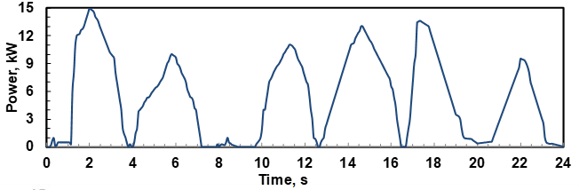
a
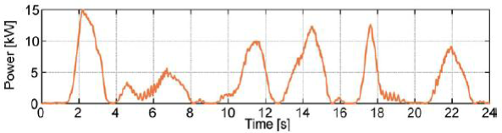
b
Figure 8a,b. The current work's extraction of energy from waves per region and Duration

SEAFRONT ENERGY
A movement or swelling of water that occurs near the sea's surface is called a sea wave. Direct local activity on the sea produces these waves. The waves are characterized by oscillating as rising, and falling motions. Fig. 9 depicts the sea wave's straightforward shape. The crest and trough of a wave, respectively, are its top and its base. The sea wave wavelengths (λ) is the distance between two successive troughs or crests, whereas the height of the wave (Hw) is the disparity between the two. The wave mass of sea energy is shown in figure (9).
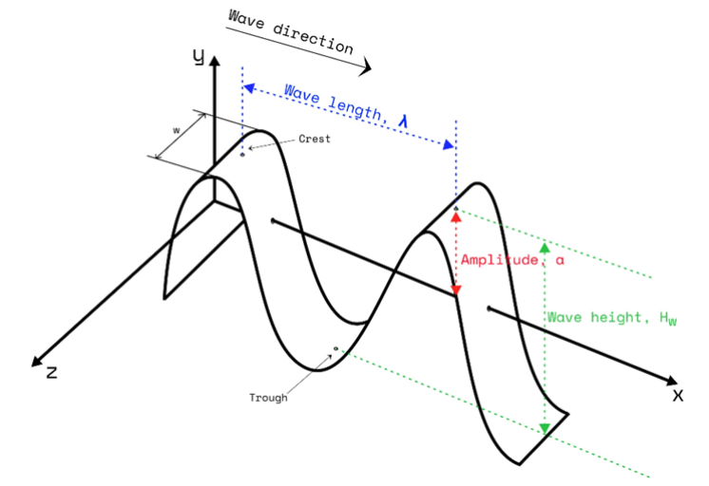
Figure 9. Sinusoidal wave

Let the sine wave be expressed as a time-independent function of x. When (x, t) = (x), the potential for energy is calculated as follows:
$\begin{aligned}d(P.E.)=\frac{1}{2}wρga^{2}\sin^{2}⁡(kx-ωt)dx \\ \int_{0}^{λ}{ }d(P.E.)=\int_{0}^{λ}{ }\frac{1}{2}wρga^{2}\sin^{2}⁡(kx-ωt)dx \\ P.E.=\int_{0}^{λ}{ }\frac{1}{2}wρga^{2}\sin^{2}⁡(kx-ωt)dx \\ =\frac{1}{2}wρga^{2}{\left[\frac{1}{2}x-\frac{1}{4}sin⁡2(kx-ωt)\right]}_{0}^{λ} \\ =\frac{1}{2}wρga^{2}\left[\frac{λ}{2}-\frac{1}{4}sin⁡2(kλ-ωt)-0\right] \\ =\frac{1}{4}wρga^{2}λ\end{aligned}$ (17)
where, 𝑎 =$HW⁄2$ is the wave amplitude (m) and 𝐻𝑤 is the wave height (m), 𝑘 =$\frac{2π}{λ}$ is the wave number, λ is the wavelength (m), 𝜔 = $\frac{2π}{T}$ is the wave frequency (rad/s), and 𝑇 is the period (s). However, every period of time has the same amount of movement energy as total potential energy.

CONCLUSION
The goal of the current dissertation has been to look at methods for calculating and managing the marine oasis that transforms waves into energy and unpredictable waves. The primary focus has been on the challenges of real-time algorithmic control implementation for a waveform energy converter (WEC). Following a review of the literature that exposed the challenges of time-domain simulation of maritime structures, latching control was found to be one of the most widely used control strategies for this type of waves power conversion. The Kalman filter was also shown to be a widely used estimating technique. These results provided the basis for additional control and estimation system enhancements. The framework of ocean waves and energy extraction from them was studied in order to gain a better understanding of the control objective. Furthermore, a basic understanding of marine structure modeling was established. The WEC model utilized in the thesis was based on the Schultz (2014) model for regular waves. Nevertheless, the system movement model was expanded to include the time-domain modeling of a WEC affected by irregular waves. Using previously estimated time series, the energy force was calculated, and the uid-memory effects were roughly depicted in a manner akin to linear time-domain methods. A study on latching control was also conducted. Influenced by Schultz's (2014) work, the control mechanism employed in this research was improved to account for the impacts of irregular waves. The development of an estimation approach for vessel control, nevertheless was the thesis' principal objective. It was chosen on measurement techniques and a simulation setup. For the purpose of estimating sea waves, an Extended Kalman filter technique was developed. The elevation of the wave was represented as a typical wave. Simulations in MATLAB and Simulink were run to evaluate the performance of the model. Due to a shortage of model information for the Ocean Oasis that the simulations used simulation data created for the Dynein, something identical towards the Ocean Oasis l. Each component was separately simulated and assessed to guarantee the model performed correctly. A comparison was made between the WEC theoretical framework and the influence of irregular waves.

REFERENCES
- Babarit and A.H. Clément, "Optimal latching control of wave energy device in regular and irregular waves," Appl. Ocean Res. 28, 77–91 (2006).
- N.J. Baker and M.A. Mueller, "Direct drive wave energy converters (in French)," Rev. Energies Renouvelables, (2001).
- J.G. Balchen, T. Andresen, and B.A. Foss, Reguleringsteknikk, Institutt for Teknisk Kybernetikk, NTNU (2003).
- S. Barstow, G. Mørk, D. Mollison, and J. Cruz, "Ocean Wave Energy," in *Green Energy and Technology (Virtual Series)*, Springer, pp. 93–132 (2008).
- M.R. Belmont, J.M.K. Horwood, R.W.F. Thurley, and J. Baker, "Filters for linear sea-wave prediction," Ocean Eng. 33, 2332–2351 (2006).
- M. Bjerregård, *Methods for Sea State Estimation*, M.Sc. Thesis, Technical University of Denmark (2014).
- E. Bjørnstad, *Control of Wave Energy Converter with Constrained Electric Power Take-Off*, M.Sc. Thesis, Norwegian University of Science and Technology (2011).
- R. Brown and P. Hwang, *Introduction to Random Signals and Applied Kalman Filtering*, 3rd ed., John Wiley & Sons, Inc. (2012).
- K. Budal, J. Falnes, and T. Onshus, "Optimal phase control of a power-buoy," Tech. Rep. 480934.00, Sintef (1979).
- V. Chabaud, S. Steen, and R. Skjetne, "Real-time hybrid testing for marine structures: Challenges and strategies," in *Proc. ASME Int. Conf. Ocean Offshore Arctic Eng.* 5, (2013).
- W.E. Counsil, *World Energy Perspective: Cost of Energy Technologies*, World Energy Council, London (2013).
- M. Aboobacker, R. Shanas, A. Alsaafani, M. Alaa, and A. Albarakati, "Wave energy resource assessment for the Red Sea," Renew. Energy xxx, 1–13 (2016).
- L. Huang, J. Liu, H. Yu, R. Qu, H. Chen, and H. Fang, "Winding configuration and performance investigations of a tubular superconducting flux-switching linear generator," IEEE Trans. Appl. Supercond. 25(3), (2015).
- L. Zhen, Y. Cui, H. Zhao, H. Shi, and S. Hyun, "Effects of damping plate and taut line system on mooring stability of small wave energy converter," Math. Probl. Eng. 2015, Article ID 814095 (2015).
- L. Tolman, "User Manual and System Documentation of WAVEWATCH III, Version 4.18," NOAA/NWS/NCEP/MMAB Tech. Note, p. 151 (2014). DOI: 10.3390/ijerph2006030011.
- W. Rafael, *Energy from Ocean Waves: Full Scale Experimental Verification of a Wave Energy Converter*, Acta Univ. Upsaliensis, Uppsala, ISBN 978-91-554-7354-9, ISSN 1651-6214 (2008).
- B. Kamranzad, A. Etemad-Shahidi, and V. Chegini, "Assessment of energy variation in the Persian Gulf," Ocean Eng. 70, 72–80 (2013).
- B. Robertson, "Wave Energy: Resources and Technologies," Ref. Module in Earth Syst. Environ. Sci. (2021).
- Ahmed, Omer K., Algburi, Sameer, Daoud, Raid W., Shubat, Hawazen N., Aziz, Enas F. "The Various Designs of Storage Solar Collectors: A Review", International Journal of Renewable Energy Development, DOI: 10.14710/ijred.2023.45969, (2023).

