Nanostructured Electrodes in Lithium-Ion Batteries Using Butler-Volmer and Fick’s Diffusion Equations
Ayaat A. Kattan ^{1, a)} and Noor A. Saeed ^{2, b)}
¹ Department of Science, College of Basic Education, University of Sumer, Thi-Qar, Iraq.
² Department of Applied Physics, Applied Sciences, University of Technology, Baghdad, Iraq
^{a)} Corresponding author: ayaatalrikaby4@gmail.com
^{b)} as.22.57@grad.uotechnology.edu.iq
Abstract. Lithium-ion (Li-ion) batteries are central to modern energy storage technologies, powering applications from portable electronics to electric vehicles and renewable energy systems. However, conventional electrode designs and modeling approaches fall short in addressing persistent limitations in energy density, ion transport, and charge transfer efficiency. To overcome these challenges, this study proposes an advanced mathematical model based on the Butler-Volmer and Fick’s diffusion equations, aimed at evaluating the impact of nanostructured electrodes on charging behavior. The model is simulated using MATLAB to analyze ion diffusion dynamics and electrochemical kinetics under varying electrode-to-efficiency ratios. Results show that increasing this ratio from 1 to 5 leads to a 33% improvement in charging current density, while maintaining a rapid charging time of 10 milliseconds and highly stable current output with a maximum fluctuation of only 0.038%. These findings highlight the potential of nanostructured electrodes to significantly enhance the performance and efficiency of Li-ion batteries. The study underscores their commercial viability and relevance in accelerating the transition toward sustainable energy systems.
Keywords: Nanostructured Electrodes, Lithium-Ion Batteries, Butler-Volmer Equation , Fick’s Diffusion Equation, Fast Charging.
INTRODUCTION
The development of affordable, high-capacity, secure, and eco-friendly batteries is essential for meeting the growing global demand for efficient energy storage systems. While lithium-ion batteries (LIBs) dominate the market, their high cost, limited lithium supply, and the use of hazardous electrolytes hinder their widespread application. In contrast, zinc-ion batteries (ZIBs), with advantages such as low cost ($25/kWh), high ionic conductivity (10−1–1 S cm−1), and good safety features, have emerged as promising alternatives for energy storage systems [1–3]. Like LIBs, ZIBs operate through the insertion/extraction of Zn2+ from the cathode and Zn plating/stripping on the anode during charge/discharge cycles. However, the larger radius of Zn2+ (74 pm) compared to Li+ (68 pm) leads to volume expansion in cathodes, reducing structural integrity and limiting the use of active materials. Frequent cycling also causes the formation of zinc dendrites, which may penetrate separators and cause short circuits[4-5]. To address these challenges, the development of advanced nanomaterials for electrodes, with high conductivity, fast reaction kinetics, and increased active sites, is crucial. Nanostructured electrodes, especially one-dimensional (1D) materials, offer improved surface area, mechanical strength, and flexibility, enhancing redox reactions and ion diffusion [6–8].
The environmental impact of fossil fuels has driven the global push for renewable energy sources, such as wind, solar, and tidal power. However, their variability limits their direct use in the grid, necessitating the development of effective energy storage technologies. Rechargeable batteries, super-capacitors, and fuel cells convert electrical and chemical energy, enabling energy storage for portable electronics, electric vehicles, and grid storage [9,10]. Lithium-ion batteries have emerged as the next-generation energy storage solution, offering high energy density, long cycle life, and fast charging capabilities. They have become integral in applications ranging from portable electronics to electric vehicles (EVs) and renewable energy storage. Despite their advantages, challenges related to resource availability, environmental impact, and energy efficiency remain. Continued research and advancements in LIB technology are critical to the future of sustainable power and electrification. Figure 1 compares typical electric poles and nano-structured poles in battery systems [11,12].
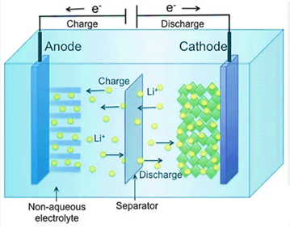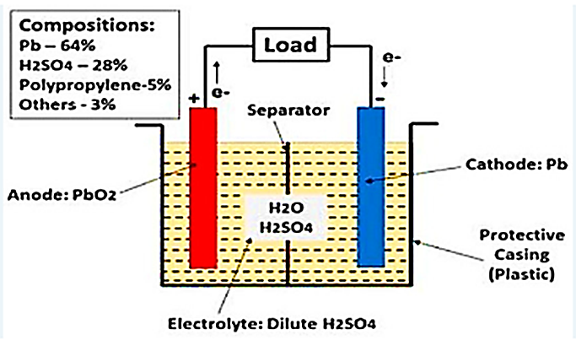
(a)
(b)
FIGURE 1. The structure of the DC battery unit, (a)Typical electrical poles model, (b)Nano-structure poles model[11].
They are excellent electrode materials because of their qualities. For instance, it has been reported that Zn3V2O8·1.85H2O nanobelts, H2V3O8 nanowires, and rod-like Na0.95MnO2 nanowires provide better cathode materials for ZIBs. Furthermore, 1D nanomaterials can provide linked ion/electron channels and adjust to volume changes, improving cycle stability and rate capability.
Electric vehicles (EVs), portable gadgets, and the integration of renewable energy sources all depend heavily on lithium-ion (Li-ion) batteries, which have emerged as the mainstay of contemporary energy storage systems. They are a better option than conventional lead-acid or nickel-based batteries because to their high energy density, extended cycle life, and quick charging speed. Li-ion batteries make it possible for solar and wind energy to be efficiently stored throughout the shift to sustainable energy, which helps to stabilize the grid and lessen reliance on fossil fuels. Figure 2 displays typical Li-ion batteries [11,12].

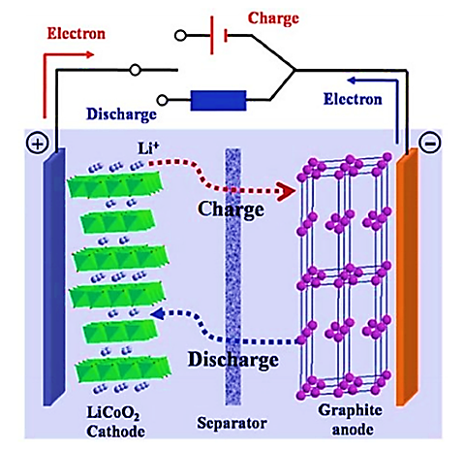
FIGURE 2. Typical structure of a lithium-ion (Li-ion) battery, showing key components like the anode, cathode, electrolyte, and separator [11,12].

Furthermore, developments in smart grids, backup power systems, and mobile energy solutions are being propelled by breakthroughs in battery technology, recycling, and safety enhancements. Notwithstanding its benefits, issues including energy efficiency, environmental effect, and resource availability continue to be important study topics. Future developments in energy storage and electrification will be greatly influenced by ongoing advancements in Li-ion battery performance, affordability, and sustainability as the need for clean energy solutions increases [11,12]. Secondary electrodes are essential for increasing the capacity, stability, and efficiency of electrochemical systems including fuel cells, batteries, and supercapacitors. These electrodes serve as auxiliary or supporting elements that enhance reaction kinetics, maximize charge transfer, and prolong the life of the primary electrodes. Enhancing conductivity and lowering polarization losses, which results in more effective electron and ion transport, is one of the primary roles of secondary electrodes. Secondary electrodes, for instance, can operate as buffer layers in lithium-ion batteries to reduce adverse reactions and structural deterioration. They balance the distribution of charges in supercapacitors, increasing their capacity to store energy. Furthermore, by addressing problems including dendritic development, electrode passivation, and capacity fading, secondary electrodes enhance stability and durability. To maximize surface area and electrochemical reactivity, they frequently incorporate cutting-edge materials like carbon-based materials, conductive polymers, or nanostructured metals into their designs. All things considered, secondary electrodes are an important advancement in next-generation energy storage and conversion technologies as they improve charge storage, cycle performance, and long-term dependability [13–15]. The Fick diffusion equation controls the flow of ions in electrolytes, whereas the Butler-Volmer equation controls the kinetics of charge transfer. By optimizing both, overvoltage is decreased, reaction times are accelerated, and ion transport is enhanced. This leads to quicker charging times, higher charging efficiency, and better battery performance. The connection between the overpotential at an electrode surface and the electrochemical reaction rate is explained by the Butler-Volmer equation. It is essential to comprehending the kinetics of charge transfer in batteries, fuel cells, and supercapacitors [15–30]:
$i=i_{o}[e^{\frac{αnFη}{RT}}- e^{\frac{-\left(1-α\right)nFη}{RT}} ]$ (1)
Whereas: i denotes the current density (A/m²). $i_{o}$ indicates the exchange current density (A/m²). $α$represents the charge transfer coefficient. n denotes the number of electrons transferred. F indicates the Faraday’s constant (96,485 C/mol). $η$ represents the over-potential (V). R depicts the universal gas constant (8.314 J/mol·K). And T indicates the temperature. The impact on charging efficiency might be explained by the following points: Faster charge transfer and increased charging efficiency are the results of higher exchange current density ($i_{o}$). An excessive over potential (η) decreases efficiency by increasing energy losses from polarization. By increasing $i_{o},$and optimizing the electrode material and surface area, charge uptake is improved and charge time is decreased. The Impact of Fick's Diffusion Equation on Charging Efficiency The diffusion of ions in an electrolyte, which is essential for charge transfer during charging and discharging, is described by Fick's laws. Fick's second law in general is :
$\frac{∂C}{∂t}=D\frac{∂^{2}C}{∂x^{2}}$ (2)
Such that: C represents the concentration of the diffusing species (mol/m³). 𝑡, indicates the time (sec). D, denotes the diffusion coefficient (m²/s). And x, represents the distance (meters).
Also, the impact on charging efficiency might be demonstrated by the below points: Concentration polarization caused by poor ion diffusion slows down charging and results in uneven charge distribution. Nanostructured electrodes can improve diffusion by providing shorter ion pathways, increasing charging efficiency. Faster ion diffusion rate (DD) improves ionic conductivity, lowering resistance and increasing charging speed. The remaining organization of this article will be as follows. Section 2 will present the most modern and important studies and scientefic articles concerning the issue of enhancing nano-structure electrodes in Li-Ion batteries as related works. The methodology of simulating the proposed model will be discussed in Section 3 with simulation design details and procedure flow chart. Section 4 will introduce the simulation results with comprehensive discussion and comparisons. Finally, conclusions will be outlined in Section 5.
RELATED STUDIES
The most significant contributions in the field of nanoelectrodes to improve the charging efficiency of lithium-ion batteries, based on recent studies, are summarized below, highlighting their efficiency, benefits, and associated challenges. In 2023, Dang et al. [15] used solvothermal techniques and in situ replacements to synthesize vanadium nitride quantum dot composites, producing hollow nano-cages. This method demonstrated improved stability and performance, with a capacitance of 278 F g⁻¹ at 0.5 A g⁻¹ and a capacity retention rate of 82.23% after 20,000 cycles at 3 A g⁻¹. However, the study's primary focus on super-capacitors means more research is needed to apply these results to other energy storage devices. Amir et al. [16] developed Ni-MnO₂/graphene nano-composites as cathode materials for zinc-ion batteries. This technology showed improved capacity (431.5 mAh g⁻¹ at 0.1 A g⁻¹) and cycling stability, but the capacity retention rate of 56% after 2,200 cycles at 2 A g⁻¹ suggests room for further improvements in long-term stability. In 2023, Zhu et al. [17] fabricated nanostructured NiCo₂O₄ anodes for lithium and sodium-ion batteries. The benefits included enhanced electrochemical performance and cycling stability, but the focus on laboratory-scale results and the need for scalability and commercial viability remain limitations. Kumar et al. [18] in 2024 developed advanced nano-bifunctional electro-catalysts for Li–air batteries. The key benefit was a high coulombic efficiency, addressing slow kinetics in oxygen reactions. However, the complexity of catalyst design may pose challenges for large-scale production. Wu et al. [19] employed nitrogen-doped carbon nano-sphere anodes in dual-ion complete batteries with concentrated electrolytes, offering stability and large capacity, with potential for both slow discharging and rapid charging applications.

EXPERIMENTAL PART
Batteries will be presented and illustrated in details. In this study, the essential technique that has been suggested to implement the nano-electrodes Li-Ion battery model requirementas which will be implemented using the MATLAB2020 m.files scriots. In this project, the proposed model will be discussed in details, supported with design settings parameters and flow chart steps. The proposed design lab system model will simulate the nano-structure electrodes in Li-Ion batteries scheme using MATLAB2020 Library for modeling the necessary equations and design parameters values. In this paper, the planned system proposed for robust and efficient design nano-structure electrodes in Li-Ion batteries model is shown in Figure 4.
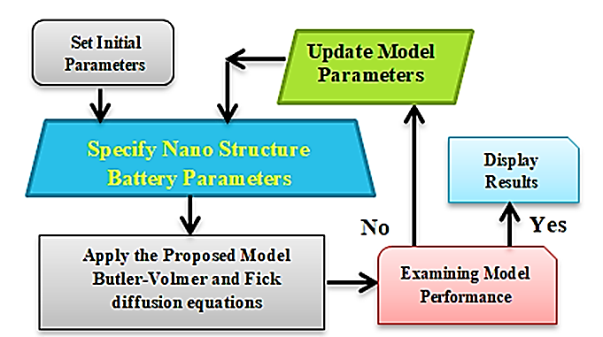
FIGURE 4. Block Diagram Illustrating the Proposed Model for Nano-Structured Electrodes in Lithium-Ion (Li-Ion) Batteries, Showing the System Components and their Interactions.
Referring to Figure 4, we could observe the structure of the proposed model, which begins by specifying the parameters and variables required to simulate the nano-electrodes for a lithium-ion battery model. The nano-electrode-based lithium-ion battery model is then simulated using Butler-Volmer and Fick diffusions. This is followed by optimization tests for charging and discharging capacity and battery life, and verification of the improvement. If the desired improvements are not achieved, the variable values ​​are readjusted according to the proposed model equations, and the simulation is repeated until the desired improvements are achieved. The results are then printed and the simulation is stopped. Table 2 shows the values ​​and specifications of the variables and constants used in the design of the proposed mathematical model for the specifications of the lithium-ion battery with nano- electrodes.
TABLE 2. Construction components used in the simulation of the proposed model
Li-Ion Battery Nano-Electrodes Components | The Suggested function Model | $F$Faraday’s constant (C/mol) | $α$the charge transfer coefficient | n the number of electrons transferred | $η$the over-potential (V) | R the universal gas constant (J/mol·K) | D the diffusion coefficient (m²/s)
First Testing | $$C\left(x,t\right)=\frac{cos⁡(2πx)}{4π^{2}}+x^{2}+\frac{1}{t}$$ | 96.465*10⁻³ | 0.001*10⁻⁶ | 20 | 20 | 8.314 | 4
Second Testing | $$C\left(x,t\right)=\frac{cos⁡(2πx)}{4π^{2}}+x^{2}+\frac{1}{t}$$ | 96.465*10⁻³ | 0.001*10⁻⁶ | 200 | 20 | 8.314 | 4

The design parameters in Table 2 show the details, values, and specifications of the variables and constants used in designing the proposed mathematical model for the specifications of the lithium-ion battery with nanoelectrodes. In this research, we relied on the application of the MATLAB program and its programming libraries to provide the dataset required to implement the simulation of the proposed mathematical model. The dataset represents the diffusion functions of the ion concentration of the nanoelectrodes of the lithium-ion battery, the representation of the distances between the electrodes, and the preparation of their matrices and time series.
RESULTS AND DISCUSSION
In this Section, the methodology of the proposed nano-structured Li-Ion battery model has been implemented utilizing MatLab2020b m. files script codes and based on Butler-Volmer and Fick diffusions equations. The essential proposed model which has been to simulated with the design paeameters and nanostructure quantities specefied in Table 2. The suggested models introduced in Figures 9, and 10 have been successfully planned, programmed, and optimized and the results have displayed and explained in the following Sections. The proposed mathematical model was implemented in MATLAB using its programming libraries. It simulated the ion concentration diffusion functions for the nano-electrodes of a lithium-ion battery, considering electrode spacing, electrode arrays, and charging time series. The Butler-Volmer and Fick equations were used to model the optimal charging conditions. The diffusion species concentration function is shown in Figure 6, where it exhibits an exponential spread parallel to the charging time values and across the nano-electrode distances. This function forms the basis for the proposed model, which calculates current concentration and charging velocity. Figure 7 illustrates the one-dimensional diffusion species concentration function against the nano-electrode pole distances at a specific time (t). It shows an exponential decay in concentration with increasing electrode spacing. Finally, the results of applying the Butler-Volmer and Fick equations to the concentration function, in relation to nano-electrode pole distances, are plotted in Figure 8.
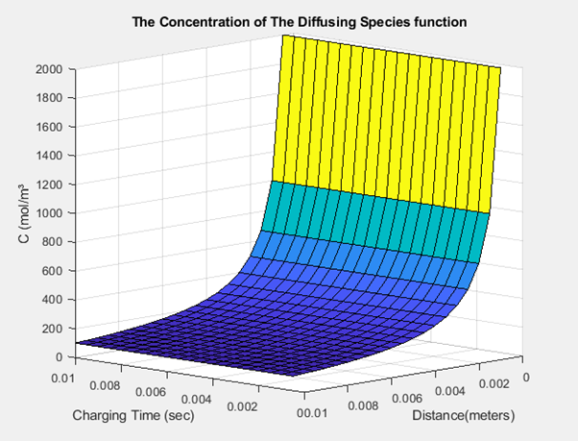
FIGURE 6. The simulated concentration function of the diffusion species function
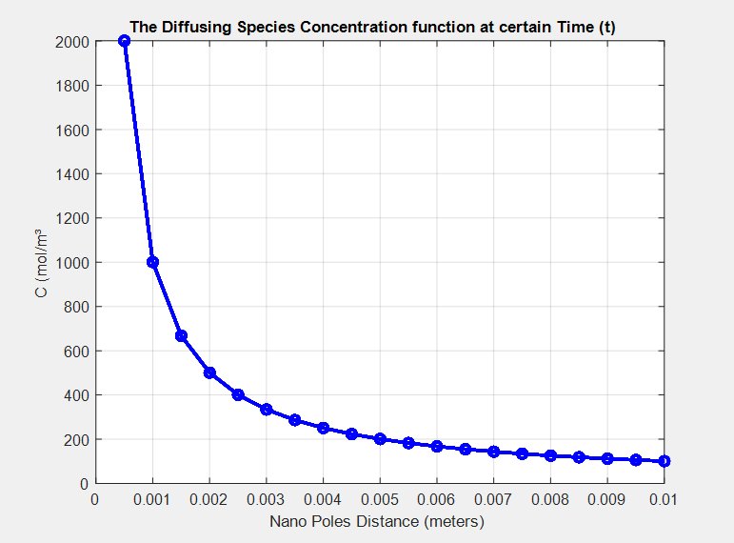
FIGURE 7. The resulting one dimentional diffusion species concentration function against nano-electrodes poles spaces for certain time (t)
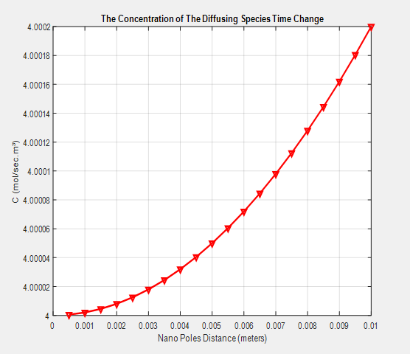
FIGURE 8. The obtained results of applying the proposed Butler-Volmer and Fick equations model for concentration function with nano-electrodes poles distances
In Figure 8 above, it is obvious that the concentration function with time has exponential increased values This result also represent the charging response of the Li-Ion batteries diffused with nano-electrodes poles. Moreover, the Li-Ion nano-electrodes current density (i) has been achieved using Butler-Volmer and Fick equations model as shown in Figure 9 in time domain for n=20 nano-electrodes poles.
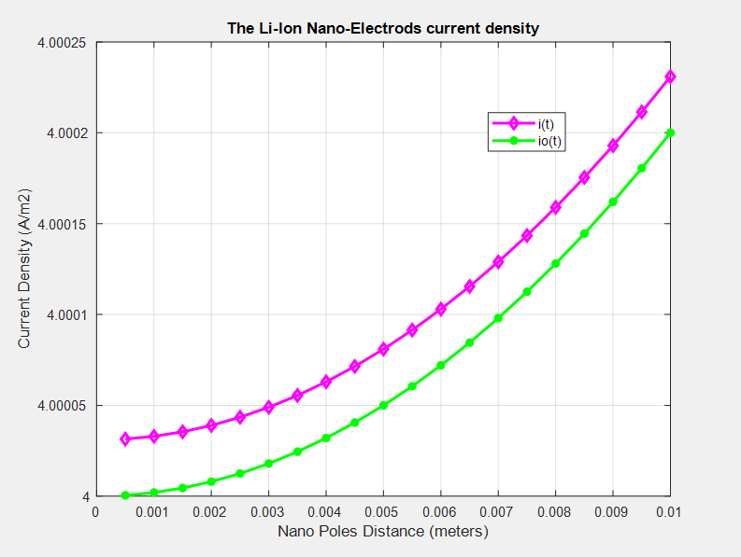
FIGURE 9. The achieved Li-Ion nano-electrodes current density (i) using Butler-Volmer and Fick equations model in time domain, for n n/η=20/20=1 poles/volts.
It is clear from Figure 9 that, the obtained results of current density and currents concentration diffusion are both exponentially decaying with charging time. Also, it is obvious that, the achieved current density has maximum value of 4.00025 A/m2 with fast charging time period of TC=10 m sec for 20 nano-electrodes poles. Furthermore, the simulation has been repeated for larger nano-electrodes poles number of n=200 with the results of current density and currents concentration diffusion as displayed in Figure 10.
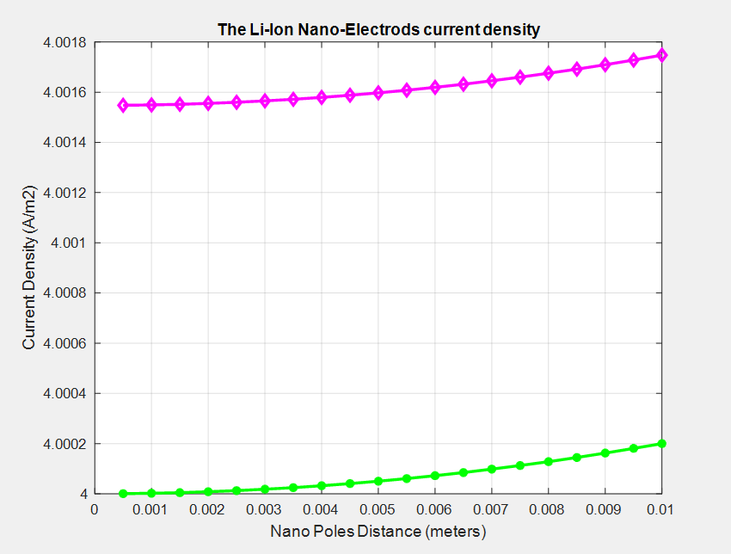
FIGURE 10. The achieved Li-Ion nano-electrodes current density (i) using Butler-Volmer and Fick equations model in time domain, for n/η=200/50=4 poles/volts
By regarding Figure 10, it might be noted that the result of the the current density and currents concentration diffusion is both still exponentially decaying with charging time. Moreover, it is obvious that, the achieved current density has maximum value of 4.0009 A/m² with the same fast charging time period of T_{C}=10 m sec.. From the achieved results, we can observe a direct proportionality between the charging current density obtained for the lithium-ion battery with the increase in the number of nano-electrodes and vice versa. Through the achieved results, a mathematical model was simulated for lithium-ion batteries with nanoelectrodes according to the equations of Butler-Volmer and Fick equations to represent the effects of nanoelectrodes in improving the diffusion of ions within the chemical solution, where we notice an improvement in the diffusion values ​​of leaving charges along the electrodes used to obtain a relatively constant current with a fast-charging rate. The diffusion charge concentration model in Table 2 was applied as a function of time and electrode spacing to simulate the Butler-Volmer and Fick equations for different values ​​of the number of electrodes to effeciency ratio in two tests. We also note that the advantage of lithium-ion batteries increases with increasing number of nanoelectrodes and vice versa. Finally, Table 3 shows summary of the achieved results for examinations simulation of the proposed nano-structured Li-Ion battery model.
TABLE 3. Summary of the results achieved for examinations simulation of the proposed nano-structured Li-Ion battery model
Obtained Results | Nano-Poles to Efficiency Ratio (n/η) (poles/volts) | The Charge Concentration i_{o}(t)=dC/dt (mol/sec.m²) |  | Current Density i(t) (A/m²) |  | DC Current Density Change (A/m²)
Obtained Results | Nano-Poles to Efficiency Ratio (n/η) (poles/volts) | Min | Max | Min | Max | DC Current Density Change (A/m²)
First Tsting | 1 | 4 | 40002 | 4.0001 | 4.00025 | 1.5*10⁻⁵
Second Testing | 5 | 4 | 40002 | 4.0016 | 4.0018 | 2*10⁻⁴
Percentage Enhancement | 4% | 0% | 0% | 0.037% | 0.038% | 33.33%

CONCLUSIONS
This research looks at the present issues and creative fixes propelling lithium-ion batteries' energy-rich future. Additionally, it looks at the energy density constraints of existing batteries and investigates cutting-edge electrode designs and materials that offer increased capacity. Using the Butler-Volmer and Fick diffusion equations, the study focuses on the usage of nanostructured electrodes in lithium-ion batteries. The study also looks at the commercial potential and uses of lithium-ion batteries in renewable energy storage, portable devices, and electric cars. It ends by highlighting how lithium-ion batteries have the revolutionary potential to speed up the energy revolution and clear the path for a sustainable energy future. applied as a function of time and electrode spacing to simulate the Butler-Volmer and Fick equations for various values of the number of electrodes to effeciency ratio in two tests. We also note that the advantage of lithium-ion batteries increases with increasing number of nanoelectrodes and vice versa. By conducting simulation tests for the proposed nanoelectrode model, improved charging current density results of up to 33% were obtained by increasing the electrode distance to efficiency ratio from 1 to 5 with a high charging speed of up to 10 ms and stable charging current with a maximum fluctuation rate of 0.038%.
REFERENCES
- M. Burla, R. Bonjour, Y. Salamin, F. Abrecht, C. Hoessbacher, C. Haffner, et al., “Plasmonics for Next-Generation Wireless Systems,” in Proc. 2018 IEEE/MTT-S Int. Microwave Symp. (IMS), Philadelphia, PA, USA, 2018, pp. 1308–1311. doi: 10.1109/MWSYM.2018.8439610.
- A. S. Abdelrazik, R. Saidur, and F. A. Al-Sulaiman, “Thermal regulation and performance assessment of a hybrid photovoltaic/thermal system using different combinations of nano-enhanced phase change materials,” Solar Energy Mater. Solar Cells, vol. 215, p. 110645, 2020. doi: 10.1016/j.solmat.2020.110645.
- S. C. Chen, C. C. Wan, and Y. Y. Wang, “Thermal analysis of lithium-ion batteries,” J. Power Sources, vol. 140, pp. 111–124, 2005. doi: 10.1016/j.jpowsour.2004.05.064.
- M. Pirsaheb, H. Seifi, T. Gholami, S. H. Ganduh, L. S. Jasim, M. A. Mahdi, et al., “Thermal analysis techniques for evaluating the thermal stability of battery materials: A comprehensive review,” J. Anal. Appl. Pyrolysis, vol. 174, p. 106136, 2023. doi: 10.1016/j.jaap.2023.106136.
- J. Yi, C. Wang, and Y. Xia, “Comparison of thermal stability between micro- and nano-sized materials for lithium-ion batteries,” Electrochem. Commun., vol. 33, pp. 115–118, 2013. doi: 10.1016/j.elecom.2013.04.015.
- K. Nakajima, F. L. Souza, A. L. M. Freitas, A. Thron, and R. H. R. Castro, “Improving thermodynamic stability of nano-LiMn2O4 for Li-ion battery cathode,” Chem. Mater., vol. 33, pp. 3915–3925, 2021. doi: 10.1021/acs.chemmater.0c04305.
- U. Rahman, A. Sahar, A. Ishaq, and A. A. Khalil, “Design of nanoparticles for future beverage industry,” in A. M. Grumezescu and A. M. Holban, Eds., Nanoengineering in the Beverage Industry. Academic Press, 2020, pp. 105–136. doi: 10.1016/B978-0-12-816677-2.00004-1.
- M. K. G. Bauer and J. R. Dahn, “Using lithium-ion differential thermal analysis to probe tortuosity of negative electrodes in lithium-ion cells,” J. Electrochem. Soc., vol. 168, no. 2, p. 020501, 2021. doi: 10.1149/1945-7111/abdde4.
- R. Premila, C. Subbu, S. Rajendran, and K. Selva Kumar, “Experimental investigation of nano filler TiO2 doped composite polymer electrolytes for lithium ion batteries,” Appl. Surf. Sci., vol. 449, pp. 426–434, 2018. doi: 10.1016/j.apsusc.2017.11.272.
- P. Sivaraj, B. Nalini, K. P. Abhilash, D. Lakshmi, P. C. Selvin, and P. Balraju, “Study on the influences of calcination temperature on structure and its electrochemical performance of Li2FeSiO4/C nano cathode for lithium ion batteries,” J. Alloys Compd., vol. 740, pp. 1116–1124, 2018. doi: 10.1016/j.jallcom.2018.01.051.
- M. Mylarappa, V. V. Lakshmi, V. M. K. R. Vishnu, N. Raghavendra, and H. P. Nagaswarupa, “Cyclic voltammetry, impedance and thermal properties of CoFe2O4 obtained from waste Li-ion batteries,” Mater. Today: Proc., vol. 5, pp. 22425–22432, 2018. doi: 10.1016/j.matpr.2018.06.612.
- C. R. Matos, P. P. Silva, and J. F. Carneiro, “Overview of compressed air energy storage projects and regulatory framework for energy storage,” J. Energy Storage, vol. 55, p. 105862, 2022. doi: 10.1016/j.est.2022.105862.
- A. Lennon, Y. Jiang, C. Hall, D. Lau, N. Song, P. Burr, et al., “High-rate lithium ion energy storage to facilitate increased penetration of photovoltaic systems in electricity grids,” MRS Energy & Sustainability, vol. 6, p. E2, 2019. doi: 10.1557/mre.2019.4.
- M. J. Mochane, T. C. Mokhena, T. H. Mokhothu, A. Mtibe, E. R. Sadiku, and S. S. Ray, “The importance of nanostructured materials for energy storage/conversion,” in M. Hussain, Ed., Handbook of Nanomaterials for Industrial Applications. Elsevier, 2018, pp. 768–792. doi: 10.1016/B978-0-12-813351-4.00044-4.
- H. Dang, L. Wang, Y. Peng, T. He, and F. Ran, “Hollow nanocages of vanadium nitride-based electrode material designed for superior charging/discharging stability supercapacitors,” New J. Chem., vol. 47, pp. 20377–20387, 2023. doi: 10.1039/D3NJ03402J.
- M. Amir, R. G. Deshmukh, H. M. Khalid, Z. Said, A. Raza, S. M. Muyeen, et al., “Energy storage technologies: An integrated survey of developments, global economical/environmental effects, optimal scheduling model, and sustainable adaption policies,” J. Energy Storage, vol. 72, p. 108694, 2023. doi: 10.1016/j.est.2023.108694.
- Q. Zhu, P. J. Ong, S. H. A. Goh, R. J. Yeo, S. Wang, Z. Liu, et al., “Recent advances in graphene-based phase change composites for thermal energy storage and management,” Nano Materials Sci., vol. 6, pp. 115–138, 2024. doi: 10.1016/j.nanoms.2023.09.003.
- P. Kumar, H. K. Channi, A. Babbar, R. Kumar, J. K. Bhutto, T. M. Y. Khan, et al., “A systematic review of nanotechnology for electric vehicles battery,” Int. J. Low-Carbon Technol., vol. 19, pp. 747–765, 2024. doi: 10.1093/ijlct/ctae029.
- H. Wu, S. Luo, L. Li, H. Xiao, and W. Yuan, “A high-capacity dual-ion full battery based on nitrogen-doped carbon nanosphere anode and concentrated electrolyte,” Battery Energy, vol. 2, p. 20230009, 2023. doi: 10.1002/bte2.20230009.

