The Effect of Pollutants from the Diyala Tributary on the Environmental Characteristics of the Tigris River Water
Rand Raad Ahmed^{1, a)} and Intisar Faisal Abed^{1, b)}
¹Department of Biology, College of Education for Pure Science Ibn Al-Haitham, University of Baghdad, Baghdad, Iraq.
^{a)} Corresponding author. rand.raad2202m@ihcoedu.uobaghdad.edu.iq
^{b)}intisar.f.a@ihcoedu.uobaghdad.edu.iq
Abstract. The Tigris River is the main water resource in central Iraq, yet its quality is increasingly threatened by pollutants from its tributaries. This study assessed the impact of the Diyala tributary on the environmental characteristics of the Tigris River by analyzing physicochemical and biological parameters across four stations from October 2024 to June 2025. Results revealed elevated turbidity, total dissolved solids, biological and chemical oxygen demand, and nutrient concentrations downstream of the confluence, particularly during low-flow seasons. Dissolved oxygen levels decreased significantly, reflecting high organic loads from untreated sewage and agricultural runoff. This study highlights significant spatial variation in the relative abundance and composition of rotifer species (Rotifera) across the four sampling stations in the Diyala and Tigris rivers and their confluence. The dominance of specific taxa such as Rotaria sp., R. neplunia, Monostyla bulla, and Keratella quadrata reflected differences in organic load, nutrient enrichment, and hydrological conditions. These findings confirm that rotifers are sensitive bioindicators of ecological status and water quality, providing reliable insights into the impacts of natural variability and anthropogenic activities on river ecosystems. Consequently, the study underscores the importance of using rotifer communities as effective tools for ecological monitoring and river management strategies.
Keywords: Tigris River, Diyala tributary, Water pollution, Physicochemical parameters, Rotifera, Biodiversity, Environmental characteristics, Iraq.

Introduction
The Tigris River is one of the most vital water resources in Iraq, supplying water for domestic, agricultural, and industrial purposes. With a basin area of approximately 190,000 km² and a total length of nearly 1,970 km, the river receives significant inflows from its tributaries, including the Greater Zab, Lesser Zab, Adhaim, and Diyala (1). Among these, the Diyala River is the third largest tributary, extending 574 km with a drainage area of 33,240 km², of which 75% lies within Iraq and 25% within Iran (2).
The river plays a crucial role in supporting agricultural irrigation and municipal water supply for surrounding populations. However, the Diyala catchment is currently subject to both water scarcity and elevated pollution levels, making it a major hydrochemical contributor to the deterioration of Tigris water quality (3, 4). Environmental stress on Iraqi rivers has intensified over recent decades due to anthropogenic pressures such as untreated wastewater discharges, agricultural runoff, and industrial effluents. These inputs significantly alter the physicochemical properties of river water, including dissolved oxygen (DO) and biological oxygen demand (BOD₅) (5).
In addition, nutrient enrichment from elevated nitrate and phosphate concentrations contributes to eutrophication, further threatening aquatic biodiversity (6, 7). Heavy metals such as lead, cadmium, and chromium, often originating from industrial activities, have also been reported as major contaminants in the Iraqi river system (8).
The ecological consequences of these pollutants extend beyond water quality degradation to impact freshwater biodiversity (9). Aquatic organisms, particularly zooplankton such as rotifers, copepods, and cladocerans, are highly sensitive to changes in water quality and can serve as bioindicators of pollution (10, 11).
Studies have shown that pollution-induced variations in temperature, dissolved oxygen, and nutrient load can cause structural shifts in plankton communities, reducing biodiversity and destabilizing aquatic ecosystems (12). Given the ecological and socio-economic importance of the Tigris River, assessing the influence of pollutants from the Diyala tributary is essential for sustainable water management.
This study aims to evaluate the impact of Diyala River pollutants on the environmental characteristics of Tigris River water, with emphasis on physicochemical parameters and ecological indicators, while benchmarking against international water quality standards (WHO, FAO, USEPA).

Materials and Methods

Study Area
This study was conducted in Baghdad, Iraq, focusing on the confluence of the Diyala River with the Tigris River. The Tigris is the main water resource in central Iraq, supplying water for drinking, irrigation, and industrial use. The Diyala tributary, which receives agricultural drainage, sewage, and industrial effluents, is considered one of the most polluted tributaries discharging into the Tigris. The climate of Baghdad is semi-arid, with hot, dry summers and short, cold winters, and rainfall occurs mainly between November and February (13, 14).

Sampling Stations
Four sampling stations were selected to evaluate the impact of pollutants from the Diyala tributary on the water quality of the Tigris River (Fig. 1):
Station 1 (Upstream Tigris): Located on the Tigris River before the confluence with the Diyala, representing background water quality.
Station 2 (Diyala River): Located on the Diyala tributary before it merges with the Tigris, directly influenced by agricultural runoff and sewage inputs.
Station 3 (Confluence): Situated at the junction where the Diyala enters the Tigris, representing the immediate mixing zone.
Station 4 (Downstream Tigris): Located on the Tigris after the confluence, representing the integrated effect of Diyala pollutants.
Geographical coordinates were recorded for each station using a GPS device.

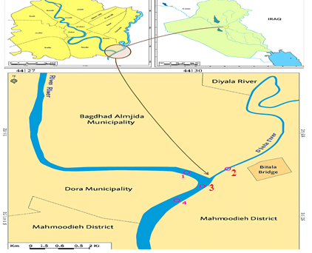
Figure 1. Map of the study area showing the four sampling stations (1. Upstream Tigris, 2. Diyala tributary, 3. Confluence of the Diyala tributary with the Tigris River and 4. Downstream Tigris).

Sample Collection
Water samples were collected monthly from October 2024 to June 2025. Physicochemical samples were taken at a depth of 15–20 cm below the surface using 2.25 L polyethylene bottles. For biological analyses, 45 L of water were filtered through a 55 µm plankton net and concentrated to 10 ml. Samples for chemical analysis were stored at 4°C until analysis, while zooplankton samples were preserved in 4% formalin.

Physicochemical Analyses
The following environmental parameters were measured:
Total Dissolved Solids (TDS): measured in situ with a portable EC/TDS meter (15).
Turbidity: measured with a portable turbidity meter, expressed as NTU (16).
Dissolved Oxygen (DO): determined using the Winkler azide titration method (17).
Biological Oxygen Demand (BOD₅): measured after 5-day incubation at 20°C in dark bottles (18).
Nutrients: nitrate concentrations measured spectrophotometrically at 220/275 nm; reactive phosphate measured using the ascorbic acid method at 860 nm (19).
Phosphate (PO₄³⁻): concentration measured using the molybdenum blue spectrophotometric method with a UV–Visible spectrophotometer (Shimadzu UV-1800, Japan), with results expressed in mg/L (20).

Biological Analyses
Rotifera were identified under a compound microscope (Kruss MBL 2100) to the lowest possible taxonomic level using a Sedgewick–Rafter counting chamber (21). All taxa present in each sample were counted. Identification followed standard taxonomic references (22, 23, 24). The abundance of rotifers was expressed as the number of individuals per cubic metre (Ind./m³).

Statistical Analysis
Data were analysed using SPSS v.25 (2019). Two-way ANOVA was applied to test the effects of stations and months on water quality parameters. The Least Significant Difference (LSD) test was used for mean separation. Pearson’s correlation coefficient (r) was calculated to assess relationships between physicochemical factors and rotifera abundance.

Results
The physicochemical parameters varied considerably across stations (Table 1). Dissolved oxygen (DO) was highest at the upstream Tigris (6–11 mg/L; mean 7.94±0.79), indicating good aeration, but dropped sharply in the Diyala tributary (1–6.5 mg/L; mean 2.45±0.47) due to the heavy organic load. At the confluence, DO averaged 5.45±0.62 mg/L, reflecting the effect of water mixing, and slightly improved downstream (5.5–9.2 mg/L; mean 6.89±0.72). In contrast, biochemical oxygen demand (BOD₅) was extremely high in the Diyala tributary (3.3–78.2 mg/L; mean 19.20±7.68), compared with much lower values in the upstream Tigris (0.80–4.6 mg/L; mean 2.36±0.37), confluence (2.9–7.6 mg/L; mean 5.03±0.48), and downstream Tigris (0.90–5.4 mg/L; mean 3.33±0.16). Similarly, total dissolved solids (TDS) reached the highest levels in the Diyala tributary (880–1920 mg/L; mean 1699±380), whereas the upstream Tigris (330–810 mg/L; mean 559±160), confluence (540–980 mg/L; mean 775±220), and downstream Tigris (450–1210 mg/L; mean 742±190) exhibited comparatively moderate values. Turbidity followed the same pattern, with the Diyala tributary showing the greatest range (2.25–34.99 NTU; mean 19.20±6.74), followed by the downstream Tigris (0–27.81 NTU; mean 8.59±0.79), while lower levels were observed at the upstream Tigris (0–20.91 NTU; mean 6.63±0.76) and confluence (1.10–18.52 NTU; mean 6.99±0.68). Overall, these findings clearly indicate that the Diyala tributary is the major contributor of organic matter, salts, and suspended solids to the Tigris River, leading to a significant deterioration in water quality at the confluence, with statistically significant differences among stations (p≤0.05).
Nutrient concentrations varied significantly among the studied stations (Table 2). Nitrate levels were extremely elevated in the Diyala tributary (0.042–37.00 mg/L; mean 12.60±3.04), reflecting strong inputs from agricultural runoff and sewage discharge. In contrast, much lower concentrations were observed at the upstream Tigris (0.019–5.00 mg/L; mean 2.50±0.37), the confluence (0.028–13.00 mg/L; mean 5.51±0.49b), and downstream Tigris (0.017–7.00 mg/L; mean 3.60±0.41). A similar trend was noted for phosphate, where the Diyala tributary recorded the highest values (0.1178–0.982 mg/L; mean 0.429±0.17), while concentrations remained relatively low at the upstream Tigris (0.010–0.0601 mg/L; mean 0.020±0.005), the confluence (0.053–0.4211 mg/L; mean 0.154±0.06), and downstream Tigris (0.0322–0.1531 mg/L; mean 0.089±0.07). These findings indicate that nutrient enrichment is primarily driven by the Diyala tributary, leading to significant increases in nitrate and phosphate concentrations downstream, with statistically significant differences among stations (p≤0.05).
The relative abundance index of rotifer species (Rotifera) across the four sampling stations (S1–S4) revealed noticeable variation, with the dominance of a particular species at each station. This pattern reflects differences in environmental and physicochemical conditions between the Diyala River, the Tigris River, and their confluence area (Fig. 2).
At station S1, Rotaria sp. was the dominant species (61%), suggesting a relatively stable environment with medium to low organic load. At station S2, higher diversity was observed, with species richness including R. neplunia (16%), Asplanchna priodonta (14%), and Keratella quadrata (13%). At station S3, the species Monostyla bulla dominated (17%), indicating site-specific conditions. Meanwhile, station S4 exhibited relatively balanced dominance, with R. neplunia (21%), M. bulla (15%), and K. quadrata (12%) occurring in comparable proportions (Fig. 2).
Overall, the results confirmed that the Diyala tributary exerts a strong influence on the environmental characteristics of the Tigris River, contributing to deterioration of water quality and altering aquatic biodiversity, particularly through increases in suspended solids and organic matter.
TABLE 1. Physicochemical parameters of water samples across stations. The results show higher TDS, turbidity, and BOD₅ downstream of the Diyala inflow compared to the upstream station.
Station | DO (mg/L) | BOD₅ (mg/L) | TDS (mg/L) | Turbidity (NTU)
Upstream Tigris (S1) | 6–11  7.94±0.79 a | 0.80–4.6  2.36±0.37 b | 330–810  559±160 b | 0–20.91  6.63±0.76 b
Diyala tributary (S2) | 1–6.5  2.45±0.47 b | 3.3–78.2  19.20±7.68 a | 880–1920  1699±380 a | 2.25–34.99  19.20±6.74 a
Confluence (S3) | 4.2–7.9  5.45±0.62 ab | 2.9–7.6  5.03±0.48 b | 540–980  775 ±220 b | 1.10–18.52  6.99±0.68 a
Downstream Tigris (S4) | 5.5–9.2  6.89±0.72 a | 0.90–5.4  3.33±0.16 b | 450–1210  742±190 b | 0–27.81  8.59±0.79 a
LSD-value | 3.371* | 4.027 * | 0.708* | 3.577*

The means with different capital letters within the same row and different small letters within the same row differ significantly from each other.
*P ≤0.05: significance different

TABLE 2. Nutrient concentrations (nitrate and phosphate) at the sampling stations. Nutrient enri
Station | Nitrate (mg/L) | Phosphate (mg/L)
Upstream Tigris | 0.019-5.00  2.50±0.37b | 0.010-0.0601  0.020±0.005b
Diyala tributary | 0.042–37.00  12.60±3.04a | 0.1178-0.982  0.429±0.17a
Confluence | 0.028–13.00  5.51±0.49b | 0.053-0.4211  0.154±0.06b
Downstream Tigris | 0.017–7.00  3.60±0.41b | 0.0322– 0.1531  0.089±0.07b
LSD-value | 3.955* | 0.146*
The means with different capital letters within the same row and different small letters within the same row differ significantly from each other.
*P ≤0.05: significance different
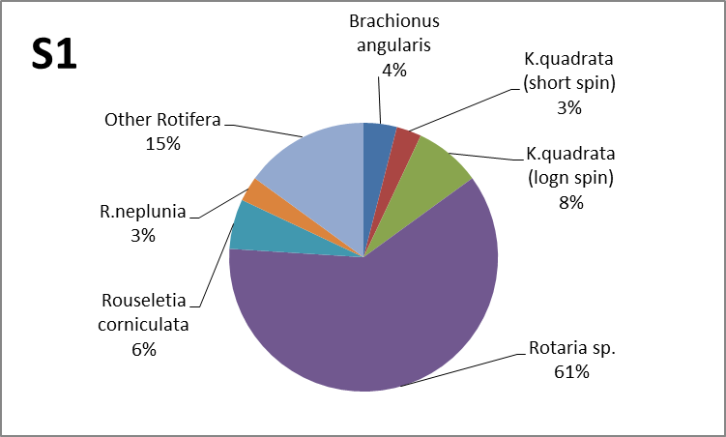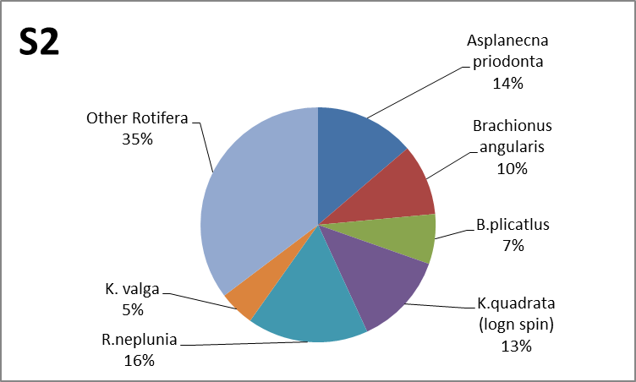
a b
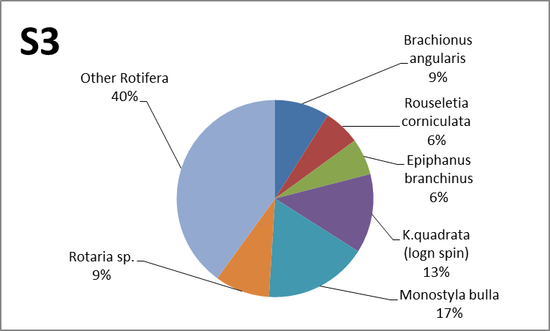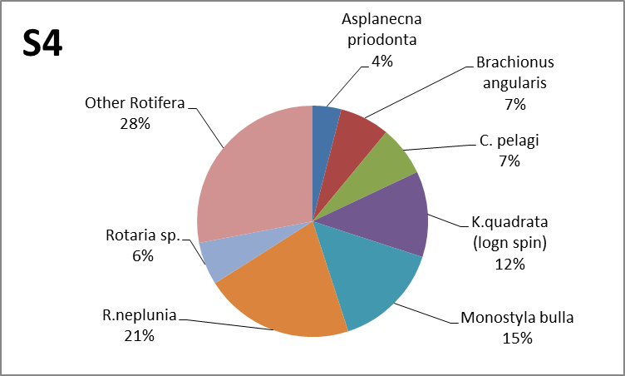
c d
Figure 2a,b,c,d. Rotifera abundance and diversity indices at different stations.

Discussion
The results of this study clearly demonstrate that the Diyala tributary has a substantial impact on the environmental characteristics of the Tigris River, particularly at and downstream of the confluence. The observed increases in TDS, turbidity, and suspended solids are consistent with findings from (3) and (4), who highlighted the role of the Diyala River as a major carrier of agricultural and municipal pollutants into the Tigris. These pollutants reduce water transparency and alter sedimentation dynamics, thereby degrading aquatic habitats (25).
The decrease in dissolved oxygen (DO), coupled with elevated BOD₅ value, indicates a high organic load, likely originating from untreated sewage and industrial effluents, in line with similar reports from other Iraqi rivers (5, 6, 26). Such conditions can create localized hypoxic zones, impairing aquatic life and limiting the self-purification capacity of the river.
Nutrient enrichment, as evidenced by elevated nitrate and phosphate concentrations, suggests strong inputs from agricultural runoff and domestic wastewater. These results agree with (7), who emphasized the risk of eutrophication under high nutrient conditions. The Diyala’s contribution to nutrient loading is particularly critical in summer when reduced flow enhances pollutant concentration and biological uptake.
The dominance of Rotaria sp. at station S1 (61%) indicates a relatively stable environment with medium to low organic load. This finding is consistent with (27), who reported the dominance of Rotaria species in the Tigris River under conditions of relatively stable temperature and moderate nutrient availability.
At station S2, the greater diversity and higher richness of rotifer species (e.g., R. neplunia 16%, A. priodonta 14%, K. quadrata 13%) suggest a more disturbed environment or seasonal fluctuations in temperature and nutrient availability. These observations align with the results of (28) and (29) on the Diyala and Tigris Rivers.
In station S3, the dominance of Monostyla bulla (17%) likely reflects nutrient-enriched conditions, particularly in areas influenced by agricultural runoff. This interpretation is supported by other study, such as (30) on the Yangtze River basin, which linked M. bulla with elevated concentrations of phosphate and nitrate in water.
Station S4 showed relatively close percentages of dominant species, including R. neplunia (21%), M. bulla (15%), and K. quadrata (12%). This pattern may be attributed to the combined environmental influences of the two rivers’ confluence and anthropogenic organic loading. A similar interpretation was reported by (21) in their study of river confluences within Iraqi river systems.
When compared with recent studies, such as (31) in Kangsabati River, West Bengal, India, and (32) in Tigris river in Iraq, it becomes evident that rotifer species serve as sensitive bioindicators of water quality changes, particularly in relation to temperature, dissolved oxygen, and nutrient availability. This agrees with the findings of the present study, where variations in species diversity and distribution provided reliable indicators of the distinct environmental conditions across the four sampling stations (33).
The variation in physicochemical parameters was directly reflected in the composition of rotifer communities. Elevated nitrate and phosphate levels were associated with the dominance of nutrient-tolerant species such as M. bulla and R. neplunia, while reduced DO and higher BOD₅ coincided with a shift toward more pollution-tolerant taxa (34). This confirms that integrating biological indicators with water chemistry provides a clearer and more comprehensive assessment of river health (35).
Overall, these findings confirm that pollutants from the Diyala tributary compromise the ecological integrity of the Tigris River by degrading water quality and reducing biodiversity. This underscores the urgent need for improved wastewater treatment, stricter regulation of industrial discharges, and the adoption of sustainable agricultural practices to mitigate nutrient and organic inputs.

CONCLUSION
The study demonstrates that pollutants from the Diyala tributary have a pronounced negative impact on the environmental characteristics of the Tigris River, leading to increased turbidity, organic and nutrient enrichment, reduced dissolved oxygen, and a decline in rotifera diversity. These findings highlight the urgent need for improved wastewater management and stricter control of agricultural and industrial discharges to protect the ecological integrity of the river.

Acknowledgments
We extend our thanks and appreciation to the staff of Department of Biology, college of Education for pure Science (Ibn Al-Haitham), University of Baghdad for their assistance in conducting the experiments and interpreting the results.

References
- E. K. Abbas, M. R. Nashaat, F. S. Moftin and E. H. Ali, Eur. Acad. Res. 4, 8561–8580 (2017).
- B. Lehner, K. Verdin and A. Jarvis, Eos Trans. Am. Geophys. Union 89, 93–94 (2008). https://doi.org/10.1029/2008EO100001.
- N. Abbas, S. A. Wasimi and N. Al-Ansari, J. Civ. Eng. Archit. 10, 1059–1074 (2016).
- V. Sissakian and N. Al-Ansari, J. Earth Sci. Geotech. Eng. 9, 291–314 (2019).
- O. S. Majeed, M. R. Nashaat and A. J. Al-Azawi, IOP Conf. Ser. Earth Environ. Sci. 1120, 012040 (2022). https://doi.org/10.1088/1755-1315/1120/1/012040.
- A. Gh. Hashim and A. M. Rabee, J. Int. Environ. Appl. Sci. 9, 493–504 (2014).
- J. Wang, X. Liu, A. H. W. Beusen and J. J. Middelburg, Environ. Sci. Technol. 57, 19395–19406 (2023). https://doi.org/10.1021/acs.est.3c06150.
- K. Olson and D. Speidel, Open J. Soil Sci. 14, 28–63 (2024). https://doi.org/10.4236/ojss.2024.141003.
- T. H. Al-Dharob, H. J. Jaweir and I. M. Al-Salman, Biochem. Cell. Arch. 20, 6375–6378 (2020). https://connectjournals.com/03896.2020.20.6375.
- S. S. Mohammed and M. B. Mahmood, Bionatura 8, 1–34 (2023).
- A. Jebir, S. Ajeel and T. Khalaf, J. Fauna Biodivers. 1, 99–112 (2024).
- H. A. H. Al-Keriawy and S. K. A. A. Al-Kalidy, Ecol. Eng. Environ. Technol. 24, 1–9 (2023).
- F. H. Saeed, M. S. Al-Khafaji and F. A. Al-Faraj, Arab. J. Geosci. 15, 1260 (2022). https://doi.org/10.1007/s12517-022-10308-4.
- 14. K. D. Muslih and A. M. Abbas, in The Geography of Iraq (Springer Nature, Cham, 2024), pp. 19–47. https://doi.org/10.1007/978-3-031-24156-9_2.
- G. E. Adjovu, H. Stephen, D. James and S. Ahmad, Remote Sens. 15, 3534 (2023). https://doi.org/10.3390/rs15143534.
- B. T. W. Putra, L. A. Rocelline and W. N. H. Syahputra, Microprocess. Microsyst. 93, 104603 (2022). https://doi.org/10.1016/j.micpro.2022.104603.
- A. Carvalho, R. Costa, S. Neves, C. M. Oliveira and R. J. B. da Silva, Microchem. J. 165, 106129 (2021).
- N. Benguennouna, D. Benabdelmoumene, S. Dahmouni, Z. Bengharbi, W. S. Qadi, H. S. Hamezah and A. Mediani, Desalination Water Treat. 101437, (2025).
- O. T. Emmanuel, AJENSR 4(1), 14–44 (2021).
- S. Ngamprasertsuk, P. Duenchay and W. Dungchai, Anal. Sci. 1–8, (2025).
- O. S. Majeed, A. J. Al-Azawi and M. R. Nashaat, Bull. Iraq Nat. Hist. Mus. 16(4), 469–493 (2021). https://doi.org/10.26842/binhm.7.2021.16.4.0469.
- D. G. Smith, Pennak's Freshwater Invertebrates of the United States: Porifera to Crustacea (John Wiley & Sons, 2001), 648 pp.
- H. Segers, Zootaxa 1564(1), 1–104 (2007).
- S. V. Bhandarkar and G. T. Paliwal, Limnology 71–87, (2020).
- R. M. N. Al-Khafaji and A. J. Hammady, Indian J. Public Health Res. Dev. 9(12), 1168 (2018).
- I. F. Abed and M. R. Nashaat, Biochem. Cell Arch. 18(2), 1877–1886 (2018). http://www.connectjournals.com/toc/CJ-033216/18/2018/02/October.
- R. M. Hadi, A. A. Al-Saboonchi and A. K. Y. Haroon, Nova Hedwigia 39(3–4), 513–557 (1984).
- F. M. Al-Rubaie and N. O. Al-Musawi, J. Eng. 25(10), 71–87 (2019). https://doi.org/10.31026/j.eng.2019.10.6.
- N. A. Alharbawee and A. J. Mohammed, Iraqi J. Sci. 65(3), 1266–1275 (2024). https://doi.org/10.24996/ijs.2024.65.3.8.
- X. Wu, L. Wang, Z. Niu, W. Jiang and Q. Cao, Atmos. Res. 292, 106883 (2023).
- S. S. Islam, S. N. Dhara and S. Midya, Cleaner Water 100103, (2025).
- O. S. Majeed, M. R. Nashaat and A. J. Al-Azawi, Iraqi J. Sci. 63(4), 1464–1479 (2022). https://doi.org/10.24996/ijs.2022.63.4.7.
- T. Aboud and M. L. Al-Doori, Biochem. Cell Arch. 19(Suppl. 1), 2051–2053 (2019). https://www.connectjournals.com/file_html_pdf/3006400H_2051A.pdf.
- S. B. Patra, Sustain. Agri. Food Environ. Res. 11, (2023).
- I. F. Abed, M. R. Nashaat and N. N. Mirza, Iraqi J. Sci. 63(2), 480–490 (2022).
- L. Bélanger, A. Garenaux, J. Harel, M. Boulianne, E. Nadeau and C. M. Dozois, FEMS Immunol. Med. Microbiol. 62, 1–10 (2011). https://doi.org/10.1111/j.1574-695X.2011.00797.x

