Performance Analysis of Green Hydrogen Production via Surplus Solar Power Supplying Alkaline Electrolysis
Ioannis E. Kosmadakis^{1, a)}, Tatiani Stimoniari^{1, b)}, Costas Elmasides^{1, c)}, and Katerina Stamatelatou^{1, d)}
¹ Department of Environmental Engineering, Democritus University of Thrace, 67132 Xanthi, Greece
^{a)} Corresponding author: ikosmada@env.duth.gr
^{b)} tstimoni@env.duth.gr,
^{c)} kelmasid@env.duth.gr,
^{d)} astamat@env.duth.gr
Abstract. This study presents the experimental setup and performance analysis of a hybrid photovoltaic–battery–electrolyzer system designed for “green” hydrogen production using surplus solar power. The setup integrates PV arrays, lithium storage, power electronics, and an alkaline electrolyzer operating dynamically under real solar conditions. Results show stable hydrogen output up to 511 L h⁻¹ at 2.5 kW and a linear correlation between electrolyzer power and hydrogen flow. The system achieved high efficiency and reliable operation under variable irradiance, confirming the technical feasibility of renewable-powered electrolysis and its potential for future Power-to-Gas (P2G) applications.

Introduction
Within the European Union’s regulatory framework that mandates the achievement of climate neutrality by 2050, and considering the environmental challenges associated with conventional combustion processes, a global transition toward cleaner and more sustainable forms of energy has already begun. In recent years, hydrogen has emerged as a key enabling technology with diverse applications across multiple sectors. Among its most significant roles are its use as a carbon-free fuel and as an alternative medium for energy storage and conversion [1]. Hydrogen possesses a high energy density, is non-toxic, and can be produced through various methods. Of particular importance is the production of green hydrogen via water electrolysis powered by renewables [2].
Among available electrolysis technologies, alkaline water electrolysis is widely used, as it represents a reliable method with high efficiency and well-established technological maturity [3]. In most renewable systems, electrolyzers are deployed to produce hydrogen by utilizing surplus electrical energy. For instance, in [4], the excess power generated by a PV-Battery system (PVBAT) is converted into hydrogen, which is later used in fuel cells to meet electrical demand. Similarly, in [5] the storage function was shifted to zero-emission vehicles equipped with onboard batteries and hydrogen systems, providing flexibility during periods of low renewable output.
Hydrogen also contributes directly to the decarbonization of power and fuel sectors [6]. A particularly promising application is the upgrading of biogas into biomethane through hydrogen-assisted methanation, producing a renewable substitute for natural gas. Biomethane offers compatibility with existing gas infrastructure, generates near-zero CO₂ emissions, and supports the transport and mobility sectors [7].
The main objective of this study is the development and operation of a Hybrid Renewable Energy System (HRES) supplying renewable electricity to an Electrolyzer for green H₂ production, used in turn for the needs of biogas upgrading into biomethane within our laboratory. To achieve this goal, continuous monitoring and analysis of key operational parameters was essential, forming an additional focus of the research. In this context, Power-to-Gas (P2G) technologies provide a promising pathway by converting excess renewable electricity into H₂, which can subsequently be transformed into fuels such as biomethane for long-term energy storage and sector coupling.
The structure of this paper is as follows: following this Introduction, Chapter 2 presents the design and experimental setup of the HRES and Electrolyzer test rig. Section 3 discusses the dynamic hydrogen production driven by surplus photovoltaic energy and provides a performance and efficiency evaluation of the system’s main components. Finally, Chapter 4 summarizes the concluding remarks and offers suggestions for future work.

Experimental sETUP
A comprehensive HRES was developed to demonstrate the conversion of solar energy into green hydrogen via controlled water electrolysis. The setup integrates PV panels, lithium battery storage, advanced power electronics, and a supervisory control system, forming a fully instrumented microgrid capable of autonomous operation. The PV arrays supply electrical energy that is either stored in batteries or routed through power converters and an inverter, to drive the alkaline electrolyzer for hydrogen production. The produced hydrogen, generated exclusively from surplus renewable power, is stored for later use within our laboratory, in Xanthi Greece. This configuration enables comprehensive evaluation of component efficiencies, battery dynamics, electrolyzer performance under variable irradiance, and the overall solar-to-hydrogen conversion efficiency, supporting the development of optimized control and operation strategies for renewable-powered hydrogen systems.

DC-Coupled PV-Battery Power Supply
Renewable system components such as PV modules, power electronics, and battery storage, can be integrated into a unified and autonomous electrification system in several ways. A key consideration when designing PVBAT systems is the nature of the load to be supplied, as well as the selection of the system architecture. These considerations determine the arrangement of power converters and the number of conversion stages required. In addition to energy generation and storage, an auxiliary power source in the form of grid backup is often incorporated to ensure full operational stability.
In this section, the system components for PVBAT powered green H₂ production are presented in detail. The main features of the setup are illustrated in Figure 1, which shows the experimental configuration used to investigate H₂ generation from solar energy sources. The system integrates PV generation, energy storage, power electronics, control subsystems, and H₂ production into a small, unified sector coupling microgrid.

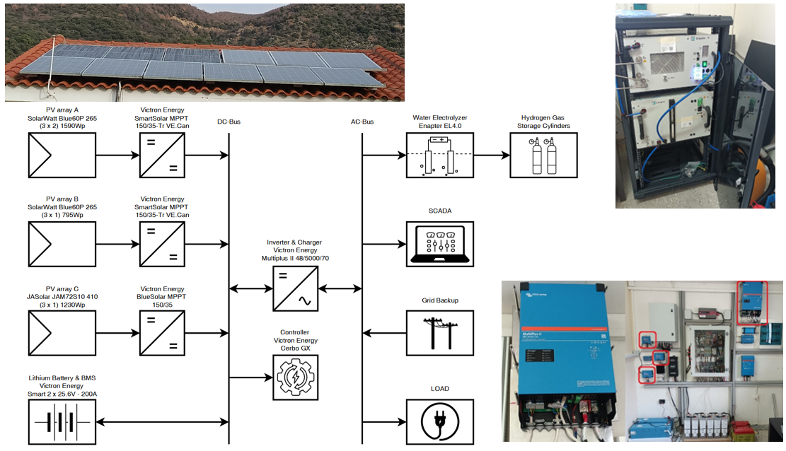

FIGURE 1. Schematic and photographic views of the lab-scale green hydrogen system integrating photovoltaic panels, an electrolyzer, and hydrogen storage units.

Three independent PV arrays feed a common DC bus through individual MPPT solar charge controllers (Victron Energy SmartSolar MPPT 150V/35A), ensuring optimal energy harvesting under variable irradiance conditions. The generated DC power is either stored in a lithium battery bank (Victron Energy LiFePO4 Smart Battery 200Ah) or converted to AC through an inverter-charger unit (Victron Energy Multiplus II 48/5000/70), which supplies primarily a critical load and the monitoring and control equipment. The electrolyzer (ELY, Enapter EL 4.0) operates dynamically, following the availability of surplus PV power, while the produced hydrogen is collected in dedicated storage cylinders of up to 35 bar pressure.
The total PV installation consists of three arrays (Figure 1, A:2x3, B:1x3, C:1x3), 9 SolarWatt Blue60P 265 PV modules and 3 JASolar JAM72S10 410W PV modules, with an installed capacity of 2385Wp and 1230Wp respectively. The last array consists of Passive Emitter and Back Contact (PERC) PVs, while the PVs of all arrays are made of monocrystalline silicon cells. The energy flows coming from the PV modules are managed, per array, by three distinct DC/DC charging regulators with a relatively stable efficiency over the entire power range up to 96%. The DC/AC inverter delivers an apparent power of up to 5000 VA and incorporates a programmable battery charger, allowing the charging current to be configured through a computer interface.
The lithium-ion battery selected has a nominal energy capacity of 10.32 kWh at 100% DOD and is controlled by a "Victron Energy Bus BMS" battery management system. The rated voltage of the battery is 51.6V with a nominal capacity of 200Ah. The battery life, at 50% DOD, is 5000 cycles, and the calendar life is 10 years. The battery is connected in parallel to the DC busbars and determines the voltage of the system. The operation of the system is governed by an energy management algorithm, implemented by the inverter, which is coordinated by the Victron Energy Cerbo GX controller. The latter functions as the central supervisory control unit that collects system data (voltages, currents, SOC, temperatures, and power flows) and communicates with the PC system for real-time monitoring and predictive control.

Inelastic Electronic Load
The electronic load (ELD, Kikusui PLZ 1000) enables the emulation of a wide range of power demand scenarios, including constant current, constant resistance, or dynamic load profiles that replicate real consumer operating conditions. Power is supplied primarily to this device acting as constant inelastic consumption used to emulate a critical load. Moreover, controlled discharge or load-following tests are performed on the system. The device allows precise adjustment of current, voltage, and power consumption levels, enabling the evaluation of the inverter’s performance, system stability, and response under different dynamic load conditions.

Hydrogen Production and Storage
The ELY operates dynamically in response to the availability of surplus PV power, generating H₂ that is collected in dedicated high-pressure storage cylinders. Based on anion exchange membrane (AEM) electrolysis, this modular system can produce up to 500 normal liters (NL) of green H₂ per hour with a purity of 99.9% (up to 99.999% after drying) at an operating pressure of 35 bar, consuming approximately 0.4 L of water and 2.4 kWh of electricity per hour. The integrated electrolysis unit includes an electrolytic cell, an ultrapure water tank with circulation pump, and control electronics, all housed within a compact modular design. During operation, an anode and a cathode are immersed in an alkaline electrolyte, typically a potassium hydroxide (KOH) solution. When electric current is applied, water molecules at the anode are oxidized to produce oxygen, while H₂ is released at the cathode. The process is enabled by the movement of hydroxide ions (OH⁻) through the electrolyte, which carry charge and sustain the electrochemical reactions. In the alkaline environment of the AEM, these hydroxide ions migrate through the membrane from the cathode to the anode, completing the ionic circuit. This transport of OH⁻ ions, the defining feature of AEM electrolysis, gives the technology its name and enables efficient hydrogen production. The overall hydrogen generation subsystem comprises the electrolytic stack, the integrated water purification and feed system, and a H₂ gas buffer module, which can also interface with downstream processes such as biomethane synthesis.

Results and discussion
Following the successful experimental setup of the HRES-ELY system, typical operation was conducted under real solar conditions to evaluate its dynamic performance and H₂ production behavior. Emphasis was placed on monitoring the energy flows between the PV arrays, the battery bank, the inverter, the ELD, and the electrolyzer, as well as quantifying the corresponding H₂ generation rates. The system was operated autonomously, allowing the electrolyzer to activate only when surplus PV energy became available, thereby replicating the real-time response of a solar-powered hydrogen production unit. Continuous data acquisition from the proprietary monitoring platforms provided synchronized measurements of electrical and H₂ flow parameters, enabling a detailed assessment of the interaction between power generation, storage, and conversion stages.

Dynamic Hydrogen Production Driven by Surplus Photovoltaic Energy
The analysis of representative operation days, presented in Figure 5, illustrates the temporal evolution of the above-mentioned parameters and highlights the energy management dynamics during periods of excess PV production. In the two individual diagrams, the time variation of these measurements for two typical days of surplus photovoltaic energy is depicted.
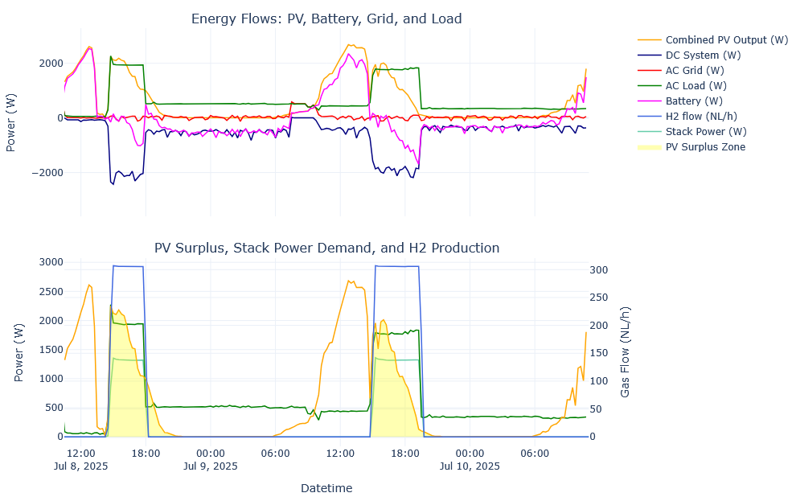
FIGURE 2. Illustration of HRES and Electrolyzer operation during periods of excess PV energy.

The first diagram (above) depicts the energy “harvesting” of the PV arrays (orange), the charging and discharging of the battery (purple), the contribution of the electrical grid as an energy reserve (AC Grid, red), as well as the energy offset on the direct current (DC) side, which results from the interaction of the PV and the battery before entering the inverter (DC System, dark blue). The inverter provides the necessary power to the total load on the alternating current side (AC Load, dark green), ensuring the balanced supply of consumption.
The second diagram (below) focuses on the time periods where there is a surplus of PV production (PV Surplus Zone, yellow shading). This surplus is channeled to the ELY (Stack Power, light green), resulting in the start of H₂ production (H₂ flow, blue line on the right axis). The H₂ production shows characteristic levels (plateau), which indicate a stable and controlled operation of the ELY under an energy surplus regime.
It becomes clear that in cases of insufficient storage space in the battery and/or absence of a corresponding electrical load, especially between 13:30 and 14:30 each afternoon, the excess photovoltaic energy is rejected. On the contrary, with the activation of the ELY at approximately 14:30, when the battery is already charged to a high level, the excess photovoltaic energy is absorbed. H2 production remains constant throughout the day and only stops when the excess solar energy decreases in the afternoon. This relatively expected operating pattern indicates a programmable steady-state H₂ production cycle under conditions of potential energy surplus.

Performance and Efficiency Evaluation of System Components
The measured production rate of the ELY as a function of time, is illustrated in Figure 3.a (black curve). Additionally, the variation of the ELY’s temperature (Fig 3a, green line) and pressure (Fig 3a, red line) over the corresponding period is also presented. The system, in the idle state, maintains a temperature of 20ºC. Upon activation, the temperature gradually increases, reaching 24ºC after 0.2h at which point both the pressure rise and H₂ production commence. The electrolyzer produces H₂ within the time interval o 0.5-1h, exhibits a steady increasing low rate, except for a brief period during which a minor drop is observed, attributed to the operational characteristics of the device, until it reaches a maximum flow rate of 511 L/h [8].
 | 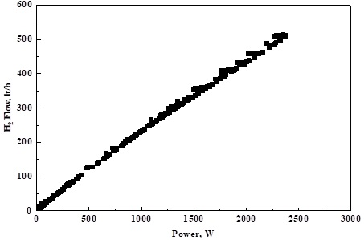
FIGURE 3. The time-dependent H₂ production profile (up). The power demand of the electrolyzer (down). | FIGURE 4. Power-dependent H₂ production profile.
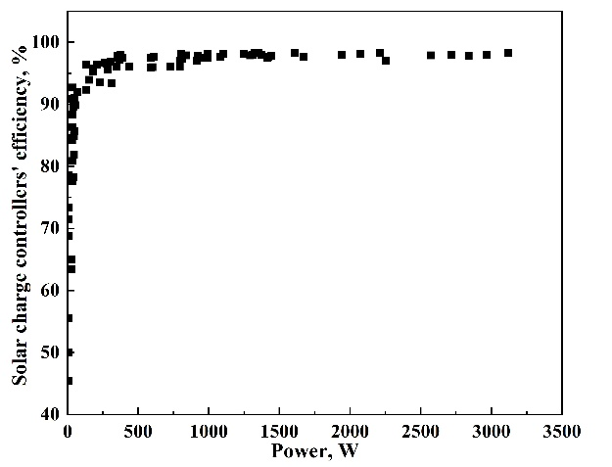 | 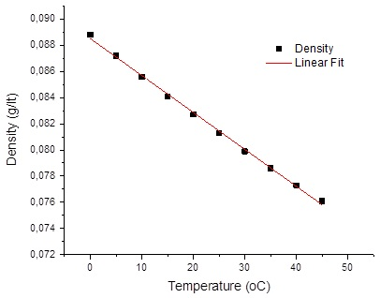
FIGURE 5. Efficiency curve of MPPT. | FIGURE 6. Density of gaseous hydrogen  as a function of temperature.
This maximum rate is then maintained throughout the remaining operation period of the system. Once H₂ production begins, the system pressure also starts to rise. After 0.1h, the pressure reaches 28.5bar and remains stable with minor fluctuations. After approximately 3h, a gradual increase is observed reaching 31bar at t = 3.5h. A continuous temperature increase is observed up to t = 1.2h, where it attains its maximum value of 55ºC. When the electrolyzer is turned off, both the H₂ and pressure drop instantaneously to zero while the temperature gradually returns to 20ºC.
In Figure 3.b, the variation of the ELY’s power demand as a function of time is presented. At 0.5h, the power begins to increase, followed by an abrupt drop after 0.1 h, the power attains its maximum value of 2365W. Subsequently, a decreasing trend is observed, stabilizing at approximately 2314 W. The comparison between the two diagrams indicates that the hydrogen flow rate and the power are directly proportional quantities. The H₂ ‘gas flow’ – ‘power demand’ relationship, is illustrated in Figure 4. It is evident that an increase in ELY’s power demand leads to a linear rise in the H₂ production rate. When the ELY reaches its maximum H₂ output of 511 L/h, the corresponding power is approximately 2500 W. The mathematical equation describing the relationship between the H₂ production flow rate and ELY’s power demand, as derived from Figure 4, is:
$$H_{2_{Flow}}=2.81914+0.22286∙Power$$ | (1)

Figure 5 shows the efficiency of the MPPTs as a function of output power (W). It shows that efficiency increases rapidly at low power levels and stabilizes near 98% once the output power exceeds approximately 300W. This indicates that the MPPTs operate at near-maximum efficiency under typical or higher load conditions, with only minor efficiency losses observed at very low power outputs. The performance demonstrates excellent conversion efficiency across the full operating range of the PV system.
The relationship between the density of gaseous hydrogen and temperature is shown in Figure 6. At 0ºC, the gas density is 0.089g/L. As temperature increases, a gradual decrease in density is observed. The final value in the graph indicates that at 45 ºC, the density decreases to 0.076 g/L. The inverse relationship between the two variables is consistent with the ideal gas law.

CONCLUSION
The present study has demonstrated that the integrated operation of a HRES-ELY system can be effectively harnessed for the reliable production of green H₂ under realistic and intermittently variable solar conditions. The developed configuration autonomously evaluates the system’s instantaneous energy balance and dynamically allocates surplus photovoltaic energy to H₂ generation, depending on real-time availability and storage capacity. This adaptive operation constitutes a critical step toward the optimization, automation, and scalability of renewable H₂ systems. Additionally, the observed linear correlation between ELY power consumption and H₂ flow rate provides a solid analytical basis for developing simplified control algorithms and predictive models applicable to similar hybrid energy systems. Overall, the findings highlight that the strategic utilization of surplus solar energy for green H₂ production is both technically feasible and environmentally sustainable, offering a robust mechanism for enhancing the autonomy and efficiency of distributed renewable systems. Future work will focus on extending this research toward Power-to-Gas (P2G) applications, where the produced H₂ can be further converted into synthetic methane or other renewable fuels, thus contributing to the broader vision of sector coupling, long-term energy storage, and carbon-neutral energy systems.

Acknowledgments
The research project was supported by the Hellenic Foundation for Research and Innovation (H.F.R.I.) under the “2nd Call for H.F.R.I. Research Projects to support Faculty Members & Researchers” (Project Number: 3209).



References
- W. Zhang and C. Xu, Energy Convers. Econ. 5(2), 78-92 (2024).
- A. Maroufmashat, F. Sayedin, S. Khavas, International Journal of Hydrogen Energy, 39(33), 18743-18757 (2014).
- H. Xu, J. Ma, F. Xue, X. Li, H. Li, W. Wang, Y. Zhong, J. Zhao, Y. Zhang, International Journal of Hydrogen Energy, 106, 65-79 (2025).
- M. Castañeda, A. Cano, F. Jurado, H. Sánchez, L. M. Fernández, International Journal of Hydrogen Energy, 38(10), 3830-3845 (2013).
- L. Hou, J. Dong, O. E. Herrera, W. Mérida, International Journal of Hydrogen Energy, 48(5), 2013-2029 (2023).
- D. Pashchenko, Renewable Energy, 223, 120033 (2024).
- M. Ongis, G. Di Marcoberardino, G. Manzolini, F. Gallucci, M. Binotti, International Journal of Hydrogen Energy, 48(51), 19580-19595 (2023).
- C. Elmasides, I. E. Kosmadakis, C. Athanasiou, Journal of Energy Storage, 106, 114790 (2025).

