Solar Tracking Performance in Residential Photovoltaic Systems to Optimize Efficiency and Profitability
Eliseo Zarate-Perez^{1, a)} and Josué Zarate-Perez^{1, b)}
¹Department of Engineering, Universidad Privada del Norte – UPN, Av. Alfredo Mendiola 6062, Los Olivos 15314, Peru.

^{a)} Corresponding author: eliseo.zarate@upn.edu.pe
^{b)}N00169159@upn.pe
Abstract. The objective of this study is to analyze and compare the energy and economic performance of residential photovoltaic systems with fixed structures and single-axis solar tracking in Lima, Peru. Hourly modeling was used, employing actual climate data, electricity demand profiles, and technical parameters from a commercial 5.67 kWp solar kit, considering the efficiency of the modules, inverters, and the annual consumption of the tracker. The analysis included estimates of annual generation, specific yield, levelized cost of energy (LCOE), net present value (NPV), internal rate of return (IRR), and payback period, as well as a sensitivity study on variations in CAPEX and electricity prices. The results show that the incorporation of solar tracking increased annual production by 43% compared to the fixed system (10,349 vs. 7,220 kWh/year), improving the LCOE to 0.076 USD/kWh. However, improvements in NPV and IRR were marginal due to the higher investment cost and low valuation of surpluses. It is concluded that, under the current tariff context, the economic viability of solar tracking depends mainly on CAPEX and the existence of incentives or favorable tariffs for surplus energy.

Keywords. Solar tracking, residential photovoltaic systems, energy performance, economic analysis, sensitivity analysis.

INTRODUCTION
Distributed generation from photovoltaic (PV) systems has experienced sustained growth in the residential sector worldwide, driven by cost reductions, increased module efficiency, and the development of policies aimed at energy transition [1]. In particular, the integration of solar tracking technologies in residential applications represents a potential strategy for maximizing energy capture and improving the performance of installations in urban contexts, where space availability and roof orientation can limit the optimal use of solar resources. Several studies have documented the benefits of solar tracking systems in large-scale PV plants and industrial applications [2–4], showing increases in annual energy production of between 20% and 45% compared to fixed configurations. However, in the residential sector, literature is still in its infancy, especially in terms of comprehensive evaluations that simultaneously consider energy performance and economic profitability under real market conditions, residential electricity rates, and technical constraints specific to urban environments [5].
This gap is particularly relevant in emerging countries, such as Peru, where the penetration of residential PV systems is still limited and regulations for net metering and surplus valuation are still under development [6]. In addition, factors such as the initial investment cost, the electricity demand profile, and local irradiance conditions have a critical impact on the viability and mass adoption of these technologies.
In this context, it is justified to analyze the real impact of solar tracking on residential PV systems, both from an energy and economic–financial perspective, using technical and economic data representative of the local market. Such an analysis makes it possible to identify the conditions under which the incorporation of solar trackers may be advisable and competitive in the residential sector.
Therefore, the objective of this study is to compare the performance of residential photovoltaic systems with a fixed structure and with single-axis solar tracking through hourly simulation and economic analysis, identifying the potential for optimization in efficiency and profitability under real conditions in the residential sector in Lima. Subsequently, the methodological section is presented, detailing the modeling approach, simulation procedures, and economic assessment criteria. The following section discusses the main results and provides an in-depth discussion of the findings. Finally, the main conclusions and recommendations of the study are presented.

METHODOLOGY
This study compares residential photovoltaic systems with fixed structures and solar tracking, evaluating energy efficiency and economic profitability. The analysis considers annual generation, specific yield, LCOE, NPV, IRR, and payback period, including investment, operation, maintenance, and consumption costs of the tracker. To this end, an hourly model of the solar resource is developed, which allows the energy and economic performance of both configurations to be simulated and compared over a typical year. Figure 1 presents the methodological flow followed in this study, which includes the collection of input data, system configuration, energy modeling, and economic analysis, as well as sensitivity analysis and final comparison of results.
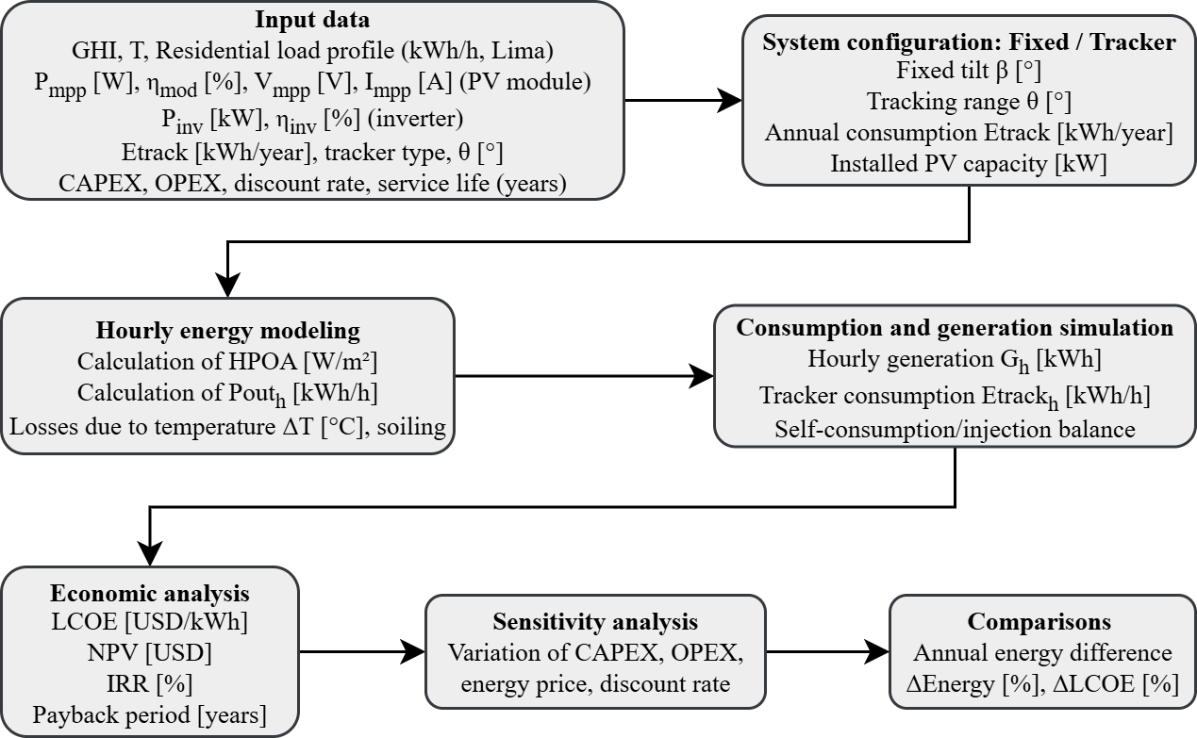
Figure 1. Methodological workflow for the hourly simulation and economic analysis of residential photovoltaic systems with and without solar tracking.

Materials
The analysis uses solar irradiance and temperature ⁷ together with the residential load profile of typical consumption in a home in Lima, as shown in Fig. 1. Similarly, the technical parameters of the photovoltaic modules, inverters, and solar tracker components are considered, as detailed in Table 1.
TABLE 1. Main input parameters used in the simulation.
Parameter | Symbol / Unit | Value
Nominal power of PV module | P_{mpp} [W] | 630
PV module efficiency | η_{mod} [%] | 21.5
Voltage at MPP | V_{mpp} [V] | 37.6
Current at MPP | I_{mpp} [A] | 16.76
Nominal power of inverter | P_{inv} [kW] | ≥5.67
Inverter efficiency | η_{inv} [%] | 98
Annual consumption of tracker | E_{track} [kWh/year] | 50
Type of solar tracker | – | Single axis (azimuthal)
Tracking range | θ [°] | ±60
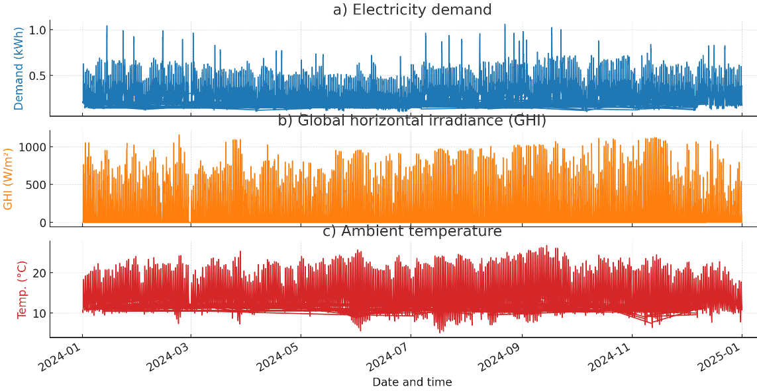
Figure 2. Hourly time series of input variables used for the simulation and analysis: a) electricity demand, b) global horizontal irradiance (GHI), and c) ambient temperature over the study period.

System Configuration and Modeling
Two residential photovoltaic configurations were analyzed: (i) a system with a fixed structure facing north and with optimal inclination (β = 6°), [8], and (ii) a single-axis solar tracking system capable of varying the tilt angle daily within a range of ±60°, using an astronomical algorithm. In both cases, the same installed power (P_{inst} = 5.67 kWp) was considered, with Tensite bifacial photovoltaic modules (P_{mpp} = 630 W, η_{mod,STC} = 21.5%) and high-efficiency inverters (η_{inv}) = 98%). The annual energy consumption of the tracker (E_{track}), year) was estimated at 50 kWh/year, considering technical specifications and references from the literature[9].
Energy modeling was performed in hourly steps, using the irradiance on the plane of the modules (G_{POA},_{h}), calculated from hourly global horizontal irradiance (GHI) data, and considering the tilt angle (fixed or variable, depending on the system). Electricity generation was estimated to use Equation 1.

$$E_{PV,h}=G_{POA,h}⋅A_{mod}⋅η_{mod,h}⋅η_{inv}$$ | (1)
Where:
- $E_{PV,h}$ is the electricity generated by the PV system in hour $h$(Wh)
- $G_{POA,h}$ is the lane-of-array irradiance in hour $h$(W/m²)
- $A_{mod}$ is the total area of PV modules (m²)
- $η_{mod,h}$ is the module efficiency at hour $h$(–)
- $η_{inv}$ is the inverter efficiency (–)
The efficiency of the modules was corrected for temperature using Equation 2.

$$η_{mod,h}=η_{mod,STC}⋅\left[1-γ⋅\left(T_{cell,h}-25\right)\right]$$ | (2)

Where:
- $η_{mod,h}$ is the module efficiency at hour $h$(–)
- $η_{mod,STC}$ is the module efficiency under standard test conditions (–)
- $γ$ is the power temperature coefficient (1/°C)
- $T_{cell,h}$ is the PV cell temperature at hour $h$(°C)
The hourly balance was adjusted by subtracting the follower's consumption in the corresponding case, using Equation 3.
$$E_{net,h}=E_{PV,h}-E_{track,h}$$ | (3)
Where:
- $E_{net,h}$ is the net hourly energy delivered to the load (Wh)
- $E_{PV,h}$ is the hourly electricity generated by the PV system (Wh)
- $E_{track,h}$ is the hourly energy consumed by the tracking system (Wh)

Economic Analysis
The economic performance of each system was evaluated using the levelized cost of energy (LCOE), net present value (NPV), internal rate of return (IRR), and payback period, following the standard methodology for residential photovoltaic projects ¹⁰. The initial investment costs (C_{inv}), annual operation and maintenance costs (C_{O&M}), and the energy consumption of the tracker were considered. The LCOE was calculated according to Equation 4.

$$LCOE=\frac{\frac{\sum_{n=1}^{N}{(C_{inv}+C_{O\&M,n})}}{{(1+r)}^{n}}}{\frac{\sum_{n=1}^{N}{E_{net,n}}}{{(1+r)}^{n}}}$$ | (4)
Where:
- $LCOE$: Levelized cost of energy (USD/kWh)
- $C_{inv}$: Initial investment cost in year $n$(USD)
- $C_{O\&M,n}$: Operation and maintenance cost in year $n$(USD)
- $E_{net,n}$: Net energy generated and delivered to the load in year $n$(kWh)
- $r$: Discount rate (–)
- $N$: Project lifetime (years)
- $n$: Year of analysis, from 1 to $N$

Sensitivity Analysis
To assess the robustness of the results, a sensitivity analysis was performed on the most influential variables: capital expenditure (CAPEX), operating and maintenance costs (OPEX), the price of electricity, and the discount rate. Variations of ±20% from the base scenario were analyzed to identify their impact on the levelized cost of energy (LCOE) and profitability indicators.

RESULTS AND DISCUSSION
This section presents and analyzes the results obtained from hourly simulations and economic analyses of residential photovoltaic systems with fixed structures and solar tracking. The main energy and economic indicators are compared, such as annual generation, specific yield, levelized cost of energy (LCOE), net present value (NPV), internal rate of return (IRR), and payback period. Likewise, the impact of the tracker's energy consumption is evaluated, and a sensitivity analysis is performed on the most relevant parameters.

Annual Energy Performance
The implementation of solar tracking in residential photovoltaic systems increased annual generation by 43%, compared to the fixed configuration, under Lima's climatic conditions and with the same installed power, as shown in Table 2.
TABLE 2. Comparative annual energy performance of fixed vs. tracking PV systems.
Indicator | Fixed system | Tracking system
Installed PV power (kWp) | 5.67 | 5.67
Annual yield (kWh) | 7220 | 10349
Specific yield (kWh/kWp·yr) | 1275 | 1825
Gain vs. fixed (%) | - | 43%

This improvement is also reflected in the specific annual yield, which increased from 1,275 to 1,825 kWh/kWp·year. These results confirm the superior energy capture of the system with a tracker and its potential to maximize the fraction of demand covered by solar energy, although the absolute benefit depends on the hourly consumption profile and the conditions for feeding surplus energy into the grid.

Economic Analysis
The economic analysis shows that, using actual local market prices, the solar tracking system achieves a LCOE of $0.076/kWh, which is lower than that of the fixed system ($0.091/kWh), due to its higher annual production. However, both systems have similar internal rates of return (IRR ≈ 11%) and payback periods of around 9 years, as the increase in the initial investment for the tracker offsets the benefit of its additional energy, as summarized in Table 3.
TABLE 3. Economic performance comparison of fixed and tracking residential photovoltaic systems.
Economic Indicator | Fixed system | Tracking system
CAPEX (USD/kWp) | 1139 | 1480
O&M cost (% CAPEX/year) | 3% | 3%
LCOE (USD/kWh) | 0.091 | 0.076
NPV 10% (USD, 25 years) | 65 | 54
IRR (%) | 11.3 | 11.1
Payback period (years) | 8.6 | 8.8
First-year savings (USD) | 326 | 423

The NPV, calculated at a discount rate of 10%, is barely positive in both cases, indicating financial viability under current tariff conditions. These results show that, in the absence of incentives or preferential tariffs for surplus energy, the economic advantage of the tracker over the fixed system is marginal in the residential context of Lima.

Impact of Tracker Energy Consumption
The energy consumption of the solar tracking system was estimated at 50 kWh/year, representing less than 0.5% of the total annual production of the photovoltaic system with tracker. This energy is subtracted from the gross generation, resulting in a net generation of 10,299 kWh/year. The energy penalty is minimal and does not significantly affect the system's annual balance or key economic indicators. However, to obtain an accurate assessment of actual performance, it is essential to incorporate this auxiliary consumption into net energy calculations and financial analysis.
TABLE 4. Impact of annual tracker energy consumption on net PV yield in the tracking system.
Indicator | Tracking system
Gross annual PV yield (kWh) | 10349
Tracker annual consumption (kWh) | 50
Net annual PV yield (kWh) | 10299
Net loss vs. gross (%) | 0.48%

Sensitivity Analysis
The sensitivity analysis shows that the LCOE and NPV of the solar tracking system are highly sensitive to the initial investment cost (CAPEX) and the price of energy, while the impact of operating and maintenance costs (OPEX) is marginal. A 20% reduction in CAPEX decreases the LCOE by 19% and transforms the NPV from negative to positive, dramatically improving the project's profitability, as shown in Table 5. Similarly, a 20% increase in the energy price makes the project financially attractive. Conversely, increases in CAPEX or reductions in the energy price significantly worsen the economic indicators, potentially making the investment unviable. Moderate variations in the discount rate also have a notable influence on the NPV but have little effect on the LCOE. These results underscore the importance of the initial investment and the tariff environment for the economic viability of residential PV systems with solar tracking.
TABLE 5. Sensitivity analysis of economic parameters for residential PV systems with solar tracking: LCOE and NPV.
Parameter Varied | Base Value | LCOE (USD/kWh) | LCOE Δ (%) | NPV (USD, 25 yr, 10%) | NPV Δ (%)
Reference (base case) | 1,480 USD/kWp | 0.076 | – | 54 | –
CAPEX –20% | 1,184 USD/kWp | 0.061 | -19% | 380 | +604%
CAPEX +20% | 1,776 USD/kWp | 0.091 | +20% | -312 | -677%
OPEX –20% | 2.4% CAPEX/yr | 0.075 | -1% | 62 | +15%
OPEX +20% | 3.6% CAPEX/yr | 0.077 | +1% | 46 | -15%
Energy price –20% | 0.214 USD/kWh | 0.076 | ≈0 | -321 | -695%
Energy price +20% | 0.320 USD/kWh | 0.076 | ≈0 | 337 | +524%
Discount rate –2% (8%) | – | 0.075 | -1% | 164 | +204%
Discount rate +2% (12%) | – | 0.077 | +1% | -172 | -419%

The results obtained in this study confirm that the implementation of single-axis solar tracking in residential photovoltaic systems significantly increases annual energy generation and specific yield, compared to fixed configurations. In the case analyzed, the system with tracker achieved a 43% gain in annual production, in line with the literature for subtropical areas. However, from an economic perspective, the profitability of the tracking system did not show a proportional improvement to the energy increase. Despite obtaining a lower LCOE (0.076 vs. 0.091 USD/kWh), the NPV and IRR remained close to those of the fixed system, mainly due to the higher initial investment cost and the limited value of the surplus energy exported in the absence of full net metering. This aspect reduces the economic impact of the additional energy, placing the investment close to the break-even point under current tariff conditions.
The sensitivity analysis highlights that CAPEX and energy prices are the most decisive factors for the viability of the system: reductions in investment costs or increases in electricity tariffs can make the investment very profitable, while increases in CAPEX or decreases in energy prices can make it unviable. In contrast, operating and maintenance costs, as well as the energy consumption of the tracker, have a marginal effect on the economic indicators.
Finally, it is important to consider that tracking systems require more maintenance and are more mechanically complex, factors that may influence the decision of residential users, who prioritize simplicity and reliability.

CONCLUSION
This study analyzed and compared the technical and economic performance of residential photovoltaic systems with fixed structures and single-axis solar tracking under the climatic and market conditions of Lima, Peru. The incorporation of solar tracking increased annual energy production by 43% compared to the fixed system, achieving specific yields of 1,826 and 1,274 kWh/kWp·year, respectively.
Despite this notable energy gain, the economic indicators (LCOE, NPV, IRR, and Payback Period) showed marginal improvements for the tracking system, mainly due to its higher initial investment cost (CAPEX) and the limited economic value of surplus energy exported under the current tariff scheme. The sensitivity analysis showed that the economic viability of both systems depends largely on the investment cost and the price of electricity.
The results highlight that solar tracking maximizes resource utilization and annual production. However, its economic attractiveness in the residential sector depends on local electricity prices, the existence of incentives, and surplus compensation policies.

ACKNOWLEDGMENTS
The authors gratefully acknowledge the support provided in part by Universidad Privada del Norte (UPN) for the development of this research.

REFERENCES
- Y.K. Hwang and Á. Sánchez Díez, Renew. Sustain. Energy Rev. 198, 114431 (2024).
- A.R. Amelia, Y.M. Irwan, I. Safwati, W.Z. Leow, M.H. Mat, and M.S.A. Rahim, IOP Conf. Ser. Mater. Sci. Eng. 767, 012052 (2020).
- M.A.M. Ramli, H.R.E.H. Bouchekara, and A.S. Alghamdi, Renew. Energy 121, 400 (2018).
- J. de D. Yáñez-Ávila and E.F. Camacho, Sol. Energy 284, 113066 (2024).
- J.C. Quispe, A.E. Obispo, and F.J. Alcantara, Clean Technol. Environ. Policy 26, 1415 (2024).
- H. Campodónico and C. Carrera, Energy Policy 171, 113261 (2022).
- U.S. Department of Energy, NSRDB: National Solar Radiation Database (2022).
- E. Zarate-Perez and R. Sebastián, Manage. Environ. Qual., in press (2025).
- A. Dolara, F. Grimaccia, S. Leva, M. Mussetta, R. Faranda, and M. Gualdoni, IEEE J. Photovolt. 2, 524 (2012).
- E. Zarate-Perez and R. Sebastián, Energy Rep. 8, 653 (2022).

