Adaptive Production and Maintenance Optimization of a Hybrid Solar–Wind System under Nigerian Operating Conditions
Aminu Tijjani^{1, 2, a)}, Aime Nyoungue^{1, b)} and Zied Hajej^{1, b)}
¹Production and Maintenance Laboratory (LGIPM), Université de Lorraine, Metz, France.
²Department of Electrical Engineering, Aliko Dangote University of Science and Technology, Wudil, Kano, Nigeria.

^{a)} Corresponding author: aminu.tijjani@univ-lorraine.fr
^{b)} aime.nyoungue@univ-lorraine.fr
^{c)} zied.hajej@univ-lorraine.fr

Abstract. This paper presents an integrated framework for production and maintenance optimization in a hybrid solar–wind energy system under Nigerian climatic conditions. The approach couples power generation forecasting with reliability-driven maintenance scheduling to minimize life-cycle cost while ensuring operational reliability. Power output is predicted using an Artificial Neural Network (ANN), while component degradation is modeled through the Weibull reliability function incorporating a virtual age formulation. A restoration impact factor (α) is introduced to represent imperfect maintenance, quantifying partial reliability recovery after each intervention. Remaining Useful Life (RUL) is predicted using an LSTM-based model trained on normalized operational covariates and updated online after each maintenance event. Results over a 60-month horizon identify the optimal strategy as five preventive and twenty-one predictive maintenance actions, achieving a total cost of €194,000 and maintaining system reliability above a threshold. Sensitivity analysis shows that increasing corrective maintenance cost shifts the optimal plan toward preventive dominance, confirming the model’s adaptive behavior. The proposed α-based framework provides a practical, data-driven tool for reliability-centered maintenance planning in hybrid renewable systems, offering improved cost efficiency and resilience in variable operating environments.

Introduction
The escalating concerns over rising carbon emissions and their impact on global temperature trends have intensified the urgency to transition toward sustainable energy solutions. (Senthilkumar & Jayasankar, 2026). Renewable energy sources, particularly solar and wind, have emerged as viable alternatives that can significantly reduce dependence on fossil fuels while mitigating environmental degradation. However, the inherent intermittency of individual renewable sources poses substantial challenges to power system reliability. To address this limitation, hybrid solar–wind systems have gained considerable attention due to their complementary operational characteristics: solar energy peaks during daylight hours while wind energy often exhibits stronger generation during evening and night periods, thereby reducing overall intermittency and enhancing system reliability.
The optimal sizing of hybrid solar–wind systems has been extensively investigated through various optimization methodologies. (Senthilkumar & Jayasankar, 2026) employed the secretary bird optimization algorithm to minimize the cost of energy and loss of power supply probability for stand-alone hybrid PV/wind/battery systems. (Akhtari & Karlström, 2025) demonstrated that levelized costs for optimized systems range between 0.16 and 0.48 $/kWh when wind energy is included, compared to 0.44–0.63 $/kWh without wind, highlighting the economic advantage of hybrid configurations under varying meteorological conditions. (Winsly et al., 2025) applied HOMER PRO to achieve 95% renewable penetration with a levelized cost of 0.040 $/kWh by integrating solar, wind, and biomass sources. (Gou et al., 2024) investigated capacity configuration optimization for hybrid renewable energy systems with concentrating solar power, determining an optimal VRE sizing of 4000 MW solar and 1000 MW wind. (Sadeghibakhtiar et al., 2024) pioneered a dual-objective optimization approach that simultaneously considered reliability and system costs, employing a genetic algorithm and NSGA-II to optimize photovoltaic panel area, wind turbine specifications, and battery capacity while accounting for component availability through failure and repair rates. (C. Wang et al., 2023) incorporated component reliability into capacity optimization using sequential Monte Carlo simulation to model fault probabilities of wind turbines and photovoltaic generators, optimizing hybrid energy storage systems with life cycle cost as the objective and loss of power supply probability as constraints. (Eryilmaz et al., 2021) derived analytical expressions for power output distribution that explicitly incorporated reliability values of renewable energy components, enabling theoretical assessment of long-term system performance.
Despite significant advances in sizing optimization, the maintenance planning dimension of hybrid systems remains substantially underexplored. (Zhang et al., 2025) developed a maintenance cost model incorporating corrective and preventive maintenance strategies alongside energy complementarity, yet the study adopted simplified maintenance assumptions. (Dwivedi et al., 2024) focused on surface defect detection for monitoring renewable assets but did not address maintenance scheduling optimization. The existing literature predominantly treats maintenance actions as binary, "perfect" or "minimal" interventions, neglecting the realistic scenario of imperfect maintenance, in which component reliability is only partially restored. Furthermore, current approaches fail to adaptively integrate degradation history with maintenance effectiveness to optimize maintenance schedules under the dynamic operating conditions characteristic of the Nigerian environment.
To address these limitations, the present study introduces an enhanced maintenance optimization framework that extends the previous sequential production–maintenance model by incorporating an imperfect maintenance mechanism based on the virtual-age concept. Each maintenance action partially restores component reliability, with an impact factor (α) that represents the effectiveness of the action. This α-based formulation allows quantifying the degree of restoration, bridging the gap between idealized “as-good-as-new” and “as-bad-as-old” assumptions. It thus provides a more realistic assessment of system reliability and cost performance. These enable an adaptive maintenance planning schedule under varying degradation conditions. By embedding this virtual-age model into the hybrid system’s reliability evaluation, the proposed approach captures both degradation history and maintenance effectiveness, thereby improving decision accuracy and cost optimization.
In summary, this work contributes:
- An integrated production–maintenance optimization scheme for hybrid solar–wind systems,
- An imperfect-maintenance reliability model governed by the impact factor α, and.
- An adaptive cost-reliability optimization framework that balances preventive and predictive maintenance actions.
The rest of the paper is organized as follows: the next section presents the problem description; this is followed by the mathematical modelling; then the maintenance and optimization strategy; the results discussion is then presented; and the last section concludes the study.

Problem Description
Hybrid renewable energy systems combining solar PV and wind turbines present a practical solution to Nigeria’s persistent energy deficit. However, the harsh and variable climatic conditions in sites such as the Northern part of Nigeria accelerate component degradation, making maintenance planning a critical challenge. Conventional periodic maintenance fails to account for partial restoration effects, leading to recurrent reliability losses. This study, therefore, develops a cost-optimized maintenance framework incorporating an α-based virtual-age model to represent imperfect repairs, enabling realistic reliability restoration and adaptive scheduling for Nigerian hybrid solar–wind installations.

Mathematical Modelling
This section presents the mathematical modelling for the hybrid system, outlining the production and maintenance modelling formulation.

Production Forecast Using Artificial Neural Network
For efficient operation and maintenance scheduling, hybrid solar-wind generation forecasts must be accurate. In this study, data on sun irradiance, wind speed, and ambient temperature are used to estimate real-time power output using an Artificial Neural Network (ANN). The network uses Mean Squared Error (MSE) to minimize prediction error and consists of several hidden layers with ReLU activation. Adaptive reliability restoration is enabled within the hybrid system's optimization framework by using the projected power profile as input to the α-based maintenance model, which links production intensity to component degradation.

Maintenance Modelling
Production outcomes and maintenance planning are sequentially integrated in this study. Since production intensity significantly impacts component dependability and failure behavior, the model accounts for real-time operational and environmental data. The ANN/LSTM model's estimated power output directly affects the rate of degradation and the level of maintenance. The effectiveness of each intervention is represented by a restoration impact factor (α), introduced because each maintenance action only partially restores reliability. To keep maintenance decisions aligned with the system's state, the model dynamically adjusts α values based on production and operational conditions. This integration reduces unplanned downtime and improves overall performance.
Virtual-age Dynamics (imperfect repair)

The degradation and subsequent restoration of a component after maintenance can be represented through the virtual-age concept, initially proposed by (Kijima, 1989). In this approach, the virtual age reflects the effective accumulated degradation of a component, rather than its chronological age. After a maintenance action, the virtual age is partially reduced according to the impact (or restoration) factor.
$$α ∈[0,1]$$
This factor quantifies the repair's effectiveness. Where a perfect repair corresponds to α =1 (the component becomes as good as new), while α=0 represents minimal maintenance with no performance restoration. The imperfect repair from different literature ((Kijima, 1989); (Doyen & Gaudoin, 2004); (Dijoux, 2009); (Finkelstein & Cha, 2022)), formulated the post-maintenance virtual age as:

 | $$v_{i}\left({t_{m}}^{+} \right)=(1-α_{i})×v_{i}\left({t_{m}}^{-}\right)$$ | (1)

Where: $v_{i}\left({t_{m}}^{-}\right)$ and $v_{i}\left({t_{m}}^{+} \right)$ denote the virtual age immediately before and after the maintenance event at time $t_{m}$, respectively.
Reliability Modelling
The solar and wind subsystems are configured in a parallel configuration. This is to enhance redundancy in the hybrid system, so we configured the photovoltaic (PV) panels and an inverter in series to form the solar subsystem. Similar to this, we considered the main shaft, gearbox, and generator for the wind turbine subsystem in the same configuration. The component reliability is modeled using the Weibull distribution function (Ghodrati et al., 2012), where after each maintenance, the reliability is updated using the new virtual age. This is expressed as:
 | $$R_{i}\left(t\right)=\exp\left(-{\left({v_{i}}/{η_{i}}\right)}^{β_{i}}\right)$$ | (2)
Where: $β_{i}$ and $η_{i}$ are the shape and scale Weibull parameters for each component, respectively.
RUL Prediction Using ANN
To accurately predict the Remaining Useful Life (RUL) of hybrid system components, a dynamic LSTM-based Artificial Neural Network (ANN) is implemented. The model employs a dual-layer LSTM architecture (64–32 units) to capture temporal degradation patterns of each component. To enhance learning and improve predictive maintenance accuracy, the virtual age $v_{i}$and the most recent restoration factor ($α_{i}$) are incorporated as additional input features. The LSTM undergoes online updates after each maintenance action using the newly observed $α_{i}$and reliability values. By integrating these auxiliary features, the model dynamically adapts its RUL predictions to reflect partial reliability restoration following each maintenance event, thereby improving both prediction accuracy and decision responsiveness. We compute the expected remaining useful life of a component with virtual age $v$ using the Weibull mean-residual-life formula (closed form via the upper incomplete Gamma function) as commonly applied in RUL studies ((Y. Wang et al., 2021); (Ghodrati et al., 2012)):
 | $${RUL}_{i}\left(v\right)=\frac{η_{i}}{β_{i}}\exp\left({\left(\frac{v_{i}}{η_{i}}\right)}^{β_{i}}\right)Γ\left(\frac{1}{β_{i}},\left({\left(\frac{v_{i}}{η_{i}}\right)}^{β_{i}}\right)\right)$$ | (3)
Where $Γ(a,x)$ is the upper incomplete gamma function.
This formulation represents the expected remaining useful life of a component with virtual age $v_{i}$, enabling a direct and efficient link between the degradation state estimated by the LSTM and the reliability update process governed by the impact factor $α_{i}$.
Maintenance Cost Function Modelling
The proposed model unifies preventive, predictive, and corrective maintenance expenses within a single cost-optimization framework. Preventive maintenance costs are evaluated using component reliability indices to sustain the desired system uptime, while LSTM-based RUL forecasts guide predictive maintenance costs to ensure timely, condition-based interventions. An impact factor characterizes each maintenance action ($α_{i}$), representing the restoration intensity and directly influencing both cost and post-maintenance reliability. Higher $α_{i}$values correspond to more comprehensive restorations, leading to higher immediate expenses but reduced future failure risks. The corrective maintenance cost component accounts for unscheduled failures despite preventive and predictive interventions. Collectively, these costs define the total maintenance cost ($C_{TM}$) over the planning horizon:
 | $$\underset{\left(N_{pr},N_{p}\right)}{\underbrace{Min }}C_{TM}=C_{p}×N_{p}+N_{pr}×C_{pr}+C_{c}×φ_{hy}\left(N_{p},N_{pr}\right)$$ | (4)

The average number of failures $φ_{hy}\left(N_{p},N_{pr}\right)$ despite maintenance actions is evaluated using:

 | $$φ_{hy}\left(N_{p},N_{pr}\right)=\sum_{k=0}^{N_{p} or N_{pr}-1}{\left[\int_{0}^{∆t}{λ_{h,k}\left(t\right)} dt\right]+\int_{N_{p} or N_{pr}.T}^{H.Δt}{λ_{h,k}\left(t\right)}dt}$$ | (5)
Where
$$λ_{h,k}\left(t\right)=\frac{-dR_{hy}\left(t\right)}{dt}$$
The preventive maintenance cost $C_{p}$is expressed as
$$C_{p}={C_{p}}^{fix}+{C_{p}}^{var}×α$$

${C_{p}}^{var}$ is the variable cost in relation to α and ${C_{p}}^{fix}$ is the fixed cost
$N_{p}$ is the total number of preventive maintenance
$N_{pr}$ is the total number of predictive maintenance actions
$C_{pr}$Is the cost of predictive maintenance
$C_{c}$ is the cost of corrective maintenance
To ensure the system is always sufficiently reliable throughout the horizon.
$$R_{hy}\left(t\right)≥ R_{min}$$

Maintenance Planning Policy
This section presents the operational framework of the proposed maintenance optimization model for the hybrid solar–wind system. The model minimizes the total maintenance cost over a five-year horizon while ensuring system reliability remains above a predefined threshold. Maintenance actions include preventive, predictive, and corrective interventions, each characterized by a restoration factor ($α_{i}$) that governs post-maintenance reliability. Preventive maintenance is scheduled at fixed intervals, while predictive actions are triggered when component RULs fall below a threshold. The model iteratively adjusts maintenance timing and α-values, updating virtual ages and reliability to identify the configuration that minimizes total cost while maintaining system reliability.

Numerical Example and Results Discussion
To validate the proposed hybrid production–maintenance optimization model, a case study was conducted using real operational data from Jigawa, Nigeria (12.985531° N, 7.617144° E). Environmental inputs, including solar irradiance, wind speed, and ambient temperature, were obtained from the NASA POWER database for the 2019–2024 period. These variables serve as inputs to the hybrid solar–wind energy production model, enabling a realistic simulation of monthly power output. The predicted production intensity directly influences component degradation within the maintenance framework. Maintenance and degradation data were collected over a five-year horizon, providing 60 time steps per component. The dataset includes normalized operational covariates, such as temperature, voltage fluctuations, and vibration, used to train the LSTM model for Remaining Useful Life (RUL) prediction. Component reliability was modeled using the Weibull distribution with a virtual-age formulation, where the impact factor governs maintenance restoration $α$ ​. This integration of real environmental and operational data ensures that both production estimation and maintenance optimization reflect the actual behavior of the hybrid system under Nigerian climatic conditions.

Maintenance Results Discussion
Figure 1 illustrates the variation of total maintenance cost with respect to the number of preventive maintenance cycles ($N_{p}$) over the 60-month planning horizon. The results exhibit a U-shaped cost pattern, indicating the trade-off between frequent scheduled interventions and the accumulation of corrective repairs. The optimal configuration occurs at $N_{p}=5$, corresponding to preventive actions every 12 months, with a minimum total cost of approximately €194,000. This configuration achieves a 16% reduction compared to the minimal preventive case for $N_{p}=1$ and over 35% savings relative to excessive scheduling 60 preventive actions. The observed minimum arises from the balanced coordination between preventive and predictive actions, where the α-based restoration factor dynamically adjusts the level of component recovery after each maintenance event. This adaptive integration ensures that reliability remains above the threshold, while controlling unnecessary maintenance intensity, thereby delivering a cost-optimal and reliability-compliant maintenance plan for the hybrid solar–wind system operating under Nigerian environmental conditions.
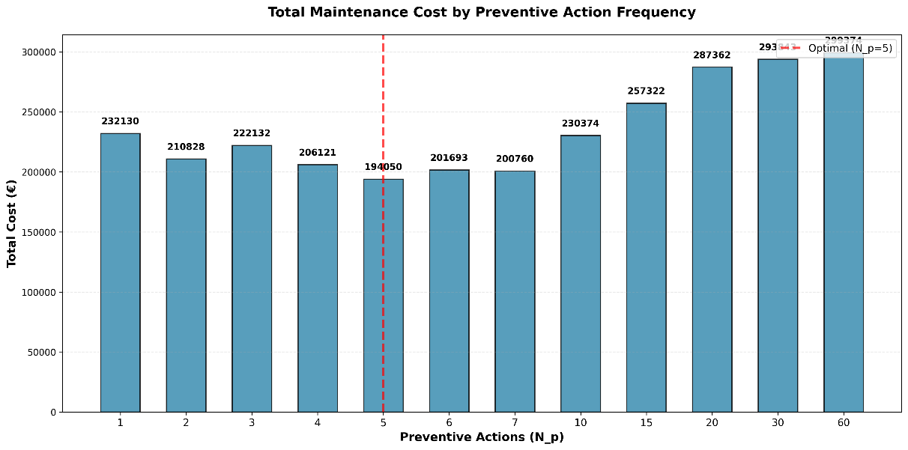

FIGURE 1. Total Maintenance Cost Analysis
Figure 2 illustrates the maintenance schedule with restoration (α) for each hybrid subsystem component over the planning horizon. The results reveal that the generator and rotor shaft underwent the most frequent predictive interventions, reflecting their mechanical exposure and degradation sensitivity to production rate and fluctuating wind conditions. The inverter and PV modules were primarily maintained through preventive maintenance cycles every 12 months, aligned with electrical reliability thresholds. The gearbox exhibited both periodic preventive actions and a late predictive intervention at period 58 with (α = 0.2), demonstrating the model’s ability to implement minimal restorative efforts when degradation is detected near the horizon. Overall, the variation in α values (0.2–0.9) across time supports the imperfect maintenance framework, in which restoration intensity is condition-dependent rather than constant. This adaptive scheduling effectively synchronizes the LSTM-based RUL predictions with the Weibull-derived reliability profiles, minimizing over-maintenance while ensuring system reliability remains above the operational threshold throughout the planning period.
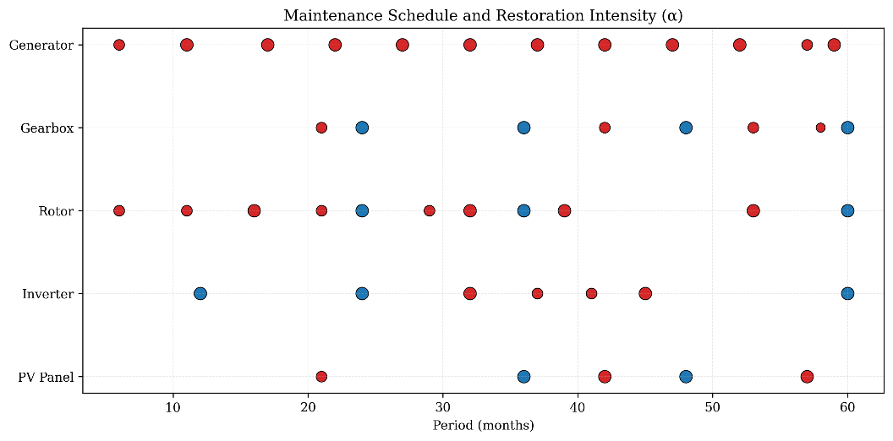

Figure 2. Maintenance Schedule

Sensitivity Analysis
A sensitivity analysis was conducted to assess the influence of corrective maintenance (CM) cost on the optimal maintenance configuration. As the CM cost increased from €4,000 to €11,000, the model shifted toward more preventive actions and fewer predictive interventions, as shown in Table 1. This adaptive transition reflects the model’s capacity to balance reliability assurance against economic penalties, demonstrating that higher CM costs incentivize earlier, preventive actions. The total maintenance cost consequently increased from €20,831 to €43,987, highlighting the importance of optimizing cost structures under uncertain economic conditions.

TABLE 1. Corrective Cost Analysis
Correct cost (€) | Preventive actions | Predictive actions | Total Cost (€)
4,000 | 5 | 26 | 20,831
7,000 | 6 | 24 | 31,344
11,000 | 10 | 15 | 43,987

A subsequent sensitivity analysis confirmed that the proposed α-based model remains robust to variations in corrective cost, adaptively shifting between preventive and predictive emphasis to sustain economic optimality across diverse maintenance scenarios.

Conclusion
This study developed an integrated production–maintenance optimization framework for a hybrid solar–wind energy system operating under Nigerian climatic conditions. The model combined Weibull-based reliability analysis, virtual-age restoration modeling, and LSTM-driven Remaining Useful Life (RUL) prediction, with an impact factor (α) introduced to quantify imperfect maintenance effects. By dynamically linking production intensity to degradation behavior, the framework enables adaptive scheduling of preventive and predictive actions that maintain reliability above the operational threshold while minimizing cost.
Results demonstrated that the optimal configuration occurs at five preventive actions and twenty-one predictive interventions, achieving a total maintenance cost of approximately €194,000 and ensuring sustained system reliability. The sensitivity analysis further confirmed that increasing corrective maintenance cost drives the strategy toward more preventive actions, reflecting the model’s capacity to adapt to economic uncertainty. The α-based imperfect restoration mechanism successfully captured partial reliability recovery, preventing excessive maintenance while avoiding degradation accumulation.
Overall, the proposed approach delivers a cost-effective, reliability-aware, and condition-responsive maintenance strategy for hybrid renewable systems. It offers a practical decision-support tool for operators in resource-constrained environments such as Nigeria, where fluctuating environmental and economic conditions necessitate adaptive maintenance planning. Future work will extend this framework to include multi-objective optimization, considering energy production, environmental impact, and stochastic reliability factors to further enhance system resilience and sustainability

References
- Akhtari, M. R., & Karlström, O, Role of wind speed and solar irradiation on the cost of medium-sized off-grid hybrid renewable energy systems under challenging weather conditions. (Energy Conversion and Management: X 2025), 27. https://doi.org/10.1016/j.ecmx.2025.101163
- Dijoux, Y, A virtual age model based on a bathtub shaped initial intensity. (Reliability Engineering and System Safety 2009), 94(5), 982–989. https://doi.org/10.1016/j.ress.2008.11.004
- Doyen, L., & Gaudoin, O, Classes of imperfect repair models based on reduction of failure intensity or virtual age. (Reliability Engineering and System Safety, 84(1), 45–56, 2004). https://doi.org/10.1016/S0951-8320(03)00173-X
- Dwivedi, D., Babu, K. V. S. M., Yemula, P. K., Chakraborty, P., & Pal, M. Identification of surface defects on solar PV panels and wind turbine blades using attention based deep learning model. (Engineering Applications of Artificial Intelligence . 2024), 131. https://doi.org/10.1016/j.engappai.2023.107836
- Eryilmaz, S., Bulanık, İ., & Devrim, Y. Reliability based modeling of hybrid solar/wind power system for long term performance assessment. (Reliability Engineering and System Safety 209, 2021),
https://doi.org/10.1016/j.ress.2021.107478
- Finkelstein, M., & Cha, J. H. Reducing degradation and age of items in imperfect repair modeling, 2022.
- Ghodrati, B., Ahmadzadeh, F., & Kumar, U. Mean Residual Life Estimation Considering Operating Environment 2012.
- Gou, H., Ma, C., & Liu, L. Optimal wind and solar sizing in a novel hybrid power system incorporating concentrating solar power and considering ultra-high voltage transmission. (Journal of Cleaner Production 470, 2024). https://doi.org/10.1016/j.jclepro.2024.143361
- Kijima, M. Applied Probability Trust Some Results for Repairable Systems with General Repair. In Source: (Journal of Applied Probability 1989). Vol. 26, Issue 1.
http://www.jstor.orgURL:http://www.jstor.org/stable/3214319
- Sadeghibakhtiar, E., Naeimi, A., Naderi, S., Pignatta, G., & Behbahaninia, A. Size optimization of a stand-alone solar-wind-battery hybrid system for net zero energy buildings: A case study. Energy and Buildings, 313 2024. https://doi.org/10.1016/j.enbuild.2024.114204
- Senthilkumar, T., & Jayasankar, T. Optimal sizing of Hybrid Solar-Wind Battery System (HSWBS) using secretary bird optimization. Electric Power Systems Research 251 2026.
https://doi.org/10.1016/j.epsr.2025.112284
- Wang, C., Jiao, S., Li, Y., & Zhang, Q. Capacity optimization of a hybrid energy storage system considering Wind-Solar reliability evaluation based on a novel Multi-strategy snake optimization algorithm. (Expert Systems with Applications, 231. 2023. https://doi.org/10.1016/j.eswa.2023.120602
- Wang, Y., Chen, Z., Zhang, Y., Li, X., & Li, Z. Remaining useful life prediction of rolling bearings based on the three-parameter Weibull distribution proportional hazards model. Insight: Non-Destructive Testing and Condition Monitoring, 62(12), 710–718 2021. https://doi.org/10.1784/INSI.2020.62.12.710
- Winsly, B. W., Ramalingam, V. K., Santhappan, J. S., Maria, A. J., Chokkalingam, M. P., & Rajendran, V. Optimal sizing and techno-economic-environmental evaluation of biomass-solar-wind-grid hybrid energy system: A case study of an institute in South India. (Energy Conversion and Management, 325, 2025. https://doi.org/10.1016/j.enconman.2024.119352
- Zhang, C., Zeng, Q., Dui, H., Chen, R., & Wang, S. Reliability model and maintenance cost optimization of wind-photovoltaic hybrid power systems. (Reliability Engineering and System Safety, 255, 2025). https://doi.org/10.1016/j.ress.2024.110673

