Simulation of Physical Docking of Doxorubicin and ¹⁸F-FDG With Carcinogenic Progesterone in Breast Cells
Iman M.. Kadhim ^{1,a)}, Bahjat B. Kadhim ^{1,b)}
¹ Department of Physics, College of Science, Mustansiriayah University,Baghdad, IRAQ

^{a)} eman.muslim@uomustansiryiah.edu.iq
^{b)} Corresponding author E-mail: sci.phy.bbk@uomustansiriyah.edu.iq

Abstract: In this study, it was used Gaussian 16, which relies on density function theory (DFT), to look at a system that includes Doxorubicin, ¹⁸F-FDG medical dye and breast cancer etiology. The computations looked at various electronic characteristics, including the energies of HOMO and LUMO, the energy gap (E_{g}), and other electronic properties like ionization energy, electron affinity, chemical hardness, and electrophilic index. They also included detailed thermodynamic properties (ΔG, ΔH and ΔS) and energetic properties, such as binding energy, deformation energy, and interaction energy. The results show that when the ¹⁸F-FDG dye docks with Doxorubicin in cancer cells examination, it led to enhances Gibbs free energy ( 0.649 eV) and lowers interaction energy (-13.3204 eV), while keeping the molecules in stable, which supports the idea of developing a targeted treatment that is both effective and safe at the molecular level. The results show that doxorubicin works well with heat treatment when docking with ¹⁸F-FDG for breast cancer etiology, as it has stable free energy (0.732 eV), moderate heat changes, and a good heat spread, which means it's a suitable option for therapy.
Keywords: breast cancer, medical dye, Density Functional Theory, thermodynamic properties, Doxorubicin.

Introduction
Materials science is an important discipline in various scientific fields, and it has countless applications, including, but not limited to, applications in the field of manufacturing superconducting materials [1, 2], in addition to other materials science applications, especially nanomaterials in the fields of thermal insulation and ablation [3, 4] within the fields of mechanical engineering and machinery, through the manufacture of nanomaterials that work against mechanical wear and reduce friction, within the science of tribology[5]. Here it can be said that materials science does not only enter the fields of engineering and physics, but extends beyond that to enter the field of medicine. In the broad medical field of materials science, its applications in treating all types of cancer are among the most important applications it deals with.
Breast cancer is one of the most common malignancies, accounting for approximately 25% of all cancers diagnosed in women worldwide. It is characterized by a high biological diversity that makes it difficult to respond to treatment[6, 7]. Breast cancer cells exhibit unique molecular characteristics, including hyperglycemia and altered electron density distribution, enabling them to grow rapidly and metastasize [8]. From this perspective, treatment is no longer limited to a traditional pharmacological approach, but is being reshaped according to a precise quantum physics understanding of the tumor's molecular structure and orbital properties.
Molecular physicists are increasingly important in this area, creating simulation tools based on theories like density function theory (DFT) to closely examine how drugs interact with their biological targets at a tiny scale. These simulations are used not just to look at how strongly a drug binds or the energy difference between the highest occupied molecular orbital (HOMO) and the lowest unoccupied molecular orbital (LUMO), but also to see how the drug moves inside the cell and to find the active sites in proteins, amino acids or DNA that are targets for treatment [9].
Doxorubicin, a chemotherapeutic drug belonging to the anthracycline family, is widely used in the treatment of breast cancer. It’s way of working involves disrupting the enzyme topoisomerase II, causing breaks in DNA strands and stopping cancer cells from growing. However, its effectiveness is limited by distribution problems within tumor tissue and its high cardio toxicity, which points to the need to improve its delivery methods in a selective and safe manner[10].
In contrast, the ¹⁸F-FDG dye is commonly used in a positron emission tomography PET scans, acting as a radioactive form of glucose that builds up in cells that are very active, like cancer cells. This accumulation makes it ideal for early tumor detection, but it has yet to be functionally exploited as a "drug carrier" that redefines the relationship between diagnosis and treatment[11].
This study is based on a new scientific hypothesis that proposes three analytical steps to evaluate the structural-energetic interaction between the drug, the medical dye, and the tumor etiology.
We docking Doxorubicin with breast cancer etiology cells to ascertain its inherent capacity to engage with the tumor, as well as to ascertain the binding energy and subsequent orbital structure. The drug binds to the ¹⁸F-FDG dye to ascertain if it modifies the diagnostic dye's properties and influences its dynamics. The docking of the Doxorubicin with ¹⁸F-FDG to the tumor etiology is analyzed to determine whether the dye enhances the drug's targeting of the tumor or alters its physical properties.
The study uses multiple molecular simulation tools, including DFT, docking, electrostatic potential (ESP) mapping analysis, and HOMO-LUMO energy, to teach us how ¹⁸F-FDG can be used as a "dual-functional carrier."
The key innovation here is the proposed "instant integration" model of diagnosis and therapy. When the docking doxorubicin with ¹⁸F-FDG is administered, tumor imaging and therapeutic targeting can be performed simultaneously, without the need for two separate systems. This vision paves the way for the application of advanced diagnostic therapeutics and realizes the principle of effective and precise targeted therapy.

Computational Methods
In this theoretical research, the molecular structures of Doxorubicin, ¹⁸F-FDG dye, and progesterone (which is considered one of etiology of breast cancer) were obtained from the PubChem database in their original, internationally recognized formats. These structures served as the foundation for quantum computations using Gaussian 16 in the context of density functional theory (DFT).
Following a structural review with Gauss View 6.0, the molecule of doxorubicin (CID: 31703) was downloaded from PubChem in its biologically active form. Its oxidation state and spatial configuration were then modified to conform to the physiological environment. The structure of the ¹⁸F-FDG dye was downloaded from PubChem (CID: 107976) in a format that works with molecular imaging techniques (PET), which means a fluorine-18 isotope was added to the second position of the glucose ring [12]. The progesterone molecule was downloaded from the same database with the code (CID: 5994), and it is commonly used as an example of a hormone that works in cancer cells, making it a good model for studying target molecules electronically.

The study focused on creating systems with three molecules in one space to understand how strong and what type of non-covalent physical interactions occur, especially those from Van der Waals interactions. Four main ways of docking molecules were tested: the first was between the Doxorubicin molecule and the tumor etiology model (Doxorubicin with cancer etiology), the second was between the ¹⁸F-FDG dye and the tumor etiology model (¹⁸F-FDG with cancer etiology), the third was between the drug and the dye alone (Doxorubicin with ¹⁸F-FDG), and the fourth docked all three into one structure (Doxorubicin with ¹⁸F-FDG and cancer etiology) which is called from now on the complex.
These setups do not include any covalent chemical interactions; instead, they focus on how the surfaces of the molecules overlap as they get close to each other via docking mechanism. This modeling enables us to study the effectiveness of the dye as a smart molecular guide that contributes to enhancing the drug's ability to selectively target tumors.
This study demonstrates the potential of exploiting the electronic properties of pharmaceutical dyes to develop smart therapeutic-diagnostic systems based on selective physical docking to design compounds capable of simultaneously delivering drugs and diagnosing tumors, enhancing treatment efficiency, and reducing random interference with healthy body tissues.

Results and Discussion
The results in Figures (1) and (2) show that all the complexes formed are stable and hold together well via docking mechanism. The shapes of the structures after docking stayed the same as the shapes of the individual structures before they docked, which means the molecules interacted using Van der Waals forces, without creating strong chemical bonds or causing big changes in structure.
The significant decrease in energy values for all three dockings, particularly Doxorubicin – cancer etiology (progesterone), shows that these interactions are strong connections that can be utilized in advanced drug targeting techniques. The way the docking ¹⁸F-FDG dye attaches to both Doxorubicin and the carcinogenic progesterone model shows that it could be a very effective way to deliver drugs directly to tumors.
These results support the main idea of the research, demonstrating that the ¹⁸F-FDG dye can do more than just assist with diagnosis[13]; it can also effectively deliver drugs directly to cancer cells, which aligns with previous findings about charged molecules like ¹⁸FDG being able to attach to active metabolic areas, particularly when used in hybrid systems that integrate therapy and diagnosis.

Figure (3) shows what happens when the three molecules docking Doxorubicin, ¹⁸F-FDG dye, and a carcinogenic progesterone model based on the dual progesterone structure come together. The total energy, which is dealing with the Self-Consistent Field (SCF), and It refers to the iterative process used to determine the electronic structure of a molecule, typically in Density Functional Theory calculations. (SCF) value is (-124396.6314 eV), which is much lower than the total energy of the individual molecules, showing that the structure is stable because of strong non-covalent interactions. All the molecules in the complex keep their specific shapes and do not show any noticeable changes in structure, which means they are held together by Van der Waals forces instead of forming direct covalent bonds. The SCF value is ( -124396.6314 eV ), which is much lower than the total energy of the individual molecules, showing that the structure is stable due to strong non-covalent interactions.
All the molecules in the complex keep their specific shapes and do not show any noticeable changes in structure, which means they are held together by Van der Waals forces instead of forming direct covalent bonds. This type of docking is ideal for biological applications, as it ensures the activity of the involved molecules is maintained and their functional structure is not distorted.
The way ¹⁸F-FDG docks with Doxorubicin in cancer cells backs up recent studies showing it might be useful. This addition strengthens the basic research hypothesis, which suggests the medical dye could be used as a smart vehicle for therapeutic action against tumor cells[14]. This integration helps create a theragnostic (diagnostic-therapeutic) system capable of operating efficiently within the patient environment.

All electronic, Pharmacological and thermal properties equations were calculated using (DFT) at the B3LYP/6-31G(d,p) level, as described in the study by [15-17].
The results presented in Table (1) indicate subtle structural and electronic changes resulting from a series of physical docking processes between the three molecules structures. In its single state, Doxorubicin exhibits the lowest energy gap (E_{g}), indicating high electronic reactivity and superior readiness to docking the biological target, as documented in previous studies on its structural and radical properties [18]. In contrast, the cancer cell records the highest gap value, indicating its relative stability before any interaction.
When Doxorubicin first docks to the cancer cell, there is a small drop in energy gap, showing that a stable electronic connection is formed. In the second docking of ¹⁸F-FDG to cancer cells, a bigger drop in the energy gap was seen, showing that the ¹⁸F-FDG dye is activated in the highly active environment of a tumor. This behavior is consistent with the documented properties of the radioactive molecular form ¹⁸F-FDG used in positron emission tomography PET[19].
In the third docking of Doxorubicin with ¹⁸F-FDG dye, the energy gap was similar to that of the single drug, showing that the two molecules can interact without affecting the drug's reactivity. However, the strongest electronic effect is seen in the docking of Doxorubicin, ¹⁸F-FDG, and cancer cells, where there is a significant drop in the energy gap and noticeable changes in the energy levels of the electrons, suggesting a strong fit that improves the chances of electronic transfer and speeds up the targeted delivery. This effect has also been documented in recent studies on tri - component complexes in targeted therapy[20].
This series of dockings, along with the stable structure and ideal energy gap in the final complex, shows that the ¹⁸F-FDG dye works as a smart carrier that improves drug delivery to cancer cells, while keeping its chemical effectiveness intact. So, the electronic data show that, this model of molecular physics could be a good way to create targeted therapy that relies on non-covalent interactions.
Table (2) presents noticeable differences in the electronic behavior of single molecules compared to the formed complexes, highlighting how non-covalent interactions directly affect the properties of the molecular system. The main cancer modeling had the highest ionization energy, showing it is stable and not eager to interact directly. In contrast, this energy dropped a lot for the ternary complex (Doxorubicin with ¹⁸F-FDG and Cancer cells), showing it became more reactive, which is a good thing for treatments that aim to target fast-growing cancer cells. As for electron affinity, Doxorubicin maintained a high value, indicating its high willingness to accept electrons. Even after docking with both the ¹⁸F-FDG dye and the cancer etiology, the Doxorubicin maintained this characteristic, demonstrating unaffected chemical activity.

TABLE 1. Molecular electronic properties (HOMO, LUMO, and energy gap, E_{g}).
Samples | HOMO (eV) | LOMO (eV) | E_{g} (eV)
18F-FDG | -6.8095 | -4.9888 | 1.8206
Doxorubicin | -6.5273 | -5.9937 | 0.5336
Cancer etiology | -9.3605 | -5.6470 | 3.7134
¹⁸F-FDG with Cancer etiology | -6.8100 | -5.6462 | 1.1638
Doxorubicin with Cancer etiology | -6.5273 | -6.0032 | 0.5240
Doxorubicin with ¹⁸F-FDG | -6.5265 | -5.9934 | 0.5330
Doxorubicin with ¹⁸F-FDG with Cancer etiology | -4.1728 | -3.2103 | 0.9624

Regarding chemical hardness, the cancer etiology modeling appeared to be the hardest entity, meaning a more resistant electronic structure. Doxorubicin, however, had a notable drop in this property, making it more flexible electronically, which helps it interact easily with other substances, especially through Van der Waals forces.
The electrophilic index was highest for Doxorubicin, both on its own and when paired with other substances, showing that it still attracts electrons well. In the ternary complex, we saw a big drop in this index, which means the charge is more evenly spread out among the parts of the system, making it easier to deliver treatment and lowering the chance of structural problems.
This analysis suggests that docking Doxorubicin with ¹⁸F-FDG in a tumor setting forms a system that has lower energy barriers and better reactivity, while still keeping the structure of the components stable. These results are consistent with the study by [21], which confirmed that ternary complexes could be used to enhance the efficiency of electronic conduction and enhance the effectiveness of drug targeting in highly active cancer environments.

TABLE 2. Quantitative indicators of chemical reactivity, Energy in eV.
Samples | Ionization  energy | Electron  affinity | chemical hardiness | electrophilic index
18F-FDG | 6.8095 | 4.9888 | 0.9103 | 19.1140
Doxorubicin | 6.5273 | 5.9937 | 0.2668 | 73.4523
Cancer etiology | 9.3605 | 5.6470 | 1.8567 | 15.1630
¹⁸F-FDG with Cancer etiology | 6.8100 | 5.6462 | 0.5819 | 33.3303
Doxorubicin with Cancer etiology | 6.5273 | 6.0032 | 0.2620 | 74.9009
Doxorubicin with ¹⁸F-FDG | 6.5265 | 5.9934 | 0.2665 | 73.5145
Doxorubicin with ¹⁸F-FDG with Cancer etiology | 4.1728 | 3.2103 | 0.4812 | 14.1594
The results in Table (3) show that all the complexes studied, including how ¹⁸F-FDG docking with Doxorubicin and to cancer cells, have good thermodynamic properties when compared to the reference values for oxyhemoglobin (OHB) from source[15]. This means they are structurally stable and do not harm the biological environment. The binding energy (E_{b}) in these complexes stayed within a stable range that doesn't involve strong chemical bonds, showing that the docking was mainly due to Van der Waals forces without changing the shape or structure of the molecules significantly. Additionally, the free energy (ΔG), enthalpy (ΔH), and randomness (ΔS) values showed good thermodynamic compatibility, indicating a flexible and safe interaction for treatment purposes. Together, these data support the hypothesis that the docking of Doxorubicin with ¹⁸F‑FDG dye represents a smart drug system capable of enhancing tumor targeting without compromising overall molecular stability, paving the way for the development of hybrid therapeutic systems that combine imaging and drug delivery with high efficacy and low toxicity, which is consistent with recent studies [22].
The results from Table (3) show that adding the ¹⁸F-FDG dye to Doxorubicin in a three-part docking with the cancer cell led to much better thermodynamic properties than just the Doxorubicin-cancer docking by itself. A decrease in the free energy and enthalpy change was observed, indicating a more spontaneous reaction and better thermal stability. The presence of the ¹⁸F-FDG dye also contributed to a decrease in entropy, reflecting a higher degree of structural order within the ternary system.
Additionally, the binding energy in the ternary complex improved, showing that strong non-covalent interactions are forming, which help the molecules stick together better. The internal energy of the system also decreased, while the deformation energy increased negatively, indicating greater geometric stability in the resulting structure.
These results show that ¹⁸F-FDG dye contrast does more than just help with diagnosis; it also plays a key role in improving how drugs are delivered and making them work better when used in a ternary system, making it a valuable option for targeted therapy approaches.
 | Table 3: Pharmacological and thermal properties. Energy in eV.
 | Energy, eV | ΔG |  | ΔH |  | ΔST |  | E_{b} |  | E_{int} |  | E_{def}
Doxorubicin with 18F-FDG |  | 0.649 | 5.346 |  | 4.697 |  | 20.863 |  | -13.3204 |  | -71751.712
18F-FDG with Cancer etiology |  | 1.335 | 19.807 |  | 18.471 |  | 4.9160 |  | 29.71199 |  | -71972.282
Doxorubicin with Cancer etiology |  | 1.748 | 18.737 |  | 16.988 |  | 4.949 |  | 27.1628 |  | -105052.222
Doxorubicin with 18F-FDG with Cancer etiology |  | 0.732 | 3.455 |  | 2.722 |  | 16725.602 |  | 7.8691 |  | -124388.762

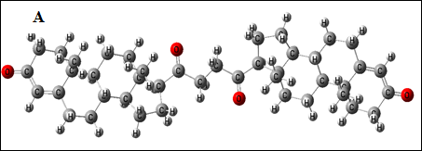

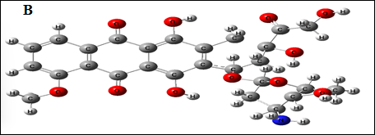

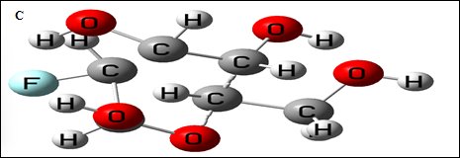

FIGURE 1. Improvement of the molecular structure before physical docking. a) Cancer (C₄₂H₅₈O₄), SCF=-52706.59138 eV, b) Doxorubicin(C₂₇H₂₉NO₁₁), SCF=-52399.95712 eV, c) ¹⁸F-FDG (C₆H₁₁FO₅), SCF=-19325.11481 eV.
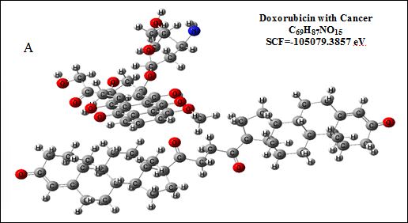

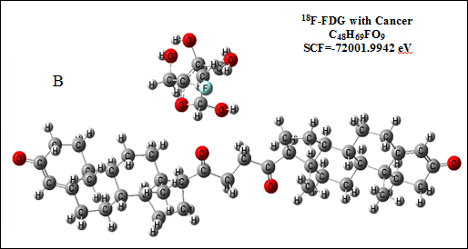

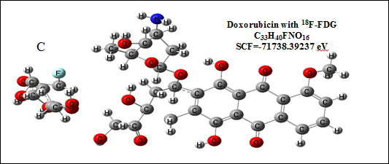

FIGURE 2a,b,c. Improved molecular structures after physical docking.
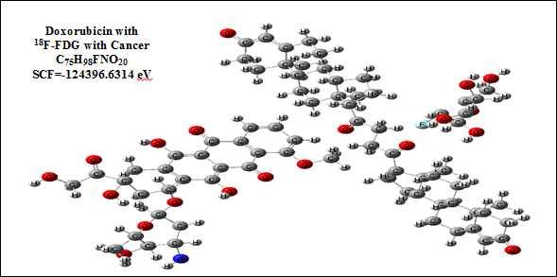

FIGURE 3. The improved structural structure of the ternary system.

Conclusion
The results show that the Doxorubicin works well with traditional medicine treatment for breast cancer, as it has stable free energy, moderate heat changes, and a good heat spread, which means it's a suitable option for therapy. When the ¹⁸F-FDG dye was docking with the system, the thermodynamic conditions improved, with both free energy and heat changes going down, making it easier for the drug to be delivered. The energy needed to change the structure also went down a lot, showing that it became more flexible, which helps the treatment work better without changing the drug's basic structure. When the ¹⁸F-FDG dye was docking with the system, the energy changes improved, meaning the environment became better for delivering the drug. The deformation energy also decreased a lot in this situation, showing that the structure is more flexible, which helps the treatment work better without changing the drug's basic structure. These signs show that the ¹⁸F-FDG dye helps improve energy flow in the system without affecting the active ingredients in the medicine. So, it can be said that adding ¹⁸F-FDG improves treatment effectiveness by managing the temperature, which helps create better and more stable treatment systems in living organisms.

References
- B.A. Ahmed, J. Mohammed, R.N. Fadhil, K.A. Jasim, A.H. Shaban, A. Al Dulaimi, The dependence of the energy density states on the substitution of chemical elements in the Se6Te4-xSbx thin film, chalcogenide Letters 19(4) (2022) 301-308.
- A.N. Abdulateef, A. Alsudani, R.K. Chillab, K.A. Jasim, A.H. Shaban, Calculating the Mechanisms of Electrical Conductivity and Energy Density of States for Se85Te10Sn5-xInx Glasses Materials, Journal of Green Engineering (JGE) 10(9) (2020) 5487-5503.
- B.B. Kadhim, Ablation characteristics of TiO2/UPE-PMMA blend nanocomposites: empirical and simulation approaches, Energy Procedia 119 (2017) 718-722.
- B.S. Abd, B.B. Kadhim, M.M. Abud, Simulating the physical properties of gum carcinoma ablation using a laser knife, AIP Conference Proceedings, AIP Publishing LLC, (2025), p. 050057.
- M.O. Kadhim, F.K. Farhan, D.A. Sabar, O.N. Abood, Friction coefficient and biophysical properties for UPEPMMA blend reinforced by nano-zinc oxide, EurAsian Journal of BioSciences 12(2) (2018).
- H. Sung, J. Ferlay, R.L. Siegel, M. Laversanne, I. Soerjomataram, A. Jemal, F. Bray, Global cancer statistics 2020: GLOBOCAN estimates of incidence and mortality worldwide for 36 cancers in 185 countries, CA: a cancer journal for clinicians 71(3) (2021) 209-249.
- S. Hyuna, Global cancer statistics 2020: GLOBOCAN estimates of incidence and mortality worldwide for 36 cancers in 185 countries, Ca Cancer J Clin 4 (2021).
- M. Perveen, L. Noreen, M. Waqas, R.F. Mehmood, J. Iqbal, S. Manzoor, S. Nazir, A.M. Shawky, R.A. Khera, A DFT approach for finding therapeutic potential of graphyne as a nanocarrier in the doxorubicin drug delivery to treat cancer, Journal of Molecular Graphics and Modelling 124 (2023) 108537.
- H.A. Rizwan, M.U. Khan, M.R.S.A. Janjua, A. Anwar, M. Idrees, N.A. Siddiqui, The Dual Role of C6O6Li6 Nanomaterial in Sensing and Drug Delivery of Nitrosourea: a DFT Perspective, Journal of Inorganic and Organometallic Polymers and Materials (2025) 1-20.
- G. Minotti, P. Menna, E. Salvatorelli, G. Cairo, L. Gianni, Anthracyclines: molecular advances and pharmacologic developments in antitumor activity and cardiotoxicity, Pharmacological reviews 56(2) (2004) 185-229.
- S.S. Gambhir, Molecular imaging of cancer with positron emission tomography, Nature Reviews Cancer 2(9) (2002) 683-693.
- M. Pontico, M. Conte, F. Petronella, V. Frantellizzi, M.S. De Feo, D. Di Luzio, R. Pani, G. De Vincentis, L. De Sio, 18F-fluorodeoxyglucose (18F-FDG) functionalized gold nanoparticles (GNPs) for plasmonic photothermal ablation of cancer: a review, Pharmaceutics 15(2) (2023) 319.
- S. Stegemann, A.B. Almarsdόttir, C. Vermehren, Patient engagement in pharmaceutical development: Where are we?–Report from a symposium, European Journal of Pharmaceutics and Biopharmaceutics 185 (2023) 1-4.
- H. Guan, H. Sun, X. Zhao, Application of density functional theory to molecular engineering of pharmaceutical formulations, International Journal of Molecular Sciences 26(7) (2025) 3262.
- S.A. Jaber, B.B. Kadhim, A.T. Mohi, Simulation investigations of thermodynamic properties for silica nanoparticles and voxelotor docking effect with hemoglobin for sickle cell disease, AIP Conference Proceedings, AIP Publishing, 2024.
- B.B. Kadhim, S.A. Jaber, Simulation of Interaction Energy and Thermodynamic Investigations of Hemoglobin Docking with Nanomaterial in Heroin Addiction Case, Journal of Nano Materials Impact (2025) 7-13.
- A.A.K. Al-mebir, M.D. Noori, B.B. Kadhim, Investigation of Electric and Thermoelectric Properties of Phthalocyanine monomer/dimer Molecular Junctions, Journal of Physics: Conference Series, IOP Publishing, 2021, p. 012037.
- E. Şahin Akdeniz, C. Selçuki, Investigation of interactions of doxorubicin with purine nucleobases by molecular modeling, Journal of Molecular Modeling 28(3) (2022) 69.
- H. Jadvar, A. Alavi, S.S. Gambhir, 18F-FDG uptake in lung, breast, and colon cancers: molecular biology correlates and disease characterization, Journal of Nuclear Medicine 50(11) (2009) 1820-1827.
- R.-D. Seban, J.S. Nemer, A. Marabelle, R. Yeh, E. Deutsch, S. Ammari, A. Moya-Plana, F.-Z. Mokrane, R.D. Gartrell, G. Finkel, Prognostic and theranostic 18F-FDG PET biomarkers for anti-PD1 immunotherapy in metastatic melanoma: association with outcome and transcriptomics, European journal of nuclear medicine and molecular imaging 46 (2019) 2298-2310.
- M. Perveen, N. Hadia, A. Noreen, R.F. Mehmood, I. Yahia, R.A. Khera, J. Iqbal, Controlled supramolecular interactions for targeted release of amiodarone drug through graphyne to treat cardiovascular diseases: An in silico study, Journal of Molecular Graphics and Modelling 121 (2023) 108452.
- E. Campbell, C. Jordan, R. Gilmour, Fluorinated carbohydrates for 18 F-positron emission tomography (PET), Chemical Society Reviews 52(11) (2023) 3599-3626.

