Synthesis, Identification, and Antibacterial Effect Assessment of New Thiazolidinones from Some Imines Bearing Substituted Phenyl Sulphonyl Amides

Saad Salem Jasim^{1, a)}, Shakhawan Beebany^{1, b)} and Jawdat Hilmi Abdulwahid^{2, c)}

¹ Department of Chemistry, College of Sciences, University of Kirkuk, Kirkuk, Iraq
² Department of Environmental and Pollution Engineering, Technical Engineering
College / Kirkuk, Northern Technical University, Mosul, Iraq

^{a)}saadsalem@uokirkuk.edu.iq
^{b)} Corresponding author: sh.beebany@uokirkuk.edu.iq
^{c)}jawdat.1965@ntu.edu.iq

Abstract: A series of new thiazolidinone derivatives (N₂₂-N₄₂) has been prepared from the reaction of some Schiff bases (N₁-N₂₁) containing sulfonylamide group with thioglycholic acid in dry benzene. The whole synthesized chemical materials have been identified through FT – IR spectroscopy. Structures for some of the newly synthesized chemical materials have been proved by proton magnetic rsonance (¹H-NMR) using (DMSO-d⁶) as a solvent and mass spectroscopy. The biological activity effect of these chemical products has been studied against certain types of bacteria: gram – positive (Streptococcus pneumonia) and gram – negative (Pseudomonas aerugenosa). Additionally, the anti fungal effect of some chemical products was investigated toward Aspergillus species and the resulte were correlated with fungal Nystatin as control sample. The results were indicated the highest inhibtion zone diameter value for derivatives (N₃₆, N₃₄ and N₄₂). These chemical compounds revealed a promising bioactivity against these microbial agents.

Keywords: Schiff bases, Amino sulfonacetamide, Methylisoxazolyl sulfonamide, Thiazolidinone.
INTRODUCTION
Heterocyclic compounds have been obtained extremely attractive from organic chemist due to their bioactive properties. More than 70% of the medications (or) used today are heterocyclic compounds, and in the preparation of polymers that have many uses in industry [1]. Thiazolidinone compound is one of these powerful materials as it is clinically importance. Thiazolidinones have numerous pharmacological properties, including anti-cancer, anti-diabetic, anti-microbial, antiviral, anti-inflammatory and anticonvulsant properties because of these wide spectrum biological properties. Thiazolidinones are called magic molecules [2]. There are many examples of active thiazolidinones biologically such as antibiofilm [3], hypoglycemic [4], anti diabetic and HIV [5], anti - tuberalosis [6], anticancer [7] and anti-inflammatory activities [8], antioxidant [9] anticonvulsant [10], antihistaminic [11], and anti antimirobial [12]. Recently, some thiazolidinone derivatives have been used as a potent antitrypanosomal agents [13].
It has been documented in the literature, the most common method to prepare thiazolidinone is undergoing a Schiff base compound to a cyclization reaction through the addition of marcapto aetic acid in dry benzene [14]. Some Schiff compounds include imidazoly ring have been convetrted to thiazolidines by the reaction of mercapto acetic acid with the Shiff in ethanol as solvent [15]. Synthesis of thiazolidinones from the addition of mercaptoacetic acid to benzothiazolyl Schiff bases was reported, using dry benzene as solvent [16-18]. The reaction of pyrimidinyl Schiff bases with mercaptoacetic acid has been documented to prepare thiazolidinone, using dry benzene as solvent [19]. Thiazolidinone synthesis has been published through the reaction of benzoxazolyl hydrazine Schiff with mercapto acetic acid in dry benzene as solvent [20]. The addition of mercapto acetic acid to tetrazolyl Schiff bases has been revealed to from thiazolidinones in dioxane as solvent. As a result, a plan has been made to convert some neew Schiff compounds to thiazolidinones. These Schiff bases bearing some pharmaceutical modes 4-aminobenzenesulfon amide, N-((4-aminophenyl) sulfonyl) acetamide, 4-amino-N-(5-methylisoxazole-3-yl) benzenesulfonamide. This will be academically additional scientific value for the field of organic chemistry. The aim of this research is focused on synthesis of new thiazolidinone-4-one derivatives from Schiff bases attached to pharmaceutical modes. In addition to evaluation their biological activity against two type of bacteria gram–positive (Streptococcus pneumonia) and gram–negative (Pseudomonas aerugenosa) and one type of fungi (Aspergillus species).
EXPERIMENTAL
Materials and Methods
All the chemicals were used in this research supplied by (BDH, GCC, Merck, Fluke, Alfa, and Aldrich) companies. The high purity of benzene is first dropped, then anhydrous magnesium sulphate (MgSO₄) is added to dehydration. The melting point was determined by using electrothermal melting point apparatus model 9300. For the purity of the prepared compounds, we used the TLC techniques. The FT-IR spectra were recorded using the FT-IR 8400s Shimadzu spectrophotometer scale (4000-400) cm⁻¹. H¹-NMR spectra were recorded on Varian operating at 400 MHz instrument using DMSO-d⁶ as a solvent, The mass spectra were measured in the laboratories of the College of Applied Sciences - University of Samarra / Iraq using a GCMS-QP2010E device equipped by the Japanese company Shimadzu.

Synthesis of Schiff Bases Derivatives (N₁-N₂₁) [21]
(0.002) Mole of different benzaldehyde and ketone compounds was dissolved in 25 mL of absolute ethanol and (3-4) drops of glacial acetic acid added followed by the addition a solution of (0.002) mole of the pharmaceutical compounds dissolved in absolute ethanol. The mixture was heated at reflux for two houres and the completition time of the reaction was followed by TLC. The reaction mixture was cooled to precipitate and filtrated, dried then recrystallized in absolute ethanol.

Synthesis of 4-Thiazolidinone Derivatives (N22-N42) [22]
(0.001) Mole of prepared Schiff bases [N₁-N₂₁] was dissolved in 10 mL of dry benzene and (0.001) mole of mercapto acetic acid added to it. The reaction mixture was heated under reflux for three hours. and the reaction time was followed by TLC. The mixture was cooled, and the precipitate filtered, dried and recrystallized from absolute ethanol.
Study of Biological Activity
The biological effect of final products wer assessed tword two types of bacteria grams–positive (Streptococcus pneumonia) and gram–negative (Pseudomonas aerugenosa) and one type of fungi (Aspergillus species). The micro-organisms have been isolated and identified at Laboratories for Biology Department/ Science College in Kirkuk University. The chemical concentrations for the tested compounds were prepared using DMSO as solvent for each substance with three concentrations of (5, 10, 15) mg/mL.

Anti Bacterial and Anti fungi Tests Method [23, 24]
For anti bacterial test, the single bacteria have been transferred to a test tube containing 5 mL of nutrition and the broth incubated at 37 °C for 24 hours. The bacterial suspension was prepared and compared with tube number 0.5 of McFarland- standards giving a cell density of (1.5×10⁸ cell/mL). A sterile cotton sweep has been dunked into a bacterial suspension and wiped in equally way on the surface of a Muller-Hinton agar plate. After that, the plates have been brooded at 37 °C for 30 minutes. The culture media on the plates have been penetrated (3 wells) by a sterilized cork borer with a diameter of 5 mm. The tested compounds (0.5 mL) were poured into the wells and then incubated at 37 °C for 24 hours. The results of the inhibtion zone diameter were measured using ruler by nanometer. The chemical concentrations for the tested compounds were (5, 10 and 15) mg/mL. For anti fungi test, fungal suspension has been prepared from fresh culture by mixing fungal colonies with 3 ml of sterile distilled water. The inoculum fungi solution was then transferred to the SDA which is supplemented with chloramphenicol using a sterile cotton swab and left to dry. The culture media on the plates were penetrated (3 wells) by a sterilized cork borer with a diameter of 5 mm. The tested compounds (0.5 mL with 5, 10 and 15 mg/mL) have been poured into the wells and then incubated at 25 ℃ for 7 days. The inhibition zone results have been recorded in mm.

RESULTS AND DISCUSSION
In our work, some new series of thiazolidine derivatives have been synthesized, as shown in Scheme (1). All the new prepared compounds were characterized by FT-IR and some by ¹H-NMR and ¹³C-NMR spectroscopy.
SCHEME 1. Schematic shows all the prepared compounds (N₁-N₄₂).
Characterization of Schiff Base Derivative Compounds (N₁-N₂₁)
Schiff bases compounds (N₁-N₂₁) were prepared from the reaction of equimolar of one of the pharmaceutical compounds with various benzaldehyde and ketone compounds in absolute ethanol as a solvent in the presence of (3-4) drops of glacial acetic acid as a catalyst, as shown in Scheme 1.
From the study of FT-IR Spectral absorption, all the spectra of the prepared compounds (N₁-N₂₁) indicated the disappearance of the aldehyde carbonyl group stretch peak (νC=O), and the disappearance of the symmetrical and asymmetrical stretch peak of the amine group. A strong peak has appeared due to the elastic vibration of the azomethene group (νC=N) at (1643-1608) cm⁻¹, and the appearance of absorption peak at the range (3097-3008) cm⁻¹ belonging to the elastic stretch (C-H) aromatic. The appearance of two peaks at the range (2995-2915) cm⁻¹ and (2933-2812) cm⁻¹ is referred to symmetrical and asymmetric stretching (C-H) aliphatic. In addition to the appearance of a strong peak at (1764-1633) cm⁻¹ returns to the amide (C=O) group of sulfa drugs, with the appearance of two absorption peaks at the range (1599-1504) cm⁻¹ and (1560-1461) cm⁻¹ for stretching (C=C) aromatic [25]. Tables (1 and 2) show some physical properties with infrared spectral data of the prepared compounds.

TABLE 1. Some physical properties and IR spectral data of Schiff base derivatives (N₁-N₁₅).
IR (KBr) cm⁻¹ |  |  |  |  |  |  | M. P.  ^{O} C | Substituent groups |  | No.
Others | ν (SO₂)  Asym.  Sym. | ν  (C=C)  Arom. | ν (C=N) | ν  (C=O) Amide | ν  (C-H)  Aliph. | ν  (C-H)  Arom. | M. P.  ^{O} C | Ar ⁻ | Ar | No.
ν (O-H)  3473 | 1380  1170 | 1510  1467 | 1579 | 1625 | 2925  2856 | 3068 | 194-196 |  |  | N₁
ν (O-H) (3343)  ν(NO₂),  Asym. (1535)  Sym. (1367) | 1385  1185 | 1589  1483 | 1626 | 1630 | 2942  2851 | 3039 | 188-200 |  |  | N₂
ν (O-H) (3452)  ν (C-O-C),  Asym. (1275)  Sym. (1074) | 1404  1170 | 1510  1463 | 1619 | 1618 | 2979  2920 | 3068 | 196-198 |  |  | N₄
ν (N-H)  3349 | 1387  1165 | 1579  1494 | 1624 | 1614 | 2991  2891 | 3095 | 145-147 |  |  | N₅
ν (O-H) (3440)  ν(NO₂),  Asym. (1523)  Sym. (1396) | 1396  1155 | 1583  1483 | 1610 | 1697 | 2966  2921 | 3062 | 225-227 |  |  | N₇
ν (O-H)  3353 | 1383  1172 | 1599  1480 | 1641 | 1764 | 2915  2886 | 3022 | 203-205 |  |  | N₁₁
ν (O-H) (3335)  ν(NO₂),  Asym. (1537)  Sym. (1337) | 1377  1168 | 1593  1481 | 1619 | 1642 | 2995  2832 | 3089 | 223-225 |  |  | N₁₂
ν (C-Cl)  833 | 1365  1155 | 1593  1471 | 1629 | 1651 | 2987  2933 | 3080 | 190-192 |  |  | N₁₃
ν (N-H)  3259 | 1396  1159 | 1595  1504 | 1608 | 1633 | 2991  2891 | 3091 | 205-207 |  |  | N₁₅

TABLE 2. Melting points and IR spectral data of Schiff base derivatives (N₁₆-N₂₁).

 | IR (KBr) cm⁻¹ |  |  |  |  |  |  |  | M. P.  ^{O} C |  | Substituent groups |  | No.
Others |  | ν (SO₂)  Asym.  Sym. | ν (C=C)  Arom. | ν (C=N) | ν  (C=O) Amide | ν  (C-H)  Aliph. | ν  C-H)  Arom. |  |  | Ar
ν (N-H)  3353 |  | 1355  1178 | 1581  1465 | 1612 | 1654 | 2983  2879 | 3055 | 165-167 |  |  |  | N₁₆
ν (N-H)  3260 |  | 1350  1163 | 1585  1471 | 1630 | 1666 | 2981  2829 | 3031 | 205-207 |  |  |  | N₁₇
ν (N-H)  3270 |  | 1360  1172 | 1595  1487 | 1639 | 1651 | 2976  2854 | 3027 | 186-188 |  |  |  | N₁₈
ν (N-H)  3299 |  | 1365  1193 | 1554  1460 | 1579 | 1629 | 2929  2881 | 3066 | 236-238 |  |  |  | N₁₉
ν (N-H)  3350 |  | 1348  1176 | 1585  1464 | 1629 | 1663 | 2972  2861 | 3024 | 182-184 |  |  |  | N₂₀
ν (N-H)  3360 |  | 1356  1168 | 1584  1482 | 1627 | 1656 | 2964  2877 | 3029 | 256-258 |  |  |  | N₂₁
Characterization of 4-Thiazolidinone Derivatives Compounds (N₂₂-N₄₂)
Thiazolidinone compounds (N₂₂-N₄₂) have been prepared from the reaction of Schiff Base derivatives (N₁-N₂₁) with of mercapto acetic acid in dry benzene as a solvent as shown in Scheme 1.The infrared spectra for 4-thiazolidinone (N₂₂-N₄₂) have revealed the disappearance of the medium peak belonging to the (C=N) group and the appearance of a strong peak at the frequency (1680 - 1645) cm⁻¹, corresponded to the elastication of the carbonyl bond (C=O) thiazolidine ring. Additionally, the apperance of other strong peaks at the range (1329-1213) cm⁻¹ is attributed to the stretching of the bond (C-N).
The rest of the peaks also maintained their normal ranges on the length of the chain derivatives, as the appearance of absorption peak at range (3098-3016) cm⁻¹ belonging to stretching, aromatic (C-H). Moreover, the appearance of two peaks at the range (2987-2871) cm⁻¹ and (2893-2816) cm⁻¹ for the symmetrical and asymmetrical stretching aliphatic (C-H). Furthermore, two beams have appeared at the range (1610-1510) cm⁻¹ and (1562-1431) cm⁻¹ due to the vibration of the aromatic (C=C) [23].
Tables (3 and 4) include some physical properties with infrared spectral data of the prepared compounds.

TABLE 3. Melting points and IR spectral data of thiazolidine-4-one derivatives compounds (N₂₂-N₃₆).
 | IR (KBr) cm⁻¹ |  |  |  |  |  |  |  | M. P.  ^{O} C |  | Substituent groups |  |  | No.
Others |  | ν  (SO₂)  Asym.  Sym. | ν  (C=C)  Arom. | ν  (C=N) | ν  (C=O) Amide | ν  (C-H)  Aliph. | ν  (C-H)  Arom. |  |  | Ar ⁻ |  | Ar
ν  (O-H)  3356 |  | 1380  1170 | 1592  1491 | 1580 | 1677 | 2978  2880 | 3076 | 221-223 |  |  |  |  | N₂₂
ν (O-H)  (3344)  ν(NO₂),  Asym. (1529)  Sym. (1342) |  | 1385  1185 | 1587  1468 | 1626 | 1670 | 2955  2841 | 3016 | 165-167 |  |  |  |  | N₂₃
ν (O-H)  (3452)  ν(C-O-C),  Asym. (1275)  Sym. (1074) |  | 1404  1170 | 1510  1463 | 1619 | 1618 | 2979  2920 | 3068 | 195-197 |  |  |  |  | N₂₅
ν (O-H)  3458 |  | 1379  1160 | 1585  1477 | 1635 | 1732 | 2953  2865 | 3073 | 180-182 |  |  |  |  | N₂₇
ν (N-H)  3325 |  | 1365  1180 | 1595  1483 | 1642 | 1687 | 2942  2818 | 3030 | 119-121 |  |  |  |  | N₃₁
ν (O-H)  3353 |  | 1383  1172 | 1599  1480 | 1641 | 1764 | 2915  2886 | 3022 | 251-253 |  |  |  |  | N₃₂
ν (O-H)  (3353)  ν(C-O-C),  Asym. (1270)  Sym. (1064) |  | 1388  1166 | 1579  1494 | 1647 | 1750 | 2918  2816 | 3040 | 240-241 |  |  |  |  | N₃₅

TABLE 4. Melting points and IR spectral data of thiazolidine-4-one derivatives compounds (N₃₇-N₄₂).
 | IR (KBr) cm⁻¹ |  |  |  |  |  |  |  | M. P.  ^{O} C |  | Substituents group |  | No.
Others |  | ν (SO₂)  Asym.  Sym. | ν (C=C)  Arom. | ν (C=N) | ν (C=O) Amide | ν  (C-H)  Aliph. | ν  (C-H)  Arom. |  |  | Ar
ν (NH₂)  3359,3233 |  | 1352  1150 | 1523  1473 | 1573 | 1656 | 2972  2844 | 3037 | 178-180 |  |  |  | N₃₇
ν (N-H)  3266 |  | 1350  1163 | 1589  1466 | 1630 | 1685 | 2945  2879 | 3053 | 221-223 |  |  |  | N₃₈
ν (N-H)  3275 |  | 1362  1155 | 1539  1489 | 1639 | 1676 | 2963  2840 | 3024 | 196-198 |  |  |  | N₃₉
ν (NH₂)  3352,3277 |  | 1365  1193 | 1598  1458 | 1579 | 1666 | 2981  2869 | 3067 | 238-240 |  |  |  | N₄₀
ν (N-H)  3348 |  | 1351  1164 | 1589  1448 | 1634 | 1692 | 2996  2855 | 3029 | 175-176 |  |  |  | N₄₁
ν (N-H)  3328 |  | 1390  1134 | 1589  1552 | 1643 | 1643 | 2974  2929 | 3037 | 244-246 |  |  |  | N₄₂

The mass spectrum of the compound (N₄) (C₁₅H₁₆N₂O₅S) has shown the molecular ion (Molecular Ion: 336 (16.2%) and the base peak value appeared at m/z: 167 (100.0%) which is attributed to fractionation (C₉H₁₁O₃)⁺ as shown in Figure 1. and Scheme 2.

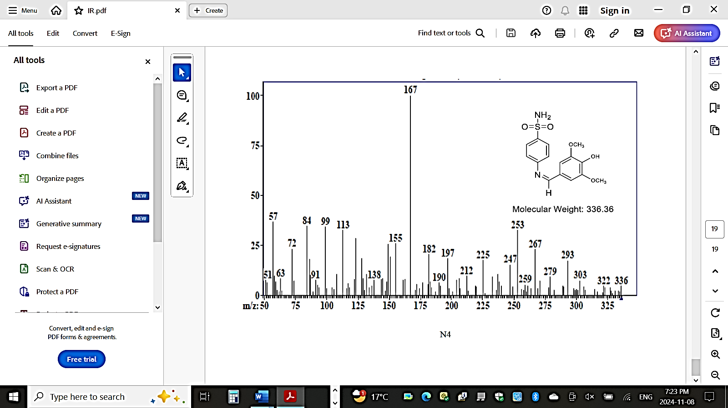
FIGURE 1. Mass spectrum of compound N₄.

The ¹H-NMR spectrum of 4-thiazolidinone compound N₂₉ has revealed a singlet signal at 3.35 ppm attributed to the HDO protons and a singlet signal was observed at (1.97) ppm attributed to the protons of the CH₃ group labeled (a). A singlet signal appeared at 3.98 ppm corresponded to the protons of the CH₂ group of the thiazolidinone five-membered ring labeled (b). Additionally, a singlet band has appeared at 6.61 ppm represented to the (C-H) proton in the thiazolidinone ring labeled (c) and multiple signals appeared at 7.28-7.87 ppm referred to the protons of the aromatic ring labeled (d) [22] and [26]. Moreover, a single signal appeared at 12.55 ppm contributed with the proton of the (N-H) group labeled (e) as shown in Figure 2.

SCHEME 2. Composite pattern of compound N₄.

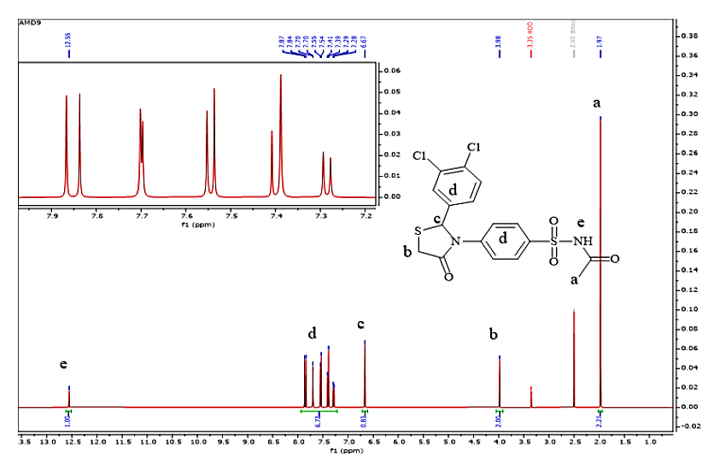
FIGURE 2. ¹H-NMR spectrum for compound N₂₉.
Evaluation of the Biological Activity of Some Prepared Compounds
The biological activity has been carried out using newely synthesized compounds (N₂₃, N₂₉, N₃₀, N₃₁, N₃₄, N₃₅, N₃₆, and N₄₂) on two types of bacteria and one type of fungi, where Gram-positive bacteria (Streptococcus pneumonia), Gram-negative bacteria (Pseudomonas auroginosa), and fungs (Aspergillus spp).
The result revealed that all the newly synthesized compounds showed good inhibitory effect in generall toward the tested bacteria and fungi especially at high concentrations compared to the low concentrations. This is related to the high concentration effect. Furthermore, the highest inhibitory effect has been obtained for N₃₆, N₄₂ in case of Streptococcus pneumonia, N₃₄, N₃₆ for Pseudomonas auroginosa and N₂₃, N_{36,} N₄₂ for Aspergillus spp as shown in Tables 5 and 6 and Figures 4-6. These results can be explained by considering the presence of polar groups in the prepared compounds or by comparing the polarity of the prepared compounds with each other or with the standard compounds. The more polarity or the more polar groups the available in compounds will lead to more inhibition efficiency. However, the lowest inhibitory activity has been recorded for N₃₅ in case of Streptococcus pneumonia, N₃₁ for Pseudomonas auroginosa and N₃₅ for Aspergillus spp.
Biological activity effect has relationship the molecular structure and the nature of the substituted groups that are present in the applied materials. The effectiveness of the prepared compounds against bacteria and fungi is attributed to the presence of electron-withdrawing groups such as (Cl, NO₂, the five-membered pyrrole ring) in the prepared compound. Strong electron-withdrawing groups like (NO₂) are more effective than electron-donating groups like (OCH₃) and the five-membered pyrrole ring. Additionally, sulfonamide group inhibits the production of bacteria for folic acid (Vitamin 9).
The mechanism of inhibition can be explained as effect of Gram-positive and Gram-negative bacteria on the distinctive composition of their cell walls. Gram-positive bacteria have a cell wall rich in teichoic acid and a high concentration of peptidoglycan polymer connected by peptide bonds. The thickness of the peptidoglycan layer is (25 nm) in Gram-positive bacteria compared to about (3 nm) in Gram-negative bacteria, allowing for easier penetration of molecules. Gram-negative bacteria contain a lower ratio of peptidoglycan chains with a layer of lipopolysaccharides in addition to phospholipids and lipoproteins, making them highly hydrophobic. The lipopolysaccharide layer in Gram-negative bacteria acts as a protective shield for the bacteria, hindering penetration [27, 28].

TABLE 5. Antibacterial activity values ​​for some of the prepared compounds.
Comp.No. | Streptococcus pneumonia (+GVe) |  |  | Pseudomonas aeruginosa (- GVe)
Comp.No. | 5 (mg/mL) | 10 (mg/mL) | 15 (mg/mL) | 5 (mg/mL) | 10 (mg/mL) | 15 (mg/mL)
N₂₃ | 7 | 10 | 13 | 8 | 11 | 13
N₂₉ | 8 | 9 | 16 | 7 | 9 | 14
N₃₁ | 8 | 11 | 14 | 7 | 10 | 12
N₃₄ | 8 | 9 | 16 | 8 | 11 | 19
N₃₆ | 9 | 13 | 20 | 9 | 11 | 16
N₄₂ | 10 | 15 | 22 | 8 | 12 | 16
4-minobenzenesulfonamide | 4 | 6 | 8 | 5 | 8 | 10
N-((4-aminophenyl)  sulfonyl) acetamide | 3 | 7 | 8 | 6 | 9 | 11
4–amino –N- (5–methylisoxazole– 3-yl) benzenesulfonamide) | 5 | 7 | 8 | 8 | 10 | 12
Nystatin | 6 | 8 | 9 | 7 | 9 | 10
Values represent inhibtion zones by cm.

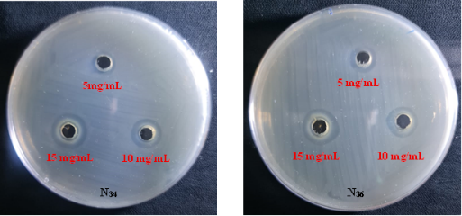
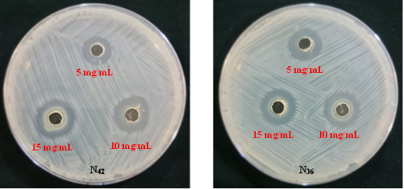

FIGURE 4. Images of biological activity results for (N₃₄ and N₃₆) at different concentrations (5, 10 and 15) mg/mL, against Pseudomonas aeruginosa.
FIGURE 3. Images of biological activity results for (N₃₆ and N₄₂) at different concentrations (5, 10 and 15) mg/mL, against Staphylococcus pneumonia.

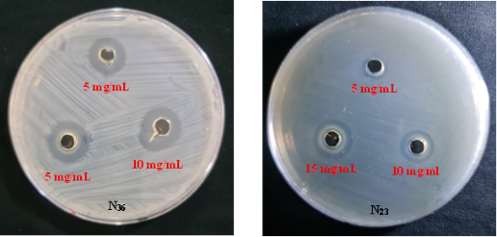

FIGURE 5. Images of biological activity results for (N₂₃ and N₃₆) at different concentrations (5, 10 and 15) mg/mL, against Asspergillus spp.
TABLE 6. Antifungal activity values ​​for some of the prepared compounds.
Comp.No. | Aspergillus spp. fungi
Comp.No. | 5 (mg/mL) | 10 (mg/mL) | 15 (mg/mL)
N₂₃ | 11 | 15 | 20
N₂₉ | 8 | 10 | 12
N₃₄ | 8 | 10 | 12
N₃₆ | 8 | 12 | 18
N₄₂ | 9 | 11 | 15
4-minobenzenesulfonamide | 8 | 10 | 11
N-((4-aminophenyl) sulfonyl) acetamide | 8 | 11 | 12
4 – amino – N - (5 – methylisoxazole – 3 - yl) benzenesulfonamide | 7 | 10 | 11
Nystatin | 8 | 11 | 12
CONCLUSION
Some new thiazolidinone derivatives have been successfully prepared through the cyclization reaction of Schiff bases with mercapto acetic acid, cantaining some active pharmaceutical modes. The all structures for the final series of the chemical products have been confirmed depending on the FTIR and ¹H-NMR. In addition to using the mass spectroscopy for some of the newely synthesized thiazolidinone for the products structure verified purposes. Generally, the new prepaered thiazolidinone derivatives h reveal to have good antibacterial and antifungi activity towards the applied bacteria and fungi particularly at high concentrations 15 mg/mL. The results also showed the highest inhibtion zone diameter value for N₃₆, N₄₂ against Streptococcus pneumonia, N₃₄, N₃₆ for Pseudomonas auroginosa and N₂₃, N_{36,} N₄₂ for Aspergillus spp. This is ascribred to the different in the polarity of the new chemical derivatives with each other and standard materials. While the lowest inhibtion zone diameter value has been observed for N₃₅ in case of Streptococcus pneumonia, N₃₁ for Pseudomonas auroginosa and N₃₅ for Aspergillus spp. The results suggest bioactive materials from above to be considered for further investigation.
REFERENCES
1. Atheer R. T. N., Khattab A. F. And Mahmood H. S., Synthesis of New polymers of Triazole Derivatives, NTU Journal of Pure Sceinces, Vol. (3), No. (3), 30-37, (2024). https://doi.org/10.56286/nst2xv26.
2. Boudissa R., Benmohammed A., Chafai N., Boudechicha A., Rekiba N., Lagraa H., Achour M., Khoumeri O., Djafri A., Terme T., and Vanelle P., Synthesis, characterization, DFT, antibacterial, ADME-T properties, and molecular docking of new N-functionalized thiazolidinones, Journal of Molecular Structure, Vo. (1307), 138004, 5 July (2024). https://doi.org/10.1016/j.molstruc.2024.138004.
3. Chadha N., Bahia M. S., Kaur M., and Silakari O., Thiazolidine-2,4-dione Derivatives: Programmed Chemical Weapons for Key Protein Targets of Various Pathological Conditions, Bioorg. Med. Chem., 23(13):2953-2974, Jul, (2015). https://doi.org/10.1016/j.bmc.2015.03.071.
4. Tratrat C., Petru A., Geronikaki A., Ivanov M., Kostic M., Sokovic M., Vizirianakis I., Theodoroula N. F., and Haroun M., Thiazolidin-4-Ones as Potential Antimicrobial Agents: Experimental and In Silico Evaluation, Molecules, 16;27(6), 1930, (2022). https://doi.org/10.3390/molecules.27061930.
5. Pradhan T., Gupta O., Kumar V., and Chawla S. G., A Comprehensive Review on the Antidiabetic Attributes of Thiazolidine-4-ones: Synthetic Strategies and Structure–Activity Relationships, Archive der Pharmazie, V (356), Issue (2), Feb., (2023). https://doi.org/10.1002/ardp.202200452.
6. Younis M. H., Mohamed A. R., Mohammed E. R., Georgey H. H., and Abdel Gawad N. M., 4-Thiazolidinones: A Structural Motif of Great Synthetic and Biological Activities, ERURJ, 2, 3, 525 - 540, (2023). https://doi.org/10.21608/ERURJ.2023.214879.1038.
7. Kenekar S., and Chavan S., The Therapeutic Journey of Heterocyclic Compound 2, 4-Thiazolidinediones as A Versatile Pharmacophore: An Insight into Its Synthesis Routes, Structure Activity Relationships, & Biological Significan, Organic & Medicinal Chemistry International Journal, 12(3): OMCIJ. MS. ID. 555837 (2023). https://doi.org/10.19080/OMCIJ.2023.12.555837.
8. Mech D., Kurowska A., and Trotsko N., The Bioactivity of Thiazlidine – 4 – Ones: A Short Reof the Most Recent Studies, Int. J. Mol. Sci., 22(21):11533, (2021). https://doi.org/10.3390/ijms222111533.
9. Qabel H. A., and Al-Majidi S. M. H., Synthesis and Identification of Some New Imidazolidine-4-one, Oxazolidine-4-one and Thiazolidine-4-one Derivatives from Phenidone and their Antimicrobial and Antioxidant Activities Investigation, Advanced Jourrnal of Chemistry, Section A, 7 (6), 894 - 909, (2024). https://doi.org/10.48309/AJCA.2024.466432.1584.
10. Sydorenko I. A., Mishchenko M. V., Shtrygol S. Y., Lozynskyy A. N., Soronovych I. I., Holota A. M., and Lesyk R. B., The Synthesis and the Anticonvulsant Activity Screening of New 5-Substituted 2-Imino-4-Thiazolidinone Derivatives, Journal of Organic and Pharmaceutical Chemistry, Vol. (20), No. 1(77), (2022). https://doi.org/10.24959/ophcj.22.248784.
11. Da Silva T. L., Miolo L. M., Sousa F.S. S., Brod L. M. P., Savegnago L., and Schneider P. H., New Thioureas Based on Thiazolidines with Antioxidant Potential, Tetrahedron Letters, Vol. (56), Issue (48), 6674 - 6680, (2015). https://doi.org/10.1016/j.tetlet.2015.10.037.
12. Jain A., and Sahu S. K., Thiazolidine Derivatives and their Pharmacological Actions, Thiazolidine Derivatives and their Pharmacological Actions, E3S Web of Conferences, 556, 01052, (2024). https://doi.org/10.1051/e3sconf/202455601052.
13. Filho G. B., Cardosa M. V., Santos A. C., Santos T. A., Silva A. C., et-al, Structural Design, Synthesis and anti-Trypanosoma Cruzi Profile of the Second Generation of 4-Thiazolidinones Chlorine Derivatives, Chemico – Biological Interactions, Vol. (345), 109514, 25 August (2021). https://doi.org/10.1016/j.cbi.2021.109514.
14. Seboletswe P., Cele N., and Singh P., Thiazolidinone-Heterocycle Frameworks: Chem. Med. Chem., Vo. (18), Issue (7), e202200618, (2023). https://doi.org/10.1002/cmdc.202200618.
15. Raad M. Muhiebes, and Entesar O. AL-Tamimi, Synthesis and Characterization of New Oxo-Aztedine, Imidazolidine and Thiazolidine Rings on Creatinine and Evaluation of their Biological Activity. Indian Journal of Forensic Medicine & Toxicology, Vol. (15), No. (4):1405-1411, (2021). https://doi.org/10.37506/ijfmt.v15i4.16904.
16. Kadhim Z. Y., Alqaraghuli H. G., and Abd M. T., Synthesis, Characterization, Molecular Docking, In Vitro Biological Evaluation and In Vitro Cytotoxicity Study of Novel Thiazolidine-4-One Derivatives as Anti-Breast Cancer Agents, Anti-Cancer Agents in Medicinal Chemistry, Vol. (21), Issue (17), 2397 – 2406, (2021). https://doi.org/10.2174/1871520621666210401100801.
17. Ahmmed M. M., Anee S. A., Babu M. A., Salim Z. R., Babu M. S., Ahmad J., and Darda M. A., Disparities in Maternal and Newborn Health Interventions in Bangladesh: Disparities in Maternal and Newborn Health Interventions, Vol. (23), Issue (16), Oct. (2020). http://dx.doi.org/10.36295/ASRO.2020.231639.
18. Azeez H. J., and, Abdulrahman B. S., Synthesis and Spectroscopic Characterization of a New Series of Thiazolidin-4-One Compounds from Heterocyclic Schiff Bases, International Conference on Pure and Applied Sciences (ICPAS 2018) (2018). http://dx.doi.org/10.14500/icpas2018.
19. Vazzana I., Terranova E., Mattioli F., and Sparatore F., Aromatic Schiff bases and 2, 3-disubstituted- 1, 3-thiazolidin-4-one derivatives as antiinflammatory agents. Issue in Honor of Prof. Vincenzo Tortorella ARKIVOC, (v) 364-374I. 1;5(1):364-374, ISSN 1424-6376, Jan., (2004). 89b6f53ceb87a302f0f2f8770ee750f27c55.pdf.
20. Askar F.W., Hassan H. A., and Jinzeel N. A., Synthesis of Some Heterocyclic Compounds Derived from 2-Mercapto Benzoxazole. Baghdad Science Journal, Vol. (10), Iss. (3), Article (24):766-778, Sep., (2013). https://doi.org/10.21123/bsj.2013.10.3.766-778.
21. Beebany S., Synthesis, Characterization of New Phenylene Bis Tetrazole and Bis Benzoxazepinedione Derivatives from some Bis Imines with its Biological Activity Assessment. Kirkuk Journal of Science, Vol. (18), Issue, (3), 21-31, (2023).
https://doi.org/10.32894/kujss.2023.143144.1119.
22. Chyad Al-Khazraji S. I., Synthesis of and characterization of some Heterocyclic Compounds derived from Thiophenol, Egyptian Journal of Chemistry, Vol. (64), No. (10), pp. (5655-5662), (2021). https://doi.org/10.21608/EJCHEM.2021.70759.3559.
23. Reller L. B., Weinstein M., Jorgensen J. H., and Ferraro M. J., Antimicrobial Susceptibility Testing:A Review of General Principles and Contemporary Practices, Clinical Infectious Diseases, Vol. (49), Issue (11), 1749-1755, Dec. (2009). https://doi.org/10.1086/647952.
24. Bonev B., Hooper J., and Parisot J., Principles of assessing bacterial susceptibility to antibiotics using the agar diffusion method, Journal of Antimicrobial Chemotherapy, Vol. (61), No. (6), 1295-1301, Jun (2008). https://doi.org/10.1093/jac/dkn090.
25. Jasim S. S., Synthesis and Characterization of Some Bis-1, 3- Oxazepine- dione and 1,3–Diazepine-4, 7-dione Derivatives. Kirkuk University Journal-Scientific Studies, Vol. 13, Issue (2):149–165, (2018). https://doi.org/10.32894/kujss.2018.145725.
26. Abdulwahid H., Beebany S., Jasim S. S., Synthesis, Characterization, and Antibacterial Activity Evaluation of Some New Benzoxazepindiones Obtained from Diphenylacrylimidamides, Iranian Journal of Chemistry and Chemical Engineering, Vol. (44), Issue (2), 400-411, (2025). https://doi.org/10.30492/ijcce.2024.2040353.6781.
27. Reller L. B., Weinstein M., Jorgensen J. H., Ferraro M. J., Antimicrobial Susceptibility Testing: A Review of General Principles and Contemporary Practices, Clinical Infectious Diseases, 49 (11): 1749-1755, (2009). https://doi.org/10.1086/647952.
28. Bonev B., Hooper J., Parisot J., Principles of Assessing Bacterial Susceptibility to Antibiotics Using the Agar Diffusion Method, Journal of Antimicrobial Chemotherapy, 61 (6): 1295-1301, (2008). https://doi.org/10.1093/jac/dkn090.

